**Project Document: Book Management System**

Table of Contents

1. Introduction

1.1. Purpose of the Document

1.2. Project Overview

1.3. Scope

2. System Requirements

2.1. Functional Requirements

3. Architecture

3.1. High-Level Architecture

3.2. Sequence Diagrams

4. User Interface

5. Technologies Used

**1. Introduction**

**1.1. Purpose of the Document**

The purpose of this document is to provide an overview of the Online Book Management System project developed using C. It outlines the system's requirements, architecture, features, user interface.

**1.2. Project Overview**

The Book Management System is a Console application that allows users to perform various activities such as book management, Add a book, and more. The system aims to provide a user-friendly interface for customer to access their books

**1.3. Scope**

The scope of the Book Management System project includes the following functionalities:

- Add a Book with BookID,BookName,ISBN NO.

- Delete a Book

- List all Books.

- Update a Book Details

**2. System Requirements**

**2.1. Functional Requirements**

1. Add a book: Users should be able to add a book.

2. book listing: User should be able to see all the books.

3. Delete Book: User should be able to delete the book.

4.Update Book: User should be able to update a book.

**3. Architecture**

**3.1. High-Level Architecture**

The Book Management System be a console application which will be a menu-based application

**3.3. Sequence Diagrams**

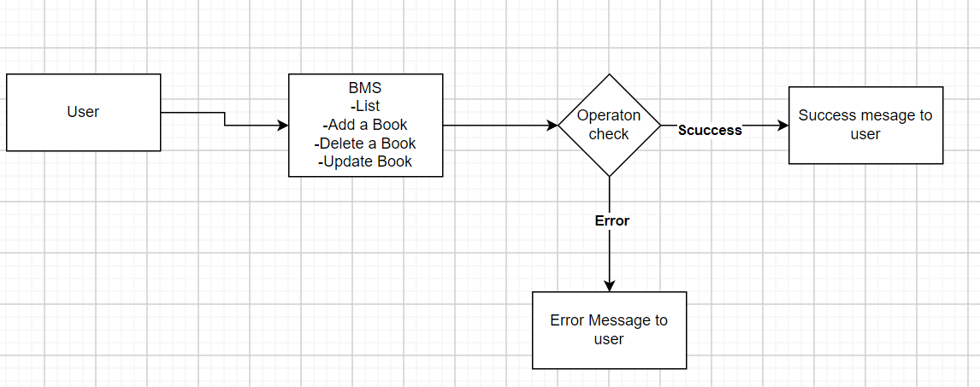

**4. User Interface**

* User interface should be a menu based
* Below will be the menu item that should be there
  + List
  + Add a Book
  + Delete a Book
  + Update a Book

**5. Technologies Used**

C