DAA_File

https://github.com/dhananjay-deshmukh/SPPU_DAA_Pracs

# Recursive Fibonacci with Step Count
def fibonacci_recursive(n, steps):
steps[0] += 1 # Counting each function call as a step
if n <= 1:
return n
return fibonacci_recursive(n - 1, steps) + fibonacci_recursive(n - 2, steps)

# Iterative Fibonacci with Step Count
def fibonacci_iterative(n):
steps = 0
if n <= 1:
return n, steps + 1 # Counting initial check as a step

a, b = 0, 1
for _ in range(2, n + 1):
steps += 1 # Each iteration is a step
a, b = b, a + b
return b, steps

# Main program
def main():
n = int(input("Enter the value of n to find the nth Fibonacci number: "))

# Recursive method
steps_recursive = [0] # Using list for pass-by-reference
fib_recursive = fibonacci_recursive(n, steps_recursive)
print(f"Recursive: Fibonacci({n}) = {fib_recursive}, Steps = {steps_recursive[0]}")

# Iterative method
fib_iterative, steps_iterative = fibonacci_iterative(n)
print(f"Iterative: Fibonacci({n}) = {fib_iterative}, Steps = {steps_iterative}")

if __name__ == "__main__":
main()

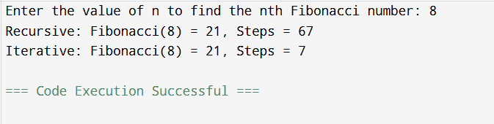

For Series:
def fib_non_recursive(n):
a, b = 0, 1
series = []
for _ in range(n):
series.append(a)
a, b = b, a + b
return series

def fib_recursive(n):
if n <= 1:
return n
return fib_recursive(n - 1) + fib_recursive(n - 2)

def fib_series_recursive(n):
return [fib_recursive(i) for i in range(n)]

n = int(input("Enter total numbers to print in Fibonacci series:\t"))

print("Fibonacci Series (non-recursive):", fib_non_recursive(n))
print("Fibonacci Series (recursive): ", fib_series_recursive(n))

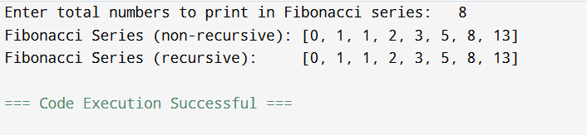

class Item:
def __init__(self, weight, value):
self.weight = weight
self.value = value

def fractional_knapsack(items, capacity):
# Calculate the value-to-weight ratio for each item
value_weight_ratio = [(item.value / item.weight, item) for item in items]

# Sort items in decreasing order of value-to-weight ratio
value_weight_ratio.sort(reverse=True)

total_value = 0.0
knapsack = []

for ratio, item in value_weight_ratio:
if capacity == 0:
break

weight = min(item.weight, capacity)
total_value += weight * ratio
capacity -= weight

knapsack.append((item, weight))

return total_value, knapsack

# Example usage
if __name__ == "__main__":
items = [Item(10, 60), Item(20, 100), Item(30, 120)]
max_capacity = 50

max_value, selected_items = fractional_knapsack(items, max_capacity)

print("Selected Items:")
for item, weight in selected_items:
print(f"Item with weight {item.weight} and value {item.value} (fraction taken: {weight / item.weight})")

print(f"Maximum value achievable: {max_value}")

def knapsack_01(values, weights, capacity):
n = len(values)

# Create a table to store the maximum values for different subproblems
dp = [[0 for _ in range(capacity + 1)] for _ in range(n + 1)]

for i in range(n + 1):
for w in range(capacity + 1):
if i == 0 or w == 0:
dp[i][w] = 0
elif weights[i - 1] <= w:
dp[i][w] = max(values[i - 1] + dp[i - 1][w - weights[i - 1]], dp[i - 1][w])
else:
dp[i][w] = dp[i - 1][w]

# Backtrack to find the items selected
selected_items = []
i, w = n, capacity
while i > 0 and w > 0:
if dp[i][w] != dp[i - 1][w]:
selected_items.append(i - 1)
w -= weights[i - 1]
i -= 1

selected_items.reverse()

for row in dp:
print(row)

return dp[n][capacity], selected_items

# Example usage
if __name__ == "__main__":
values = [60, 100, 120]
weights = [10, 20, 30]
max_capacity = 50

max_value, selected_items = knapsack_01(values, weights, max_capacity)

print("Selected Items:")
for item in selected_items:
print(f"Item with weight {weights[item]} and value {values[item]}")

print(f"Maximum value achievable: {max_value}")

def is_safe(board, row, col, n):
# Check if there's a Queen in the same column
for i in range(row):
if board[i][col] == 1:
return False

# Check upper left diagonal
for i, j in zip(range(row, -1, -1), range(col, -1, -1)):
if board[i][j] == 1:
return False

# Check upper right diagonal
for i, j in zip(range(row, -1, -1), range(col, n)):
if board[i][j] == 1:
return False

return True

def solve_n_queens_with_known_first_queen(n, first_queen_row, first_queen_col):
board = [[0 for _ in range(n)] for _ in range(n)]

# Place the first Queen at the specified row and column
board[first_queen_row][first_queen_col] = 1

def solve_n_queens_util(row):
if row == n:
return True

for col in range(n):
if is_safe(board, row, col, n):
board[row][col] = 1
if solve_n_queens_util(row + 1):
return True
board[row][col] = 0

return False

if not solve_n_queens_util(first_queen_row + 1):
print("No solution exists.")
else:
for row in board:
print(row)

n = 4
first_queen_row = 0
first_queen_col = 1
solve_n_queens_with_known_first_queen(n, first_queen_row, first_queen_col)

Huffman Encoding

import heapq
from collections import defaultdict, Counter

class HuffmanNode:
def __init__(self, char, freq):
self.char = char
self.freq = freq
self.left = None
self.right = None

def __lt__(self, other):
return self.freq < other.freq

def build_huffman_tree(freq_dict):
priority_queue = [HuffmanNode(char, freq) for char, freq in freq_dict.items()]
heapq.heapify(priority_queue)

while len(priority_queue) > 1:
left = heapq.heappop(priority_queue)
right = heapq.heappop(priority_queue)
merged_node = HuffmanNode(None, left.freq + right.freq)
merged_node.left = left
merged_node.right = right
heapq.heappush(priority_queue, merged_node)

return priority_queue[0]

def build_huffman_codes(root, current_code, huffman_codes):
if root is not None:
if root.char is not None:
huffman_codes[root.char] = current_code
build_huffman_codes(root.left, current_code + '0', huffman_codes)
build_huffman_codes(root.right, current_code + '1', huffman_codes)

def huffman_encoding(data):
if not data:
return None, None

freq_dict = dict(Counter(data))
root = build_huffman_tree(freq_dict)
huffman_codes = {}
build_huffman_codes(root, '', huffman_codes)

encoded_data = ''.join(huffman_codes[char] for char in data)
return encoded_data, root

def huffman_decoding(encoded_data, root):
if not encoded_data:
return None

decoded_data = ""
current_node = root
for bit in encoded_data:
if bit == '0':
current_node = current_node.left
else:
current_node = current_node.right

if current_node.char is not None:
decoded_data += current_node.char
current_node = root

return decoded_data

# Example usage
if __name__ == "__main__":
data = "this is an example for huffman encoding"

encoded_data, tree = huffman_encoding(data)
print(f"Encoded data: {encoded_data}")

decoded_data = huffman_decoding(encoded_data, tree)
print(f"Decoded data: {decoded_data}")

