Tab 1
cd desktop/Dod

git init
git add .
git remote add origin URL

git commit -m “commit1”
git config –global user.email “priyasarja9@gmail.com”
git config –global user.username “PriyaSarja”

git push origin master
git log
git status
git clone
git reset

echo “Hello VVCE”>new.txt
git add .
git commit -m “new commit”
git checkout -b newbrach

echo “Good Evening”>new2.txt
git add .
git commit -m “merge commit”

git switch master
git merge newbranch
diff

c-url: Application Tool Kit: download files in a client url

Copy of Tab 1
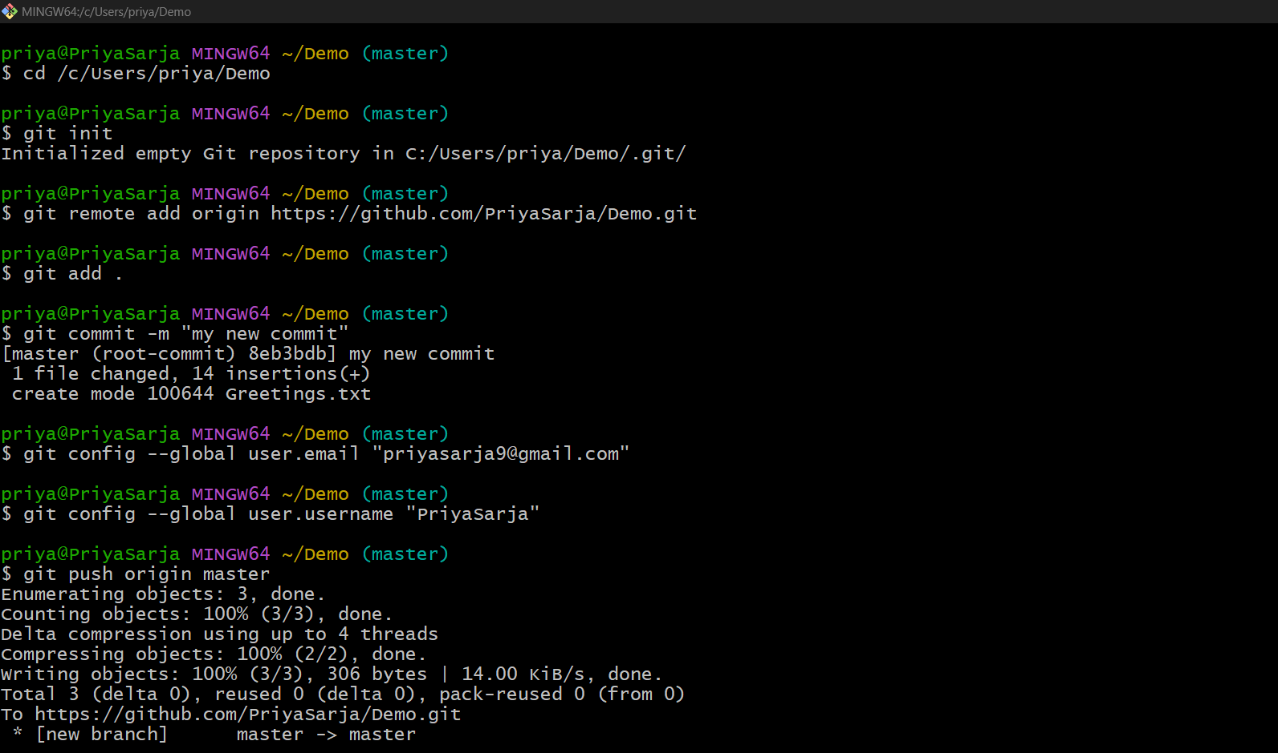

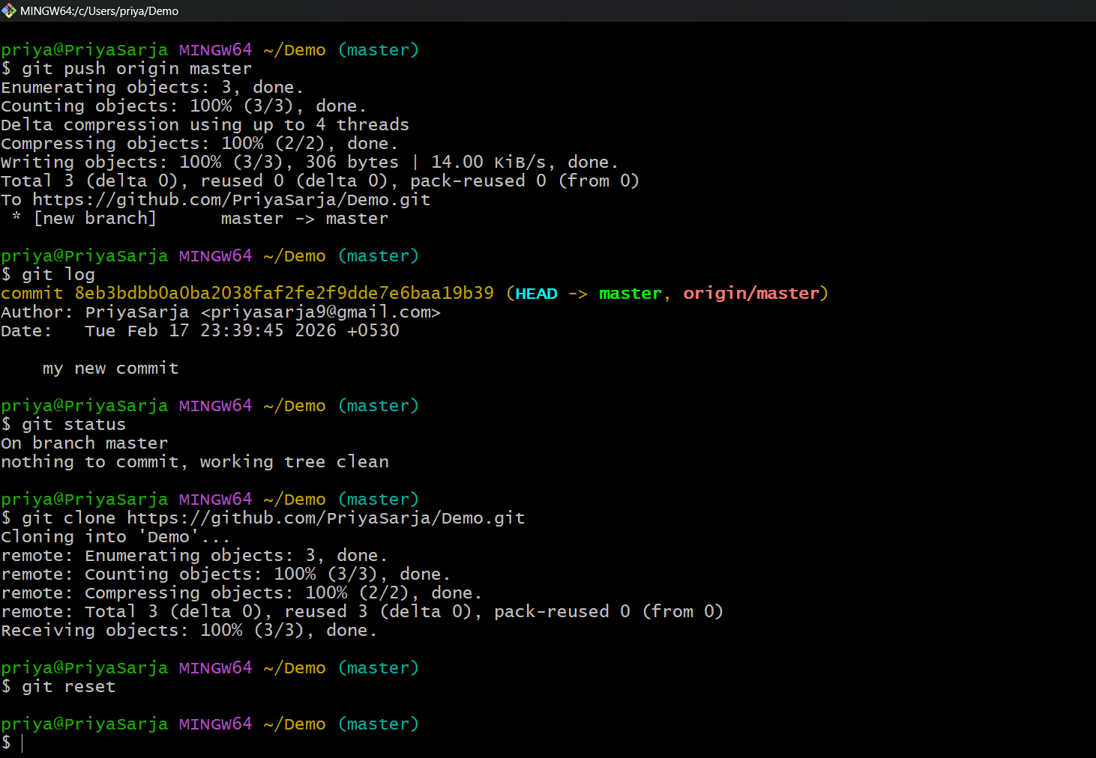

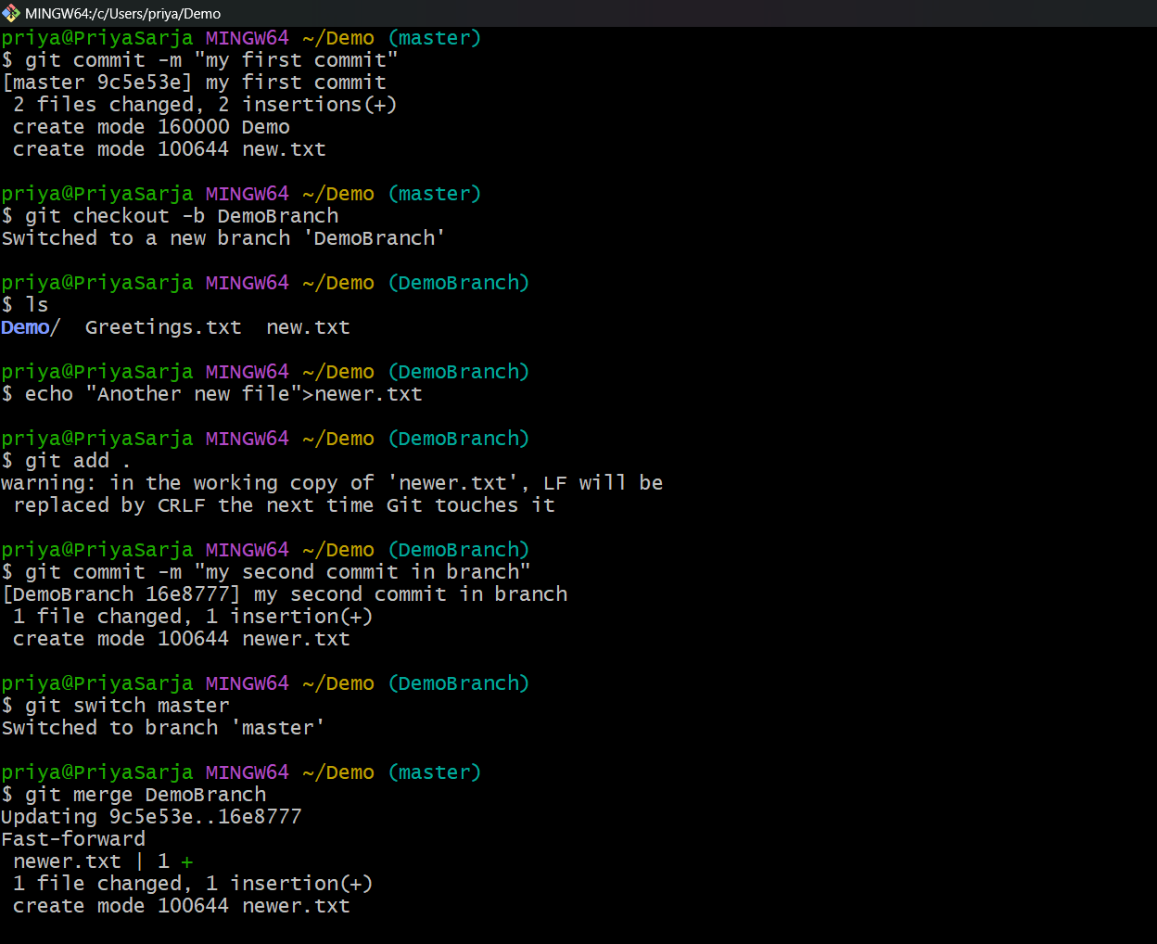

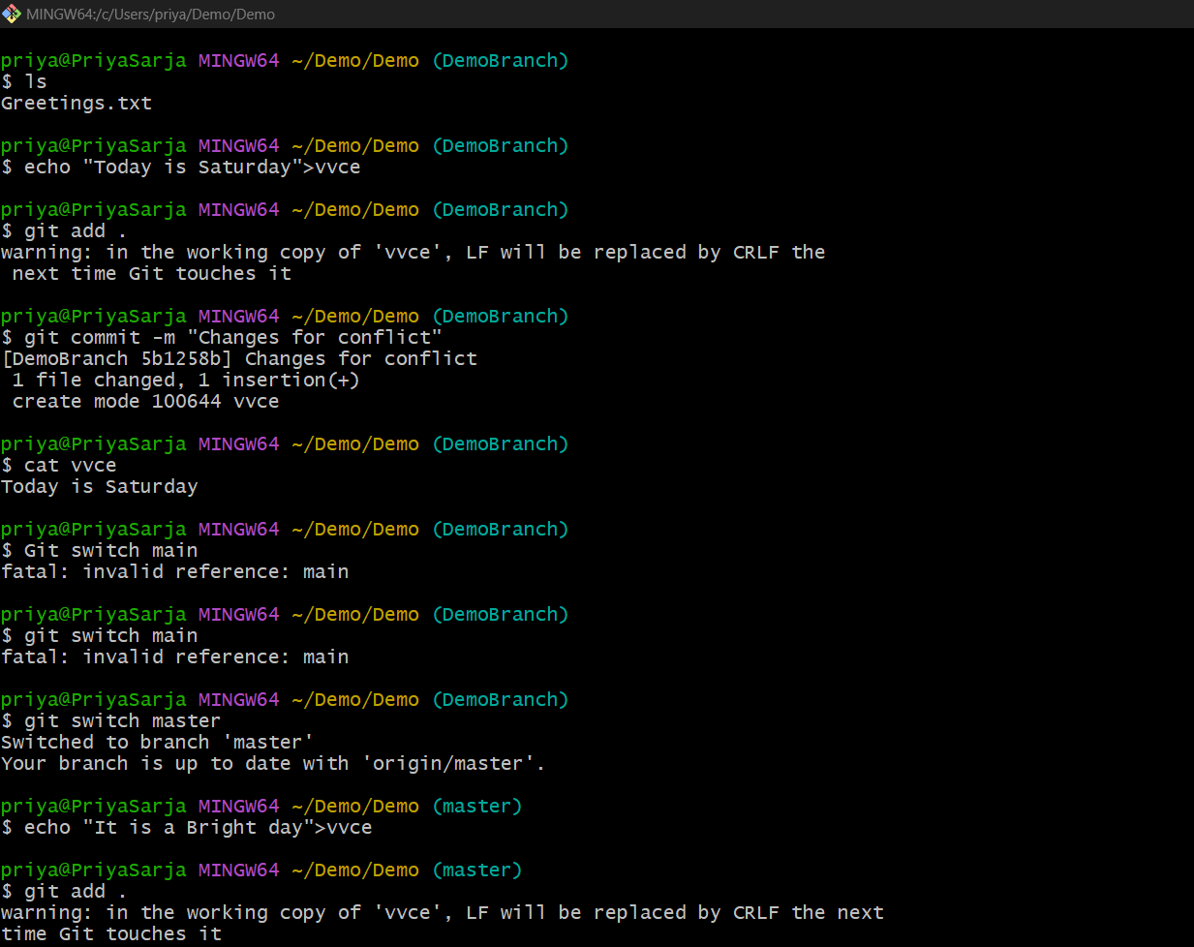

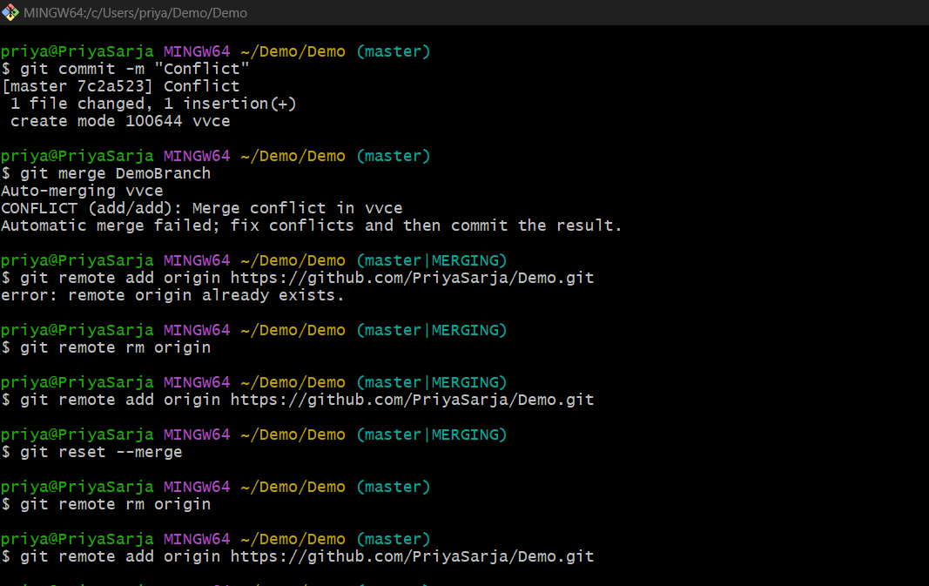

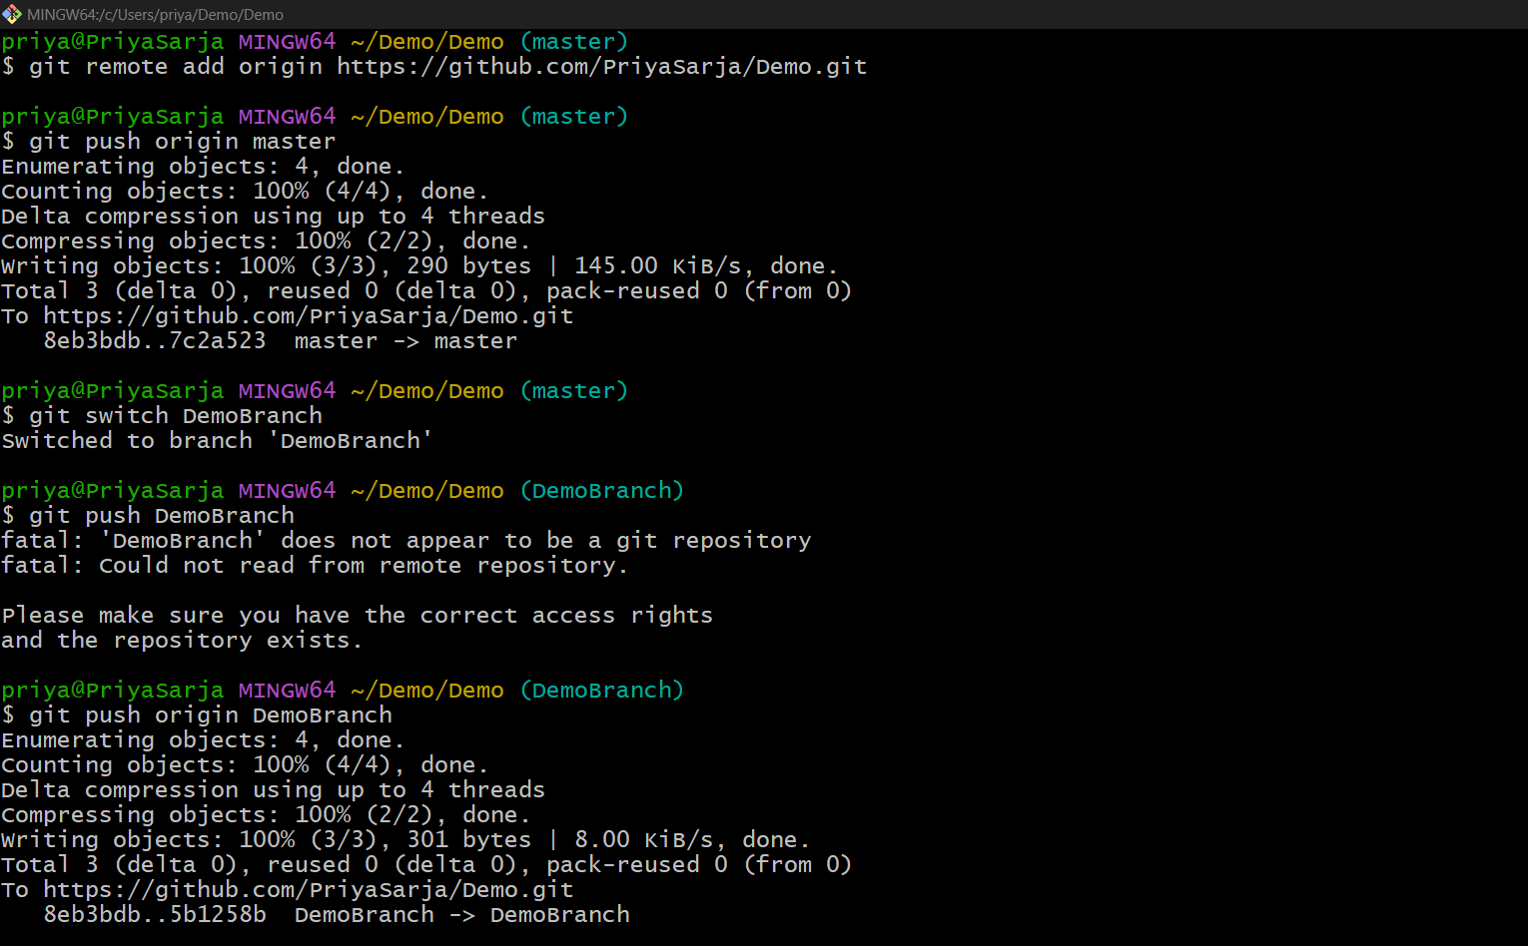

Jenkins

What is Jenkins
Jenkins is a CI Server
Integrates your Build and Automation
Report Generation Tool == will give us the details about what we did with the project
Integration and Testing

Requirements
Need a Source code manager like Git Hub
Need JDk version 23 or higher

How to install Jenkins and Create a Webhook
JAVA Download -> Oracle
Check version & Os -> x64 Installer -> 183.27 MB
https://download.oracle.com/java/25/latest/jdk-25_windows-x64_bin.exe (sha256)
Run exe file
Add path to Environment Variables
C:\Program Files\Java\jdk-25.0.2
Choose Edit under System Variables so all apps can access it, click on New and paste your path of JDK with Version
Click Ok
http://localhost:8080 to check

Jenkins -> Download -> 2.55 -> windows and download it
Run service as LocalSystem.
Port No. = 8087 (8080 ~ 8090)
Change folder
C:\Program Files\Java\jdk-21\
Java -> JDK version 21 or 25
Start Service
Will be installed on local drive

http://localhost:8087/login?from=%2F
In Red??????????
C:\Program Data\Jenkins\secrets\initialAdminPassword
932c95c90680479f94079ef6241423c9
ca62148bf3994cae8fdde22860d128e2
Paste the Above password and
Next Install Suggested Plugins

Under Getting Started
Skip and continue as Admin
Save and Install
Start using Jenkins
Apply and Save

How to create the project in Jenkins

C:\Program Files\Jenkins\secrets\initialAdminPassword
Command window = type "C:\Program Files\Jenkins\secrets\initialAdminPassword"

C:\Program Files\Jenkins
Jenkins.err
Ctrl + F = password
Admins
16 bit hash code is the password
932c95c90680479f94079ef6241423c9

New item
Itemname
Freestyle project
Build Steps -> Add build step -> Execute Windows batch command
java --version
Build Now
Green tick is the project has been created correctly

Create repo in github
creating a new file with .java as extension
Commit Changes
Copy repo cath from code
https://github.com/PriyaSarja/JenkinsDemo.git
class and file name should be same

GitHub Project

Configure
https://github.com/PriyaSarja/
https://github.com/PriyaSarja/JenkinsDemo.git
Branch = master or main
javac Geeks.java
java Geeks

Poll SCM
H/2 * * * *

Automatic creation of project

Make changes in github java file and commit changes
After 2mins the build will start

Go to Manage Jenkins -> Plugin Manager -> check for git hub plugin
Available Plugins -> GitHub Integration

Ngrok
Download Ngrok, add to environmental variables and check the version after extraction
In ngrok -> Sign up with email -> got to set up and installation -> copy the URL: ngrok config add-authtoken 3AkFkHhiF9U15dLnczYBMMEcC3p_7mmkxe5n2YTWyZ4WY5Szd

Paste it in ngrok terminal
Paste “ngrok http 80” in terminal and then the application starts to run

ngrok
https://marcela-fumaric-unphilosophically.ngrok-free.dev
Put his in github

Azure
Got to: azuredevopslabs.com
Sign up for free
Create one
priyasarja9
Say yes to everything and if passkey is not create just skip it you will be able to login
Code = path on clone

New project
New repo using plus symbol
Copy path of repo

In CLI
cd desktop
git init
echo “hello”>hello.txt create a file
ls
git add .
git commit
git push origin main or master path
git commit -m

git clone https://github.com

create pull request in azure

Source code manager == azuredevops

Docker

DOCKER

Docker - Containerization tool that became open source in 2013
Combination of Application and Configuration

Docker Containers:
- Isolation: Containers isolate the application and its dependencies from the underlying system. This allows you to run applications with consistent behavior, regardless of the environment they are deployed in (e.g., development, testing, or production).
- Lightweight: Unlike virtual machines (VMs), containers share the host operating system's kernel, making them more efficient and faster to start up than VMs.
- Portability: You can create a container image (a snapshot of the application and its environment) that can be run on any machine with Docker installed, regardless of the underlying OS or hardware.
- Dockerfile: A text file that contains instructions to build a Docker image. It specifies what software and dependencies the container needs and how to set up the environment.
- Image vs. Container:
  - Docker Image: A read-only template that includes the operating system, software, and application configurations.
  - Docker Container: A running instance of a Docker image. Containers can be started, stopped, moved, and deleted.
Virtualization allows you to create virtual versions of physical resources like servers, storage, or operating systems. It enables multiple virtual machines (VMs) to run on a single physical server, each with its own OS and applications.

Key Concepts:
- Hypervisor: Software that manages VMs. It sits between the physical hardware and the virtual machines. There are two types:
  - Type 1 (Bare-metal): Runs directly on physical hardware (e.g., VMware ESXi).
  - Type 2 (Hosted): Runs on top of an existing operating system (e.g., VirtualBox).
- Virtual Machine (VM): A fully isolated environment that acts like a real computer. Each VM runs its own OS and software but shares physical resources like CPU, memory, and storage.

Installing Docker

- Windows 10/11 64-bit at least 4GB of RAM
- Updated version of Windows Subsystem for Linux 2, Hypervisor/Hyper-V enabled
- Enable it via "Turn Windows features on or off", restart your PC, and use Hyper-V Manager to create, manage, and run virtual OS instances (e.g., Windows/Linux) by assigning virtual resources like RAM, disk, and network
- Install Docker from any browser desktop for windows-x86-AMD

- Docker Client - VS Code - allows you to perform various operations on the command line
- Docker Daemon - Docker Desktop - Docker’s Engine - locally running engine
- Docker Registry - Docker Hub - Public registry
- Docker Image - application and docker file - Static, configurations of tools, information about the base image and language and current working directory, env variables, commands and libraries. All information about the application : how to run, what is there.
Building, tagging and checking it in docker desktop.
- Collection of Running Images → Docker Container → Dynamic form of Image
- Olumne is a storage space for your container, just like secondary storage
- Container duplicate and backup

CODING
Start Docker desktop
Go to VS Code (Docker Client) and create two files

Fibonacci.java
public class Fibonacci {
public static void main(String[] args) {
int n = 10, t1 = 0, t2 = 1;
System.out.print("First " + n + " terms: ");
for (int i = 1; i <= n; ++i) {
System.out.print(t1 + " + ");
int sum = t1 + t2;
t1 = t2;
t2 = sum;
}
}
}

Dockerfile
FROM eclipse-temurin:25-jdk
WORKDIR /app
COPY . /app
RUN javac Fibonacci.java
CMD ["java","Fibonacci"]

In Terminal and repository name must be lowercase
docker build -t fib .
docker images
docker run fib
docker--rm fib .
See output in terminal
First 10 terms: 0 + 1 + 1 + 2 + 3 + 5 + 8 + 13 + 21 + 34 +

https://hub.docker.com/ - Sign Up - priyasarja9@gmail.com
Under Hub -> Explore and My Hub

Docker Image is created
docker build -t image-name:v1 #- t is tag
docker images

DOCKER COMMANDS
- FROM: Defines base images
- WORK DIR: Current working directory
- COPY and ADD: like Crul, we use Add to extract apps from urls and the zip files
- RUN and CMD: Compile and run/execute the file
- Env: Setting up paths

docker login → Docker hub user name and password
docker tag <image ID> <dockerhub login>/demobook:v1
afc2640030f0 and

docker tag fib:latest priyasarja/demobook:v1
docker images
Take your name

Login
docker login #with a URL

Push
docker push priyasarja/demobook:v1

Check your dockerhub, the new image will be displayed and run it
Push Image to Docker hub -> folder with application and docker file

Pull
docker pull
docker run -d --name mysql-container -e MYSQL_ROOT_PASSWORD=root123 -p 8081:8081 mysql
Digest: sha256:c5df04bee1a42b74a5841c6409e669cf62126cd0416f00c1cea8ab933b9361b9
Status: Downloaded newer image for mysql:latest

Now execute container
docker exec -it mysql-container mysql -u root -p
You should see mysql>
CREATE DATABASE school_db;
USE school_db;
CREATE TABLE students (
student_id INT AUTO_INCREMENT PRIMARY KEY,
name VARCHAR(100),
email VARCHAR(100),
phone VARCHAR(15)
);
Stop and remove
docker stop mysql-container
Docker rm mysql-container
Local testing in docker desktop and we can run it in docker desktop also

LAB

Push Image using Jenkins Piple line
In git hub
Dockerfile
FROM eclipse-temurin:21-jdk
WORKDIR /app
COPY . /app
RUN javac HelloWorld.java
CMD ["java","HelloWorld"]

HelloWorld.java
public class HelloWorld {
public static void main(String[] args) {
System.out.print("Hello World!");

}
}

Create Jenkins file
pipeline {
agent any

environment {
DOCKERHUB_CREDENTIALS = 'Docker-credentials'
IMAGE_NAME = 'shilpakevala/new_docker_image'
}

stages {

stage('Build Java Application') {
steps {
bat 'javac HelloWorld.java'
}
}

stage('Run Java Program') {
steps {
bat 'java HelloWorld'
}
}

stage('Build Docker Image') {
steps {
bat 'docker build -t %IMAGE_NAME%:latest .'
}
}

stage('Login to DockerHub') {
steps {
withCredentials([usernamePassword(
credentialsId: 'Docker-credentials',
usernameVariable: 'USER',
passwordVariable: 'PASS')]) {

bat 'echo %PASS%| docker login -u %USER% --password-stdin'
}
}
}

stage('Push Docker Image') {
steps {
bat 'docker push %IMAGE_NAME%:latest'
}
}
}
}

Go to jenkins → settings → manage credentials → add credentials → add your docker user name and password → create
Check for updates and also remember to login using localhost with password in .err file
Keep Docker Desktop on

Jenkins → New Item → Pipeline Project → OK
Pipeline:
Select pipeline script from SCM
SCM → Select Git → repo link → credentials
Branch → main

Apply and Save
Build Now

Green Tick and Image in Docker Desktop

DockerHub Password: Priya@doc123

Maven

MAVEN

Page/Project Object Model = continuous integration

Launch Eclipse IDE → File → New → Maven Project → Choose Template → double click on maven-archtype-quickstart version: 1.1 or 1.4→ Group ID and Artifact Name can be anything Package Name same as Group ID → Y in terminal and then access the App.java file →
Add dependency after the tag

Got to chrome and type maven repository
Search for JSON Simple

<!-- Source: https://mvnrepository.com/artifact/com.googlecode.json-simple/json-simple -->
<dependency>
<groupId>com.googlecode.json-simple</groupId>
<artifactId>json-simple</artifactId>
<version>1.1.1</version>
<scope>compile</scope>
</dependency>
Paste this dependency in pom.xml after the closing tag of the previous dependency and before the closing tag

Dependency → reusable code and place it somewhere in the project

Type casting the JSON as String using emoji

scr/test/java
Demo.java
package VVCE_ISE_C.fib;
import java.util.*;
import java.io.IOException;
import java.io.FileReader;
import org.json.simple.JSONObject;
import org.json.simple.parser.JSONParser;
import org.json.simple.parser.ParseException;
public class Demo {
public static void main(String[] args) throws IOException, ParseException{
// TODO Auto-generated method stub
JSONParser jp = new JSONParser();
FileReader reader = new FileReader(".\\JSON\\demo.json");
Object obj =jp.parse(reader);
JSONObject empjo = (JSONObject)obj;

String fname = (String) empjo.get("firstname");
String lname = (String) empjo.get("lastname");

System.out.println("First name: "+ fname);
System.out.println("Last name: "+ lname);
}
catch (Exception e){
e.printStackTrace();
}
}

package/new/file
demo.json
{
"firstname" : "Priya",
"lastname" : "Sarja"
}

Save and Run

Slack

SLACK
app.slack.com → Sign-in
https://app.slack.com/client/T0ANT18EXV2/C0ANT18Q0P6
Join C Section→ Create New Channel: c_section_demo_new_157
More (...) → Tools → Apps → Search Jenkins → Open App → Configure → Add to Slack → Select the channel you have created and integrate
Locate Step 3 and copy token: oJJkwuGE6KX5EdeYPLOjvnB7

Login to Jenkins
Check for slack plugins
Available Plugins → Global Slack Notifier & Slack Notification
Install them

Settings → Manage Jenkins → System → Slack
csection-workspace

Credentials
Add Global → Add Secret text
Scope: Global → Secret Text: oJJkwuGE6KX5EdeYPLOjvnB7 → ID: anything → Create
Next
Click on drop down → Click on +
Test Connection → must show Success
Apply and Save

Create New Item
Freestyle project → Ok
Build Steps:
Add Build Steps → Execute Windows batch command → java - -version

Post Build Actions:
Add post build action → Slack Notifications
Select:
Notify Build Start
Notify Success
Notify Aborted

Apply and Save
Build Now

Tab 7
VS Code – >< arrows → connect to → WSL using Distro → Ubuntu 20.4
Docker → Settings → Resources → WSL Integration → Ubuntu 20.4

In VS Code terminal
Create directory
mkdir DevOps
cd DevOps
951205
Open folder

At terminal
sudo apt update
sudo apt install -y build-essential curl git \
libssl-dev zlib1g-dev libbz2-dev libreadline-dev \
libsqlite3-dev libffi-dev liblzma-dev tk-dev \
xz-utils wget llvm

git clone https://github.com/prasannac-ai/k8s

https://docs.google.com/document/d/1_beXfA0s0G0aMp_bAtOaf9hHodJ5_oXpNj_neYRw5A4/edit?usp=sharing

cd k8s
cd setup
bash
./install-tools-ubuntu.sh
./setup.sh
./setupregistory.sh

cd ..
python3 –version
cd todo
pip3 install -r requirements.txt

In todo.py
from fastapi import FastAPI
from pydantic import BaseModel
from typing import List, Optional

app = FastAPI(title="Todo API")

class TodoItem(BaseModel):
id: int
title: str
completed: bool = False

# In-memory storage for simplicity
todos = [
TodoItem(id=1, title="Buy groceries", completed=False),
TodoItem(id=2, title="Learn FastAPI", completed=True),
TodoItem(id=3, title="Walk the dog", completed=False)
]

@app.get("/")
def read_root():
return {"message": "Welcome to the Todo API"}

@app.get("/todos", response_model=List[TodoItem])
def get_todos():
return todos

@app.post("/todos", response_model=TodoItem)
def create_todo(todo: TodoItem):
todos.append(todo)
return todo

@app.get("/todos/{todo_id}", response_model=TodoItem)
def get_todo(todo_id: int):
for todo in todos:
if todo.id == todo_id:
return todo
return {"error": "Todo not found"}

Github → Readme.md → has commands to run application
In terminal
uvicorn todo:app --port 8000 --reload
Add /docs

from fastapi import FastAPI
from pydantic import BaseModel
from typing import List, Optional
from fastapi import FastAPI, HTTPException

app = FastAPI(title="Todo API")

class TodoItem(BaseModel):
id: int
title: str
completed: bool = False

# In-memory storage for simplicity
todos = [
TodoItem(id=1, title="Buy groceries", completed=False),
TodoItem(id=2, title="Learn FastAPI", completed=True),
TodoItem(id=3, title="Walk the dog", completed=False)
]

@app.get("/")
def read_root():
return {"message": "Welcome to the Todo API"}

@app.get("/todos", response_model=List[TodoItem])
def get_todos():
return todos

@app.post("/todos", response_model=TodoItem)
def create_todo(todo: TodoItem):
todos.append(todo)
return todo

@app.get("/todos/{todo_id}", response_model=TodoItem)
def get_todo(todo_id: int):
for todo in todos:
if todo.id == todo_id:
return todo
return {"error": "Todo not found"}

@app.delete("/todos/{todo_id}")
def delete_todo(todo_id: int):
for index, todo in enumerate(todos):
if todo.id == todo_id:
deleted = todos.pop(index)
return {"message": "Todo deleted", "todo": deleted}
raise HTTPException(status_code=404, detail="Todo not found")

docker build -t localhost:5001/todo-api:latest .
docker run -d - -name my-todo-app -p 8000:8000 localhost:5001/todo-api:latest

docker stop my-todo-app
docker compose up

docker compose up - - scale todo-api=2

Any server listens from 80 and then e routes to any f the instances in docker container

