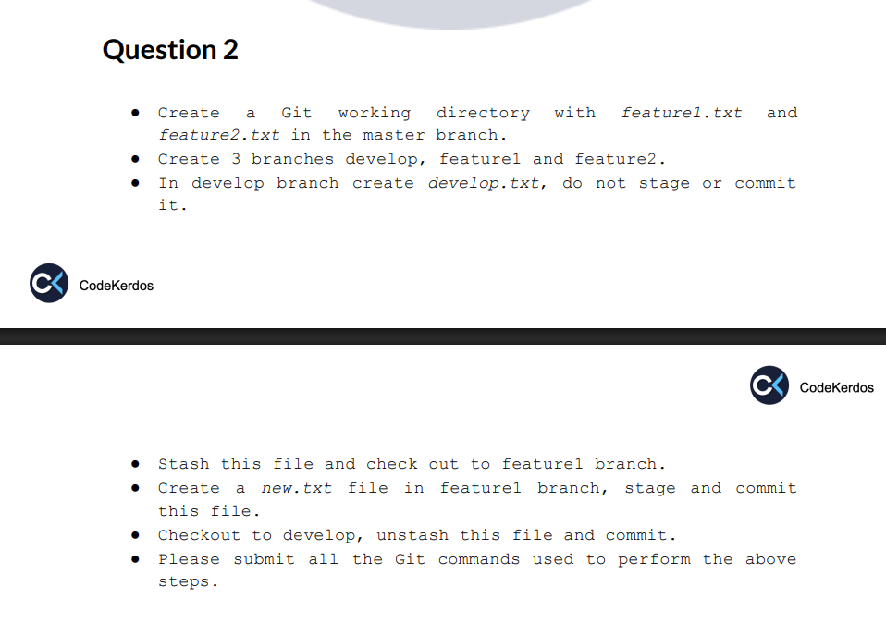

●Create a Git working directory with feature1.txt and feature2.txt in the master branch.
mkdir question2
cd question2
git init
touch feature1.txt feature2.txt
git add feature1.txt feature2.txt
git commit -m "Add feature1.txt and feature2.txt"

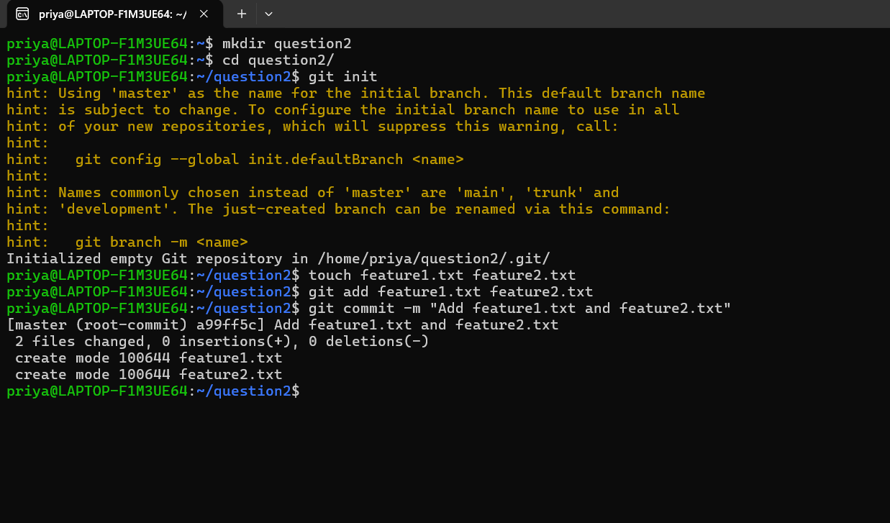
Note: Git does not create any branch until the first commit is made.
● Create 3 branches develop, feature1 and feature2.
git branch develop
git branch feature1
git branch feature2
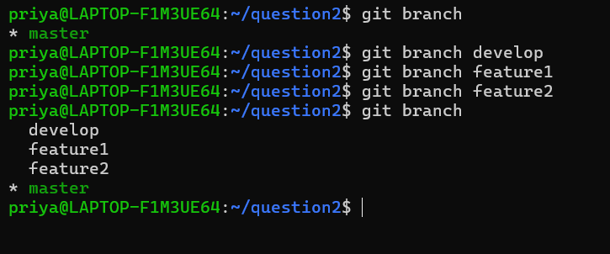

● In develop branch create develop.txt, do not stage or commit it.
Note: Git checkout does below things
git checkout develop # switch branch
git checkout file.txt # restore file
git checkout -b feature3 # create + switch
git switch only switches the branch.
git switch develop/git checkout developEither one you can use.
touch develop.txt
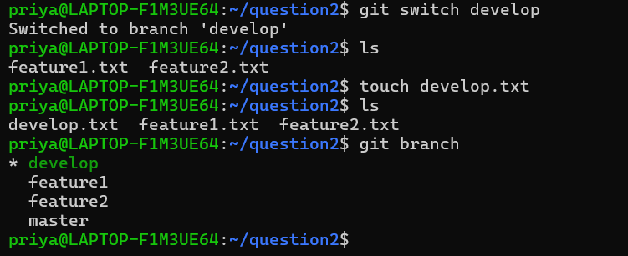
● Stash this file and check out to feature1 branch.
Note: Stash means it will save the file temporarily without committing. You can work on another branch later you can go to the particular file and commit.
git stash -u
git checkout feature1
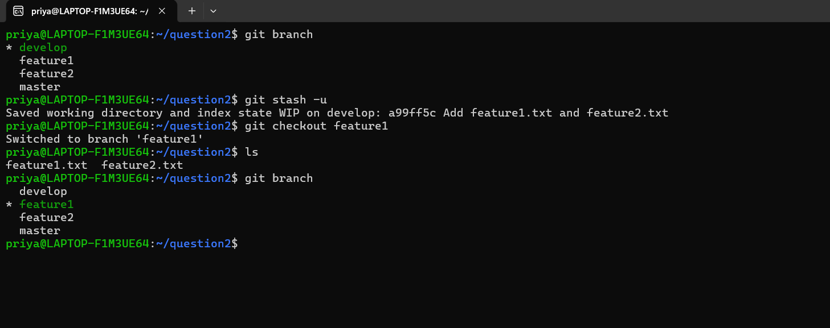
● Create a new.txt file in feature1 branch, stage and commit this file.
touch new.txt
git add new.txt
git commit -m “adding new.txt file in feature1 branch”
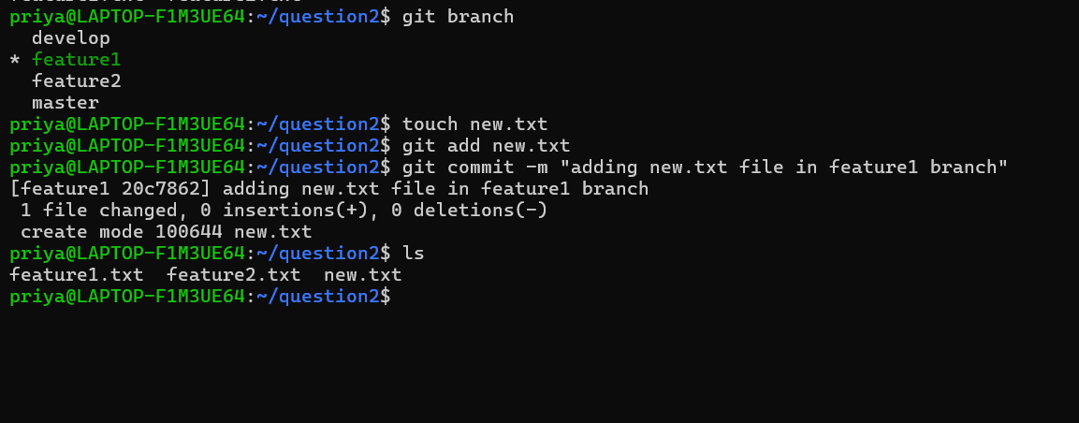
● Checkout to develop, unstash this file and commit.
git checkout develop
git stash pop
Note: git stash pop
- Restores develop.txt from stash.
- Removes it from stash list.
git add develop.txt
git commit -m “adding develop.txt to develop branch after unstash”
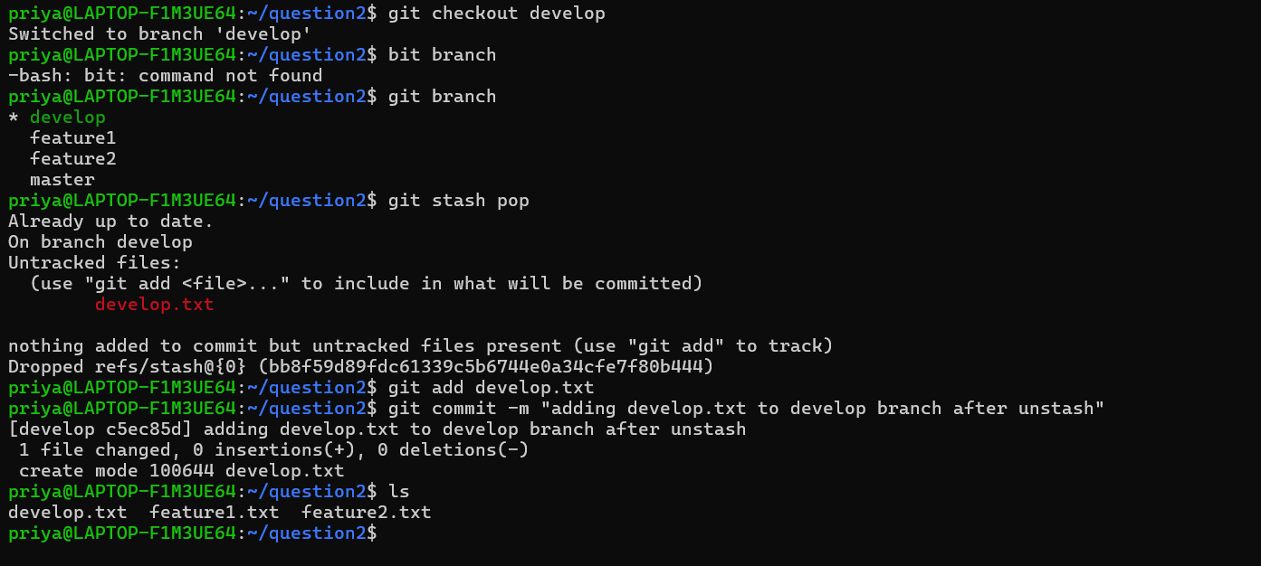
● Please submit all the Git commands used to perform the above steps.
mkdir question2
cd question2
git init
touch feature1.txt feature2.txt
git add feature1.txt feature2.txt
git commit -m "Add feature1.txt and feature2.txt"
git branch develop
git branch feature1
git branch feature2
git switch develop/git checkout developEither one you can use.
touch develop.txt
git stash -u
git checkout feature1
touch new.txt
git add new.txt
git commit -m “adding new.txt file in feature1 branch”
git checkout develop
git stash pop
git add develop.txt
git commit -m “adding develop.txt to develop branch after unstash”

