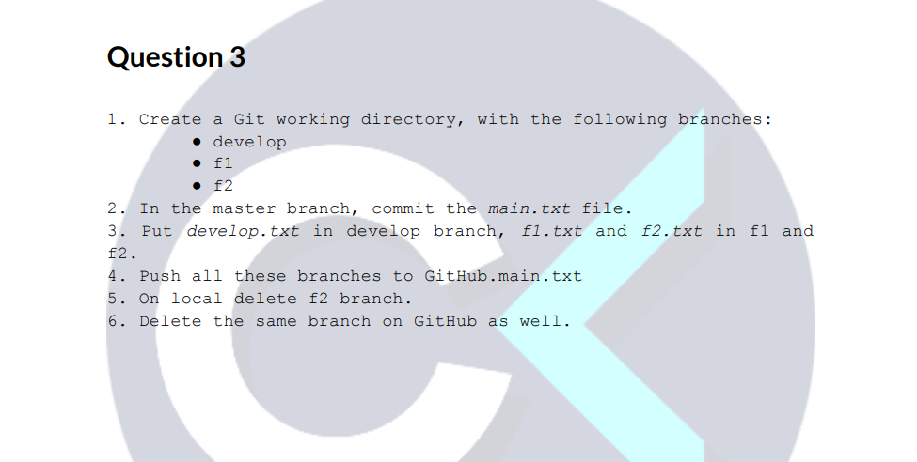
- Create a Git working directory, with the following branches:
● develop
● f1
● f2

I tried to create git branch develop with out making the question3 directory as git directory using git init command. So it displayed below error.
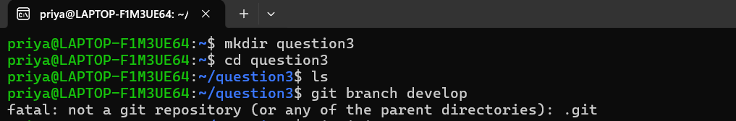
Note: Then initialized the git for this project and it created. git hidden folder is created to store everything it needs to manage versions. Without. git, the directory is just a normal directory.

Then tried to create branches as per the tasks. But it throwed below error as no commit is made for the new project. Branch name is the pointer to a commit. If no commit is made there is no branch. This error triggers when we try to create or reference a branch before making the first commit in a newly initialized repository.
fatal: not a valid object name: 'master'
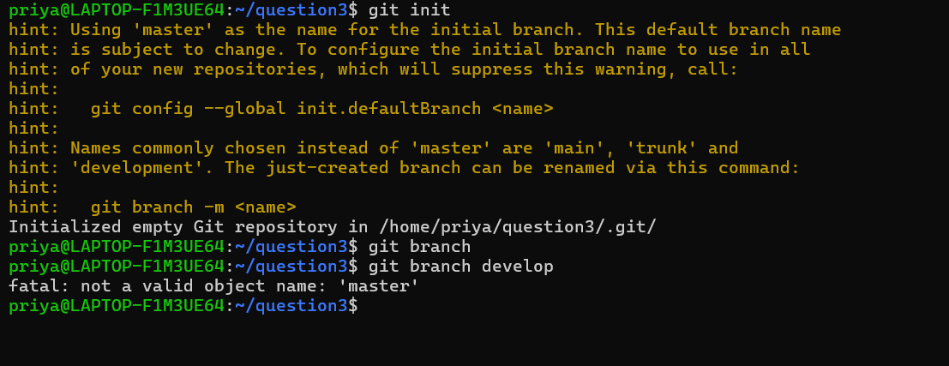

- So worked on step 2 first, that is In the master branch, commit the main.txt file.

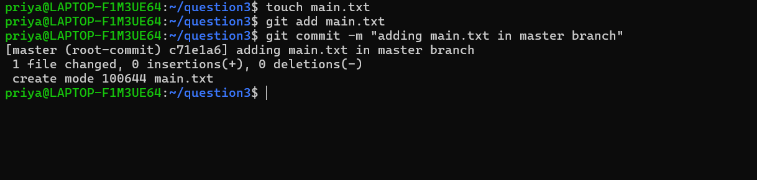
Now master branch is created now creating below branches.
● develop
● f1
● f2
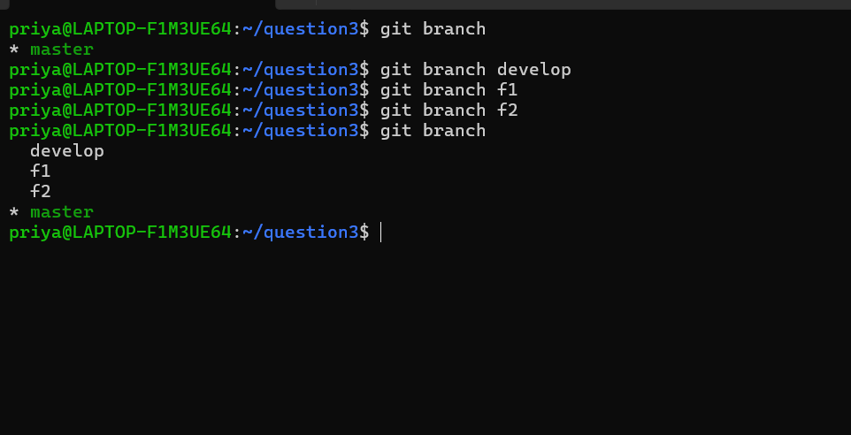
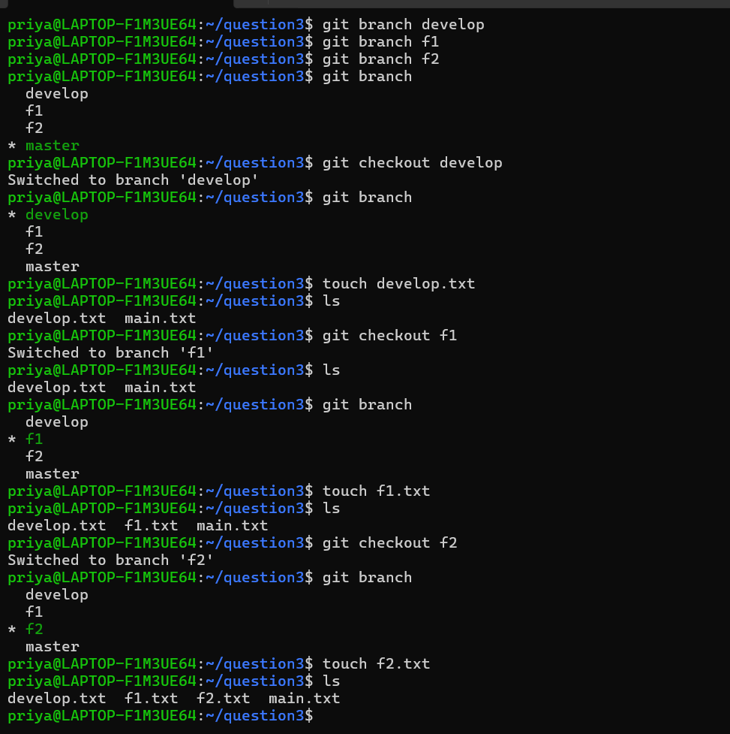
- Put develop.txt in develop branch, f1.txt and f2.txt in f1 and f2.
I just switched to respective branch and created the files accordingly. But when I check the branches, I could see all the files are available in all the branch. Then analysed that, if we switch branch without committing whatever files we are creating it would be available in all the branches.
Note: Uncommitted files are not branch-specific and remain in the working directory across branch switches.
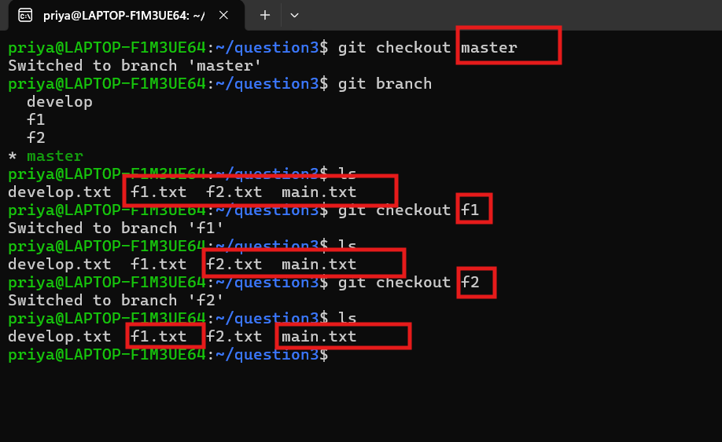
4.Push all these branches to GitHub.main.txt
git remote set-url origin https://gitlab.com/PriyaSettu/assignments_git.git
git remote -v
git push -u origin master
git push -u origin develop
git push -u origin f1
git push -u origin f2
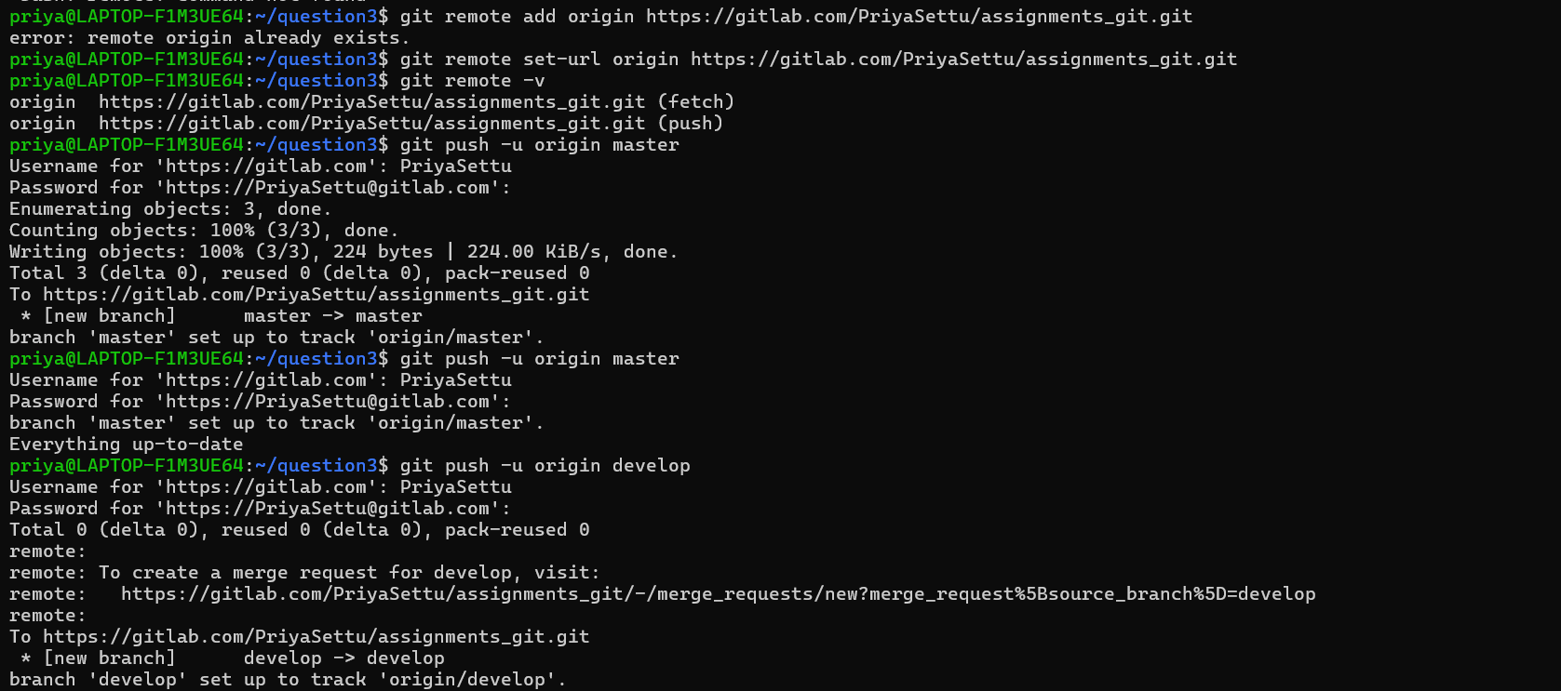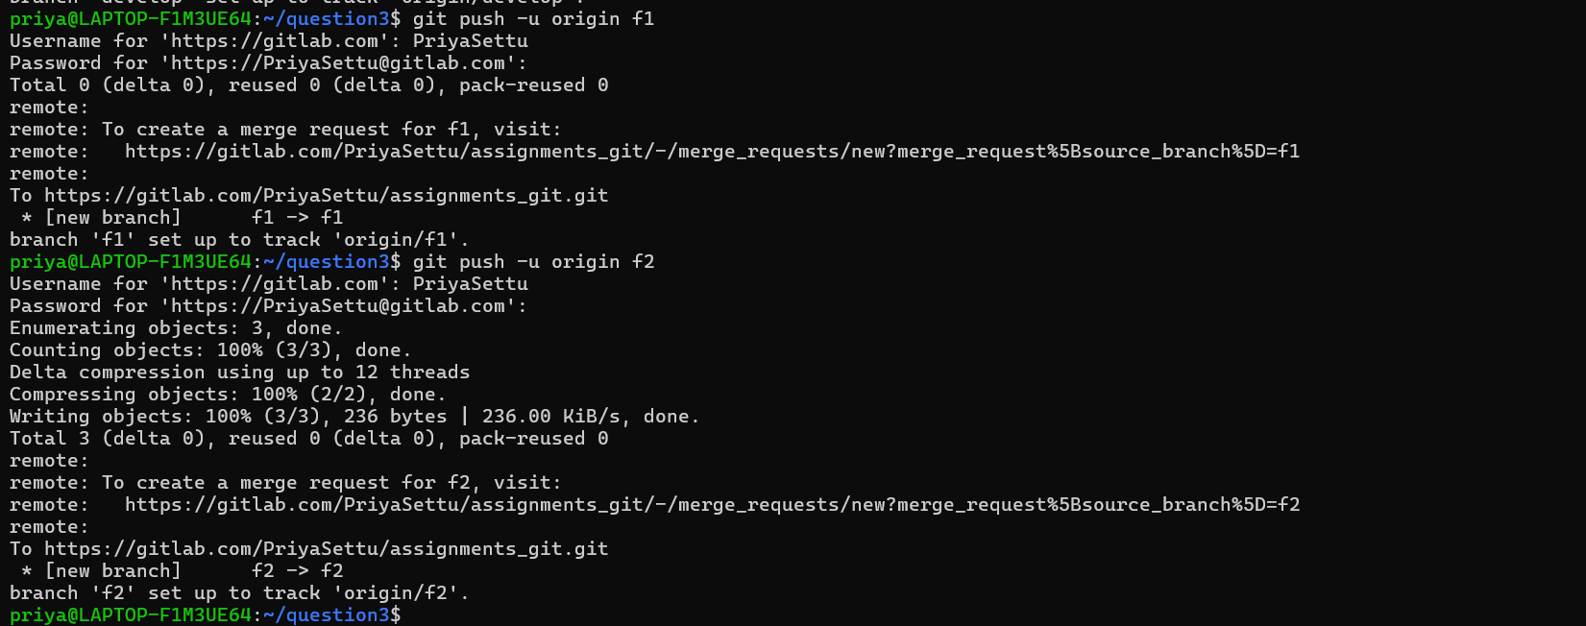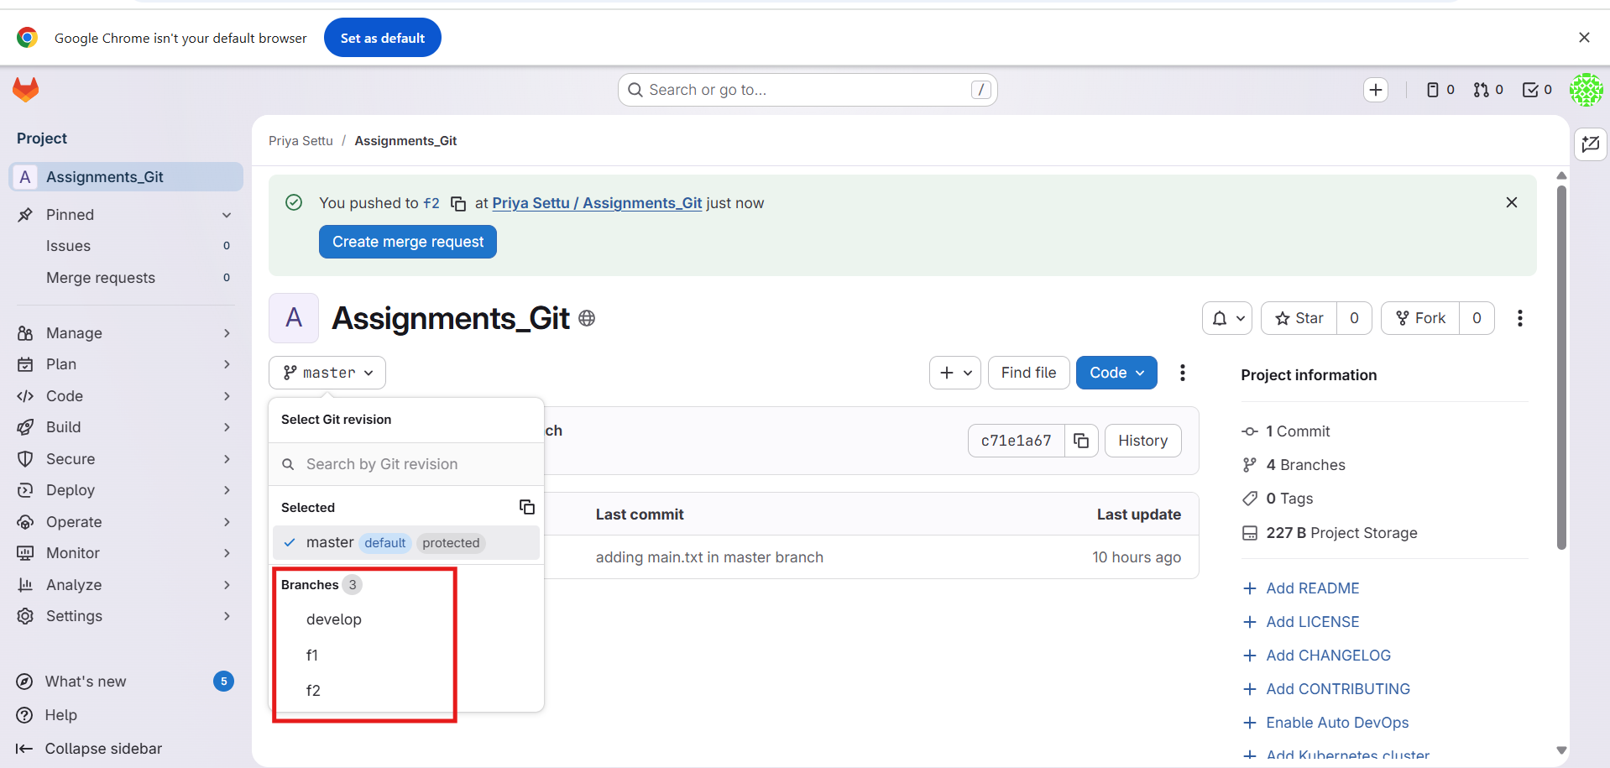
5. On local delete f2 branch.
git branch -d f2
you can’t delete the branch when you are currently on the same branch. So, always move to another branch and delete the branch whatever you want to delete.
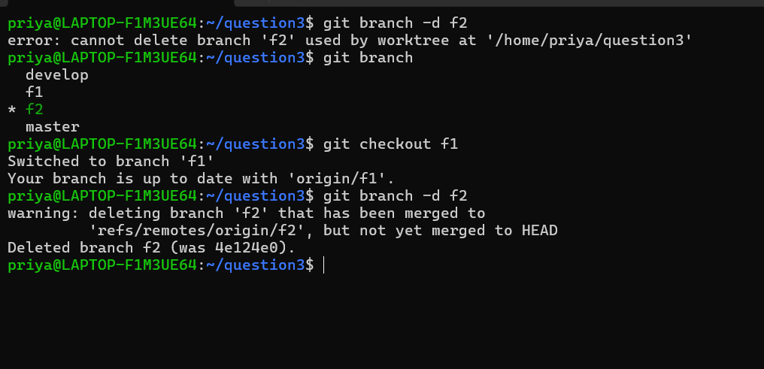
The f2 branch deleted successfully.
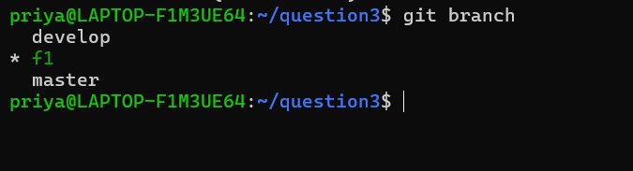
6. Delete the same branch on GitHub as well.
git push origin –delete f2
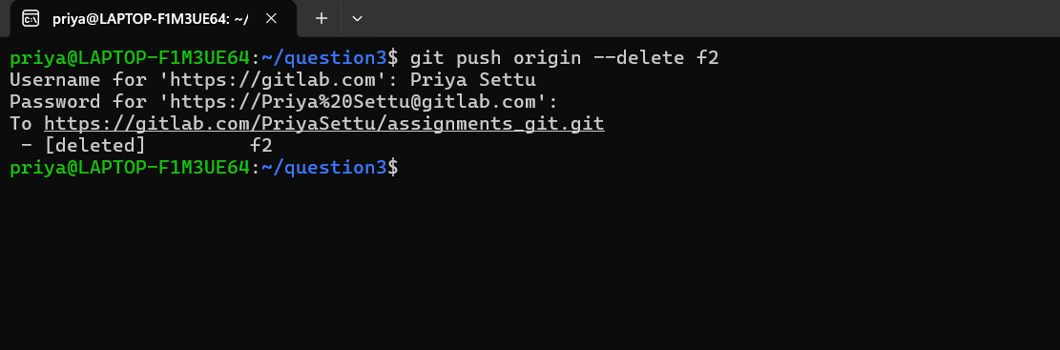
Branch f2 is deleted from remote repo as well
