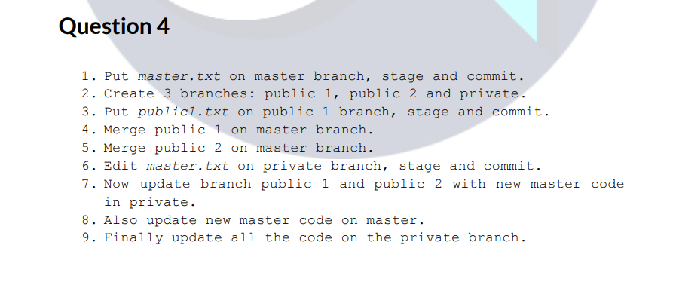

STEP 1: Put master.txt on master branch, stage and commit
mkdir question4
git init
touch master.txt
git add master.txt
git commit -m "adding master.txt. So, it will be added to master branch once the 1st commit is made"
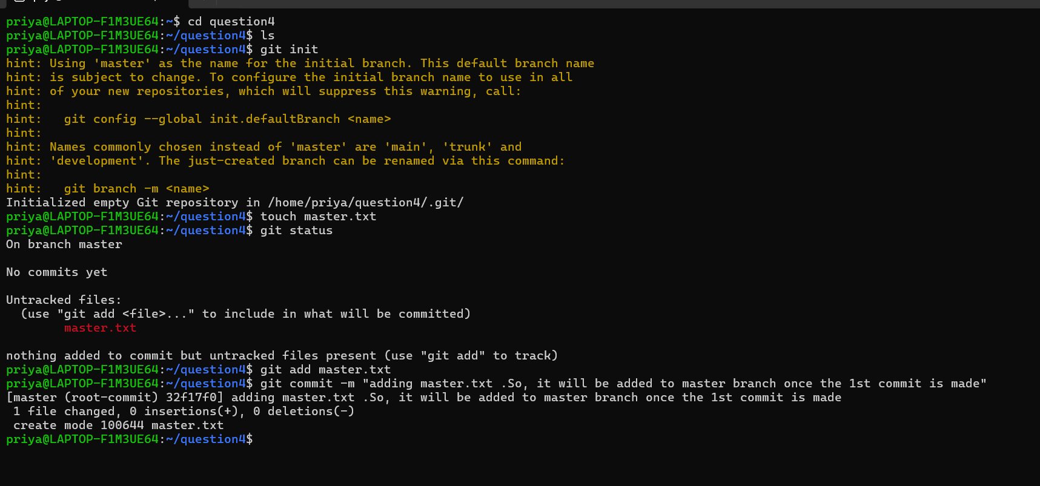
Now master branch is available. Inside master branch we could see the file we have created.
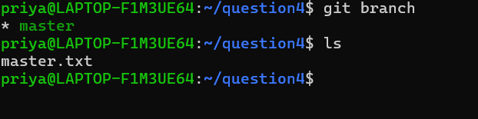
STEP 2: Create 3 branches: public1, public2, private

STEP 3: Put public1.txt on public1 branch, stage and commit
git checkout public1
touch public1.txt
git add public1.txt
git commit -m “adding public1.txt to public1 branch”
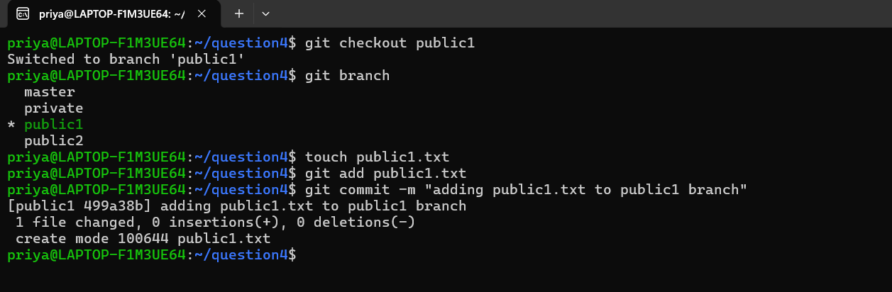
STEP 4: Merge public1 on master
git checkout master
git merge public1
now whatever files are there in public1 all are merged in master by creating new commit id without changing the existing ones.
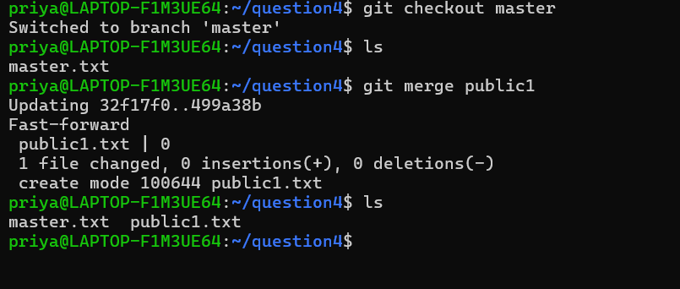
STEP 5: Merge public2 on master
git checkout master
git merge public2
Note: public 2 has no changes. hence it says already up to date.
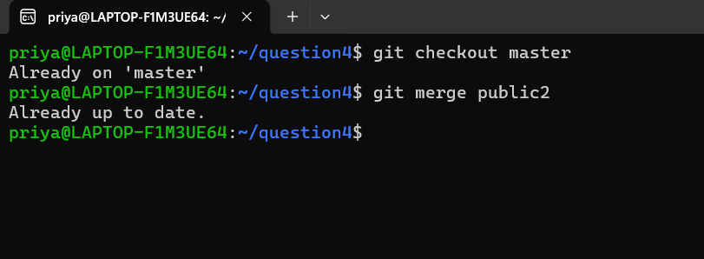
STEP6: Edit master.txt on private branch, stage and commit
I just edited the file from private branch.
git checkout private
vi master.txt

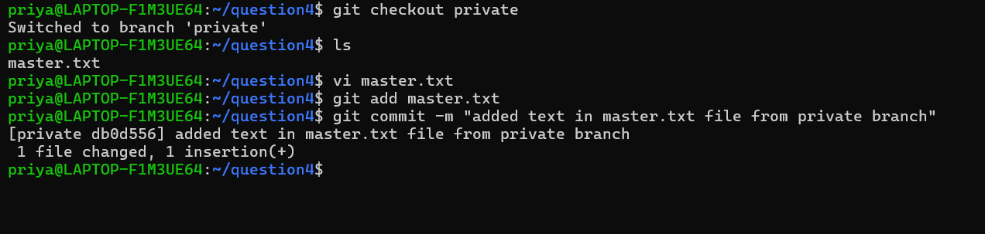
STEP 7: Update public1 and public2 with new master code from private
As per the task 1st we need to merge the private branch with master branch. Then we can merge both public 1 and 2 with master branch.
Git checkout master
Git merge private
Git checkout public1
Git merge master
Git checkout public2
Git merge master
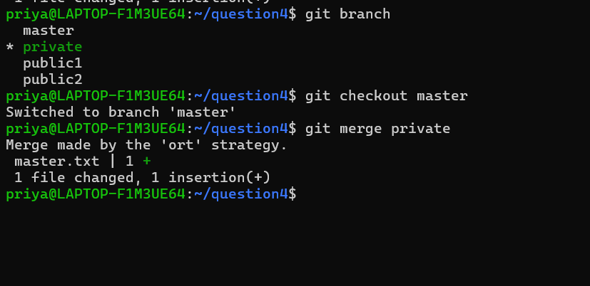
The branch is successfully merged.
Git branch you should be in master branch
Lsit list all the files and directories
Cat master.txt you should see the same content that you have updated in private branch.
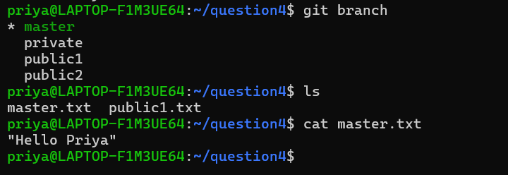
STEP 8: Update new master code on master
Already done when I merged private → master
STEP 9: Finally update all the code on the private branch
Now I have merged all the branches with master branch. So, now I can directly merge master branch only to update all the code on the private branch.
git checkout private
git branch
ls
git merge master
ls
Note: here Git performed a fast-forward merge because the branch had no diverging commits and could be updated by simply moving the branch pointer to the latest master commit.

