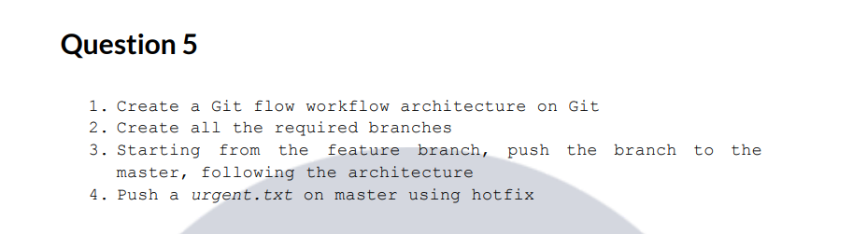

Git Flow separates development and production using develop and master branches, features are merged via develop, and urgent production fixes are handled using hotfix branches directly from master.
Branch | Environment | Purpose
feature/* | Local / Dev | Individual development
develop | SIT | Integrated testing
release/* | UAT | Business testing
master | PROD | Live users
hotfix/* | PROD | Emergency fixes

1. Git Flow Workflow Architecture
The Git Flow model separates work into several branches with specific roles:
- master (or main): Contains production-ready code.
- develop: The integration branch for features.
- feature/*: Used for developing new features.
- release/*: Prepares for a new production release (testing/bug fixes).
- hotfix/*: Used to quickly patch production issues.

Example:
- master: The "Store Shelf." It only contains finished, working products ready for customers.
- develop: The "Workshop." This is where all the new features are combined and tested together.
- feature: The "Individual Desk." Each person works on one specific part here, so they don't mess up anyone else's work.
- release: The "Quality Check." A temporary lane used to polish the code before moving it to the Store Shelf.
- hotfix: The "Emergency Repair." A special lane used only to fix major problems found in production immediately.
2) Create required branches
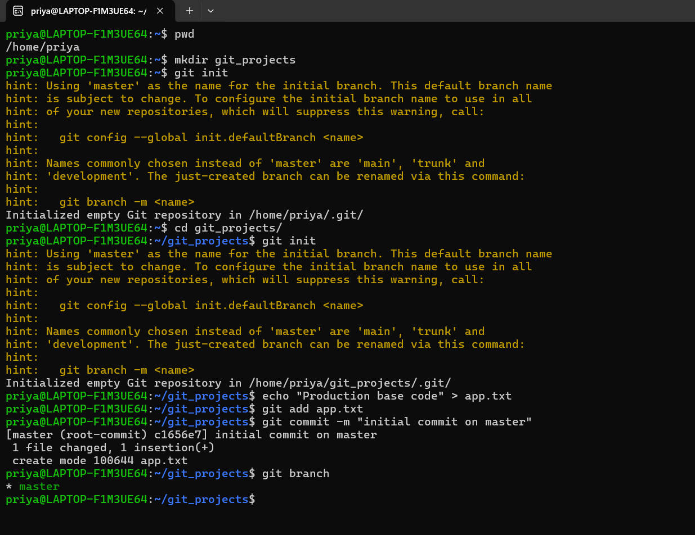
Create develop Branch
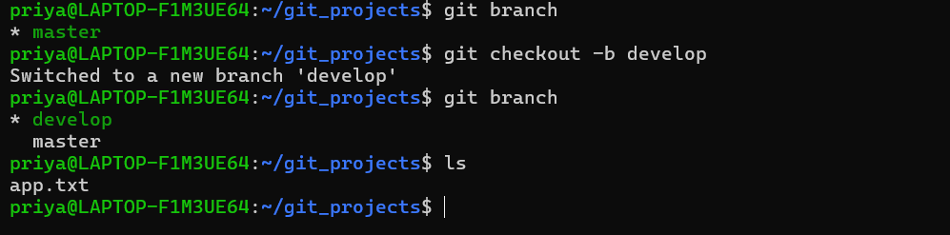
Create feature branch 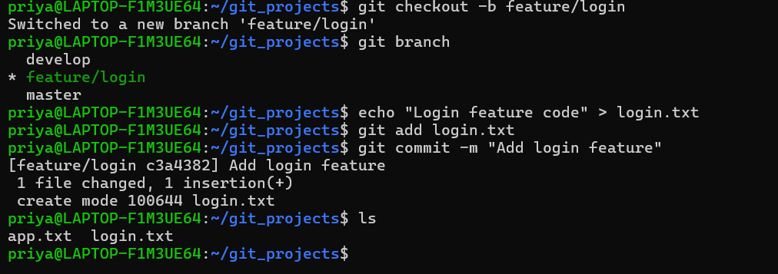
3) Starting from the feature branch, push the branch to the master, following the architecture
Merged the code to develop first
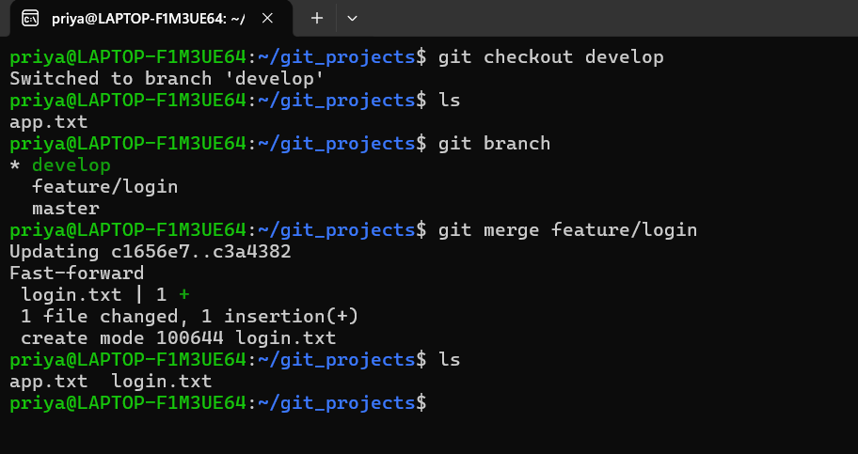
Before merging the branch to master(production) created release branch (UAT) to test the functionality.
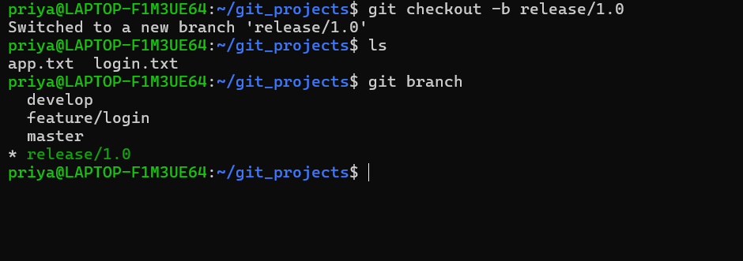
Now merging with master
To merge with master, you need to get into master then merge it.
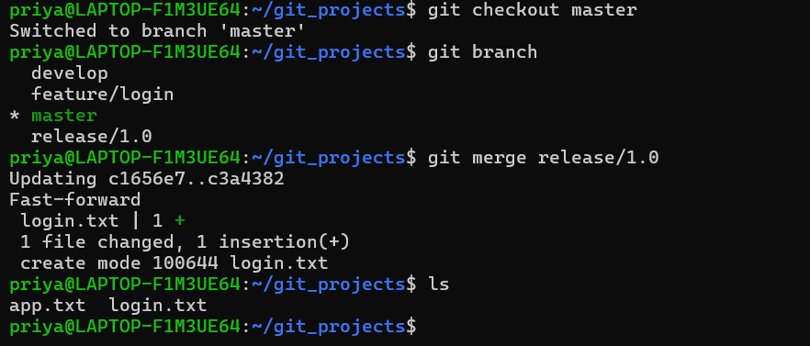
4. Push a urgent.txt on master using hotfix.
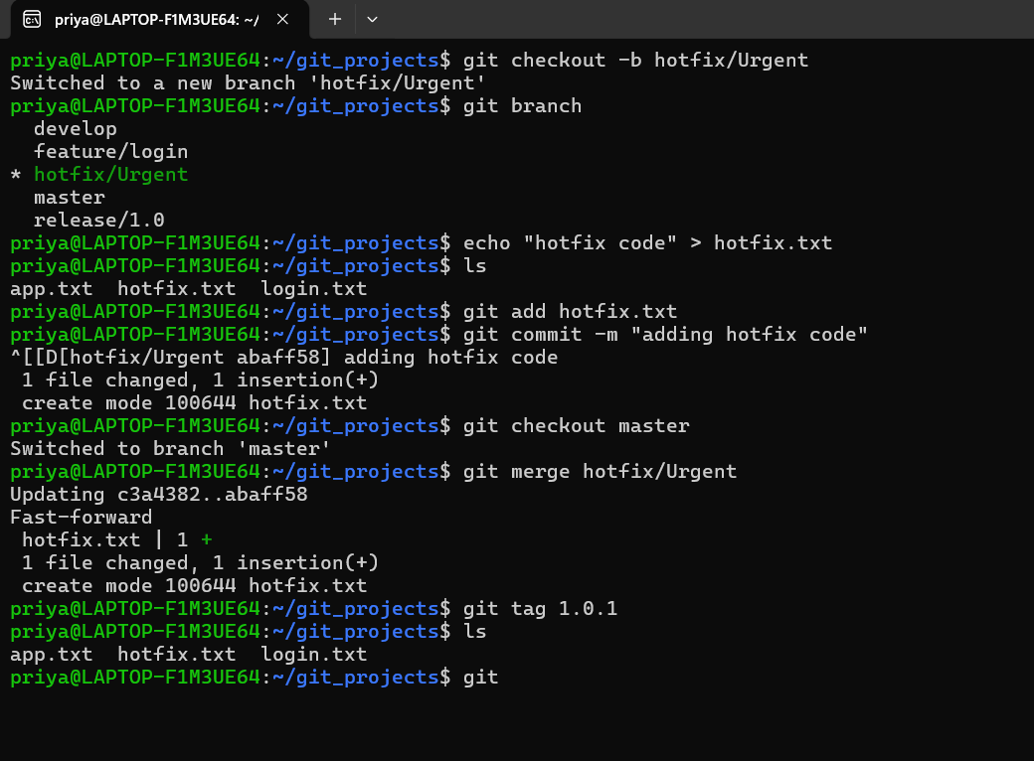
Now all the branch should be in sync. So, I’m going to sync develop branch with master now.
