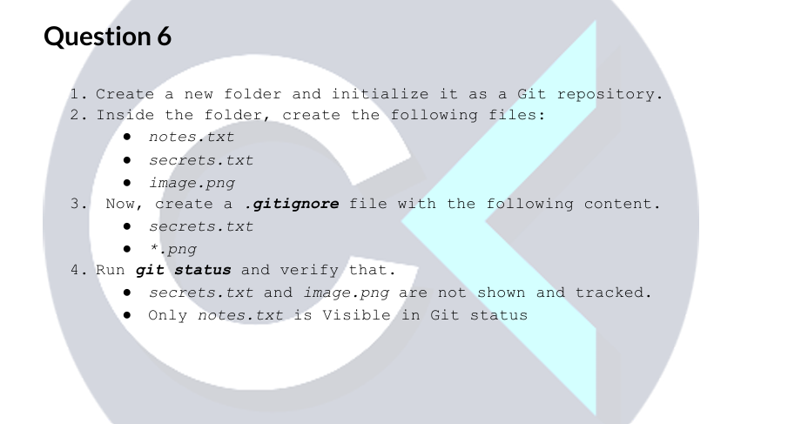
- Create a new folder and initialize it as a Git repository.
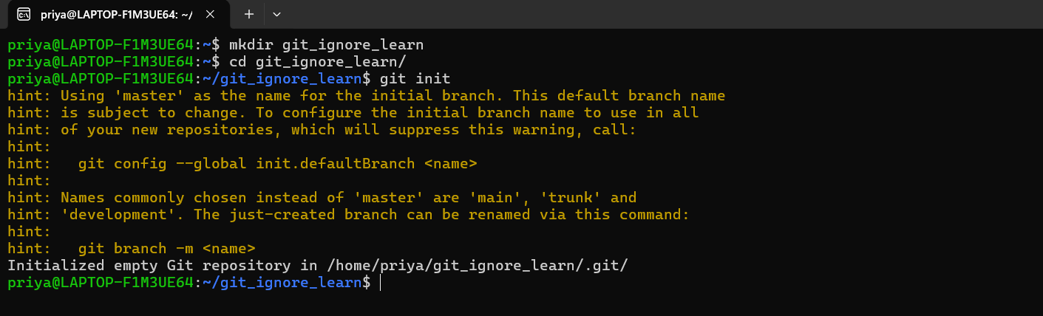
- Inside the folder, create the following files: ● notes.txt ● secrets.txt ● image.png
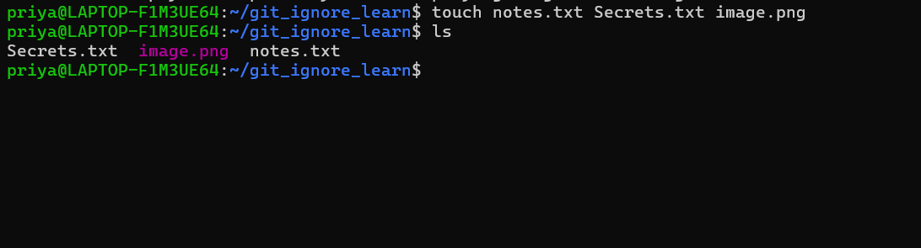
- Now, create a. gitignore file with the following content. ● secrets.txt ● *.png
Added these 2 files to ignore
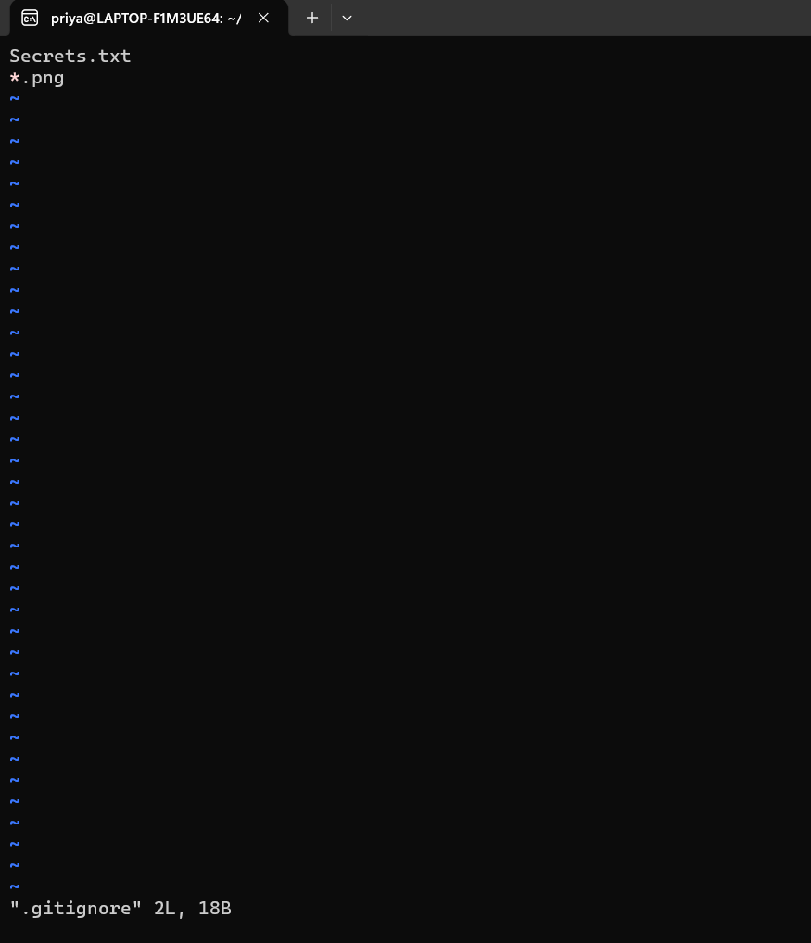
Git status. Now we could see Secrets.txt .png files are ignored.
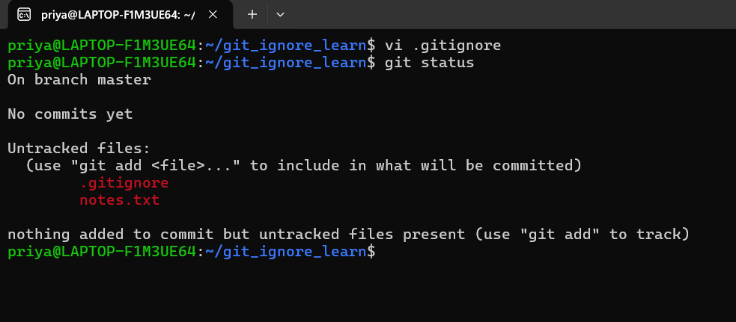
I just committed .gitignore to see only the notes.txt file as per the task
