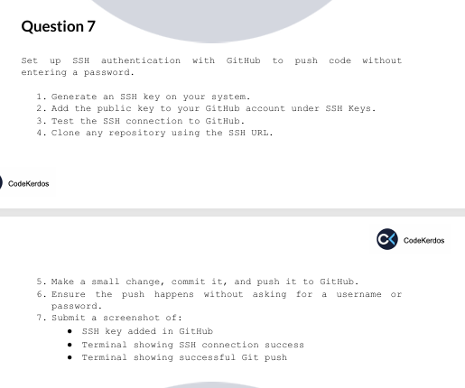
- Generate SSH Key on Your System
ssh-keygen -t ed25519 -C priyasettu330@gmail.com
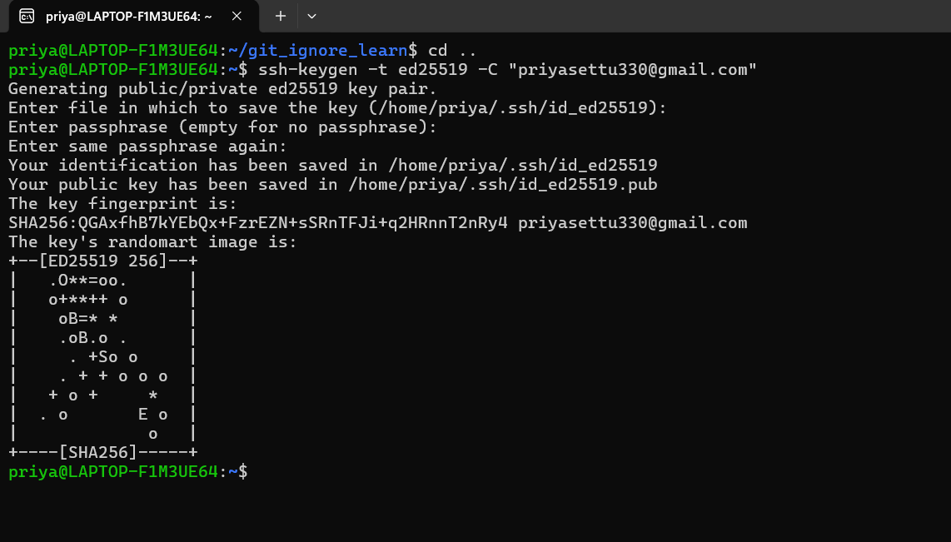
Start SSH Agent & Add Key
eval "$(ssh-agent -s)"
ssh -add /home/priya/.ssh/id_ed25519

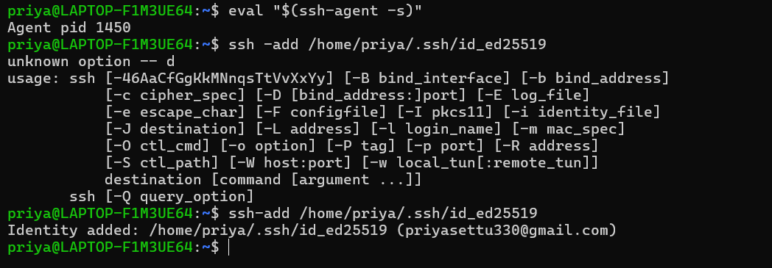

- Add the public key to your GitHub account under SSH Keys.
cat ~/.ssh/id_ed25519.pub
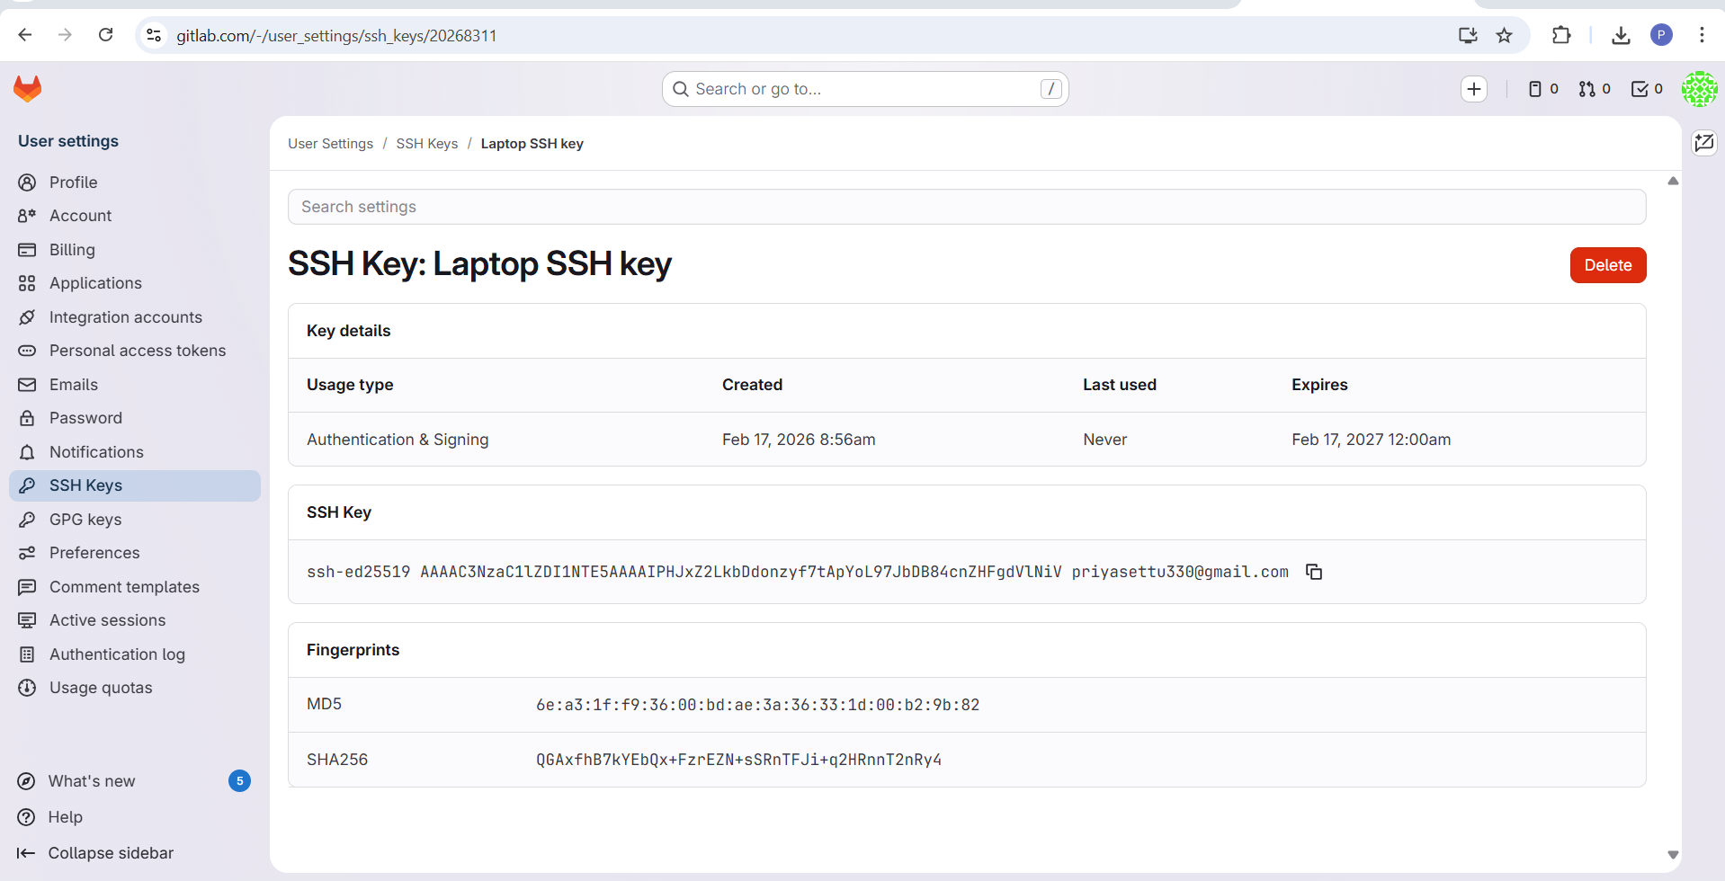

- Test SSH Connection to GitLab
ssh -T git@gitlab.com
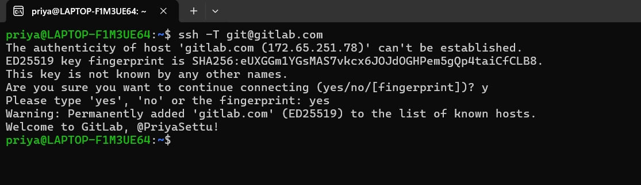
- Clone any repository using the SSH URL.
git@gitlab.com:PriyaSettu/assignments_git.git
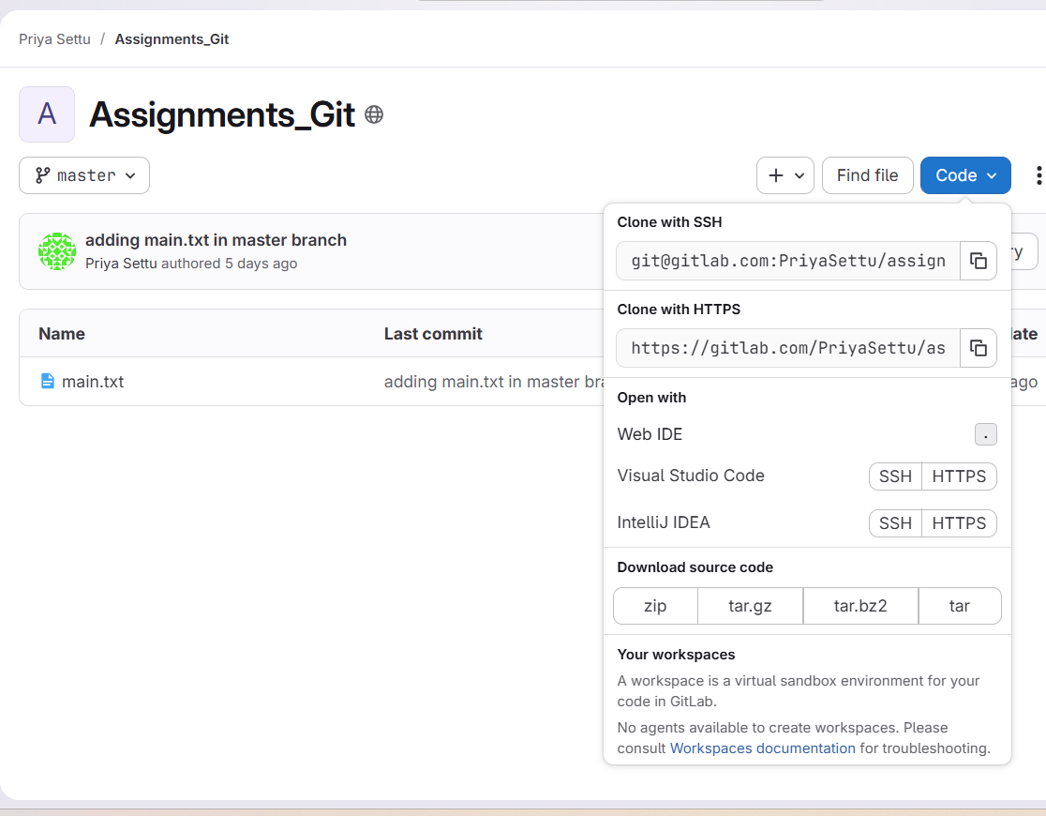
- Make a small change, commit it, and push it to GitHub.
Added one more file and committed.
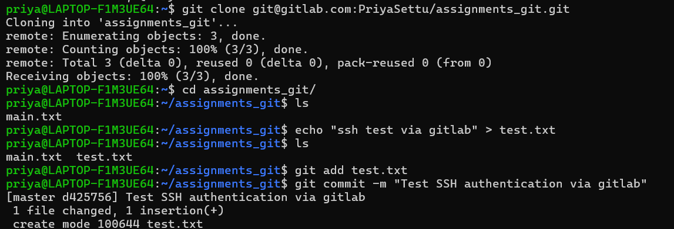
- Ensure the push happens without asking for a username or password.
It didn’t ask for username and password as expected.
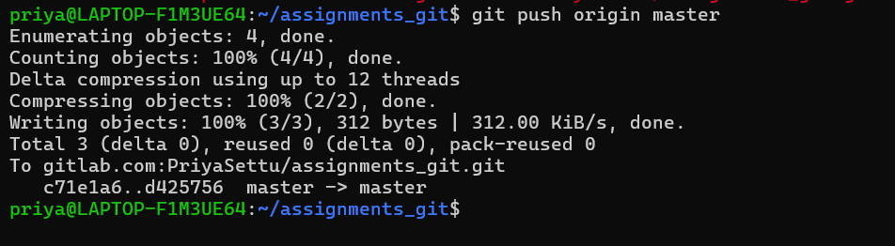
- Submit a screenshot of: ● SSH key added in GitHub ● Terminal showing SSH connection success ● Terminal showing successful Git push
SSH key added in Gitlab:
Terminal showing SSH connection success
Terminal showing successful Git push
