1. CREATE DATABASE
MongoDB Query:
use Students
Explanation: Creates or switches to the Student database.

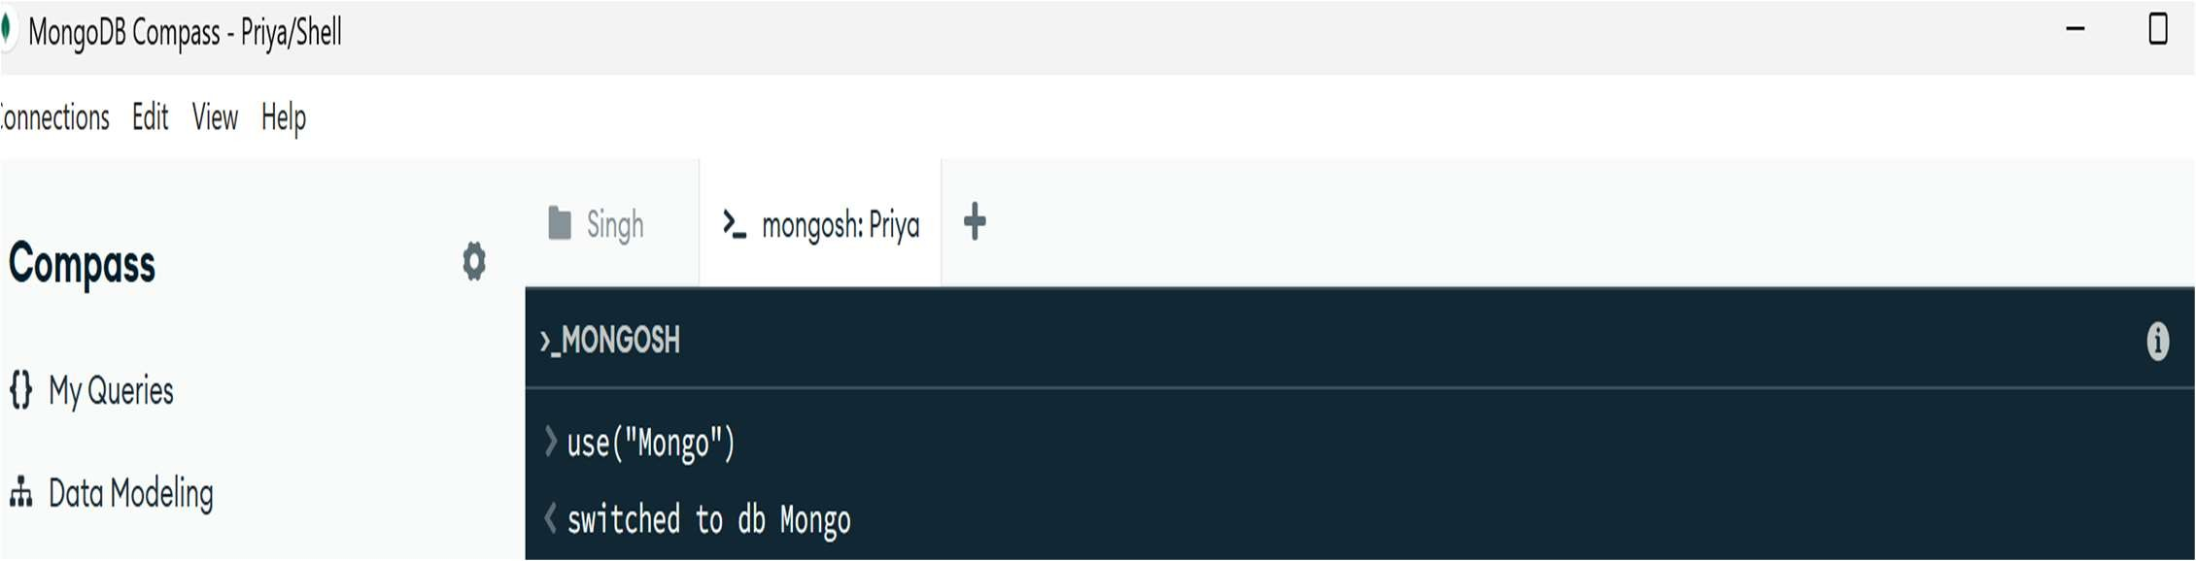

2. CREATE COLLECTION MongoDB Query:
db. create Collection("students")
Explanation: Creates a collection named students.
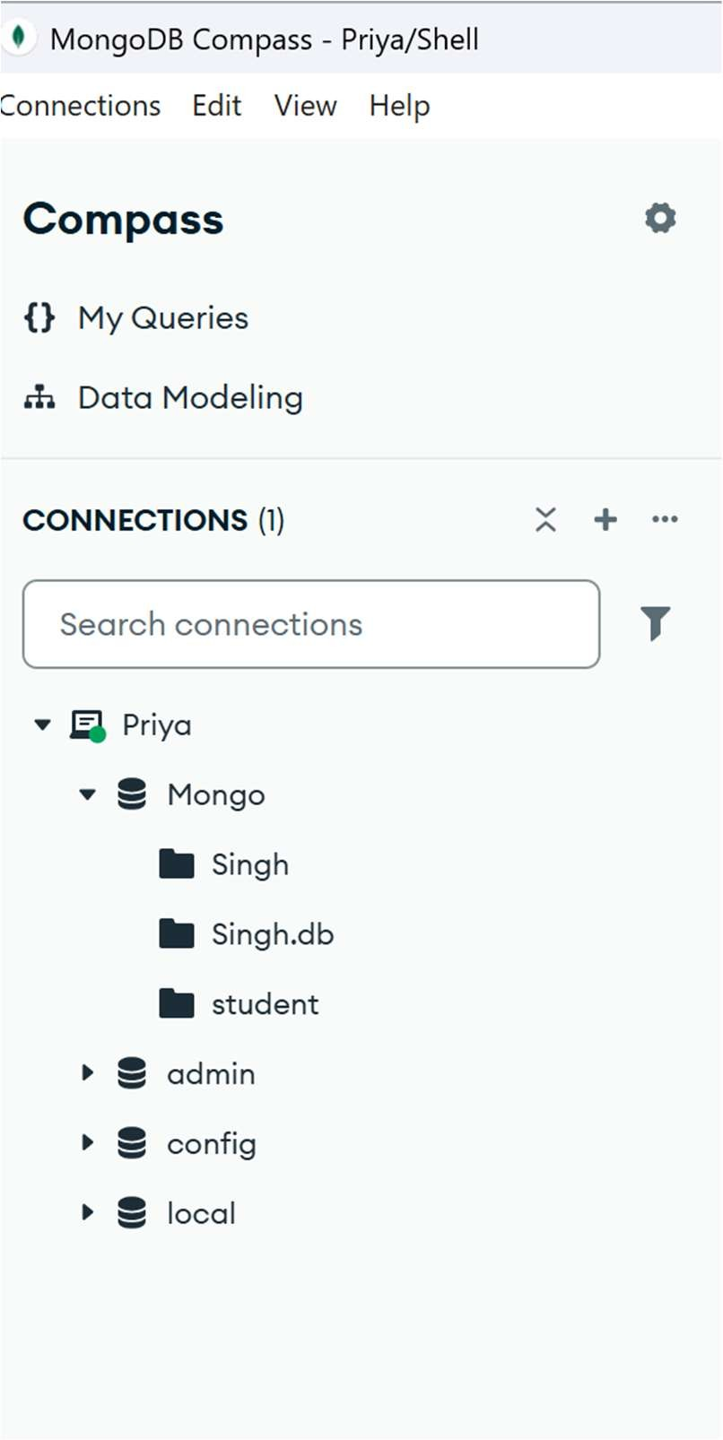

3. INSERT 50 STUDENTS
MongoDB Query:

db.students.insertMany([
{roll:1, name:"Riya", age:18, marks:82, city:"Lucknow"},
{roll:2, name:"Kunal", age:19, marks:74, city:"Kanpur"},
{roll:3, name:"Sneha", age:20, marks:91, city:"Varanasi"},
{roll:4, name:"Raghav", age:18, marks:68, city:"Ayodhya"},
{roll:5, name:"Pooja", age:19, marks:85, city:"Jaunpur"},
{roll:6, name:"Arjun", age:20, marks:88, city:"Prayagraj"}, {roll:7, name:"Simran", age:18, marks:79, city:"Lucknow"},
{roll:8, name:"Mohit", age:19, marks:93, city:"Kanpur"},
{roll:9, name:"Kavya", age:20, marks:76, city:"Gorakhpur"},
{roll:10, name:"Ritesh", age:18, marks:64, city:"Bareilly"},
{roll:11, name:"Nikita", age:19, marks:87, city:"Jaunpur"},
{roll:12, name:"Sakshi", age:20, marks:95, city:"Lucknow"},
{roll:13, name:"Abhishek", age:18, marks:81, city:"Ayodhya"},
{roll:14, name:"Muskan", age:19, marks:89, city:"Prayagraj"},
{roll:15, name:"Rohit", age:20, marks:72, city:"Varanasi"},
{roll:16, name:"Komal", age:18, marks:86, city:"Lucknow"},
{roll:17, name:"Deepak", age:19, marks:78, city:"Kanpur"},
{roll:18, name:"Ishita", age:18, marks:57, city:"Gonda"},
{roll:19, name:"Manish", age:20, marks:92, city:"Lucknow"},
{roll:20, name:"Aarav", age:19, marks:66, city:"Bareilly"},
{roll:21, name:"Shivani", age:18, marks:83, city:"Lucknow"},
{roll:22, name:"Varun", age:19, marks:75, city:"Jaunpur"},
{roll:23, name:"Nandini", age:20, marks:80, city:"Kanpur"},
{roll:24, name:"Vikas", age:19, marks:88, city:"Ayodhya"},
{roll:25, name:"Payal", age:18, marks:69, city:"Prayagraj"},
{roll:26, name:"Rajat", age:20, marks:94, city:"Lucknow"},
{roll:27, name:"Isha", age:19, marks:84, city:"Varanasi"},
{roll:28, name:"Saurabh", age:18, marks:62, city:"Gorakhpur"},
{roll:29, name:"Tanvi", age:19, marks:77, city:"Kanpur"}, {roll:30, name:"Yash", age:20, marks:90, city:"Lucknow"},
{roll:31, name:"Preeti", age:18, marks:71, city:"Jaunpur"},
{roll:32, name:"Harshit", age:19, marks:89, city:"Lucknow"},
{roll:33, name:"Mansi", age:20, marks:59, city:"Ayodhya"},
{roll:34, name:"Dev", age:18, marks:85, city:"Kanpur"},
{roll:35, name:"Shubham", age:19, marks:96, city:"Prayagraj"},
{roll:36, name:"Anjali", age:20, marks:73, city:"Lucknow"},
{roll:37, name:"Nikhil", age:18, marks:82, city:"Varanasi"},
{roll:38, name:"Aditi", age:19, marks:67, city:"Gorakhpur"},
{roll:39, name:"Varsha", age:20, marks:93, city:"Lucknow"},
{roll:40, name:"Rishabh", age:19, marks:86, city:"Kanpur"},
{roll:41, name:"Kiran", age:18, marks:75, city:"Jaunpur"},
{roll:42, name:"Siddharth", age:20, marks:91, city:"Lucknow"},
{roll:43, name:"Pallavi", age:19, marks:63, city:"Ayodhya"},
{roll:44, name:"Aakash", age:18, marks:79, city:"Prayagraj"},
{roll:45, name:"Shalini", age:20, marks:87, city:"Lucknow"},
{roll:46, name:"Tarun", age:19, marks:70, city:"Kanpur"},
{roll:47, name:"Nisha", age:18, marks:61, city:"Gonda"},
{roll:48, name:"Viveka", age:20, marks:90, city:"Lucknow"},
{roll:49, name:"Sameer", age:19, marks:65, city:"Bareilly"},
{roll:50, name:"Divya", age:18, marks:92, city:"Varanasi"}
])
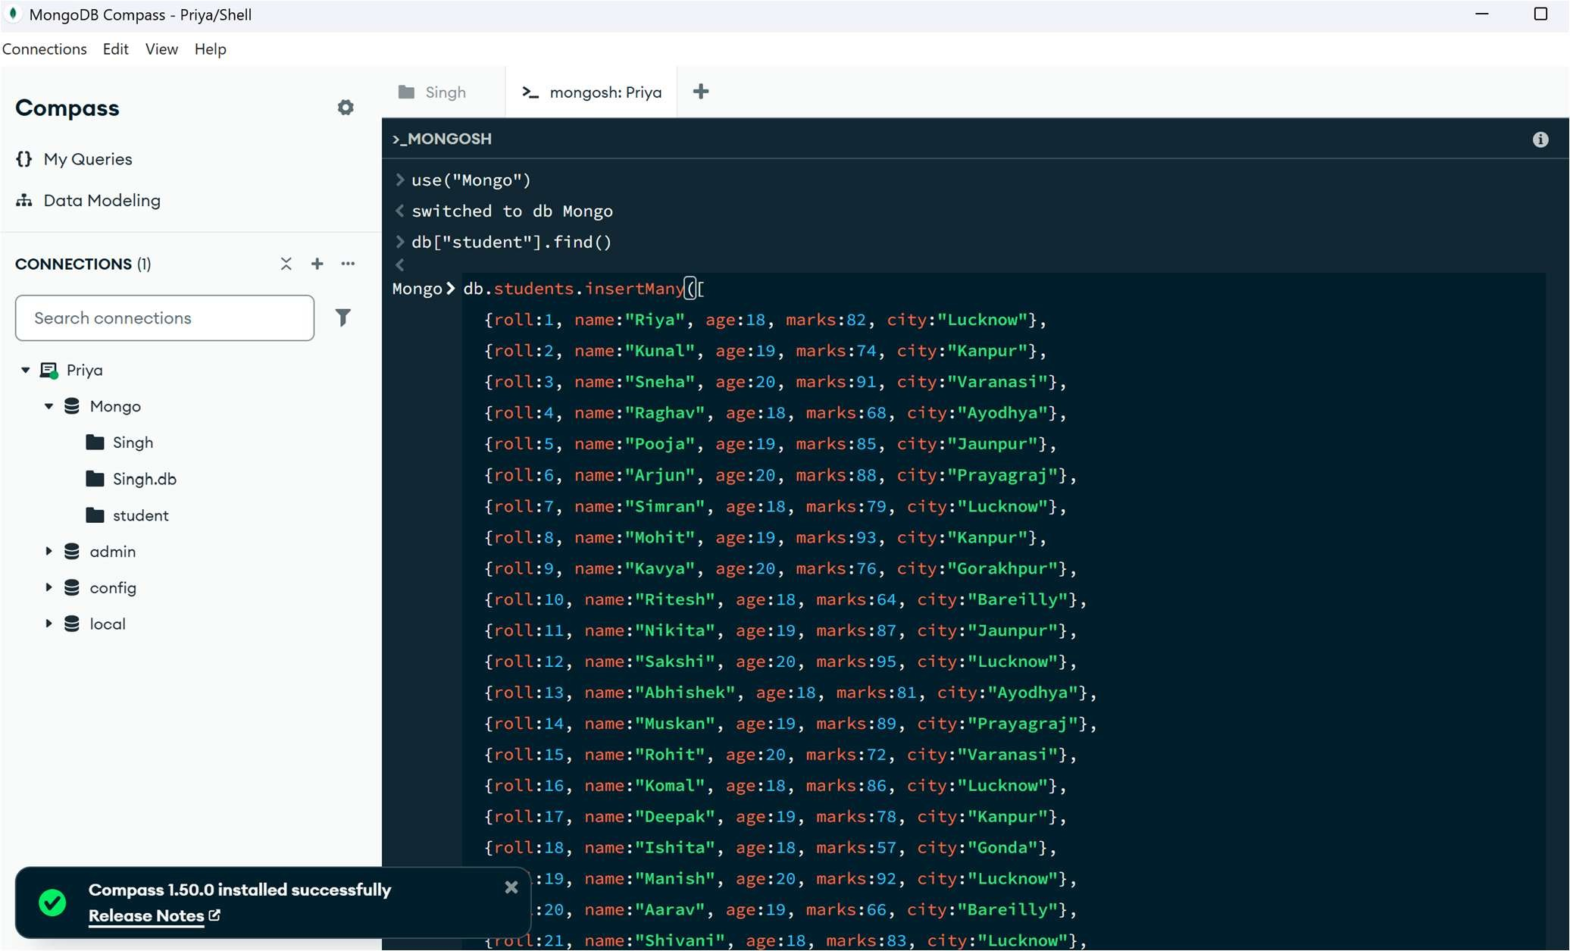
Explanation: Inserts multiple student documents into the collection.

4. DISPLAY ALL STUDENTS
MongoDB Query:
db. students. Find ()
Explanation: Retrieves documents from the students collection.
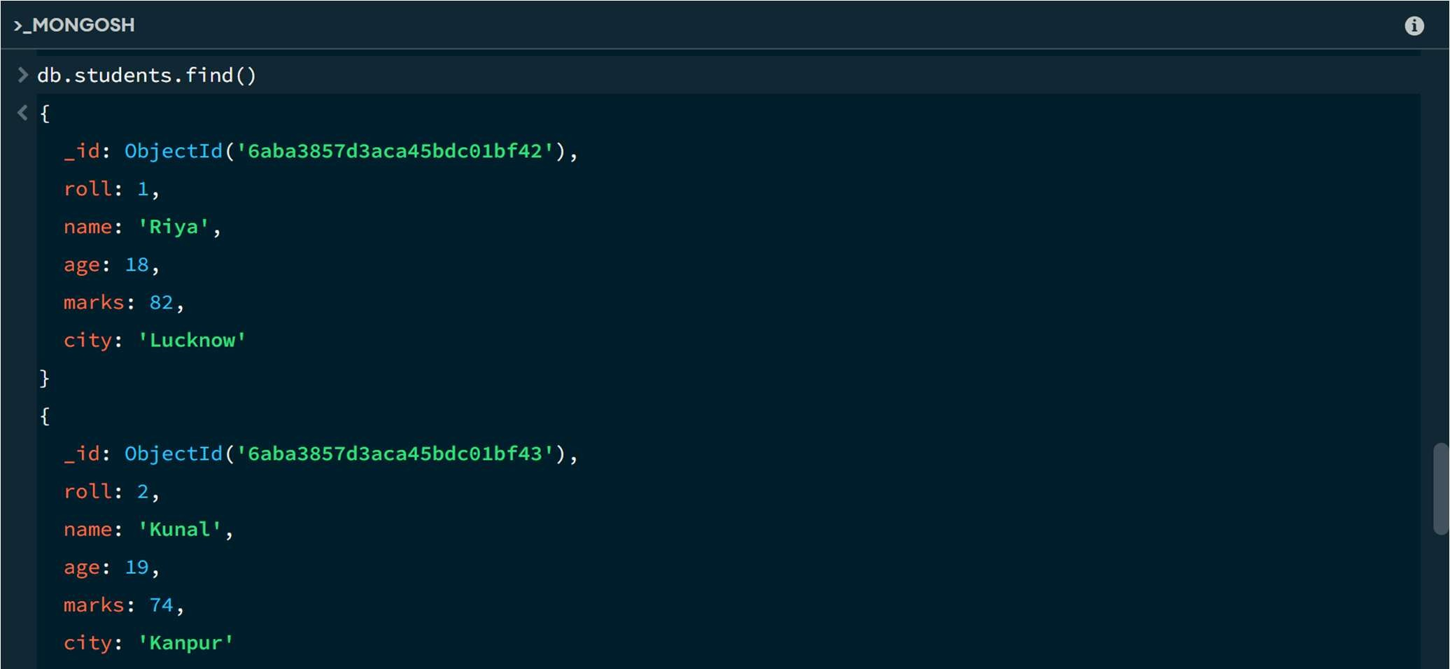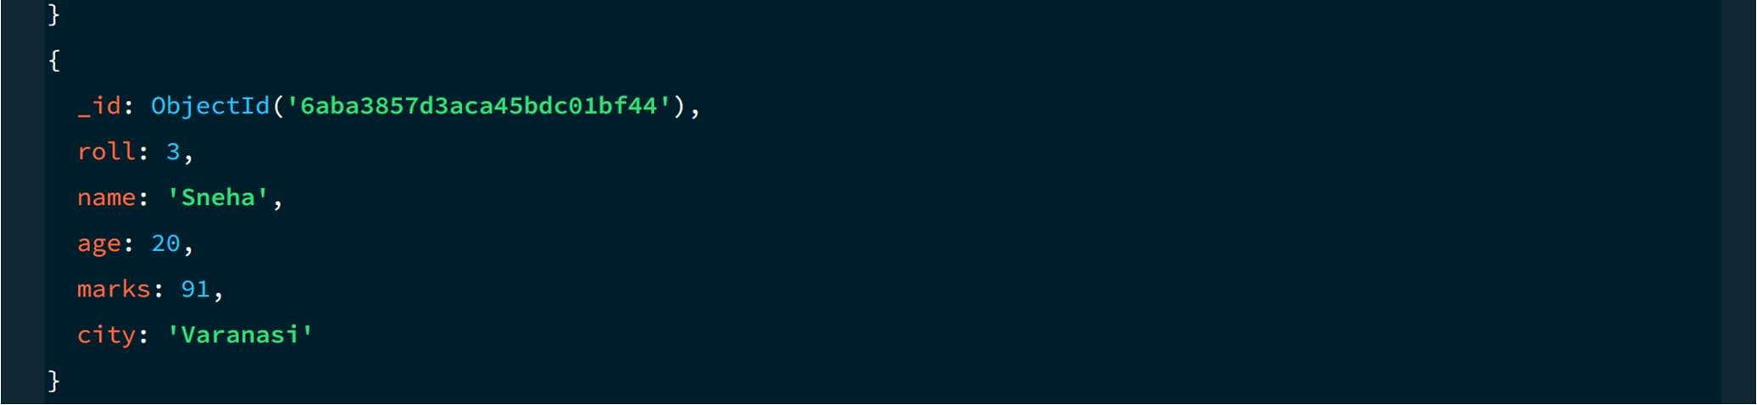
5. EQUAL TO — $eq MongoDB Query:
db. students. Find ({marks: {$eq: 88}})
Explanation: Finds students whose marks are exactly 88.

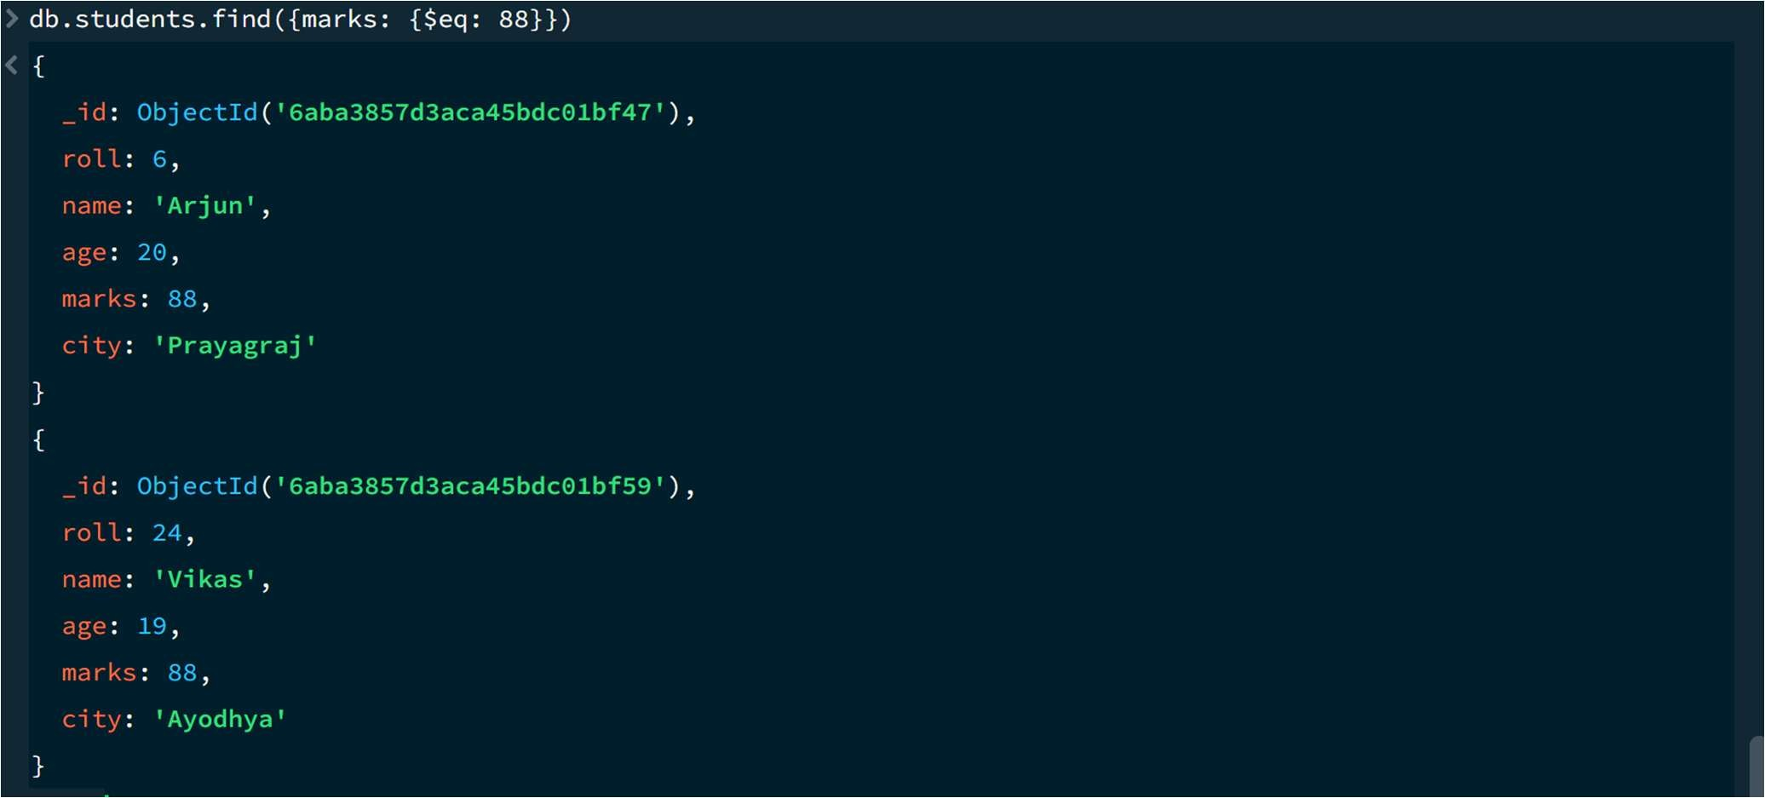

6. GREATER THAN — $gt
MongoDB Query:
db.students.find({marks: {$gt: 85}})
Explanation: Finds students whose marks are greater than 85.
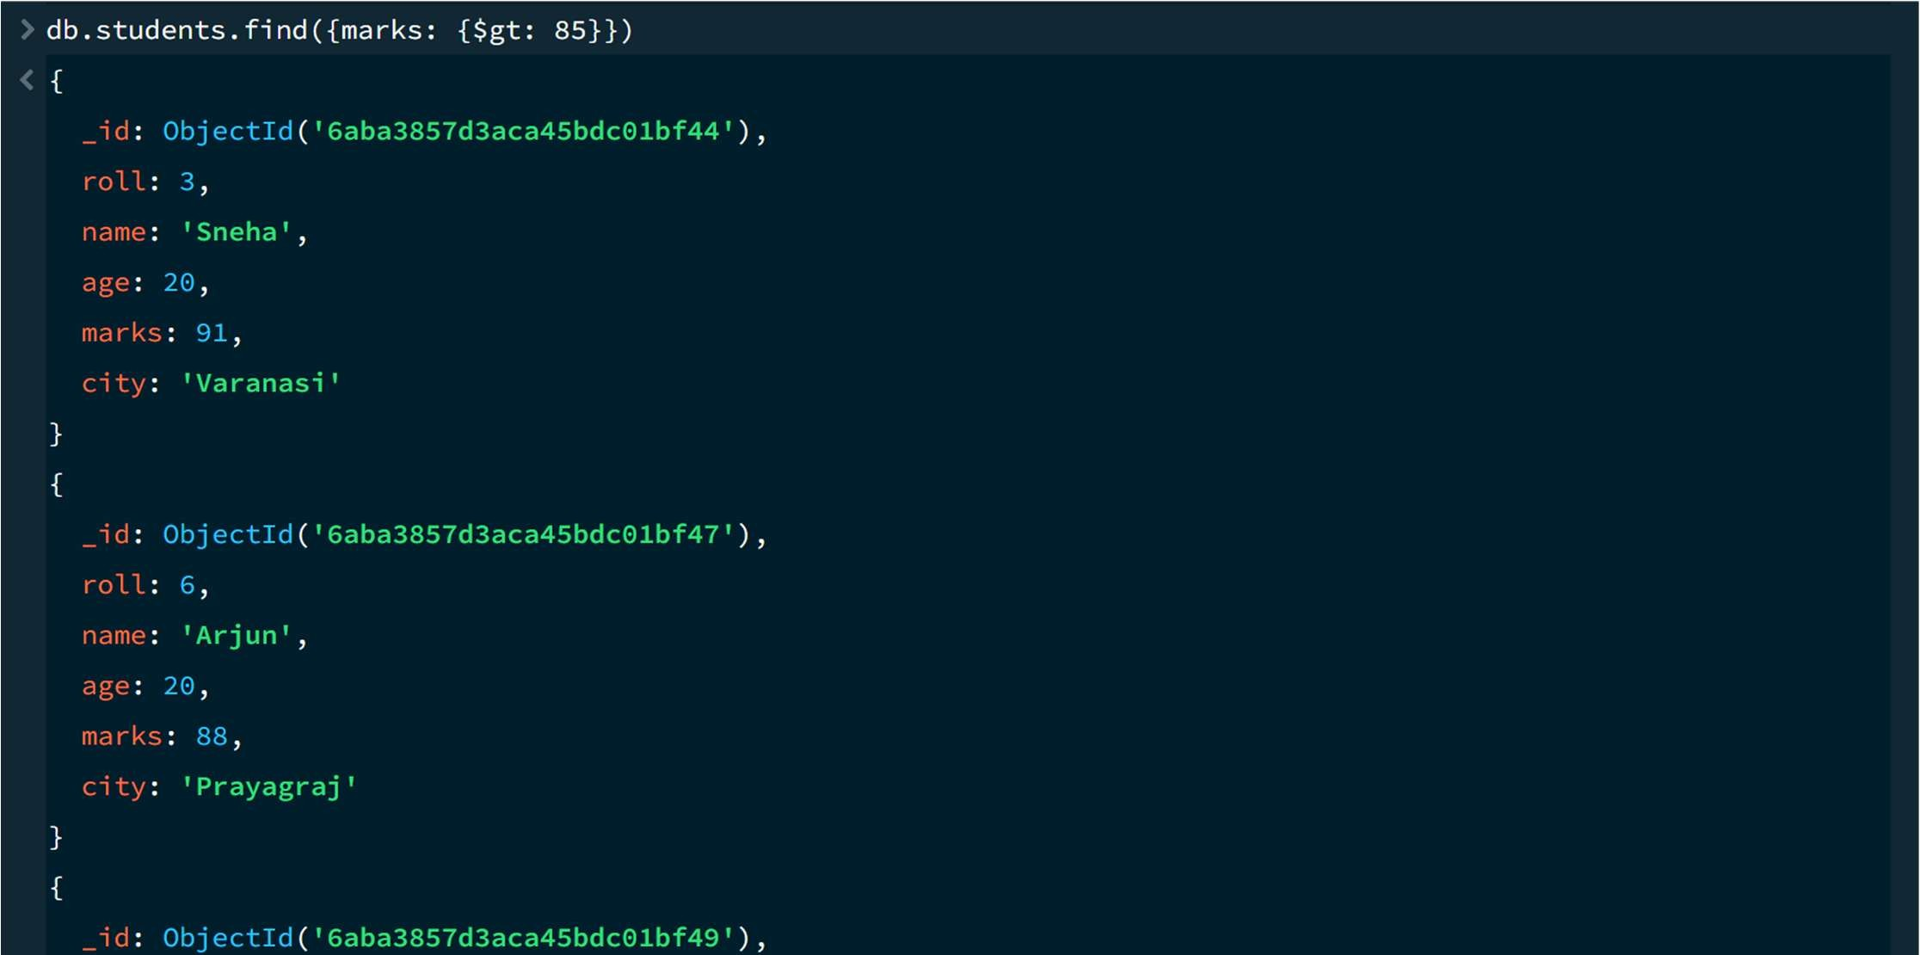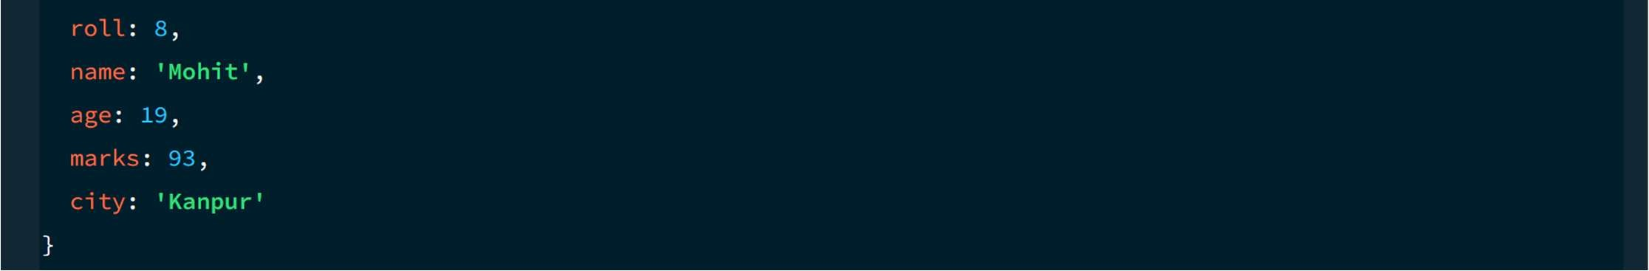

7. LESS THAN — $lt MongoDB Query:
db. students. find ({marks: {$lt: 60}})
Explanation: Finds students whose marks are less than 60.
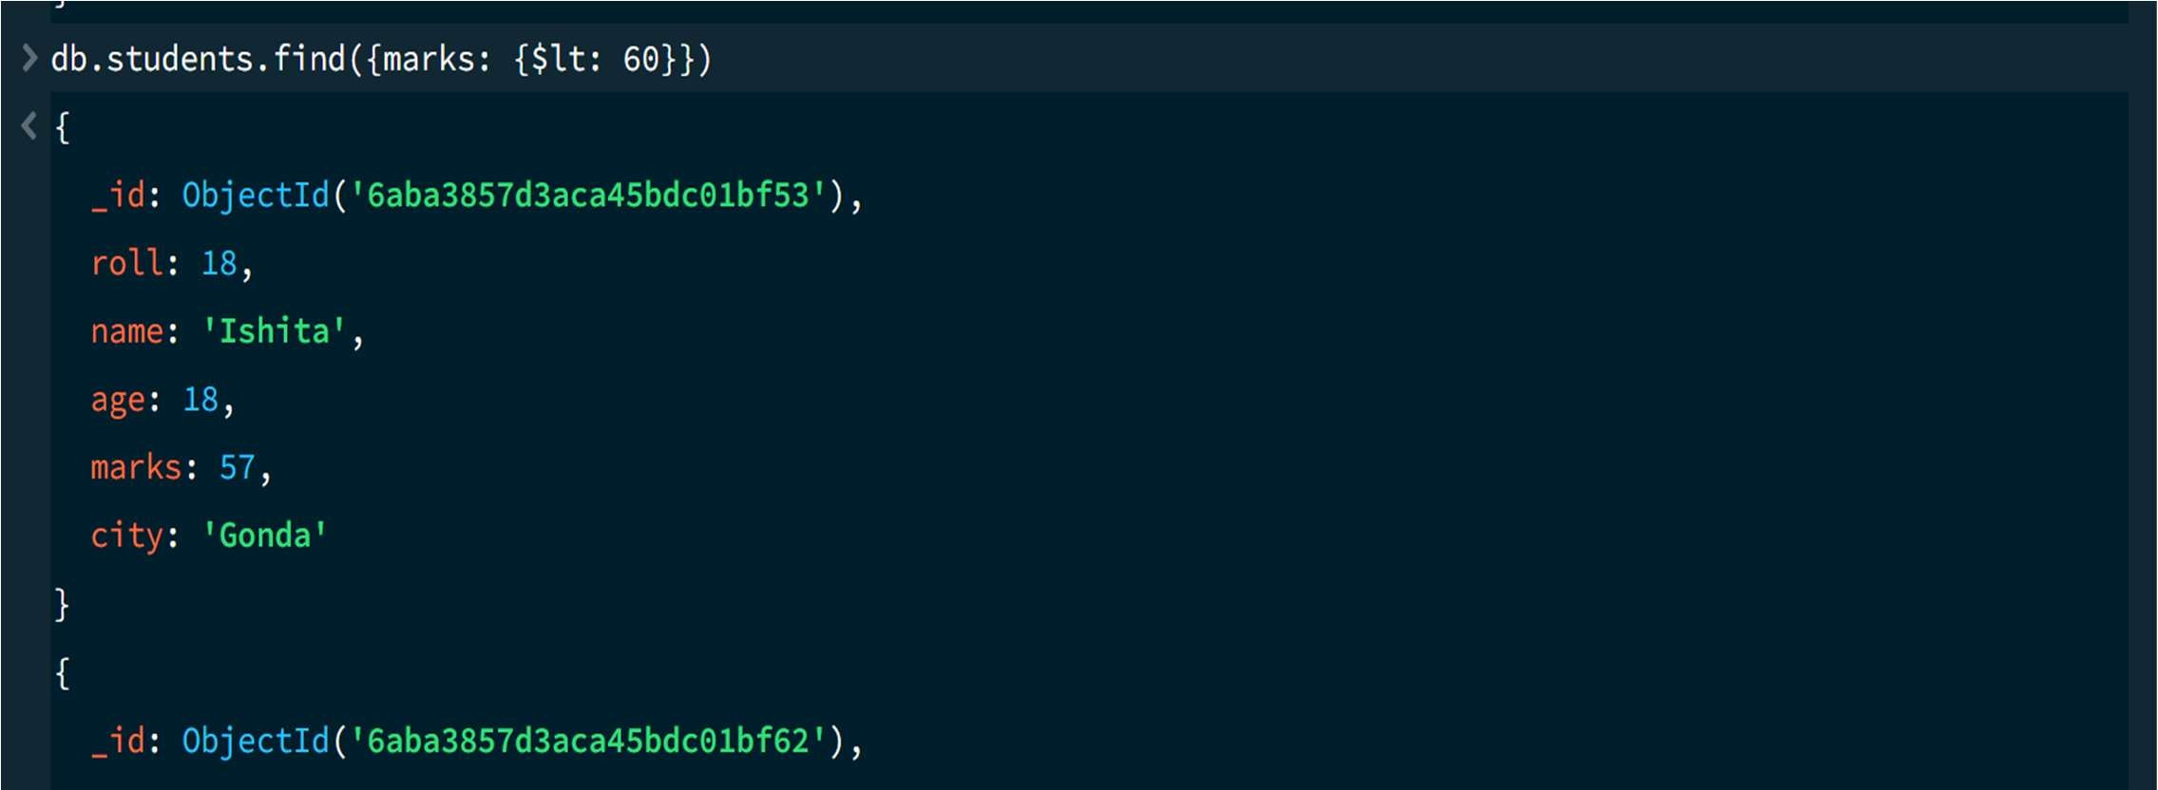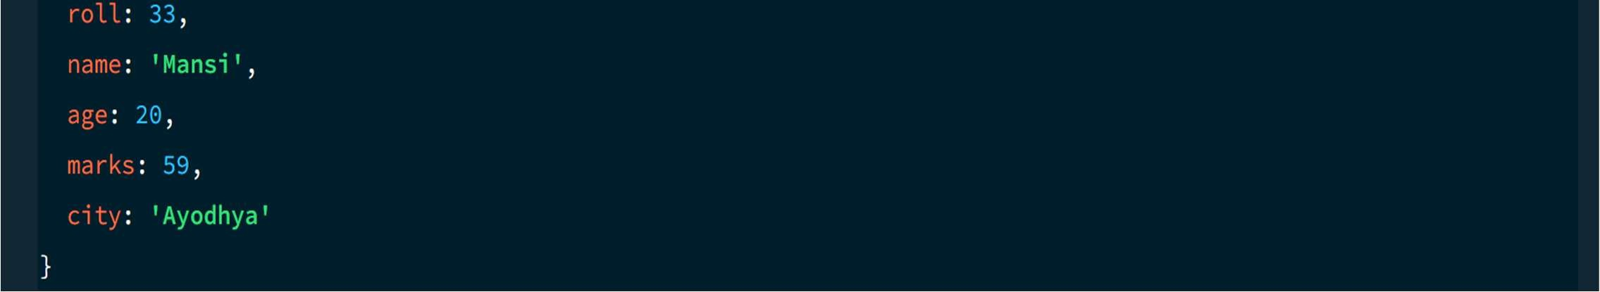

8. GREATER THAN OR EQUAL TO — $gte
MongoDB Query:
db. students. find({marks: {$gte: 90}})
Explanation: Finds students whose marks are 90 or above.
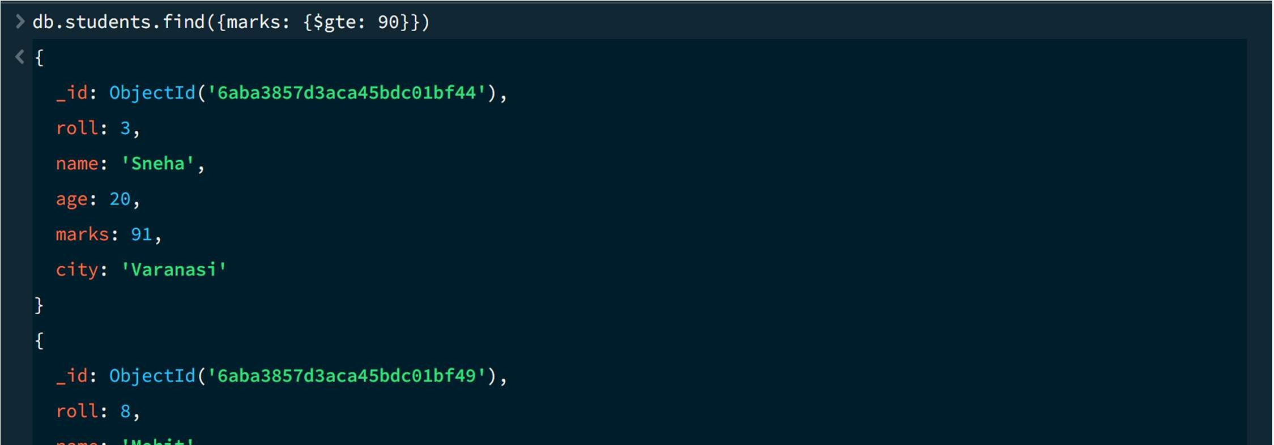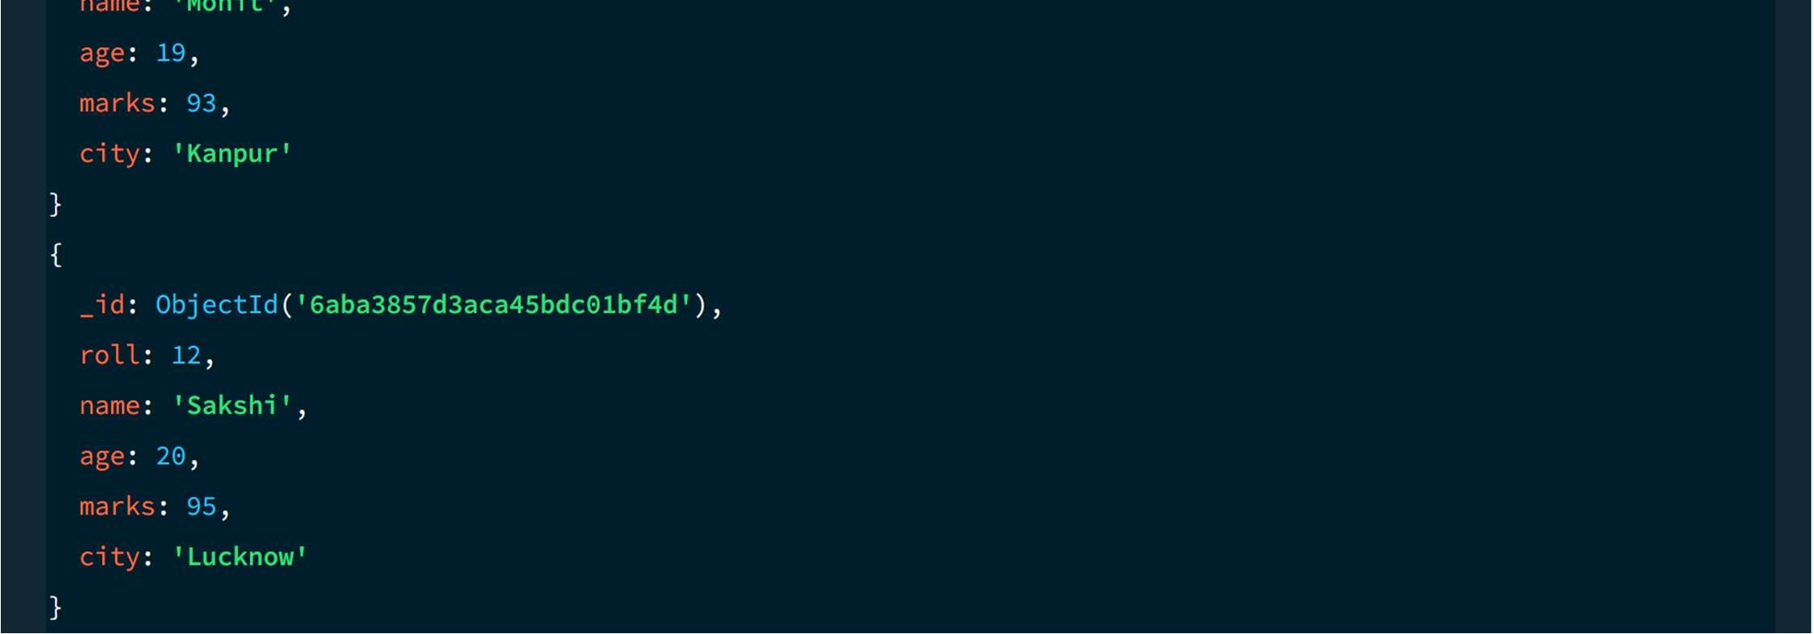

9. LESS THAN OR EQUAL TO — $lte
MongoDB Query:
db. students. find({marks: {$lte: 70}})
Explanation: Finds students whose marks are 70 or below.
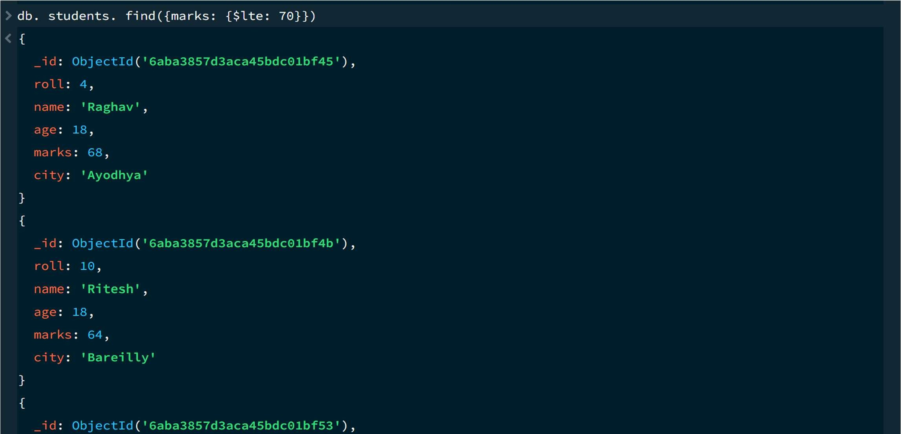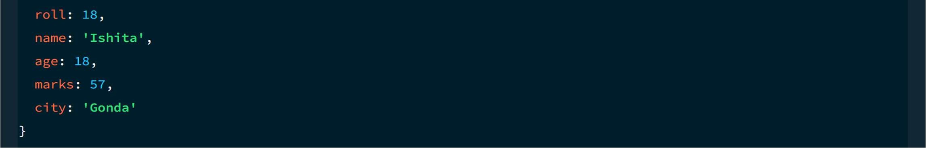

10. UPDATE OPERATION
MongoDB Query:
db.students.updateOne(
{roll:5},
{$set:{marks:95}} )
Explanation: Updates the marks to 95 of the student with roll number 5.
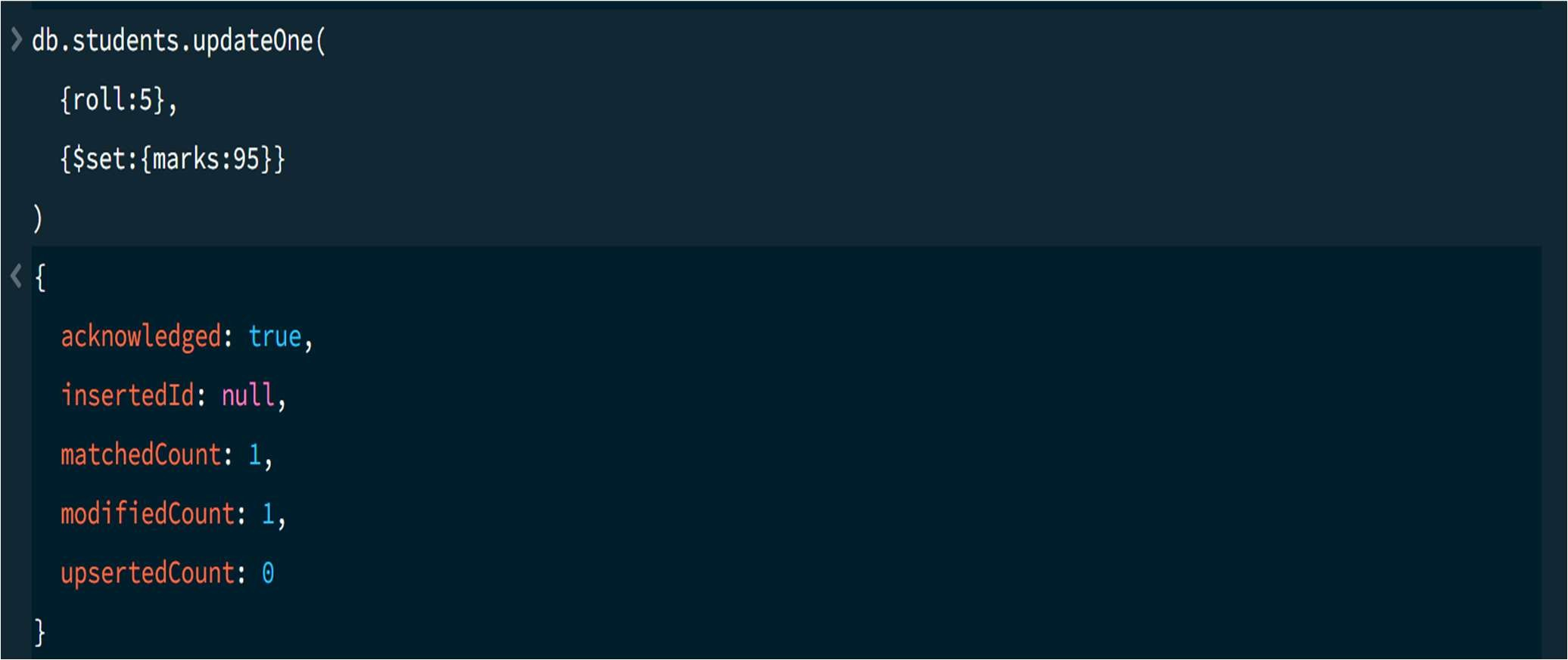

11. DELETE ONE OPERATION MongoDB Query:
db.students.deleteOne({roll:10})
Explanation: Deletes one document matching roll number 10.

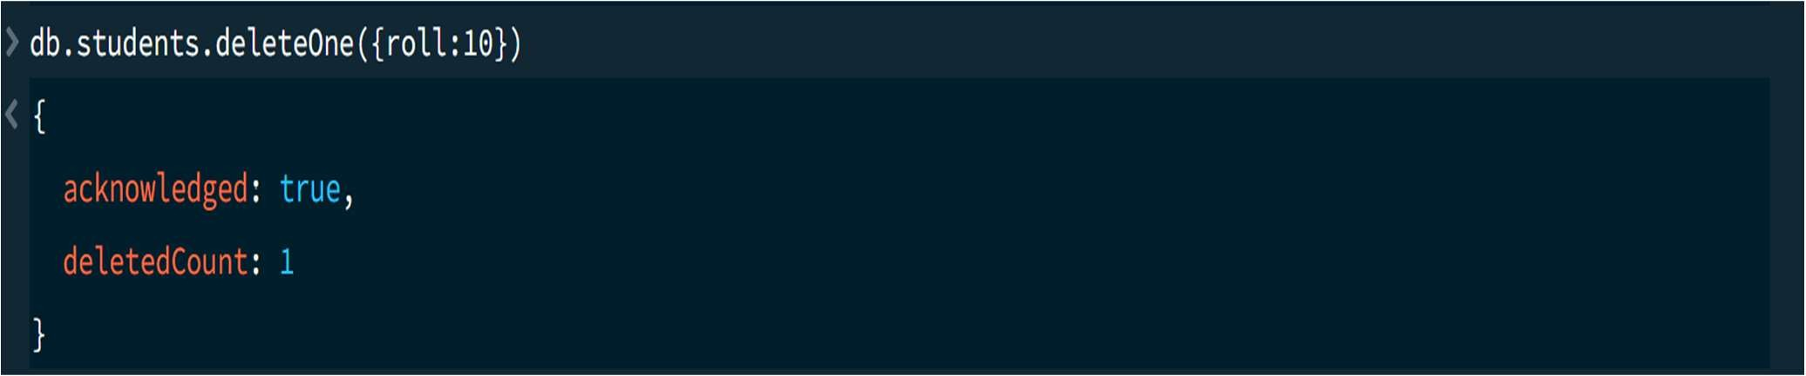

12. DELETE MANY OPERATION
MongoDB Query:
db.students.deleteMany({ marks: {$lt:60} })
Explanation: Deletes all students having marks below 60.

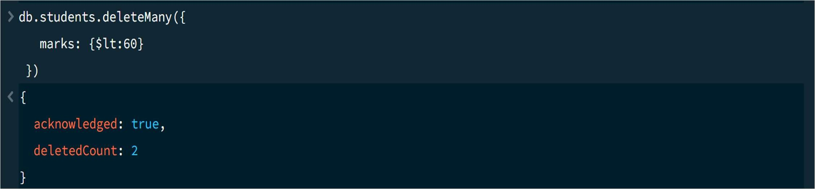

13. AND OPERATION — $and
MongoDB Query:
db. students. find({
$and:[
{marks:{$gt:80}},
{age:19}
] })
Explanation: Finds students satisfying both conditions.
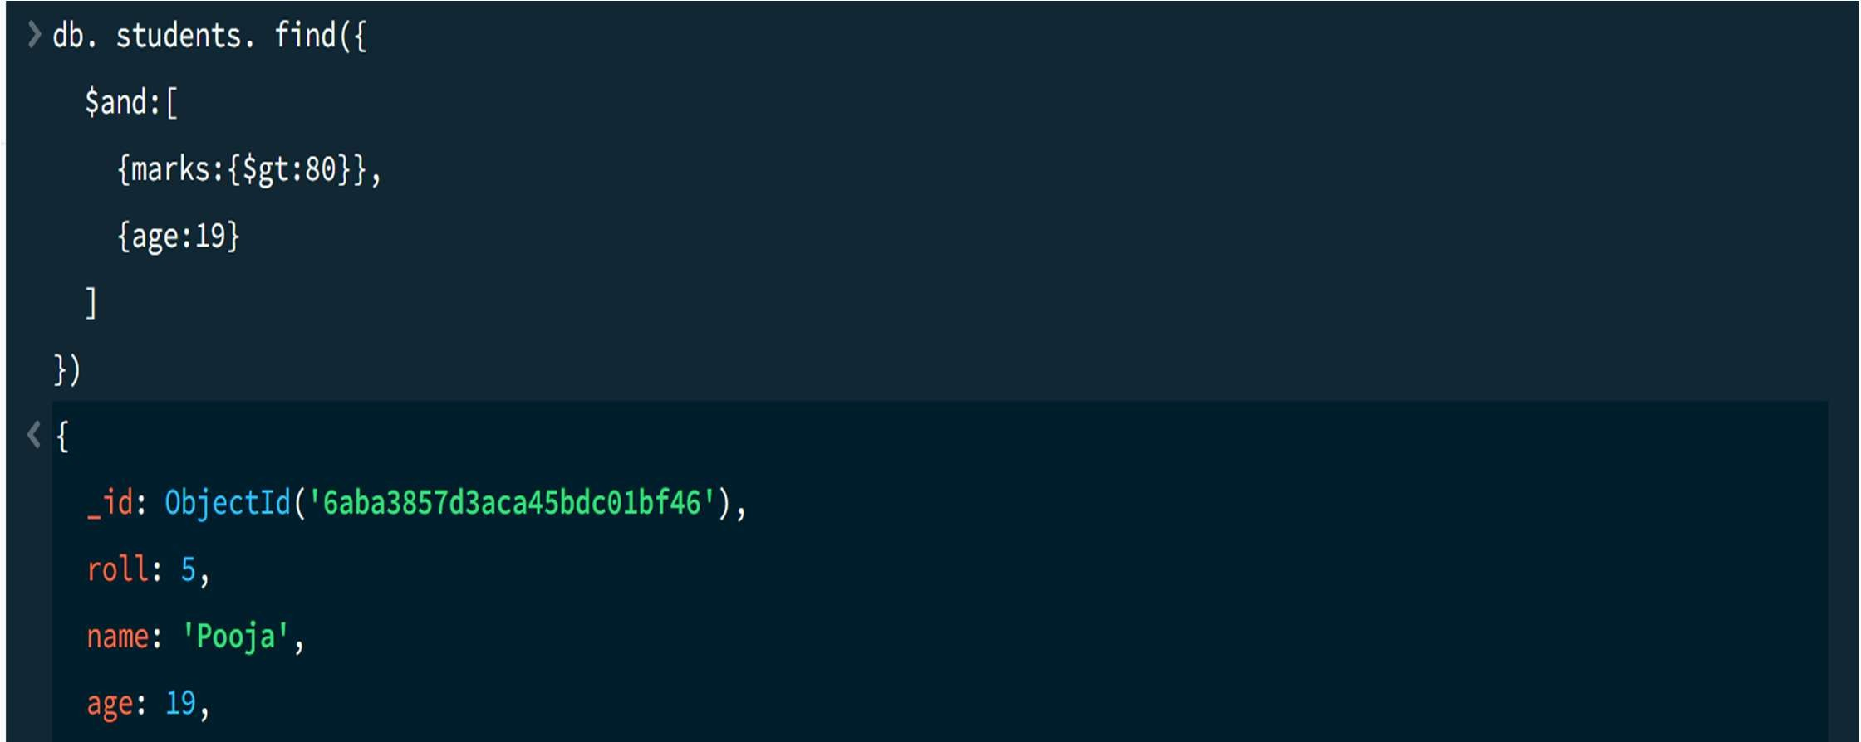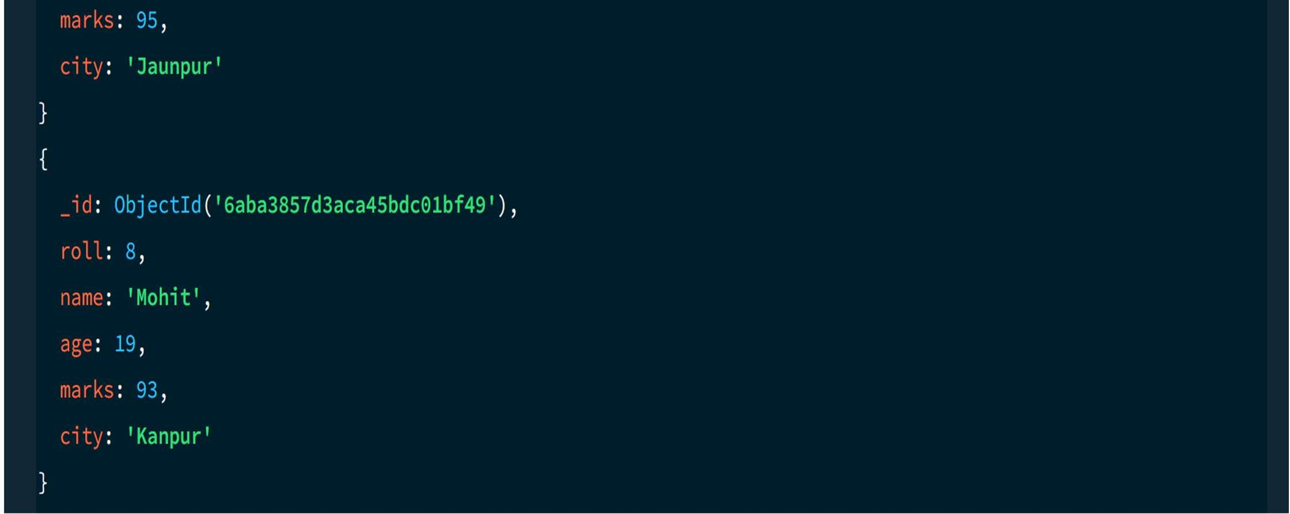

14. OR OPERATION — $or
MongoDB Query:
db.students.find({
$or:[
{city:"Lucknow"},
{city:"Kanpur"}
] })
Explanation: Finds students from Lucknow or Kanpur.
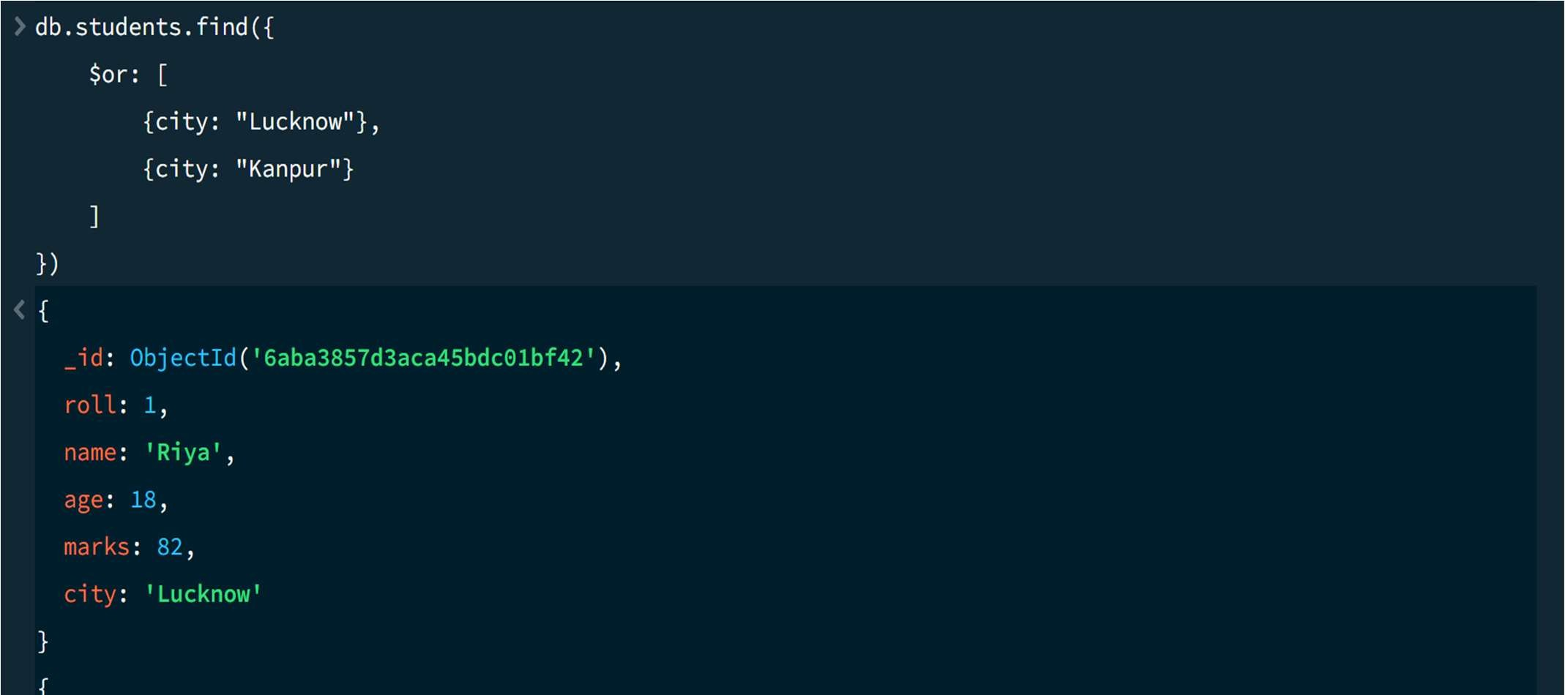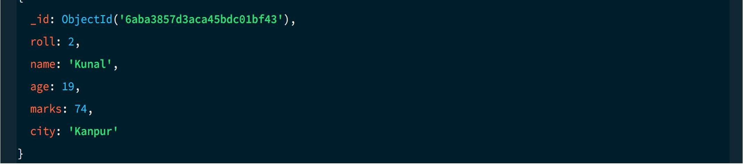

15. SORT OPERATION A.MongoDB Query:
db. students. find (). sort({marks : 1})
Explanation: Sorts students by marks from lowest to highest. Use 1 for ascending order.
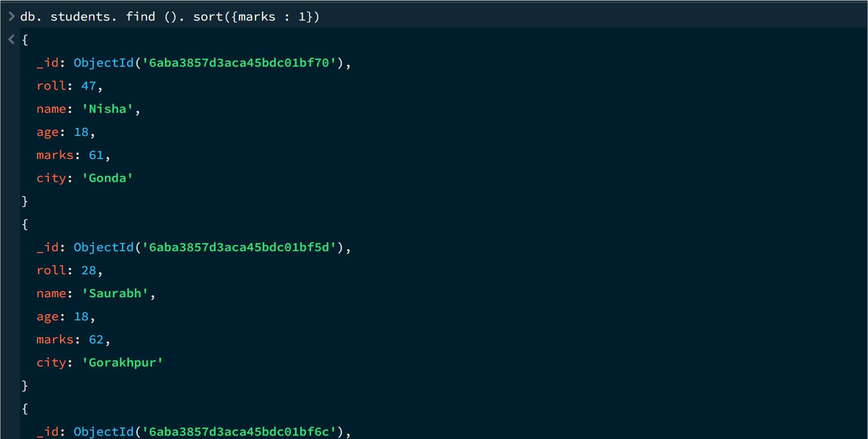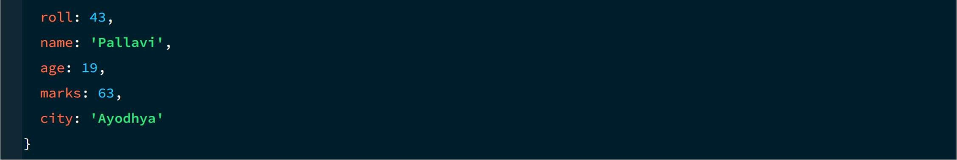

B. MongoDB Query:
db. students. find (). Sort ({marks: -1})
Explanation: Sorts students by marks from highest to lowest. Use -1 for descending order.

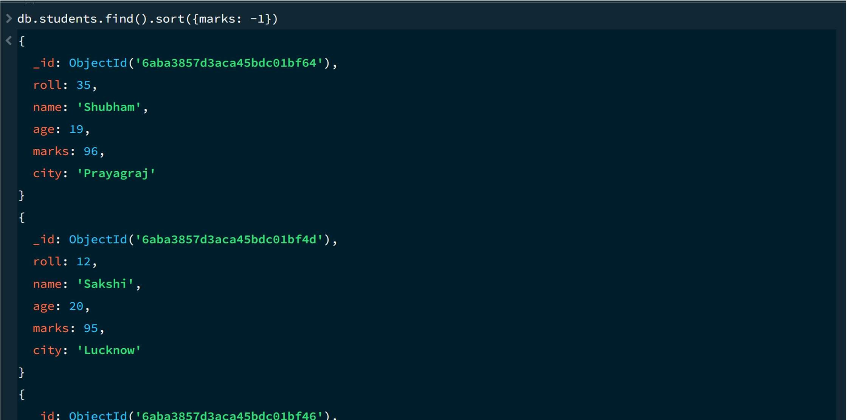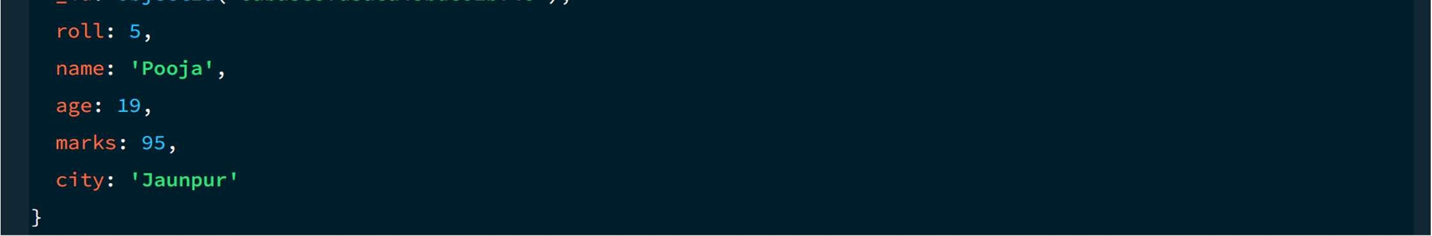
16. LIMIT OPERATION MongoDB Query:
db. students. find (). limit (5)
Explanation: Displays only the first five documents.

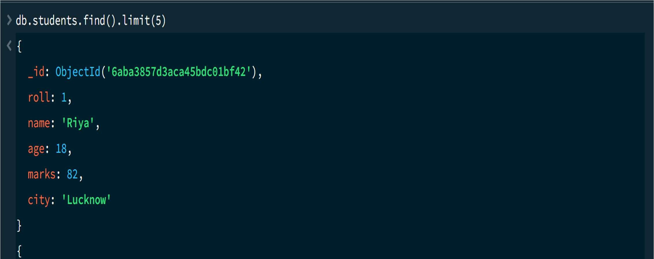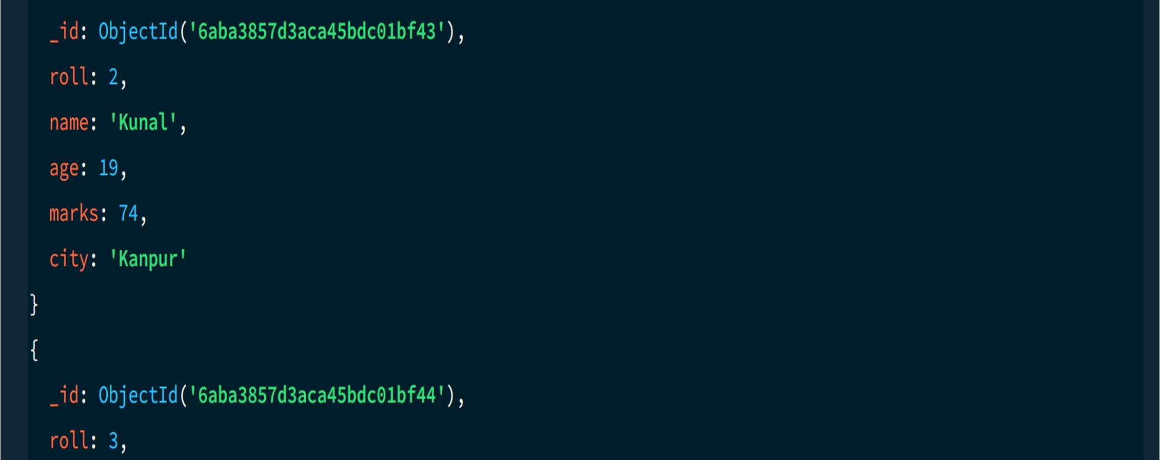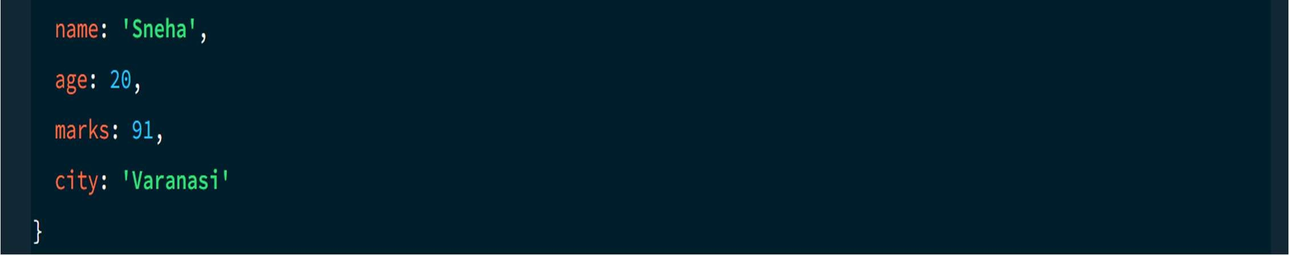

17. SEARCH BY CITY
MongoDB Query:
db.students.find({city:"Lucknow"})
Explanation: Finds all students whose city is Lucknow.
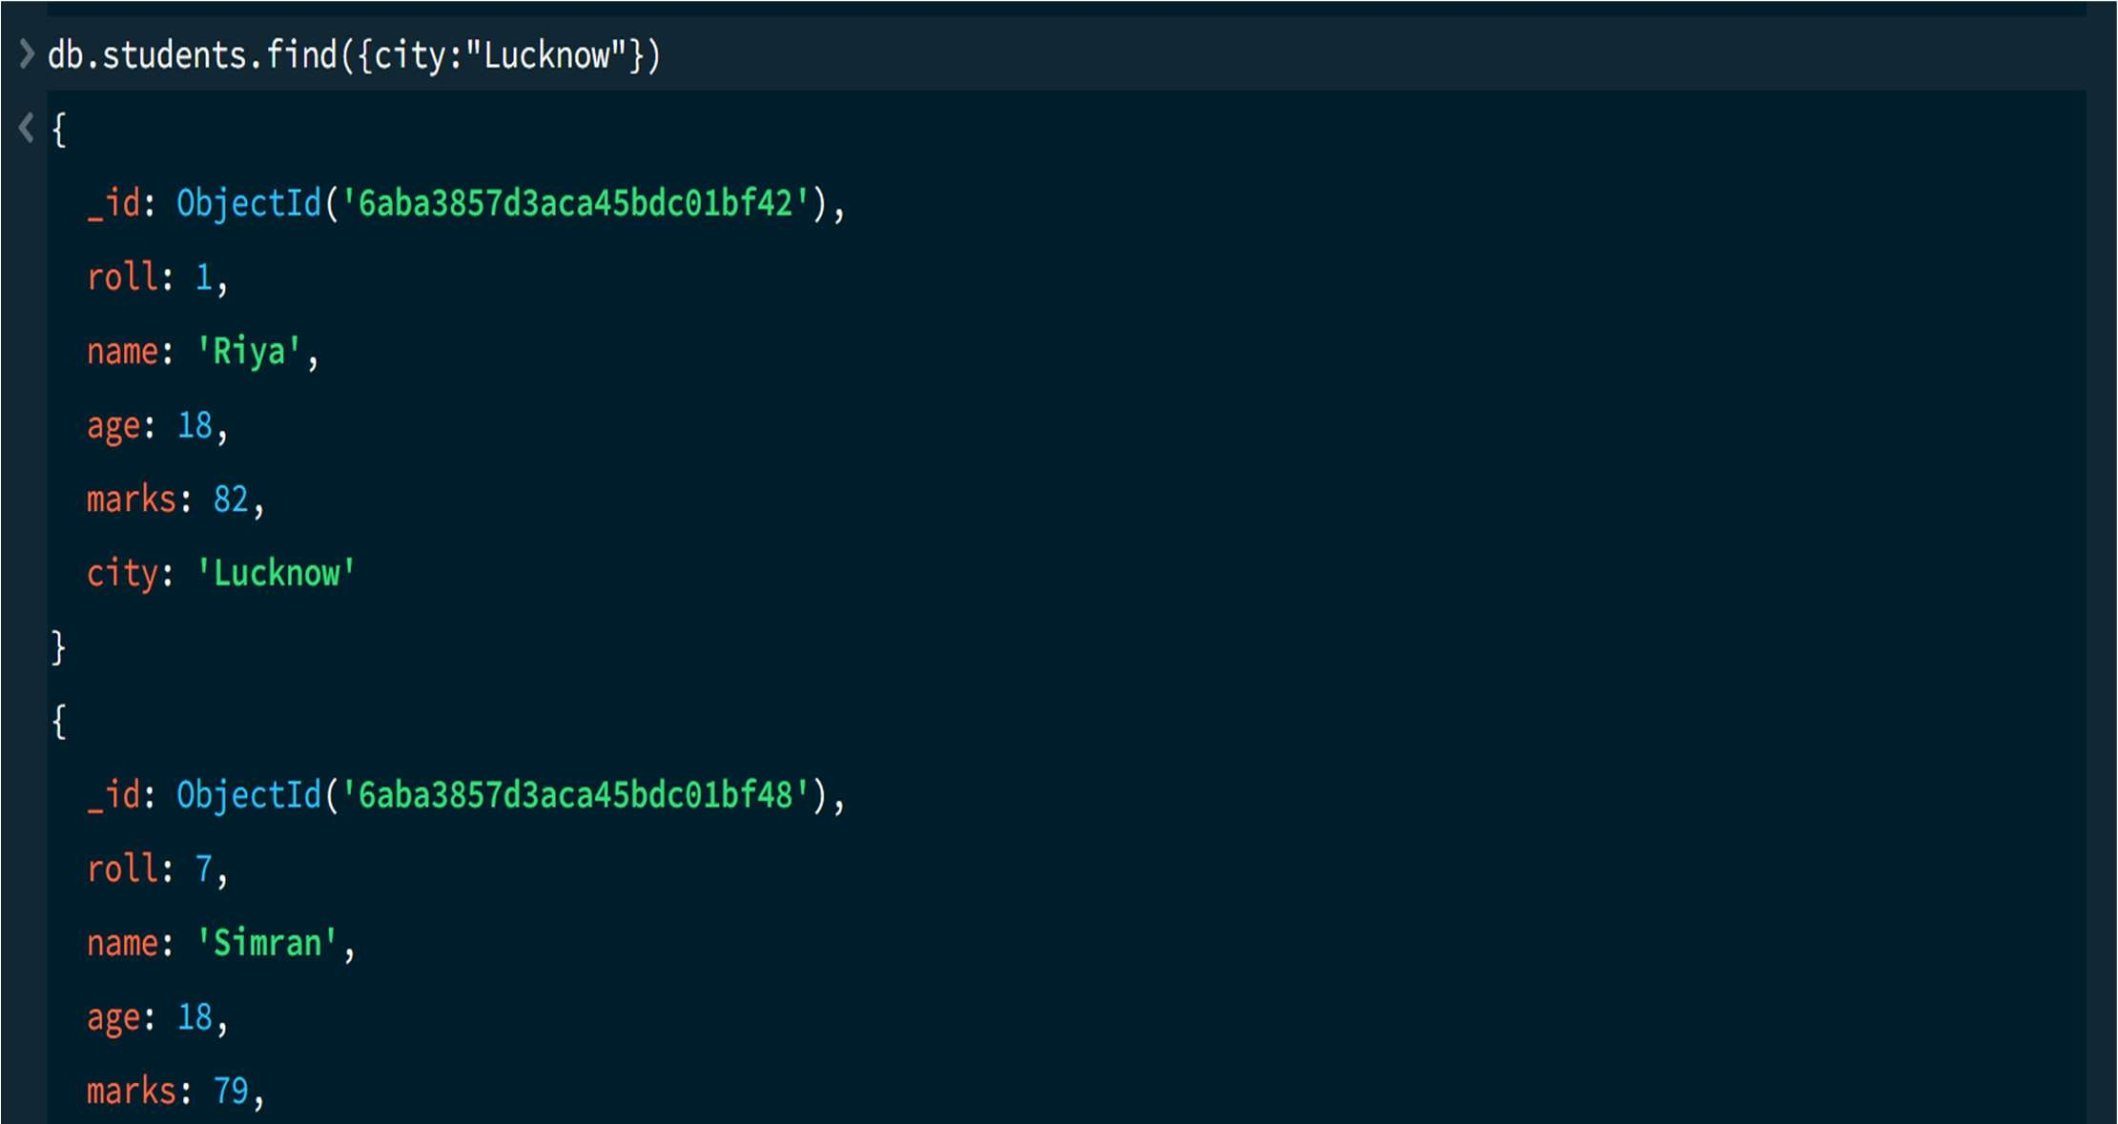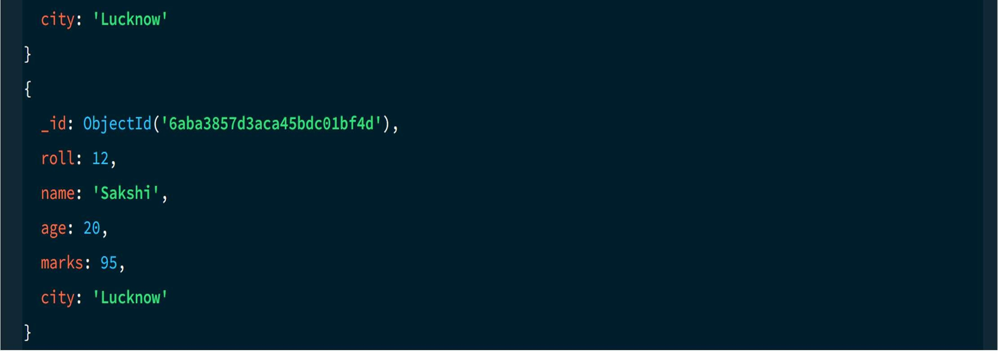

18. COUNT DOCUMENTS MongoDB Query:
db. students. count Documents ()
Explanation: Counts documents currently present in the collection (performing after the delete function).
