EDS MIGRATION — SCOPE & ANALYSIS HANDOVER
Bed Bath N' Table (Australia)
Content-layer migration assessment for Adobe Edge Delivery Services

Field | Value
Site analysed | https://www.bedbathntable.com.au/
Analysis date | 2026-08-27
URLs in sitemap | 2,860 (2,033 products · 531 categories · 60 CMS · 253 pages) — representative 77-page sample analysed
Locale | en (Australia)
Functional templates | 7
Block variants | 102 (all screenshotted)
Platform detected | Adobe Commerce (Magento 2) + PageBuilder, Fastly CDN, AB Tasty
1. Executive Summary
Bed Bath N' Table Australia is the brand's flagship Adobe Commerce (Magento 2) storefront on Fastly CDN, with 2,860 URLs in categorized sitemaps. All were recorded for counts; a representative 77-page sample was analysed (100% success) covering every template type.
- 2,860 sitemap URLs: 2,033 products, 531 categories, 60 CMS, 253 pages (incl. ~170 store-locator).
- 7 functional page templates — including a dedicated store-locator template not present on the SG site.
- 102 reusable block variants catalogued (22 form, 19 carousel, 15 columns, 12 hero) — all screenshotted.
- AB Tasty experimentation + Google Maps + richer payments (Afterpay/PayPal/Zip/Apple Pay/Google Pay) are AU-specific.
- Homepage loads Adobe Edge Delivery RUM (rum.hlx.page) — an EDS measurement pilot appears to be in place.

Key insight: Migration economics are inverted from a content site — the huge PDP volume (2,033) plus ~170 uniform store-locator pages are the EASY, data-driven bulk-automated part. Effort concentrates in merchandised home/campaign pages, PLP facet configuration, commerce integrations (5 payment methods), and the AB Tasty experimentation layer. Estimates assume the Adobe Commerce backend is retained for transactions.
2. Templates Inventory
# | Template | Complexity | Reasoning | Reference URL
1 | product-detail (PDP) | High | Gallery + zoom, title/brand, price w/ strike-through + stock, variant selector, feature icons, cross-sell, size-guide accordion. | /dalia-glass-vase-round-26133001
2 | product-listing (PLP) | High | Faceted filters (Category/Size/Price/Colour), grid w/ badges + swatches, sort, Load More. | /bed/bed-linen/pillowcases
3 | category-landing | Medium | Hero + subcategory tile grid + "Shop By Collection". | /bed, /table, /outdoor
4 | homepage | High | Merchandised PageBuilder: promo heroes, tiles, campaign banners, carousels. | /
5 | store-locator | Medium | Store detail: address, Get Directions, phone, opening hours, map, "Search Other Stores". | /locator/bed-bath-n-table-ballarat
6 | blog / content | Medium | Blog index + long-form articles (hero, image+text, product callouts, share). | /blog, /blog/mulberry-silk
7 | CMS / static & guides | Low–Med | Delivery/returns, about, policies, size guides, competitions, how-to guides. | /delivery-returns, /bath-size-guide
Template screenshots
homepage
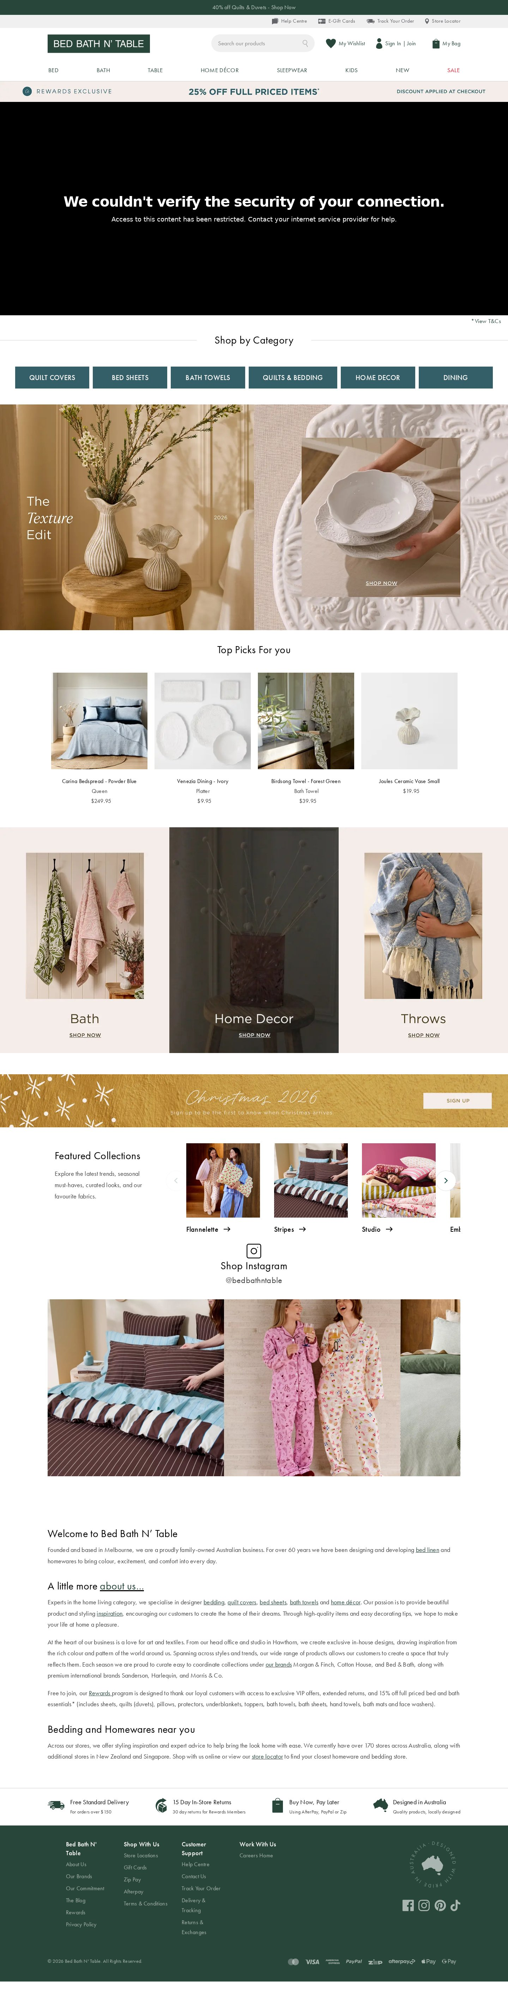
Template: homepage — representative page
category-landing
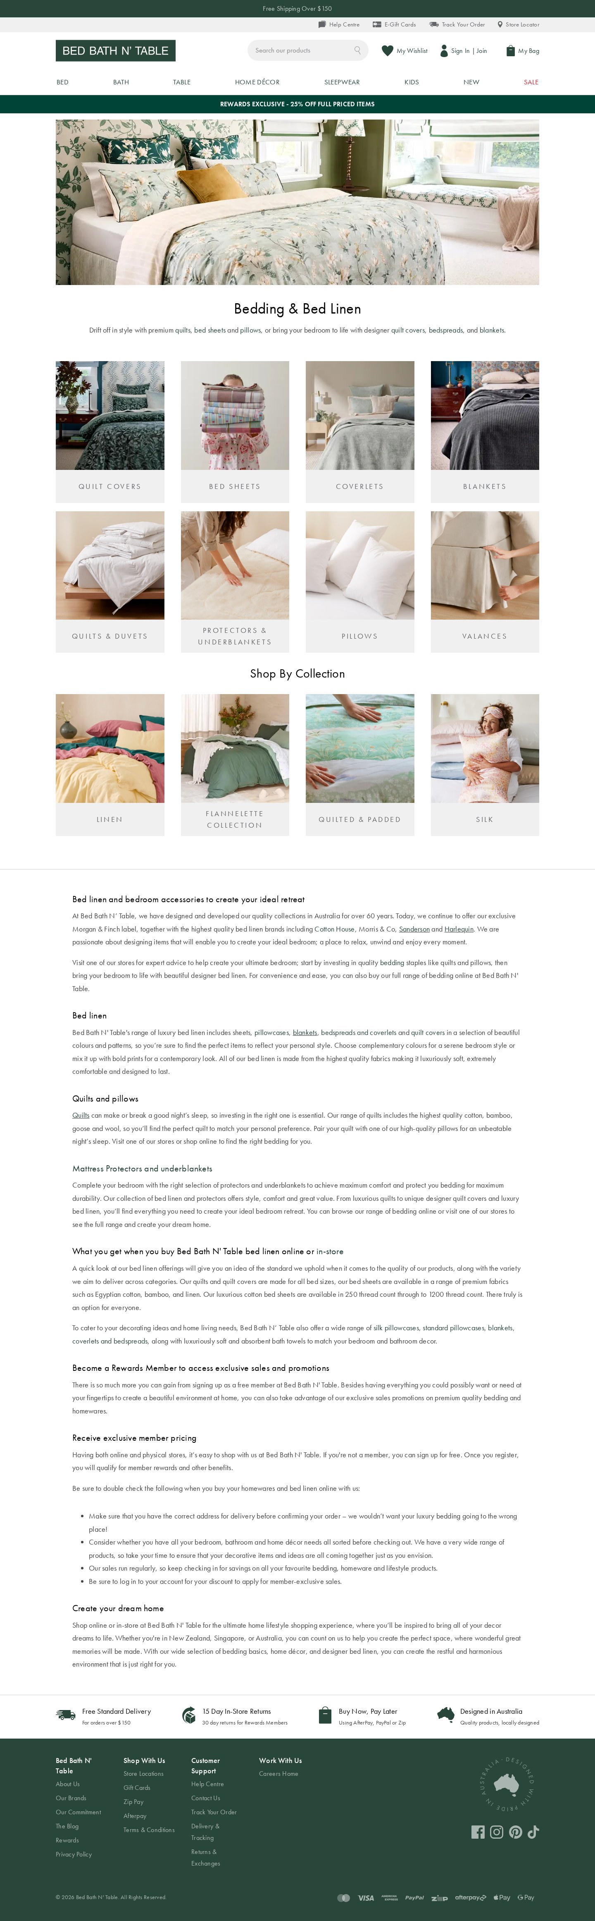
Template: category-landing — representative page
product-detail (PDP)
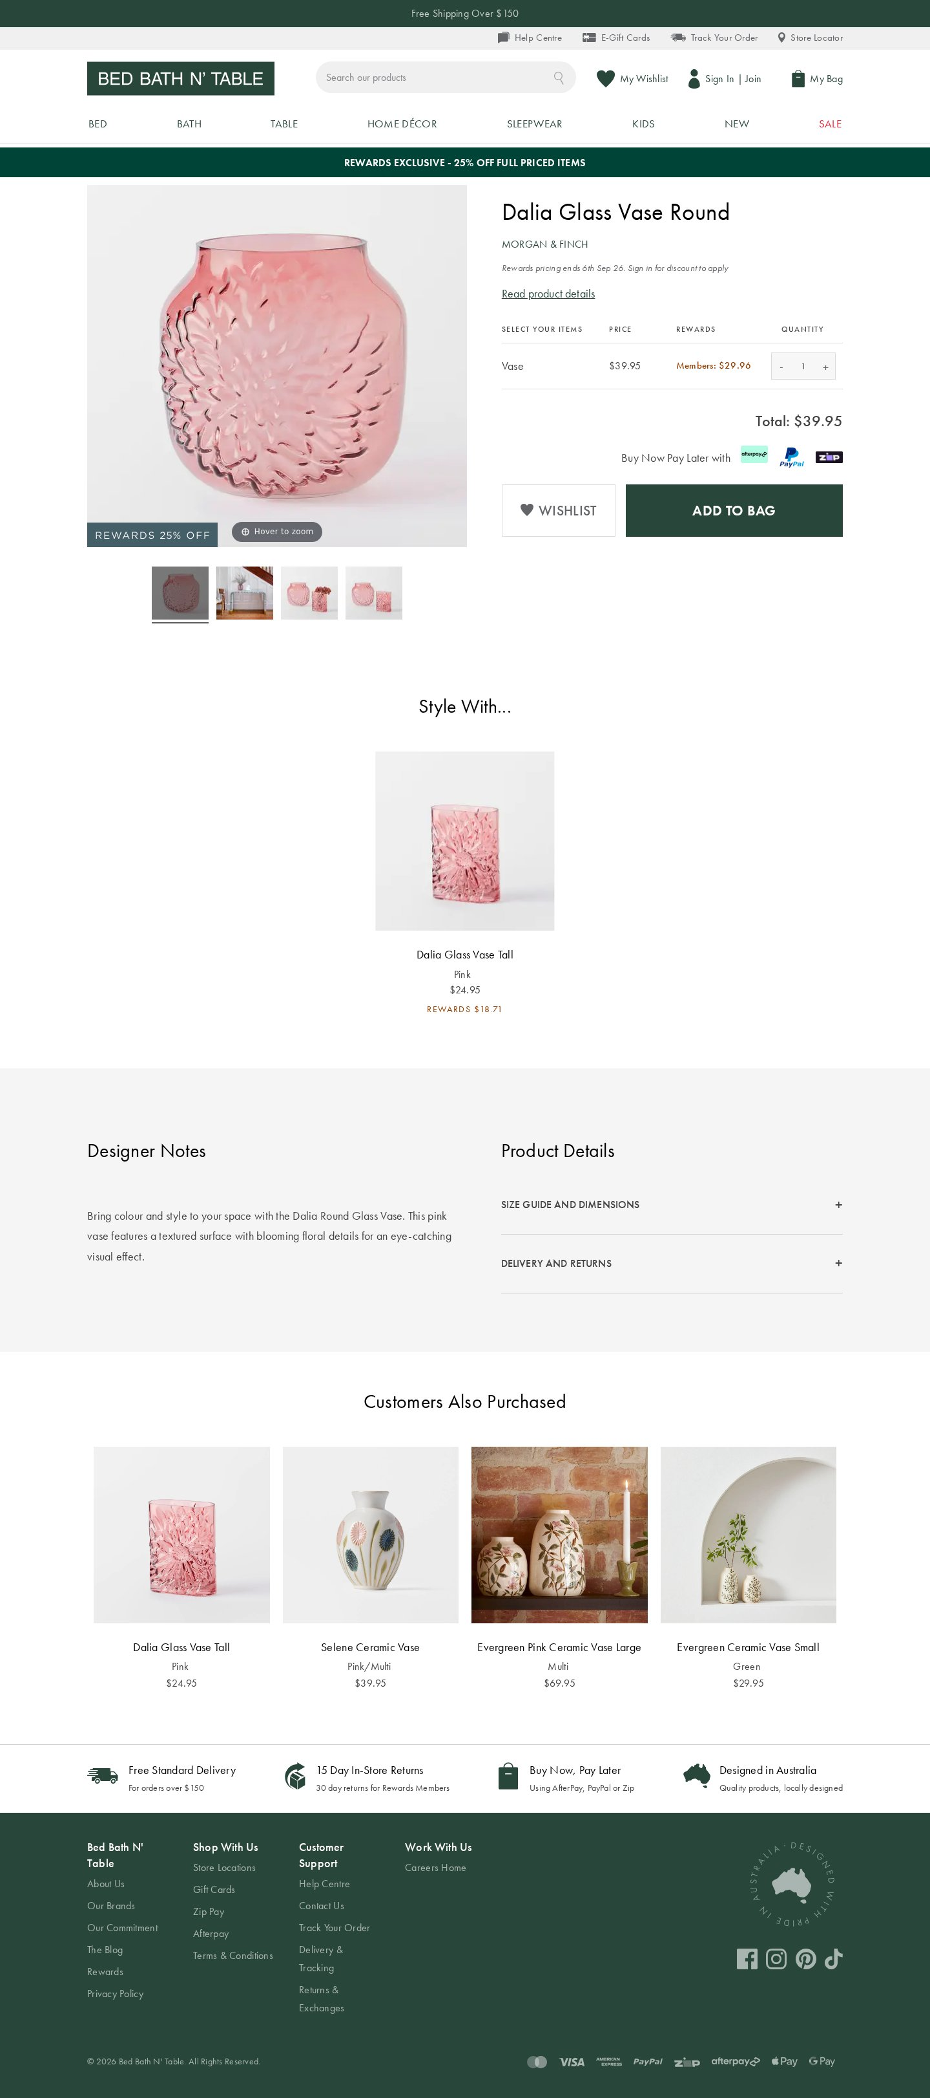
Template: product-detail (PDP) — representative page
product-listing (PLP)
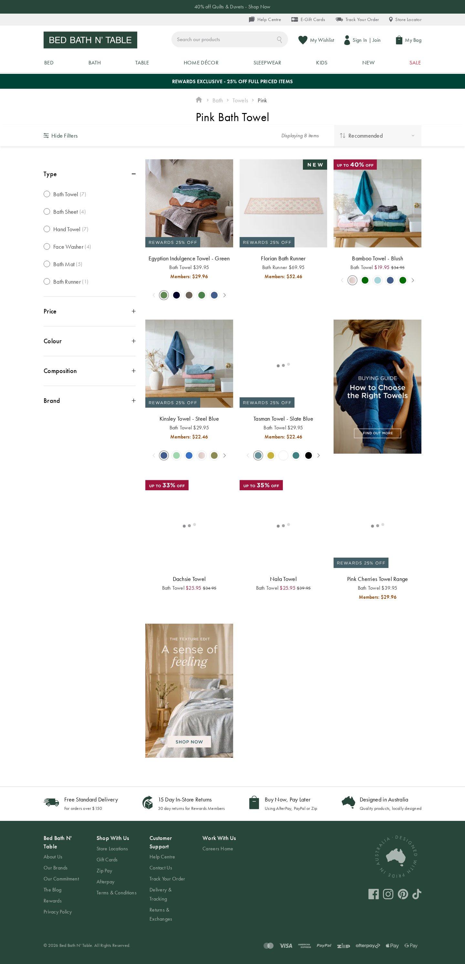
Template: product-listing (PLP) — representative page
store-locator
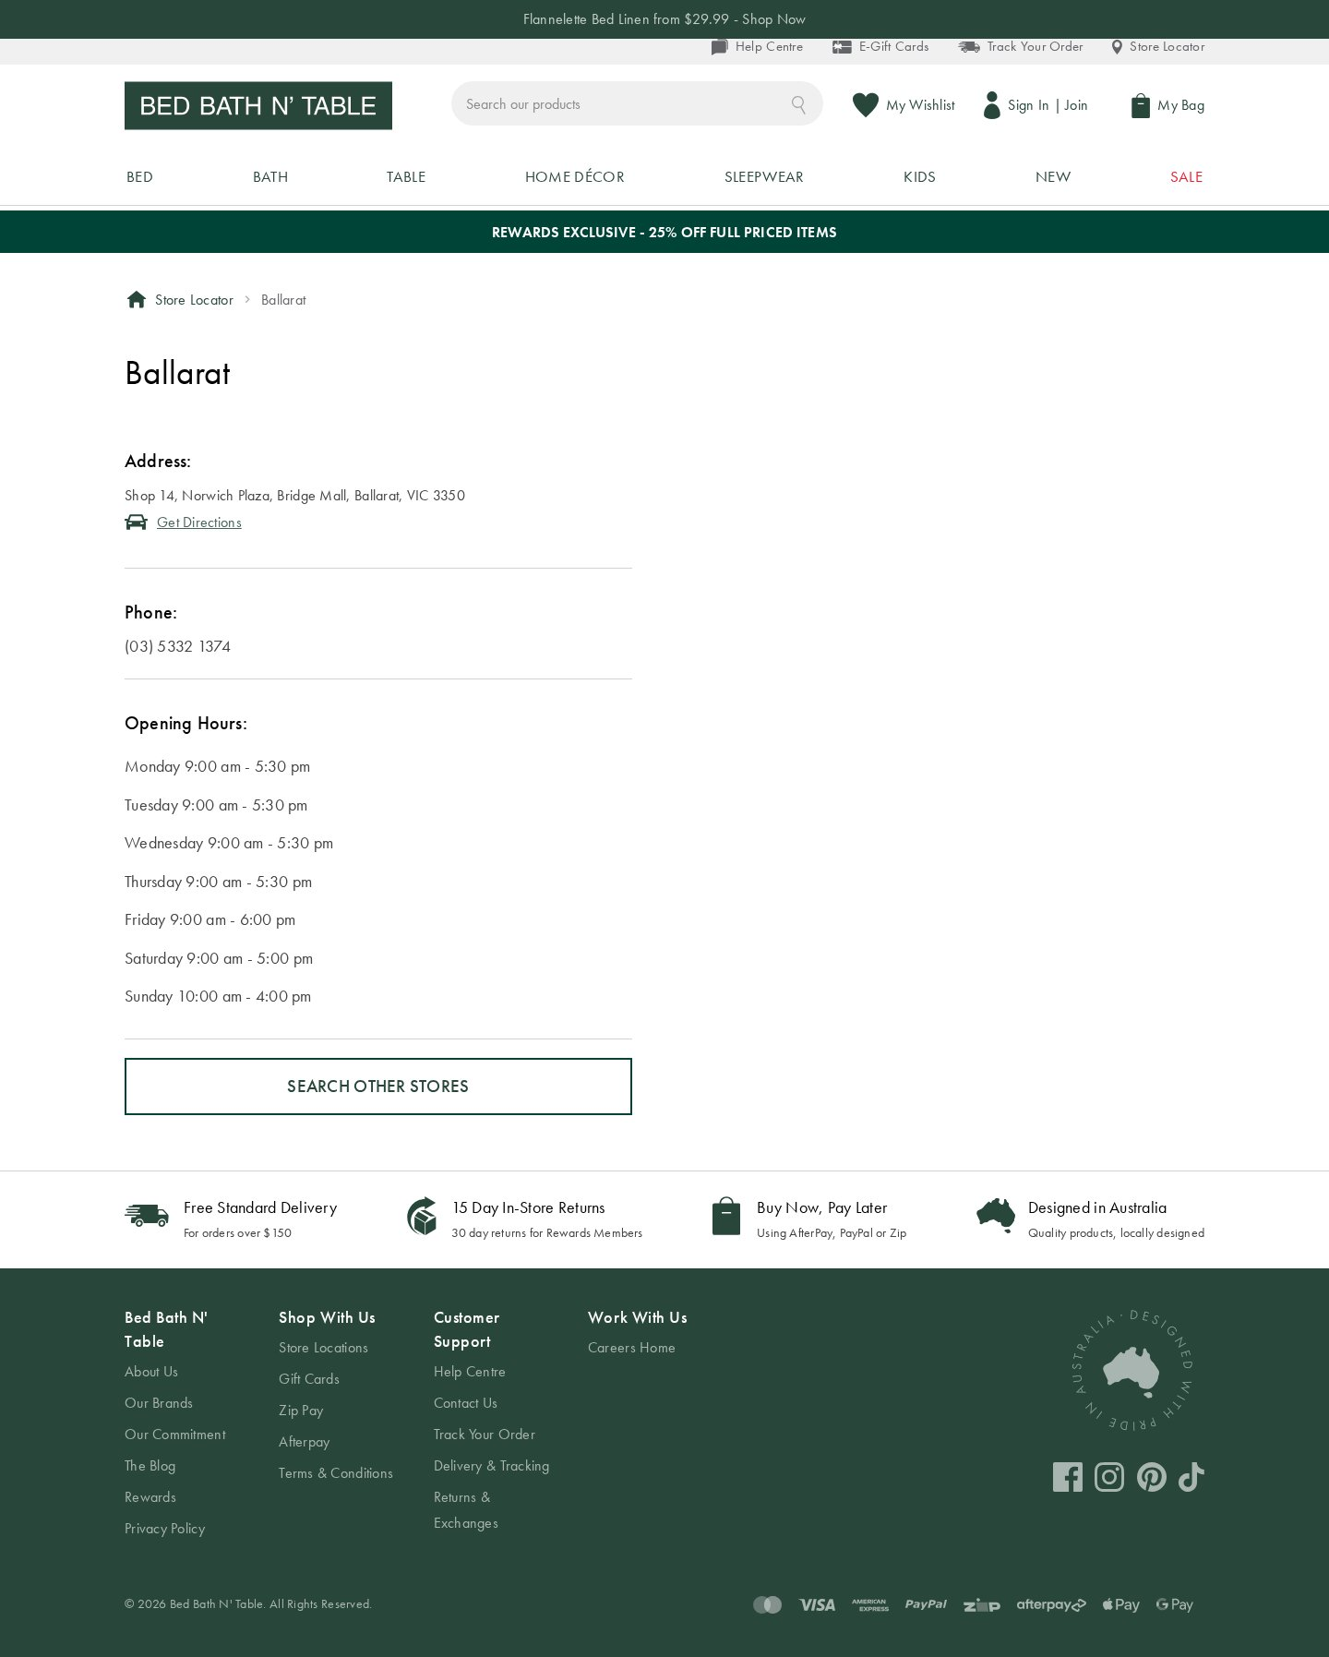
Template: store-locator — representative page
blog / content
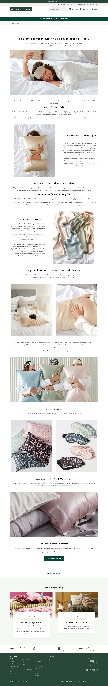
Template: blog / content — representative page
CMS / static
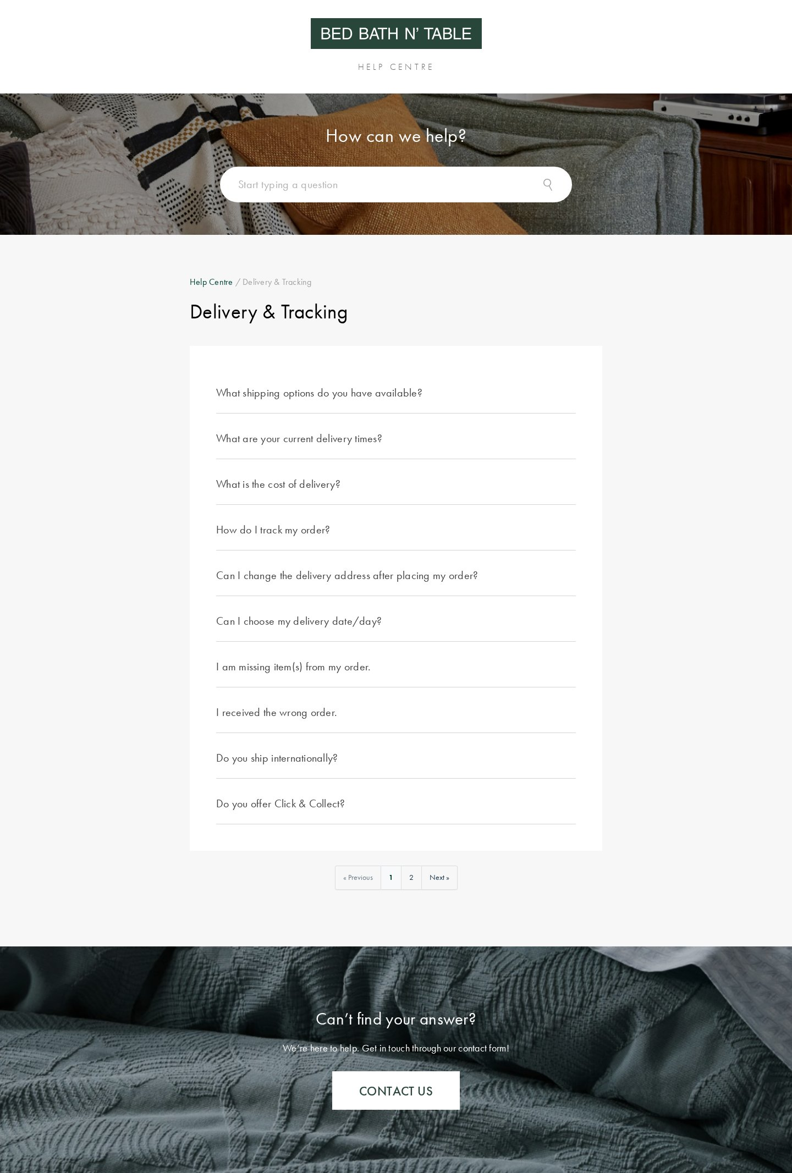
Template: CMS / static — representative page
3. Blocks / Components Catalog
102 block variants catalogued and consolidated by content model. E-commerce sites are block-rich; the standouts are 22 form, 20 custom, 19 carousel, 15 columns and 12 hero variants.
Block (base) | Variants | Complexity | Behaviour / Functionality | Reference URL
header (global) | 1 | High | Utility bar (Help/E-Gift/Track/Locator), logo, search, Wishlist, Sign In/Join, My Bag, mega-nav. | all pages
footer (global) | 1 | Medium | 4-column nav, social, payment logos, "Designed in Australia". | all pages
form | 22 | High | Search, newsletter, login/account, add-to-cart, filters, contact, store search, competitions; reCAPTCHA. | site-wide
carousel | 19 | Medium | Product/image/hero carousels, "Style With", collections. | home, PDP
columns | 15 | Low–Med | PageBuilder multi-column layout rows. | home, blog
hero | 12 | Medium | Promo/category banners; many merchandising variants. | /, /bed
table | 4 | Low | Size guides, opening hours, spec tables. | size guide, locator
cards | 2 | Medium | Product/category card grids. | /sale
video | 2 | Medium | Embedded video. | blog/campaign
embed | 2 | Medium | Google Maps, social embeds. | store locator
tabs | 1 | Medium | PDP info tabs / accordions. | PDP
search | 1 | Medium | Product search. | site-wide
custom / unknown | 20 | High | Composite PageBuilder compositions. | content pages
Block screenshots — all 102 variants
Every catalogued block variant is shown below, grouped by base block. Each caption gives the variant identifier and the number of sampled pages it appeared on.
header (1 variant)
header-global — undefined pages
footer (1 variant)
footer-global — undefined pages
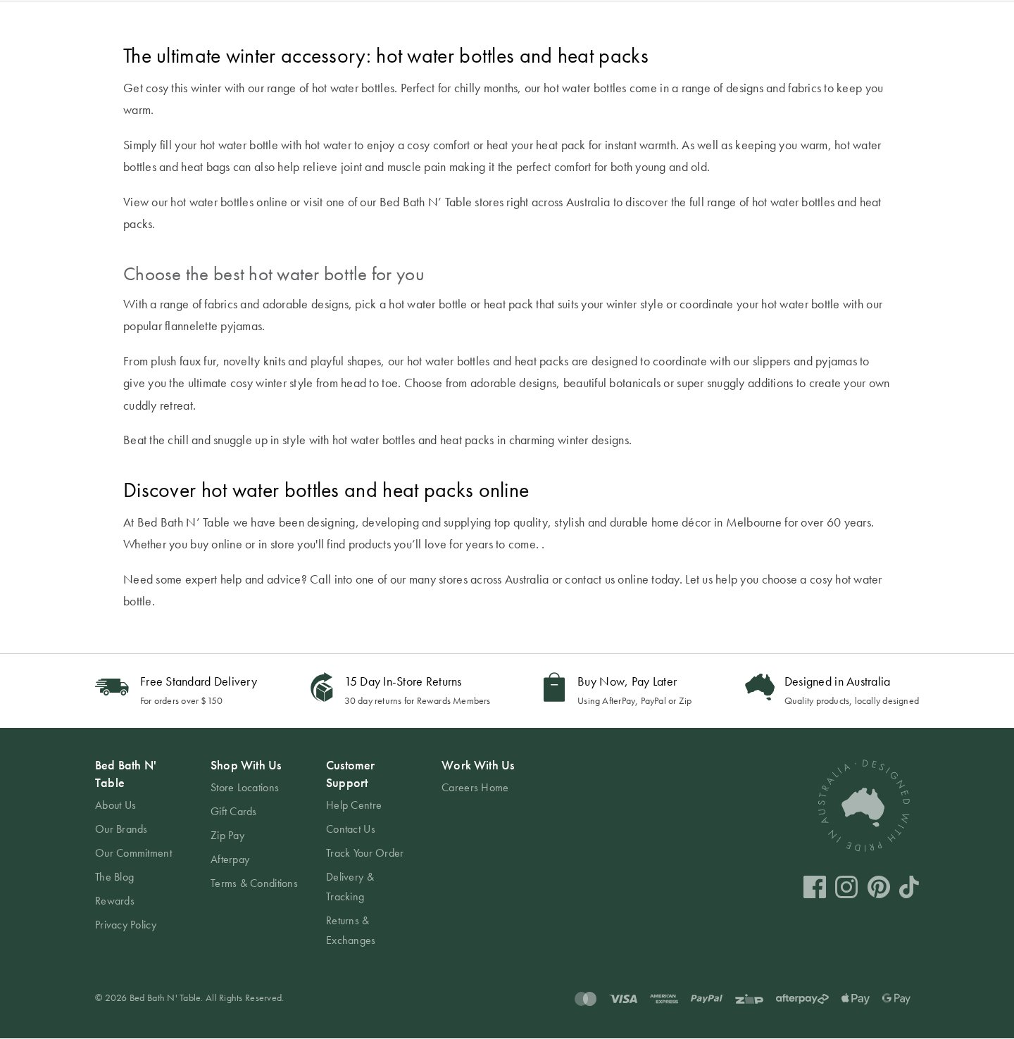
hero (12 variants)
hero-minimal-dark — undefined pages

hero-minimal-dark-withimg — undefined pages
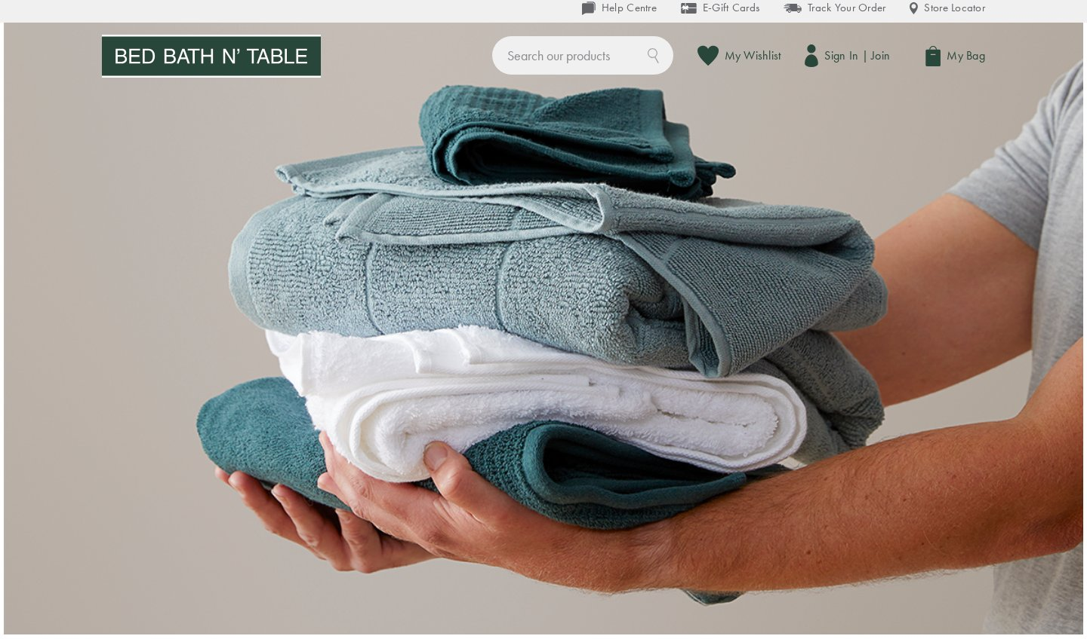
hero-minimal-dark-1 — undefined pages

hero-minimal-dark-withimg-1 — undefined pages
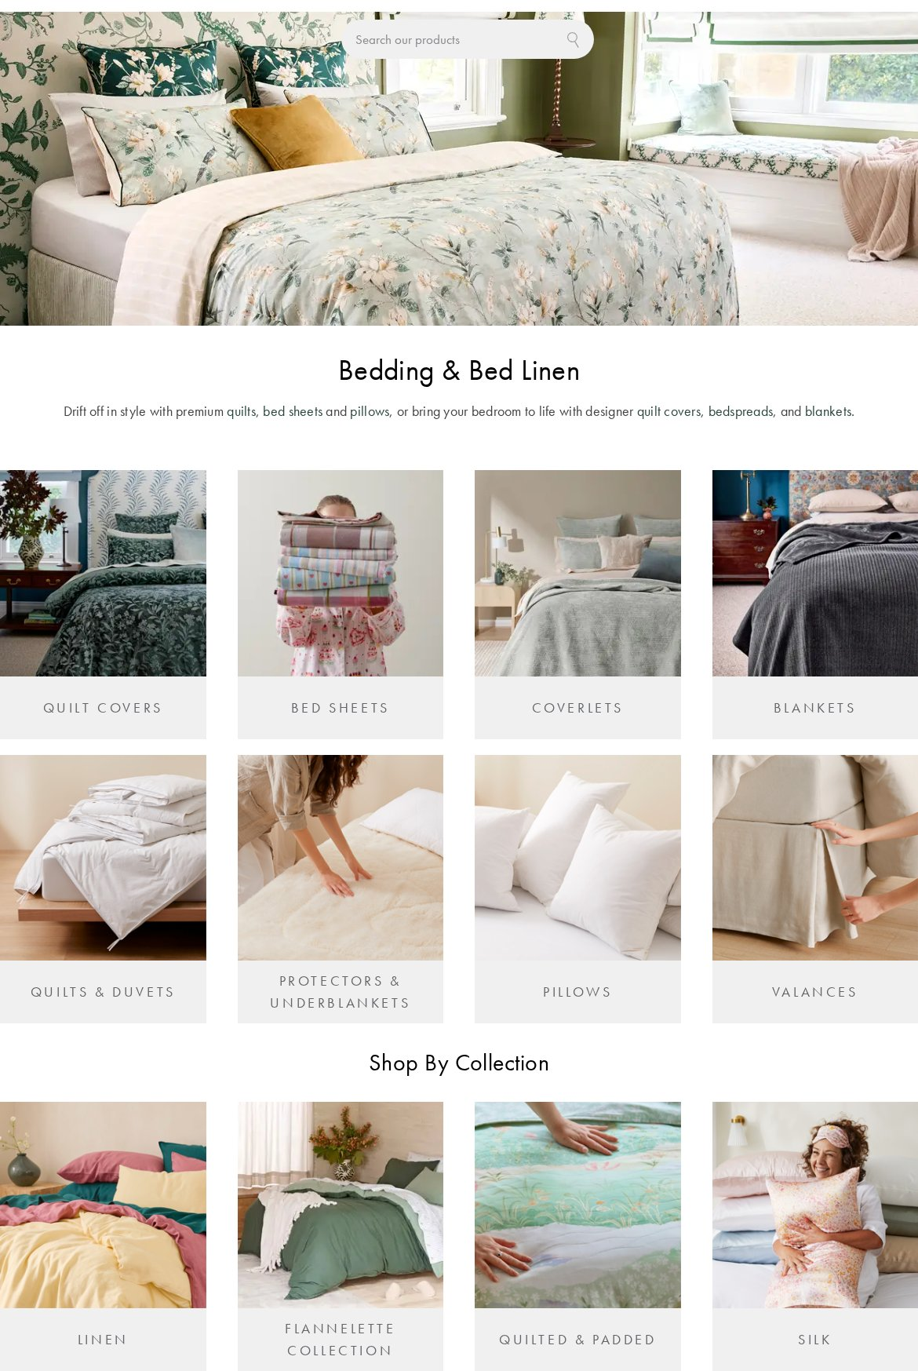
hero-minimal-dark-withimg-2 — undefined pages

hero-moderate-dark — undefined pages

hero-moderate-dark-1 — undefined pages

hero-minimal-dark-withimg-3 — undefined pages
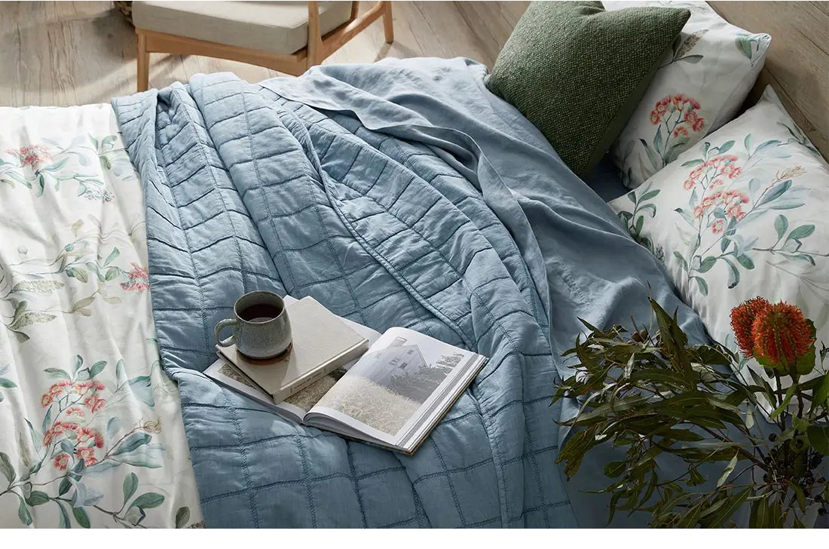
hero-minimal-dark-withimg-4 — undefined pages
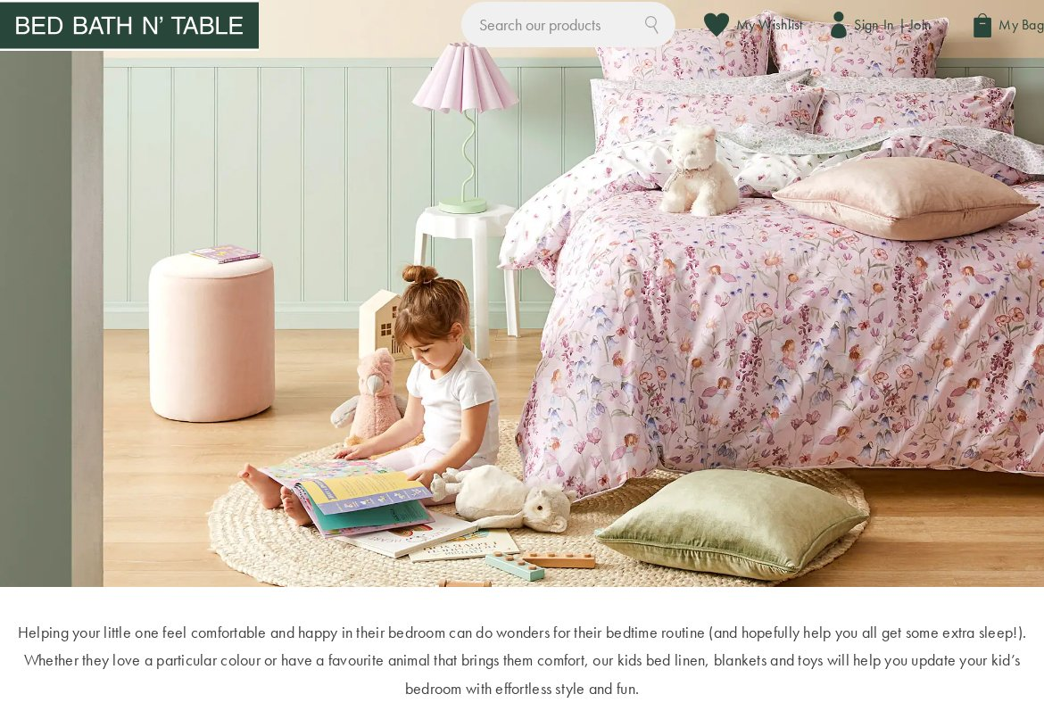
hero-minimal-dark-withimg-5 — undefined pages
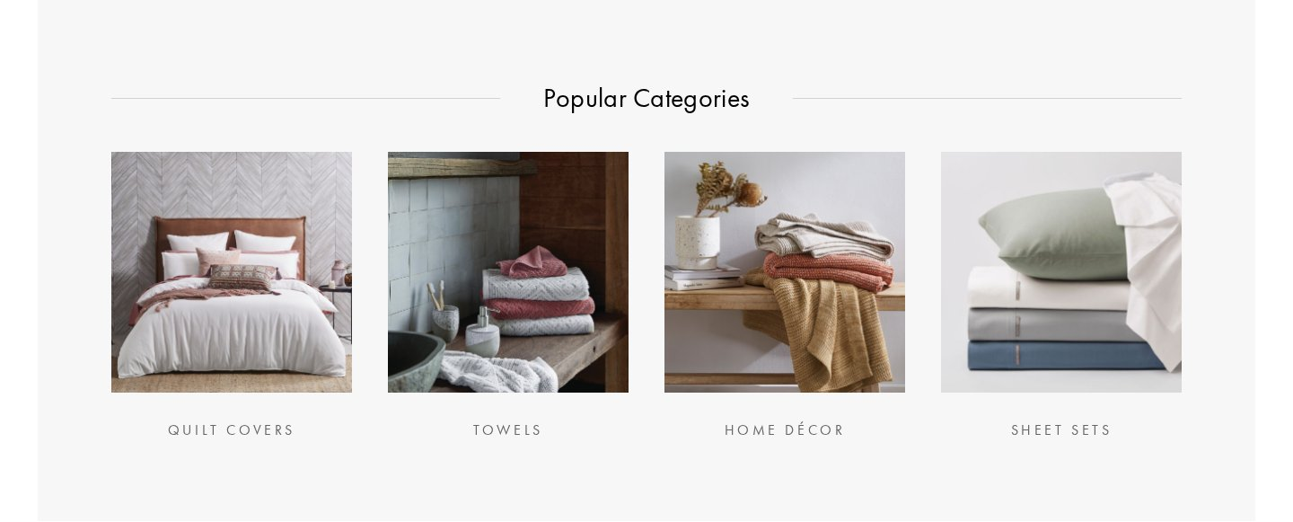
hero-minimal-dark-2 — undefined pages
hero-minimal-dark-3 — undefined pages
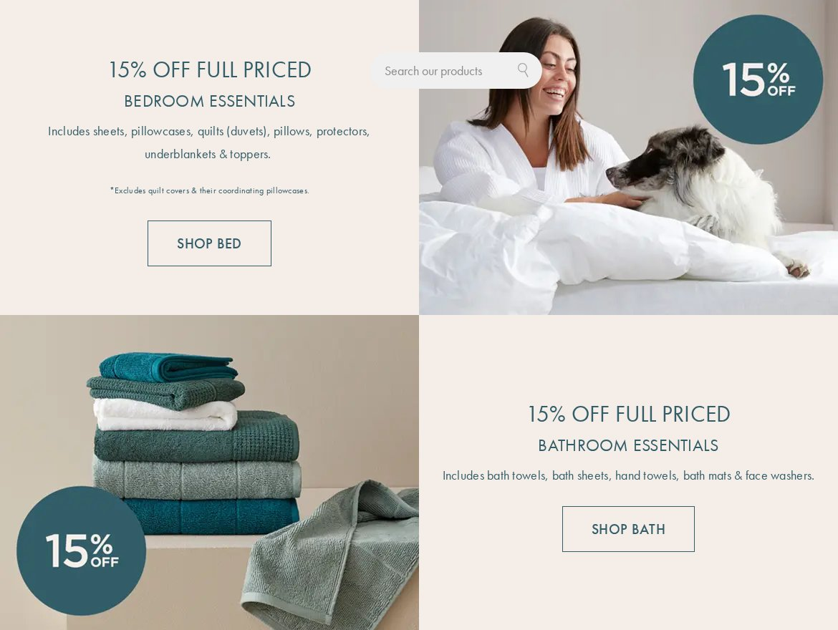
cards (2 variants)
cards-moderate-dark — undefined pages
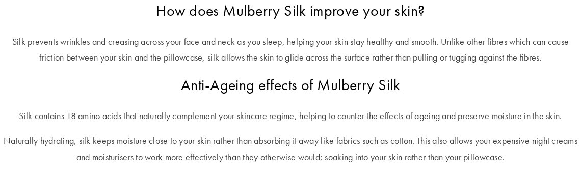
cards-moderate-light — undefined pages
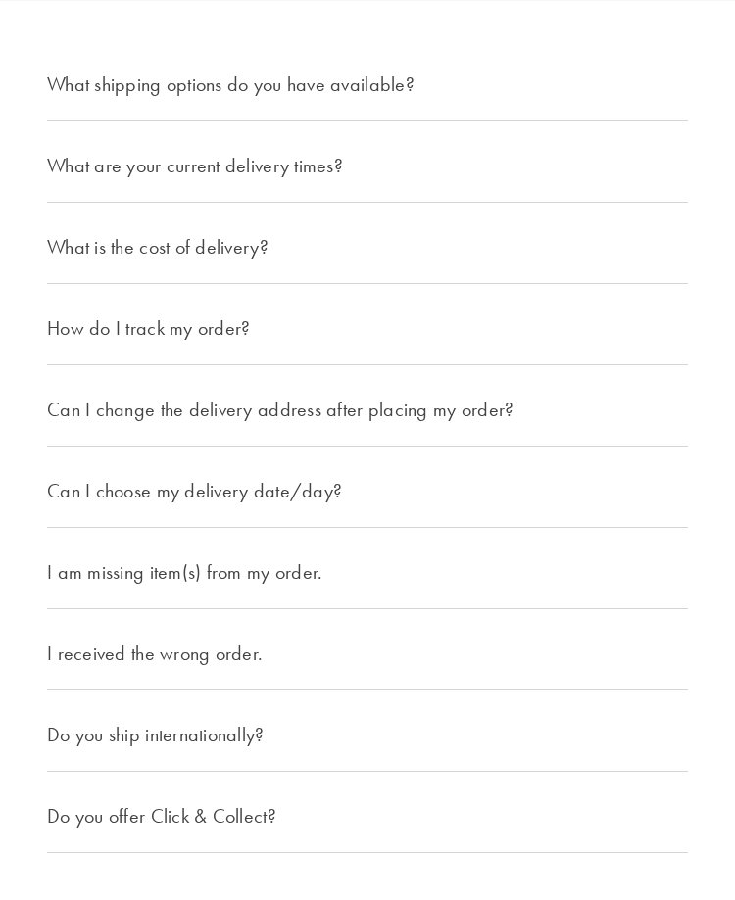
carousel (19 variants)
carousel-minimal-dark-withimg — undefined pages
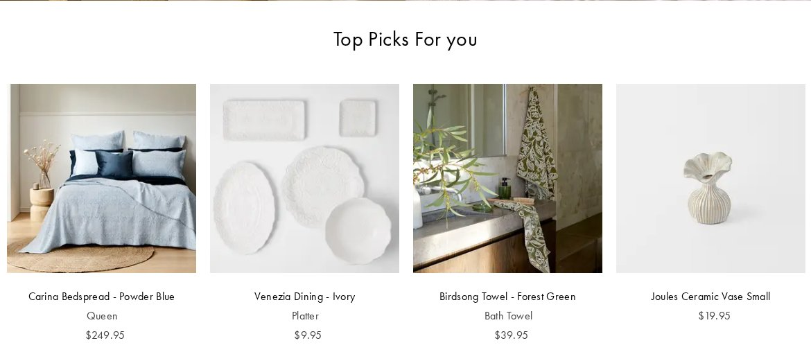
carousel-minimal-dark-withimg-1 — undefined pages

carousel-moderate-dark — undefined pages

carousel-minimal-dark-withimg-2 — undefined pages
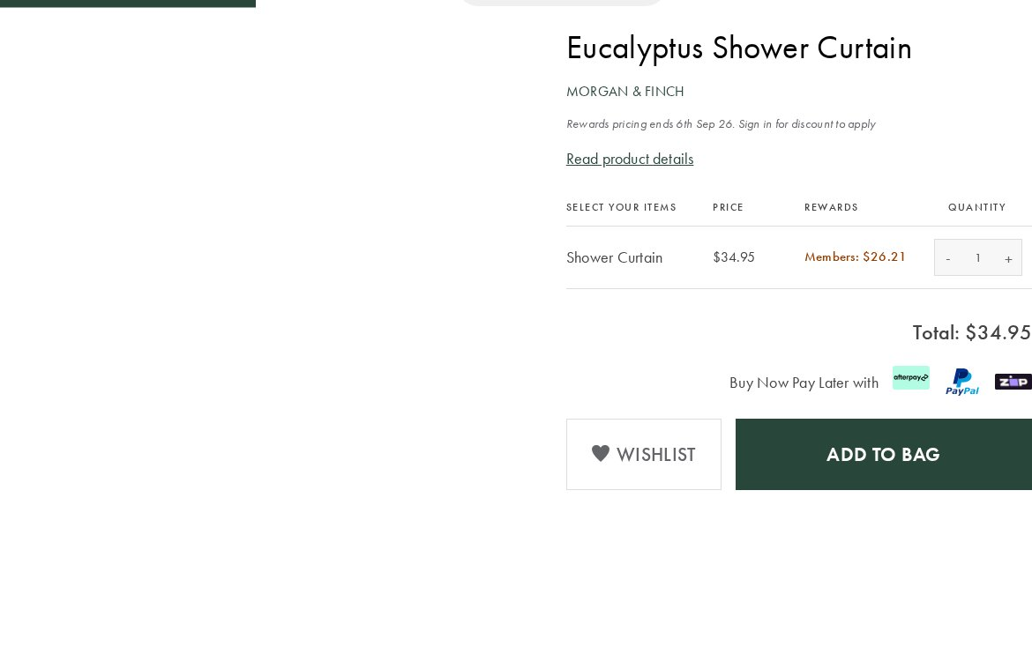
carousel-minimal-dark-withimg-3 — undefined pages
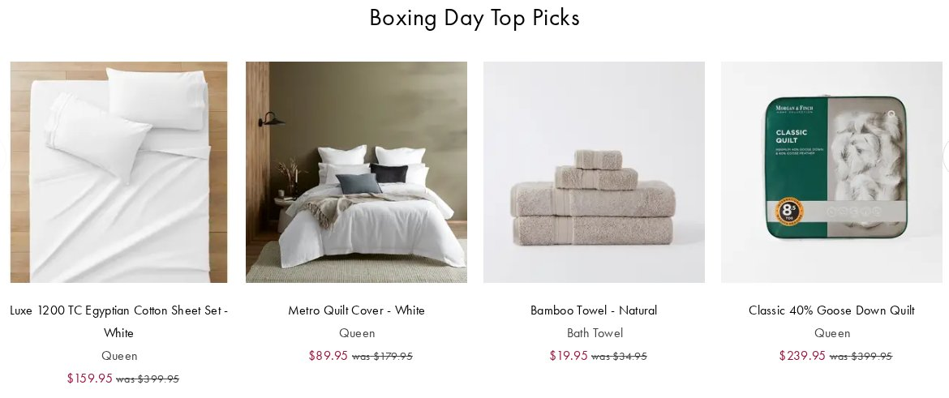
carousel-minimal-light-withimg — undefined pages
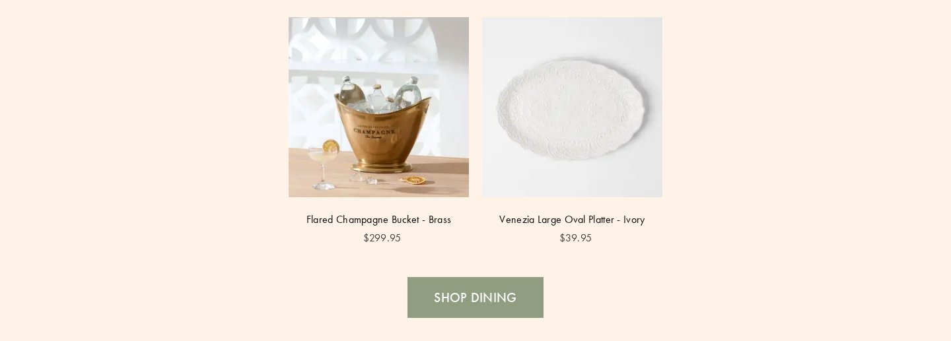
carousel-minimal-dark — undefined pages
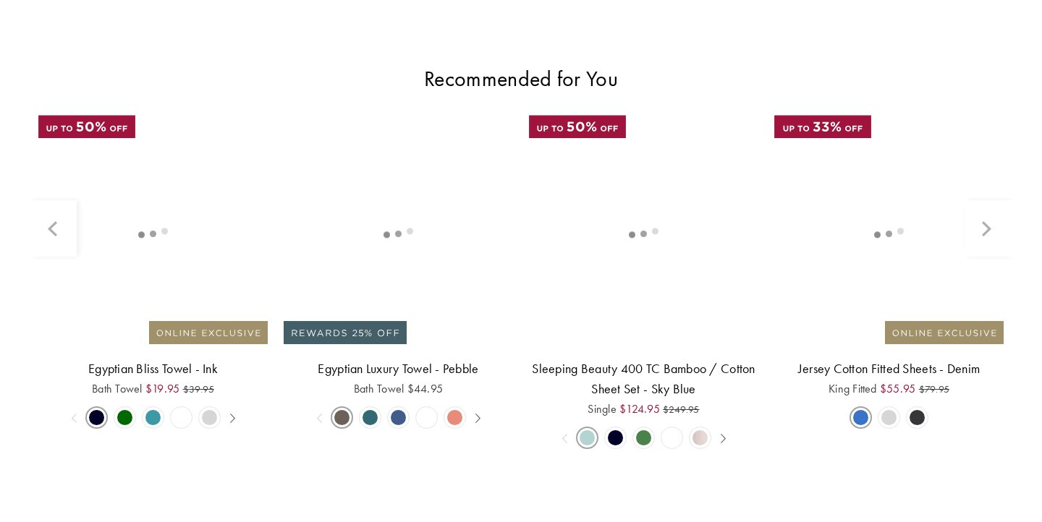
carousel-minimal-dark-withimg-4 — undefined pages
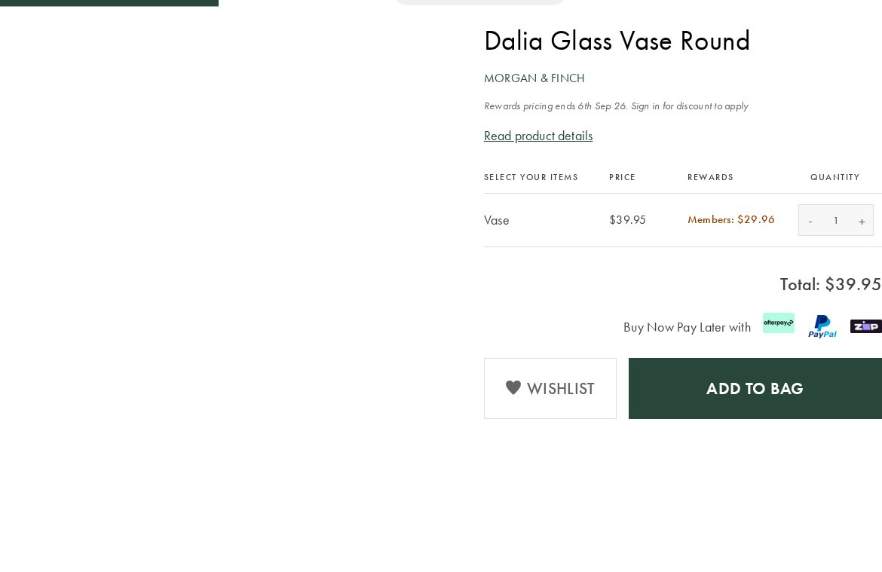
carousel-minimal-dark-withimg-5 — undefined pages
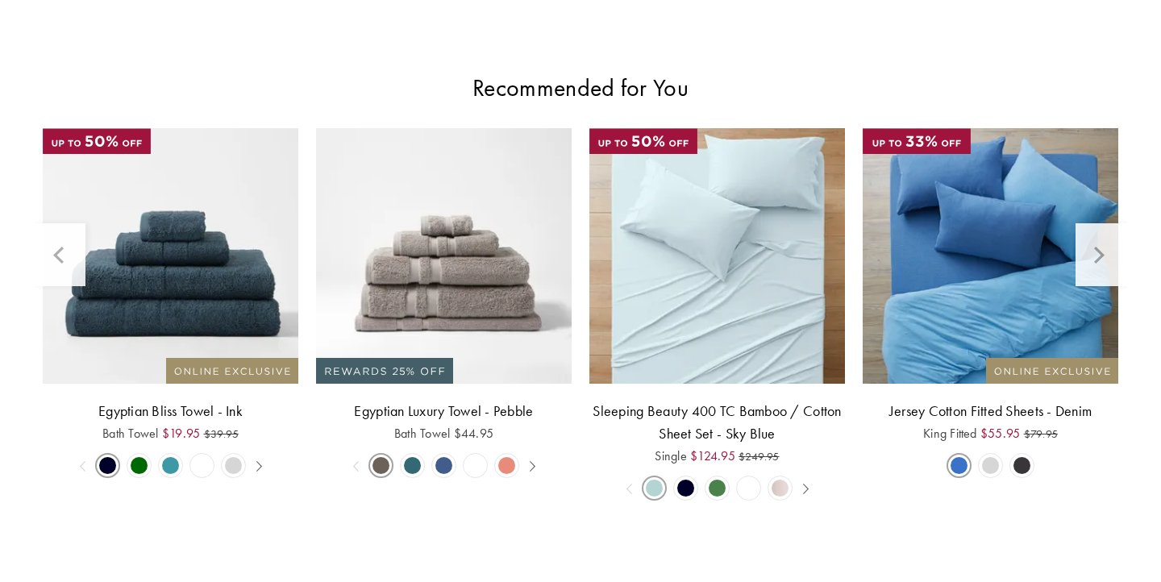
carousel-minimal-dark-withimg-6 — undefined pages

carousel-minimal-dark-1 — undefined pages

carousel-minimal-light-withimg-1 — undefined pages
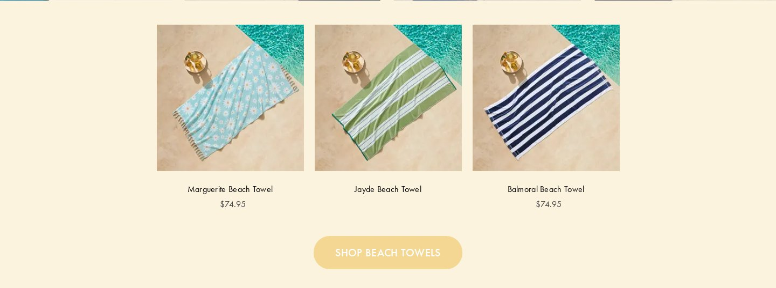
carousel-minimal-light-withimg-2 — undefined pages
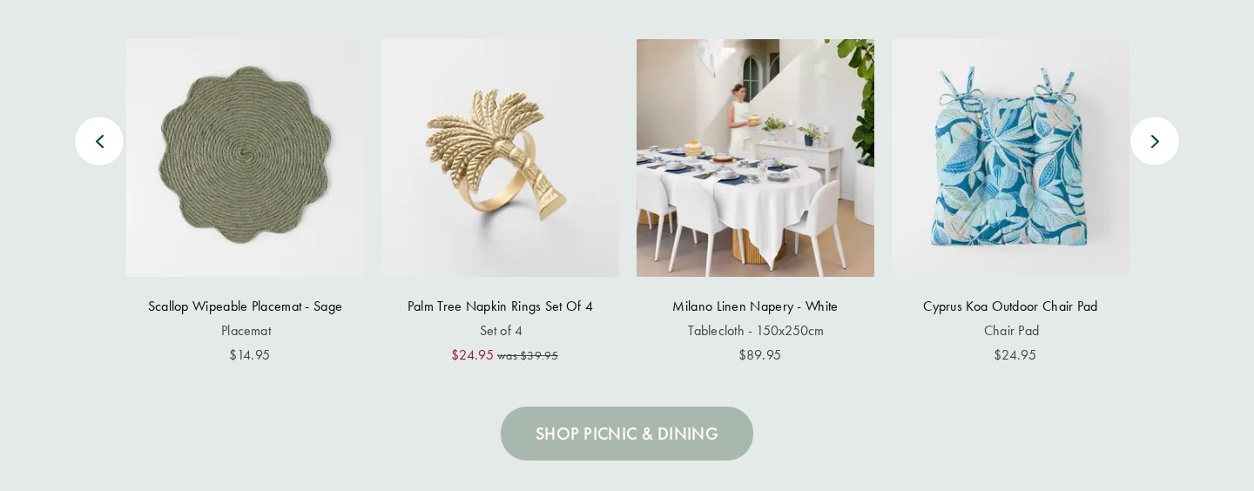
carousel-minimal-light-withimg-3 — undefined pages
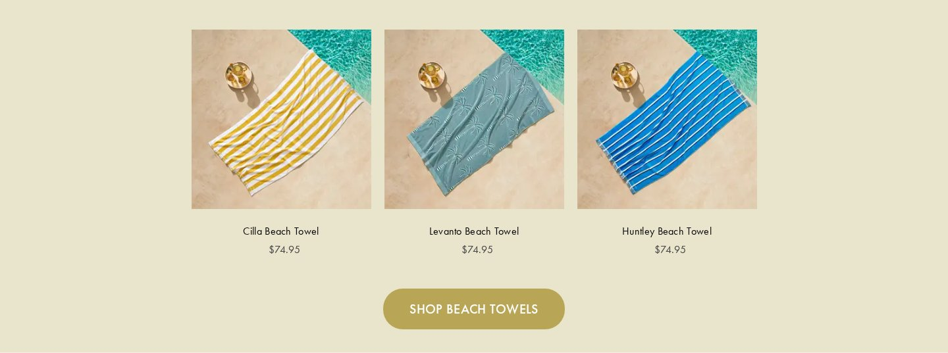
carousel-minimal-light-withimg-4 — undefined pages
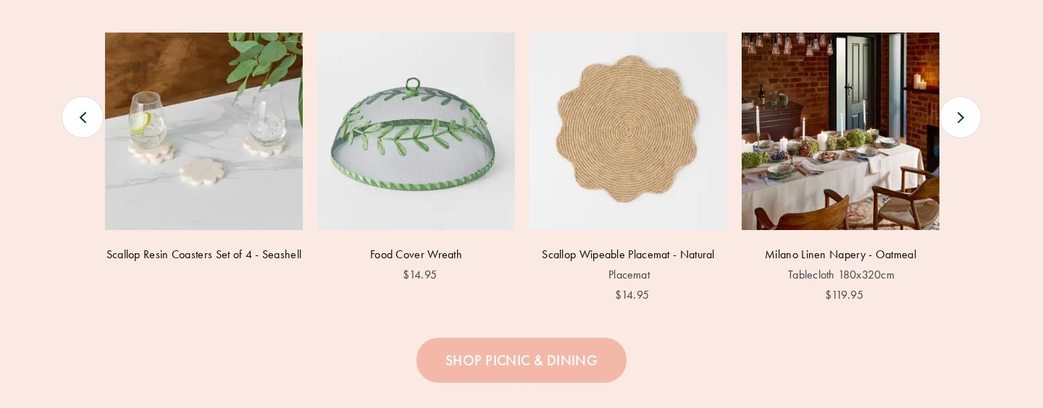
carousel-minimal-light-withimg-5 — undefined pages

carousel-minimal-light-withimg-6 — undefined pages

carousel-minimal-light-withimg-7 — undefined pages
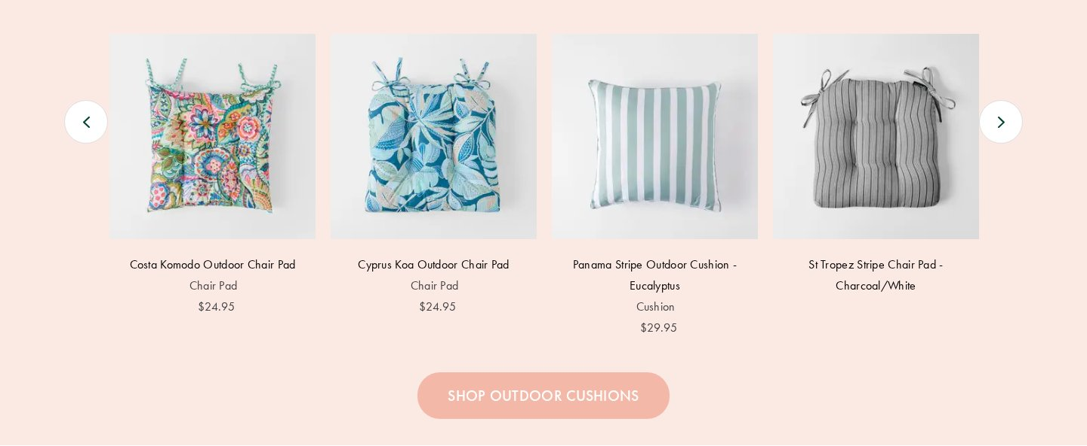
carousel-minimal-light-withimg-8 — undefined pages
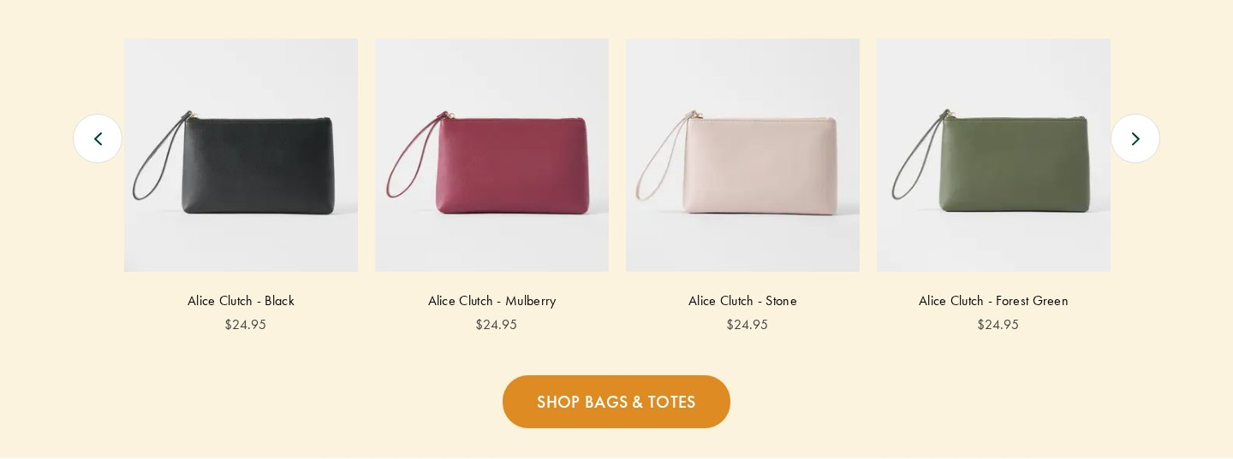
tabs (1 variant)
tabs-minimal-dark-withimg — undefined pages
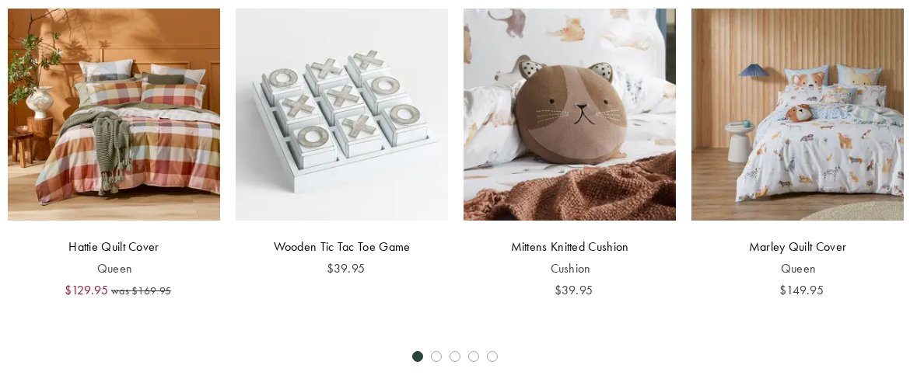
columns (15 variants)
columns-minimal-dark — undefined pages

columns-minimal-dark-withimg — undefined pages
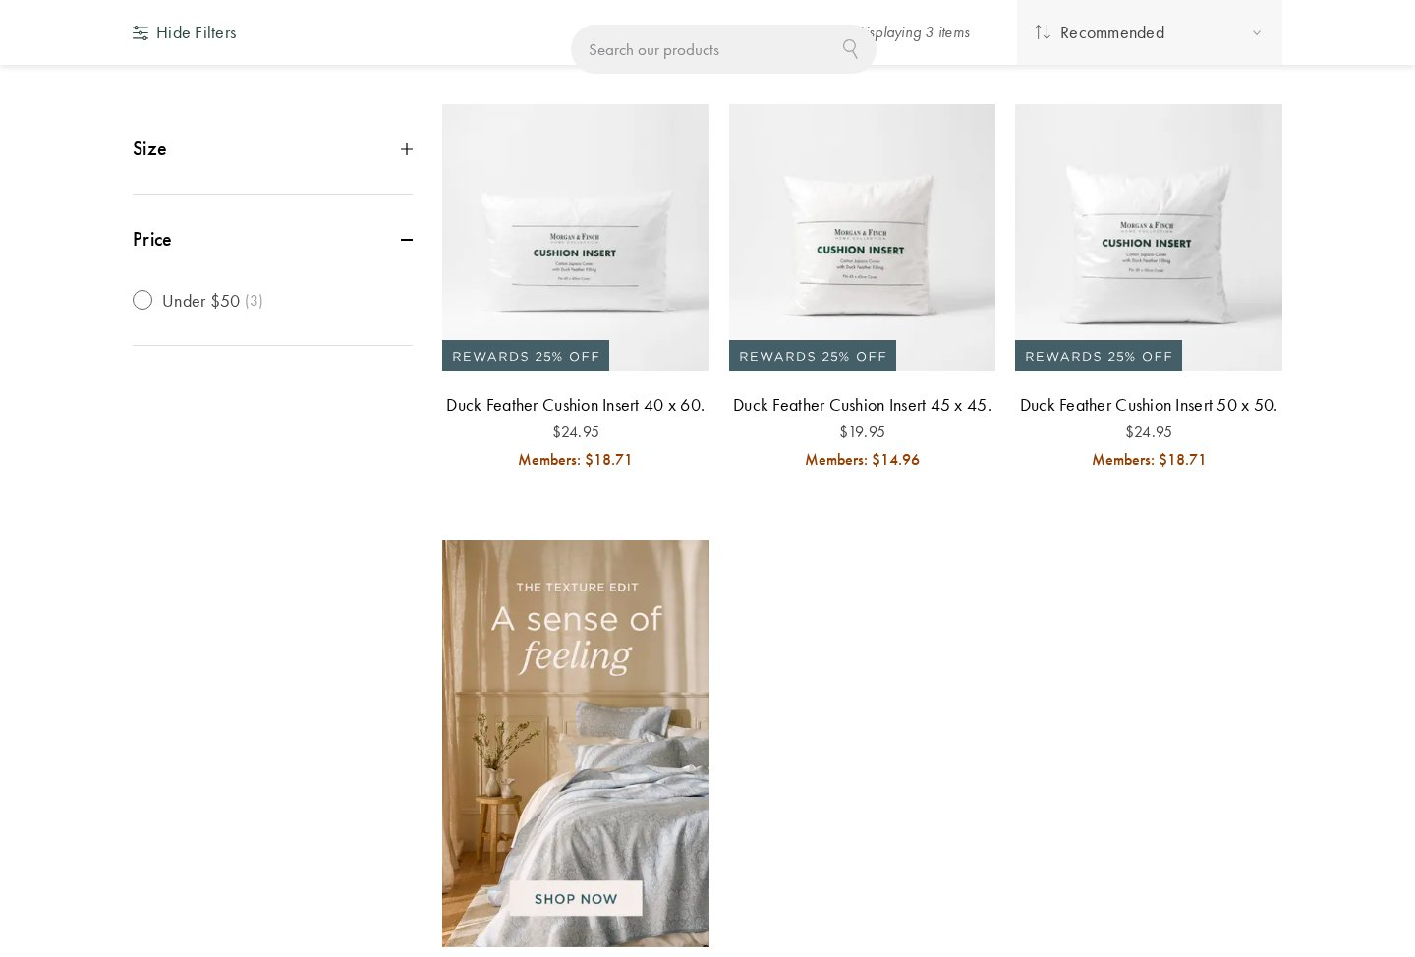
columns-minimal-dark-withimg-1 — undefined pages
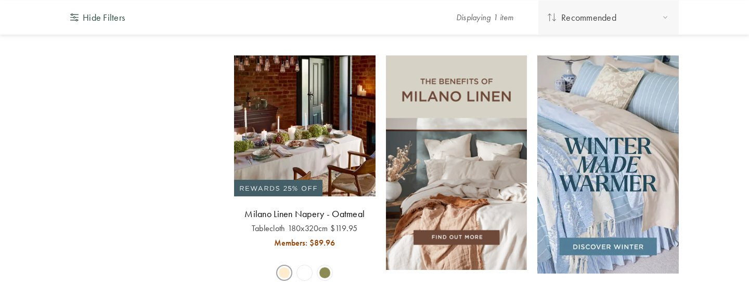
columns-moderate-dark — undefined pages
columns-minimal-dark-1 — undefined pages
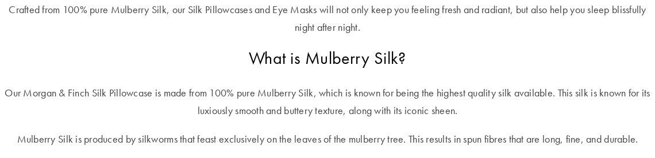
columns-minimal-dark-2 — undefined pages
columns-moderate-dark-1 — undefined pages

columns-moderate-dark-2 — undefined pages
columns-minimal-dark-withimg-2 — undefined pages
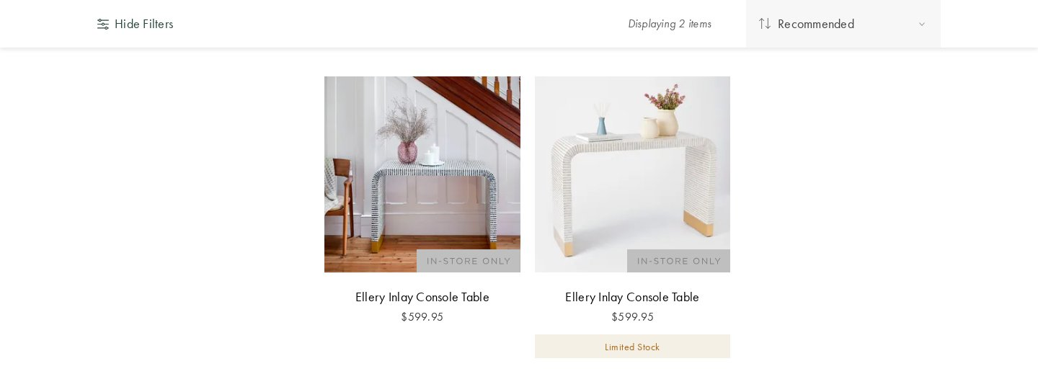
columns-minimal-light-withimg — undefined pages
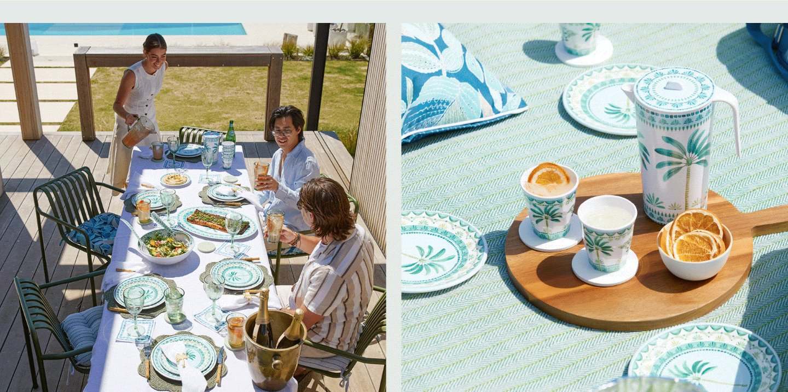
columns-minimal-light-withimg-1 — undefined pages
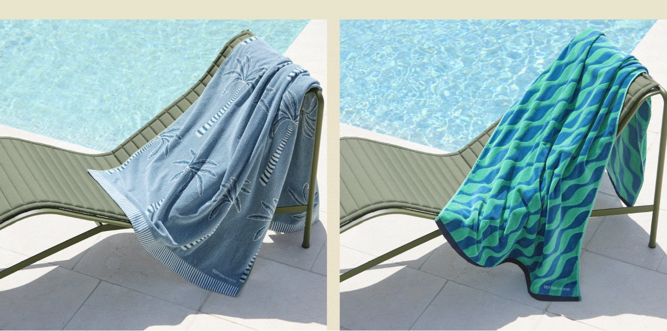
columns-moderate-light-withimg — undefined pages
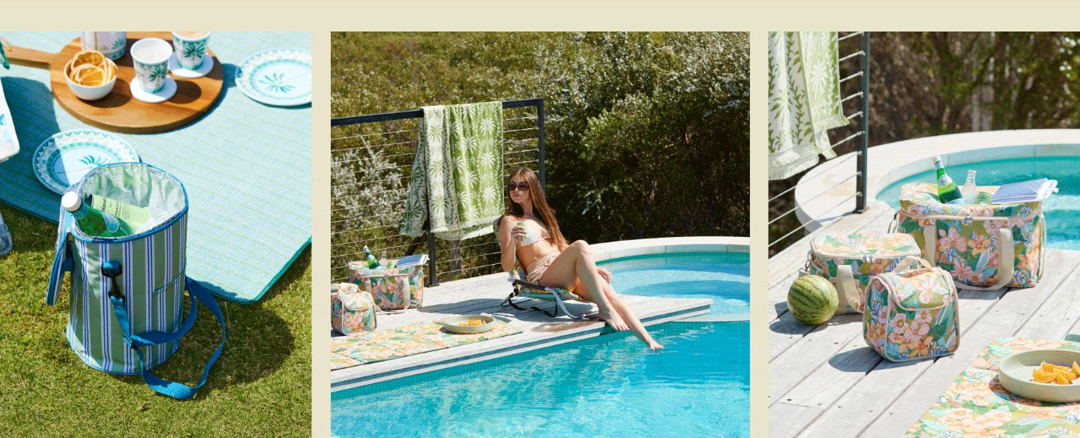
columns-minimal-dark-withimg-3 — undefined pages
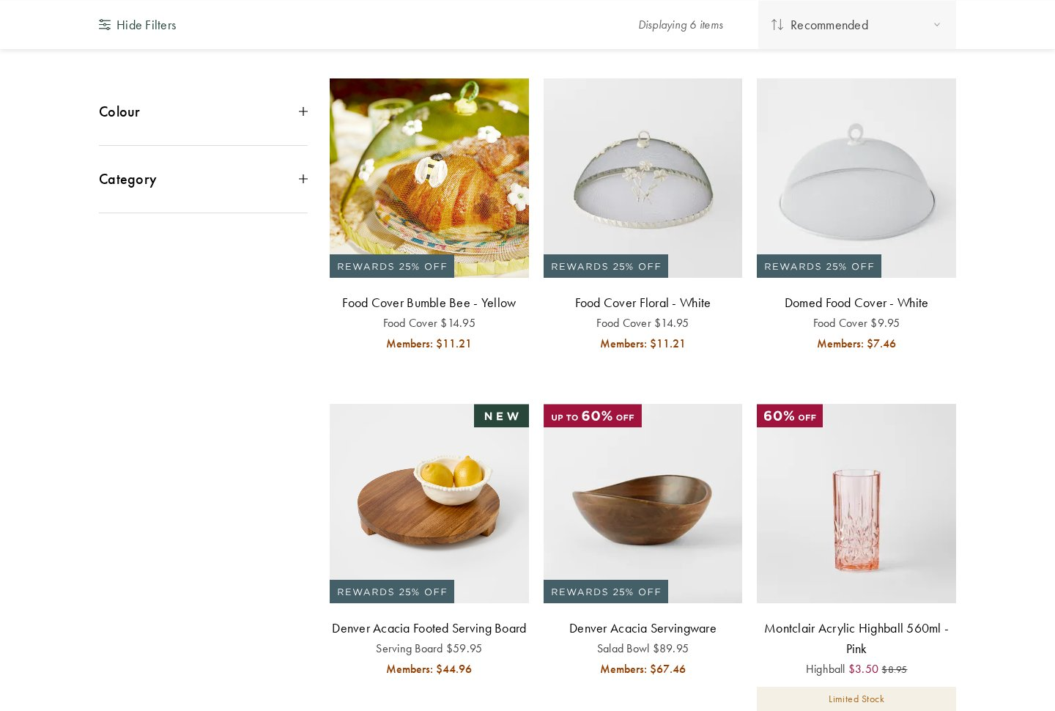
columns-minimal-dark-withimg-4 — undefined pages
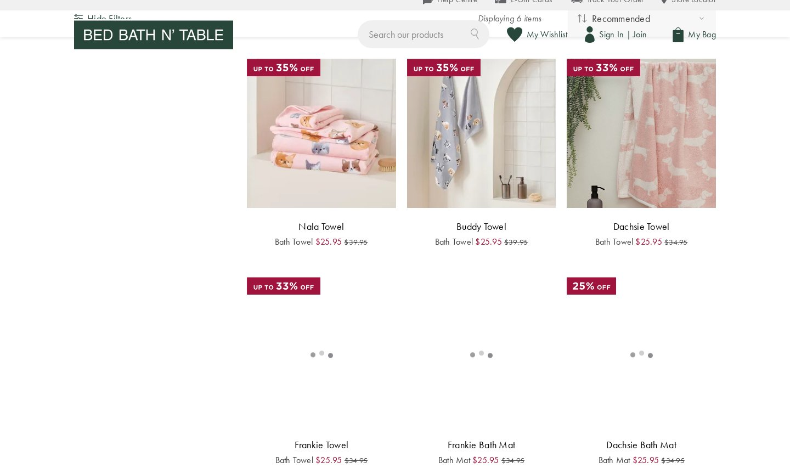
columns-minimal-dark-3 — undefined pages

form (22 variants)
form-minimal-dark-withimg — undefined pages
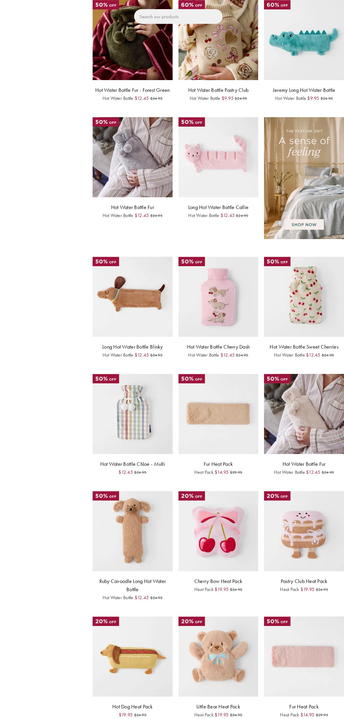
form-minimal-dark — undefined pages
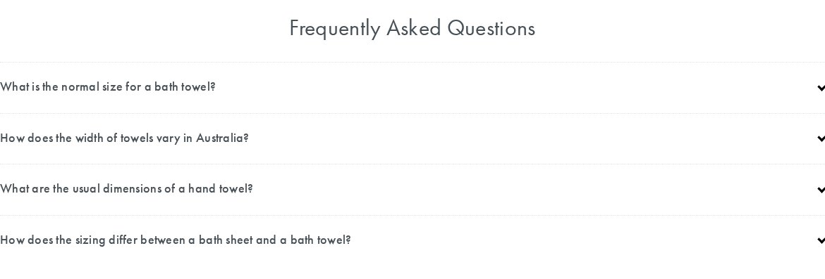
form-minimal-dark-withimg-1 — undefined pages
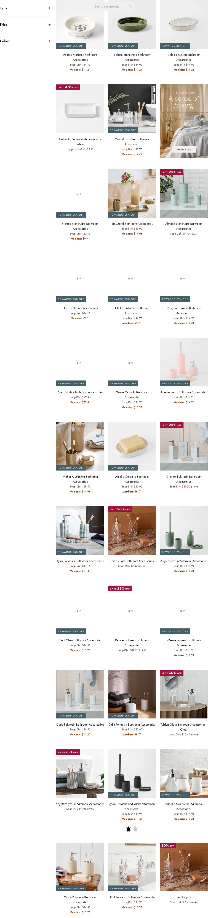
form-minimal-dark-withimg-2 — undefined pages
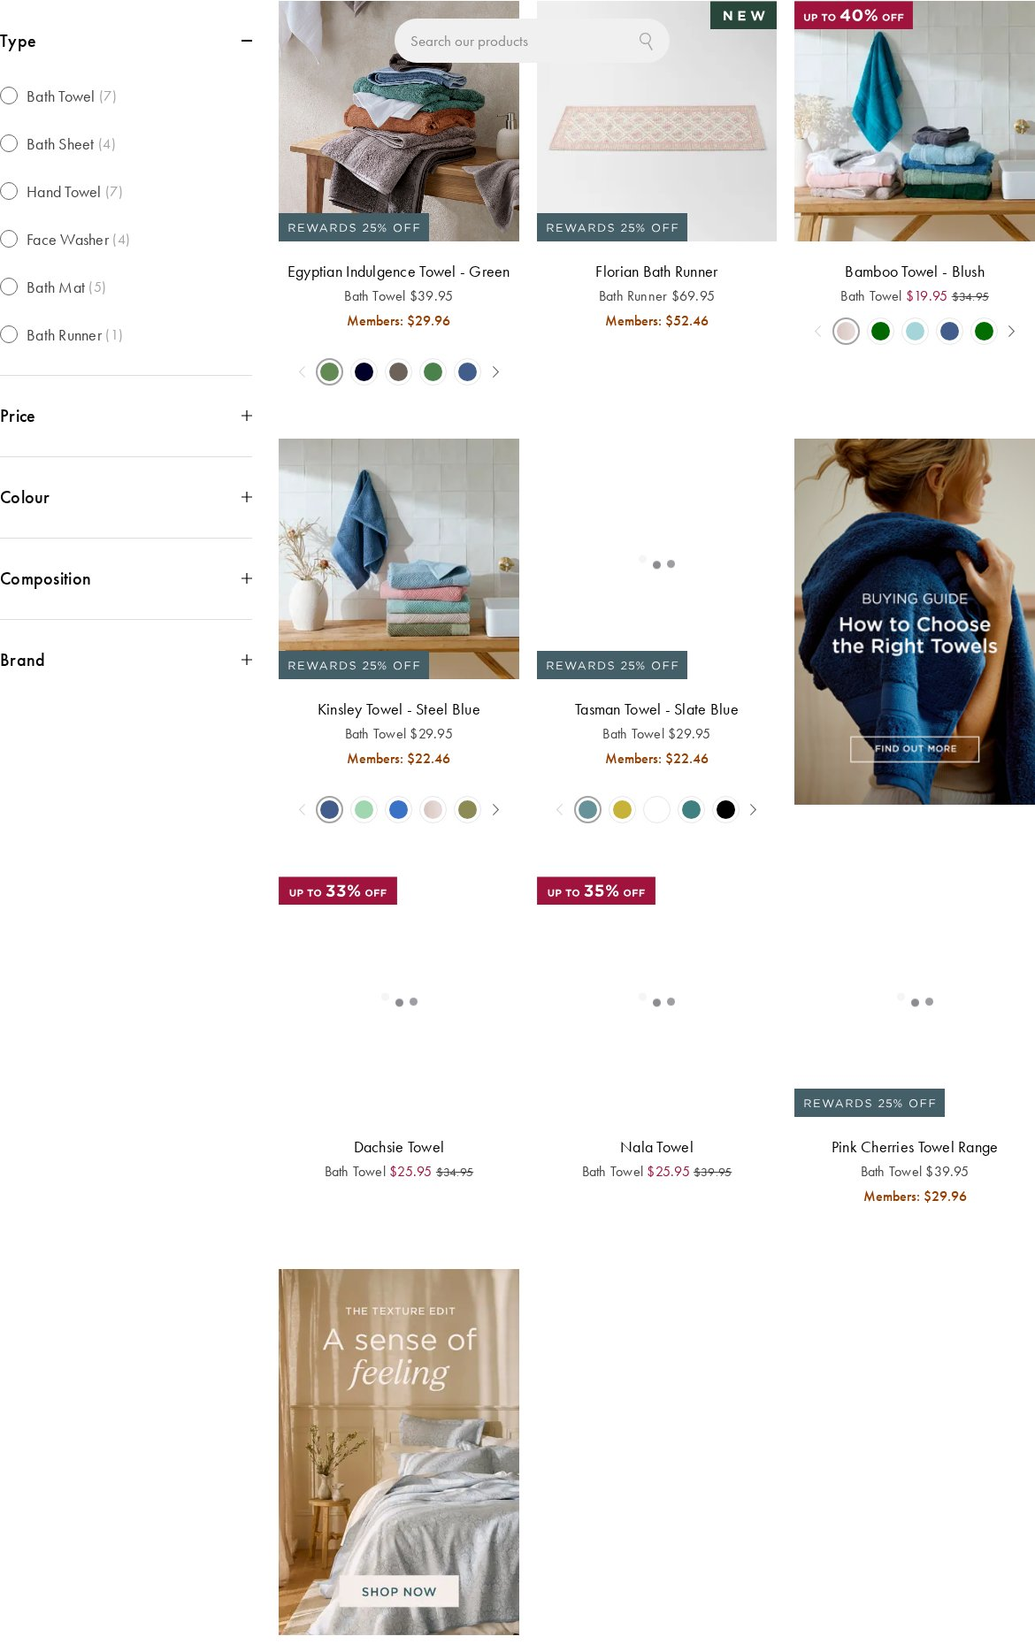
form-minimal-dark-withimg-3 — undefined pages
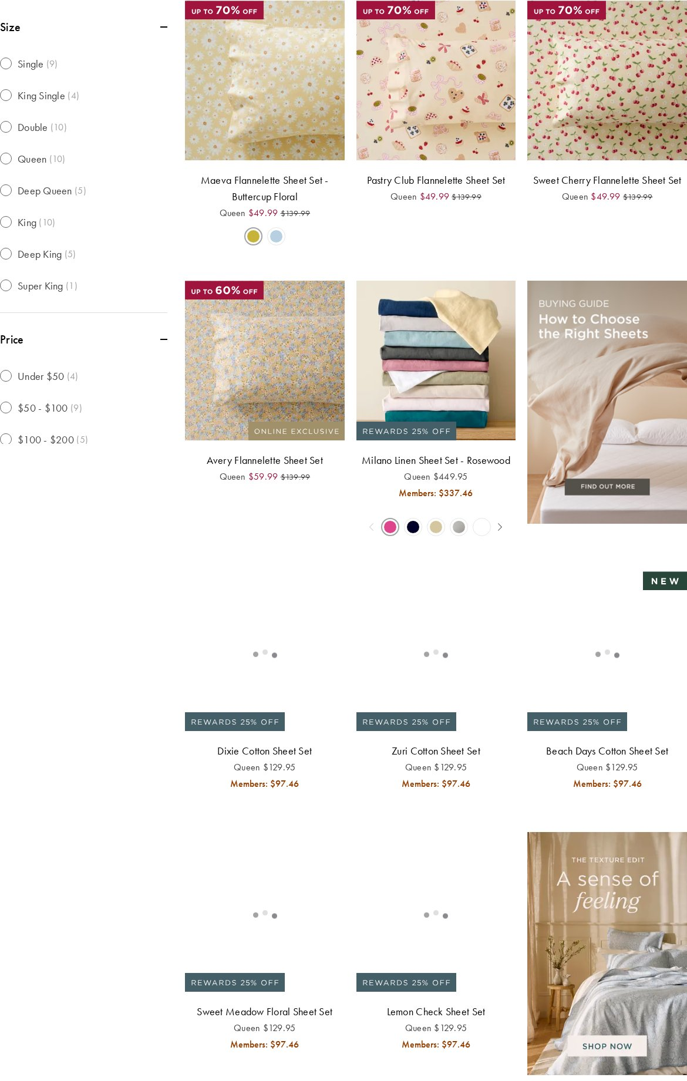
form-minimal-dark-withimg-4 — undefined pages
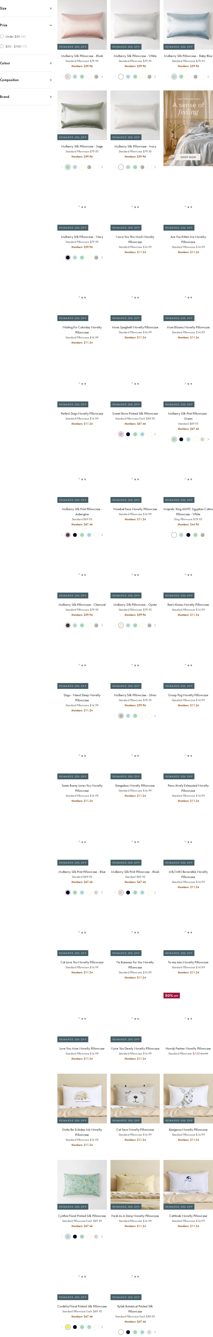
form-minimal-dark-withimg-5 — undefined pages
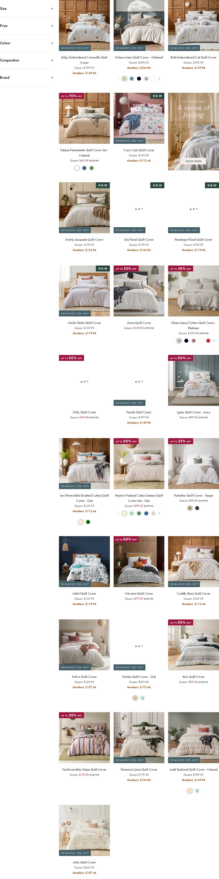
form-minimal-dark-withimg-6 — undefined pages
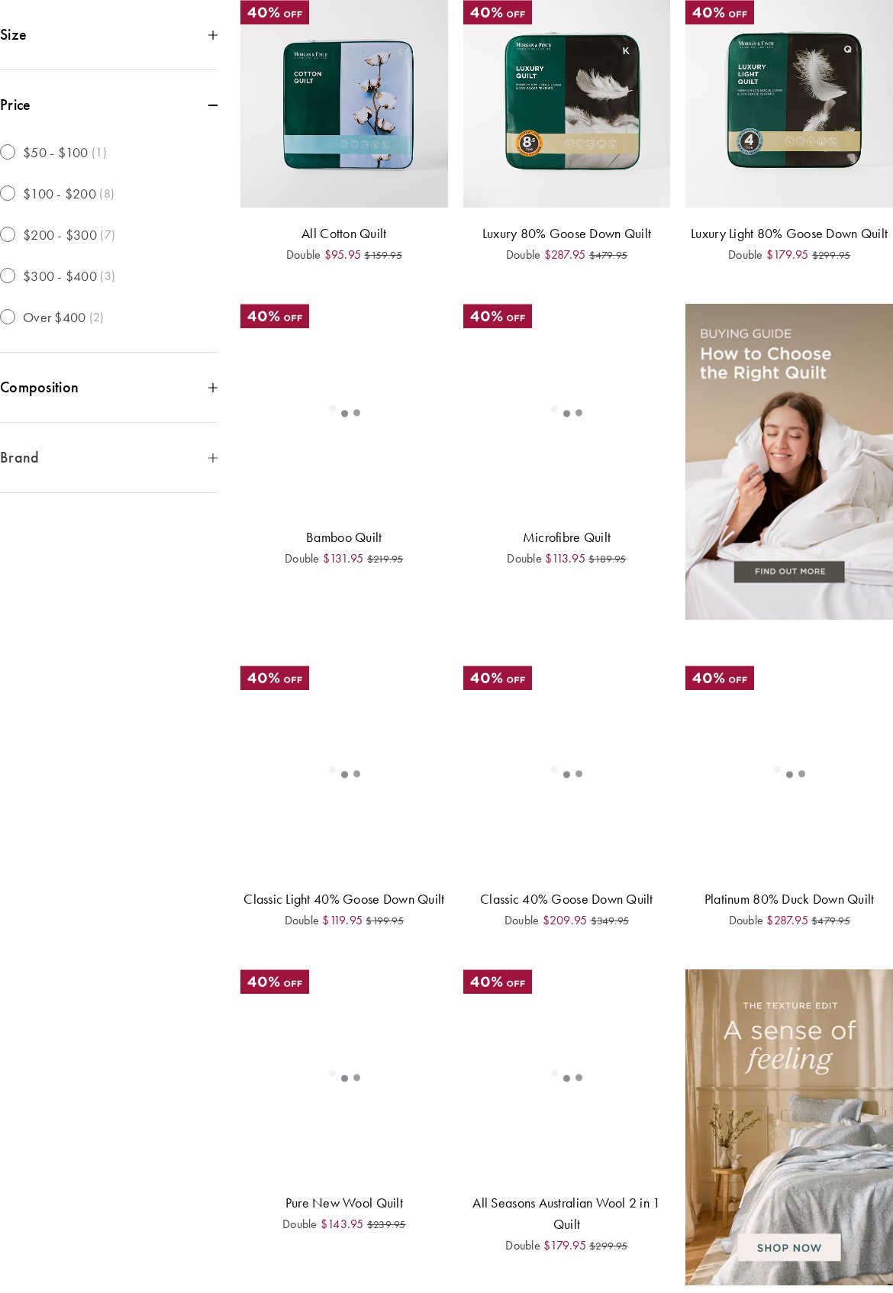
form-minimal-dark-withimg-7 — undefined pages
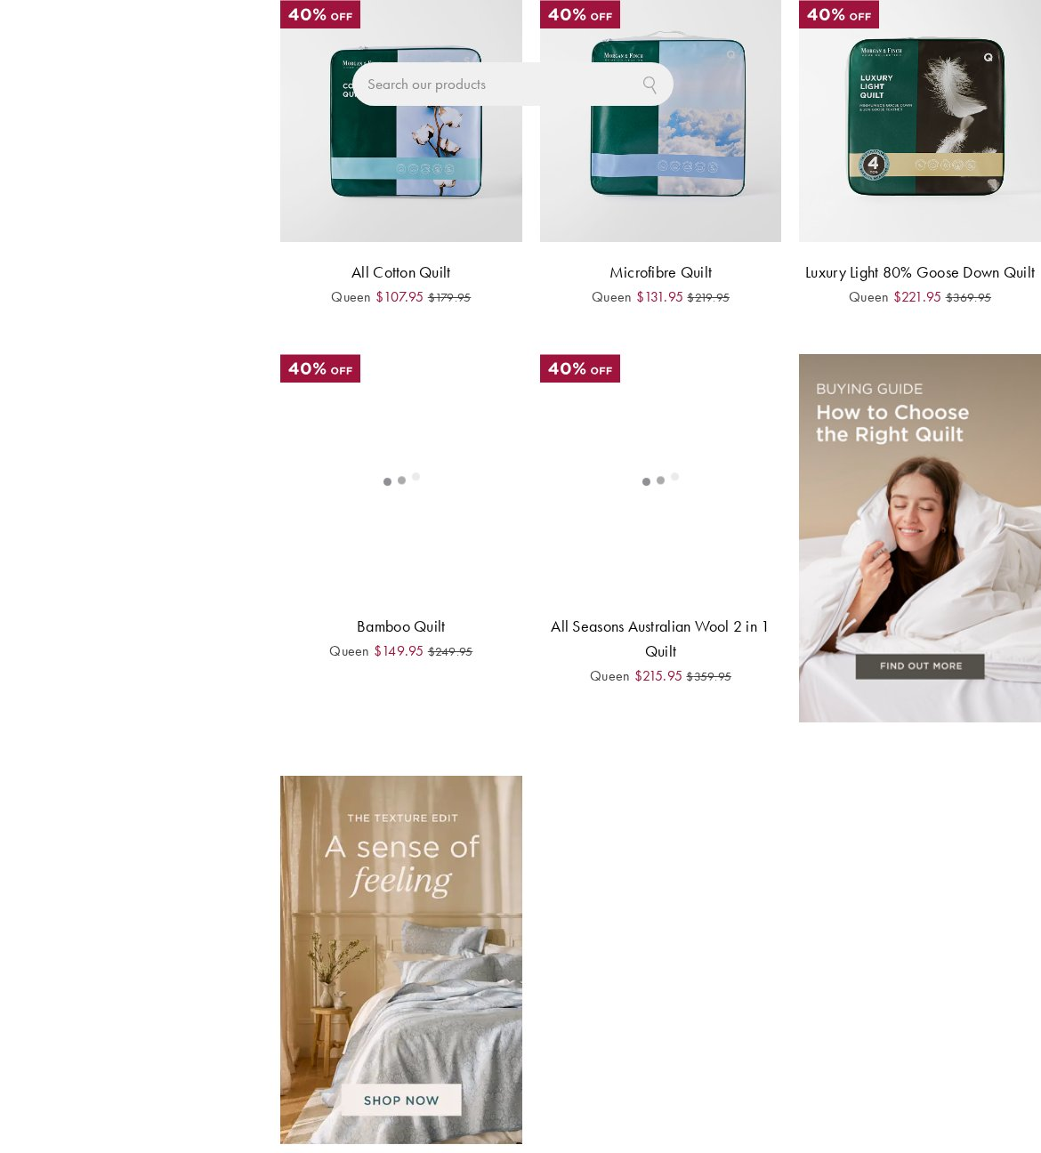
form-minimal-dark-withimg-8 — undefined pages
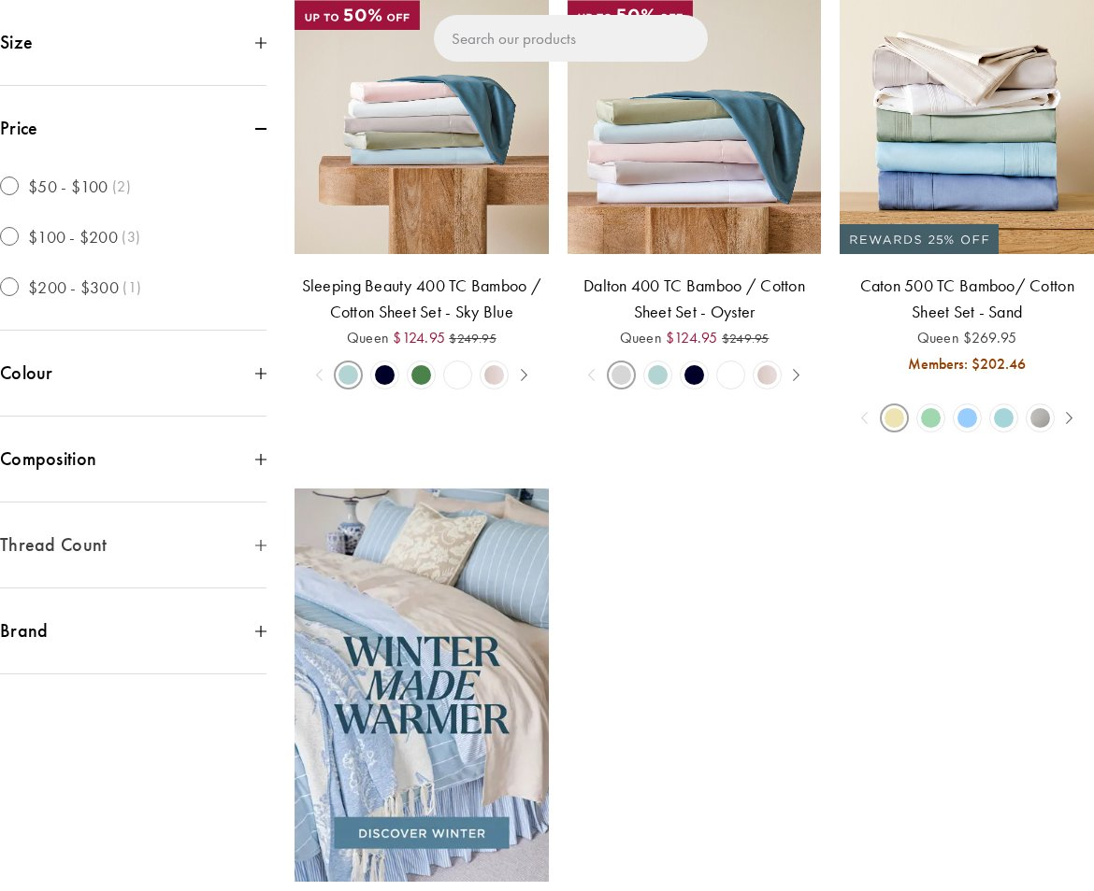
form-moderate-dark-withimg — undefined pages
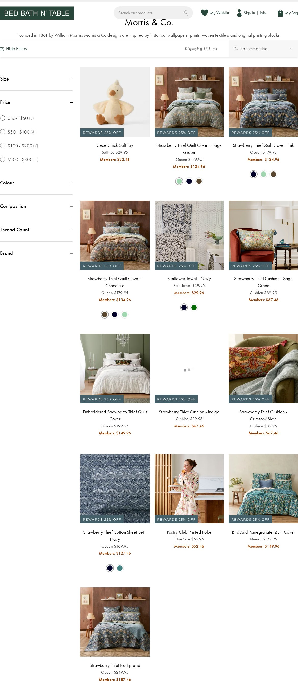
form-moderate-dark — undefined pages
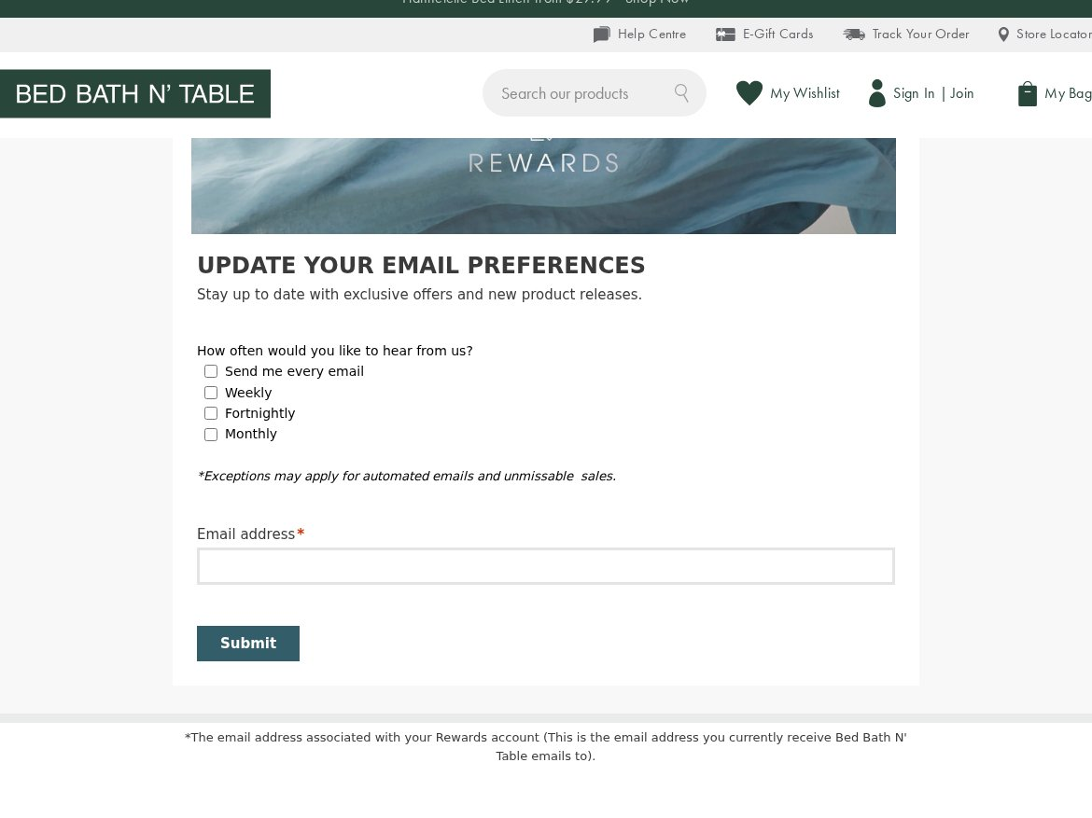
form-minimal-dark-withimg-9 — undefined pages
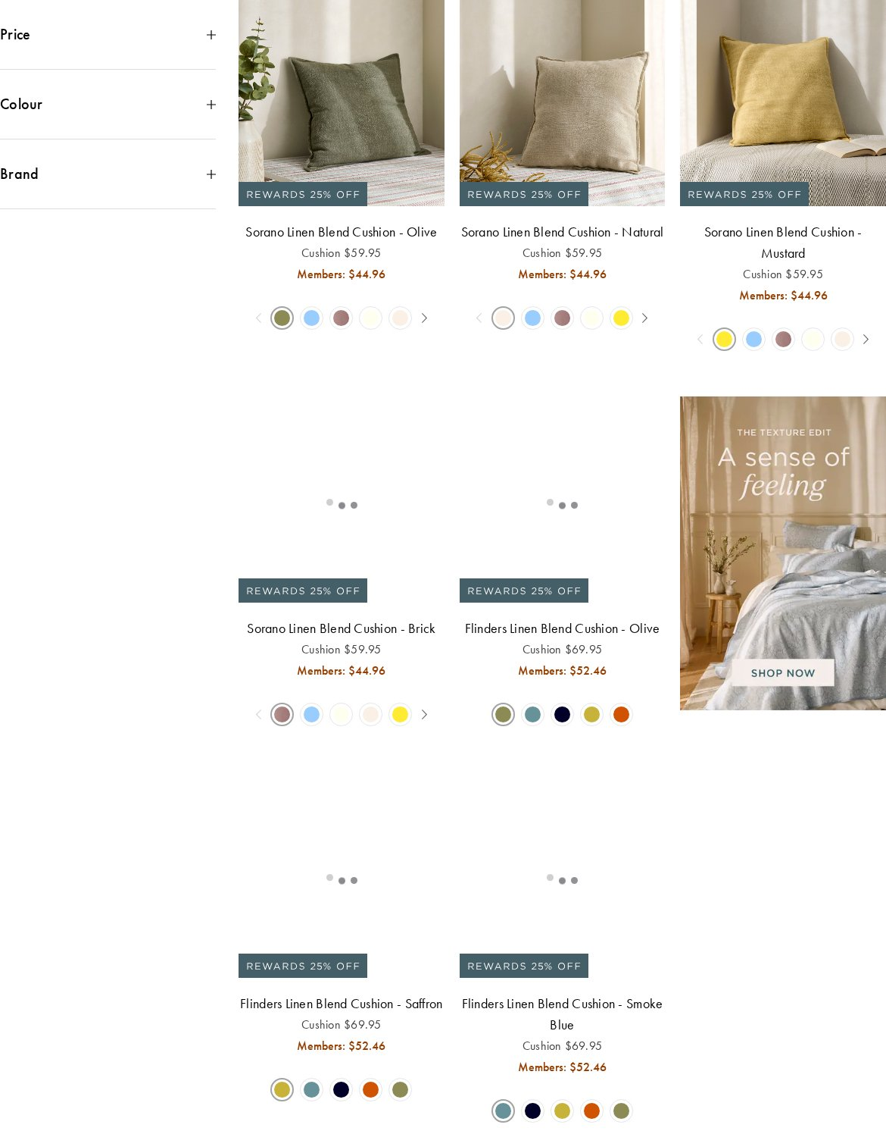
form-minimal-dark-withimg-10 — undefined pages
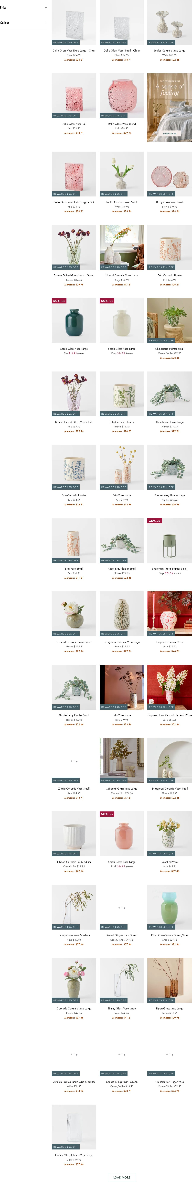
form-moderate-dark-1 — undefined pages
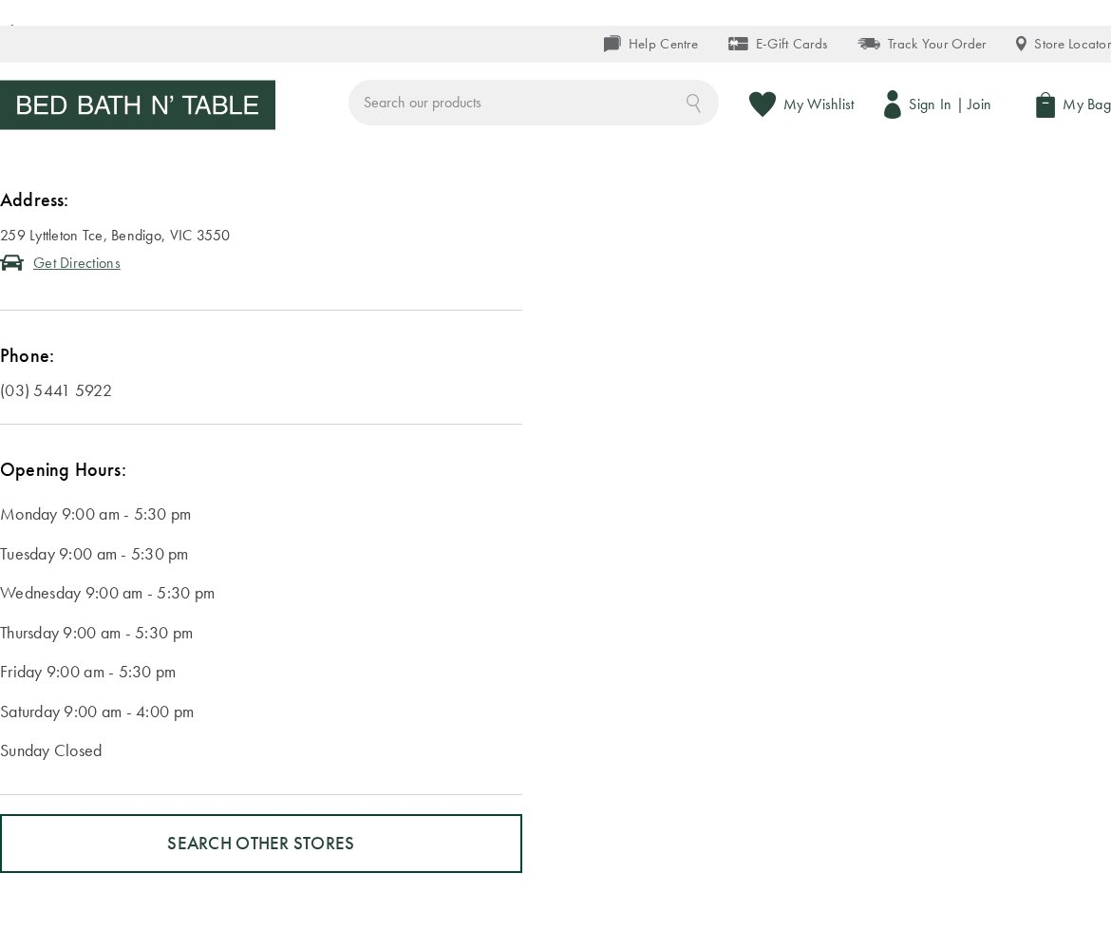
form-minimal-dark-1 — undefined pages
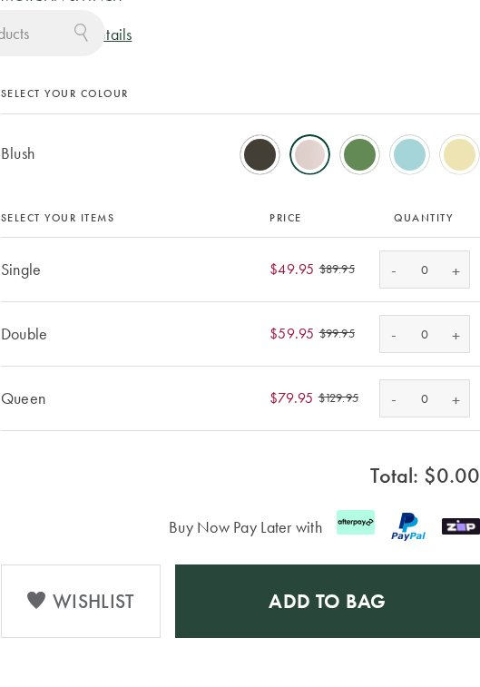
form-minimal-dark-withimg-11 — undefined pages
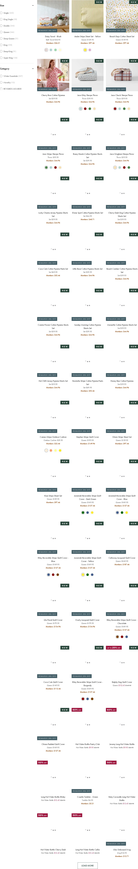
form-minimal-dark-withimg-12 — undefined pages
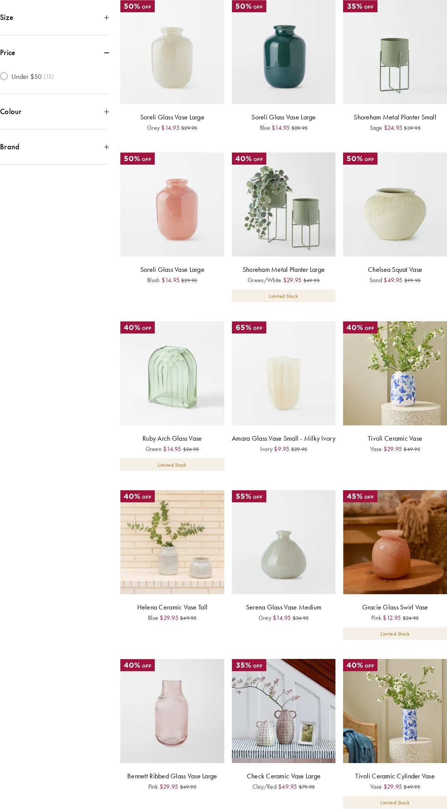
form-minimal-dark-withimg-13 — undefined pages
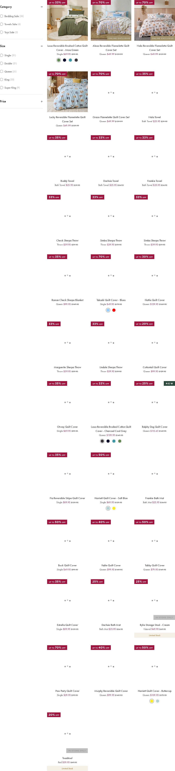
form-minimal-dark-withimg-14 — undefined pages
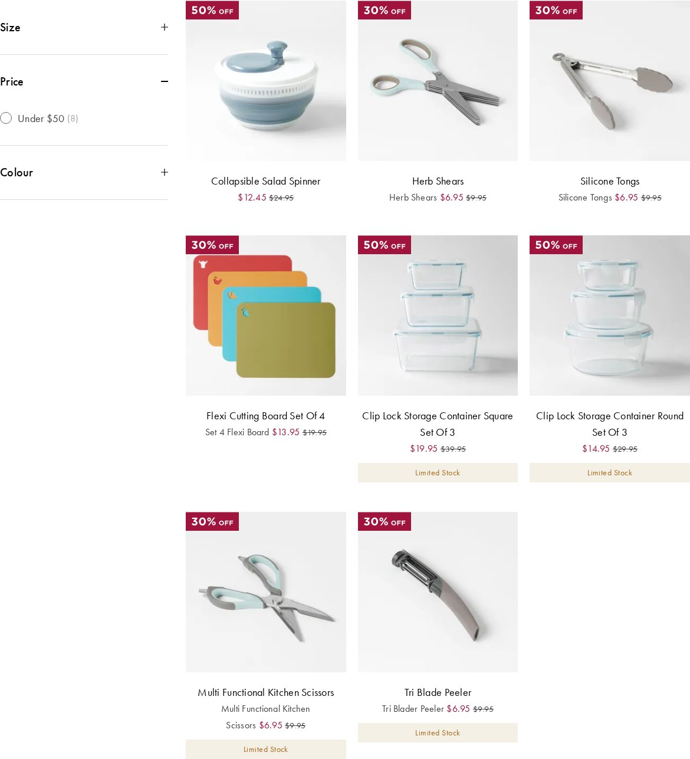
form-minimal-dark-2 — undefined pages
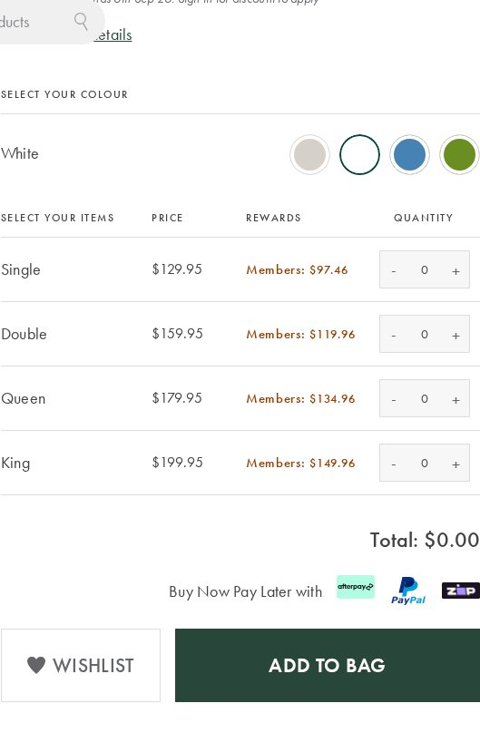
form-minimal-dark-withimg-15 — undefined pages
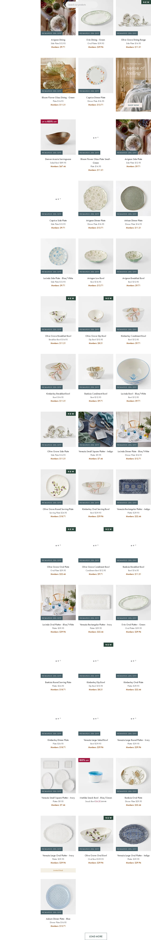
table (4 variants)
table-minimal-dark — undefined pages
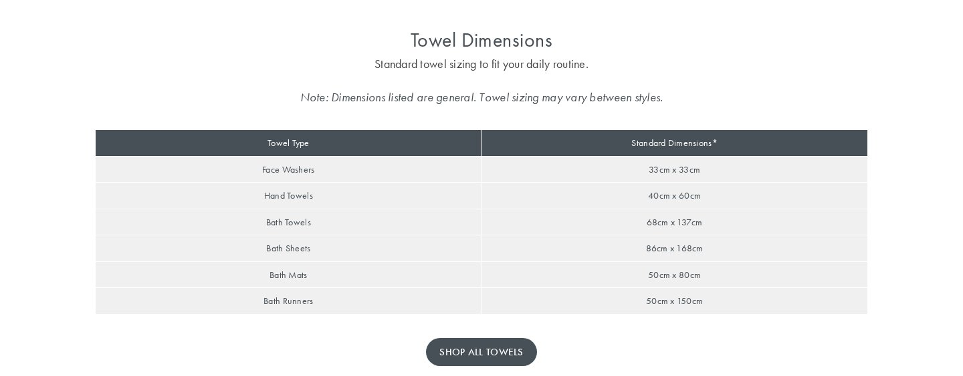
table-minimal-dark-1 — undefined pages
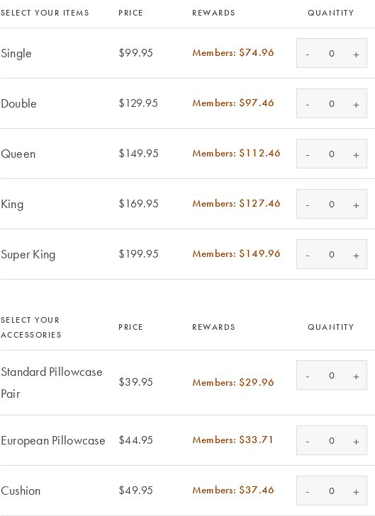
table-minimal-dark-2 — undefined pages
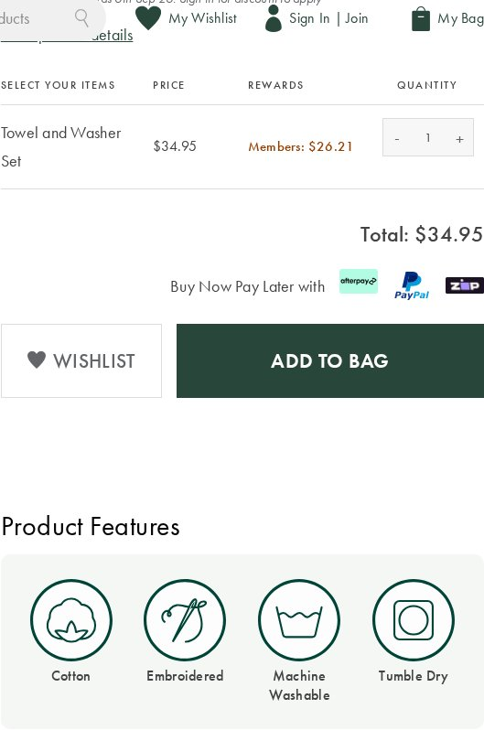
table-minimal-dark-3 — undefined pages
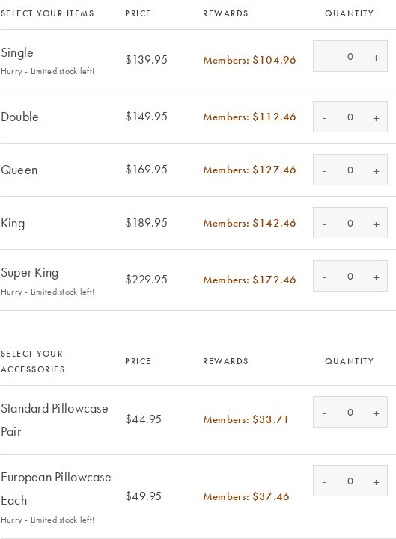
search (1 variant)
search-minimal-dark — undefined pages
video (2 variants)
video-moderate-dark-withimg — undefined pages
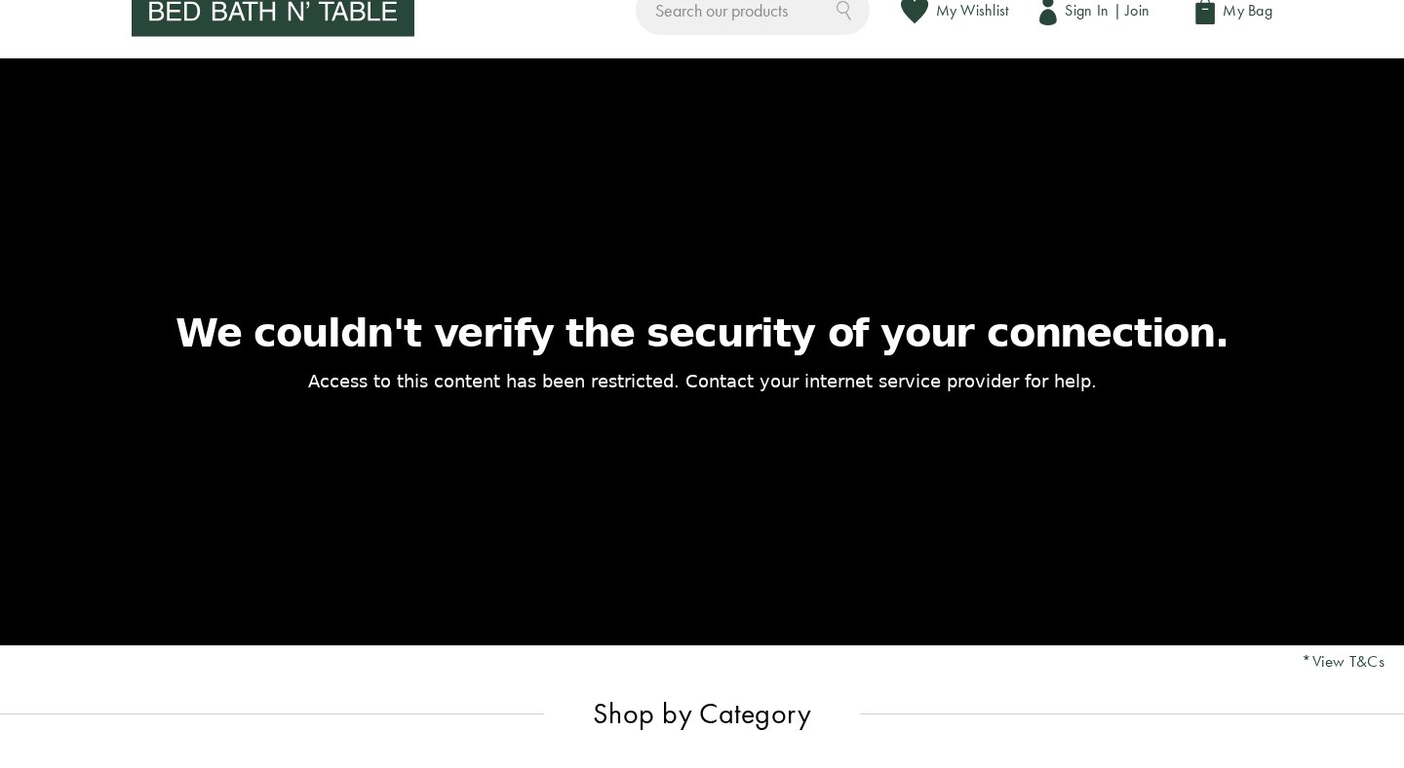
video-minimal-dark-withimg — undefined pages
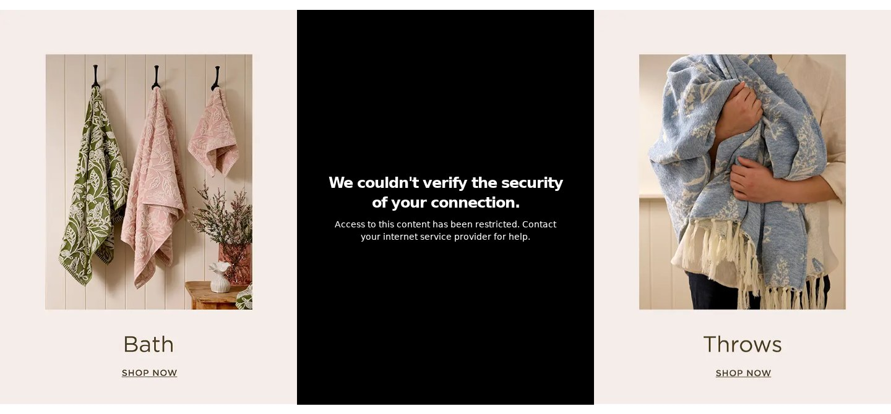
embed (2 variants)
embed-minimal-light — undefined pages
embed-minimal-dark — undefined pages
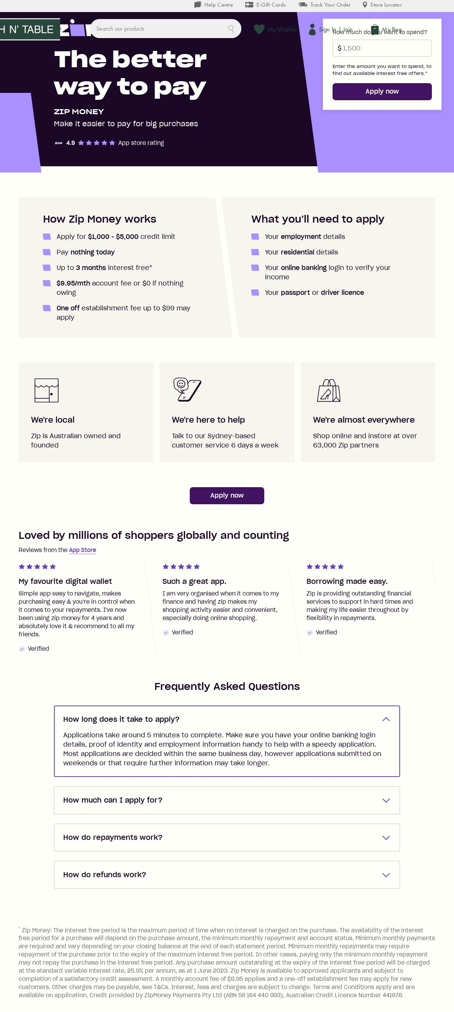
unknown (20 variants)
2 images block-minimal-dark-withimg — undefined pages
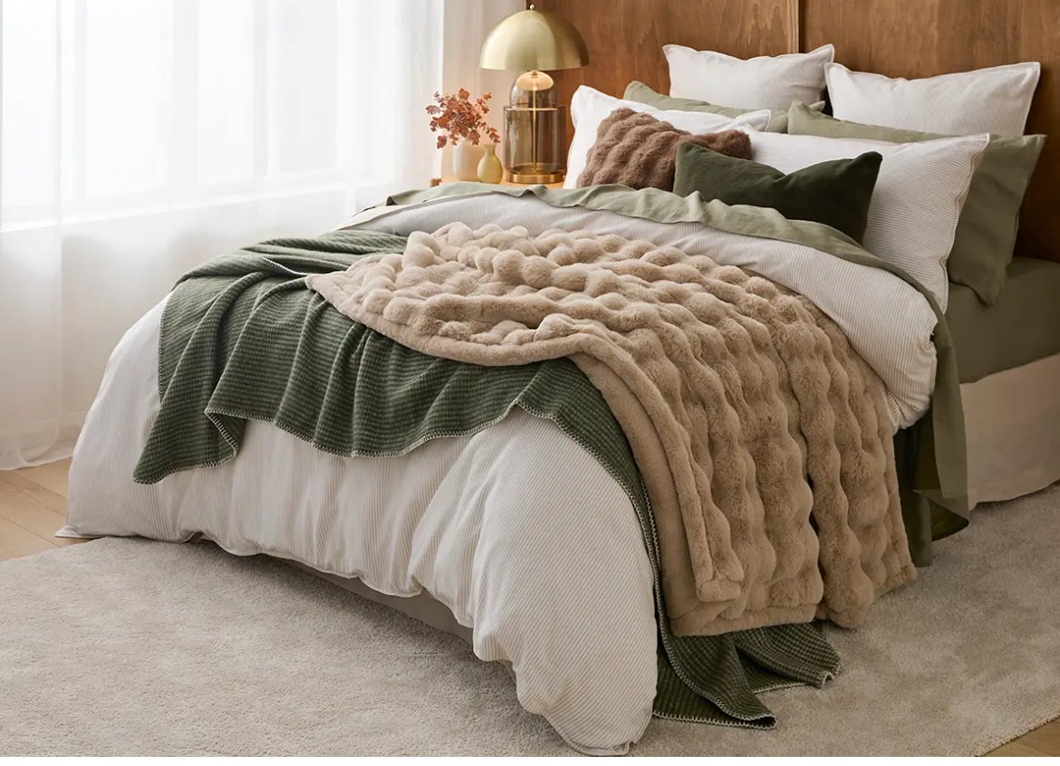
2 ctas + 3 paragraphs block-minimal-light — undefined pages
1 heading + 4 images + 3 paragraphs block-minimal-dark-withimg — undefined pages

4 ctas block-minimal-dark — undefined pages
3 ctas block-minimal-light — undefined pages
1 heading + 1 image + 1 paragraph block-minimal-dark-withimg — undefined pages
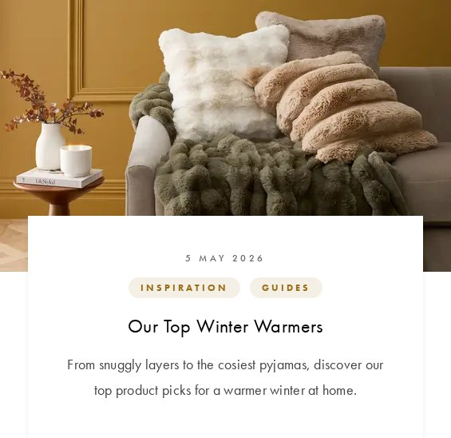
1 image block-minimal-dark-withimg — undefined pages
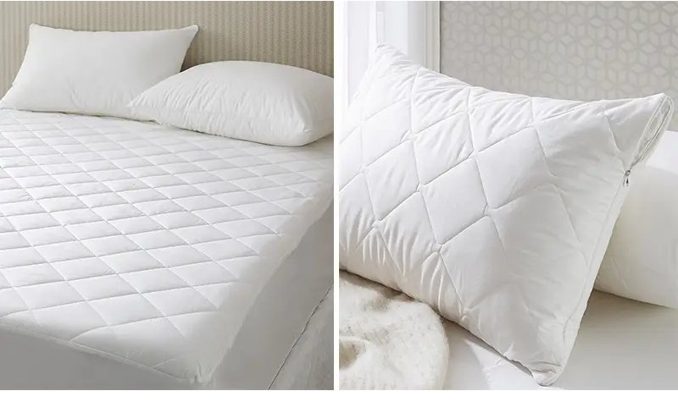
3 headings + 2 images + 2 paragraphs block-minimal-dark-withimg — undefined pages
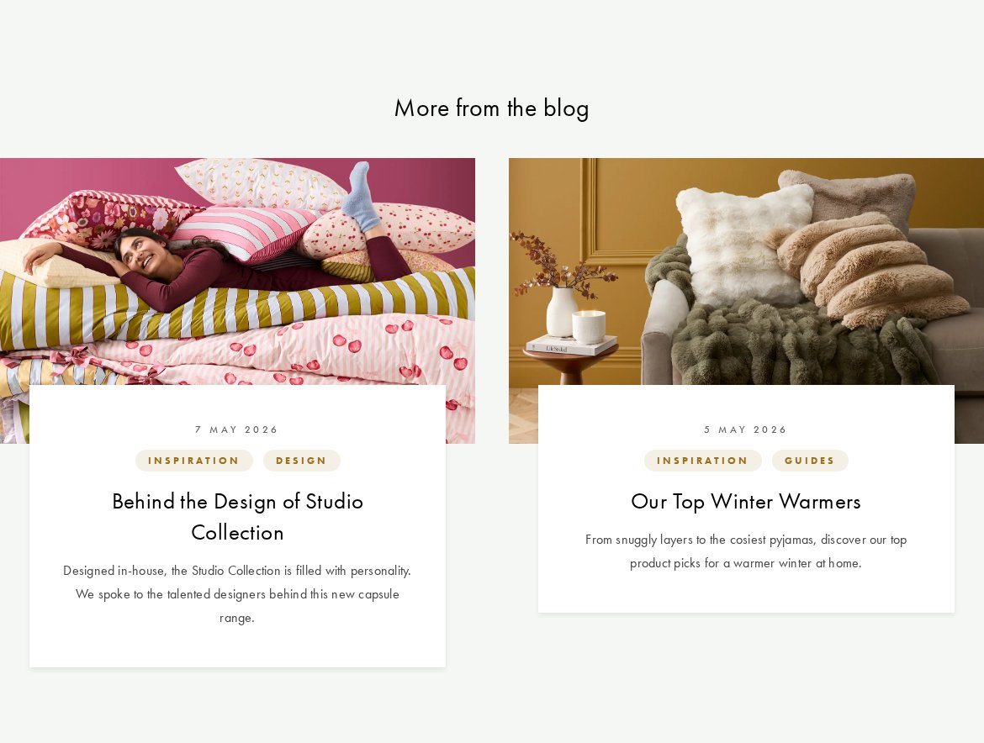
1 cta block-minimal-dark — undefined pages
2 headings + 1 cta + 3 paragraphs block-minimal-dark — undefined pages
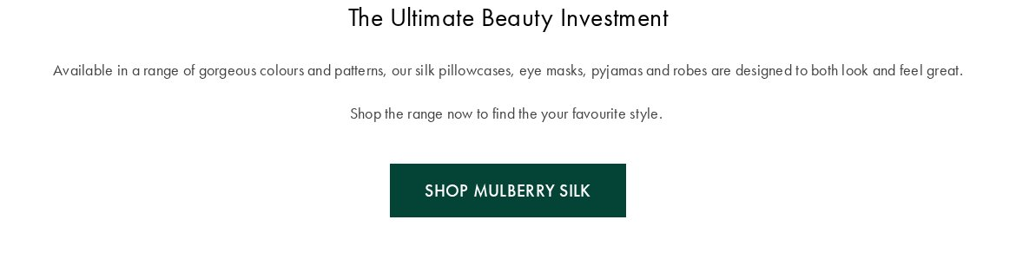
2 images + 1 cta + 1 paragraph block-minimal-dark-withimg — undefined pages
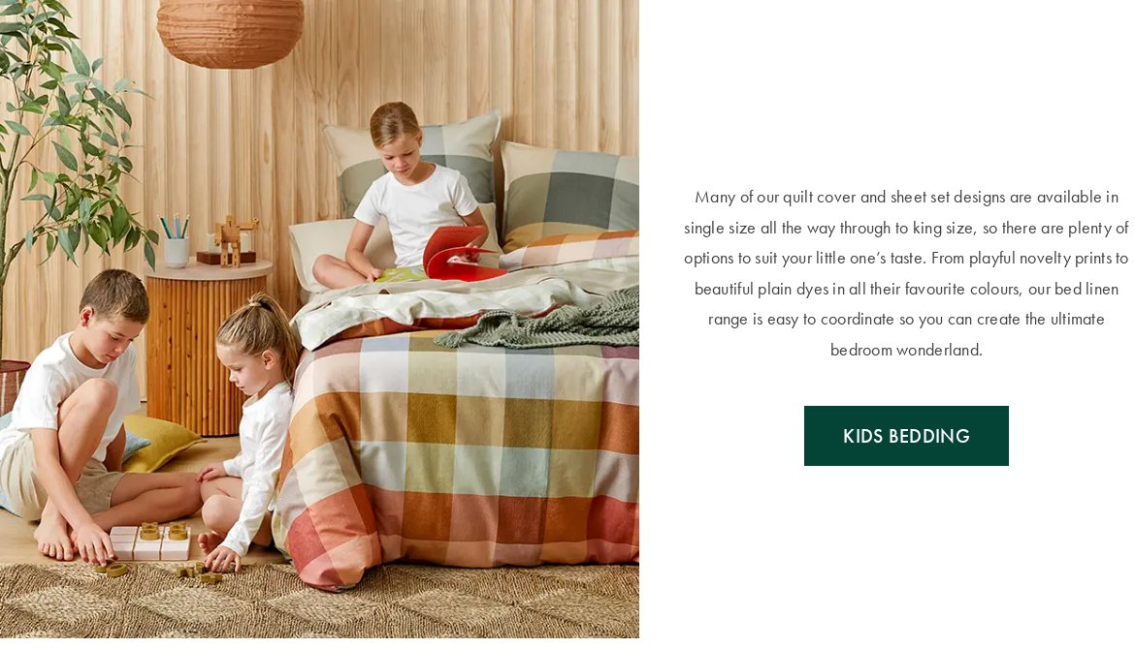
4 images block-minimal-dark-withimg — undefined pages
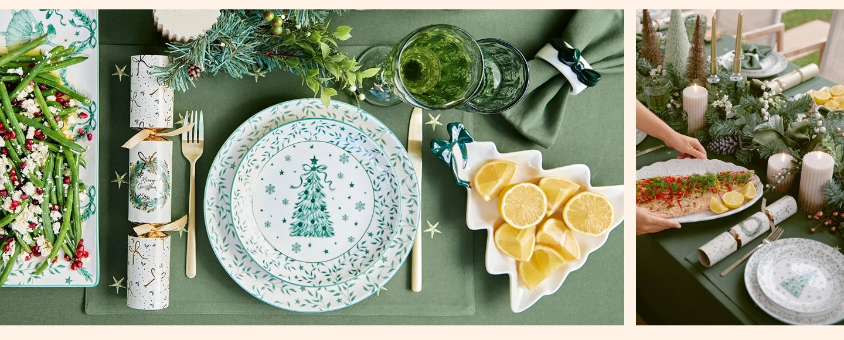
1 heading + 8 ctas block-minimal-dark — undefined pages
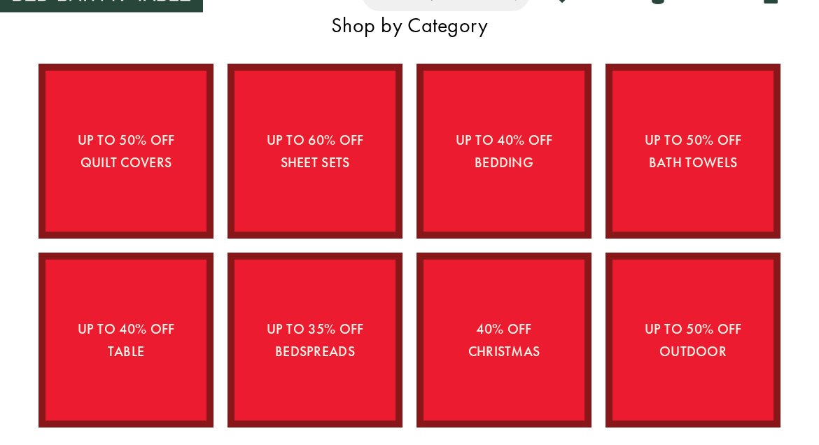
3 images block-minimal-dark-withimg — undefined pages

6 images block-minimal-dark-withimg — undefined pages
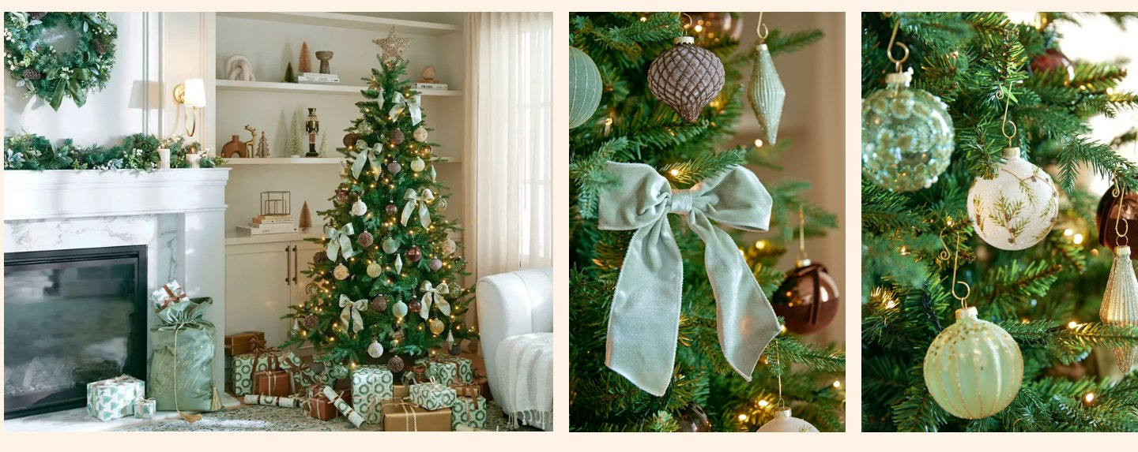
1 cta block-minimal-light — undefined pages
8 images + 2 ctas + 2 paragraphs block-minimal-dark — undefined pages

2 images + 1 paragraph block-minimal-dark — undefined pages

2 ctas block-minimal-dark — undefined pages
3 images + 1 paragraph block-minimal-dark — undefined pages
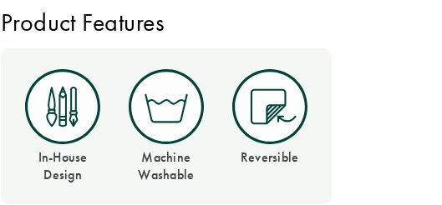
4. Page Counts by Template & Migration Classification
Counts scaled to the full 2,860-URL sitemap.
Template | Pages | Migration Path | Rationale
product-detail (PDP) | 2,033 | Automated (data-driven) | Uniform; migrate via catalog/feed export.
product-listing + category-landing | 531 | Semi-auto | Category tree + facet config.
store-locator | 170 | Automated (data-driven) | Uniform store template from store data feed.
blog / content | 67 | Semi-auto | Editorial PageBuilder bodies.
CMS / static & guides | ~59 | Semi-auto / Manual | Policies auto; competitions/how-to bespoke.
homepage + campaign | ~a few | Manual | Merchandised, hand-built.
Total | 2,860 | Automated ~77% | Semi-auto ~21% · Manual ~2%
Same inverted economics as SG: PDPs + store-locator (both data-driven) are the easy bulk-automated part; merchandised pages, PLP facets and commerce integrations are the effort.
5. Integrations Analysis
Integration | Type | Complexity | Where used
Adobe Commerce (Magento 2) | Platform / backend | High | Site-wide
Magento PageBuilder | CMS / content | Medium | Home, category, CMS, blog
Fastly CDN | Platform / caching | Medium | Site-wide
AB Tasty (try.abtasty.com) | Experimentation / personalization | High | Site-wide (A/B testing) — AU-specific
Google Maps | API / embed | Medium | Store-locator (170 pages)
Afterpay / PayPal / Zip / Apple Pay / Google Pay | Payment gateways | High | Cart, checkout, PDP
Google reCAPTCHA | Security / forms | Low | Forms
Google Tag Manager + gtag | Analytics / tags | Medium | All pages
Dotdigital | Email / marketing automation | Medium | Newsletter, email capture
Adobe Edge Delivery RUM (rum.hlx.page) | Measurement | Low | Homepage (pilot)
Social: Facebook, Pinterest, TikTok, Instagram | Pixels / embeds | Low | Tracking + footer
Wishlist / My Bag / customer sections | Commerce feature | Medium | Account, PDP, cart
6. Complex Use Cases & Observations
# | Complex behaviour | Instances | Where | Why complex
1 | Product catalog & variants | 2,033 PDPs | product pages | SKU/variant, pricing, inventory — data-sourced.
2 | Faceted search / filtering | 531 categories | category/sale | Dynamic facets + Load More.
3 | Store locator | 170 | /locator/* | Map integration, structured store data, hours — AU-specific.
4 | Cart / checkout / payments | site-wide | cart, checkout | 5 payment methods; transactional.
5 | AB Tasty experimentation | site-wide | all pages | A/B tests + personalization variants may alter content — migration decisions needed.
6 | Customer accounts / wishlist / bag | site-wide | account, PDP | Auth, session, saved state.
7 | PageBuilder compositions | home + campaigns | merchandised | 20 custom block comps to model.
8 | Competitions & dynamic CMS | several | /spring-refresh-competition etc. | Form logic, entry handling.
7. Migration Estimates
Content/presentation-layer scope. The commerce engine (cart, checkout, payments, catalog DB) is assumed to remain on Adobe Commerce.
Effort by workstream
Workstream | Estimate | Notes
Block development (102 variants → ~24–30 EDS blocks + variations) | 22–30 days | Heavy: 22 form + 19 carousel + 15 columns + 12 hero
Template setup (7 templates incl. store-locator) | 8–11 days
PDP automation (catalog feed, ~2,033) | 5–8 days | Scripted from Magento catalog
Store-locator automation (~170, map + data) | 4–6 days | Google Maps + store data feed
PLP + category (facets, tree, curation) | 8–12 days
Homepage + campaign/CMS pages | 6–9 days | Merchandised, bespoke
Blog + content import (~67) | 4–6 days
Header / footer / mega-nav / search | 5–7 days
Commerce integrations (cart/checkout/5 payments/search) | 10–16 days
AB Tasty experimentation strategy + re-wire | 4–6 days | Decide migrate vs rebuild
Analytics & marketing (GTM/Dotdigital/pixels/RUM) | 3–5 days
QA & testing (functional, commerce, visual, a11y, PageSpeed) | 12–18 days
PM / UAT / fixes | 8–12 days
Totals
Metric | Estimate
Total effort | ~99–146 person-days (≈ 20–29 weeks of work)
Recommended team | 2–3 developers + 1 commerce specialist + 1–2 QA + PM
Calendar schedule | ~13–19 weeks with the team above
Indicative cost | At a blended ~$600/day → ≈ $59k–$88k (adjust to your rates)
Recommended phasing
- Phase 1 — Blocks + templates + navigation
- Phase 2 — PDP + store-locator bulk automation + PLP/category
- Phase 3 — Home/campaign/blog/CMS
- Phase 4 — Commerce + AB Tasty integrations
- Phase 5 — QA/UAT
8. Caveats & Assumptions
- Analysis used a 77-page representative sample across all template types (full 2,860-page browser crawl is unnecessary for scoping). Coverage is 100% of template types.
- Estimates assume the Adobe Commerce backend is retained for transactions; a full re-platform of cart/checkout/payments is a separate, larger effort.
- AB Tasty adds scope uncertainty — a decision is needed on whether experiments/personalization migrate or are rebuilt.
- Cost figures are indicative and use a placeholder blended day rate; adjust to your actual rates.
9. Analysis Artifacts
Artifact | Description
template-catalog.json | 7 named templates with page assignments and reference URLs
block-catalog.json | 102 block variants with usage counts and canonical models
summary.json | Site metrics and coverage summary
urls-all.json / urls-grouped.json | 2,860 discovered URLs, grouped by pattern
.pages/{slug}/full-page.jpg | Full-page screenshot per analysed page
.blocks/{variant}/screenshots/ | Screenshots per block variant (all 102)
Bed Bath N' Table (AU) — EDS Migration Handover · Generated 2026-08-27 · Content/presentation-layer scope (Adobe Commerce backend assumed retained for transactions).

