EDS MIGRATION — SCOPE & ANALYSIS HANDOVER
Bed Bath N' Table (Singapore)
Content-layer migration assessment for Adobe Edge Delivery Services

Field | Value
Site analysed | https://www.bedbathntable.com.sg/
Analysis date | 2026-08-25
URLs in sitemap | 6,756 (representative 51-page sample analysed across all template types)
Locale | en (Singapore)
Functional templates | 8
Block variants | 61
Platform detected | Adobe Commerce (Magento 2) + PageBuilder, Fastly CDN
1. Executive Summary
Bed Bath N' Table Singapore is a large Adobe Commerce (Magento 2) storefront fronted by Fastly CDN, with 6,756 URLs in its sitemap. All 6,756 were recorded for accurate counts; a representative 51-page sample was analysed covering every template type (a full browser crawl of the catalog is unnecessary for scoping — products share one template).
- 6,756 sitemap URLs; ~5,165 are product detail pages (PDPs).
- 8 functional page templates identified (PDP, PLP, category, home, blog, content).
- 61 reusable block variants catalogued (20 form + 13 hero variants stand out).
- Magento PageBuilder is used heavily — content maps reasonably well to EDS blocks.
- The homepage already loads Adobe Edge Delivery RUM (rum.hlx.page) — an EDS measurement pilot appears to be in place.

Key insight: The migration economics are inverted from a typical content site. The huge PDP volume is the EASY part — one template, data-driven bulk import from the Magento catalog. The effort concentrates in the merchandised home/campaign pages, PLP facet configuration, and commerce integrations (cart, checkout, Afterpay, PayPal). Estimates assume the Adobe Commerce backend is retained for transactions; EDS fronts the content/browse experience.
2. Templates Inventory
Magento serves a uniform shell, so structural fingerprinting groups pages loosely; below is the functional template inventory (what matters for migration), confirmed via rendered screenshots.
# | Template | Complexity | Reasoning | Reference URL
1 | product-detail (PDP) | High | Gallery + zoom + thumbnails, title/brand, price w/ strike-through + stock, variant selector, feature icons, "Style With" cross-sell, designer notes, size-guide accordion. | /hana-breakfast-bowl-white-22497601
2 | product-listing (PLP) | High | Faceted filters (Category/Size/Price/Colour), product grid with discount badges + colour swatches, Load More, sorting. Dynamic query-driven. | /sale
3 | category-landing | Medium | Hero banner + subcategory tile grid + "Shop By Collection" curated tiles. | /bed, /bath, /table
4 | homepage | High | Merchandised PageBuilder layout: promo heroes, category tiles, campaign banners, carousels. | /
5 | blog-article | Medium | Long-form editorial: hero, alternating image+text, product callouts, Shop CTA, social share, "More from the blog". | /blog/mulberry-silk
6 | blog/content-index | Medium | Blog listing, author, and category index pages. | /blog, /blog/inspiration
7 | influencer / shop-the-look | Medium | Curated influencer content linking products. | /products/influencers/jessiikawilson
8 | CMS/static | Low | About, Terms, Privacy, Contact, Store Locator (PageBuilder/CMS pages). | /about-us-type pages
Template screenshots
homepage
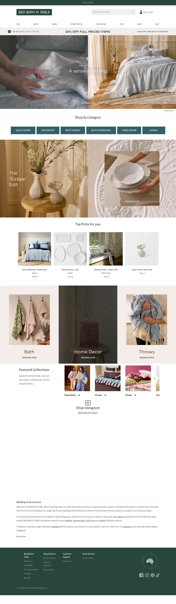
Template: homepage — representative page
category-landing
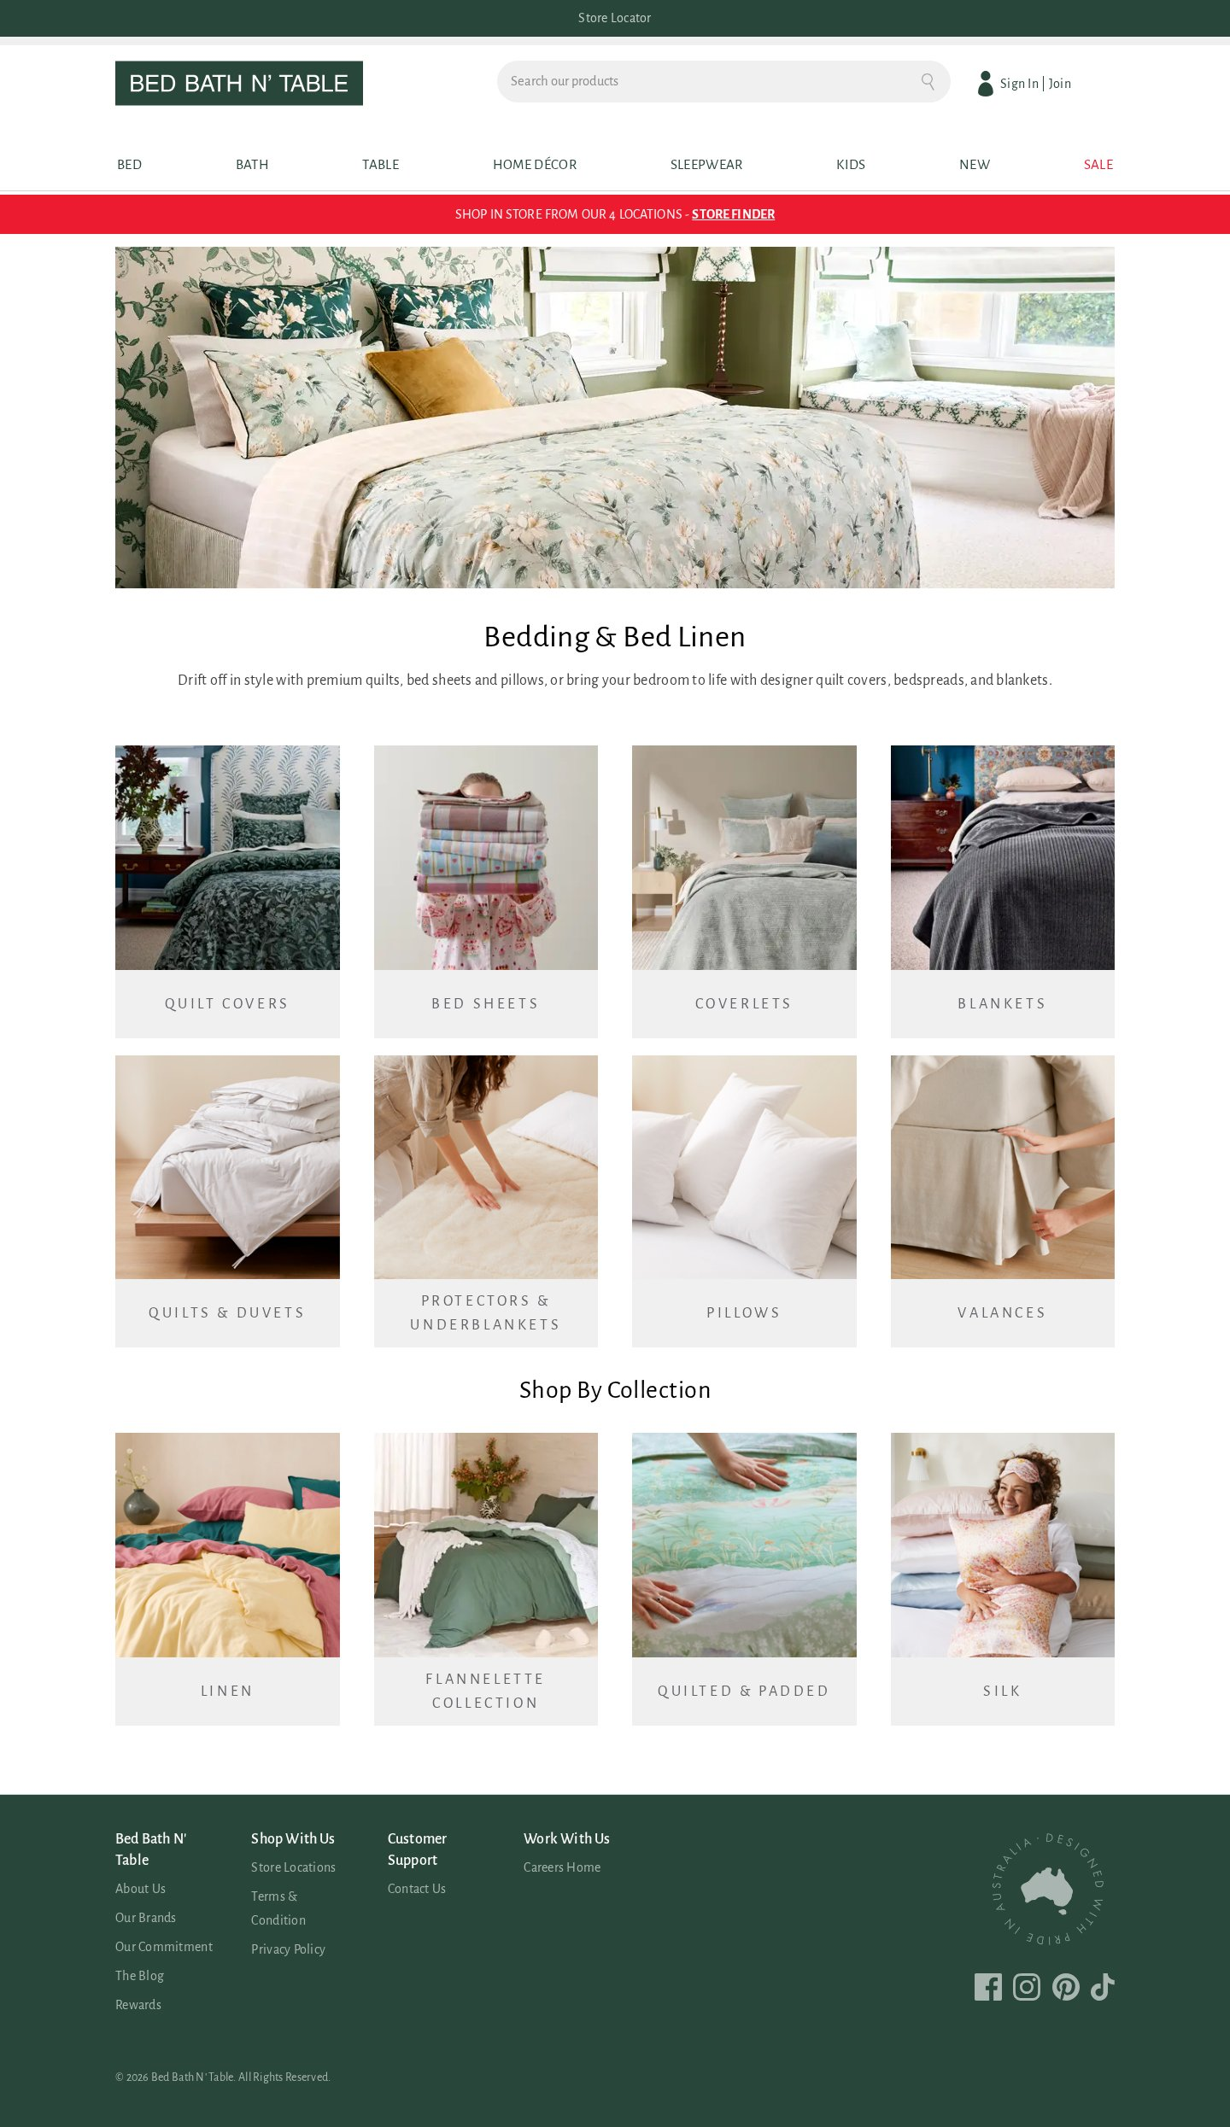
Template: category-landing — representative page
product-detail (PDP)
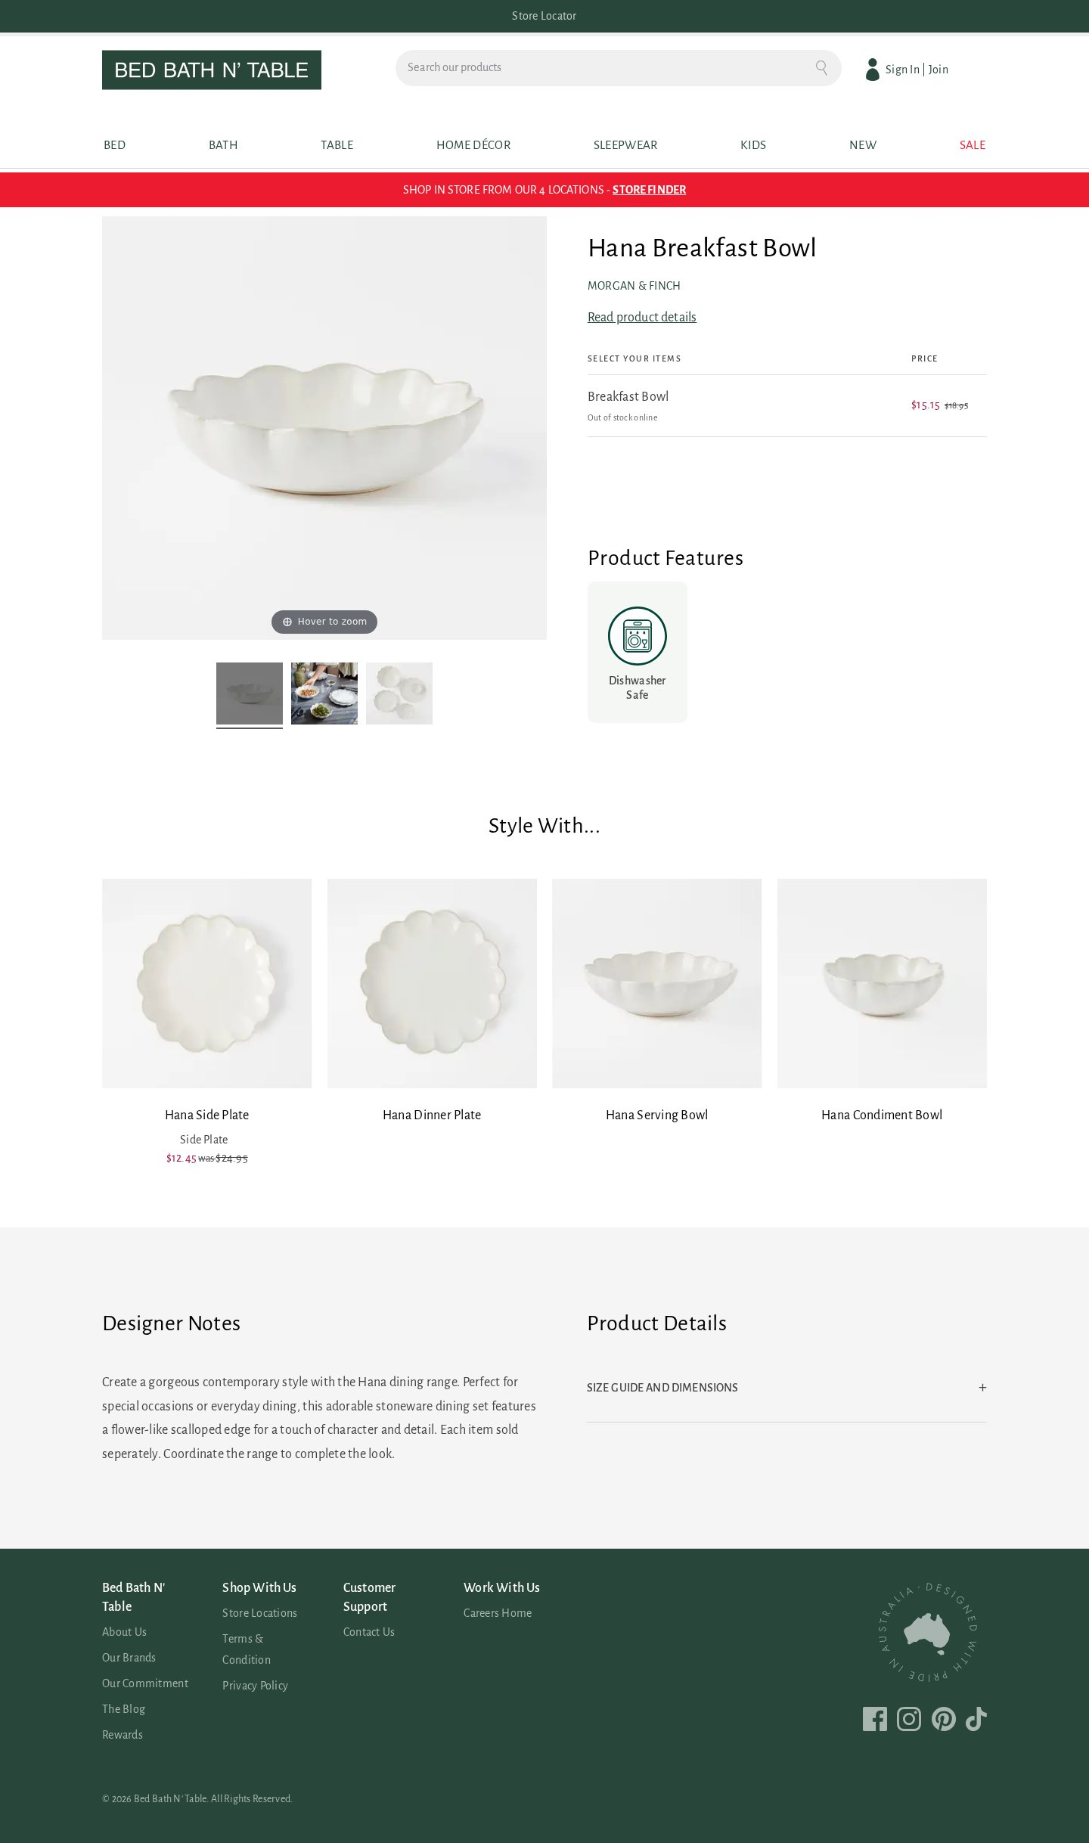
Template: product-detail (PDP) — representative page
product-listing (PLP)
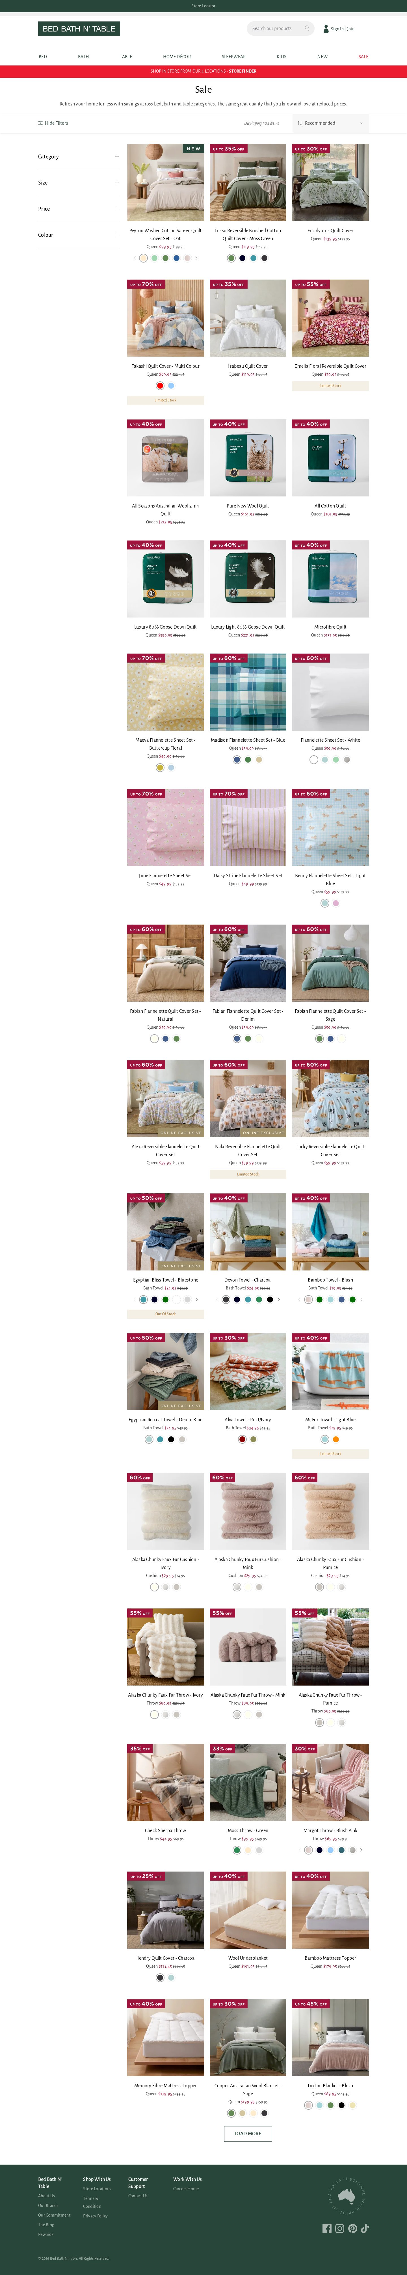
Template: product-listing (PLP) — representative page
blog-article
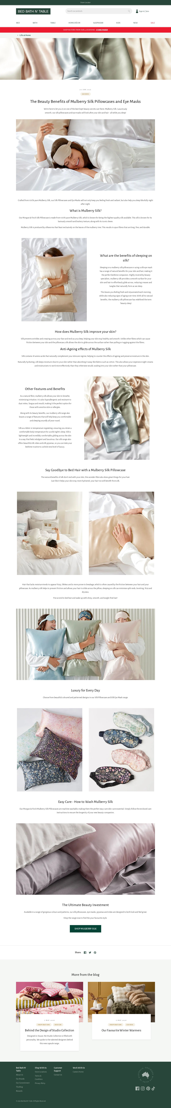
Template: blog-article — representative page
influencer / shop-the-look
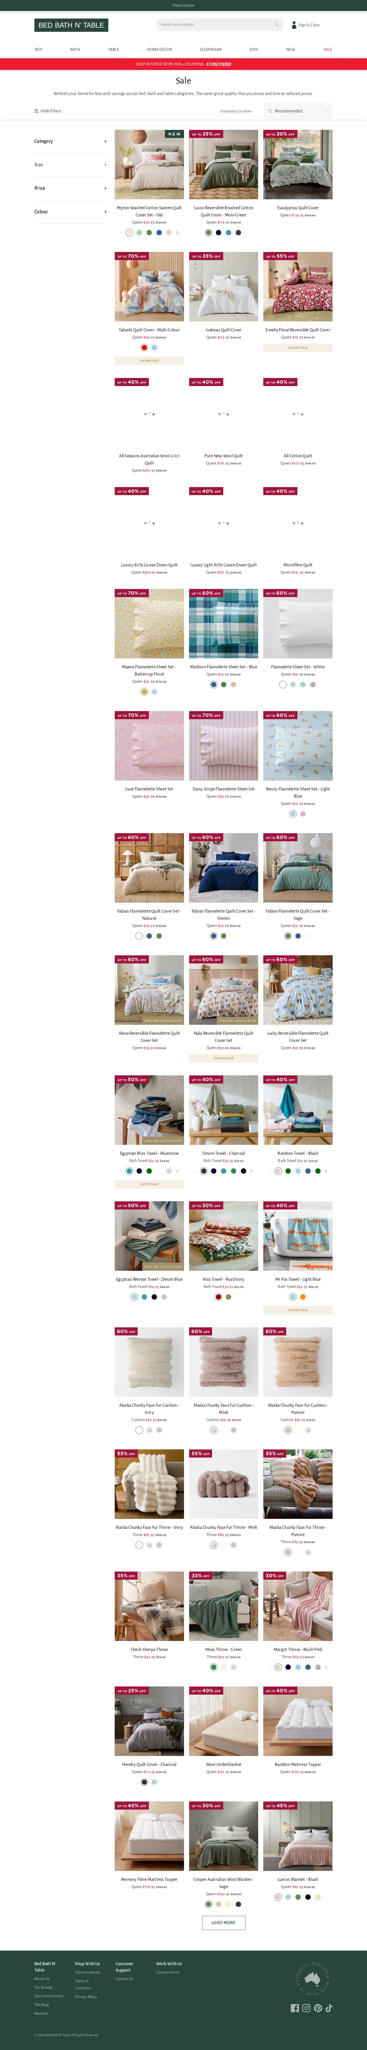
Template: influencer / shop-the-look — representative page
3. Blocks / Components Catalog
61 block variants catalogued and consolidated by content model. E-commerce sites are block-rich; the standouts are 20 form variants and 13 hero variants.
Block (base) | Variants | Complexity | Behaviour / Functionality | Reference URL
header (global) | 1 | High | Store-locator bar, logo, product search, Sign In/Join, mega-nav (Bed/Bath/Table/Home Décor/Sleepwear/Kids/New/Sale), mini-cart. | all pages
footer (global) | 1 | Medium | 4-column link nav, social icons, "Designed in Australia" seal, legal. | all pages
hero | 13 | Medium | Full-width promo/category banners; many merchandising variants. | /, /bed
form | 20 | High | Search, newsletter, account/login, add-to-cart, filters, contact, store-locator, reCAPTCHA-protected forms. | site-wide
cards | 1 | Medium | Product/category card grid (image, title, price, badge, swatch). | /sale
carousel | 4 | Medium | Product/image carousels ("Style With", collections). | PDP
tabs | 5 | Medium | Product info tabs / accordions (details, size guide). | PDP
columns | 5 | Low–Med | PageBuilder multi-column layout rows. | blog, home
video | 2 | Medium | Embedded video blocks. | blog/campaign
embed | 2 | Medium | Third-party embeds (maps, social). | store locator
custom / unknown | 7 | High | Composite PageBuilder compositions (heading+image+CTA+paragraph combos). | content pages
Block screenshots — all 61 variants
Every catalogued block variant is shown below, grouped by base block. Each caption gives the variant identifier and the number of sampled pages it appeared on.
header (1 variant)
header-global — undefined pages
footer (1 variant)
footer-global — undefined pages
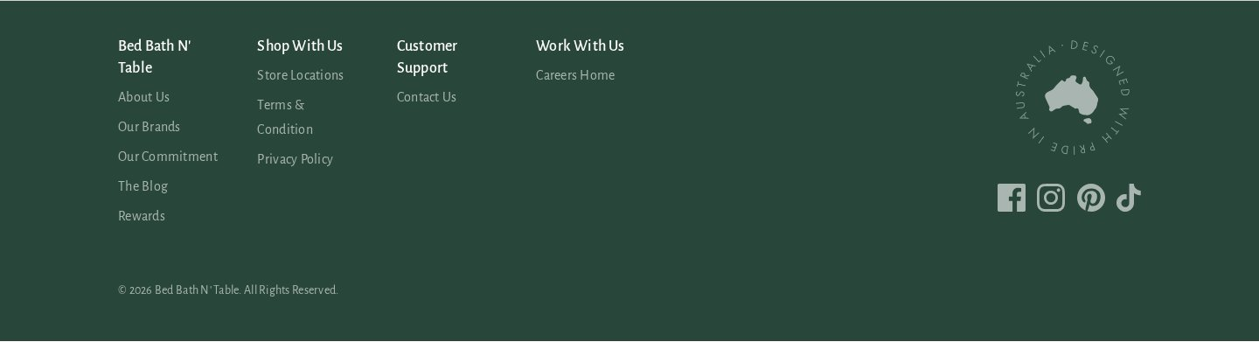
hero (13 variants)
hero-minimal-dark-withimg — undefined pages
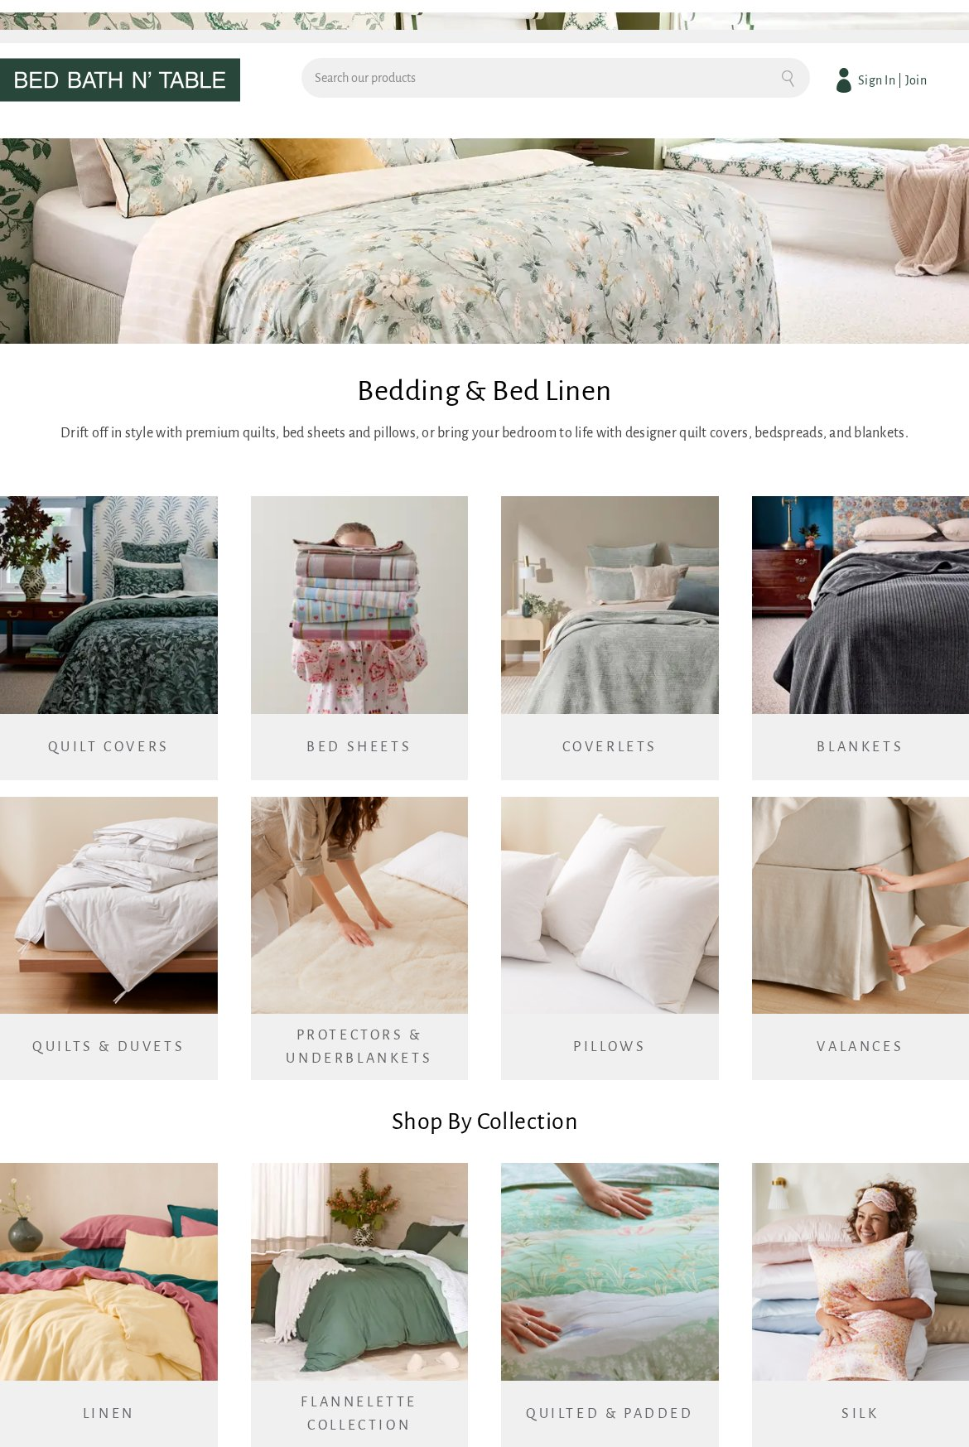
hero-minimal-dark — undefined pages
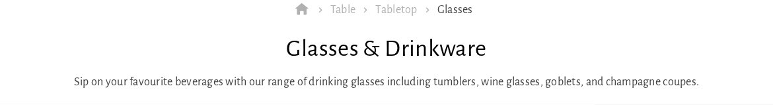
hero-minimal-dark-withimg-1 — undefined pages
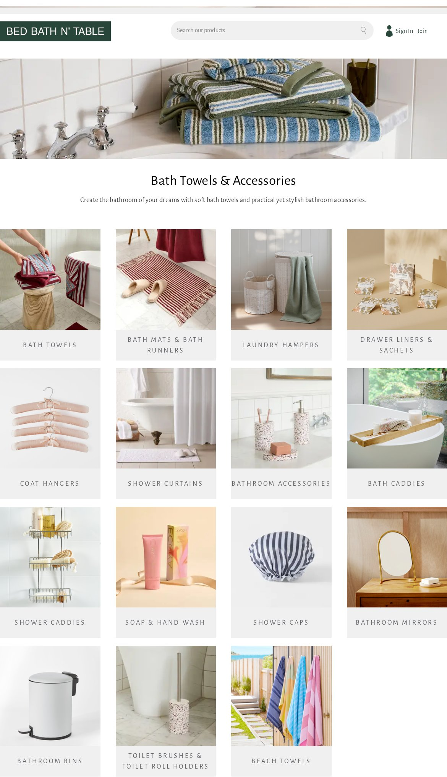
hero-moderate-dark — undefined pages

hero-minimal-dark-withimg-2 — undefined pages
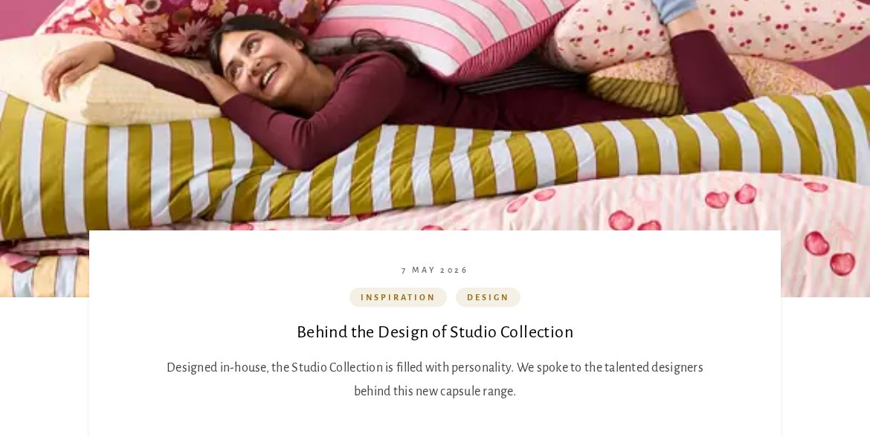
hero-minimal-dark-withimg-3 — undefined pages

hero-moderate-dark-1 — undefined pages
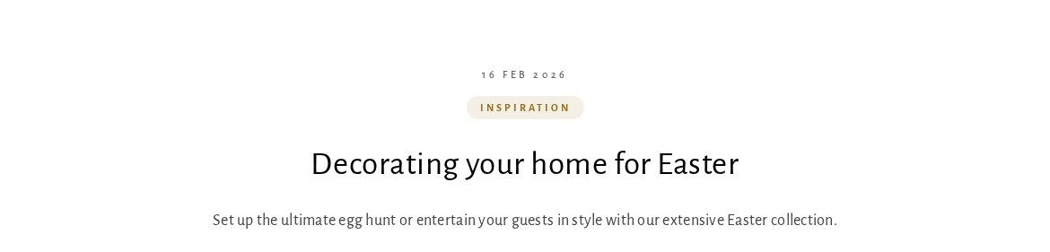
hero-minimal-dark-1 — undefined pages
hero-minimal-dark-withimg-4 — undefined pages
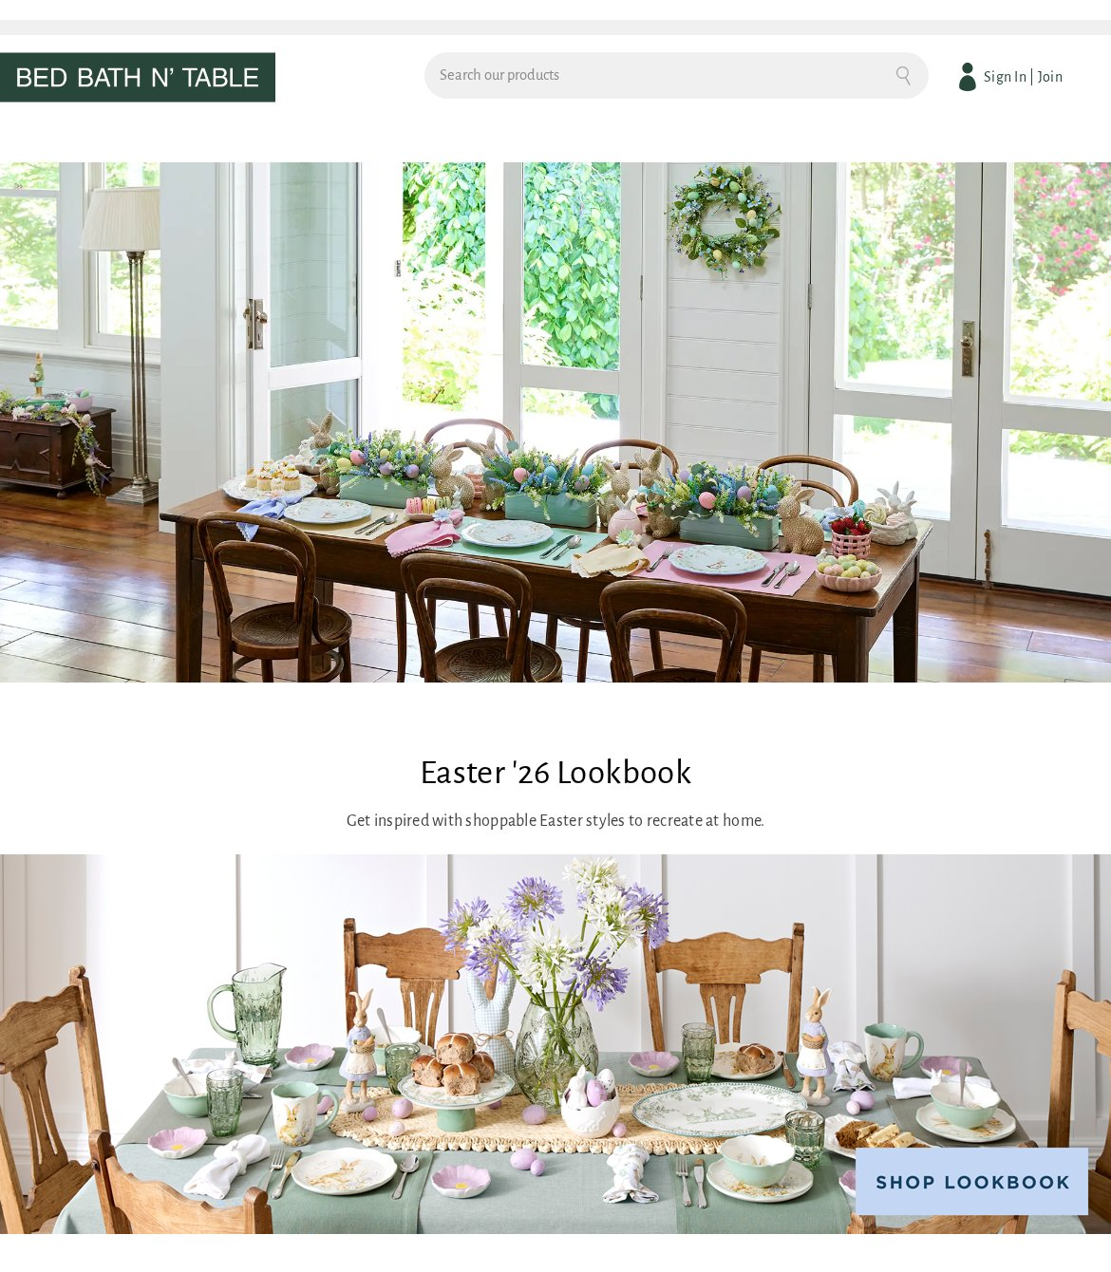
hero-minimal-dark-withimg-5 — undefined pages
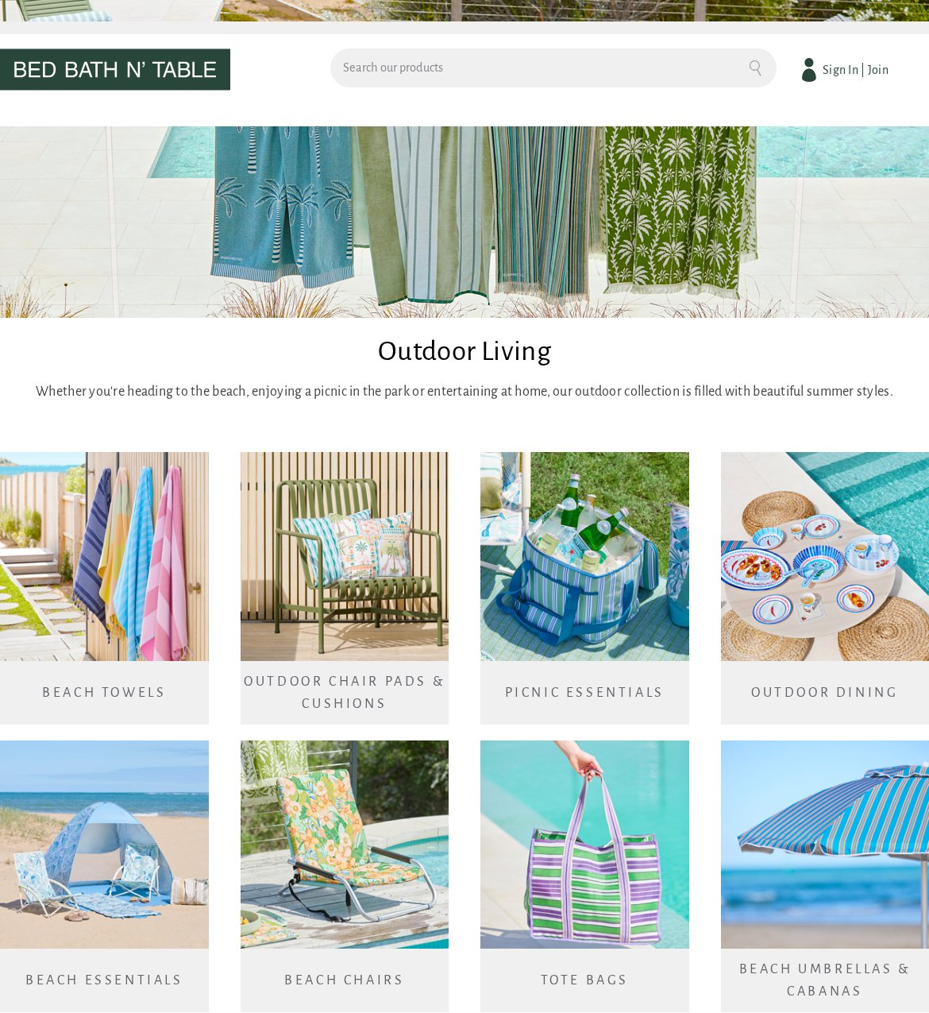
hero-minimal-dark-2 — undefined pages
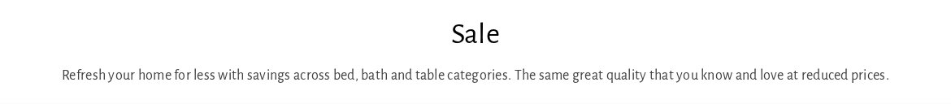
hero-minimal-dark-3 — undefined pages
hero-minimal-dark-withimg-6 — undefined pages
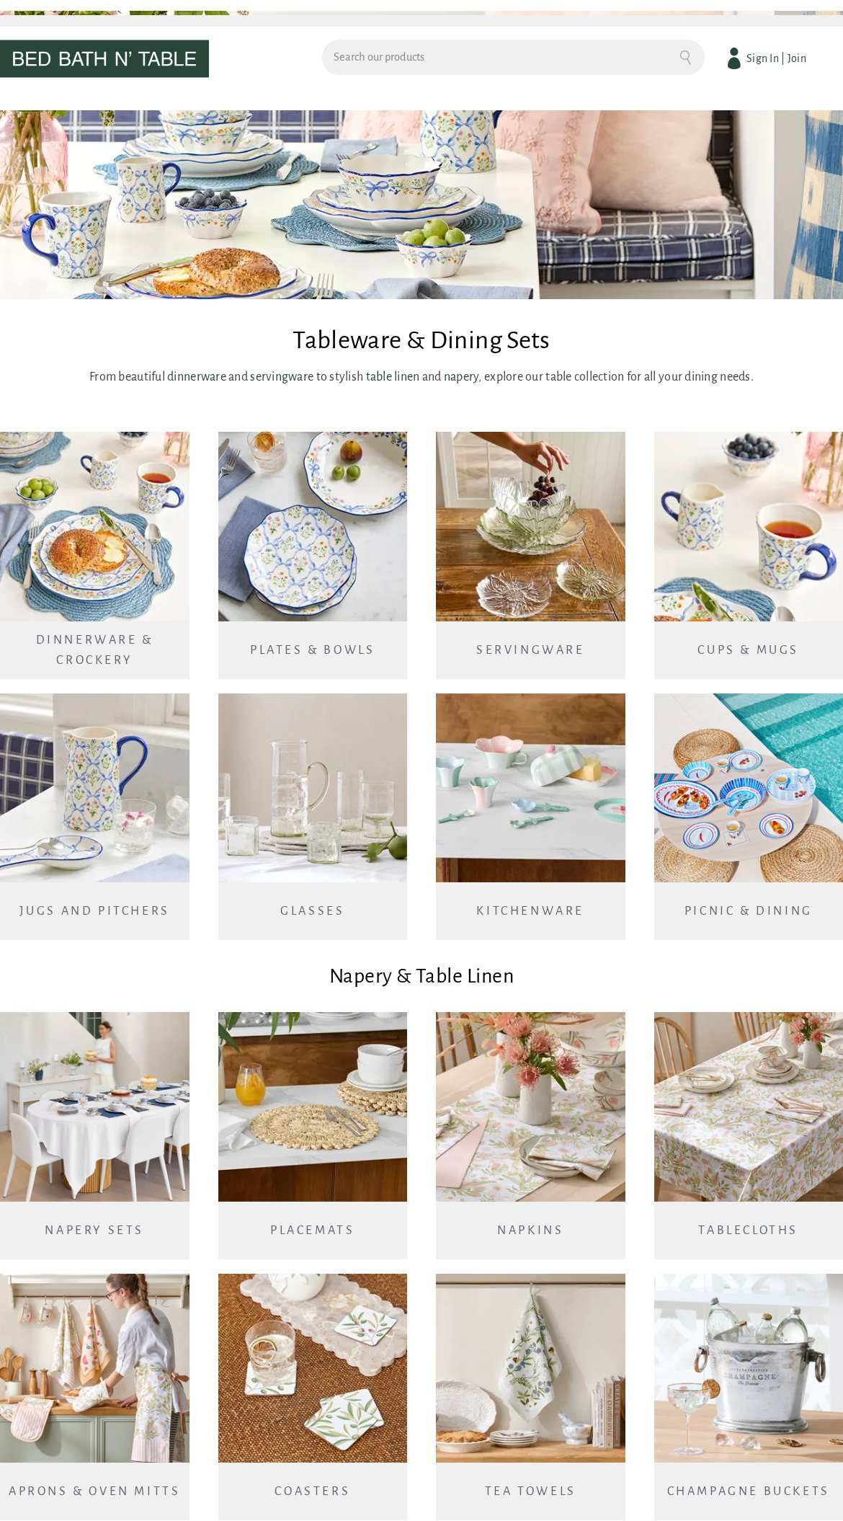
cards (1 variant)
cards-moderate-dark — undefined pages
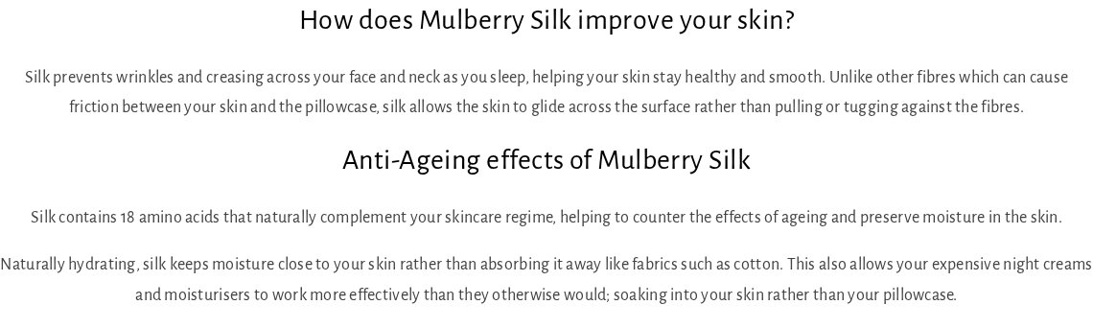
carousel (4 variants)
carousel-minimal-dark-withimg — undefined pages
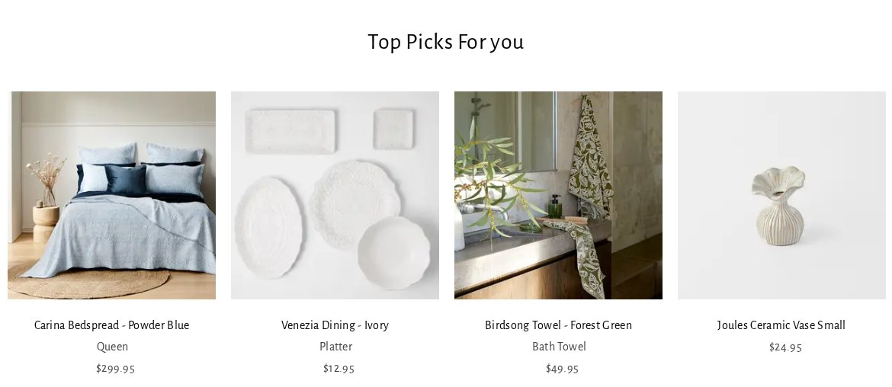
carousel-minimal-dark-withimg-1 — undefined pages
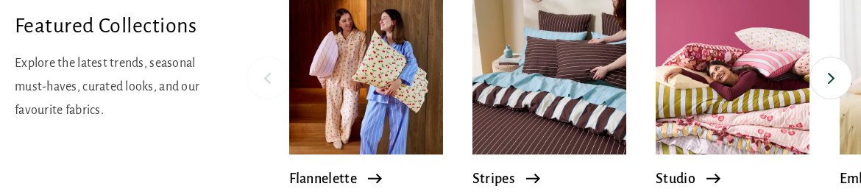
carousel-moderate-dark — undefined pages
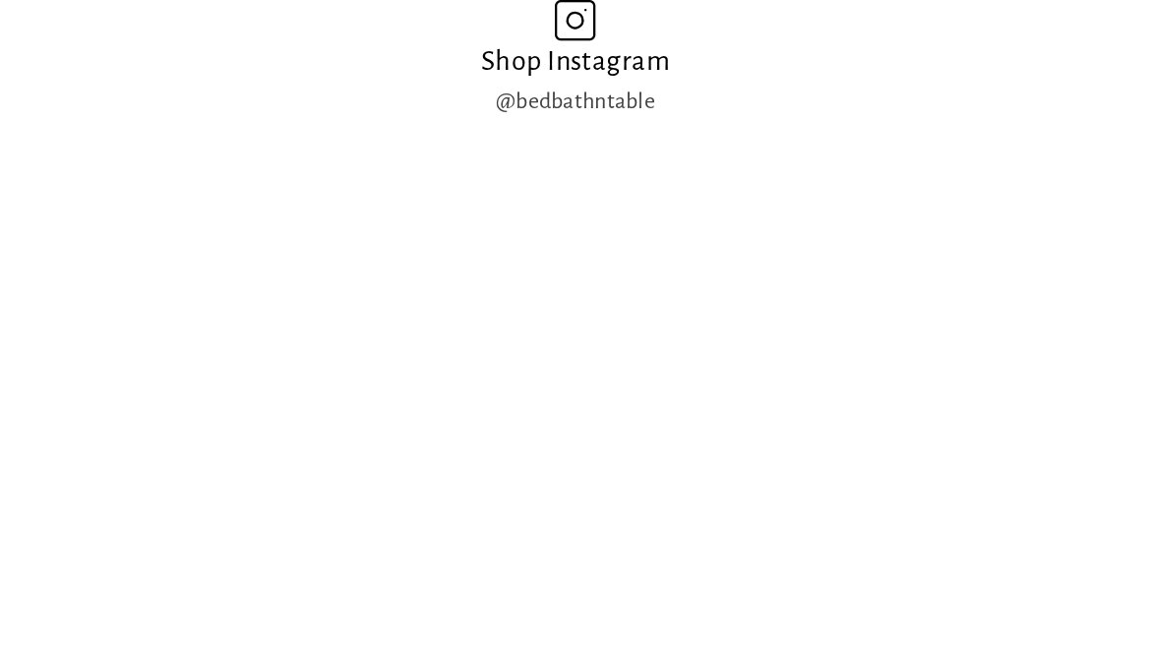
carousel-minimal-dark-withimg-2 — undefined pages
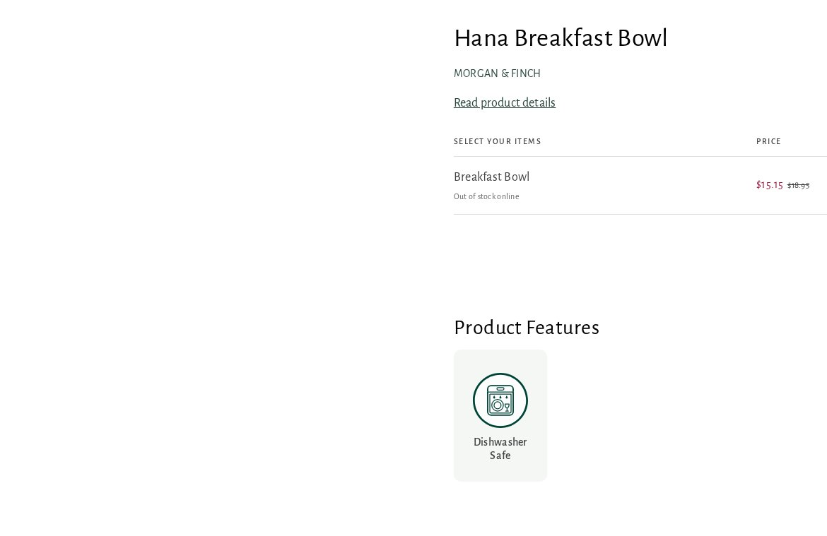
tabs (5 variants)
tabs-minimal-dark-withimg — undefined pages
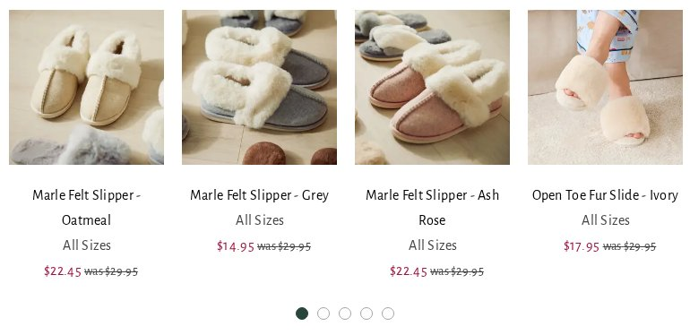
tabs-minimal-dark-withimg-1 — undefined pages
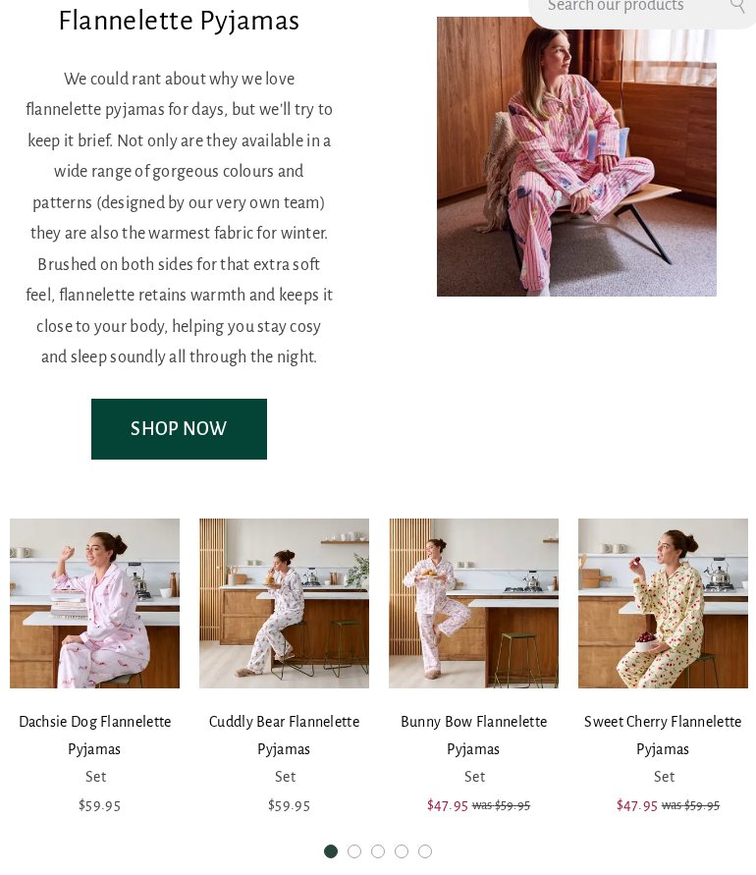
tabs-minimal-dark-withimg-2 — undefined pages
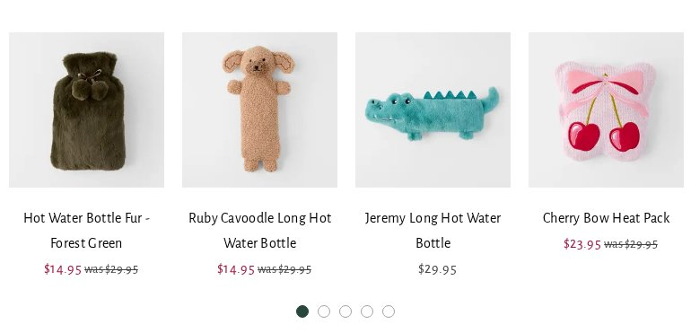
tabs-minimal-dark-withimg-3 — undefined pages
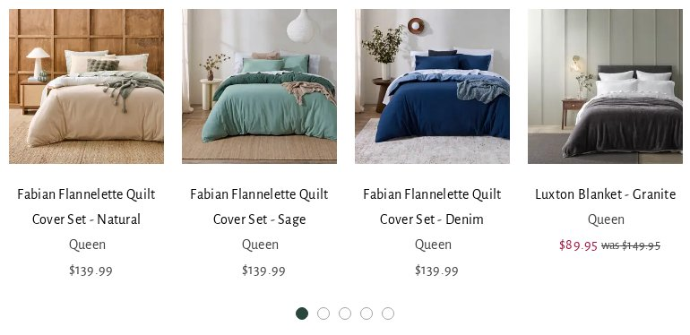
tabs-minimal-dark-withimg-4 — undefined pages
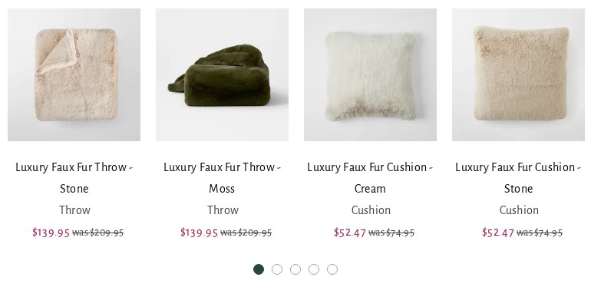
columns (5 variants)
columns-minimal-dark — undefined pages

columns-minimal-dark-1 — undefined pages

columns-minimal-dark-2 — undefined pages
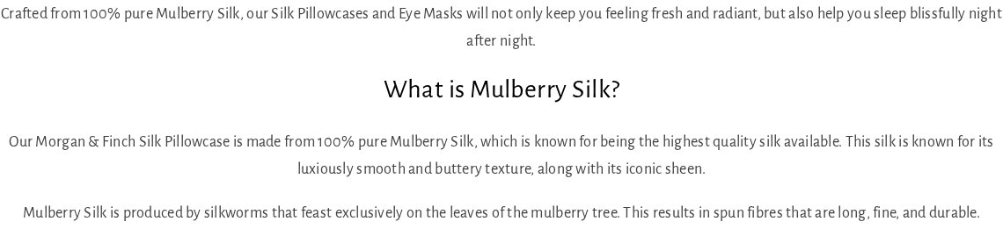
columns-minimal-dark-withimg — undefined pages
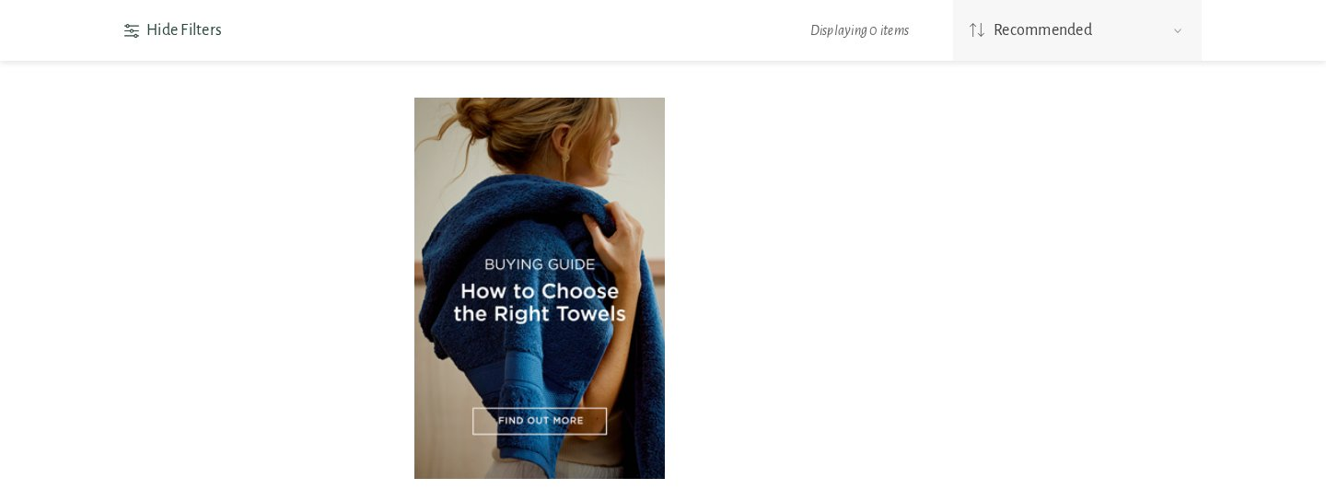
columns-minimal-dark-withimg-1 — undefined pages
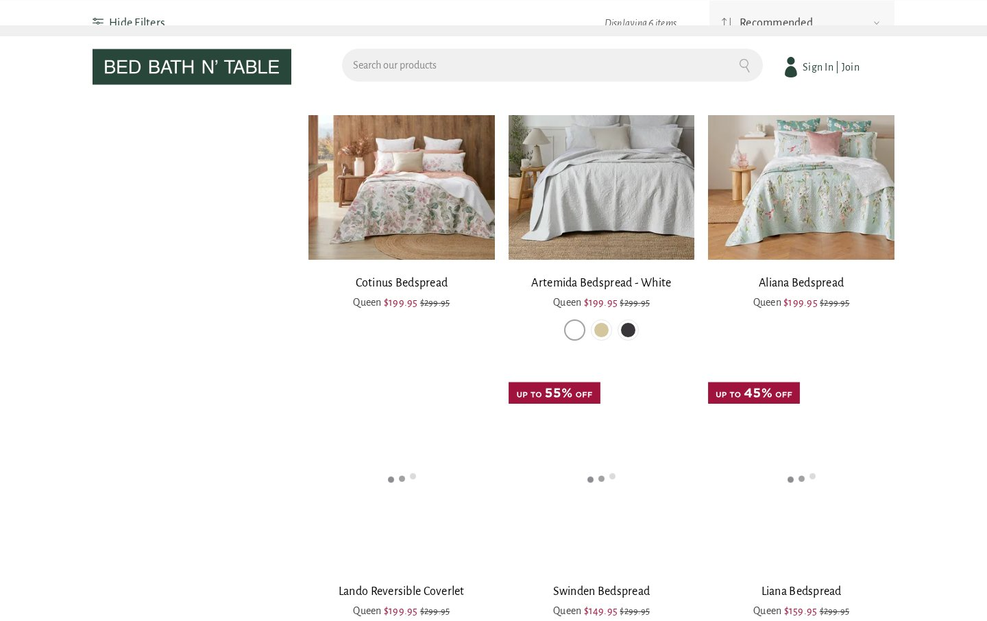
form (20 variants)
form-minimal-dark-withimg — undefined pages
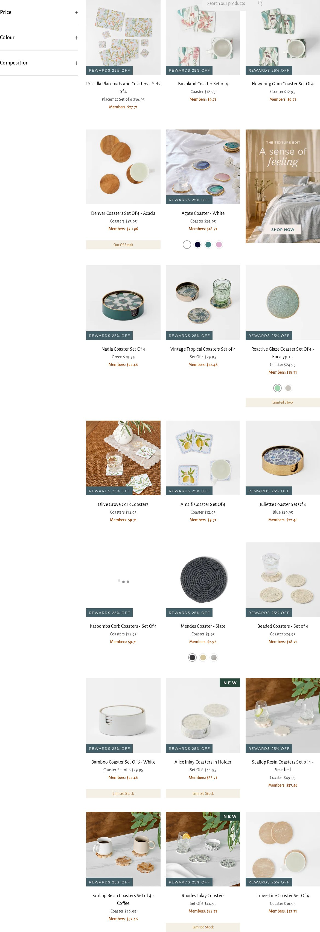
form-minimal-dark — undefined pages
form-minimal-dark-withimg-1 — undefined pages
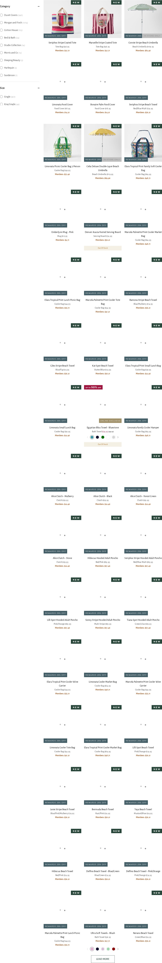
form-minimal-dark-1 — undefined pages
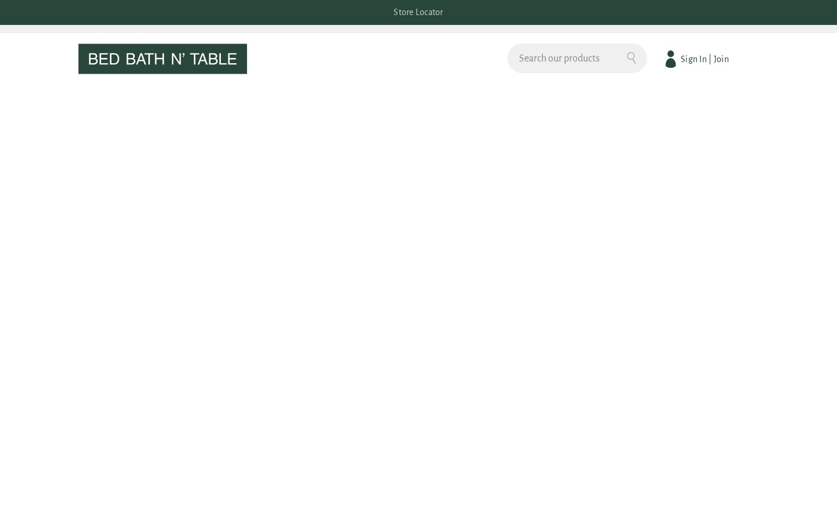
form-minimal-dark-withimg-2 — undefined pages
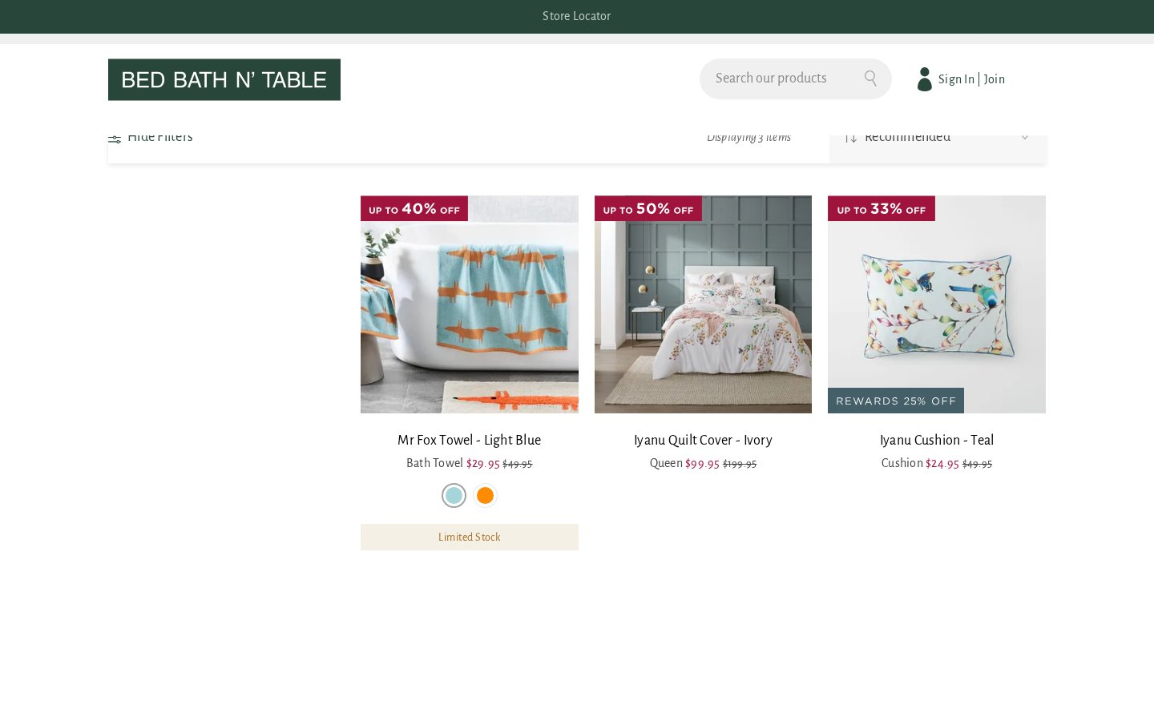
form-moderate-dark — undefined pages
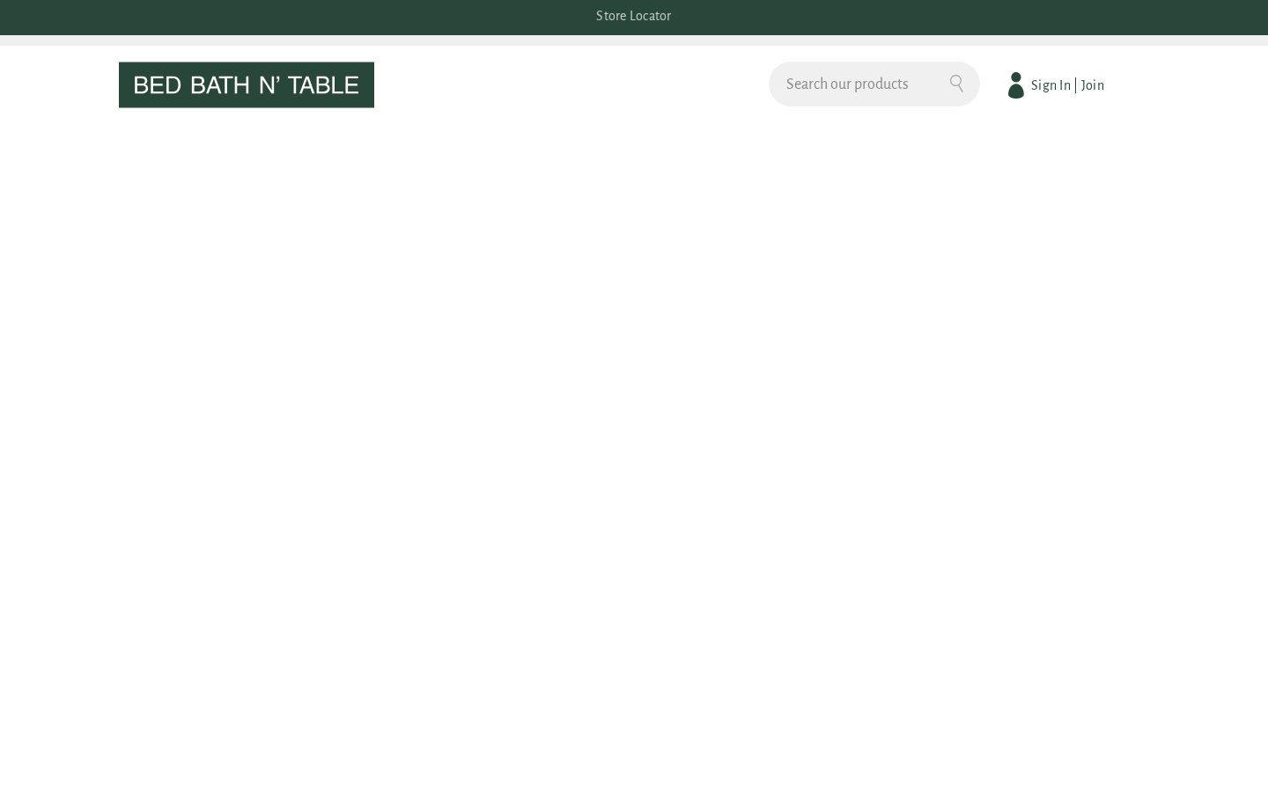
form-minimal-dark-withimg-3 — undefined pages
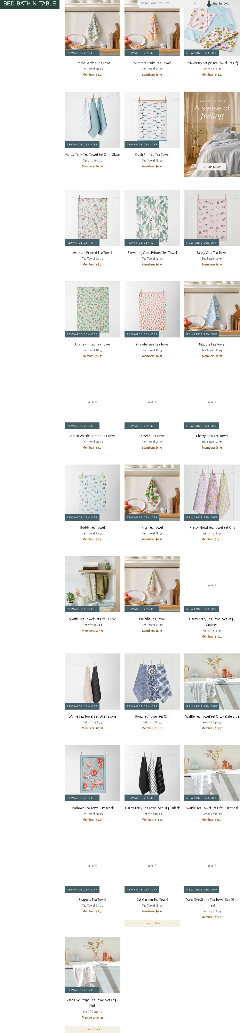
form-minimal-dark-withimg-4 — undefined pages
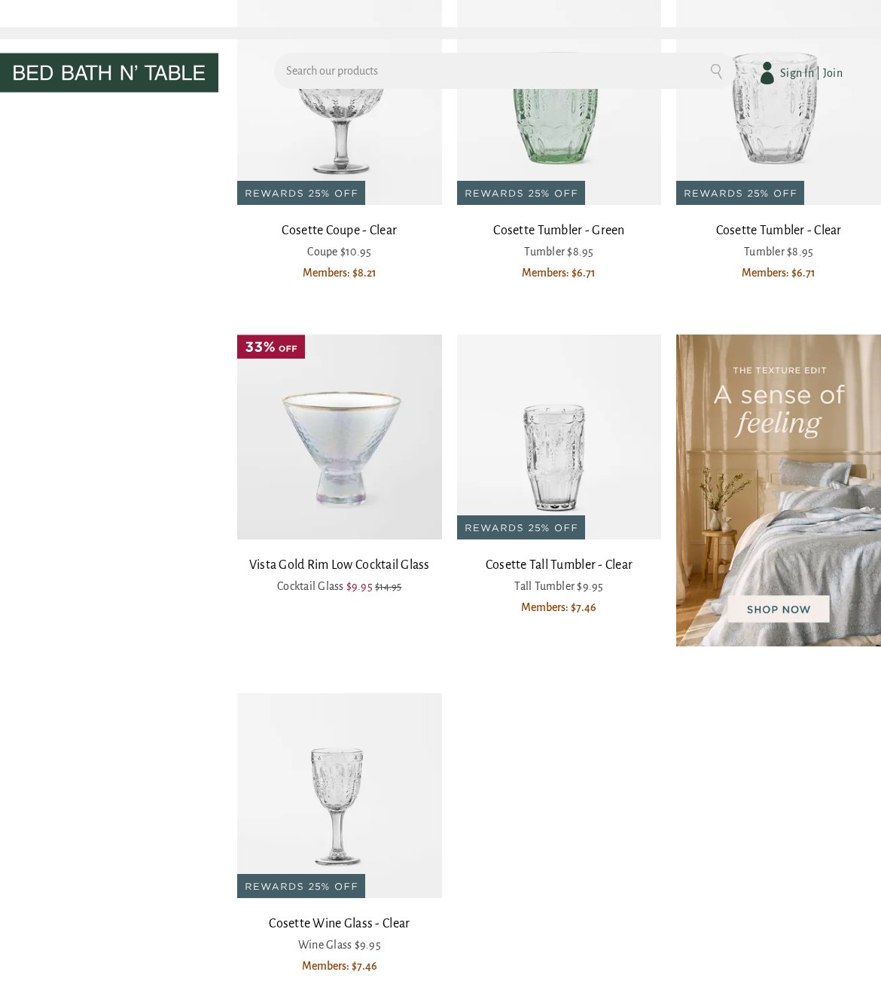
form-minimal-dark-withimg-5 — undefined pages
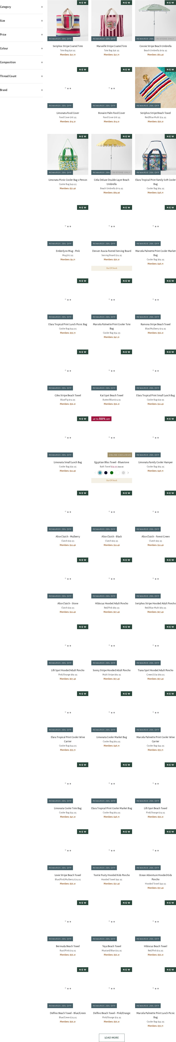
form-minimal-dark-withimg-6 — undefined pages
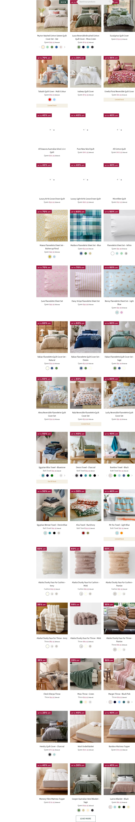
form-minimal-dark-withimg-7 — undefined pages
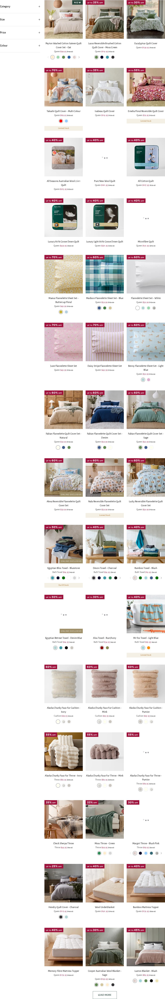
form-minimal-dark-withimg-8 — undefined pages
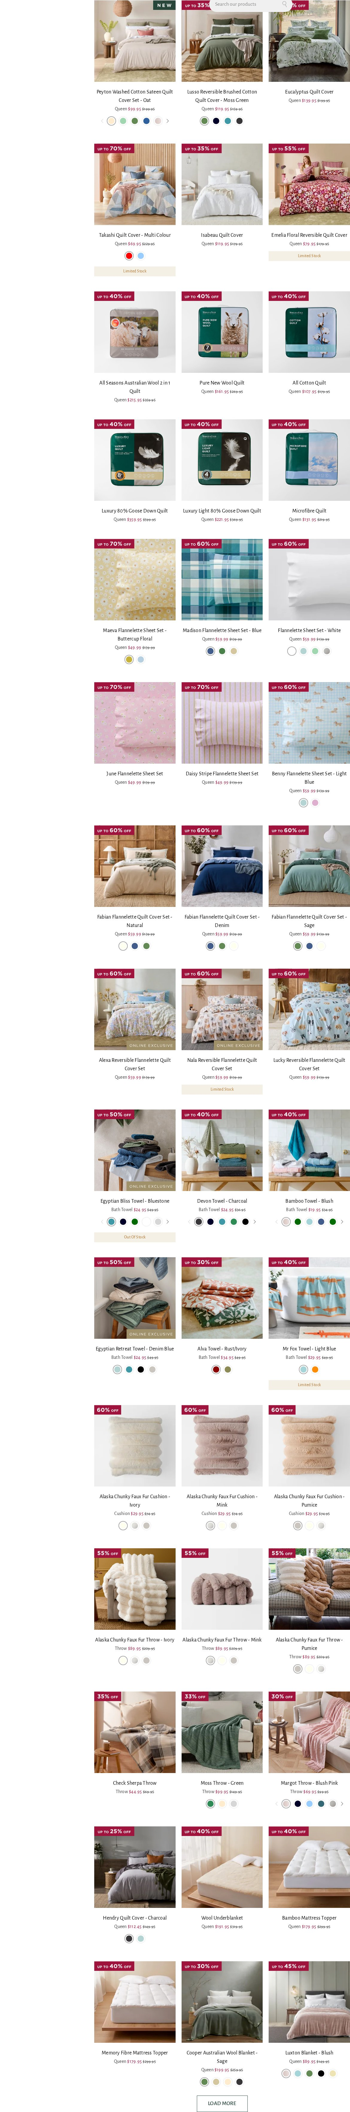
form-minimal-dark-withimg-9 — undefined pages
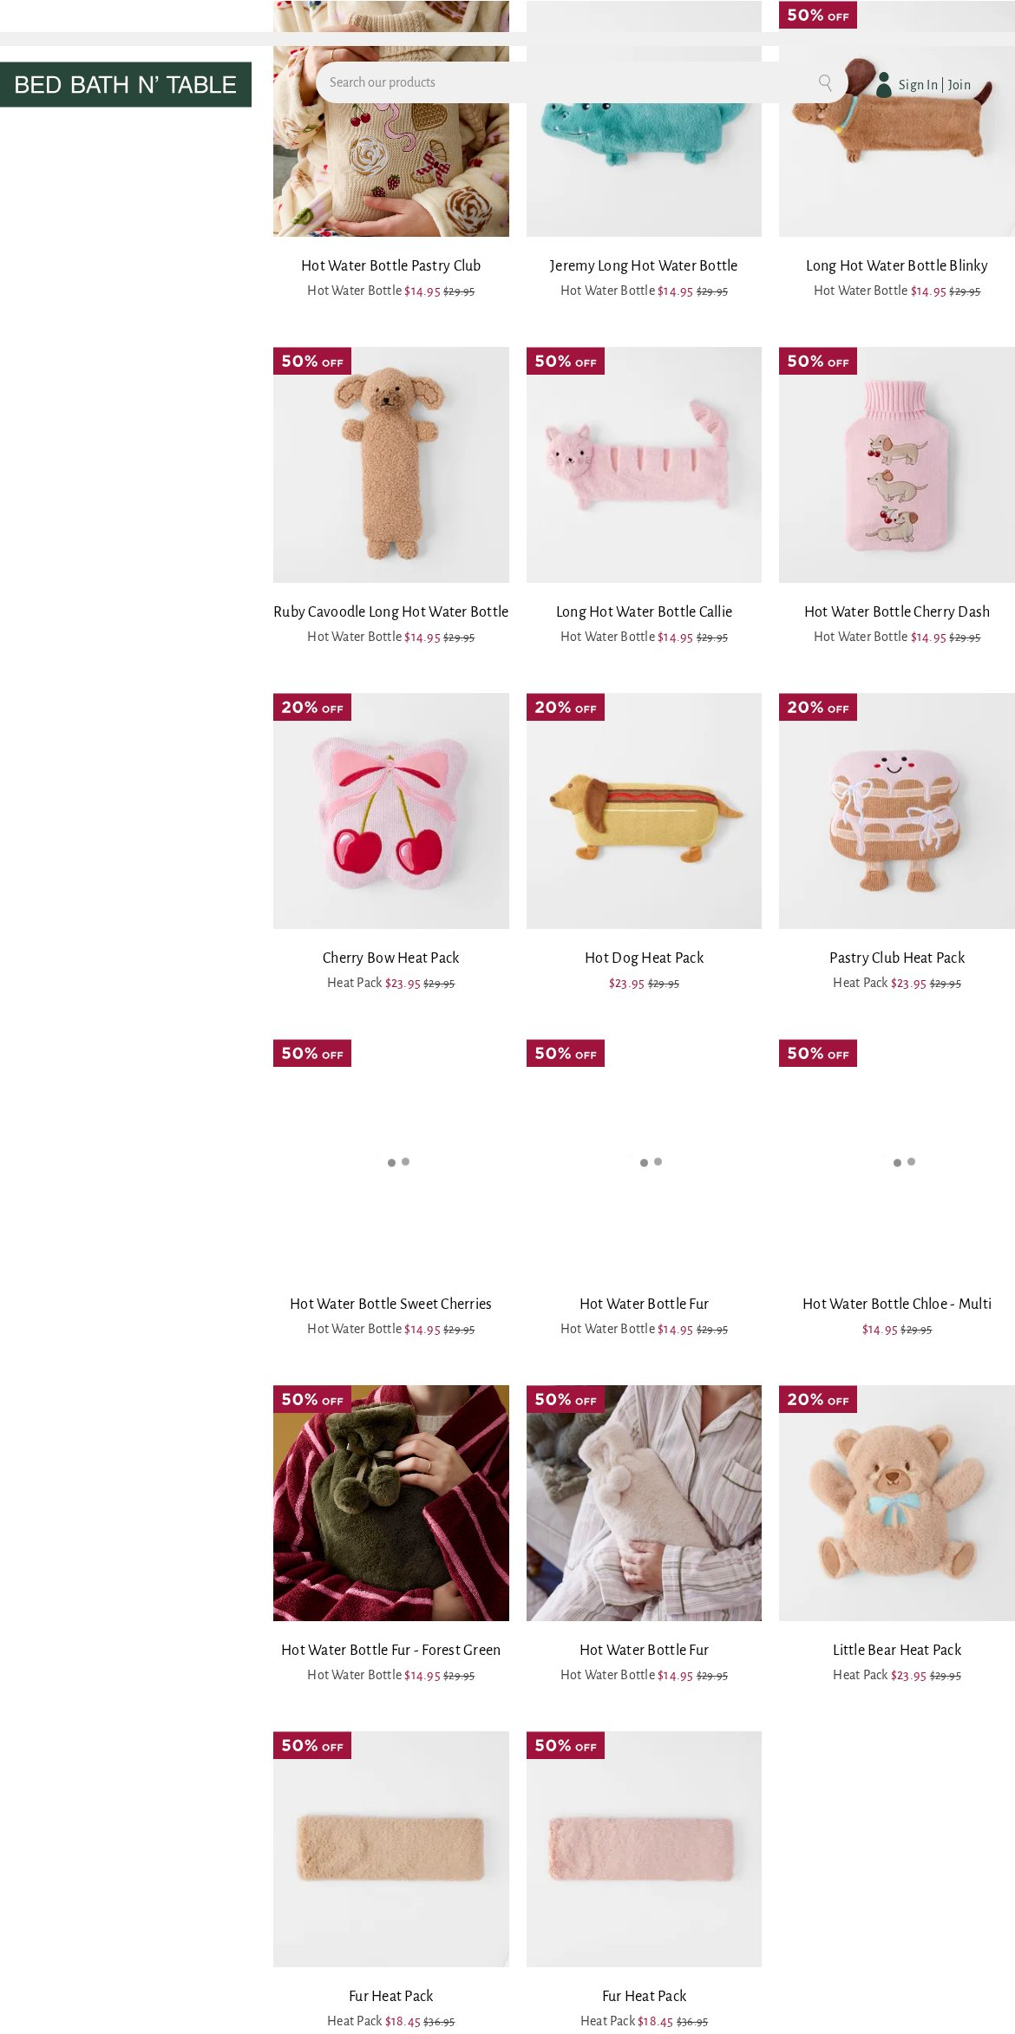
form-minimal-dark-withimg-10 — undefined pages
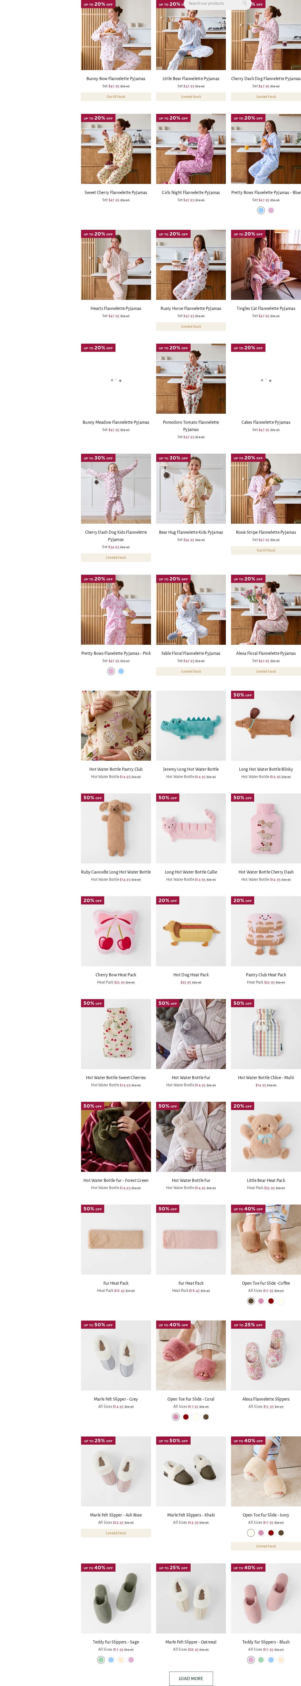
form-minimal-dark-withimg-11 — undefined pages
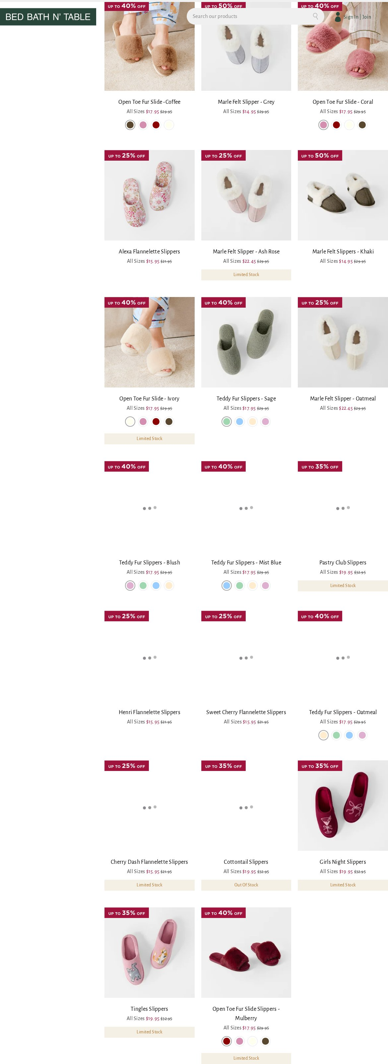
form-minimal-dark-withimg-12 — undefined pages
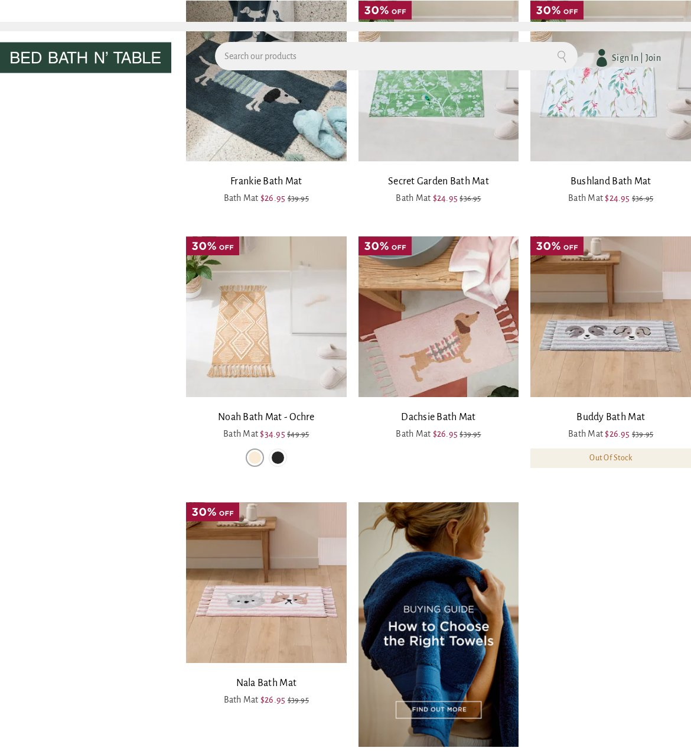
form-minimal-dark-withimg-13 — undefined pages
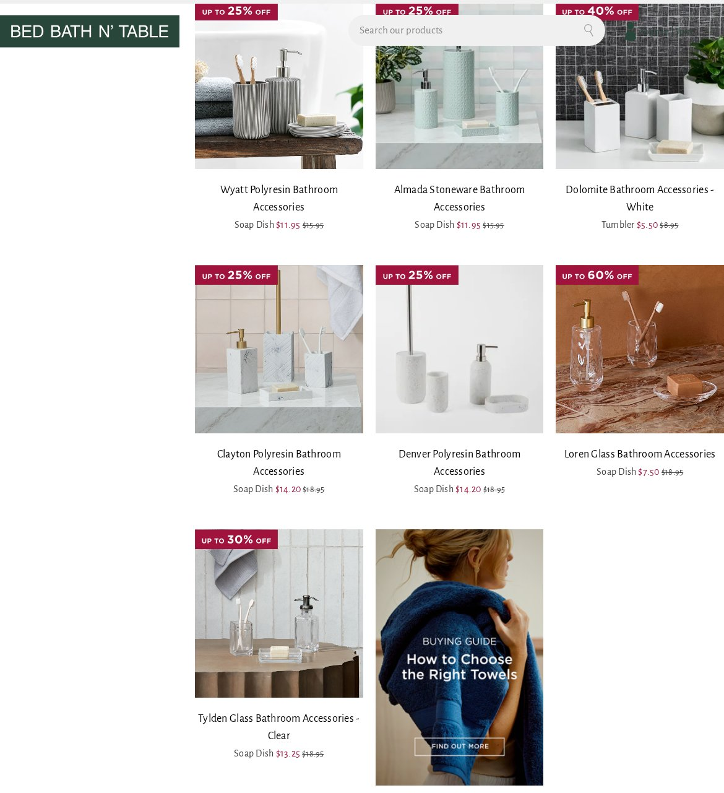
form-minimal-dark-withimg-14 — undefined pages
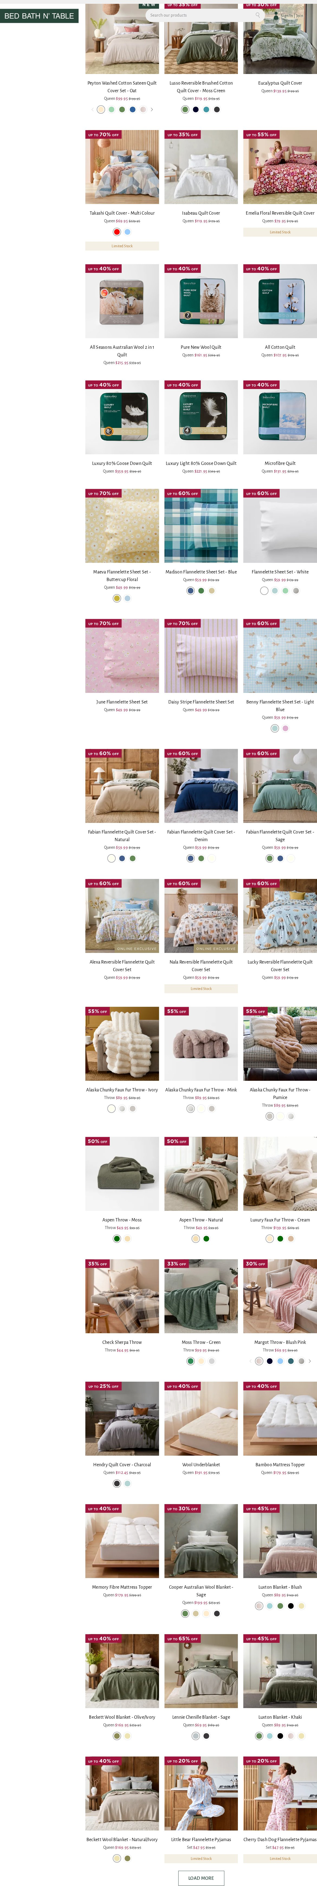
form-minimal-dark-withimg-15 — undefined pages
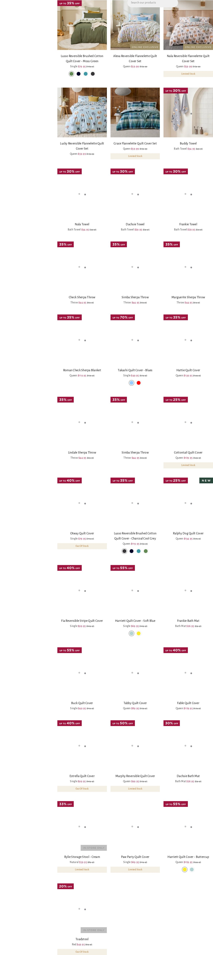
form-minimal-dark-withimg-16 — undefined pages
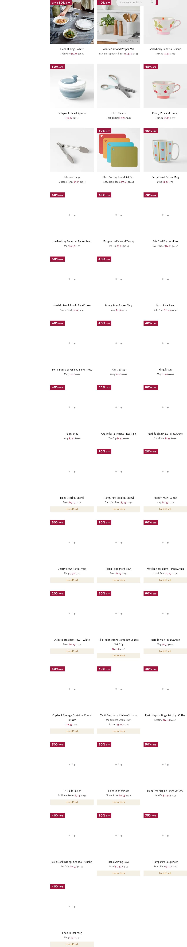
video (2 variants)
video-moderate-dark-withimg — undefined pages
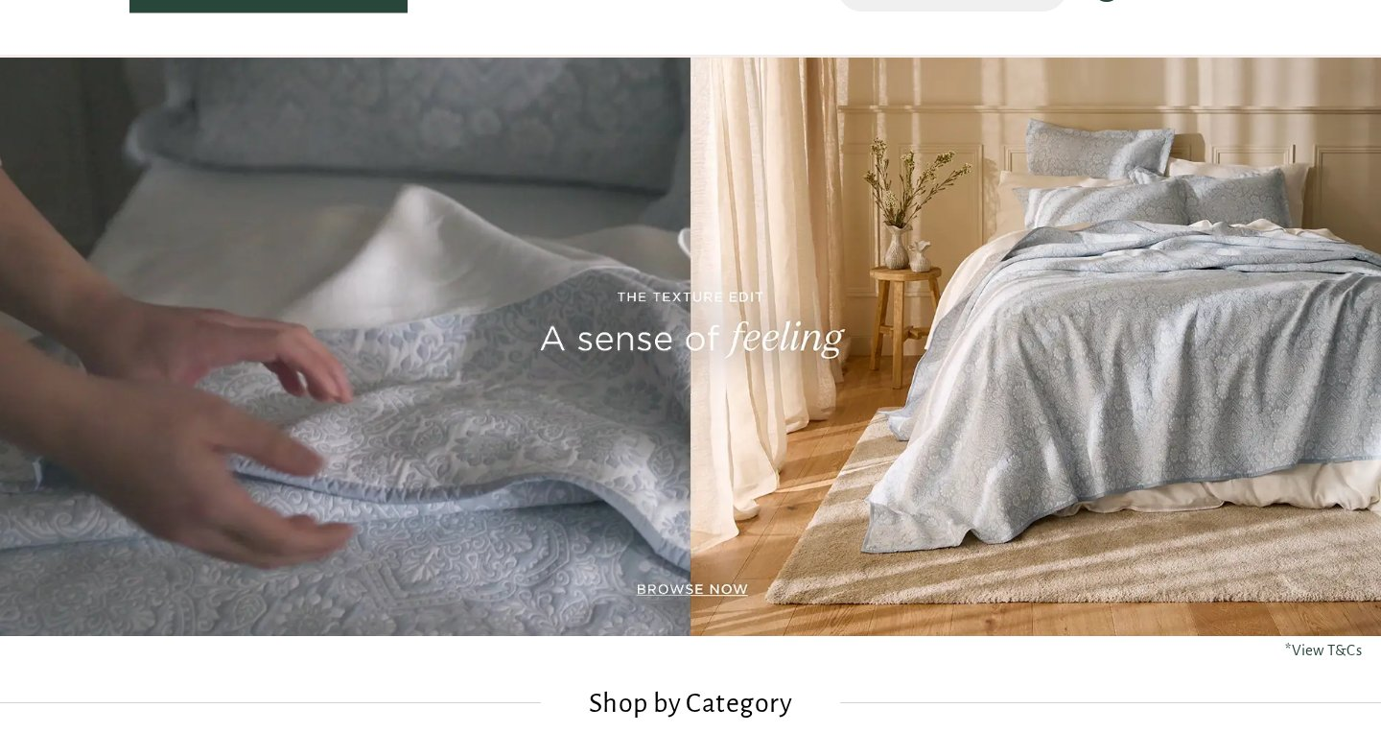
video-minimal-dark-withimg — undefined pages
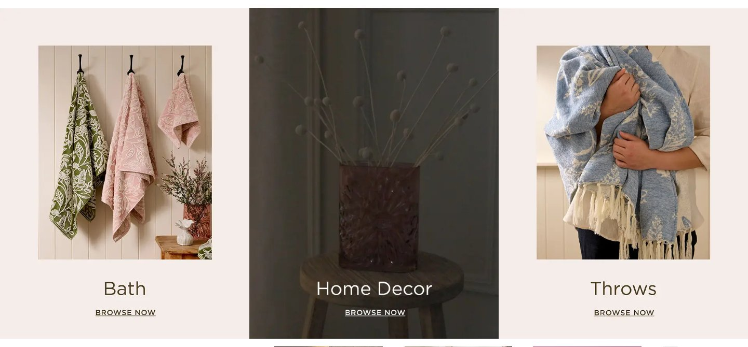
embed (2 variants)
embed-minimal-light — undefined pages
embed-minimal-dark-withimg — undefined pages
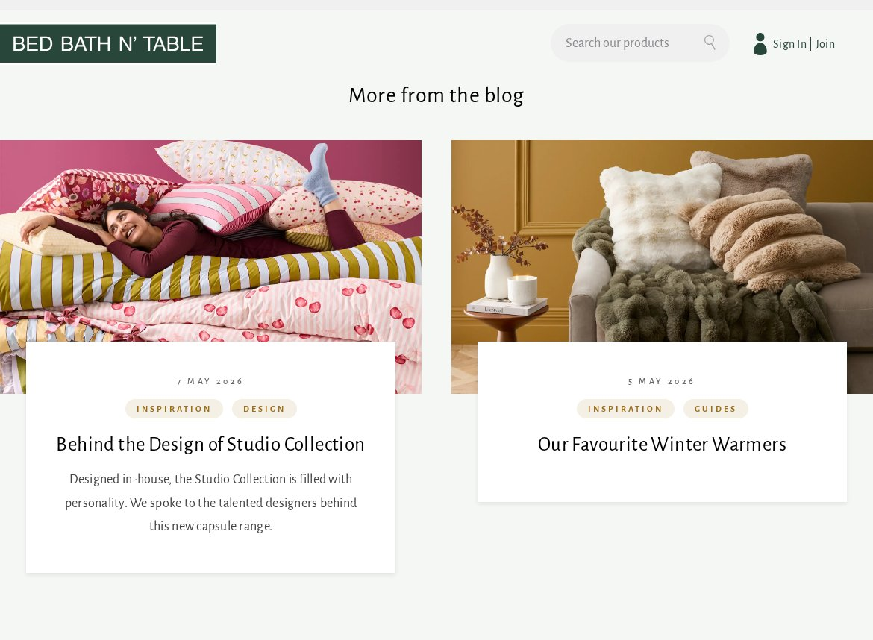
unknown (7 variants)
2 images block-minimal-dark-withimg — undefined pages
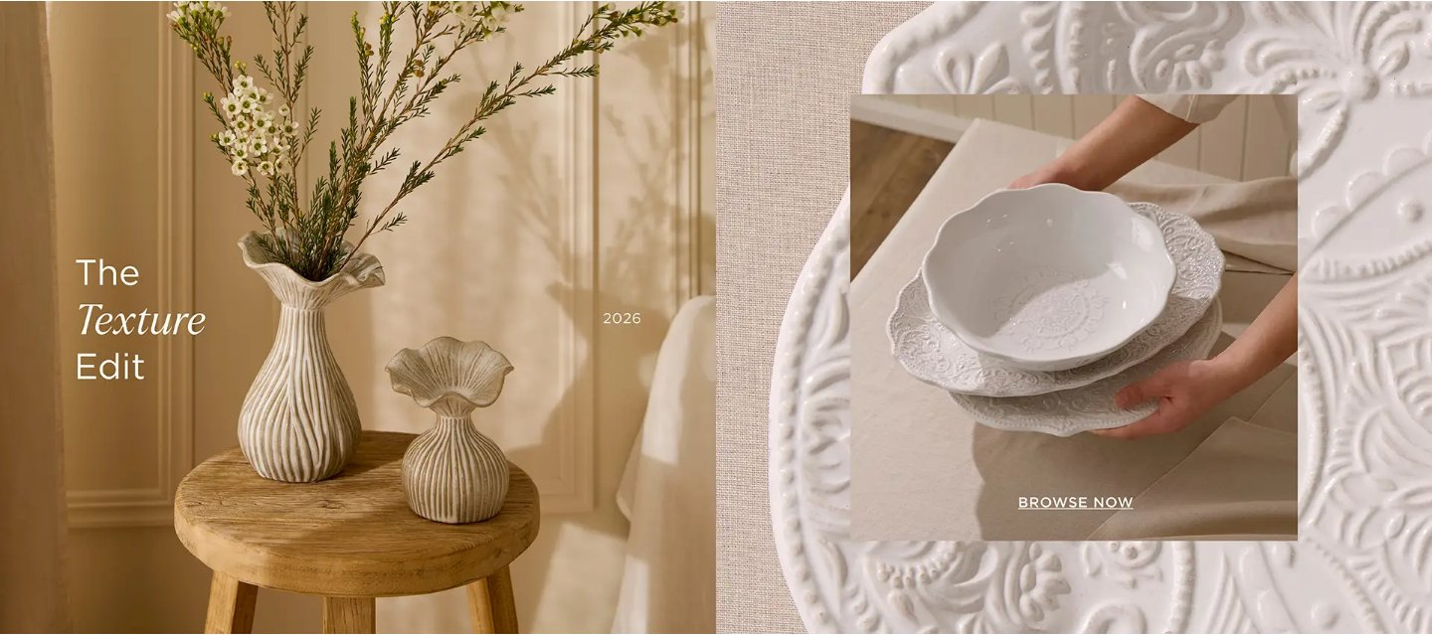
2 ctas + 3 paragraphs block-minimal-light — undefined pages
1 heading + 1 image + 1 paragraph block-minimal-dark-withimg — undefined pages
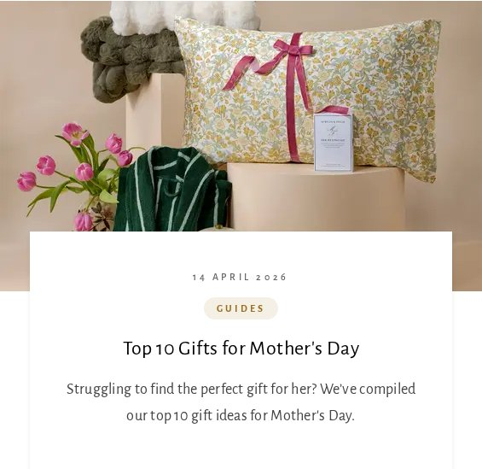
1 heading + 2 images + 1 cta + 1 paragraph block-minimal-dark-withimg — undefined pages

1 cta block-minimal-dark — undefined pages
4 images block-minimal-dark-withimg — undefined pages
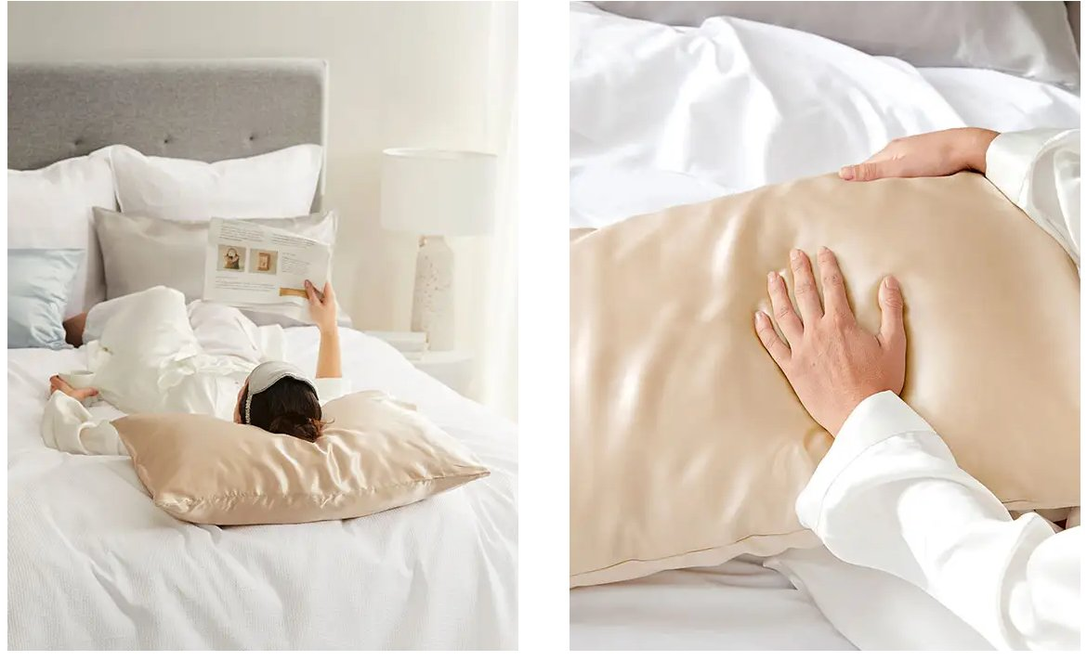
1 heading + 1 cta + 2 paragraphs block-minimal-dark — undefined pages
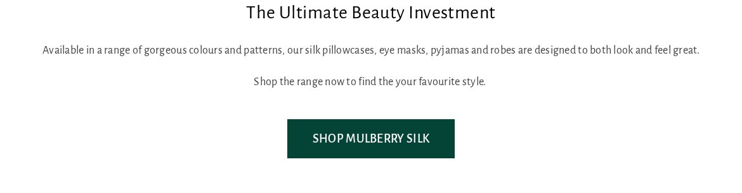
4. Page Counts by Template & Migration Classification
Counts scaled to the full 6,756-URL sitemap.
Template | Pages (approx) | Migration Path | Rationale
product-detail (PDP) | 5,165 | Automated (data-driven) | Uniform template; migrate via catalog/feed export, not page scraping. Ideal for bulk automation.
product-listing + categories | ~1,390 | Semi-auto | Category tree + facet config; grids data-driven but filters/curation need setup.
blog (articles + indexes) | 87 | Semi-auto | Editorial import; rich PageBuilder bodies.
influencer / shop-the-look | 47 | Semi-auto | Curated product links.
catalog/category/view (id dupes) | 17 | Automated (redirect) | Canonical duplicates → redirect rules.
homepage + CMS/static | ~50 | Manual | Merchandised/bespoke; hand-build.
Total | 6,756 | Automated ~77% | Semi-auto ~22% · Manual ~1%
The huge PDP volume is the easy part (one template, data-driven bulk import from the Magento catalog), while the merchandised home/campaign pages and PLP facet configuration are the effort.
5. Integrations Analysis
Integration | Type | Complexity | Where used
Adobe Commerce (Magento 2) | Platform / backend | High | Site-wide (catalog, cart, checkout, customer)
Magento PageBuilder | CMS / content | Medium | Home, category, CMS, blog
Fastly CDN | Platform / caching | Medium | Site-wide (/fastlyCdn/)
Afterpay | Payment (BNPL) | High | PDP, cart, checkout (mini-cart integration)
PayPal | Payment gateway | High | Cart, checkout (billing agreements)
Google reCAPTCHA | Security / forms | Low | Login, registration, forms
Google Tag Manager + gtag | Analytics / tags | Medium | All pages
Dotdigital | Email / marketing automation | Medium | Newsletter, email capture
Adobe Edge Delivery RUM (rum.hlx.page) | Measurement | Low | Homepage (pilot)
Social: Facebook, Pinterest, TikTok, Instagram | Pixels / embeds | Low | Tracking + footer
Store Locator | Feature / embed | Medium | Store-locator pages
Wishlist / customer sections | Commerce feature | Medium | Account, PDP
6. Complex Use Cases & Observations
# | Complex behaviour | Instances | Where | Why complex
1 | Product catalog & variants | 5,165 PDPs | product pages | Variant/SKU selection, pricing, inventory — needs catalog data source, not page scrape.
2 | Faceted search / filtering | ~1,390 PLPs | category/sale pages | Dynamic Category/Size/Price/Colour facets + Load More; query-driven.
3 | Cart / checkout / payments | site-wide | cart, checkout | Afterpay + PayPal + reCAPTCHA; transactional — stays on/integrates with commerce backend.
4 | Customer accounts / wishlist | site-wide | account, PDP | Auth, session, saved items.
5 | PageBuilder compositions | home + campaigns | merchandised pages | Bespoke layouts → map to EDS blocks.
6 | Stale sitemap entries (404s) | 27 of 78 sampled (~35%) | products + blog | Discontinued products/seasonal posts still listed — real URL count is lower; needs validation pass.
7 | Duplicate canonical URLs | 17+ | /catalog/category/view/id/* | Same category via slug + id → redirect strategy.
8 | Rich blog editorial | 87 | /blog/* | Long-form image+text + product callouts.
7. Migration Estimates
Estimates cover the content/storefront presentation layer. The commerce engine (cart, checkout, payments, catalog DB) is assumed to remain on Adobe Commerce — EDS fronts the content/browse experience while transactions stay on Magento.
Effort by workstream
Workstream | Estimate | Notes
Block development (61 variants → ~18–22 EDS blocks + variations) | 18–25 days | Heavy: 20 form + 13 hero variants, carousels, tabs
Template setup (8 functional templates) | 8–10 days | PDP, PLP, category, home, blog, content
PDP automation (catalog-feed import, ~5,165) | 6–10 days | Scripted from Magento catalog/API — the big win
PLP + category setup (facets, tree, curation) | 8–12 days | Data-driven grids + filter config
Homepage + campaign/CMS pages | 6–9 days | Merchandised, bespoke
Blog + influencer content import (~134) | 5–8 days | Editorial PageBuilder bodies
Header / footer / mega-nav / search | 5–7 days | Commerce nav + mini-cart
Commerce integrations (cart/checkout/Afterpay/PayPal/search) | 8–14 days | Front-end integration to Magento
Analytics & marketing (GTM/Dotdigital/pixels/RUM) | 3–5 days
URL validation + redirects (404s, canonical dupes) | 3–5 days | ~35% stale-URL signal needs a crawl-verify pass
QA & testing (functional, commerce, visual, a11y, PageSpeed) | 12–16 days | Commerce QA is heavier
PM / UAT / fixes | 8–10 days
Totals
Metric | Estimate
Total effort | ~90–130 person-days (≈ 18–26 weeks of work)
Recommended team | 2–3 developers + 1 commerce specialist + 1–2 QA + PM
Calendar schedule | ~12–18 weeks with the team above
Indicative cost | At a blended ~$600/day → ≈ $54k–$78k (adjust to your rates)
Recommended phasing
- Phase 1 — Blocks + templates + navigation
- Phase 2 — PDP bulk automation + PLP/category
- Phase 3 — Home/campaign/blog/content
- Phase 4 — Commerce integrations
- Phase 5 — QA/UAT + redirects
8. Caveats & Assumptions
- 6,756 URLs come from the sitemap; the sample showed ~35% stale/404 entries (discontinued products, seasonal posts), so the true live page count is meaningfully lower — a URL-validation crawl is recommended before final counts.
- Analysis used a 51-page representative sample across all template types (full-catalog browser analysis was intentionally skipped as unnecessary for scoping). Coverage is 100% of template types.
- Estimates assume the Adobe Commerce backend is retained for transactions; a full re-platform of cart/checkout/payments would be a separate, larger effort.
- Cost figures are indicative and use a placeholder blended day rate; adjust to your actual rates.
9. Analysis Artifacts
Artifact | Description
template-catalog.json | Named templates with page assignments and reference URLs
block-catalog.json | 61 block variants with usage counts and canonical models
summary.json | Site metrics and coverage summary
urls-all.json / urls-grouped.json | 6,756 discovered URLs, grouped by pattern
.pages/{slug}/full-page.jpg | Full-page screenshot per analysed page
.blocks/{variant}/screenshots/ | Screenshots per block variant
Bed Bath N' Table (SG) — EDS Migration Handover · Generated 2026-08-25 · Content/presentation-layer scope (Adobe Commerce backend assumed retained for transactions).

