Website Analysis Report
myAstraZeneca Switzerland
https://www.myastrazeneca.ch/
Templates Inventory & Blocks / Components Catalog
Prepared for AEM Edge Delivery Services migration planning
Report date: 24 July 2026

Executive Summary
myAstraZeneca Switzerland is a medical-professional information portal published in four languages (German, French, Italian and English). It presents AstraZeneca’s therapy areas, indications, products and downloadable resources, and includes a branded disease-awareness campaign microsite ("See the PATTRNS").
Metric | Value
Site | https://www.myastrazeneca.ch/
URL discovery method | XML sitemap (/sitemap.xml)
Total pages discovered | 105
Languages / locales | 4 — DE 46 / FR 20 / IT 22 / EN 17
Pages analysed | 96 of 105 (91% coverage)
Unique page templates | 12
Reusable blocks / components | 9 logical blocks (30 design variations detected)

Note on coverage: 9 pages could not be captured because the source site rate-limited (HTTP 403) or returned server errors (HTTP 500/404) during crawling. All affected pages belong to template groups that were successfully analysed via other localized pages, so template and block coverage is complete.

1. Templates Inventory
The site is built from 12 unique page templates. The table below summarises each template; detailed descriptions and reference screenshots follow.
Template | Complexity | Pages | Reference URL (example)
Homepage  homepage | High | 4 | https://www.myastrazeneca.ch/de/startseite.html
Indication / disease detail  indication-detail | High | 37 | https://www.myastrazeneca.ch/de/startseite/therapiegebiete/cvrm/acutecare.html
Product listing  product-listing | Medium | 4 | https://www.myastrazeneca.ch/de/startseite/produkte.html
Product detail  product-detail | Medium | 7 | https://www.myastrazeneca.ch/de/startseite/produkte/trixeo/aerosphere-technologie.html
Resource detail (gated download)  resource-detail | Medium | 17 | https://www.myastrazeneca.ch/de/startseite/produkte/trixeo/ressourcen/3-molekuele-der-dreifachtherapie-gegen-kardiopulmonales-risiko-de.html
Resource listing  resource-listing | Low | 1 | https://www.myastrazeneca.ch/de/startseite/produkte/trixeo/ressourcen.html
Contact form  contact-form | Medium | 11 | https://www.myastrazeneca.ch/de/startseite/contact-us.html
Campaign microsite – landing  campaign-microsite-landing | High | 9 | https://www.myastrazeneca.ch/fr/startseite/therapiegebiete/cvrm/see-the-pattrns/about-amylodosis-attr.html
Campaign microsite – overview  campaign-microsite-overview | High | 2 | https://www.myastrazeneca.ch/de/startseite/therapiegebiete/cvrm/see-the-pattrns/about-amylodosis-attr.html
Campaign microsite – diagnosis  campaign-microsite-diagnosis | High | 2 | https://www.myastrazeneca.ch/de/startseite/therapiegebiete/cvrm/see-the-pattrns/diagnosis.html
Campaign microsite – symptoms  campaign-microsite-symptoms | Medium | 1 | https://www.myastrazeneca.ch/de/startseite/therapiegebiete/cvrm/see-the-pattrns/symptomes.html
Campaign microsite – treatment  campaign-microsite-treatment | Medium | 1 | https://www.myastrazeneca.ch/de/startseite/therapiegebiete/cvrm/see-the-pattrns/treatement.html

1.1 Template details

1. Homepage
Identifier: homepage Complexity: High Pages using: 4
Reasoning: Multiple distinct block types stacked: full-width hero, intro copy, three-column therapy-area cards with per-column CTAs and imagery, and an image + CTA product-promo band. Rich layout composition.
Reference URLs:
- https://www.myastrazeneca.ch/de/startseite.html
- https://www.myastrazeneca.ch/en/startseite.html
- https://www.myastrazeneca.ch/fr/startseite.html
- https://www.myastrazeneca.ch/it/startseite.html
Screenshot:
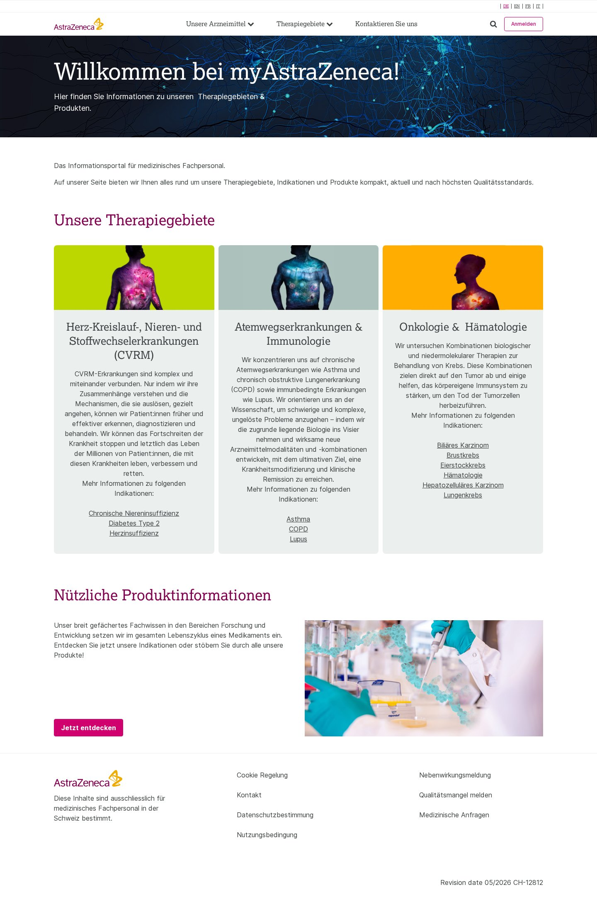

2. Indication / disease detail
Identifier: indication-detail Complexity: High Pages using: 37
Reasoning: Longest and richest template (37 pages). Title banner, intro, three-column stat/icon cards, several alternating text-and-image content sections, reference/footnote lists, and a product-promo CTA.
Reference URLs:
- https://www.myastrazeneca.ch/de/startseite/therapiegebiete/cvrm/acutecare.html
- https://www.myastrazeneca.ch/de/startseite/therapiegebiete/cvrm/chronischeniereninsuffizienz.html
- https://www.myastrazeneca.ch/de/startseite/therapiegebiete/cvrm/diabetes.html
- https://www.myastrazeneca.ch/de/startseite/therapiegebiete/cvrm/herzinsuffizienz.html
- … and 33 more
Screenshot:
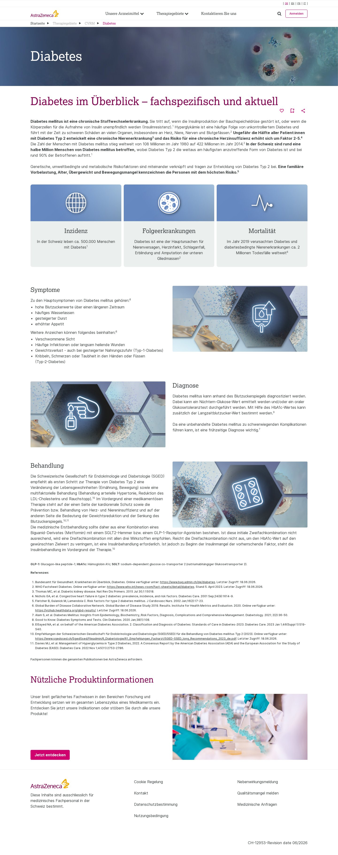

3. Product listing
Identifier: product-listing Complexity: Medium Pages using: 4
Reasoning: Page-title banner, category tab bar, a grid of product cards each with CTA button, and a full-width image CTA band. Interactive tabs raise it above a plain listing.
Reference URLs:
- https://www.myastrazeneca.ch/de/startseite/produkte.html
- https://www.myastrazeneca.ch/en/startseite/produkte.html
- https://www.myastrazeneca.ch/fr/startseite/produkte.html
- https://www.myastrazeneca.ch/it/startseite/produkte.html
Screenshot:
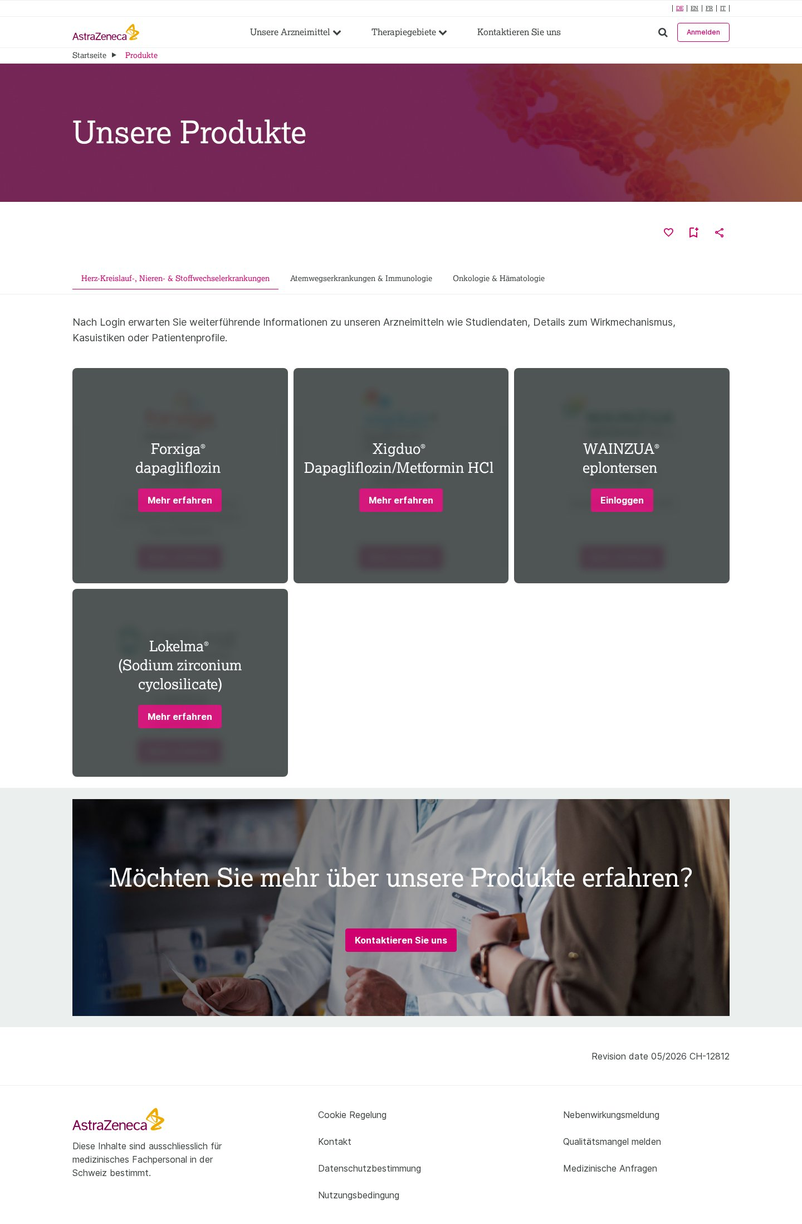

4. Product detail
Identifier: product-detail Complexity: Medium Pages using: 7
Reasoning: Breadcrumb, horizontal product sub-navigation tab bar, heading and rich text body. Consistent structure; interactivity limited to the tab navigation.
Reference URLs:
- https://www.myastrazeneca.ch/de/startseite/produkte/trixeo/aerosphere-technologie.html
- https://www.myastrazeneca.ch/de/startseite/produkte/trixeo/copd-management.html
- https://www.myastrazeneca.ch/de/startseite/produkte/trixeo/events.html
- https://www.myastrazeneca.ch/de/startseite/produkte/trixeo/sicherheit.html
- … and 3 more
Screenshot:
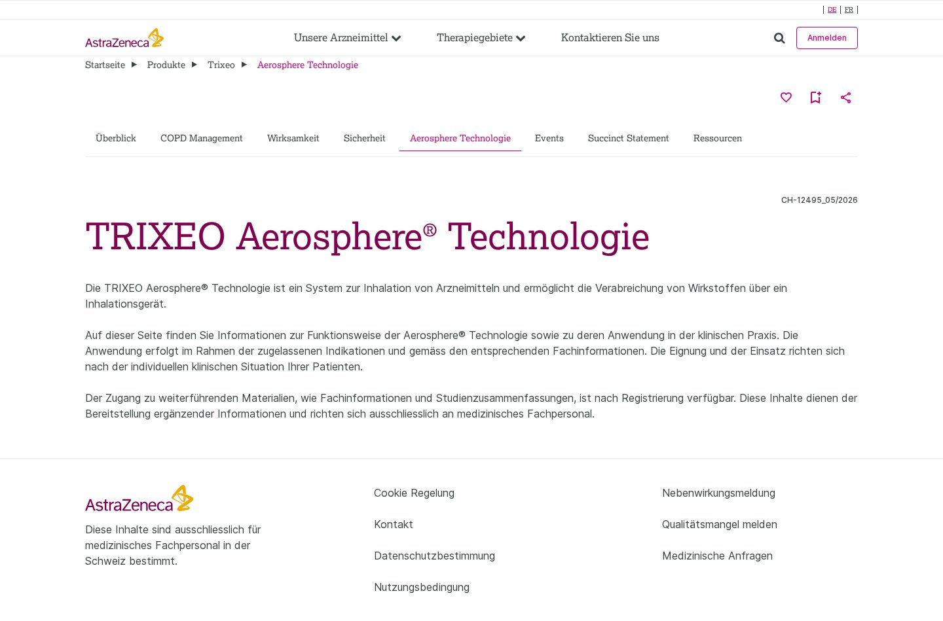

5. Resource detail (gated download)
Identifier: resource-detail Complexity: Medium Pages using: 17
Reasoning: Breadcrumb, large heading, descriptive text and a registration-gated download note. Simple layout but with gated-content / download behaviour (17 pages).
Reference URLs:
- https://www.myastrazeneca.ch/de/startseite/produkte/trixeo/ressourcen/3-molekuele-der-dreifachtherapie-gegen-kardiopulmonales-risiko-de.html
- https://www.myastrazeneca.ch/de/startseite/produkte/trixeo/ressourcen/anwendungsbroschuere-trixeo-aerosphere-de.html
- https://www.myastrazeneca.ch/de/startseite/produkte/trixeo/ressourcen/anwendungskarte-trixeo-aerosphere-de.html
- https://www.myastrazeneca.ch/de/startseite/produkte/trixeo/ressourcen/checkliste-fuer-copd-exazerbationen-de.html
- … and 13 more
Screenshot:
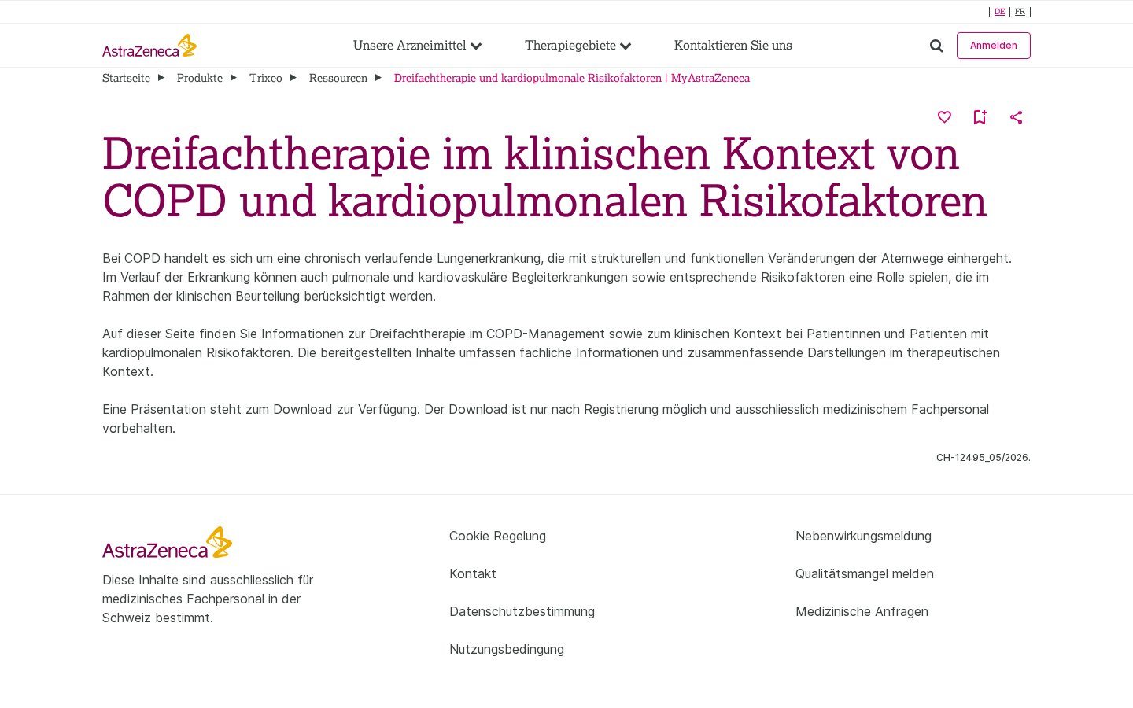

6. Resource listing
Identifier: resource-listing Complexity: Low Pages using: 1
Reasoning: Structurally identical to product-detail (breadcrumb + product tab bar + heading + intro text) but serves as the resources hub. Minimal unique composition.
Reference URLs:
- https://www.myastrazeneca.ch/de/startseite/produkte/trixeo/ressourcen.html
Screenshot:
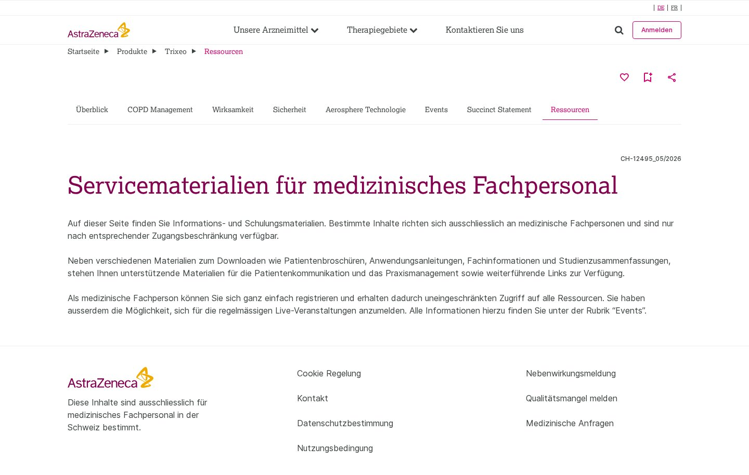

7. Contact form
Identifier: contact-form Complexity: Medium Pages using: 11
Reasoning: Title banner plus a multi-field contact form with select, textarea, consent checkboxes and submit — form validation and submission behaviour add functional complexity (11 localized pages).
Reference URLs:
- https://www.myastrazeneca.ch/de/startseite/contact-us.html
- https://www.myastrazeneca.ch/de/startseite/therapiegebiete/onkologie/brustkrebs.html
- https://www.myastrazeneca.ch/en/startseite/contact-us.html
- https://www.myastrazeneca.ch/en/startseite/therapiegebiete.html
- … and 7 more
Screenshot:
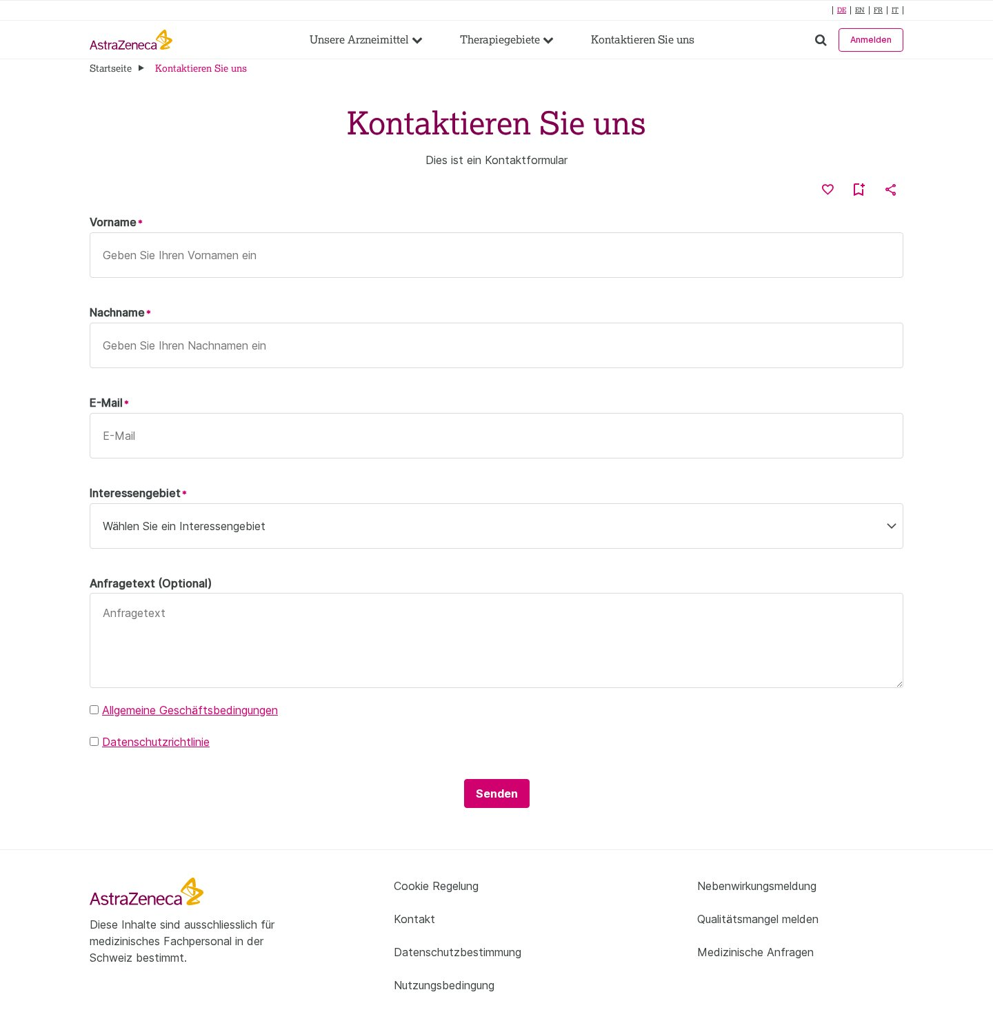

8. Campaign microsite – landing
Identifier: campaign-microsite-landing Complexity: High Pages using: 9
Reasoning: Custom-branded dark-theme campaign ("See the PATTRNS") with bespoke header/sub-nav, hero, icon stat blocks, illustrated process diagram, embedded video, comparison cards, and circular stat gauges. Heavy custom design.
Reference URLs:
- https://www.myastrazeneca.ch/fr/startseite/therapiegebiete/cvrm/see-the-pattrns/about-amylodosis-attr.html
- https://www.myastrazeneca.ch/fr/startseite/therapiegebiete/cvrm/see-the-pattrns/home.html
- https://www.myastrazeneca.ch/fr/startseite/therapiegebiete/cvrm/see-the-pattrns/symptomes.html
- https://www.myastrazeneca.ch/fr/startseite/therapiegebiete/cvrm/see-the-pattrns/treatement.html
- … and 5 more
Screenshot:
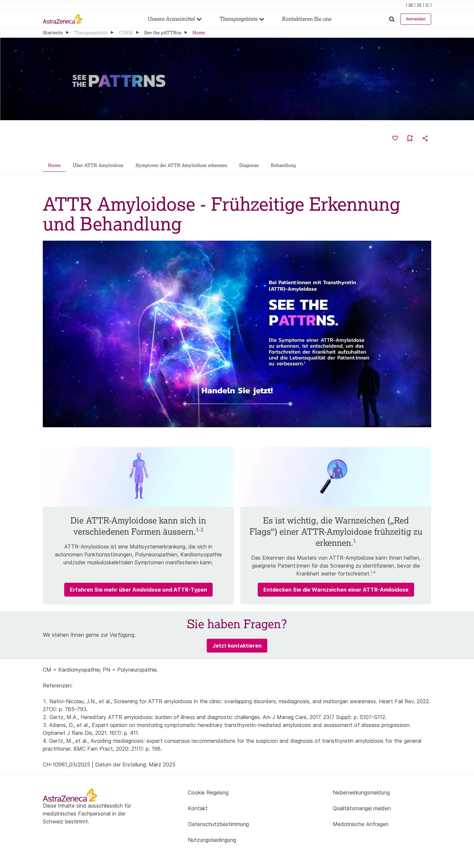

9. Campaign microsite – overview
Identifier: campaign-microsite-overview Complexity: High Pages using: 2
Reasoning: Campaign sub-page (dark theme) mixing icon stat blocks, illustrated diagrams and text/image sections beneath the campaign hero and sub-nav.
Reference URLs:
- https://www.myastrazeneca.ch/de/startseite/therapiegebiete/cvrm/see-the-pattrns/about-amylodosis-attr.html
- https://www.myastrazeneca.ch/de/startseite/therapiegebiete/cvrm/see-the-pattrns/home.html
Screenshot:
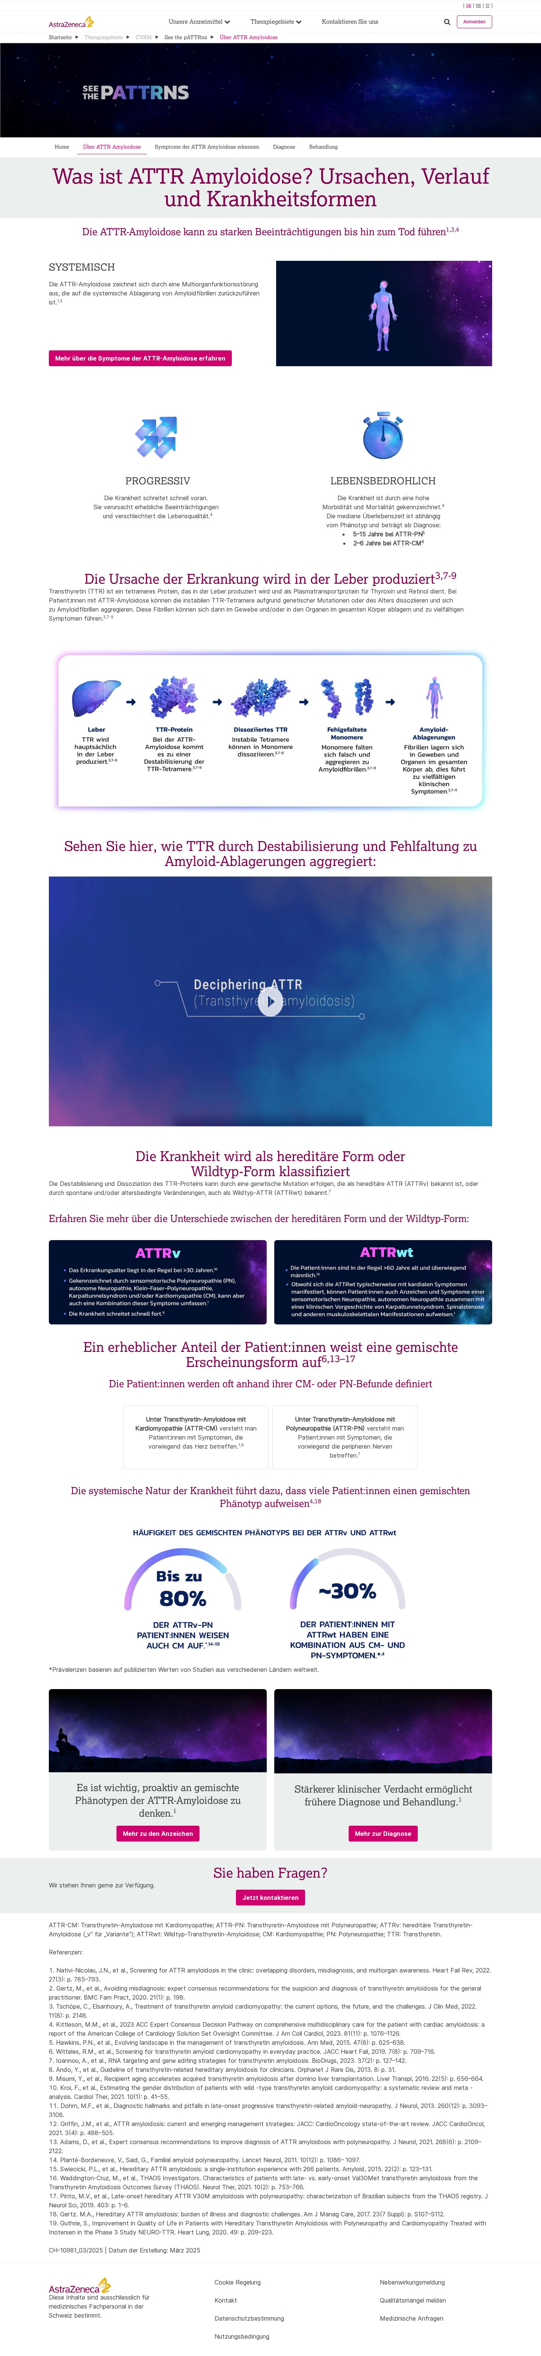

10. Campaign microsite – diagnosis
Identifier: campaign-microsite-diagnosis Complexity: High Pages using: 2
Reasoning: Campaign sub-page with multi-step illustrated diagnosis-pathway flow diagrams, stat cards, gated download and comparison cards on the dark campaign theme.
Reference URLs:
- https://www.myastrazeneca.ch/de/startseite/therapiegebiete/cvrm/see-the-pattrns/diagnosis.html
- https://www.myastrazeneca.ch/fr/startseite/therapiegebiete/cvrm/see-the-pattrns/diagnosis.html
Screenshot:
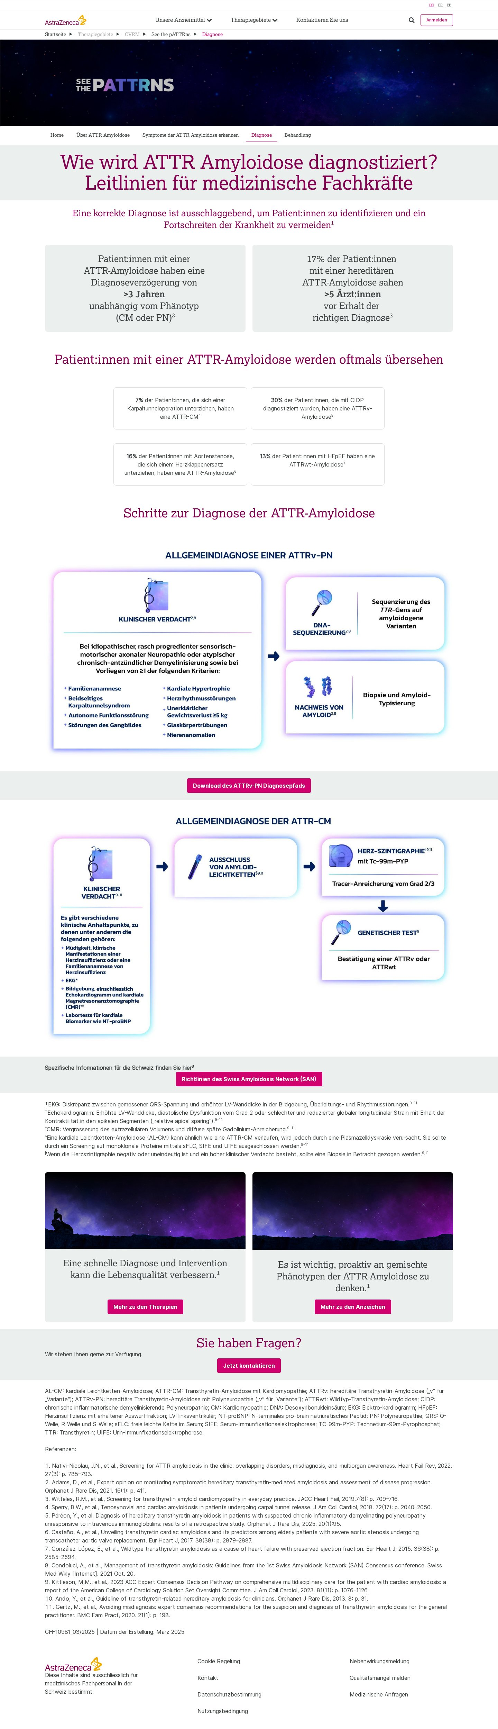

11. Campaign microsite – symptoms
Identifier: campaign-microsite-symptoms Complexity: Medium Pages using: 1
Reasoning: Campaign sub-page on the dark theme; hero plus symptom-focused icon blocks and text/image content sections. Fewer distinct block types than the landing page.
Reference URLs:
- https://www.myastrazeneca.ch/de/startseite/therapiegebiete/cvrm/see-the-pattrns/symptomes.html
Screenshot:
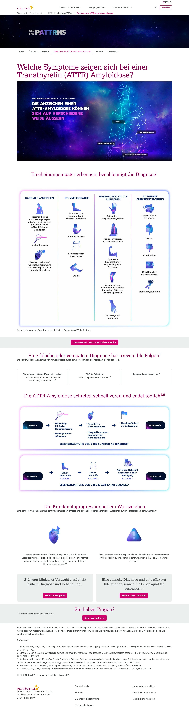

12. Campaign microsite – treatment
Identifier: campaign-microsite-treatment Complexity: Medium Pages using: 1
Reasoning: Campaign sub-page on the dark theme; hero plus treatment-focused content sections with illustrations and references.
Reference URLs:
- https://www.myastrazeneca.ch/de/startseite/therapiegebiete/cvrm/see-the-pattrns/treatement.html
Screenshot:
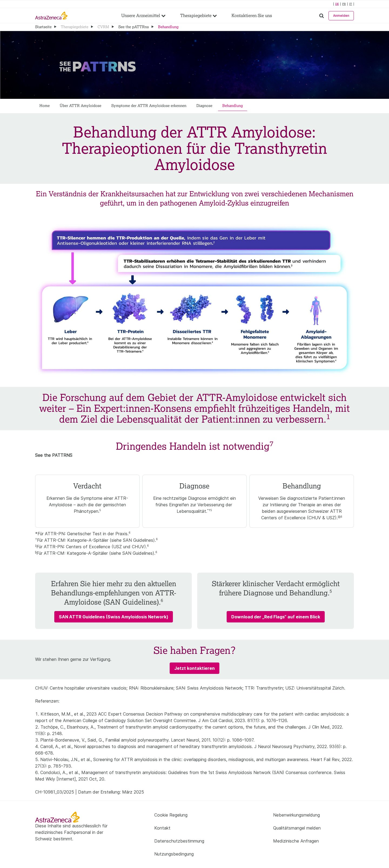

2. Blocks / Components Catalog
The site is composed of the reusable blocks below. Following the migration convention, visually different layouts that share the same content model are treated as design variations of a single block rather than separate blocks. In total the automated analysis detected 30 design variations across these blocks.
Block / Component | Complexity | Approx. pages | Design variations
Header / Global Navigation | Medium | 105 | Single global variant. On the "See the PATTRNS" campaign microsite it is replaced by a bespoke dark-theme campaign header + sub-nav.
Footer / Global | Low | 105 | Single global variant reused on every page.
Hero / Page-title banner | Medium | 60 | Several design variations sharing one content model (heading + optional text + background image): (a) full-bleed dark network image on the homepage; (b) solid magenta title band on listing/detail pages; (c) dark starfield campaign hero on the "See the PATTRNS" microsite.
Cards (Therapy-area / Product / Stat) | Medium | 5 | Design variations on a shared "collection of cards" model — coloured therapy-area cards (light), stat/icon cards (light), and dark-theme campaign stat cards. Product cards on the listing page use the same card pattern with a CTA button per card.
Tabs / Section sub-navigation | Medium | 4 | Two variations of the same tab model differing only in the number of tab items / linked resources (product sub-nav vs. therapy-area filter).
Columns / Text + Image content | Medium | 84 | Design variations of a shared heading+text+image(s) model: light theme (indication pages), dark theme with illustrations/diagrams (campaign microsite), and multi-image process-diagram rows.
Image / Diagram group | Medium | 51 | Multiple design variations grouped by image count (single image, 2-image, 4-image and 6-image diagram groups), all on a shared "image collection" model, predominantly on the dark campaign theme.
CTA / Promo band | Low | 28 | Design variations of a shared heading+text+CTA model: full-width image promo band (homepage/listing), light inline CTA (indication pages), and dark campaign contact prompt.
Contact form | Medium | 4 | Design variations of one form model differing by field set (with/without the message textarea and consent list) across the localized contact pages.

2.1 Block details

1. Header / Global Navigation
Complexity: Medium Approx. pages using: 105
Behaviour & functionality: Site-wide top navigation: AstraZeneca logo, primary menu ("Unsere Arzneimittel", "Therapiegebiete") with dropdown fly-outs, a "Kontaktieren Sie uns" link, search toggle, login ("Anmelden") button and a language switcher (DE / EN / FR / IT). Sticky across all pages.
Design variations: Single global variant. On the "See the PATTRNS" campaign microsite it is replaced by a bespoke dark-theme campaign header + sub-nav.
Reference URLs:
- https://www.myastrazeneca.ch/de/startseite.html
Screenshot:

2. Footer / Global
Complexity: Low Approx. pages using: 105
Behaviour & functionality: Site-wide footer with AstraZeneca logo, medical-professional disclaimer, and two link columns (Cookie policy, contact, data protection, terms of use, adverse-event reporting, quality complaints, medical enquiries). Revision-date / job code shown on content pages.
Design variations: Single global variant reused on every page.
Reference URLs:
- https://www.myastrazeneca.ch/de/startseite.html
Screenshot:


3. Hero / Page-title banner
Complexity: Medium Approx. pages using: 60
Behaviour & functionality: Full-width banner at the top of content pages. Carries the page title (and on the homepage an intro sub-heading) over a coloured or dark image background. Used as the visual entry point of nearly every template.
Design variations: Several design variations sharing one content model (heading + optional text + background image): (a) full-bleed dark network image on the homepage; (b) solid magenta title band on listing/detail pages; (c) dark starfield campaign hero on the "See the PATTRNS" microsite.
Reference URLs:
- https://www.myastrazeneca.ch/de/startseite.html
- https://www.myastrazeneca.ch/de/startseite/produkte.html
Screenshot:

Coloured indication title banner variation


4. Cards (Therapy-area / Product / Stat)
Complexity: Medium Approx. pages using: 5
Behaviour & functionality: Multi-column card grid. On the homepage: three therapy-area cards, each with a coloured image, heading, description and a list of indication links. On indication pages: three-column statistic/icon cards. On the campaign microsite: KPI/stat cards.
Design variations: Design variations on a shared "collection of cards" model — coloured therapy-area cards (light), stat/icon cards (light), and dark-theme campaign stat cards. Product cards on the listing page use the same card pattern with a CTA button per card.
Reference URLs:
- https://www.myastrazeneca.ch/de/startseite.html
- https://www.myastrazeneca.ch/de/startseite/therapiegebiete/cvrm/diabetes.html
Screenshot:

5. Tabs / Section sub-navigation
Complexity: Medium Approx. pages using: 4
Behaviour & functionality: Horizontal tab bar used for in-section navigation. On product pages it switches between product sub-pages (Überblick, COPD Management, Wirksamkeit, Sicherheit, …); on the product listing it filters product cards by therapy area. Each tab links to / reveals its associated content.
Design variations: Two variations of the same tab model differing only in the number of tab items / linked resources (product sub-nav vs. therapy-area filter).
Reference URLs:
- https://www.myastrazeneca.ch/de/startseite/produkte/trixeo/aerosphere-technologie.html
- https://www.myastrazeneca.ch/de/startseite/produkte.html
Screenshot:
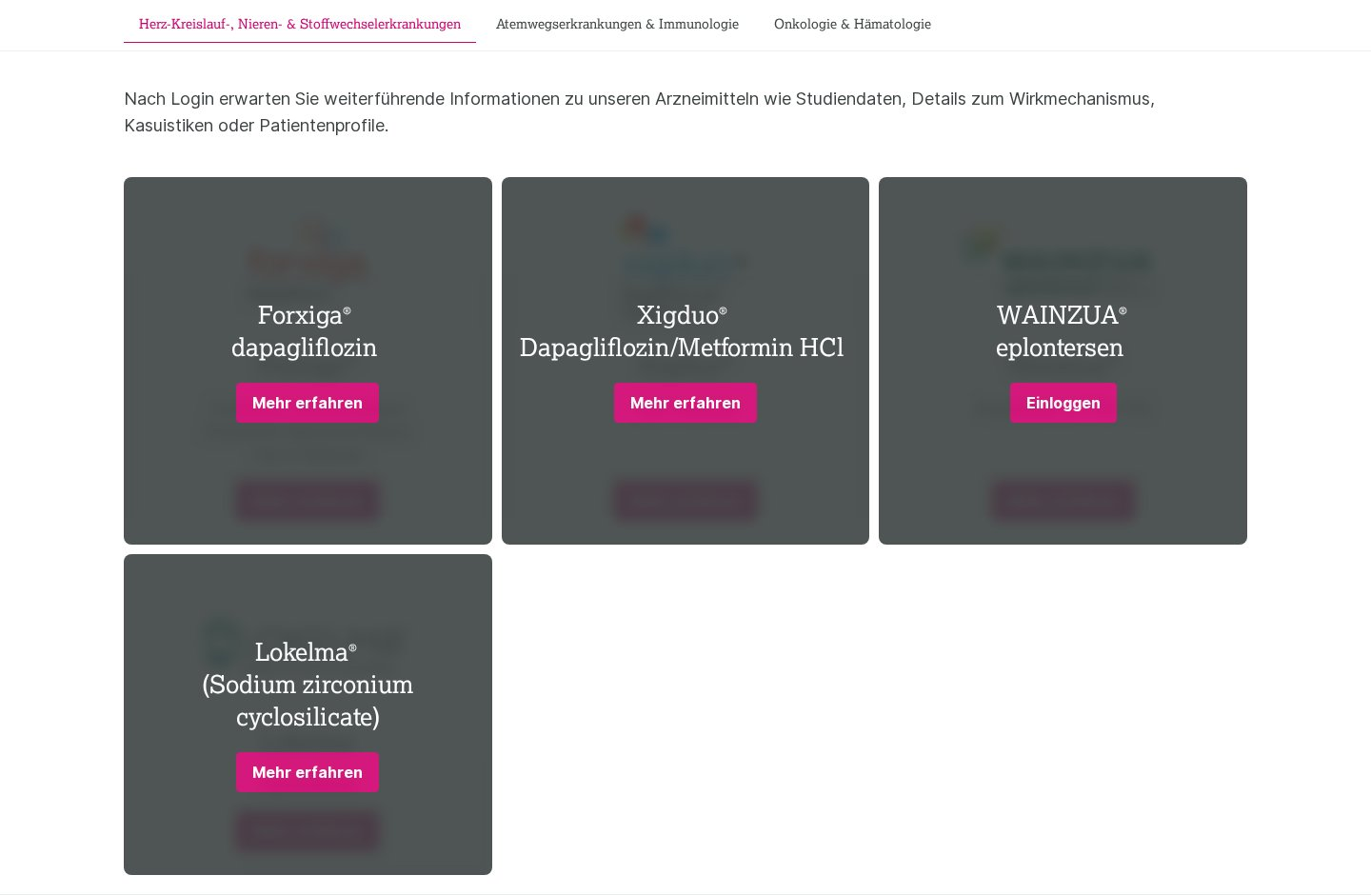

6. Columns / Text + Image content
Complexity: Medium Approx. pages using: 84
Behaviour & functionality: Alternating text-and-image content rows used throughout indication pages and the campaign microsite to present symptoms, diagnosis, mechanism-of-action illustrations, etc. Heading + body copy paired with one or more images.
Design variations: Design variations of a shared heading+text+image(s) model: light theme (indication pages), dark theme with illustrations/diagrams (campaign microsite), and multi-image process-diagram rows.
Reference URLs:
- https://www.myastrazeneca.ch/de/startseite/therapiegebiete/cvrm/diabetes.html
- https://www.myastrazeneca.ch/de/startseite/therapiegebiete/cvrm/see-the-pattrns/about-amylodosis-attr.html
Screenshot:
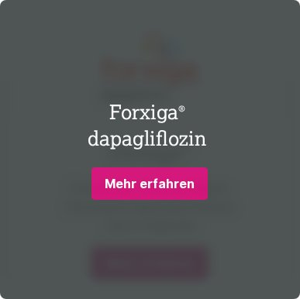

7. Image / Diagram group
Complexity: Medium Approx. pages using: 51
Behaviour & functionality: Standalone image or grouped set of images used for illustrated process diagrams, mechanism-of-action visuals, comparison graphics and stat gauges on indication pages and the campaign microsite. Frequently combined with short captions.
Design variations: Multiple design variations grouped by image count (single image, 2-image, 4-image and 6-image diagram groups), all on a shared "image collection" model, predominantly on the dark campaign theme.
Reference URLs:
- https://www.myastrazeneca.ch/de/startseite/therapiegebiete/cvrm/see-the-pattrns/about-amylodosis-attr.html
- https://www.myastrazeneca.ch/de/startseite/therapiegebiete/cvrm/acutecare.html
Screenshot:
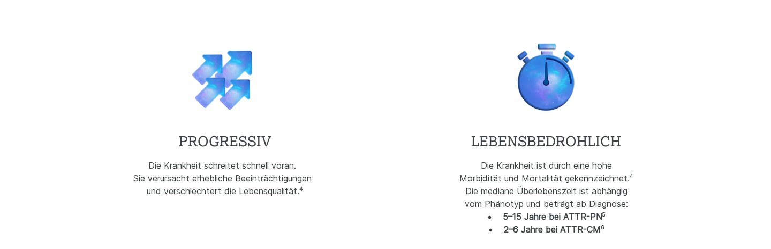

8. CTA / Promo band
Complexity: Low Approx. pages using: 28
Behaviour & functionality: Call-to-action element: a button (e.g. "Jetzt entdecken", "Kontaktieren Sie uns", "Mehr erfahren") optionally paired with a heading and short paragraph. Used as product-promo bands, "questions?" contact prompts and inline links to gated content.
Design variations: Design variations of a shared heading+text+CTA model: full-width image promo band (homepage/listing), light inline CTA (indication pages), and dark campaign contact prompt.
Reference URLs:
- https://www.myastrazeneca.ch/de/startseite.html
- https://www.myastrazeneca.ch/de/startseite/produkte.html
Screenshot:


9. Contact form
Complexity: Medium Approx. pages using: 4
Behaviour & functionality: Lead / enquiry form: first name, last name, e-mail, an "area of interest" select, an optional free-text message, two consent checkboxes (terms & data-protection) and a Send button. Client-side validation on required fields and submission handling.
Design variations: Design variations of one form model differing by field set (with/without the message textarea and consent list) across the localized contact pages.
Reference URLs:
- https://www.myastrazeneca.ch/de/startseite/contact-us.html
- https://www.myastrazeneca.ch/fr/startseite/contact-us.html
Screenshot:
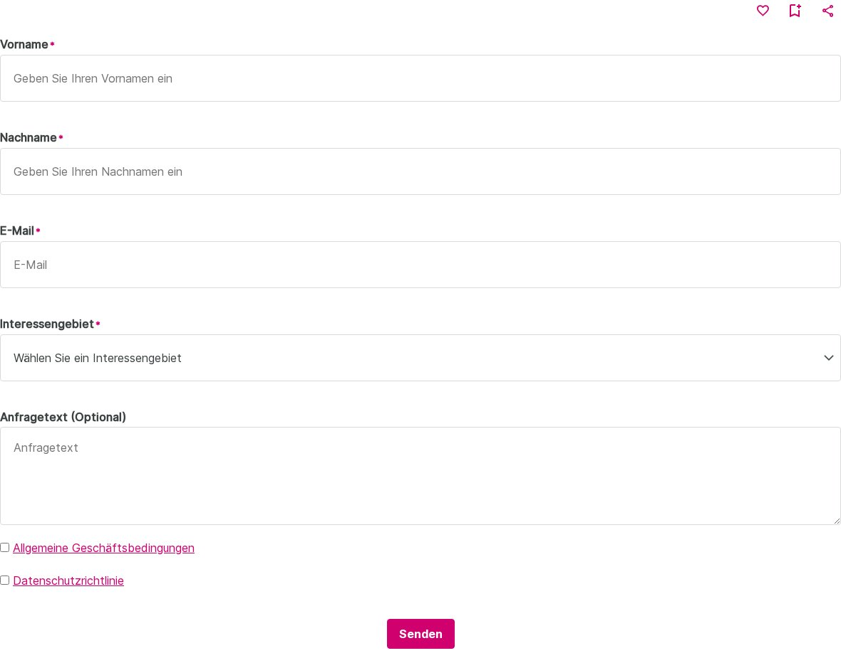

Appendix A — Methodology & Notes
- URLs were discovered from the site’s XML sitemap (105 pages).
- Pages were rendered and captured with an automated headless browser; structure fingerprints were clustered to derive page templates.
- Templates were named by layout structure (not by content topic), so localized copies of the same layout collapse into one template.
- Blocks were rolled up from per-page block analysis; variants sharing a content model are grouped as design variations of one block.
- 9 of 105 pages were not captured due to source-site rate-limiting (HTTP 403) or server errors; their layouts are represented by sibling localized pages, so no template or block is missing.

