EDS MIGRATION — SCOPE & ANALYSIS HANDOVER
Riyadh Air (en)
Content-layer migration assessment for Adobe Edge Delivery Services

Field | Value
Site analysed | https://www.riyadhair.com/en/home
Analysis date | 2026-08-25
Pages discovered | 260 (260 analysed — 100% coverage, 0 failed)
Locale | en
Templates | 8
Block variants | 21
Platform detected | Next.js SPA + headless Adobe AEM (GraphQL), behind Akamai
1. Executive Summary
A full crawl and structural analysis of the Riyadh Air English site was completed to scope an Adobe Edge Delivery Services (EDS) migration.
- 260 pages discovered via the on-site /en/sitemap page (Akamai blocks robots.txt & XML sitemap).
- 260 pages analysed — 100% coverage, 0 failures.
- 8 unique page templates identified.
- 21 reusable block variants catalogued.
- 1 locale in scope (en), with a few embedded Spanish legal pages.

Key finding: Riyadh Air is a Next.js single-page application backed by headless Adobe AEM (content served via GraphQL), behind Akamai bot protection. Most interior-page content renders client-side, so static captures show mainly the header/hero shell and newsletter footer. This is why 248 of 260 pages fingerprinted into one structural template. The biggest migration cost driver is whether AEM/GraphQL content export access is available — with it, the large content family becomes highly automatable; without it, expect rendered-DOM capture per page.
2. Templates Inventory
# | Template | Complexity | Reasoning | Reference URL
1 | content-landing | High | Universal Next.js layout: nav, hero panel w/ sub-links, intro, alternating image+text feature sections + CTAs, newsletter footer. Content hydrated client-side. Spans home, section landings, about-us, experience, sfeer, discover-riyadh, plan-book, media-hub articles. | /en/home, /en/about-us
2 | feature-detail | Medium | Feature/detail variant with hero + media-rich body sections. | /en/experience/chauffeur
3 | help-article | Medium | Breadcrumb + "Explore all help articles" search box + heading + client-rendered body. | /en/help/flight-disruption-policy
4 | help-article-rich | Medium | Help article with richer inline structured media. | /en/help/in-flight-entertainment-and-wi-fi
5 | legal-terms | Low | Heading + long-form legal rich text + footer. | /en/legal/best-offer-guaranteed-terms-conditions
6 | localized-legal | Low | Spanish-language legal doc inside the English tree. | /en/conditions-of-carriage-es
7 | manage-booking-tool | High | Booking-servicing application page (cancel booking); minimal static markup. | /en/manage/cancel-booking
8 | manage-order-tool | High | Order-retrieval/servicing application page. | /en/manage/manage-order
Template screenshots
content-landing
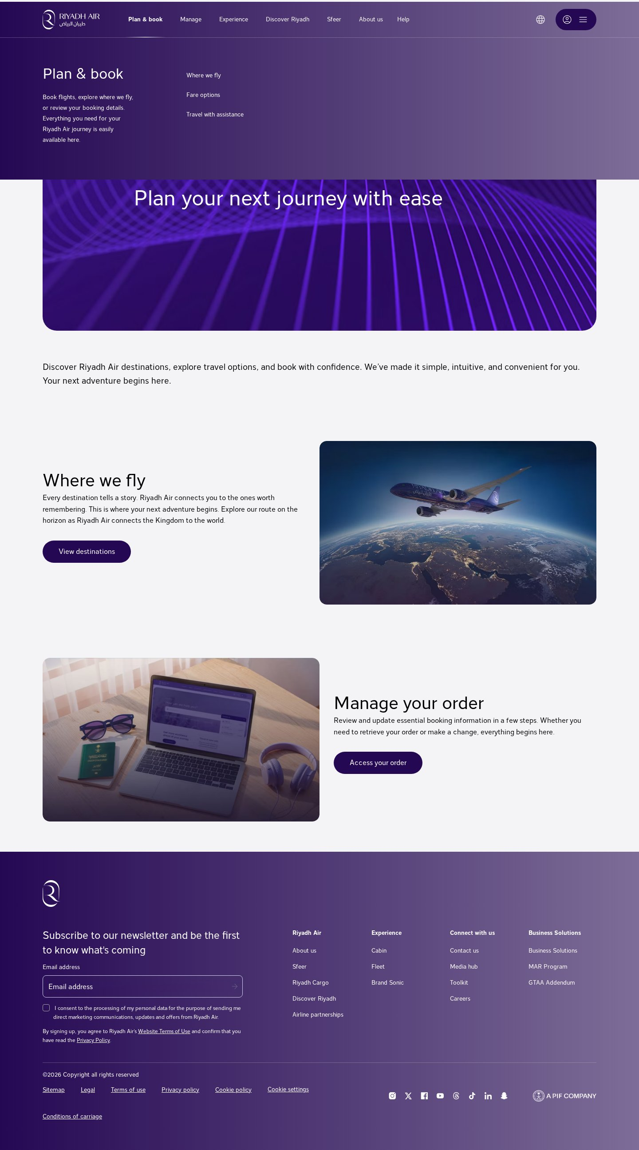
Template: content-landing — representative page
feature-detail
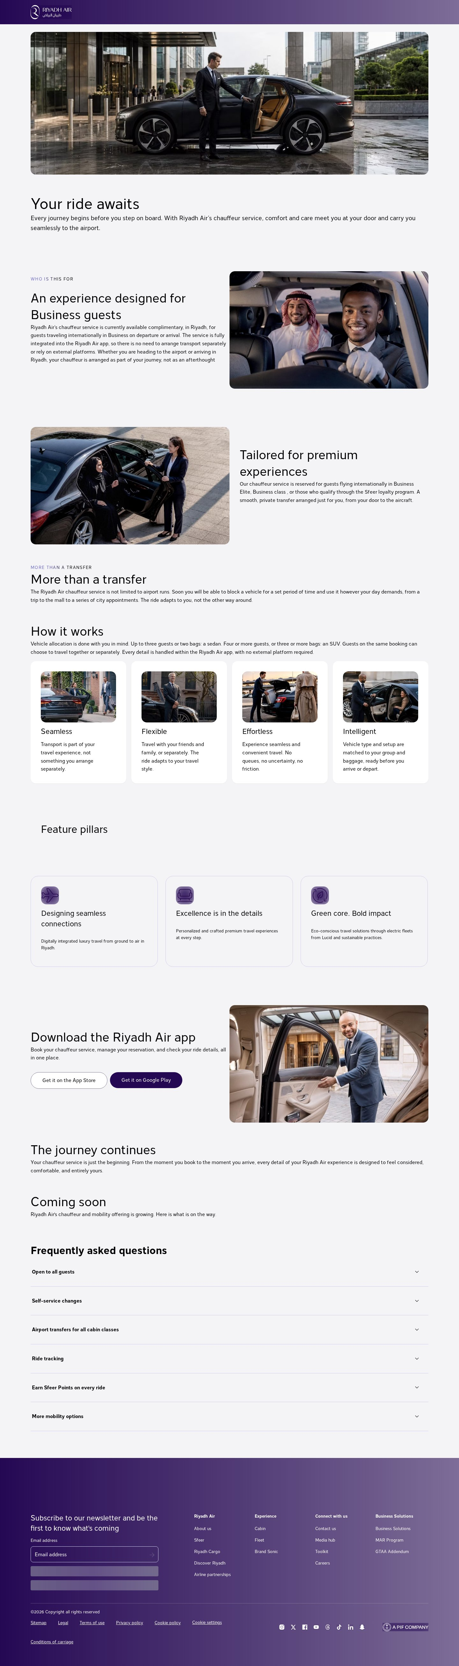
Template: feature-detail — representative page
help-article
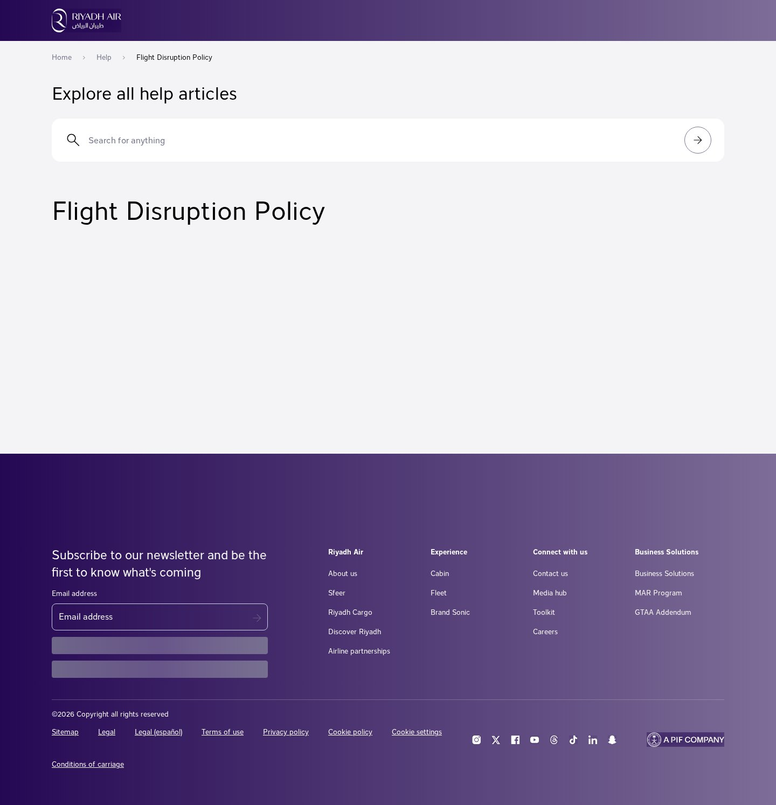
Template: help-article — representative page
help-article-rich
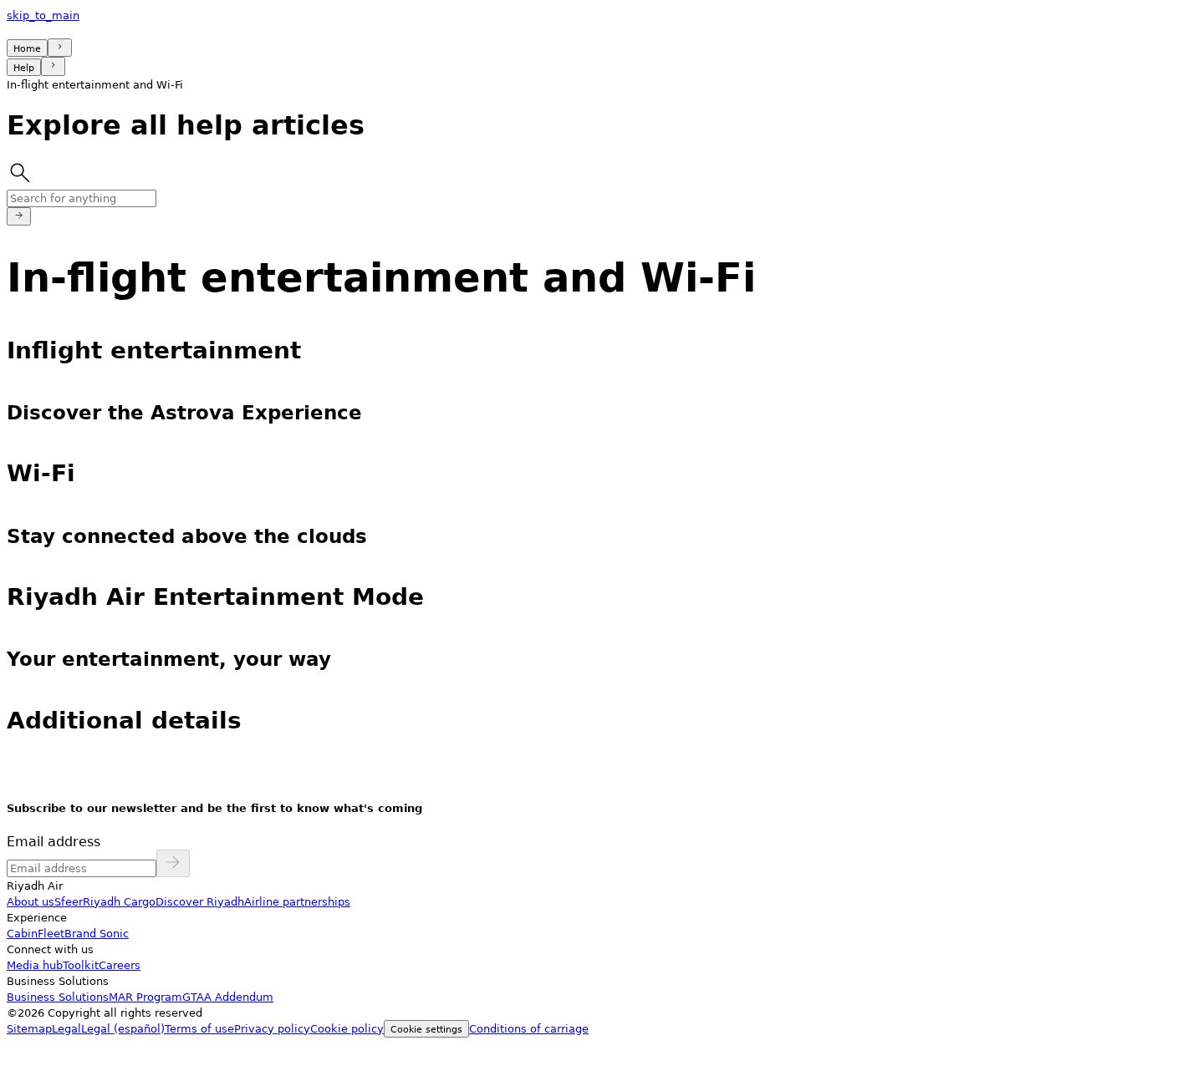
Template: help-article-rich — representative page
legal-terms
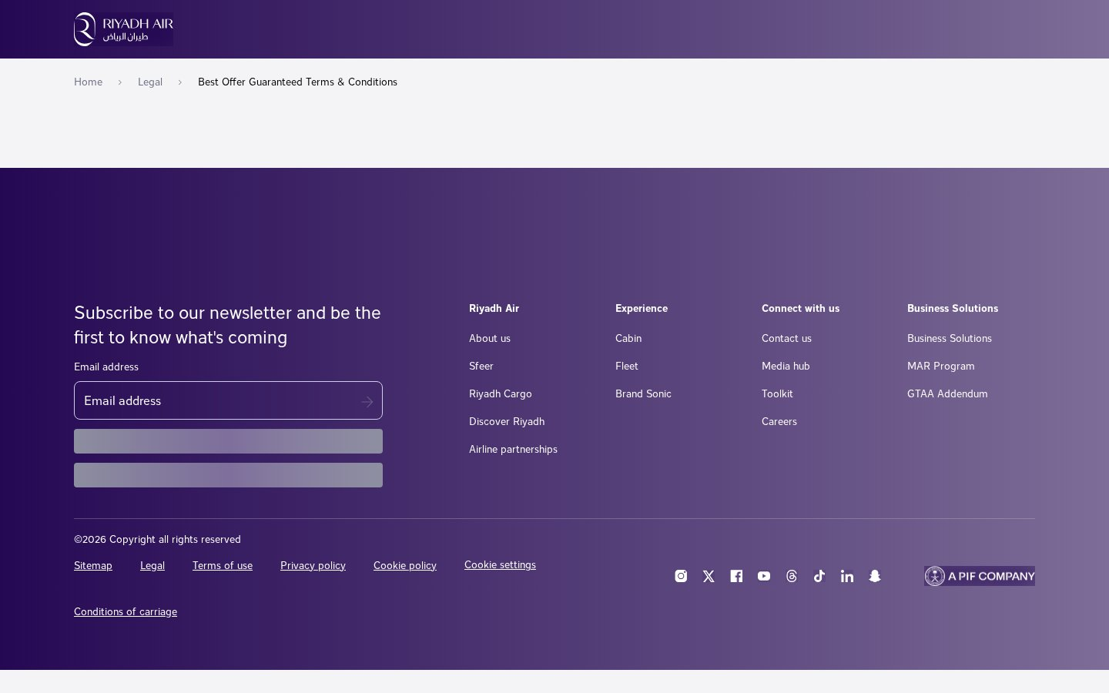
Template: legal-terms — representative page
localized-legal
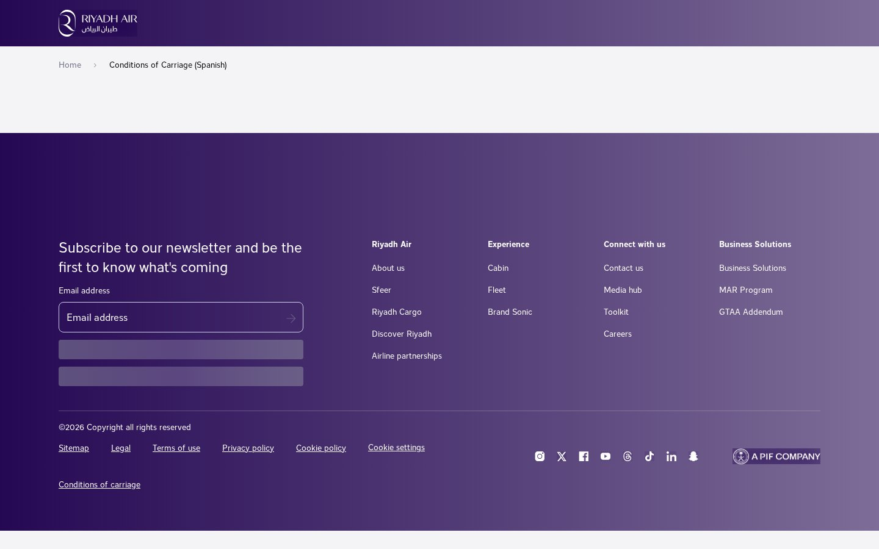
Template: localized-legal — representative page
manage-booking-tool
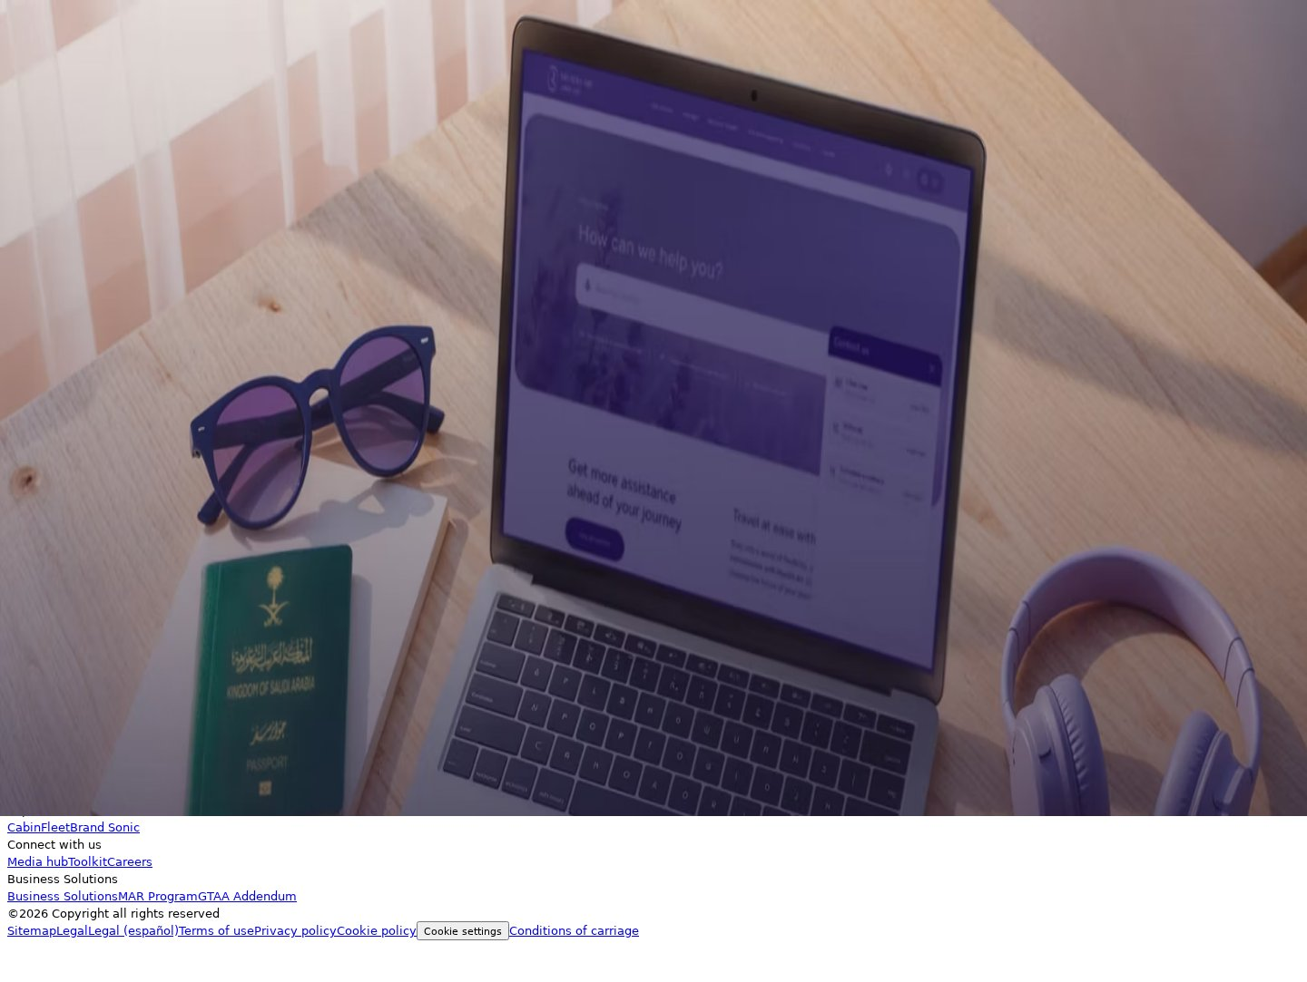
Template: manage-booking-tool — representative page
manage-order-tool

Template: manage-order-tool — representative page
3. Blocks / Components Catalog
21 block variants catalogued and consolidated by content model — visual variations grouped as variants of the same base block.
Block (base) | Variants | Complexity | Behaviour / Functionality | Reference URL
header (global) | 1 | Medium | Sticky nav: logo, primary menu (Plan & book, Manage, Experience, Discover Riyadh, Sfeer, About us, Help), language switcher, account, hamburger. | all pages
footer (global) | 1 | Medium | Newsletter subscribe with consent checkbox + 4-column link nav + social icons + "A PIF Company" + legal row. | all pages
hero | 6 | Low–Med | Page banner: title, sub-links, branded imagery; light/dark, with/without image. Dominant block: 244 pages. | /en/home
cards | 1 | Medium | Card grid (feature/section cards with image + heading + CTA). | /en/home
columns | 1 | Low | Alternating image+text feature rows. | /en/home
search | 2 | Medium | Help-centre "Search for anything" box with submit. | /en/help/flight-disruption-policy
custom / unknown | 9 | High | Composite hydrated fragments — heading+image+CTA+paragraph combos, multi-heading/image/CTA grids, styled text. No standard EDS equivalent. | across content pages
Block screenshots
header
Block: header
hero
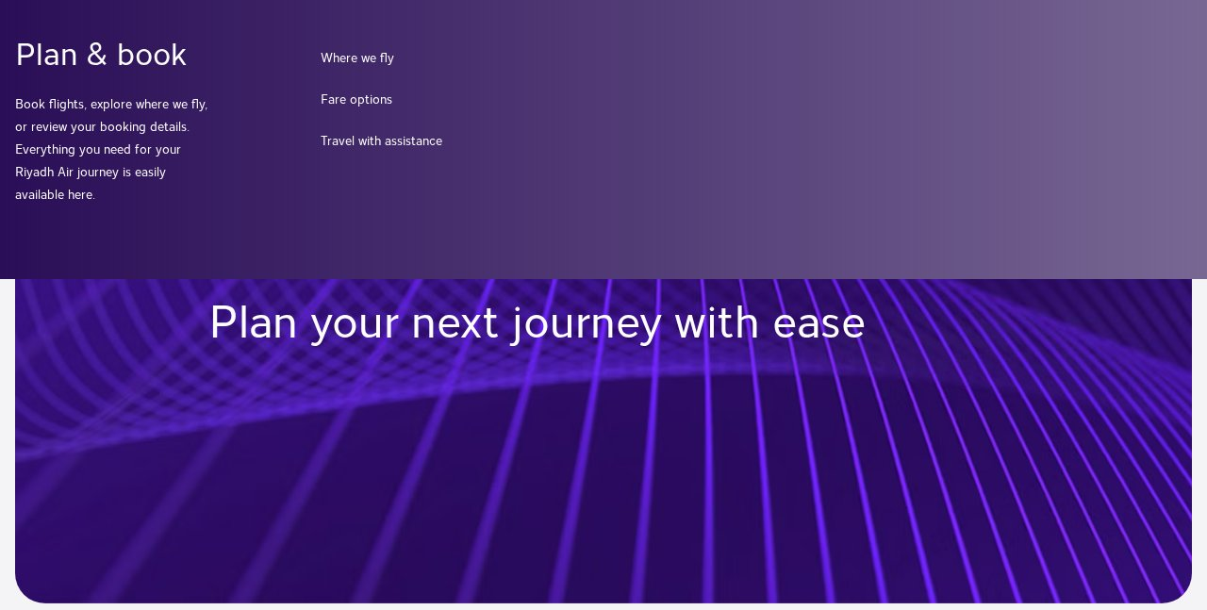
Block: hero
cards
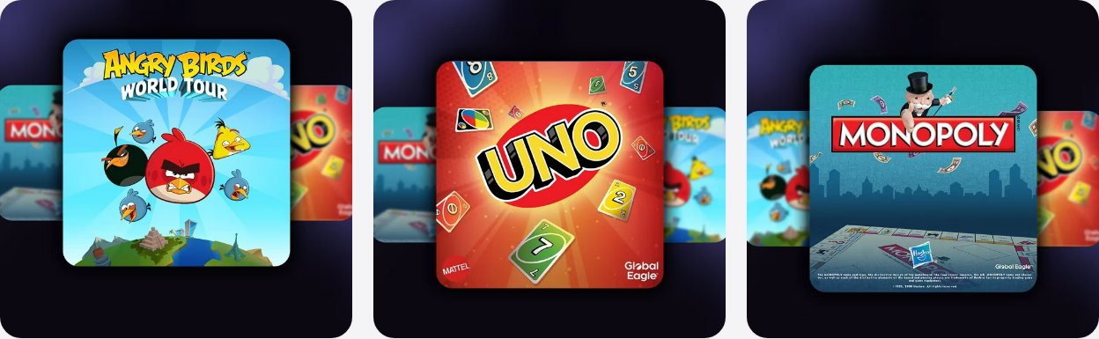
Block: cards
columns
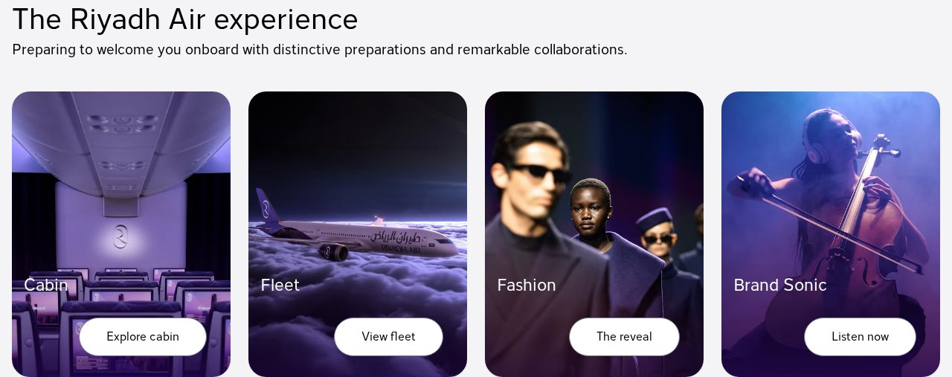
Block: columns
search
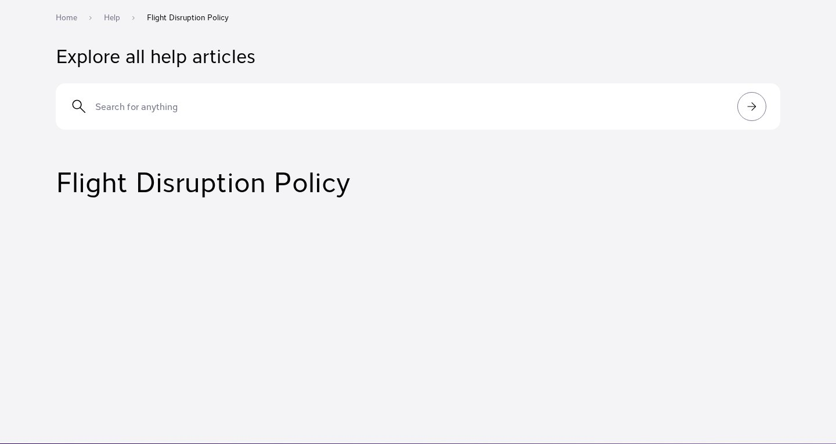
Block: search
footer
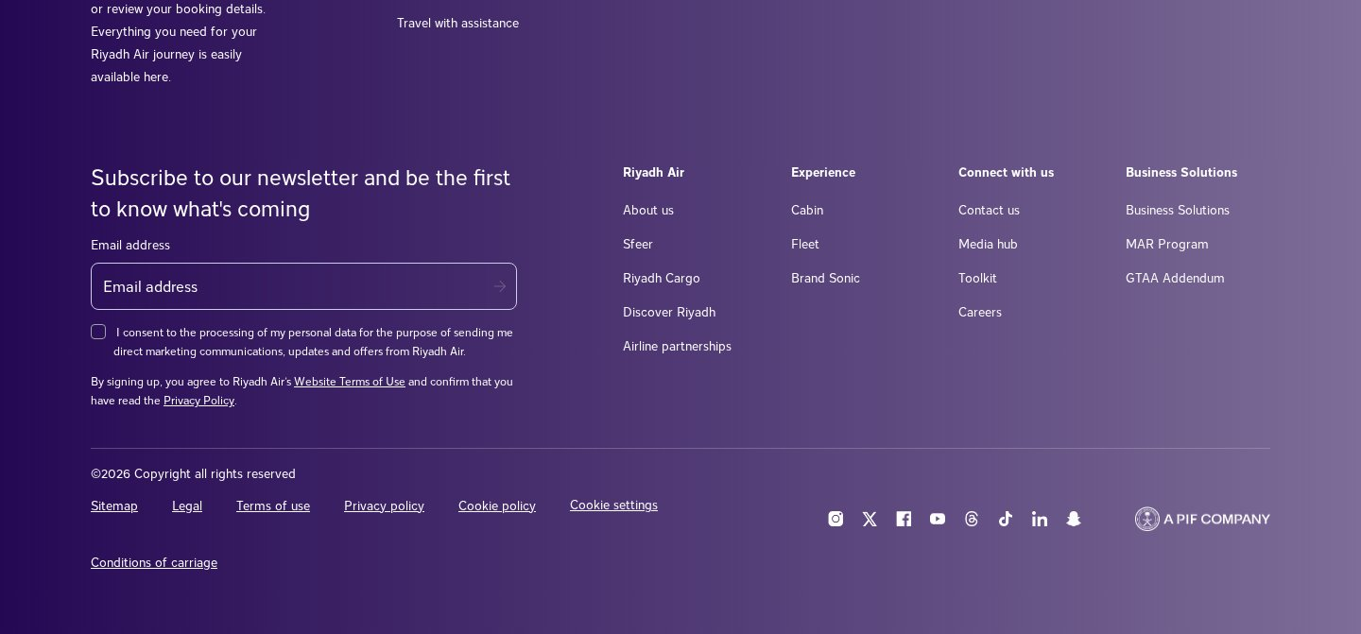
Block: footer
4. Page Counts by Template & Migration Classification
Template | Pages | Migration Path | Rationale
content-landing | 248 | Manual-heavy (content via AEM/GraphQL) | Identical shells; actual content client-rendered from AEM. Bulk-scriptable only with API access.
feature-detail | 4 | Semi-auto | Media-rich composition.
help-article | 3 | Semi-auto | Search + client-rendered body.
help-article-rich | 1 | Semi-auto | Richer inline media.
legal-terms | 1 | Automated | Static rich text.
localized-legal | 1 | Automated | Static rich text (ES).
manage-booking-tool | 1 | Manual / Exclude | Transactional app.
manage-order-tool | 1 | Manual / Exclude | Transactional app.
Total | 260 | Automated 2 | Content-via-CMS/semi-auto 256 · Manual 2
Note: because the site is already an AEM-backed headless app, the ~136 media-hub articles and other content pages are highly templatised. With AEM/GraphQL export access the 248-page family becomes largely automatable (one importer, many records); without it, each requires rendered-DOM capture (manual-heavy). This single decision swings the estimate substantially.
5. Integrations Analysis
Integration | Type | Complexity | Where used
Adobe Experience Manager (headless + GraphQL) | API / CMS backend | High | Site-wide (__env__.aem_host / graphql_api, assets.adobedtm.com)
Adobe DTM / Launch (tag manager + analytics) | Custom code / embed | Medium | All pages
Google Tag Manager + gtag / dataLayer | Embed | Medium | All pages (GTM-TB3GRWRT)
OneTrust cookie consent | Embed / plugin | Low | All pages (cdn.cookielaw.org)
Media CDN (media.riyadhair.com) | Asset delivery | Low | All pages (images/video)
Booking / order engine | External app | High | /en/manage/*, plan-book booking flow
Social embeds (Instagram, X, Facebook, YouTube, Threads, TikTok, LinkedIn, Snapchat) | Embed / link | Low | Footer
Akamai bot protection / CDN | Platform | Medium | Site-wide (blocks robots.txt & XML sitemap)
Next.js runtime / hydration | Framework | High | All content pages
6. Complex Use Cases & Observations
# | Complex behaviour | Instances | Where | Why complex
1 | Client-side-rendered content (Next.js hydration) | ~256 | content-landing, help, feature | Content absent from delivered HTML; source from AEM/GraphQL or rendered DOM.
2 | Headless AEM + GraphQL backend | site-wide | all content | Content model in AEM; path depends on export/API access.
3 | Transactional apps (manage booking/order, plan-book) | ~3+ areas | /en/manage/*, plan-book | Out of EDS content scope; integration or link-out.
4 | Help-centre search | ~36 | /en/help/* | Dynamic search/index behaviour to reproduce.
5 | Bot protection (Akamai) | site-wide | all pages | Blocks robots.txt/XML sitemap; import tooling needs browser context + throttling.
6 | 9 custom/unknown block compositions | ~10 uses (pattern repeats) | content pages | Bespoke hydrated fragments; require content modeling.
7 | Bilingual content in EN tree (-es pages) | ~5 | legal/conditions/fare pages | Locale handling within a single tree.
8 | Large press-release archive | 136 | /en/media-hub/* | Volume; ideal for automation if CMS export available.
7. Migration Estimates
Estimates cover the English content site (260 pages, 8 templates, 21 blocks). Excludes the booking/order transactional apps.
Effort by workstream
Workstream | Estimate | Notes
Block development (21 variants → ~8–10 EDS blocks + variations) | 8–12 days | Incl. 9 custom compositions, search, newsletter
Template setup (8 templates) | 4–5 days | content-landing dominates
Content import — with AEM/GraphQL export | 4–6 days | Scripted bulk import of 248-page family + 136 articles
Content import — without API (rendered-DOM capture) | +10–16 days | Contingency if no CMS access
Header / footer / navigation (global) | 3–4 days | Mega-nav + newsletter footer
Help-centre search | 2–4 days | Index + search behaviour
Integrations & analytics re-wire (AEM/GTM/DTM/OneTrust) | 4–6 days | + runtime audit
QA & testing (functional, visual, a11y, PageSpeed) | 6–8 days | Target Lighthouse 100
PM / UAT / fixes | 4–6 days
Totals by scenario
Scenario | Total effort | Schedule | Indicative cost (~$600/day)
With AEM/GraphQL content export (recommended) | ~35–51 person-days | ~7–9 weeks | ≈ $21k–$31k
Without API (DOM capture) | ~45–67 person-days | ~9–12 weeks | ≈ $27k–$40k
Team & phasing
- Recommended team: 2 developers + 1 QA + PM (part-time).
- Phase 1 — Blocks + templates + global navigation
- Phase 2 — Content import (API-driven if possible)
- Phase 3 — Help search + integrations
- Phase 4 — QA / UAT
8. Caveats & Assumptions
- Akamai protection blocks robots.txt and the XML sitemap; URLs were harvested from the on-site /en/sitemap page (260 URLs, high confidence). Page rendering succeeded via a real browser (100% analysed).
- Content is client-rendered from headless AEM; the biggest cost driver is whether CMS/GraphQL export access is available.
- Manage booking / order and the booking flow are transactional applications and are excluded from the content-migration counts and estimates.
- Cost figures are indicative and use a placeholder blended day rate; adjust to your actual rates.
9. Analysis Artifacts
Artifact | Description
template-catalog.json | 8 named templates with page assignments and reference URLs
block-catalog.json | 21 block variants with usage counts and canonical models
summary.json | Site metrics and coverage summary
urls-all.json / urls-grouped.json | 260 discovered URLs, grouped by directory pattern
.pages/{slug}/full-page.jpg | Full-page screenshot per analysed page
.blocks/{variant}/screenshots/ | Screenshots per block variant
Riyadh Air (en) — EDS Migration Handover · Generated 2026-08-25 · Content-layer scope only (excludes transactional booking/order applications).

