EDS MIGRATION — SCOPE & ANALYSIS HANDOVER
Virgin Atlantic (en-IN)
Content-layer migration assessment for Adobe Edge Delivery Services

Field | Value
Site analysed | https://www.virginatlantic.com/en-IN
Analysis date | 2026-08-25
Pages discovered | 446 (444 analysed — 99.6% coverage)
Locale | en-IN
Templates | 12
Block variants | 27
1. Executive Summary
A full crawl and structural analysis of the India locale of virginatlantic.com was completed to scope an Adobe Edge Delivery Services (EDS) migration.
- 446 pages discovered via the site XML sitemap (hreflang alternates).
- 444 pages successfully analysed — 99.6% coverage (2 pages failed to render).
- 12 unique page templates identified.
- 27 reusable block variants catalogued.
- 1 locale in scope (en-IN).

Key constraint: The passenger site is a JavaScript-heavy, application-driven site behind Akamai bot protection. The booking engine, check-in, flight status, seat maps and account areas run on separate application subdomains (flights., flywith., vaabrowse.virginatlantic.com) and are OUT OF SCOPE for content migration — they are transactional applications, not authored content. The 446 pages in this report are the migratable marketing/content layer.
2. Templates Inventory
# | Template | Complexity | Reasoning | Reference URL
1 | marketing-landing | High | Section-hub landing: hero, promo cards, alternating image+text rows, icon-link row. Some regions render client-side. | /en-IN, /en-IN/corporate
2 | rich-text-article | Low | Hero banner + breadcrumb + long-form rich text. Standardized. | /en-IN/policies/air-carrier-access-act
3 | editorial-travel-guide | Medium | Byline/read-time, hero, alternating story sections, inline CTA, related-inspiration teaser. | /en-IN/inspiration/africa/cape-town-travel-guide
4 | client-rendered-content | High | Main content rendered client-side; static capture shows only header/footer shell. | /en-IN/contact-us/payment-options
5 | accordion-content | Medium | Hero + intro + expand/collapse accordion sections + contact block. | /en-IN/corporate/engineering
6 | news-listing | Medium | Hero + CTAs + dated card grid + "See all" pagination. | /en-IN/travel-news
7 | promo-feature | Medium | Campaign/reward layout: hero, media-rich sections, CTA blocks. | /en-IN/experience/football-world-cup-2026
8 | reference-document | Low | Hero + short reference text/links. Sparse. | /en-IN/corporate/annual-reports
9 | inspiration-hub | Medium | Inspiration index: hero + card grid to guides. | /en-IN/inspiration/south-korea
10 | destination-detail | Medium | Where-we-fly leaf: hero, destination overview, booking prompts. | /en-IN/where-we-fly/caribbean/tobago
11 | itinerary-guide | Medium | Stepped/day-by-day editorial content. | /en-IN/where-we-fly/.../los-angeles-itinerary
12 | manage-booking-app | High | Application/tool page driven by embedded booking app; minimal static markup. | /en-IN/manage-booking
Template screenshots
marketing-landing
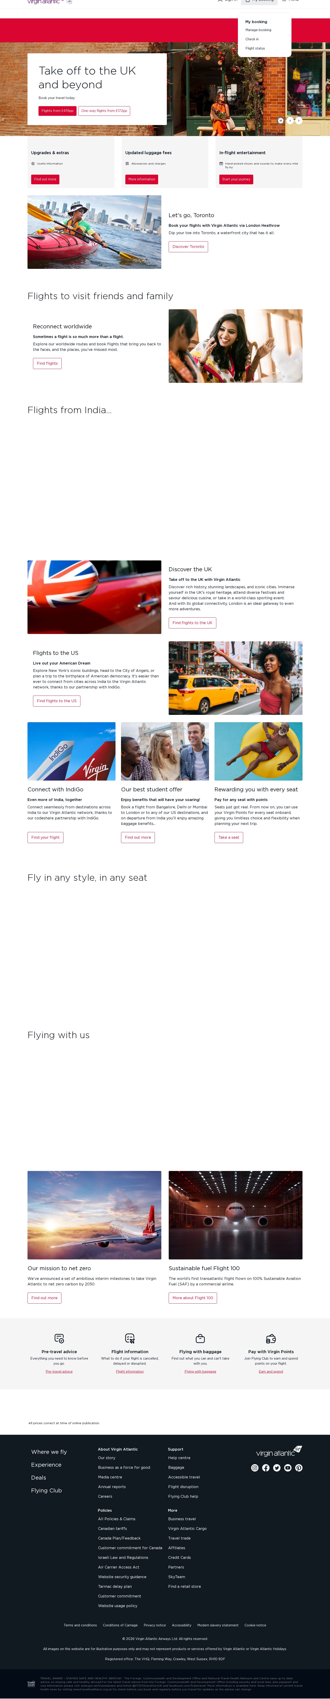
Template: marketing-landing — representative page
rich-text-article
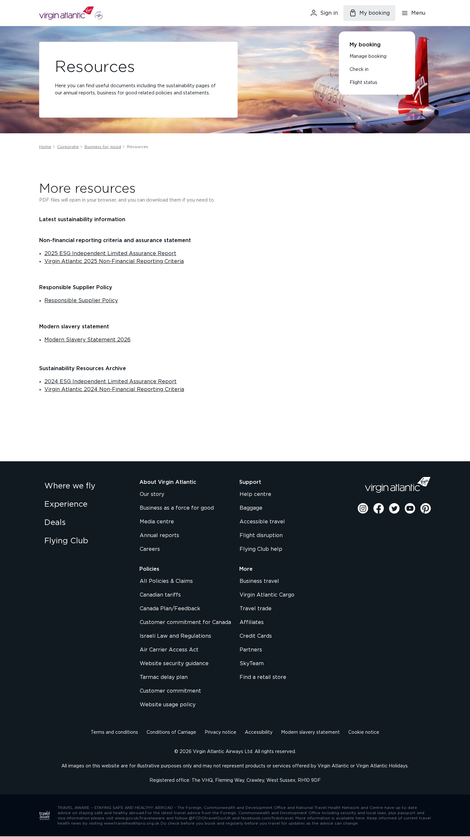
Template: rich-text-article — representative page
editorial-travel-guide
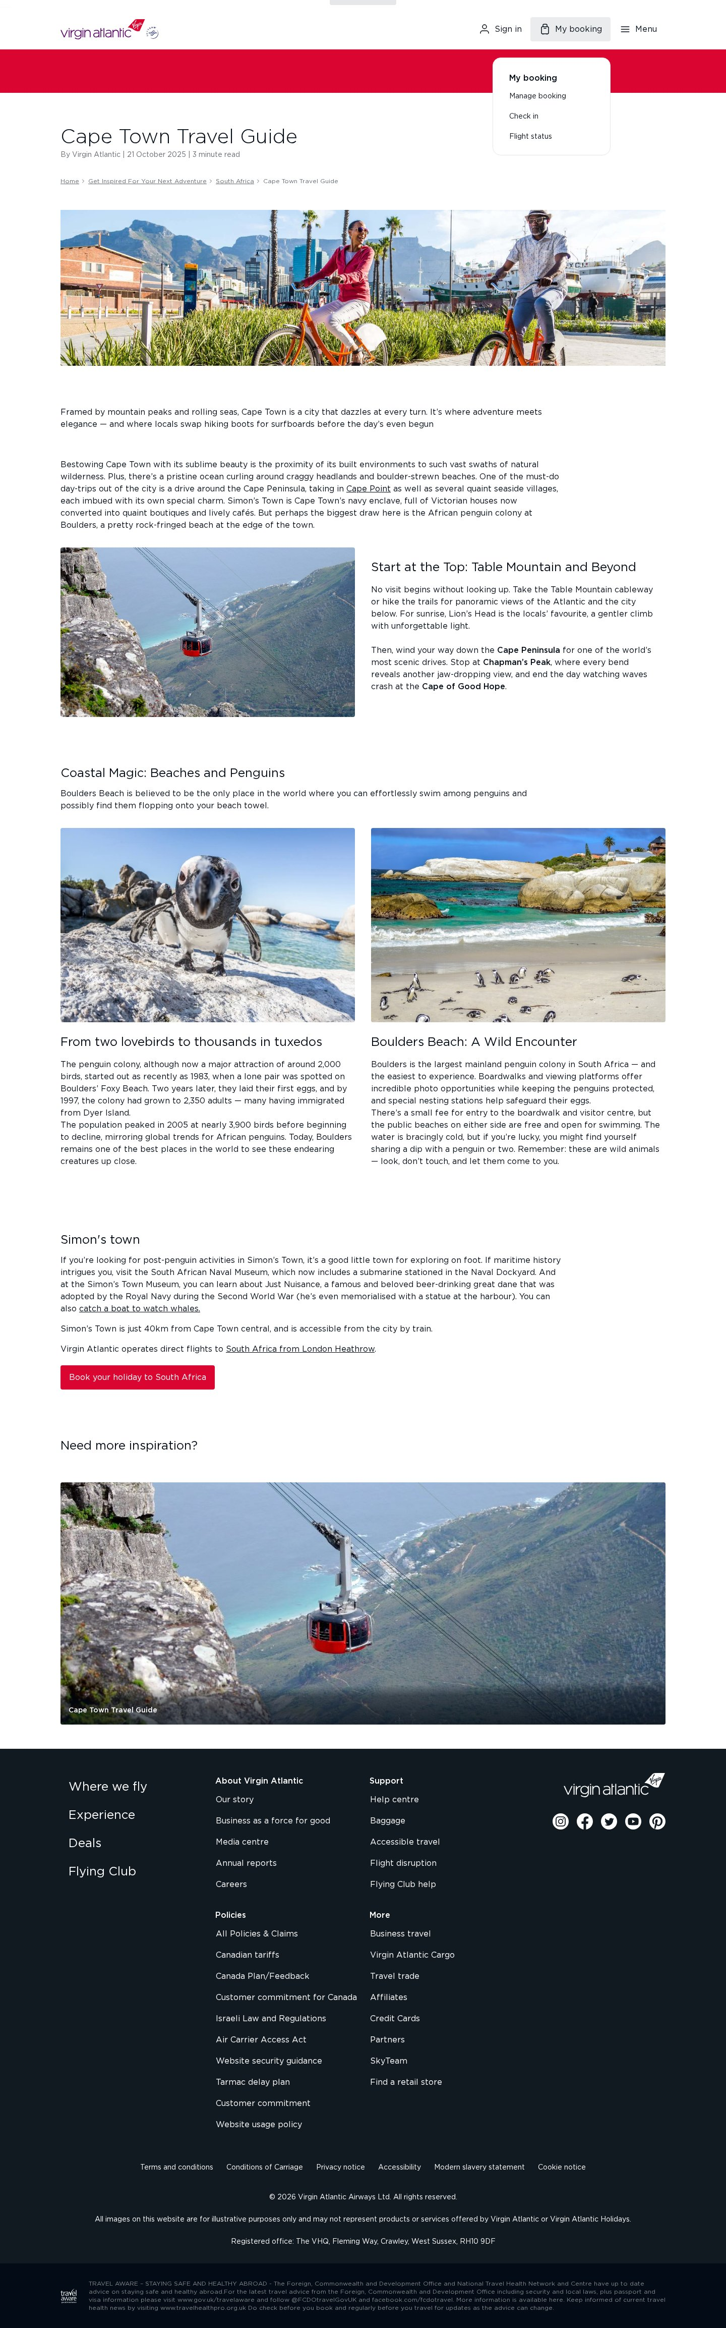
Template: editorial-travel-guide — representative page
accordion-content
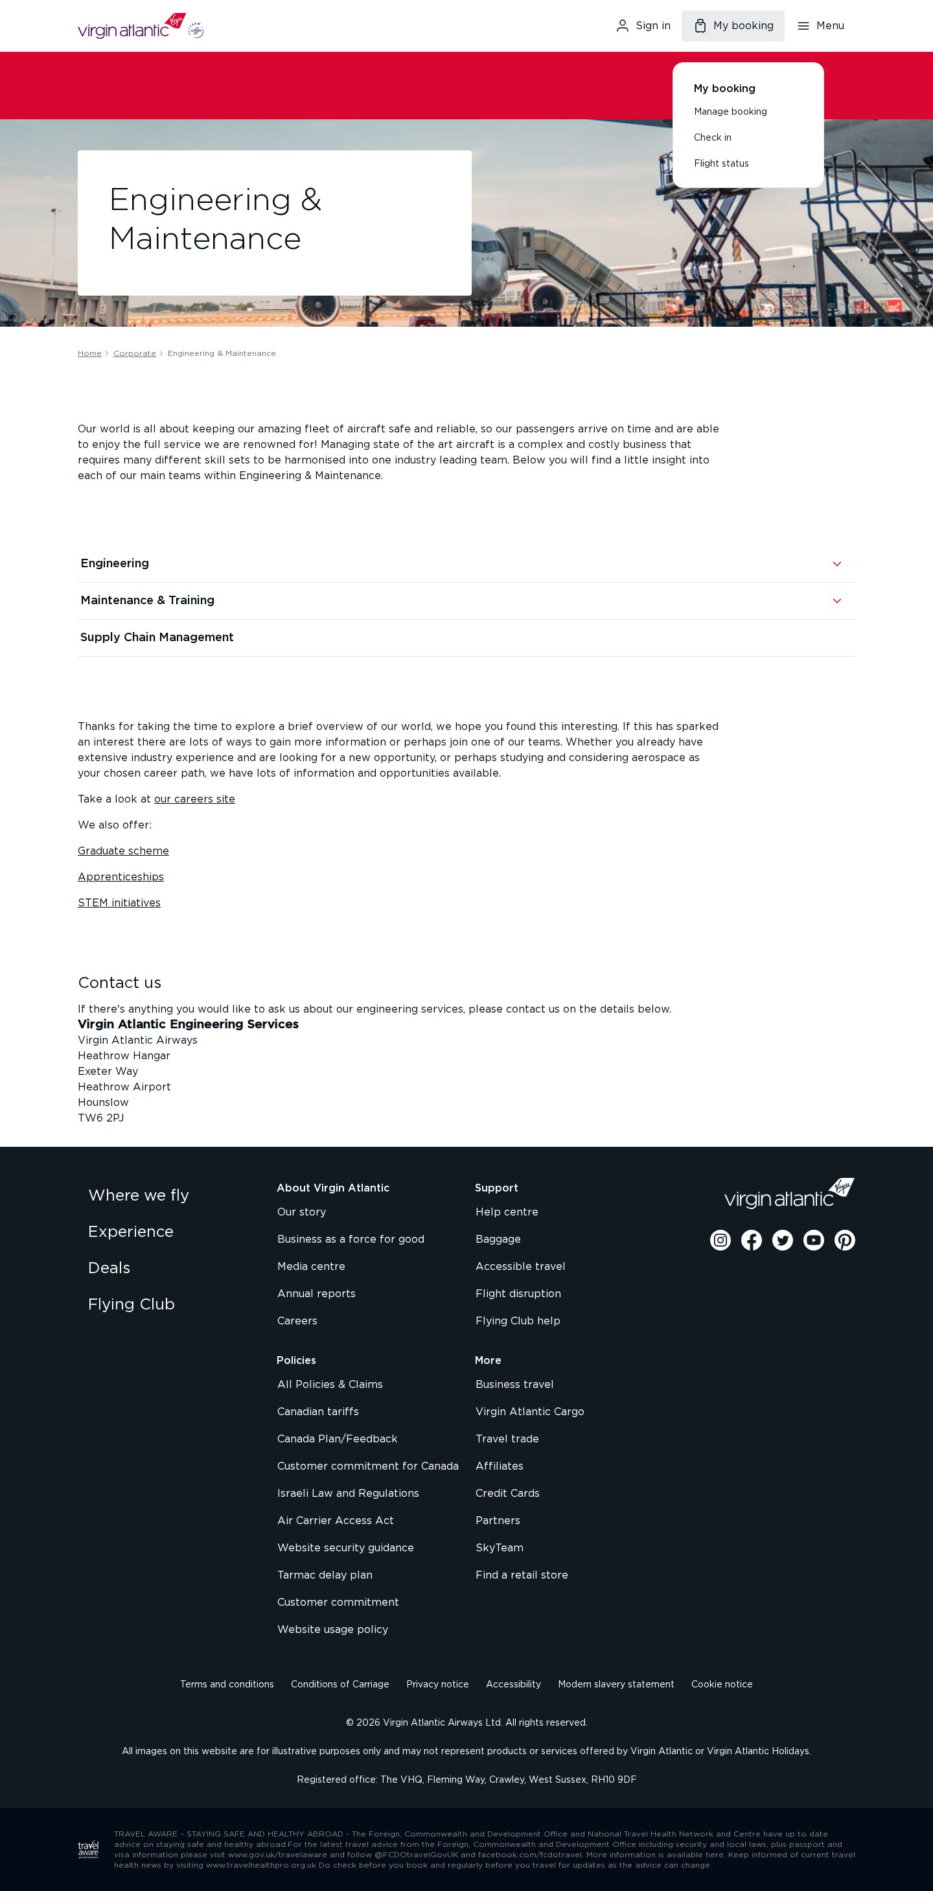
Template: accordion-content — representative page
news-listing
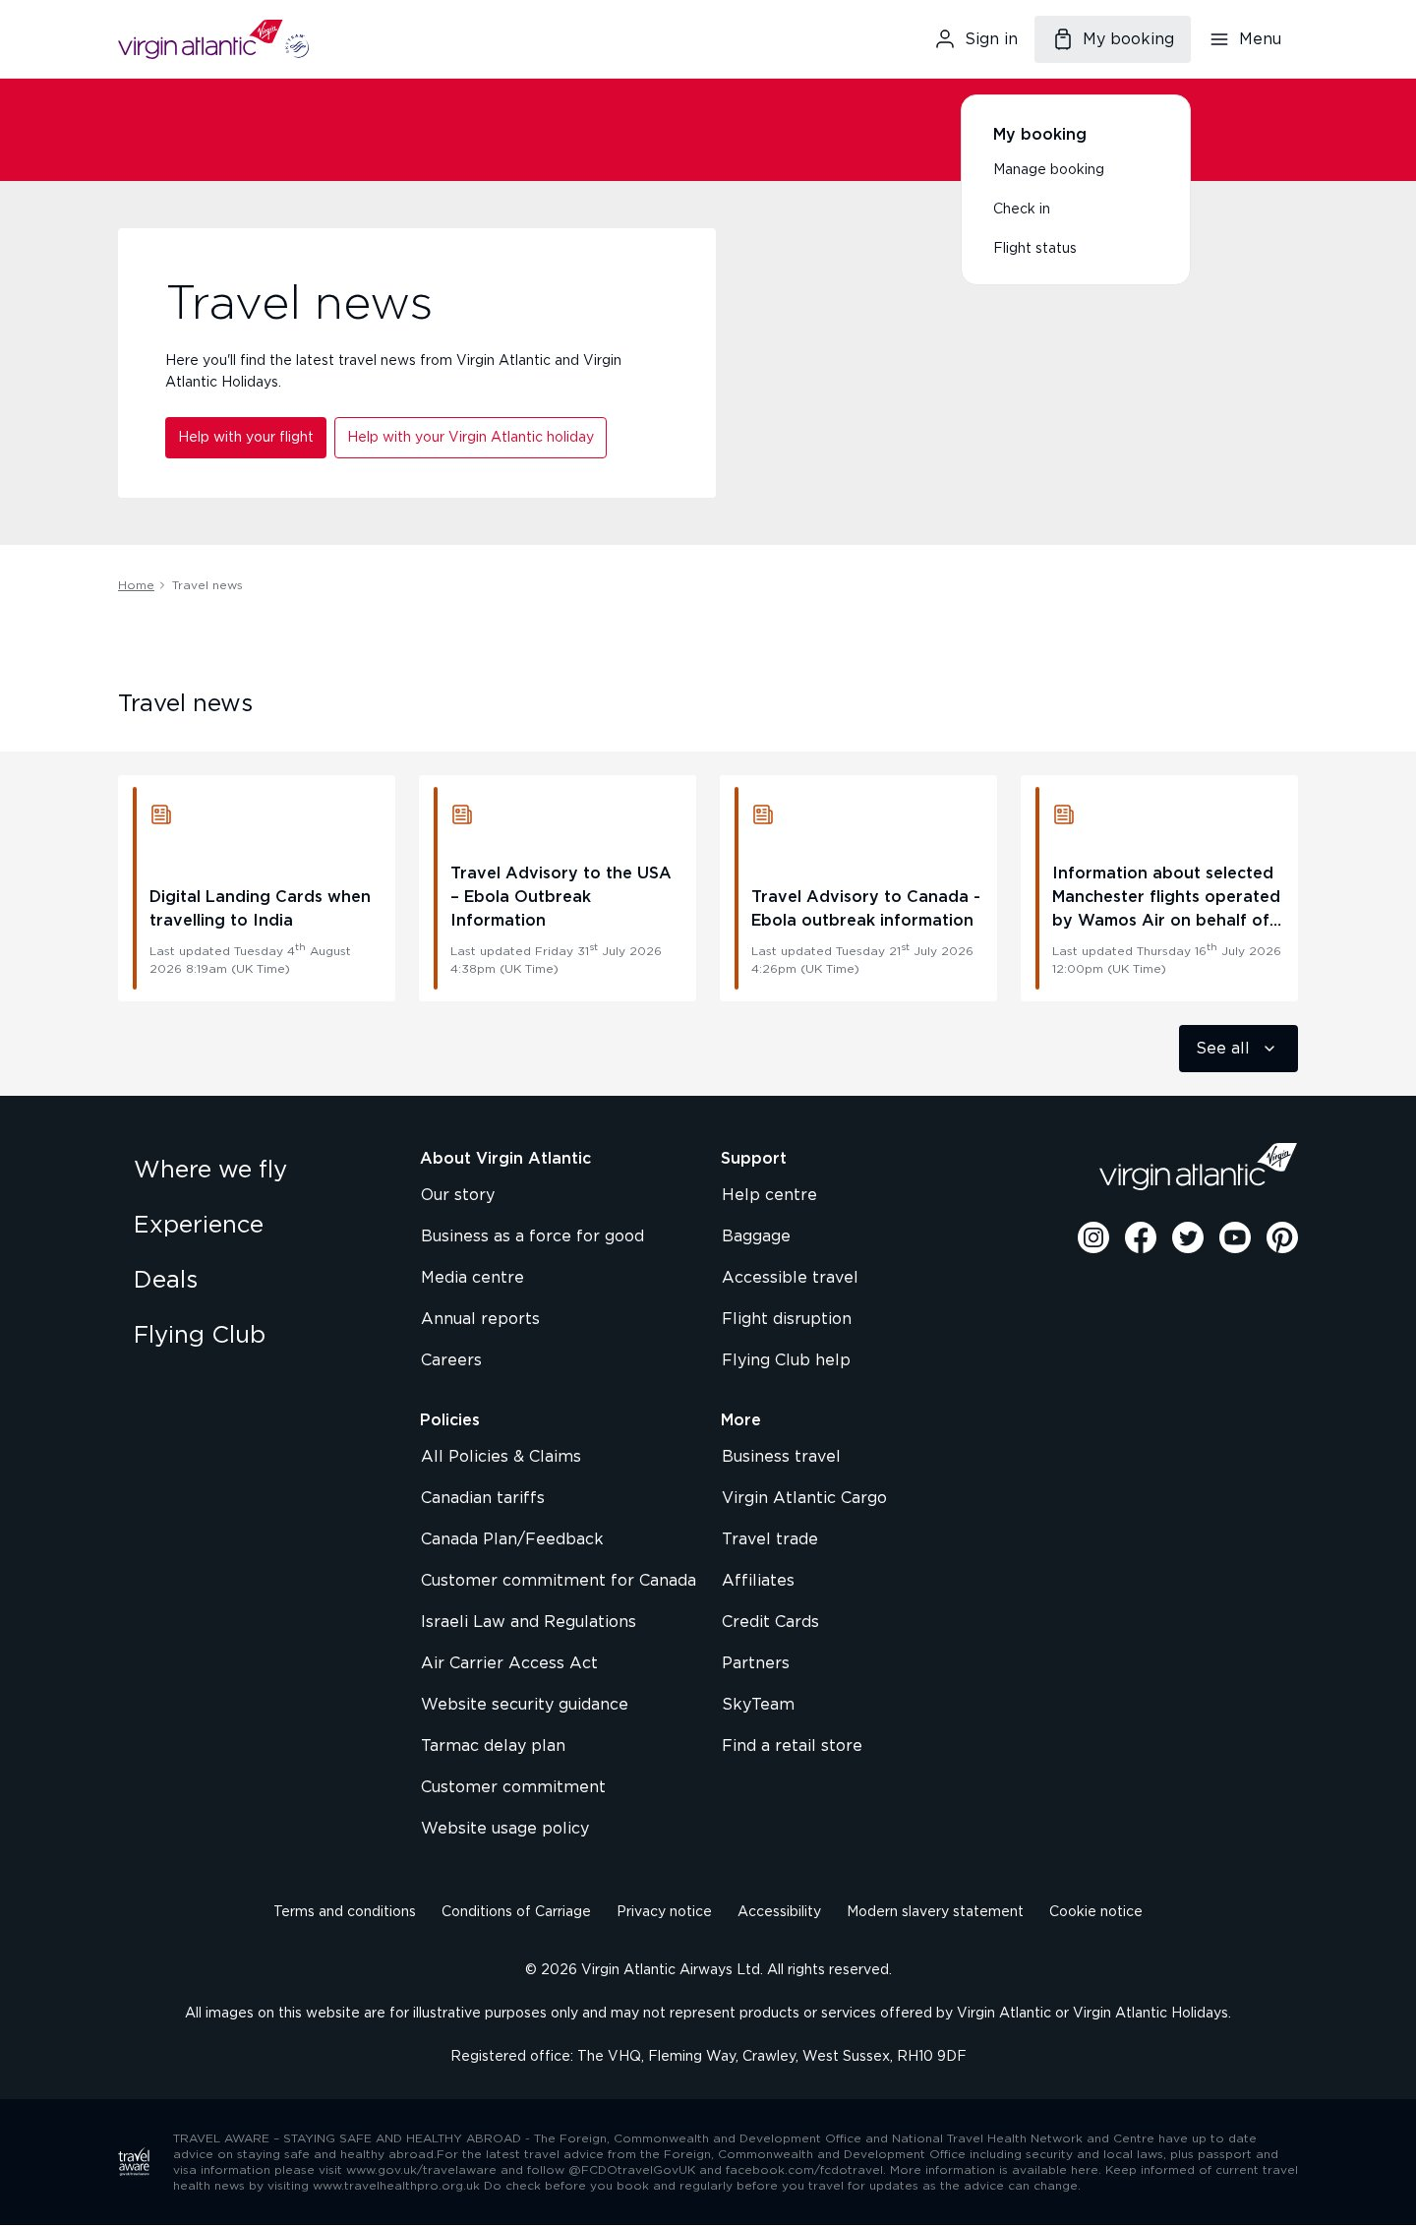
Template: news-listing — representative page
promo-feature
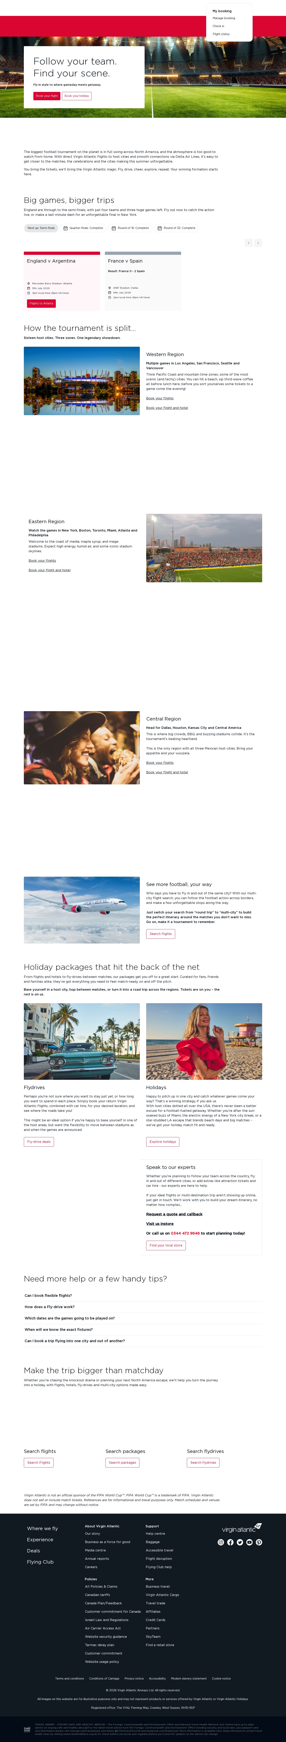
Template: promo-feature — representative page
reference-document
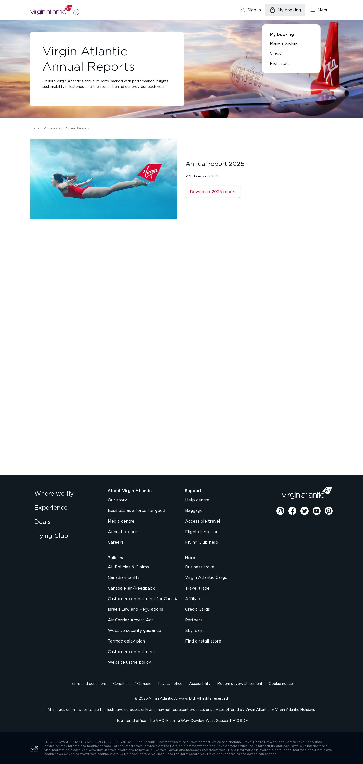
Template: reference-document — representative page
inspiration-hub
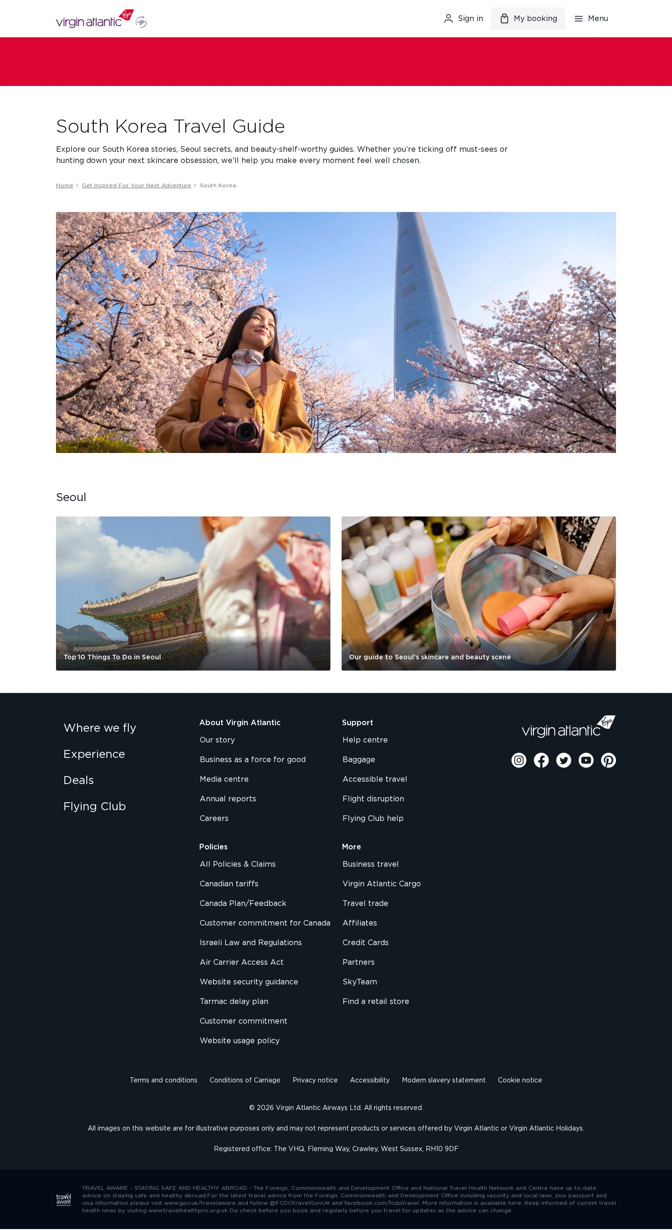
Template: inspiration-hub — representative page
destination-detail
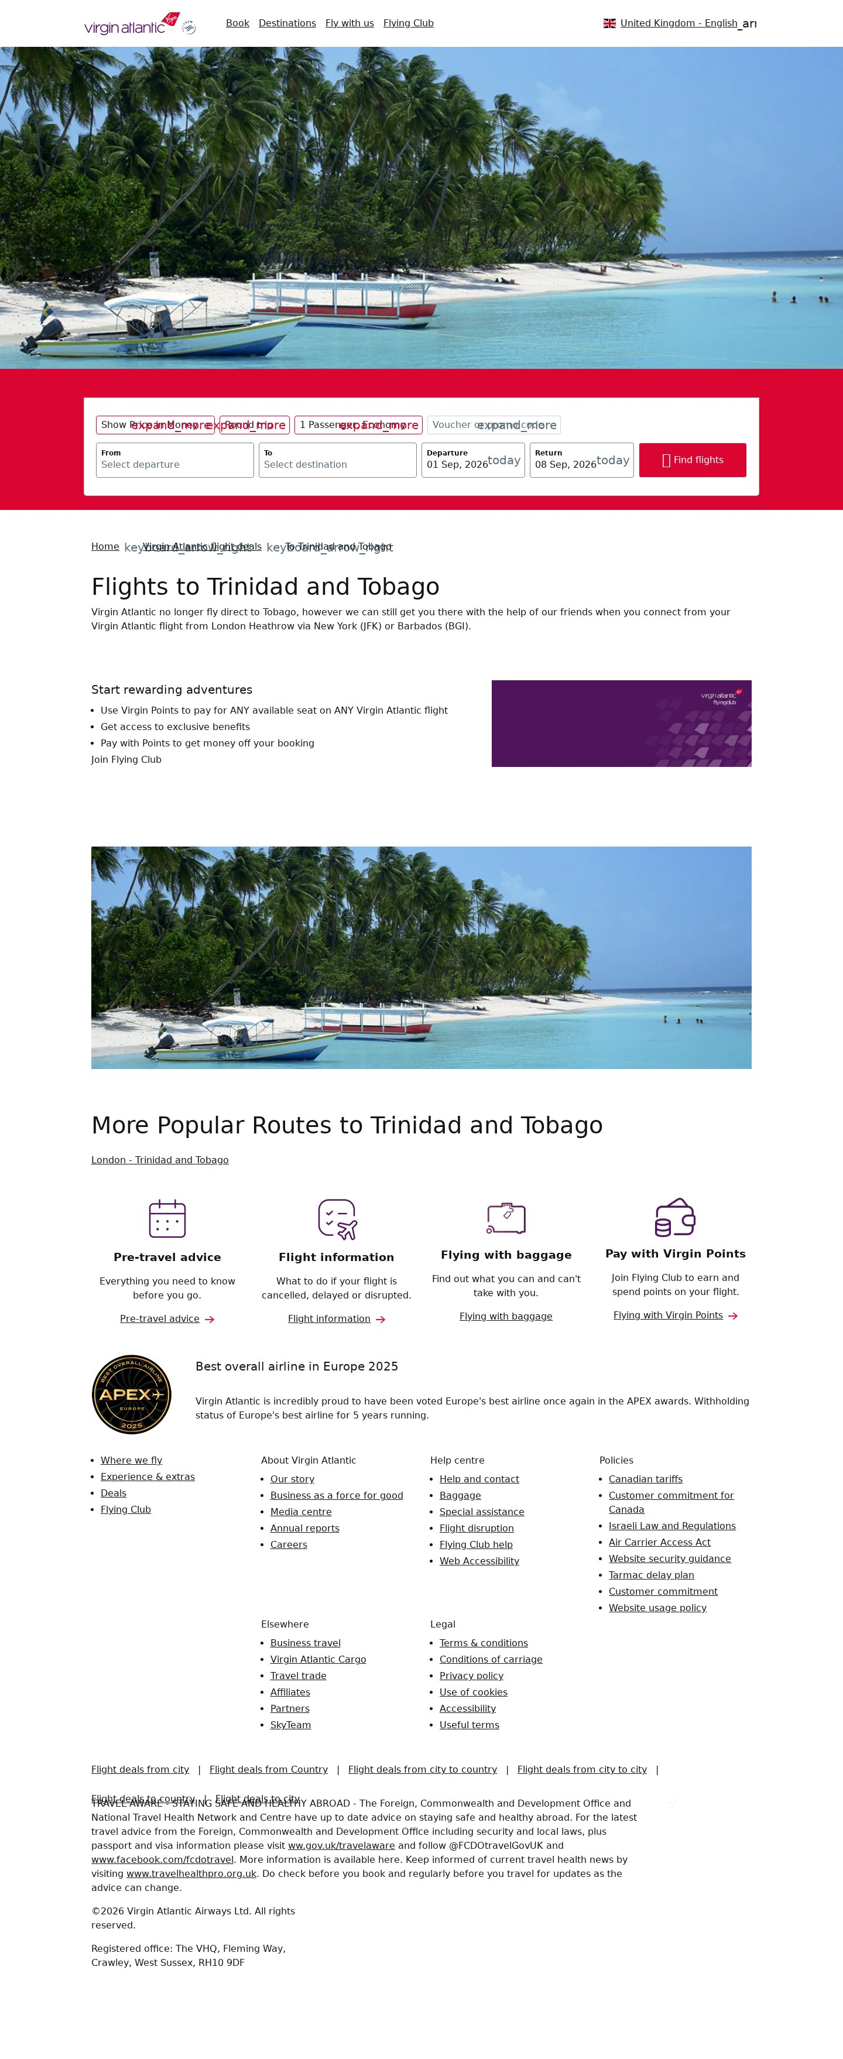
Template: destination-detail — representative page
itinerary-guide
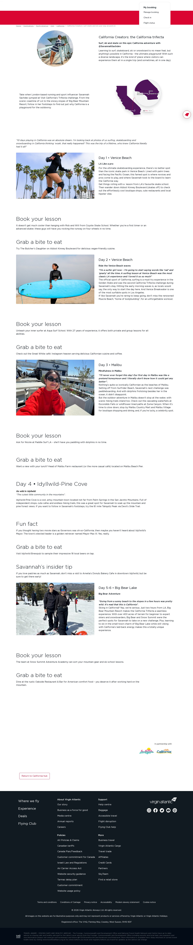
Template: itinerary-guide — representative page
client-rendered-content
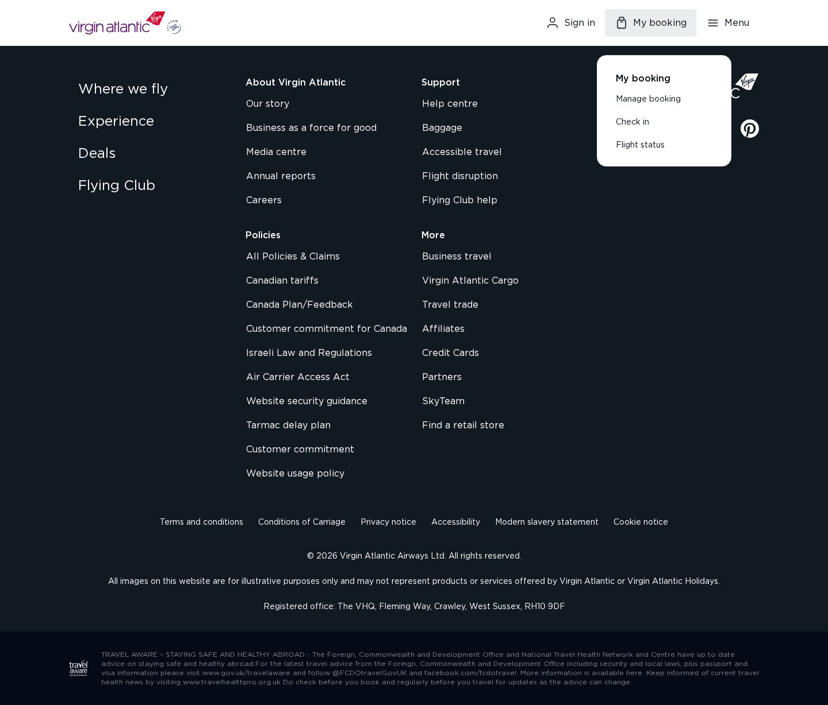
Template: client-rendered-content — representative page
manage-booking-app
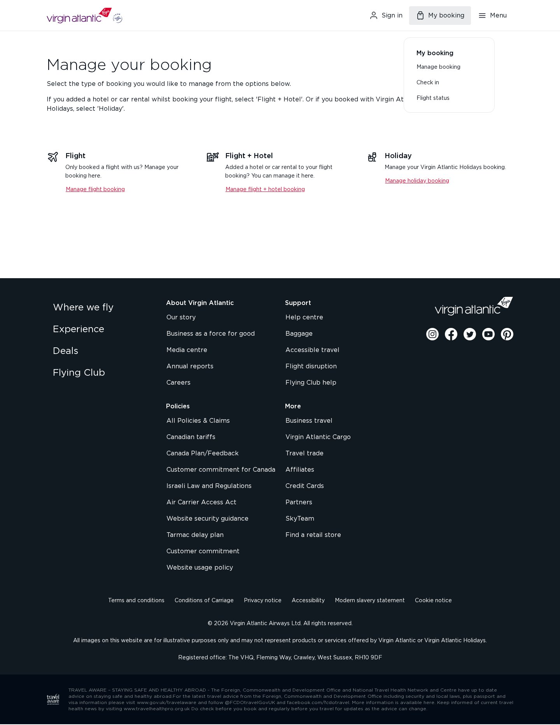
Template: manage-booking-app — representative page
3. Blocks / Components Catalog
27 block variants catalogued and consolidated by content model — visual variations are grouped as variants of the same base block rather than as separate blocks.
Block (base) | Variants | Complexity | Behaviour / Functionality | Reference URL
header (global) | 1 | Medium | Sticky nav: logo, Sign in, "My booking" flyout (Manage booking / Check in / Flight status), hamburger mega-menu. | all pages
footer (global) | 1 | Low | 4-column link nav, social icons, legal/Travel-Aware notice. | all pages
hero | 4 | Low–Med | Page banner: heading over full-bleed image or solid panel; light/dark themes. | /en-IN
cards | 3 | Medium | Card grid — feature/promo/news cards with image, heading, text, CTA. Most-used block: 279 pages. | /en-IN/travel-news
breadcrumbs | 5 | Low | Home > Section > Page trail; light/dark themes. | /en-IN/corporate/engineering
columns | 1 | Low | Multi-column image+text feature rows. | /en-IN
carousel | 1 | Medium | Rotating slides/gallery. | 3 pages
tabs | 1 | Medium | Tabbed content switcher. | 1 page
table | 1 | Low | Data table (fees/specs). | 1 page
form | 1 | High | Interactive form (contact/feedback). | 1 page
accordion / expander | ~3 | Medium | Expand/collapse sections. | /en-IN/corporate/engineering
unknown / custom | 8 | High | Composite fragments with no standard EDS equivalent (heading+CTA+list combos, image grids, grid-item React components). | various
Representative screenshots of the base blocks are shown below (one per block type).
Block screenshots
header
Block: header
hero

Block: hero
breadcrumbs
Block: breadcrumbs
cards
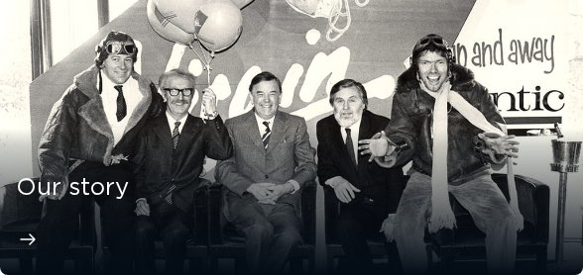
Block: cards
columns

Block: columns
carousel

Block: carousel
tabs
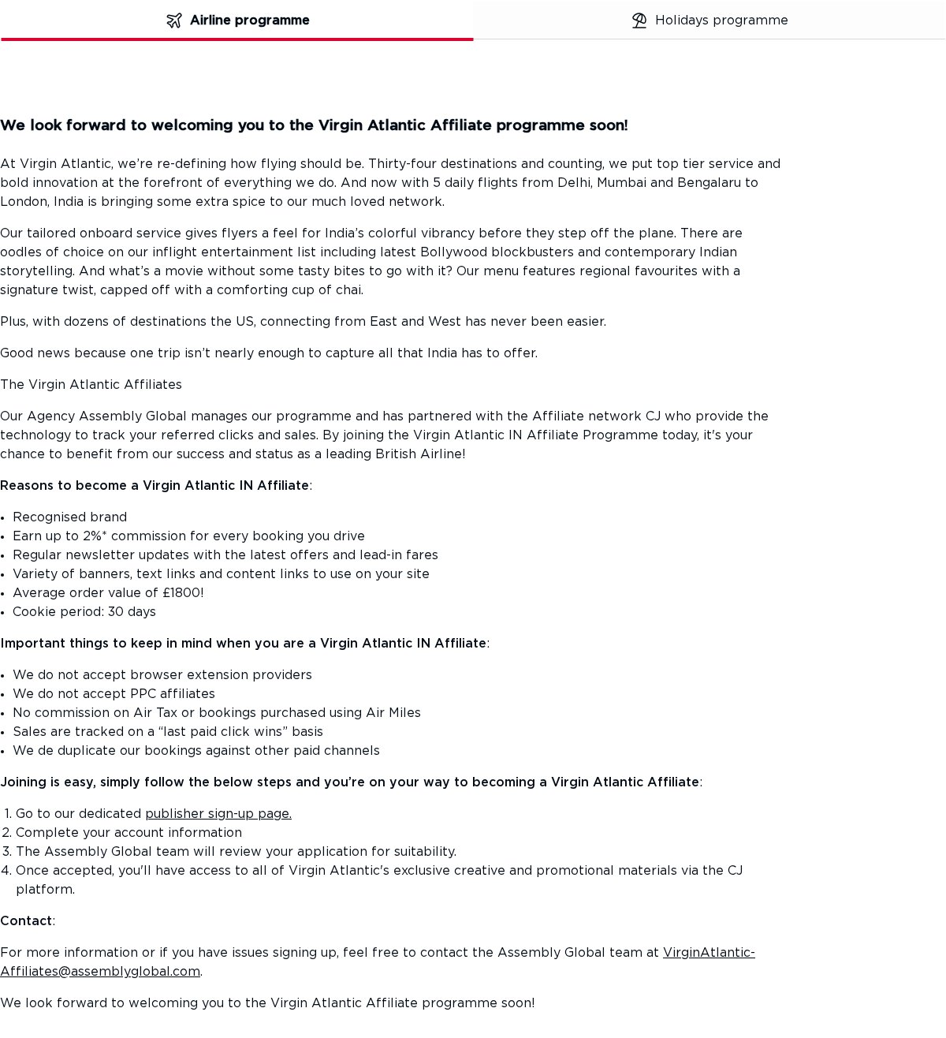
Block: tabs
table

Block: table
form
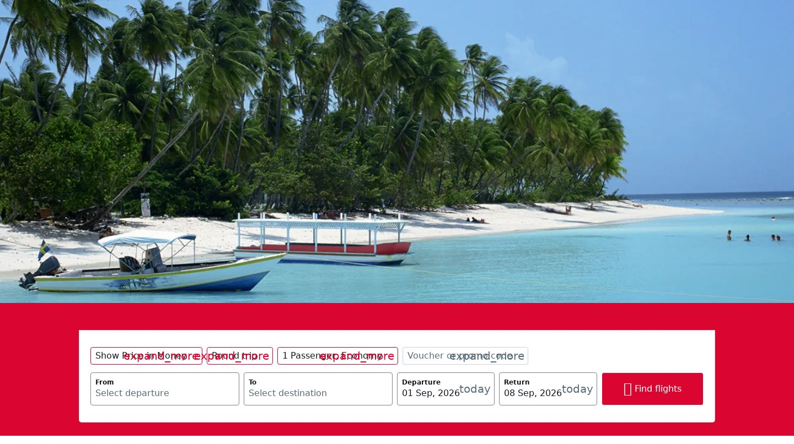
Block: form
footer
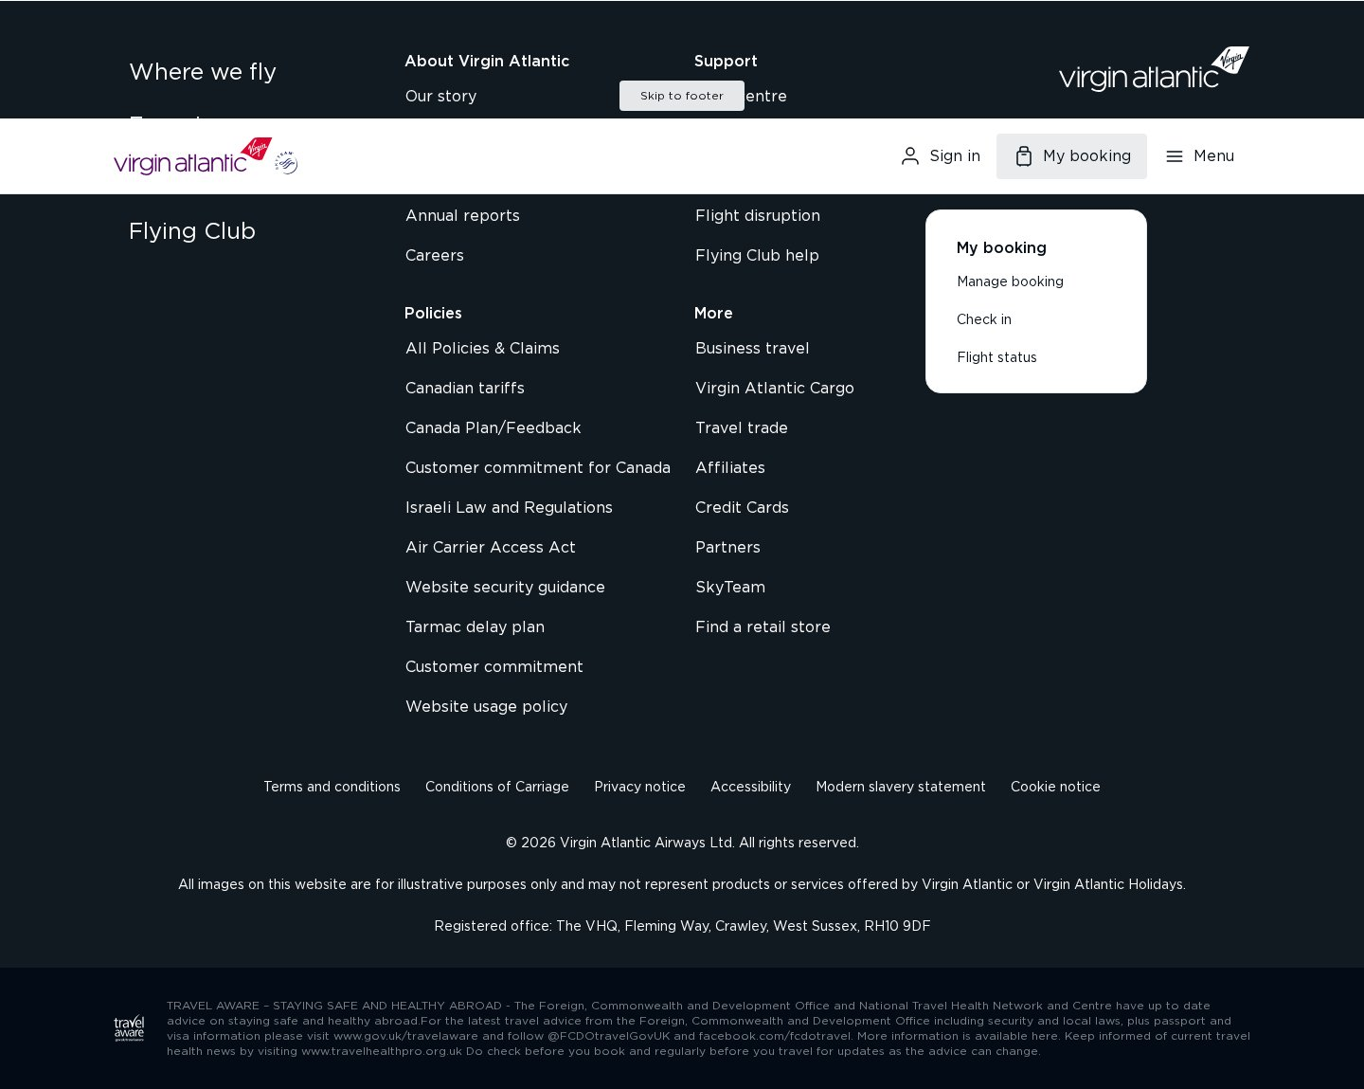
Block: footer
4. Page Counts by Template & Migration Classification
Template | Pages | Migration Path | Rationale
marketing-landing | 319 | Mixed (bulk auto + QA) | Structurally uniform but hero/feature regions vary; some render client-side.
rich-text-article | 49 | Automated | Standardized rich text.
editorial-travel-guide | 21 | Automated (light manual) | Consistent article structure.
client-rendered-content | 18 | Manual | Content not in static HTML; must be rebuilt.
accordion-content | 15 | Semi-auto | Accordion behaviour needs block wiring.
news-listing | 10 | Semi-auto | Dynamic card feed; needs listing logic.
promo-feature | 6 | Semi-auto | Campaign composition varies.
reference-document | 2 | Automated | Sparse text.
inspiration-hub | 1 | Semi-auto | Index/card grid.
destination-detail | 1 | Semi-auto | Overview + booking prompt.
itinerary-guide | 1 | Automated | Editorial content.
manage-booking-app | 1 | Manual / Exclude | Transactional app, not content.
Total | 444 | Auto 73 (16%) | Semi-auto 353 (80%) · Manual 19 (4%)
5. Integrations Analysis
Integration | Type | Complexity | Where used
Self-hosted Tag Management (tms.virginatlantic.com/.../Bootstrap.js) | Custom code / embed | High | All pages — loads analytics/marketing tags
Analytics data layer (window.digitalData / dataLayer) | Custom code | Medium | All pages
Booking engine (flights. / flywith. / vaabrowse.) | External app (redirect) | High | Booking, manage-booking, check-in, flight-status
Facebook / Meta | Pixel + social | Low–Med | Homepage, social links
Social embeds (Instagram, Twitter/X, Pinterest, YouTube) | Embed / link | Low | Footer, editorial pages
Flying Club loyalty (vsflyinghub.com) | External app | Medium | Flying Club section
Cross-property links (Cargo, Careers, Virgin Holidays) | Link-out | Low | Footer / corporate
Akamai bot protection / CDN | Platform | Medium | Site-wide (impacts crawl/migration tooling)
React/Next.js runtime (__NEXT_DATA__) | Framework | High | Client-rendered content pages
The self-hosted TMS obscures the exact downstream vendors (Adobe/Google/etc. load dynamically). A runtime network audit during migration is recommended to enumerate the full tag list.
6. Complex Use Cases & Observations
# | Complex behaviour | Instances | Where | Why complex
1 | Client-side-rendered content (React/Next) | ~19 | client-rendered-content, manage-booking | Content absent from static HTML; must be re-authored.
2 | Booking / transactional apps | subdomains | flights/flywith/vaabrowse | Out of EDS scope; require integration or link-out.
3 | "My booking" flyout + session state | all pages | Global header | Auth-gated actions depend on session.
4 | Dynamic news/advisory listing | 10 | news-listing | Date-sorted feed with pagination.
5 | Interactive blocks (accordion, tabs, carousel, form) | ~21 | accordion/tabs/carousel/form | Require JS behaviour beyond static content.
6 | 8 custom/unknown block variants | ~36 uses | across templates | No standard EDS equivalent; bespoke modeling required.
7 | Self-hosted TMS / analytics | site-wide | All pages | Full vendor list hidden behind bootstrap loader.
8 | Bot protection (Akamai) | site-wide | All pages | Throttles/blocks automated import tooling.
9 | Deep multilingual/locale sitemap | 446 / ~19 locales | sitemap | en-IN content largely shared across locales; multi-locale rollout multiplies effort.
7. Migration Estimates
Estimates cover the en-IN content layer only (446 pages, 12 templates, 27 blocks). Excludes the booking engine and other transactional apps.
Effort by workstream
Workstream | Estimate | Notes
Block development (27 variants → ~12–15 EDS blocks + variations) | 12–16 days | Incl. 8 custom + interactive (form/tabs/carousel/accordion)
Template setup (12 templates) | 5–7 days | Auto-block rules, section styling
Automated import (~73 clean pages) | 2–3 days | Scripted bulk import
Bulk-with-QA import (~353 pages) | 8–12 days | Import + per-page correction
Manual migration (~19 client-rendered/app pages) | 4–6 days | Re-authoring
Header / footer / navigation (global) | 3–5 days | Mega-menu + "My booking" flyout
Integrations & analytics re-implementation | 4–6 days | TMS/data-layer/tag re-wire + runtime audit
QA & testing (functional, visual, a11y, PageSpeed) | 8–10 days | Target Lighthouse 100
Project mgmt / UAT / fixes | 5–7 days
Totals
Metric | Estimate
Total effort | ~51–72 person-days (≈ 10–14 weeks of work)
Recommended team | 2 developers + 1 QA + PM (part-time)
Calendar schedule | ~8–10 weeks with the team above
Indicative cost | At a blended ~$600/day → ≈ $30k–$43k (adjust to your rates)
Recommended phasing
- Phase 1 — Blocks + templates + global navigation
- Phase 2 — Automated + bulk import of the ~419 content pages
- Phase 3 — Manual rebuild of the 19 dynamic pages + integrations
- Phase 4 — QA / UAT
8. Caveats & Assumptions
- The site sits behind bot protection; a small number of rapid requests were throttled during discovery. Final page coverage was still 99.6%.
- The 63 non-fatal errors logged during the run were mostly transient navigation/redirect retries on a JS-heavy site — they did not reduce final coverage.
- Booking, check-in, flight-status and account flows are separate applications and are NOT included in the content-migration counts or estimates above.
- Cost figures are indicative and use a placeholder blended day rate; adjust to your actual rates.
9. Analysis Artifacts
Artifact | Description
template-catalog.json | 12 named templates with page assignments and reference URLs
block-catalog.json | 27 block variants with usage counts and canonical models
summary.json | Site metrics and coverage summary
urls-all.json / urls-grouped.json | 446 discovered URLs, grouped by directory pattern
.pages/{slug}/full-page.jpg | Full-page screenshot per analysed page
.blocks/{variant}/screenshots/ | Screenshots per block variant
Virgin Atlantic (en-IN) — EDS Migration Handover · Generated 2026-08-25 · Content-layer scope only (excludes transactional booking applications).

