Website Analysis Report
Virgin Atlantic Cargo
https://www.virginatlanticcargo.com/gb/en.html
Templates Inventory & Blocks / Components Catalog
Prepared for AEM Edge Delivery Services migration planning
Report date: 5 August 2026

Executive Summary
Virgin Atlantic Cargo is the air-freight arm of Virgin Atlantic. The GB/English site presents its products and service levels, worldwide office network and flight schedules, booking and e-services tools (myVS), news and operational notifications. It is an Adobe Experience Manager Sites site with a single English (GB) locale.
Metric | Value
Site | https://www.virginatlanticcargo.com/gb/en.html
URL discovery method | Site crawl (sitemap unavailable)
Content pages analysed | 95 (100% coverage, 0 failures)
Downloadable documents found | 19 PDFs (guides, schedules, forms)
Locale | Single — GB / English
Unique page templates | 14
Reusable blocks / components | 8 logical blocks (48 design variations detected)

Notes: legacy duplicate URLs (an "our-porducts-services" typo path and older "our-products" paths) were 301/302 redirects to the current "our-products-services" section and were excluded from the count. The worldwide-office pages are a client-side JavaScript application, so their static capture shows an initialization dialog; they are catalogued as one dynamic "office detail" template.

1. Templates Inventory
The site is built from 14 unique page templates. The table below summarises each; detailed descriptions and reference screenshots follow.
Template | Complexity | Pages | Reference URL (example)
Homepage  homepage | High | 2 | https://www.virginatlanticcargo.com/
Content / news article  content-article | Medium | 33 | https://www.virginatlanticcargo.com/gb/en/Footer.html
Product / service detail  product-detail | High | 7 | https://www.virginatlanticcargo.com/gb/en/our-products-services/products/Fresh.html
Worldwide office detail  office-detail | High | 27 | https://www.virginatlanticcargo.com/gb/en/our-network/worldwide-offices/aberdeen.html
Editorial mosaic  editorial-mosaic | High | 10 | https://www.virginatlanticcargo.com/gb/en/about-us.html
Section hub / overview  section-hub | Medium | 2 | https://www.virginatlanticcargo.com/gb/en/eservices.html
News listing  news-listing | Medium | 1 | https://www.virginatlanticcargo.com/gb/en/news.html
Team profiles  team-profiles | Medium | 1 | https://www.virginatlanticcargo.com/gb/en/about-us/news/meet-the-team.html
Contact hub  contact-hub | Medium | 1 | https://www.virginatlanticcargo.com/gb/en/contact-us.html
FAQ (accordion)  faq-accordion | Medium | 1 | https://www.virginatlanticcargo.com/gb/en/contact-us/faqs.html
Notifications & alerts  notifications-list | Medium | 1 | https://www.virginatlanticcargo.com/gb/en/notifications.html
Guidance article  guidance-article | Medium | 2 | https://www.virginatlanticcargo.com/gb/en/notifications/shipping-guidance.html
Hero + CTA landing  hero-cta-landing | Low | 6 | https://www.virginatlanticcargo.com/gb/en/book/pets2.html
Legal / terms (long-form)  legal-longform | Low | 1 | https://www.virginatlanticcargo.com/gb/en/Footer/termsandconditions/product-service-level-terms.html

1.1 Template details

1. Homepage
Identifier: homepage Complexity: High Pages using: 2
Reasoning: Composes the most block types: a rotating carousel hero, a quick-link icon row, several three-column promo-card rows (products, "book it your way", latest news) and a rich footer. High visual and functional density.
Reference URLs:
- https://www.virginatlanticcargo.com/
- https://www.virginatlanticcargo.com/gb/en.html
Screenshot:
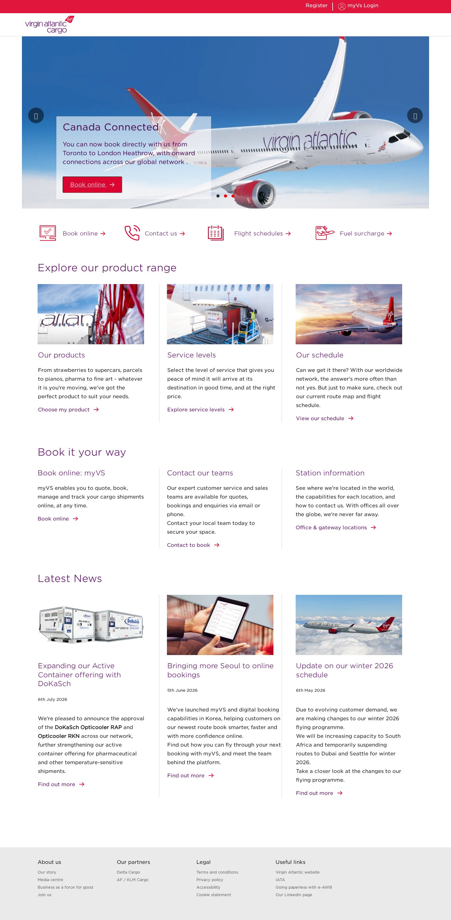

2. Content / news article
Identifier: content-article Complexity: Medium Pages using: 33
Reasoning: The most-used template (33 pages). Title, optional date, and a flexible stack of rich-text and text-plus-image sections with inline quotes and CTAs. Straightforward structure, high content variability.
Reference URLs:
- https://www.virginatlanticcargo.com/gb/en/Footer.html
- https://www.virginatlanticcargo.com/gb/en/Footer/accessibility.html
- https://www.virginatlanticcargo.com/gb/en/Footer/cookie-statement.html
- https://www.virginatlanticcargo.com/gb/en/Footer/termsandconditions.html
- … and 29 more
Screenshot:
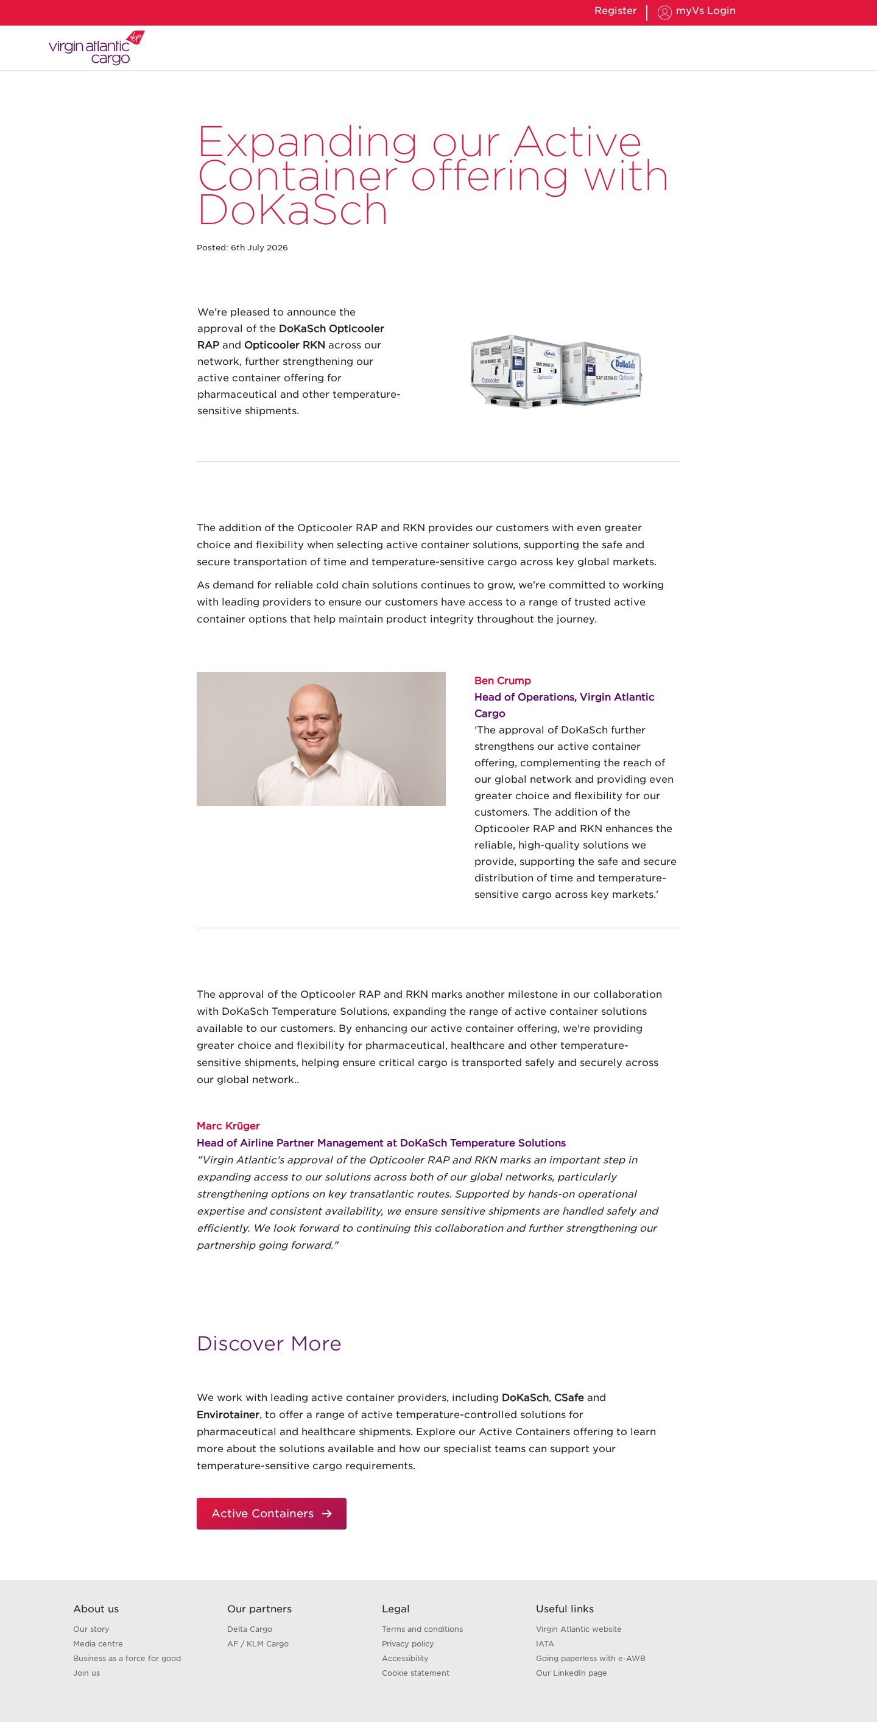

3. Product / service detail
Identifier: product-detail Complexity: High Pages using: 7
Reasoning: Rich fixed composition: hero, "Why X?" intro with a product-features box, a three-column service-levels block, a booking/contact block and a "Discover more" three-card row. 7 product pages.
Reference URLs:
- https://www.virginatlanticcargo.com/gb/en/our-products-services/products/Fresh.html
- https://www.virginatlanticcargo.com/gb/en/our-products-services/products/General.html
- https://www.virginatlanticcargo.com/gb/en/our-products-services/products/pharma.html
- https://www.virginatlanticcargo.com/gb/en/our-products-services/products/cars.html
- … and 3 more
Screenshot:
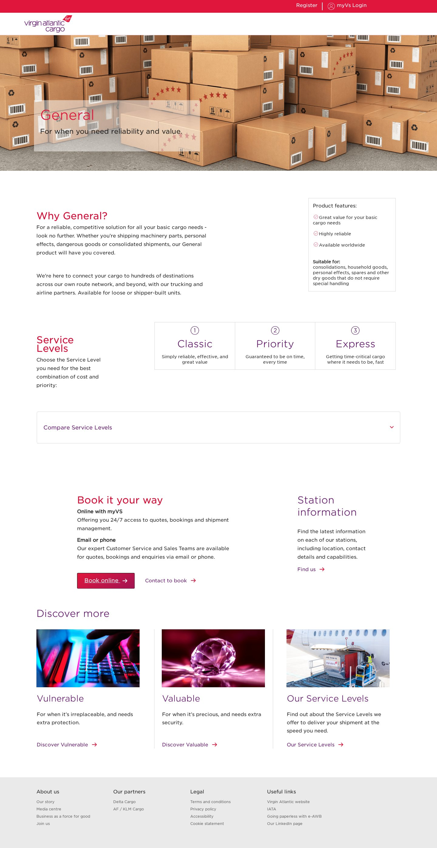

4. Worldwide office detail
Identifier: office-detail Complexity: High Pages using: 27
Reasoning: A client-side JavaScript "station information" application (renders blank / shows an init dialog to crawlers). Dynamic data loading and interactivity push complexity up despite a simple visual footprint. 27 office pages.
Reference URLs:
- https://www.virginatlanticcargo.com/gb/en/our-network/worldwide-offices/aberdeen.html
- https://www.virginatlanticcargo.com/gb/en/our-network/worldwide-offices/atlanta.html
- https://www.virginatlanticcargo.com/gb/en/our-network/worldwide-offices/belfast.html
- https://www.virginatlanticcargo.com/gb/en/our-network/worldwide-offices/bengaluru.html
- … and 23 more
Screenshot:
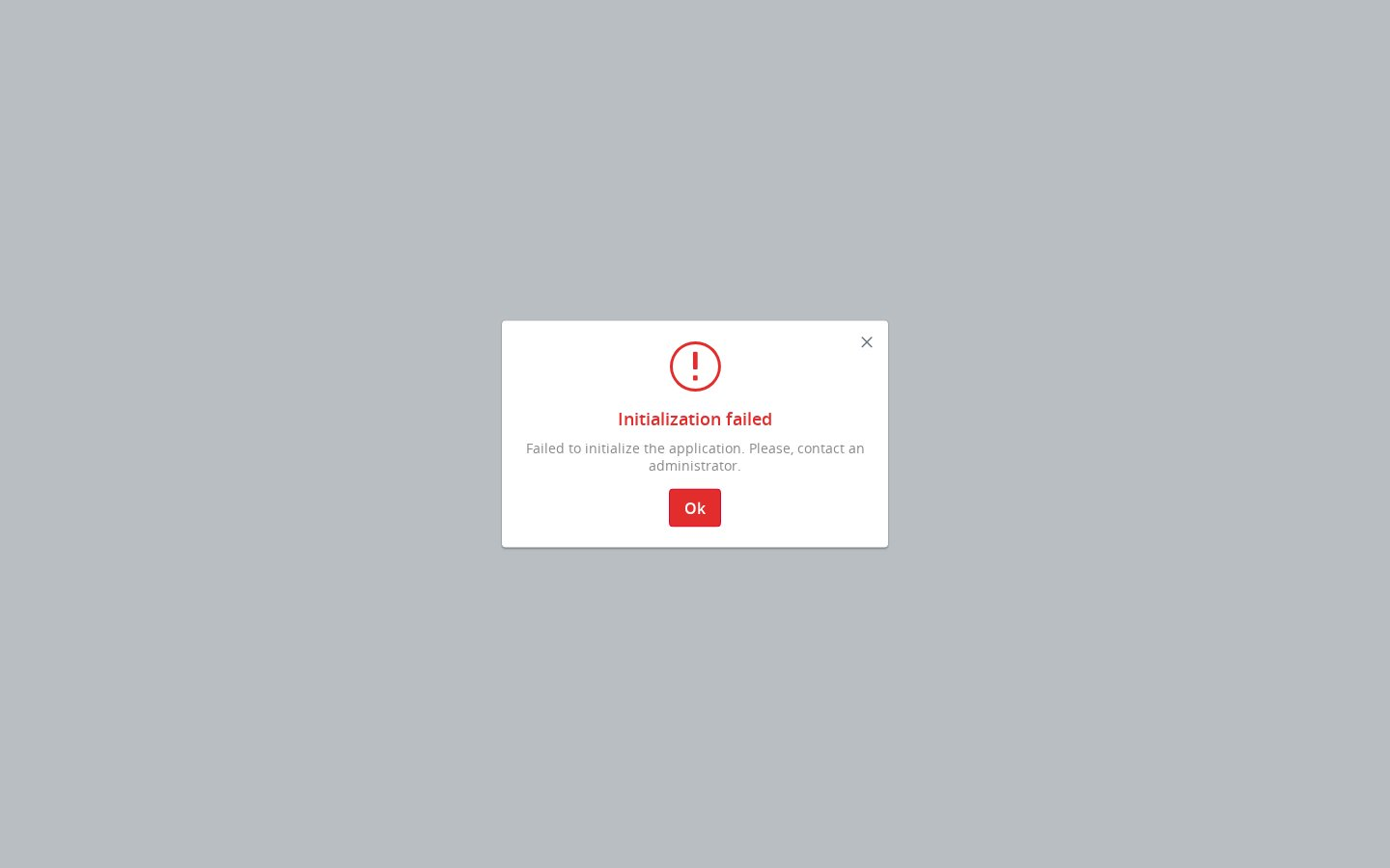

5. Editorial mosaic
Identifier: editorial-mosaic Complexity: High Pages using: 10
Reasoning: About-us / Media-centre landing pages built from an interlocking mosaic of image tiles and text tiles with links, plus supporting text. Bespoke asymmetric grid layout. 10 pages.
Reference URLs:
- https://www.virginatlanticcargo.com/gb/en/about-us.html
- https://www.virginatlanticcargo.com/gb/en/about-us/news.html
- https://www.virginatlanticcargo.com/gb/en/about-us/news/Press_releases.html
- https://www.virginatlanticcargo.com/gb/en/about-us/our-story.html
- … and 6 more
Screenshot:
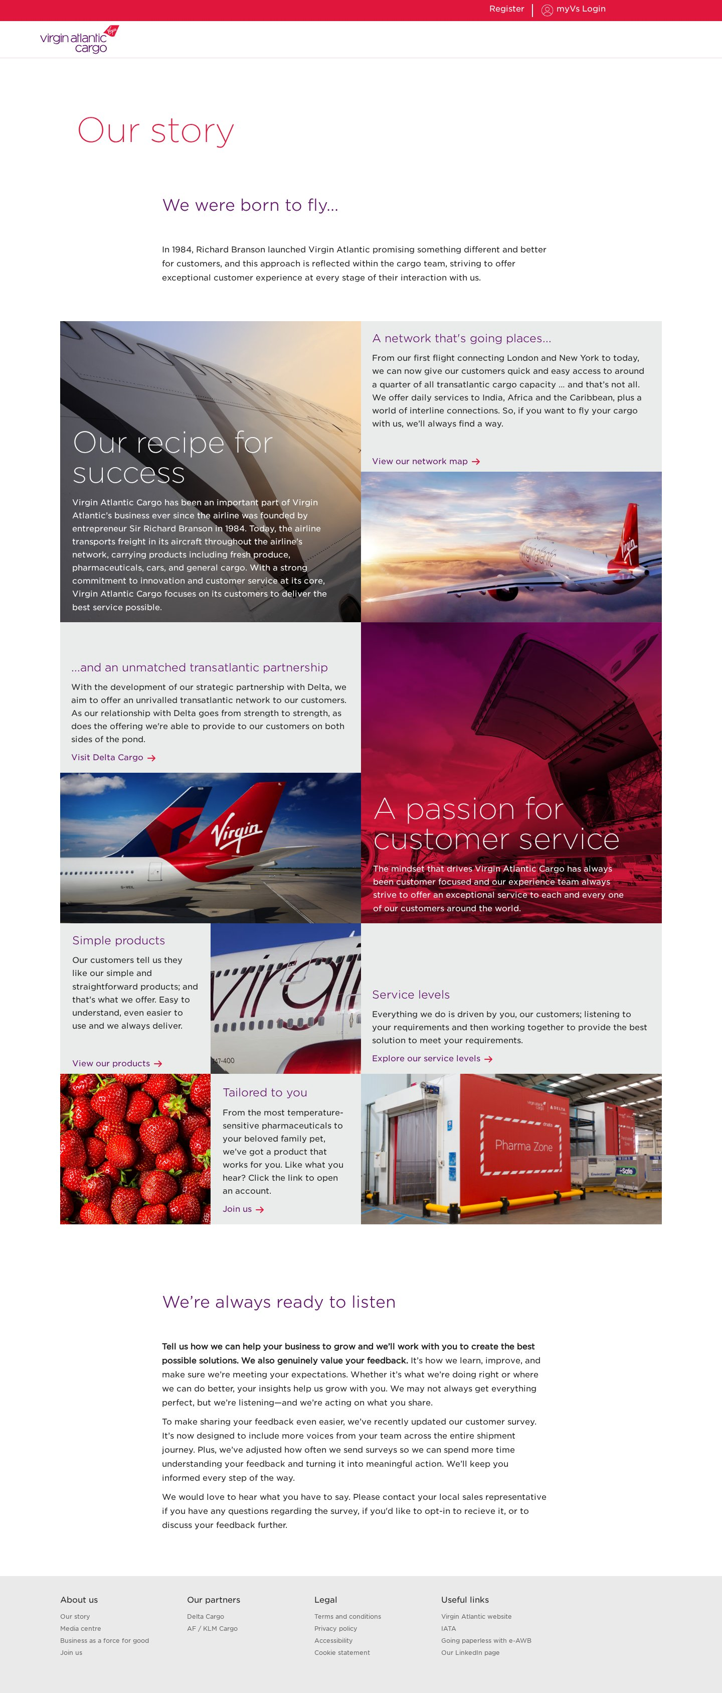

6. Section hub / overview
Identifier: section-hub Complexity: Medium Pages using: 2
Reasoning: Section landing (e-Services, Products & services): title, intro and a grid of promo cards (image + heading + text + link) into the section.
Reference URLs:
- https://www.virginatlanticcargo.com/gb/en/eservices.html
- https://www.virginatlanticcargo.com/gb/en/our-products-services/products.html
Screenshot:
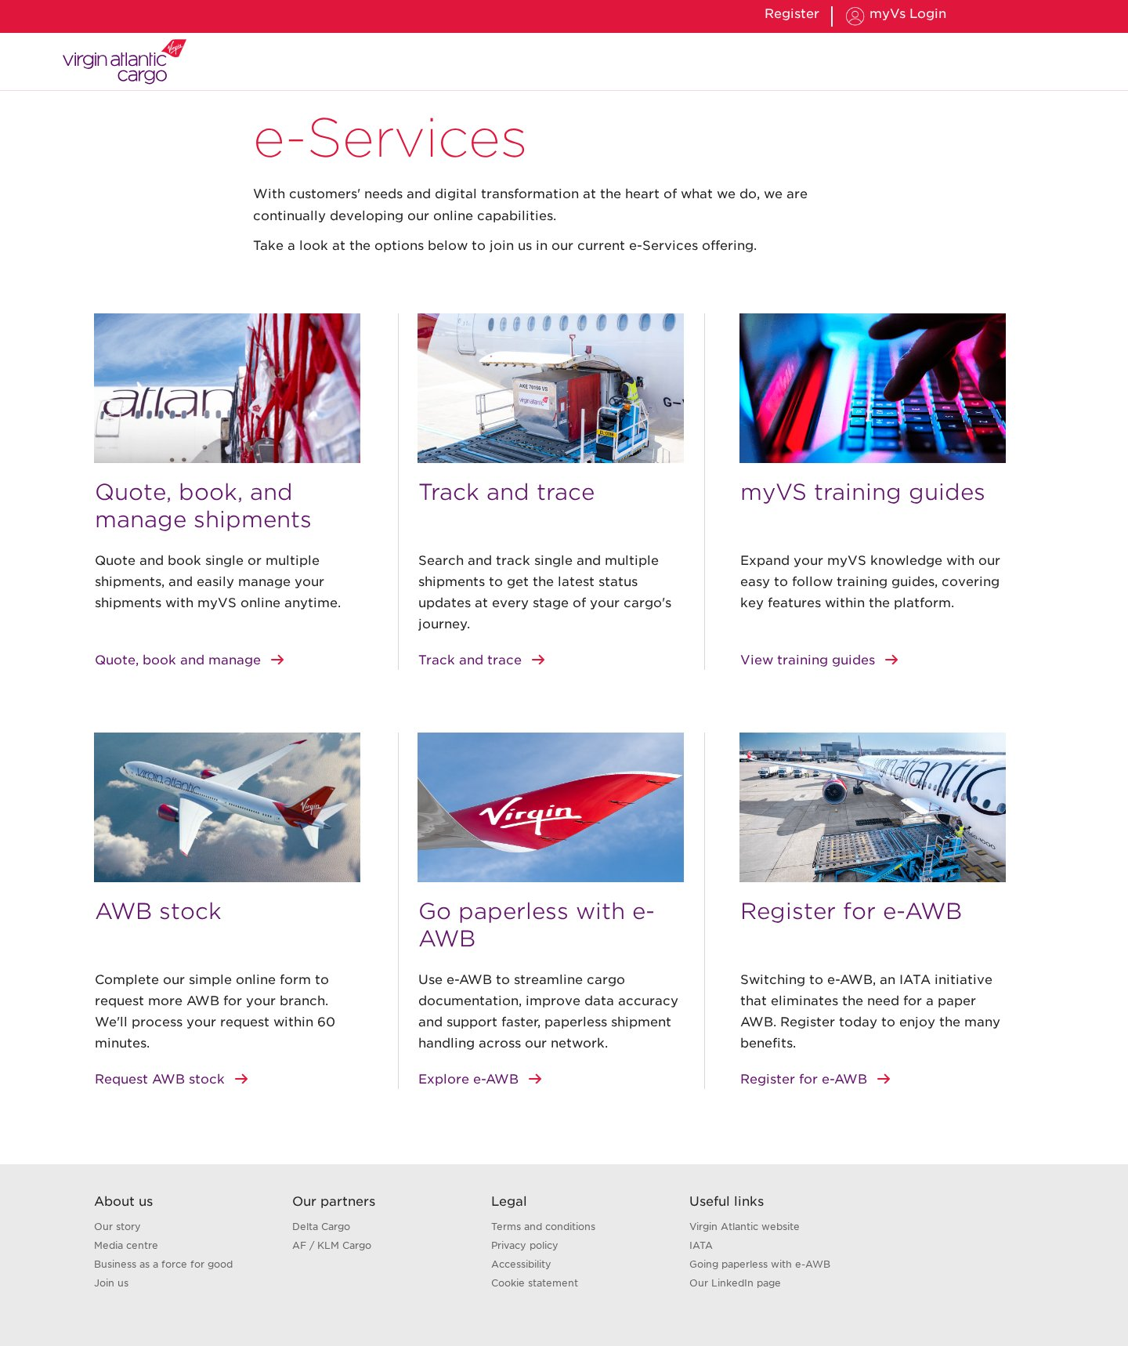

7. News listing
Identifier: news-listing Complexity: Medium Pages using: 1
Reasoning: News index: title and a mosaic/grid of news teasers linking to individual articles. Shares the mosaic grid pattern.
Reference URLs:
- https://www.virginatlanticcargo.com/gb/en/news.html
Screenshot:
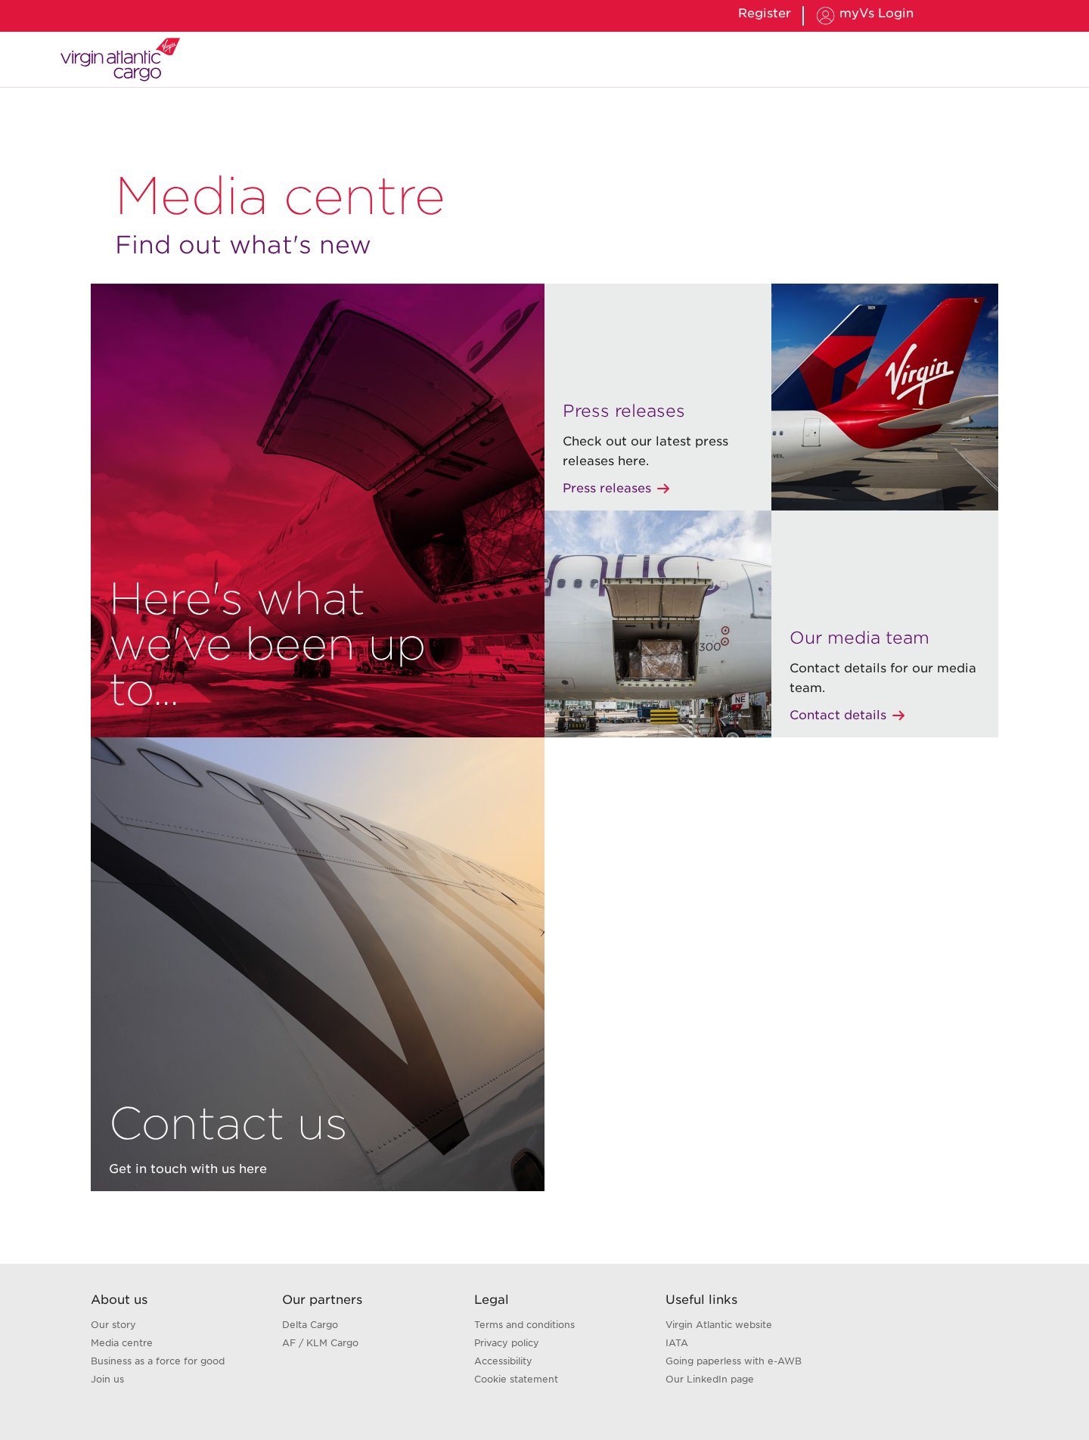

8. Team profiles
Identifier: team-profiles Complexity: Medium Pages using: 1
Reasoning: Title plus a series of repeating team-member rows (portrait, name/role, biography, LinkedIn CTA). Simple but highly repetitive structured content.
Reference URLs:
- https://www.virginatlanticcargo.com/gb/en/about-us/news/meet-the-team.html
Screenshot:
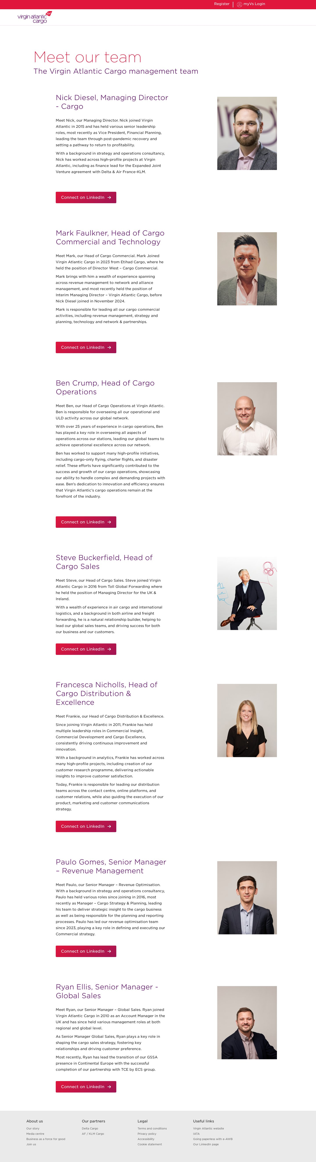

9. Contact hub
Identifier: contact-hub Complexity: Medium Pages using: 1
Reasoning: Title, intro text with inline links/CTAs, and a region-based accordion of contact information plus a support/incident CTA.
Reference URLs:
- https://www.virginatlanticcargo.com/gb/en/contact-us.html
Screenshot:
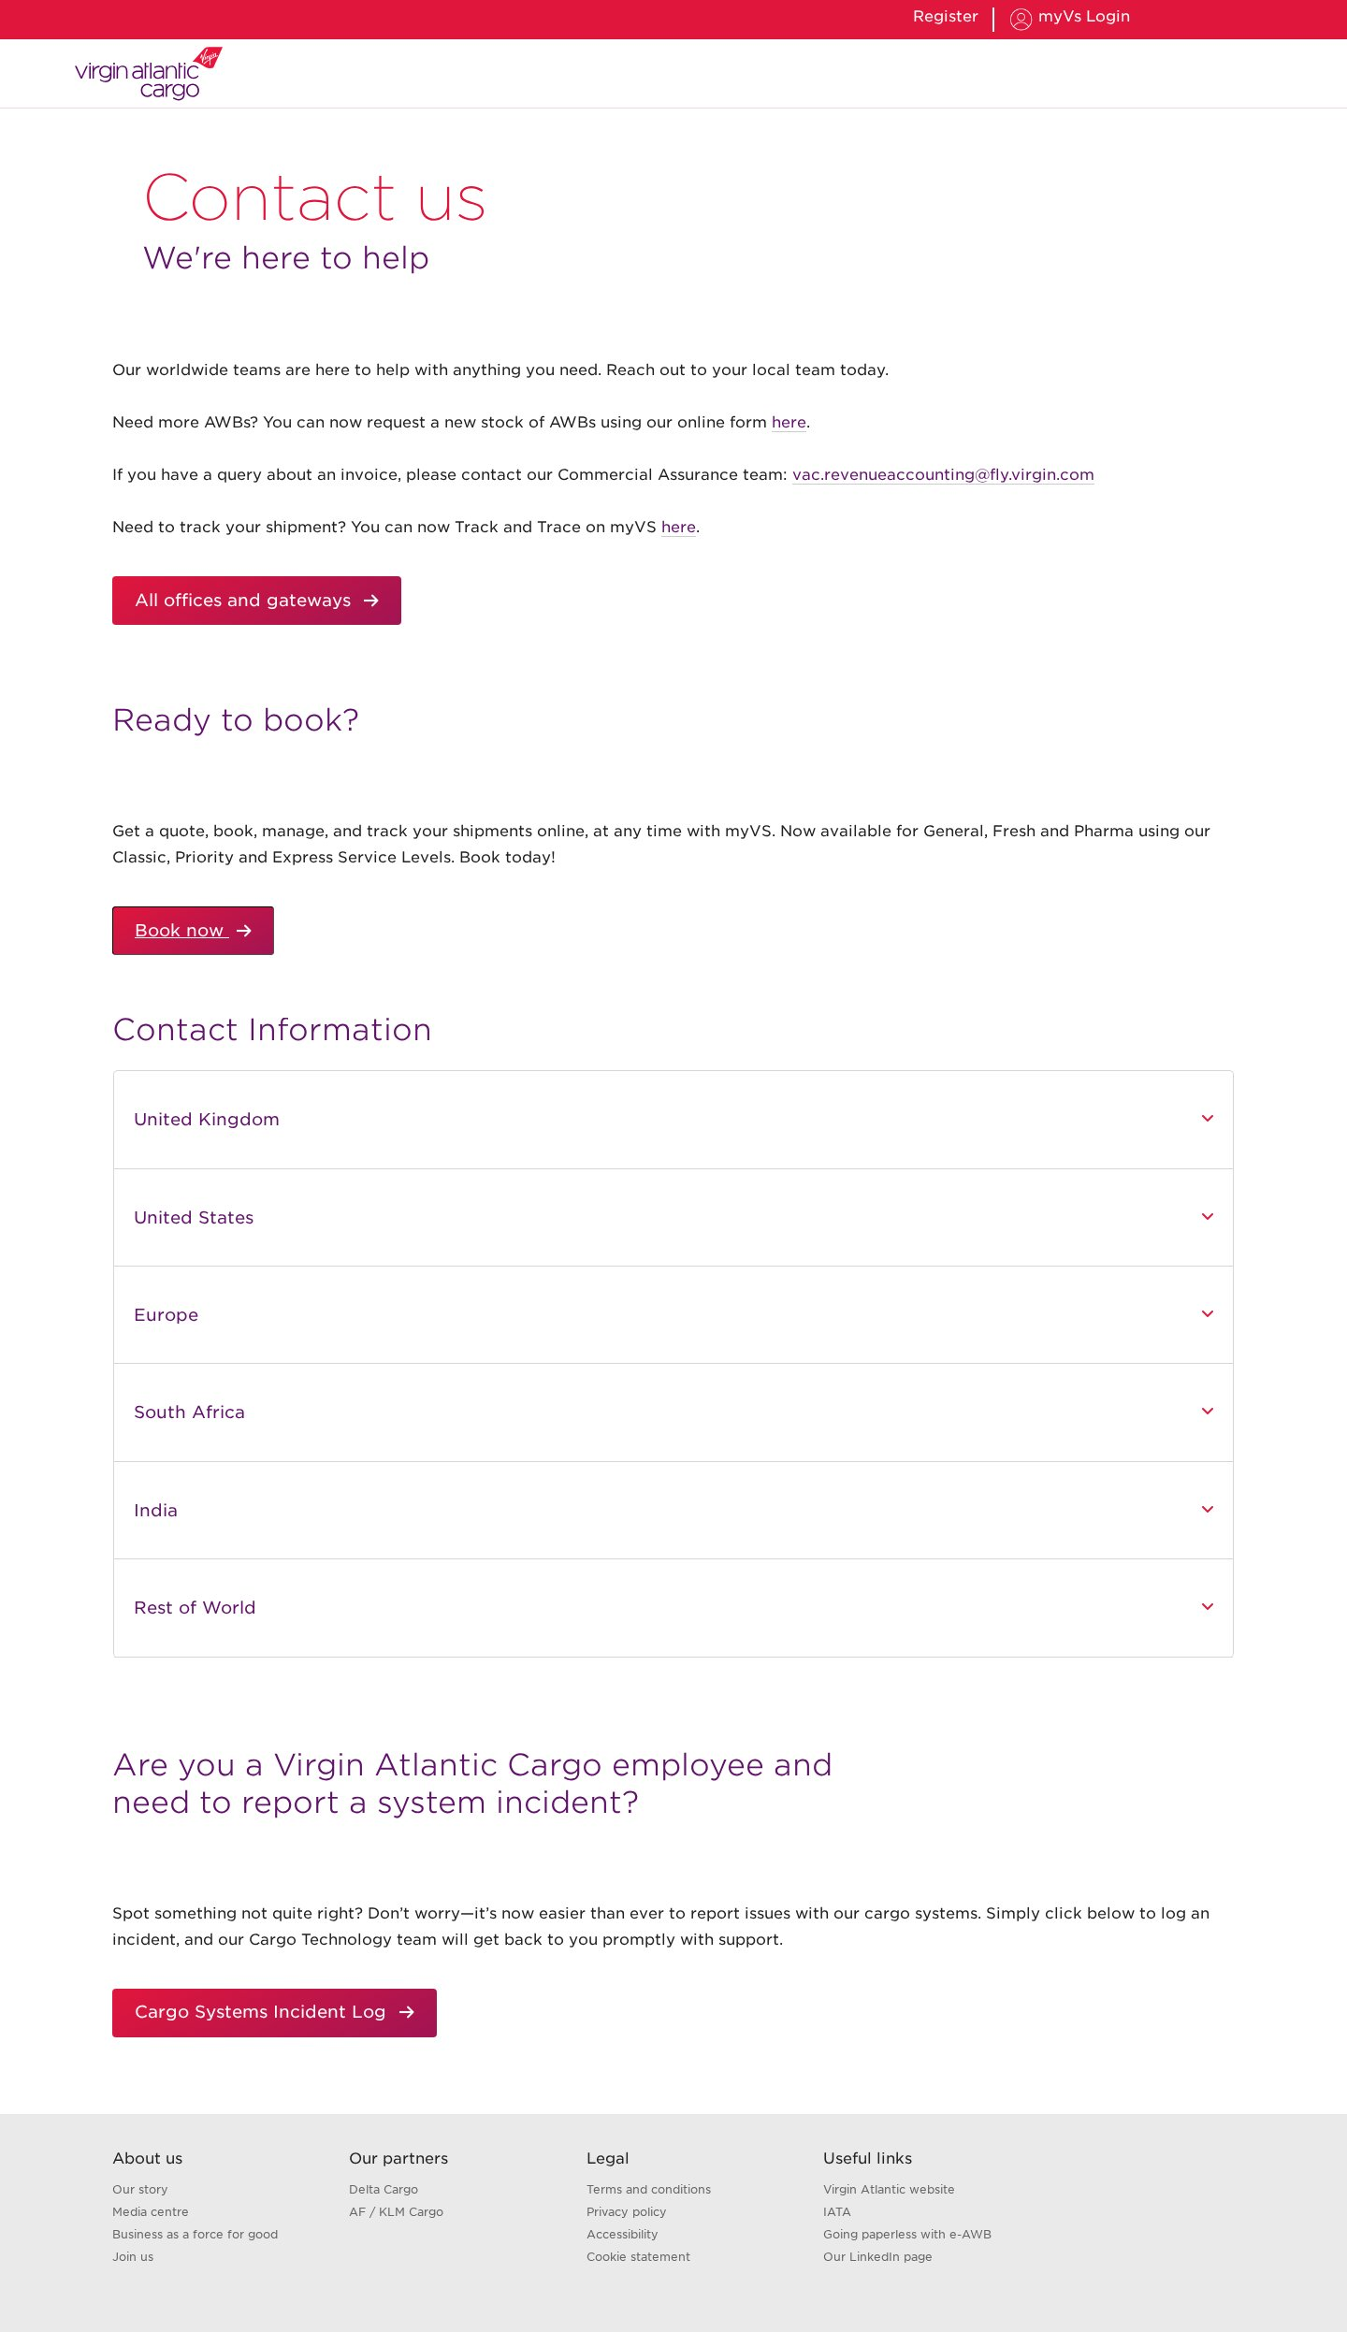

10. FAQ (accordion)
Identifier: faq-accordion Complexity: Medium Pages using: 1
Reasoning: Title/subtitle plus a full-width accordion of expand/collapse question-and-answer items. Interactivity from the accordion behaviour.
Reference URLs:
- https://www.virginatlanticcargo.com/gb/en/contact-us/faqs.html
Screenshot:
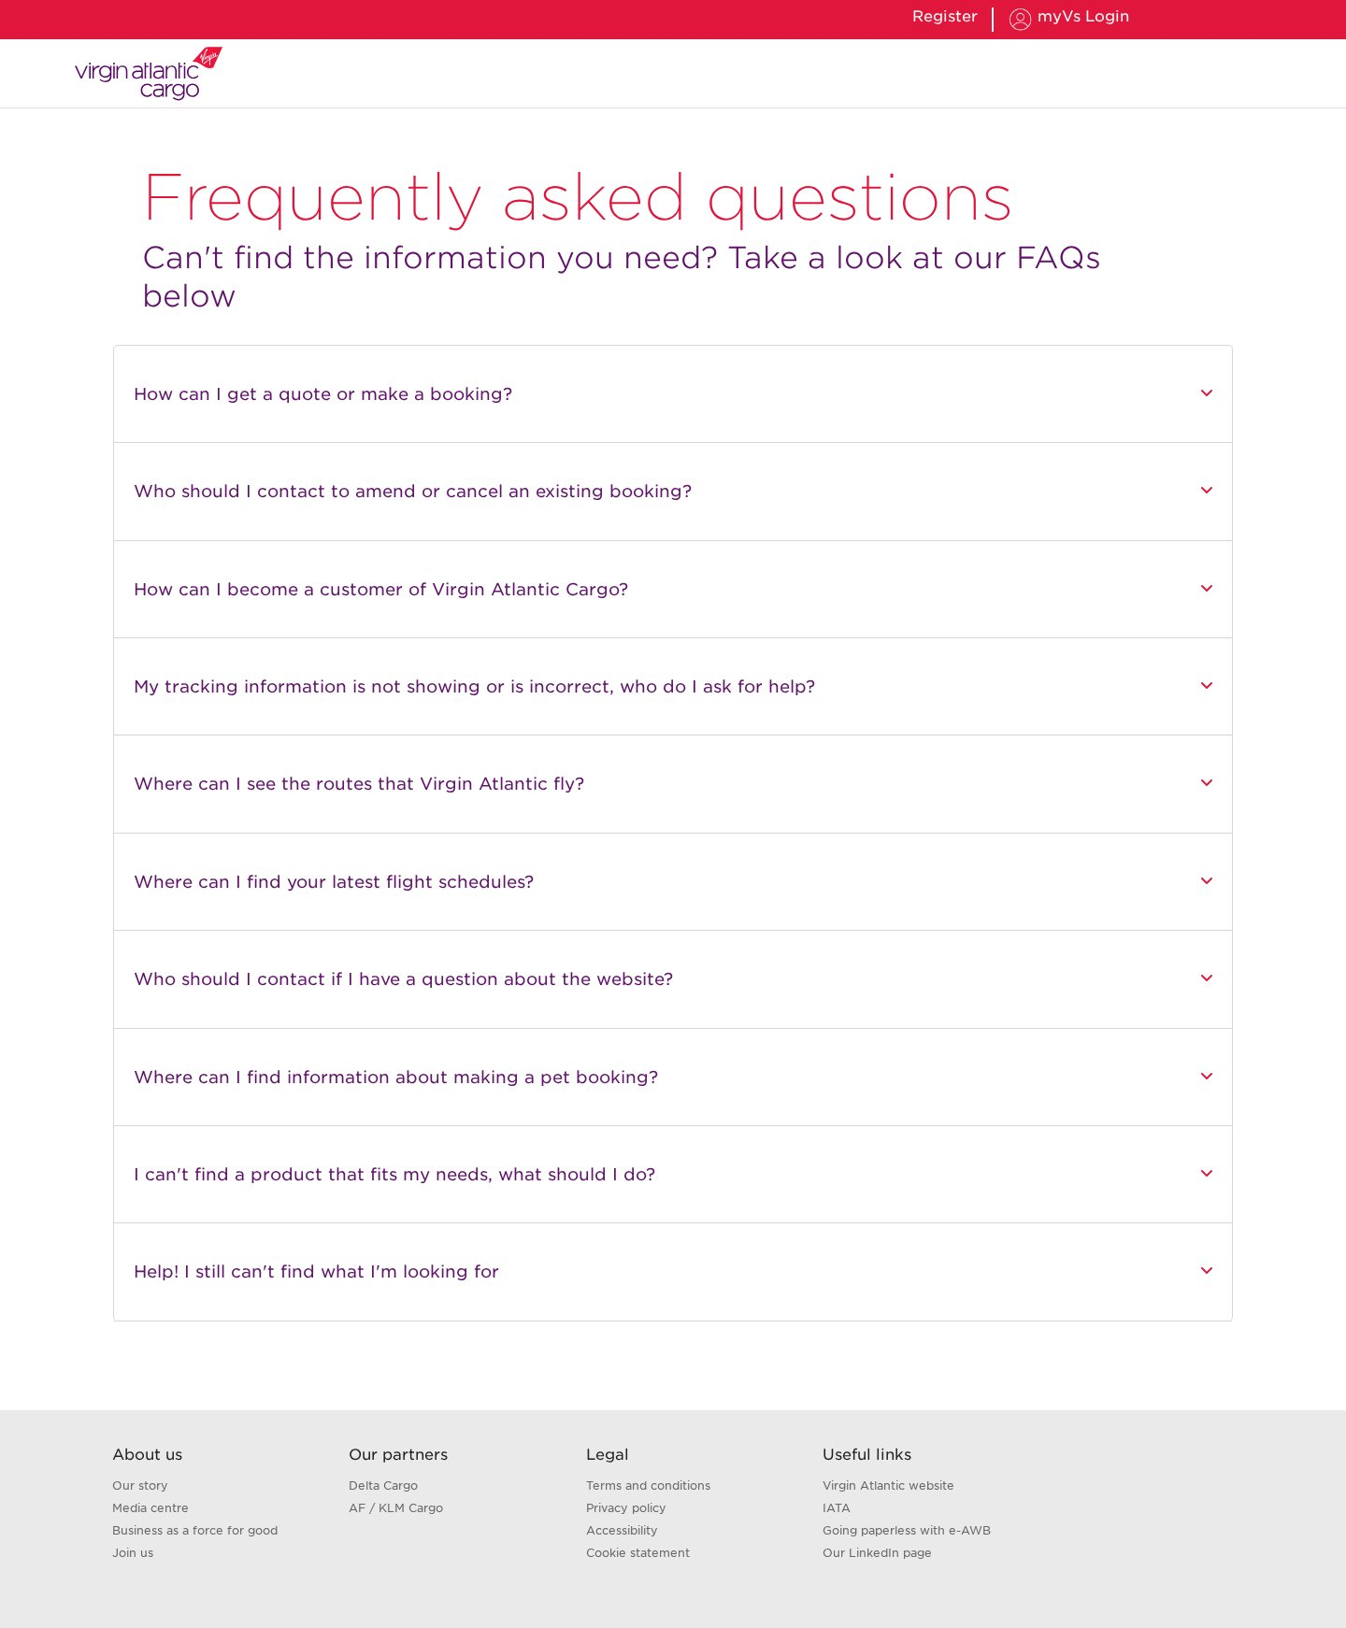

11. Notifications & alerts
Identifier: notifications-list Complexity: Medium Pages using: 1
Reasoning: Title plus a very long two-column list of dated notification entries (operational alerts, opening hours). Simple but content-heavy.
Reference URLs:
- https://www.virginatlanticcargo.com/gb/en/notifications.html
Screenshot:

12. Guidance article
Identifier: guidance-article Complexity: Medium Pages using: 2
Reasoning: Hero banner, structured text sections with bullet lists, topic accordions and an FAQ accordion at the foot. A richer content-article variant.
Reference URLs:
- https://www.virginatlanticcargo.com/gb/en/notifications/shipping-guidance.html
- https://www.virginatlanticcargo.com/gb/en/our-products-services.html
Screenshot:
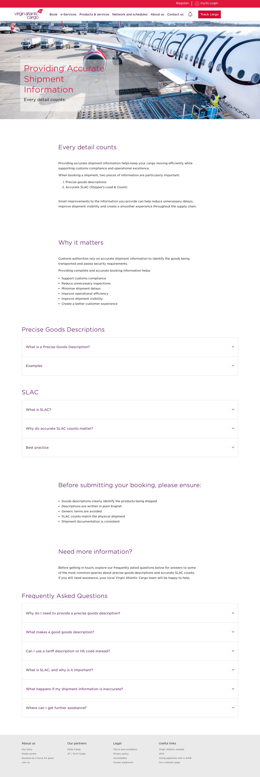

13. Hero + CTA landing
Identifier: hero-cta-landing Complexity: Low Pages using: 6
Reasoning: A single full-width hero banner with an overlaid heading and one call-to-action button, and little or no body content. Minimal composition. 6 pages.
Reference URLs:
- https://www.virginatlanticcargo.com/gb/en/book/pets2.html
- https://www.virginatlanticcargo.com/gb/en/book/pharmazone.html
- https://www.virginatlanticcargo.com/gb/en/our-products-services/products/active-containers0.html
- https://www.virginatlanticcargo.com/gb/en/our-products-services/products/courier.html
- … and 2 more
Screenshot:
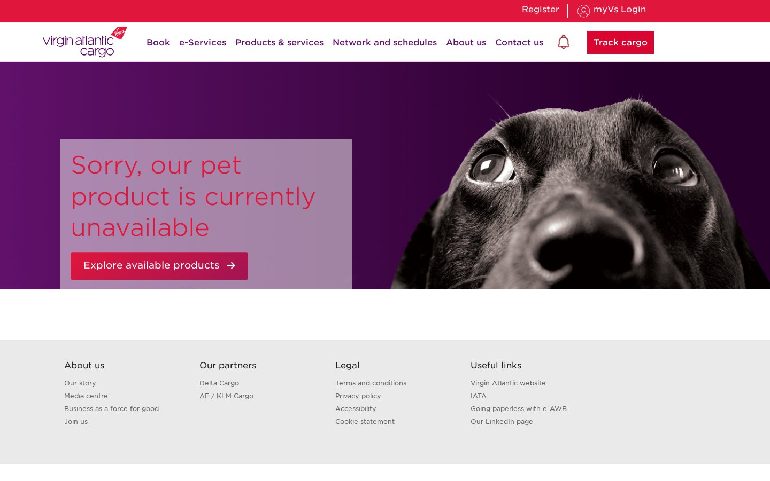

14. Legal / terms (long-form)
Identifier: legal-longform Complexity: Low Pages using: 1
Reasoning: Title and a single long-form rich-text body of numbered clauses. Minimal structure, purely textual.
Reference URLs:
- https://www.virginatlanticcargo.com/gb/en/Footer/termsandconditions/product-service-level-terms.html
Screenshot:
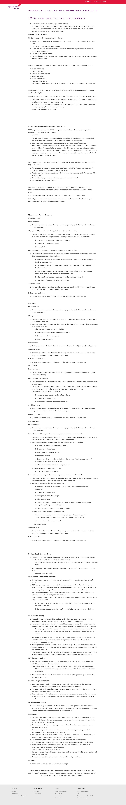

2. Blocks / Components Catalog
The reusable blocks below make up the site. Following the migration convention, visually different layouts that share a content model are treated as design variations of one block rather than separate blocks. The automated analysis detected 48 design variations across these blocks (the accordion and carousel/card families account for most of them).
Block / Component | Complexity | Approx. pages | Design variations
Header / Global Navigation | Medium | 95 | Single global variant across all pages.
Footer / Global | Low | 95 | Single global variant reused on every page.
Hero / Banner | Medium | 66 | Several design variations on a shared heading + optional text + image model: heading-only band (25 pages), heading + text + image (14), heading + CTA "light" variant used on office pages (20), and multi-image heroes.
Carousel / Promo cards | Medium | 32 | Many design variations of a shared image + heading + text + CTA card/slide model, differing by column count and image count (1-up hero slide, 2-up, 3-up card rows, multi-image galleries).
Accordion | Medium | 24 | A single accordion model with many instances differing only by the number of rows (from a few items up to large schedule tables). Grouped as design variations of one block.
Text + Image content | Medium | 64 | Several design variations of a shared heading + text + image(s) model: single image + paragraphs, multi-heading multi-image mosaics, and image-only groups. (Reported by analysis as "custom" content blocks.)
Call to action (button) | Low | 5 | Design variations of a shared CTA model: button-only, heading + button, and image + button + text bands.
Form | Medium | 8 | A few design variations of a shared form model differing by field set and whether an image accompanies the form.

2.1 Block details

1. Header / Global Navigation
Complexity: Medium Approx. pages using: 95
Behaviour & functionality: Site-wide top bar: red utility strip (Register, myVS Login), Virgin Atlantic Cargo logo, primary menu (Book, e-Services, Products & services, Network and schedules, About us, Contact us) with dropdowns, a notifications bell and a red "Track cargo" button.
Design variations: Single global variant across all pages.
Reference URLs:
- https://www.virginatlanticcargo.com/gb/en.html
Screenshot:

2. Footer / Global
Complexity: Low Approx. pages using: 95
Behaviour & functionality: Site-wide footer with four link columns — About us, Our partners, Legal and Useful links — over a light-grey band.
Design variations: Single global variant reused on every page.
Reference URLs:
- https://www.virginatlanticcargo.com/gb/en.html
Screenshot:


3. Hero / Banner
Complexity: Medium Approx. pages using: 66
Behaviour & functionality: Full-width page banner. Carries the page (or product) title over a photographic or coloured background; some variants add a short intro and a call-to-action button. The entry visual on almost every template.
Design variations: Several design variations on a shared heading + optional text + image model: heading-only band (25 pages), heading + text + image (14), heading + CTA "light" variant used on office pages (20), and multi-image heroes.
Reference URLs:
- https://www.virginatlanticcargo.com/gb/en/our-products-services/products/General.html
- https://www.virginatlanticcargo.com/gb/en/book/pets2.html
Screenshot:

Heading + CTA "light" hero (office / landing pages)


4. Carousel / Promo cards
Complexity: Medium Approx. pages using: 32
Behaviour & functionality: Rotating carousel and multi-column promo-card rows. Used for the homepage hero slider and for "card" content blocks across the site (product cards, e-Services cards, news teasers) — each card pairs an image, heading, text and a link/CTA.
Design variations: Many design variations of a shared image + heading + text + CTA card/slide model, differing by column count and image count (1-up hero slide, 2-up, 3-up card rows, multi-image galleries).
Reference URLs:
- https://www.virginatlanticcargo.com/gb/en.html
- https://www.virginatlanticcargo.com/gb/en/eservices.html
Screenshot:
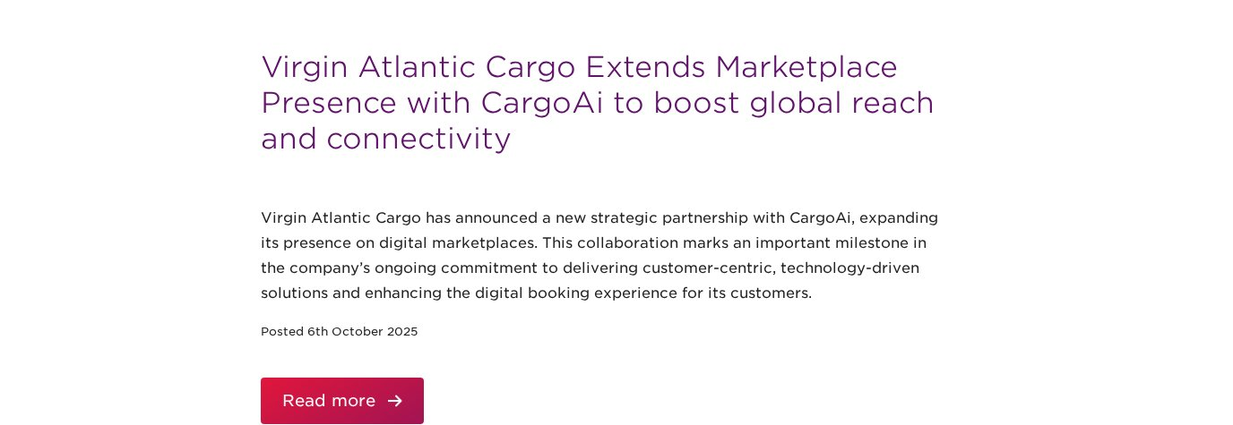

5. Accordion
Complexity: Medium Approx. pages using: 24
Behaviour & functionality: Expand/collapse list used for FAQs, regional contact details, service-level comparisons, flight-schedule tables and topic sections. Each item toggles its answer/detail panel open.
Design variations: A single accordion model with many instances differing only by the number of rows (from a few items up to large schedule tables). Grouped as design variations of one block.
Reference URLs:
- https://www.virginatlanticcargo.com/gb/en/contact-us/faqs.html
- https://www.virginatlanticcargo.com/gb/en/our-network/flight-schedule.html
Screenshot:
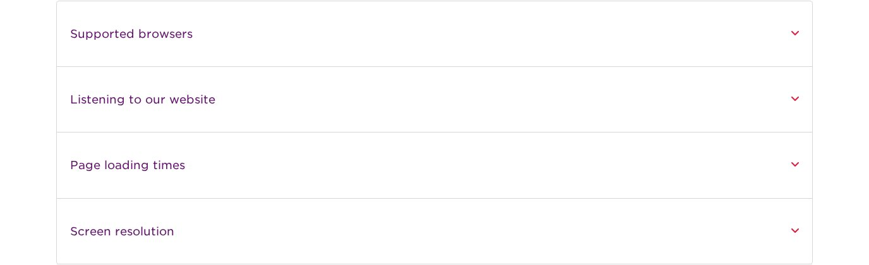

6. Text + Image content
Complexity: Medium Approx. pages using: 64
Behaviour & functionality: Flexible content rows pairing a heading, body copy and one or more images (and sometimes an inline CTA or quote). The workhorse block for article bodies, product intros and editorial mosaics.
Design variations: Several design variations of a shared heading + text + image(s) model: single image + paragraphs, multi-heading multi-image mosaics, and image-only groups. (Reported by analysis as "custom" content blocks.)
Reference URLs:
- https://www.virginatlanticcargo.com/gb/en/about-us.html
- https://www.virginatlanticcargo.com/gb/en/news/dokasch-opticooler.html
Screenshot:
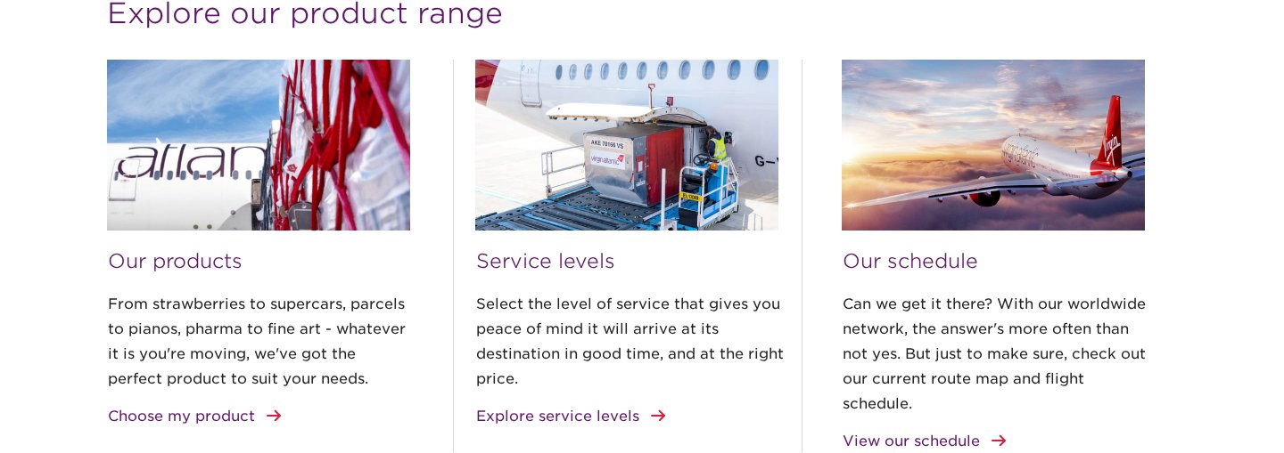

7. Call to action (button)
Complexity: Low Approx. pages using: 5
Behaviour & functionality: Standalone red action button (e.g. "Book online", "Explore available products", "Enquire now", "Track cargo") linking to booking, contact or gated tools. Often paired with a short heading and paragraph.
Design variations: Design variations of a shared CTA model: button-only, heading + button, and image + button + text bands.
Reference URLs:
- https://www.virginatlanticcargo.com/gb/en/book/pets2.html
- https://www.virginatlanticcargo.com/gb/en/contact-us.html
Screenshot:

8. Form
Complexity: Medium Approx. pages using: 8
Behaviour & functionality: Interactive forms for e-AWB registration, AWB requests and station enquiries: labelled input fields with validation and a submit action. Some forms are embedded third-party/app widgets.
Design variations: A few design variations of a shared form model differing by field set and whether an image accompanies the form.
Reference URLs:
- https://www.virginatlanticcargo.com/gb/en/cargoform/awb.html
- https://www.virginatlanticcargo.com/gb/en/cargoform/eawbregistrationform.html
Screenshot:
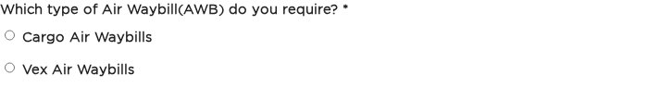

Appendix A — Methodology & Notes
- URLs were discovered by crawling the site (the XML sitemap returned only a single entry).
- 95 content pages were rendered and captured with an automated headless browser; structure fingerprints were clustered to derive page templates.
- Templates were named by layout structure, not content topic. Near-identical clusters (e.g. individual product pages, worldwide offices) were merged into a single template.
- Blocks were rolled up from per-page block analysis; variants sharing a content model are grouped here as design variations of one block. The raw analysis detected 48 variations, dominated by the accordion and carousel/card families.
- 19 PDF documents (booking guides, flight schedules, claim/registration forms) were catalogued separately from HTML pages.
- Worldwide-office pages load their content via a client-side application; static capture shows an initialization dialog, so they are represented as one dynamic template.

