PROJECT DESIGN PHASE-II
Data Flow Diagram & User Stories
Date | 30 September 2026
Team ID | SWTID-2026-9882
Project Name | AI-Powered Legal Document Registration
Maximum Marks | 4 Marks
Team Leader | Priya Varshini S A
Team Members | Ramya A; Nishana A K; Nithya Sri S

Data Flow Diagrams
A Data Flow Diagram (DFD) is a visual representation of information flows within a system. It shows how data enters and leaves the system, how the information is processed, and where the information is stored. The following Level-0 DFD is adapted for the AI-Powered Legal Document Registration project.
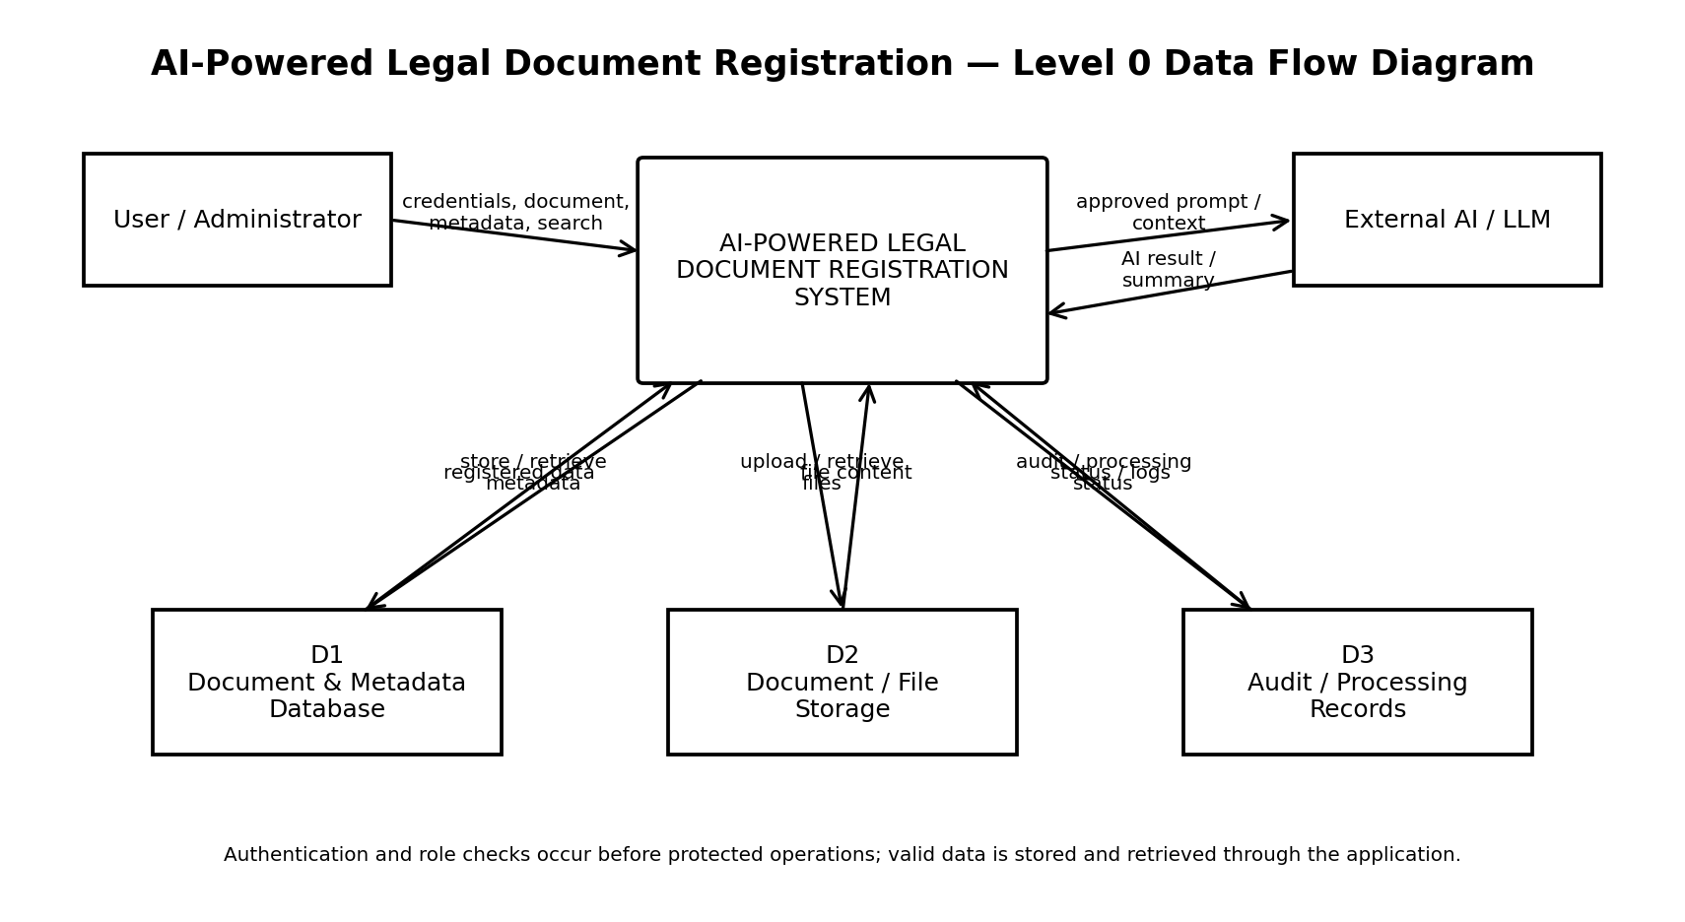
DFD Data Stores & Interfaces
- D1 Document & Metadata Database stores registered document records and associated metadata.
- D2 Document / File Storage stores supported uploaded legal-document files.
- D3 Audit / Processing Records stores processing status and relevant application records.
- External AI / LLM receives approved document context or prompts and returns configured AI-assisted results such as extracted information or summaries.
- Authentication and role checks occur before protected document-registration operations.
User Stories
The following user stories adapt the supplied template's user-story structure to the AI-Powered Legal Document Registration project. Acceptance criteria are stated as testable outcomes.
User Type | Functional Requirement (Epic) | User Story Number | User Story / Task | Acceptance Criteria | Priority | Release
User | Registration & Authentication | USN-1 | As a user, I can register or create an account with valid credentials so that I can access the application. | Valid account is created and accepted credentials allow access. | High | Sprint-1
User | Login & Authentication | USN-2 | As a user, I can log in with valid credentials and receive authenticated access. | Valid credentials are accepted; invalid credentials are rejected. | High | Sprint-1
User | Legal Document Registration | USN-3 | As a user, I can upload and register a legal document with the required metadata. | Valid document and required metadata are stored successfully. | High | Sprint-2
User | Document Discovery & Retrieval | USN-4 | As a user, I can view and retrieve my registered legal documents. | Only authorized/registered documents available to the user are returned. | High | Sprint-2
User | Document Categorization & Search | USN-5 | As a user, I can categorize and search legal documents using supported metadata. | Matching documents are returned for valid category or search criteria. | Medium | Sprint-2
User | Document Metadata Management | USN-6 | As an authorized user, I can update permitted document metadata. | Authorized user can update permitted fields and changes are persisted. | High | Sprint-2
User | Document Record Management | USN-7 | As an authorized user, I can remove or archive a registered document when the workflow permits it. | Authorized request is processed and the record reflects the permitted action. | High | Sprint-3
User | AI-Assisted Document Processing | USN-8 | As a user, I can submit a supported legal document for AI-assisted processing. | Configured AI processing returns a usable result without corrupting the registered record. | High | Sprint-3
User | AI-Assisted Summarization | USN-9 | As a user, I can generate a concise summary from supported legal document content. | System returns a concise summary or structured result for the submitted content. | High | Sprint-3
Administrator | Role Management | USN-10 | As an administrator, I can access protected management functions according to my role. | Unauthorized roles receive an access error; authorized role can access permitted functions. | High | Sprint-1
Administrator | User Access Management | USN-11 | As an administrator, I can manage user access according to defined permissions. | Only authorized administrator actions are accepted. | Medium | Sprint-4
Administrator | Document Administration | USN-12 | As an administrator, I can manage permitted document records and system settings. | Authorized administrative changes are validated and persisted. | High | Sprint-4
System | Input Security | USN-13 | As the system, I must validate and sanitize document metadata and user inputs before processing. | Invalid or malicious payloads are rejected or safely handled. | High | Sprint-1
System | File Security | USN-14 | As the system, I must validate supported file types and file constraints before storage. | Unsupported, corrupted, or invalid files are rejected safely. | High | Sprint-2
System | AI Failure Handling | USN-15 | As the system, I must handle AI/LLM failures without corrupting registered document data. | Controlled error is returned and invalid/incomplete AI output is not saved as valid data. | Medium | Sprint-3
System | Application Performance | USN-16 | As the system, I should support efficient document search and retrieval for larger collections. | Large queries return bounded and usable result sets within the application's supported limits. | Medium | Sprint-4

Team Information
College | To be confirmed
Team Leader | Priya Varshini S A
Team Members | Ramya A; Nishana A K; Nithya Sri S
Source Note This document preserves the structure and terminology of the supplied Data Flow Diagram & User Stories template, while adapting the project-specific content to AI-Powered Legal Document Registration. The supplied template describes DFDs as showing data entry/exit, transformation, and storage, and its original user stories cover registration, authentication, CRUD, search, AI processing, security, administration, and performance.

