PROJECT DESIGN PHASE
Solution Architecture
Date | 30 September 2026
Team ID | SWTID-2026-9882
Project Name | AI-Powered Legal Document Registration
Maximum Marks | 4 Marks
Team Size | 4
Team Leader | Priya Varshini S A
Team Members | Ramya A; Nishana A K; Nithya Sri S
Solution Architecture:
Solution architecture bridges the business problem and the technology solution. For this project, the architecture describes how users register and manage legal documents, how requests are authenticated and validated, how document information is stored, and how AI-assisted processing is integrated through a configured external LLM service.
Example – Solution Architecture Diagram:
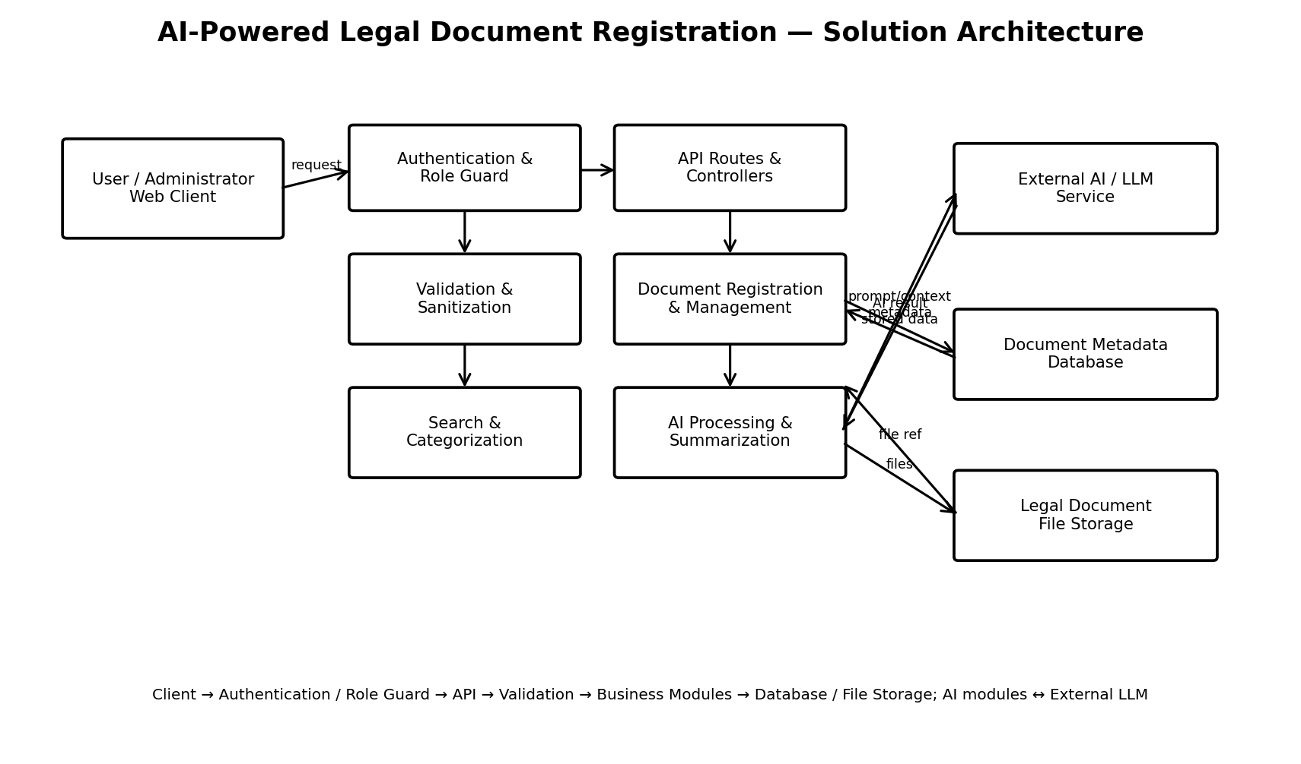
AI-Powered Legal Document Registration – Solution Architecture
The system follows a layered REST API architecture. Client requests are authenticated and authorized according to user roles, then routed through API controllers and validated before reaching document-management, search, storage, and AI-processing services. The database stores users, document records, metadata, categories, processing status, and related information, while uploaded legal-document files are maintained in file/object storage.
Core Architecture Components
- Client / API Consumer: Sends requests for legal document registration, management, search, retrieval, and AI-assisted processing.
- Authentication & Role-Based Route Guard: Validates authenticated access and restricts protected operations according to user roles.
- API Routes & Controllers: Receives requests and coordinates the required backend operations.
- Validation & Sanitization Layer: Validates metadata and request payloads and sanitizes supported inputs before processing.
- Document Registration & Management Module: Handles legal document registration, metadata, retrieval, updates, and permitted record-management actions.
- Categorization & Search Module: Maintains document categories/types and supports filtering and discovery.
- AI Legal Document Processing Pipeline: Uses configured external LLM abstractions and context-aware prompts to extract, organize, or process information from supported legal documents.
- Content Summarization Engine: Produces concise summaries or structured information from supported legal document content.
- Database Layer: Persists users, document records, metadata, categories, processing status, and related application data.
- File Storage Layer: Stores uploaded legal-document files and maintains references between files and database records.
High-Level Data Flow
Client → Authentication / Role Guard → API Routes & Controllers → Validation / Sanitization → Document Management / Search / AI Modules → Database and File Storage. When AI processing is requested, the AI processing and summarization modules communicate with the configured external LLM service and return the generated result to the application client.
Key Requirements
- Secure authenticated access and role-based authorization.
- Legal document registration with required metadata.
- Document retrieval, search, categorization, and permitted management operations.
- Input validation and sanitization for security protection.
- Secure file validation and storage for supported legal documents.
- AI-assisted legal document processing using a configured external LLM service.
- AI-assisted document summarization or structured information generation.
- Controlled error handling for database, storage, and AI-service failures.
Team Information
College | To be confirmed
Team Leader | Priya Varshini S A
Team Members | Ramya A; Nishana A K; Nithya Sri S
Source Note
This document adapts the supplied Solution Architecture template to the AI-Powered Legal Document Registration project. The template defines solution architecture as the bridge between business problems and technology solutions and uses architecture overview, core components, high-level data flow, and key requirements as its main structure.

