PROJECT DESIGN PHASE-II
Technology Stack (Architecture & Stack)
Date | 30 September 2026
Team ID | SWTID-2026-9882
Project Name | AI-Powered Legal Document Registration
Maximum Marks | 4 Marks
Team Leader | Priya Varshini S A
Team Members | Ramya A; Nishana A K; Nithya Sri S

Technical Architecture
The proposed architecture is a secure, layered application for registering, managing, retrieving, and AI-processing legal documents. It separates the client interface, authentication and API logic, document services, AI integration, database, and file storage.
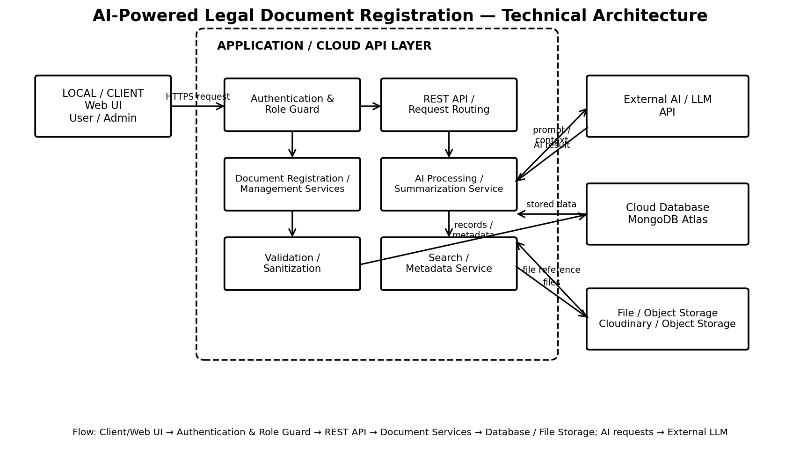
Architecture Flow: Client/Web UI → Authentication & Role Guard → REST API → Document Registration/Management Services → MongoDB Atlas and File/Object Storage. AI requests are routed to an external LLM API for configured document processing and summarization.
Architecture Guidelines
- Include application logic and technology blocks for the complete document-registration workflow.
- Provide infrastructure demarcation between local/client components and cloud/external services.
- Indicate external interfaces such as the AI/LLM API and other supported third-party services.
- Indicate data-storage components for document metadata and uploaded files.
- Indicate the interface to machine-learning/LLM services used for AI-assisted document processing.
Table-1: Components & Technologies
S.No | Component | Description | Technology
1 | User Interface | Web interface for users and administrators to register, view, search and manage legal documents. | HTML5, CSS3, JavaScript / React.js
2 | Application Logic-1 | REST API, authentication, authorization, routing and request processing. | Python, FastAPI
3 | Application Logic-2 | Legal document registration, metadata management, validation, search and retrieval services. | FastAPI, Pydantic
4 | Application Logic-3 | AI-assisted document processing and summarization pipeline. | Python, LLM API, prompt templates
5 | Database | Users, roles, registered documents, categories, metadata, processing status and audit information. | MongoDB, PyMongo / Motor
6 | Cloud Database | Managed cloud database for scalable application storage. | MongoDB Atlas
7 | File Storage | Separate storage for uploaded legal documents and supported files. | Cloudinary / Object Storage
8 | External API-1 | External AI service used for document processing, extraction or summarization. | LLM API
9 | External API-2 | Email/notification service for application notifications where required. | SMTP / Transactional Email API
10 | Machine Learning Model | Generates summaries or structured information from supplied legal-document context. | Large Language Model (LLM)
11 | Infrastructure (Server / Cloud) | Cloud-ready API deployment with database and container support. | Python runtime, Docker, AWS/Render-style cloud hosting

Table-2: Application Characteristics
S.No | Characteristics | Description | Technology
1 | Open-Source Frameworks | Open-source frontend/backend, API, validation and database libraries are used for maintainability. | Python, FastAPI, Pydantic, MongoDB drivers
2 | Security | JWT authentication, role checks, password hashing, validation, sanitization, security headers, CORS and rate limiting. | JWT, bcrypt/passlib, FastAPI security, Pydantic, CORS middleware, rate limiting
3 | Scalable Architecture | Layered separation of client, API/business logic, AI integration and data storage supports independent scaling. | Layered architecture, REST API, Docker
4 | Availability | Stateless API instances and managed database services support restart/recovery and cloud deployment. | MongoDB Atlas, cloud hosting, health checks
5 | Performance | Indexed document queries, pagination, bounded payloads and separated file storage reduce API/database workload. | MongoDB indexes, pagination, caching-ready API design, object storage

Implementation Note
The supplied template provides a technology-stack format and an example AI Blog Nest API stack. For this project, the stack above is adapted to an AI-Powered Legal Document Registration workflow. Exact vendors for cloud hosting, object storage, email, and the LLM can be selected according to the final deployment.
Team Information
College | To be confirmed
Team Leader | Priya Varshini S A
Team Members | Ramya A; Nishana A K; Nithya Sri S
References
- https://c4model.com/
- https://developer.ibm.com/patterns/online-order-processing-system-during-pandemic/
- https://www.ibm.com/cloud/architecture
- https://aws.amazon.com/architecture
- https://medium.com/the-internal-startup/how-to-draw-useful-technical-architecture-diagrams-2d20c9fda90d

