**DESIGN OF A REMOTE LIGHT OPERATION USING BOLT (IOT)**

**INTRODUCTION:**

In the present day, security systems play an important role in the protection of lives and investment.This is achieved by the incorporation of various subsystems into the security system with a single control unit such as surveillance, intruder control, access control, fire detection, etc. A smart home is one that is equipped with lighting, heating, and electronic devices that can be controlled remotely by smartphone or via the internet. An internet based home automation system focuses on controlling home electronic devices whether you are inside or outside your home [1]. Home automation gives an individual the ability to remotely or automatically control things around the home. A home appliance is a device or instrument designed to perform a specific function, especially an electrical device, such as a refrigerator, for household use. The words appliance and devices are used interchangeably.

Automation is today’s fact, where things are being controlled automatically, usually the basic tasks of turning ON/OFF certain devices and beyond, either remotely or in close proximity [2]. Automation lowers human judgment to the lowest degree possible but does not completely eliminate it. The concept of remote management of household devices over the internet from anywhere, any time in the world today can be a reality. Assume a system where from the office desk, the user could view the status of the devices and decides to take control by tuning his TV set to his favorite channel, turns on the cooling system, say the air conditioner, and switches on or off some of the lights. This user could walk back home and only find a very comfortable, pleasant home.

The recent developments in technology which permit the use of Bluetooth and Wi-Fi have enabled different devices to have capabilities of connecting with each other [3]. Using a WIFI shield to act as a Micro web server for the Arduino eliminates the need for wired connections between the Arduino board and computer which reduces cost and enables it to work as a standalone device.TheWi-Fishieldneedsconnectiontotheinternetfromawireless router or wireless hotspot and this would act as the gateway for the Arduino to communicate with the internet. With this in mind, an internet based home automation system for remote control of home appliances is designed.

**HARDWARE:**

* The Bolt Wifi module
* 1 x 330 ohm Resistor
* 1 x LED

**DESIGN AND IMPLEMENTATION:**

Connecting the LED to the Bolt

***Step 1:*** Take one leg of the resistor and wrap it around the longer leg of the LED i.e positive leg. This resistor helps limit the current flowing through the LED and protects the LED and the Bolt from short circuits.

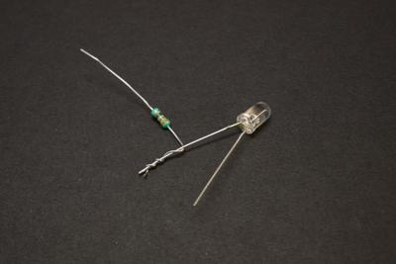

***Step 2:*** Insert the negative leg of the LED into the ground pin of the Bolt.

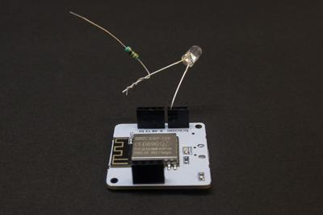

***Step 3:*** Insert the other leg of the resistor in digital pin 0 of the Bolt.

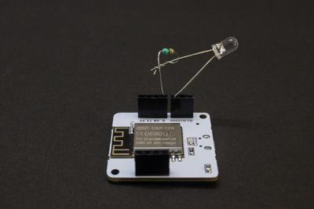

**WEB APPLICATION:**

**Controlling LED Over Bolt Cloud:**

***Step 1:***  Go to cloud.boltiot.com and create a new product. While creating the product, choose product type as Output Device and interface type as GPIO. After creating the product, select the recently created product and then click on the configure icon.

***Step 2****:* Move to the code tab and write the following code to control the LED.

In the header, we will include a javascript file which has some pre-defined functions like DigitalRead, digitalWrite etc already hosted on our Bolt Cloud.

Script to be included is given below:

<script type="text/javascript" src="https://cloud.boltiot.com/static/js/boltCommands.js"></script>

Note: If you want to see the source code of the same open

https://cloud.boltiot.com/static/js/boltCommands.js link in the browser.

Now the next step is to set the API key and device name. Syntax for the same is given below:

<script type="text/javascript">setKey('{{ApiKey}}','{{Name}}');</script>

Note: API key and Device name will be auto-initialized by Bolt cloud. You don't have to replace the device name and API key in the above code.

Now inside the <body> tag you have to place two buttons, one for turning the LED on and other to turn it off. The syntax for the same is given below:

<body>

<center>

<button >ON</button>

<button >OFF</button>

</center>

</body>

In the above code, we have placed 2 buttons and put the text as 'ON' and 'OFF' respectively. You can change the text as per your choice.

Note: We have put both the buttons inside the <center></center> tag to make the button align center.

Now we have to make these 2 buttons clickable. To do so, we have to call a javascript function named as onclick() which you have already read in lesson 'Creating your functions in Javascript'. Inside the onclick function, we are calling a function named digitalWrite().

<button onclick="digitalWrite(0, 'HIGH');">ON</button>

<button onclick="digitalWrite(0, 'LOW');">OFF</button>

digitalWrite() function has two parameter. The first parameter is pin number and the second parameter state.

To turn the LED ON, the state would be HIGH and to turn it OFF state would be LOW.

Note: In the above example, the first parameter has value 0 which means LED is connected to pin 0. You can change this value based on your connection where have you connected the LED.

Below is the complete code:

<!DOCTYPE html>

<html>

<head>

<title>Bolt IoT Platform</title>

<script type="text/javascript" src="https://cloud.boltiot.com/static/js/boltCommands.js"></script>

<script>

setKey('{{ApiKey}}','{{Name}}');

</script>

</head>

<body>

<center>

<button onclick="digitalWrite(0, 'HIGH');">ON</button>

<button onclick="digitalWrite(0, 'LOW');">OFF</button>

</center>

</body>

</html>

***Step 3****:* Once you have written the complete code in the editor, give the file name as ledcontrol and in the drop-down select the file extension as html. Below is the screenshot of how it looks after this step.

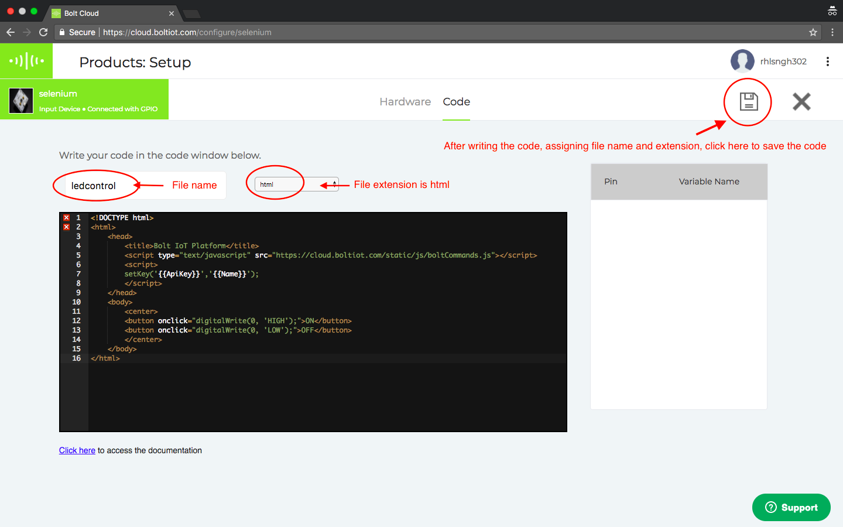

***Step 4****:* Now click on save icon to save the code. Now go back to the dashboard by clicking on 'X' icon.

***Step 5****:* In the products tab, select the product created and then click on the link icon. Select your Bolt device in the popup and then click the 'Done' button.

***Step 6****:* Now click on view this device icon to view the page that you have designed. Below is the screenshot of the final output.

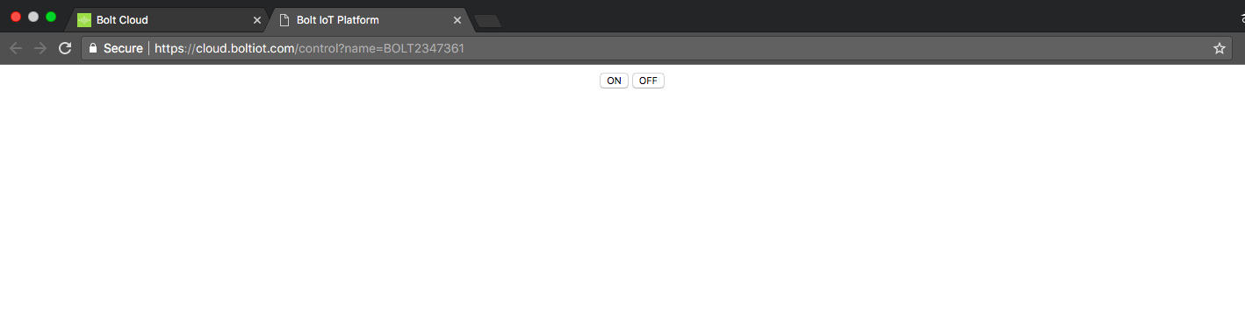

Now click on the ON button, it will turn the LED on. Similarly, clicking on the OFF button will turn the LED off.

Is it working as expected? Awesome!! Now as an assignment connect the LED to different pins and try to turn it ON/OFF.

**TROUBLESHOOTING:**

In case your LED is not turning ON/OFF below are some of the steps to troubleshoot what went wrong:

1: Go back to the products configuration page and check whether the code that you have written is properly saved or not. If the code is not present, then again copy the code from above and paste in the editor and save the code.

2: Check your connection whether the LED is properly connected or not. Refer to the previous lesson for the circuit connections.

3: Check on which pin the LED is connected. Make sure you have passed the same value in digitalWrite() function as the first parameter.

4: Make sure your API key is enabled. You can check the same by clicking on the API icon on the left side of your dashboard.

That's it. In the next lesson, we will learn how to build a Safety Alert system using Bolt.

**CONCLUSION:**

In this paper,novel architecture for low cost and flexible light control and monitoring system using android based smartphone is proposed and implemented.The proposed architecture utilizes a micro webserver and application layer for communicating between the remote user and home light.Any android based smartphone with built-in support for WI-FI can be used to access and control the devices at home.When a WI-FI connection is not available mobile cellular networks such as 3Gor 4G can be used to access the system.By creating a wireless network within the home environment for controlling and monitoring the smartlight.