Nikhil Agrawal  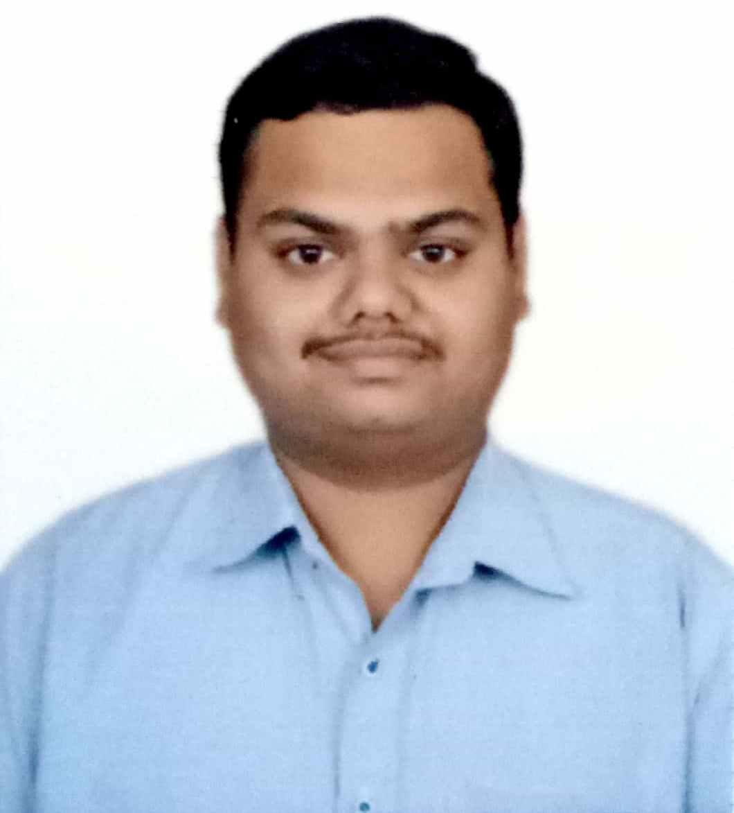  Technology:  C, C++, Java, Python,  HTML and CSS.  Email  nikhil1977agrawal@gmail.com  Contact No. +91 7898795587  Permanent Address  34/6, Malharganj, Kadabin,  Indore, (M.P.). 452002  Current Address  Same as above.  Personal Data  Father’s Name:  Late Shri Paresh Agrawal  Date of Birth: 17/11/1997  Gender: Male  Nationality: Indian  Marital Status: Single  Languages  Known: English, Hindi | Objective: -  To seek a challenging career in an organization having the environment that encourages continuous learning and provides exposure to new technologies, so as to achieve professional and personal growth as a Software Engineer.  Keen on learning new skills specially in machine learning area.  Education: -  Currently pursuing B. Tech in computer science engineering from Medicaps university Indore .  Skill-Set:  Programming Language: C & C++, Java, Python  Web Development :HTML,CSS  Database : MYSQL  Operating Systems : Windows 8 and 10.  Tools & Frameworks. : Turbo C, NetBeans  Courses and Trainings:  - Ypsilon IT Solutions Private Limited, Indore, India - (June 2018 - August 2018).  - Attended training sessions on java technology.  - Develop a project on login window by java core technology.  - Completed “Python for everybody” MOOC by University of Michigan from Coursera.  - Ongoing course on “Machine Learning” MOOC by Stanford University from Coursera.
  Qualification | College/University | Year | Percentage/  CGPA
  B.Tech  (pursuing) | Medicaps university | 2020 | 9.5
  10+2 | MP BOARD | 2015 | 87.2%
  10 | MP BOARD | 2013 | 86.8%

Self-Project Experience:

Project Name | Library Management System | Team Size | Individual
Description | Library Management System is designed for better interaction between Management and Customers. Library Mgmt. System handles all the requirements for easy Library Management. This software will help the Library to structuralize the activities and maintain data transparency where needed and properly store data for regular operations and future analysis.
Features: | - Administrator functions  - Manage Members  - Employees  - Attendance  - Accounts  - Books Setup  - Statistics
Technologies | Java, MySQL and NetBeans IDE

Project Name | Snake & Ladder Game | Team Size | Individual
Description | Developed desktop based application using java for two players to play.
Features: | Everything a basic snake & ladder game should have.
Technologies | JAVA and NetBeans IDE

Extra-Curricular Activities:

- Organized entertainment Quiz(Catechize) in the Moonstone 2018 annual cultural fest of Medi-caps university.
- Student Member in Student Technical and Innovation club (STIC) Indore.
- Qualified for 3rd round of TCS Enginx (April 19).

Declaration:

I here by declare that above furnished details are correct and complete to the best of my knowledge.

PLACE: Indore Nikhil Agrawal

