NATIONAL ENGINEERING COLLEGE, K.R. NAGAR, KOVILPATTI – 628 503
(An Autonomous Institution, Affiliated to Anna University – Chennai)

DEPARTMENT OF INFORMATION TECHNOLOGY

23IT52C - Artificial Intelligence
CO1 & CO2 – Problem Solving Questions

SET 1
1. | Consider the following graph where S is the start node and move to Goal state.  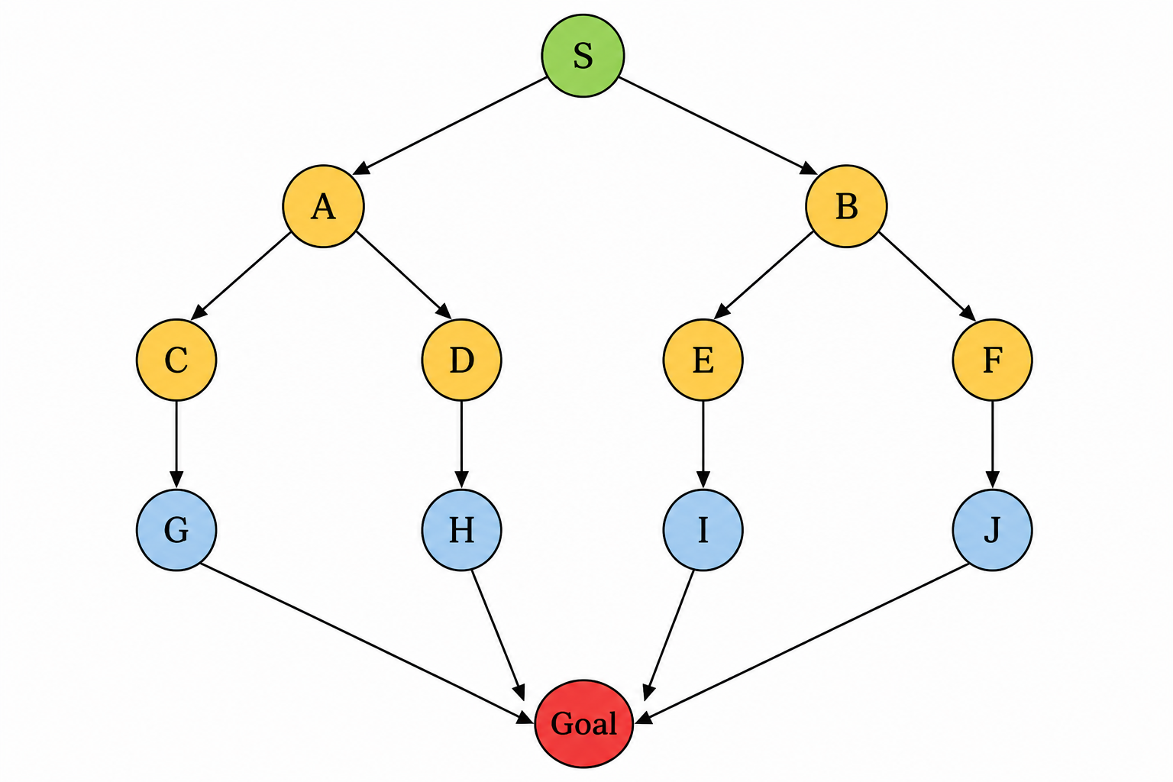  (a) Apply Depth-First Search (DFS) and show the order of node expansion. (6M)  (b) Apply Breadth-First Search (BFS) and determine the shortest path from S to Goal. (6M)  (c) Compare BFS and DFS in terms of completeness, optimality, time complexity, and space complexity. (4M)
2. | Consider the 6-Queen problem with initial states (2,4,6,2,3,5) and (3,5,2,6,1,4). Determine the solution for the problem using Local Beam Search technique with beam size 2 and explain the procedure used in it.

SET 2
1. | 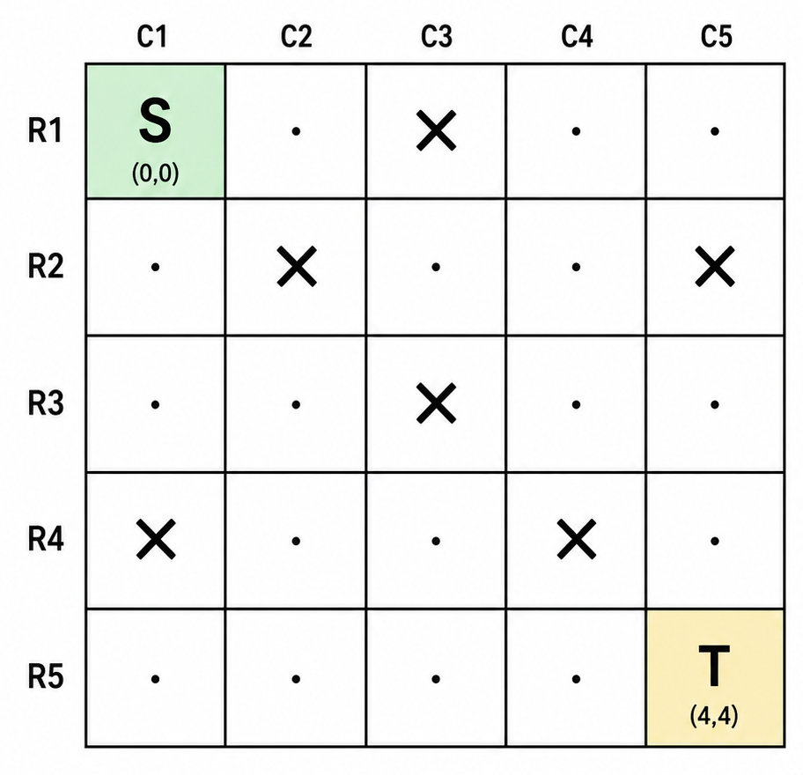  In the Maze problem, ‘S’ represents the initial state and ‘T’ represents the Treasure in the maze. The agent has to find the shortest path to sneak the treasure by moving Left/Right/Down/Diagonally. Explain the Search strategy that can be applied to the agent to reach its goal. Also derive the sequence of actions taken.(16)
2. | An educational organisation requires formation of 3 committees. There are 4 male, 5 female students and 3 staff members. Each committee must have at least one staff member. The count of male students should not outnumber the no.of female students. Each committee must have at least one female student. Formulate the AI problem and frame the committee using CSP-Backtracking technique and explain the steps involved in it.
SET 3
1. | Schematically discriminate the functioning of the following. (10M)  (a) Goal based Agent b) Utility-based Agent.
2. | Suppose there are 5 cities: A, B, C, D, E. The salesman is in city A and he has to find the shortest route to travel through all the cities back to city A. Form a suitable chromosome representing the path chosen by the salesman. Initially generate 3 random tours. Using the distance matrix [ Dist(i,j) - Straight Line Distance between city-i] calculate the fitness value.  (a) Select dominant parents and apply (i) Single-Point and Two-point cross over to generate new alternate tours.  (b) Select a random parent after step (a), apply possible mutations.  (c) After step (a) & (b) perform Population revision using Roulette-Wheel Selection
  Dist(I,j) | A | B | C | D | E
  A | 0 | 2 | ∞ | 12 | 5
  B | 2 | 0 | 4 | 8 | ∞
  C | ∞ | 4 | 0 | 3 | 3
  D | 12 | 8 | 3 | 0 | 10
  E | 5 | ∞ | 3 | 10 | 0

SET 4
1. | Consider the following board state: (16M)  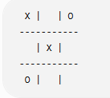  1.Define the problem formulation for this game.  2.List all legal operators.  3.Generate all possible successor states for Player X.  4.Expand the game tree for the next 3 stages by alternating between Player X and Player O.  5.Mark all terminal states (Win/Loss/Draw).
2. | Given the Variables: X1, X2, X3  Domains: D1 ={1, 2, 3, 4}; D2 ={a, b, c }; D3 ={α, β, γ}.  Constraints: C(X1, X2) = {(1,a), (2,b), (3,a), (3, b), (4, b)}  C(X1, X3) ={ (1, β), (3, β), (4, β)}  C(X2, X3) = {(a, γ), ( b, β ), (b, α ), (c, γ)}  Solve the problem using backtracking with minimum-remaining-values and least-constraining-value heuristics and forward checking.

SET 5
1. | An autonomous warehouse robot must move from the Start (S) location to the Goal (G) while avoiding obstacles in a 6 × 6 grid. The robot can move Up, Down, Left, and Right.  (a) Formulate this as an AI search problem by specifying the initial state, state space, actions, goal test, and path cost. (6M)  (b) Construct the search tree up to two levels. (4M)  (c) Apply Uniform Cost Search (UCS) to determine the optimal path and list the sequence of actions. (6M)
2. | A magic square is a 3x3 matrix, where numbers 1 to 9 are filled in each cell such that they sum up to 15 when numbers in a row/column/diagonal are added. With T=100 and cooling rate 90%, Determine the solution using Stimulated Annealing and explain the steps involved in it.

SET 6
1. | A magic square is a 3x3 matrix, where numbers 1 to 9 are filled in each cell such that they sum up to 15 when numbers in a row/column/diagonal are added. With T=100 and cooling rate 90%, Determine the solution using Stimulated Annealing and explain the steps involved in it.
2. | Consider a two-player, zero-sum deterministic game represented by the following game tree. The MAX player attempts to maximize the utility value, whereas the MIN player attempts to minimize it. Assume that the game tree is traversed from left to right. Apply the Alpha-Beta Pruning algorithm to evaluate the game tree. Show the initialization and updating of alpha and beta values at each node. Clearly indicate the nodes that are pruned during the search process and determine the optimal move and the final utility value for the MAX player.  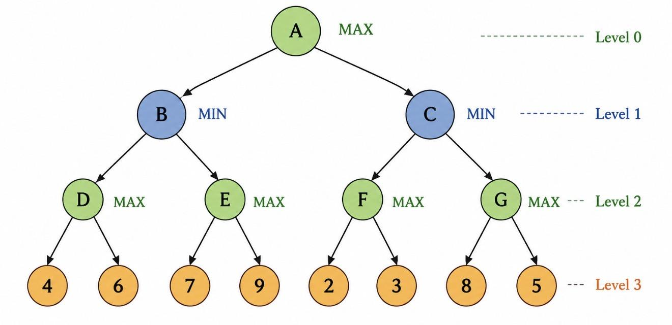

SET 7
1. | An AI agent is assigned the task of solving the 8-Queens Problem. The agent places one queen in each row of an 8 × 8 chessboard such that no two queens attack each other (i.e., no two queens share the same row, column, or diagonal). The current state of the chessboard, generated after placing the first two queens, is shown in the figure below. The remaining empty cells are available for placing the other queens.  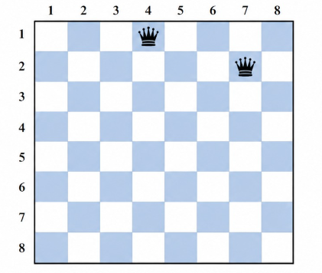  Using the given board, formulate the AI problem by specifying the initial state, state space, goal state and path cost. Apply an appropriate search strategy to obtain a valid sequence of queen placements that reaches the goal state. Draw the final board configuration and justify why it is a valid solution. (16M)
2. | A university is organizing a Research Mentorship Program in which students must be assigned to experts based on their areas of interest. Each expert has specific areas of expertise, while each student has one or more preferred areas. The university has 5 experts and 8 students. Solve this CSP problem using Constraint Propagation based allocation and explain the algorithm used in it.  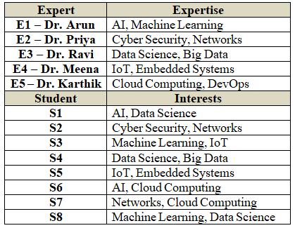  Constraints  - Every student must be assigned to exactly one expert. An expert can be assigned multiple students.  - An expert's expertise cannot be compromised. Therefore, a student can only be assigned to an expert if at least one of the student's interests matches one of the expert's expertise areas.  - A student can compromise on their interest. A student does not need all their interests to match the expert's expertise but at least one.  The objective is to maximize the number of students assigned to their first-choice interest and each expert is assigned at least one student.

SET 8
1. | Given Maze as Grid with Initial Stage (0, 0) & Goal Stage (6, 0). Find the optimal path using a level-ordered search strategy to reach the Goal by exploring child cells with L/R/U/D operations from any grid cell at location (i, j) . Develop a Pseudo code based algorithm for the solution. (16)  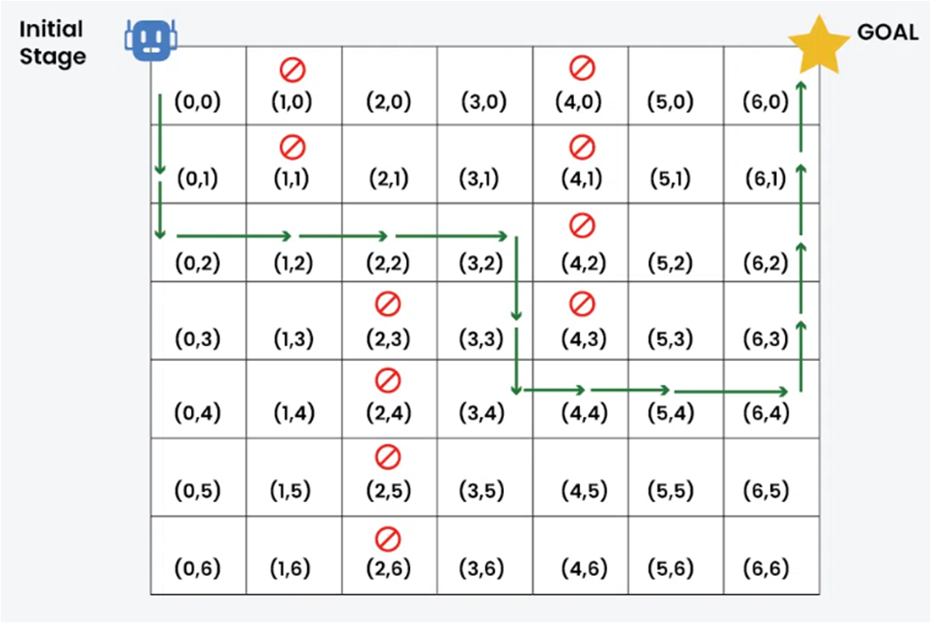
2. | College Timetable Scheduling (CSP)  A College Timetable Scheduling Problem is a real-world example of a Constraint Satisfaction Problem (CSP). The objective is to assign subjects, teachers, rooms, and time slots in such a way that no two constraints are violated.  1. Variables: Class periods (P1, P2, P3, P4, P5)  2. Domains: Possible subject-teacher-room combinations  Constraints:  - A teacher cannot teach two classes in the same period.  - A room cannot host two classes at the same time.  - Lab subjects must be assigned to their specific labs.  - Each student group attends exactly one class per period  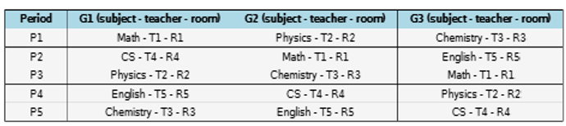

SET 9
1. | Consider the Water Jug Problem with a 4-litre jug and a 3-litre jug. Initially, both jugs are empty. The objective is to obtain exactly 2 litres in the 4-litre jug.  (a) Formulate the AI problem by specifying the initial state, goal state, operators, and state space. (6M)  (b) Draw the state-space tree up to three levels. (4M)  (c) Apply Breadth-First Search (BFS) to obtain the solution path.(6M)
2. | Given tic-tac-toe state, compute the heuristic function that measures the difference between total possible paths of winning for both players.  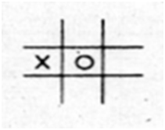  Justify whether this heuristic function is helpful to construct a Min-Max game tree?

SET 10
1. | - ‘Curiosity’ is a Mars rover developed by the United Nations to explore the planet. Identify the type of this intelligent agent and environment. Sketch and explain the working of the agent in its environment with pseudocode. (10)  - The 8-puzzle problem has an initial state (1,3,4,2,6,7,5,8,blank). Formulate the AI problem and determine whether the goal can be reached from this state. Justify your answer.(6)
2. | Using CSP, solve the following Crypt arithmetic problem with the assumption of assigning a unique number to each alphabet, so that the arithmetic constraint is satisfied.  C R O S S  + R O A D S  _______________  D A N G E R  _______________

SET 11
1. | 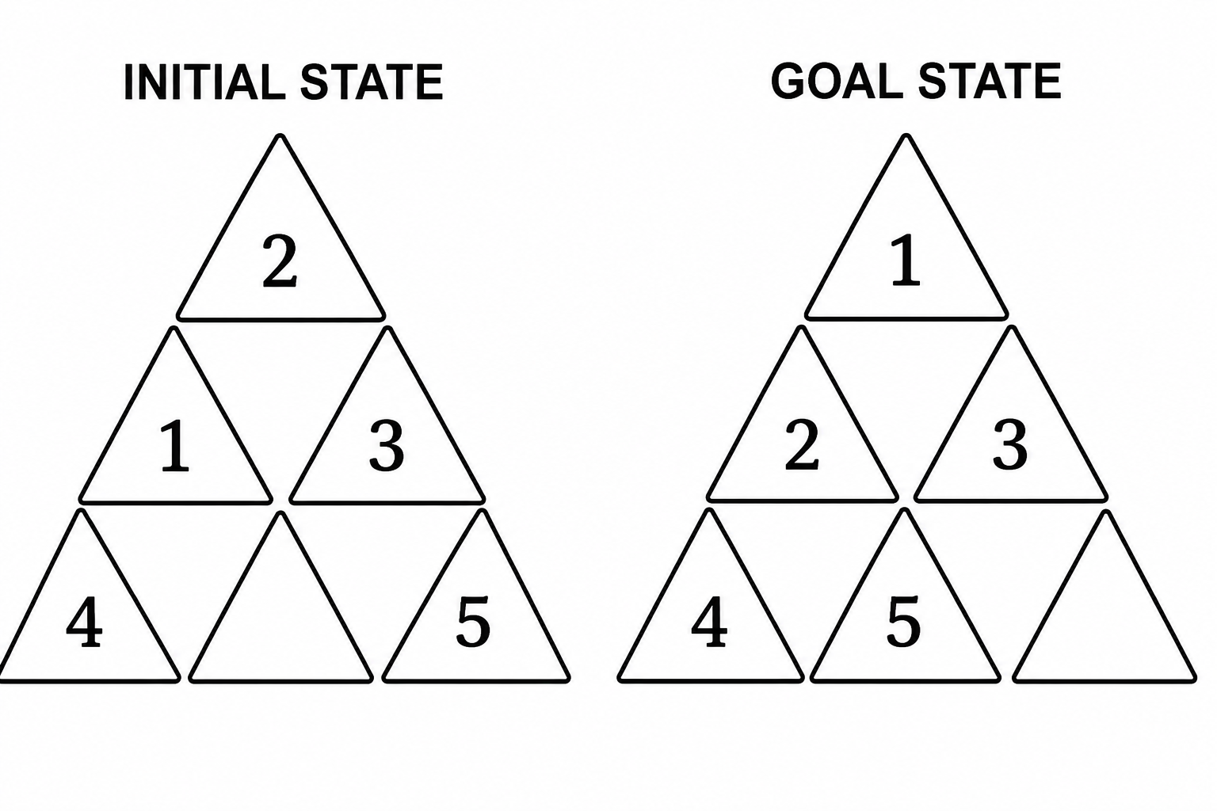  An AI agent is assigned with the task of moving the triangles from initial state to goal state. The agent can swap the blank triangle LEFT, RIGHT and DIAGONALLY. Formulate the AI problem, frame the state space up to two levels and solve it using the BFS strategy. (16)
2. | A university is organizing a Research Mentorship Program in which students must be assigned to experts based on their areas of interest. Each expert has specific areas of expertise, while each student has one or more preferred areas. The university has 5 experts and 8 students. Solve this CSP problem using Constraint Propagation based allocation and explain the algorithm used in it.  Constraints  - Every student must be assigned to exactly one expert. An expert can be assigned multiple students.  - An expert's expertise cannot be compromised. Therefore, a student can only be assigned to an expert if at least one of the student's interests matches one of the expert's expertise areas.  - A student can compromise on their interest. A student does not need all their interests to match the expert's expertise but at least one.  The objective is to maximize the number of students assigned to their first-choice interest and each expert is assigned at least one student.
SET 12
1. | 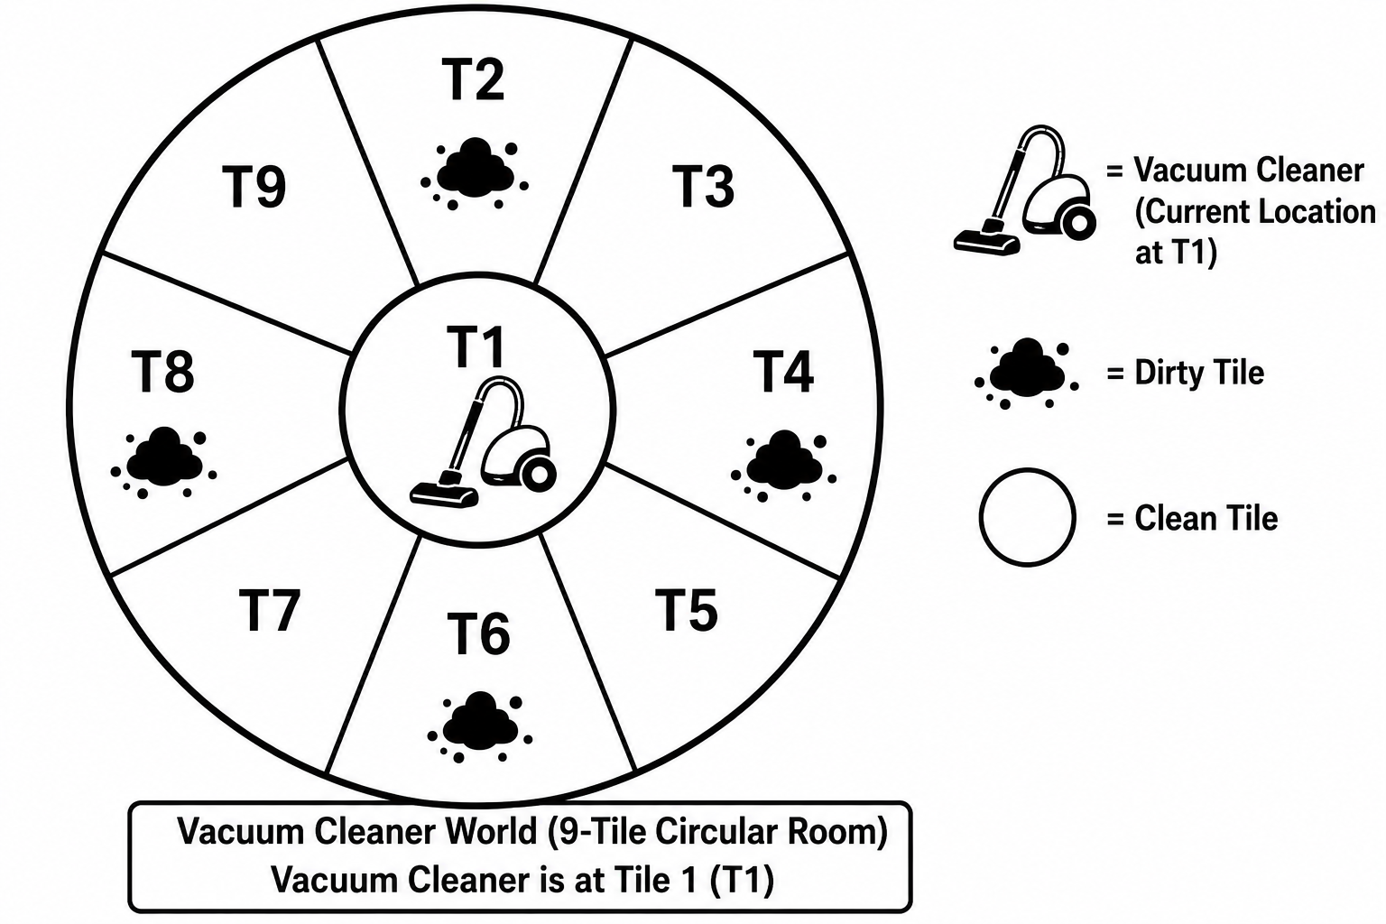  A Vacuum Agent is initially at T1. The agent has to visit all 9 rooms and verify the cleanliness of each room. The rationality of the agent is measured by saving energy in actions taken. Formulate the problem and apply appropriate search strategy to make the agent clean all rooms in an efficient manner. Also return the sequence of actions taken.(16)
2. | A magic square is a 3x3 matrix, where numbers 1 to 9 are filled in each cell such that they sum up to 15 when numbers in a row/column/diagonal are added. With T=100 and cooling rate 90%, Determine the solution using Stimulated Annealing and explain the steps involved in it.

SET 13
1. | Specify the PEAS description for the following. (10M)  a) ATM Machine b) Email Spam Filter
2. | College Timetable Scheduling (CSP)  A College Timetable Scheduling Problem is a real-world example of a Constraint Satisfaction Problem (CSP). The objective is to assign subjects, teachers, rooms, and time slots in such a way that no two constraints are violated.  1. Variables: Class periods (P1, P2, P3, P4, P5)  2. Domains: Possible subject-teacher-room combinations  Constraints:  - A teacher cannot teach two classes in the same period.  - A room cannot host two classes at the same time.  - Lab subjects must be assigned to their specific labs.  - Each student group attends exactly one class per period

SET 14
1. | Consider the Farmer, Fox, Goose, and Grain river crossing problem. A farmer must transport a fox, a goose, and a bag of grain across a river using a boat that can carry only the farmer and one additional item. The fox cannot be left alone with the goose, and the goose cannot be left alone with the grain.  (a) Formulate the problem by specifying the initial state, goal state, operators, and constraints. (6M)  (b) Draw the state-space tree up to three levels. (4M)  (c) Apply Breadth-First Search (BFS) to derive a valid sequence of crossings. (6M)
2. | An educational organisation requires formation of 3 committees. There are 4 male, 5 female students and 3 staff members. Each committee must have at least one staff member. The count of male students should not outnumber the no.of female students. Each committee must have at least one female student. Formulate the AI problem and frame the committee using CSP-Backtracking technique and explain the steps involved in it.

SET 15
1. | Consider the Missionaries and Cannibals problem. Three missionaries and three cannibals are on the left bank of a river with one boat that can carry a maximum of two people. At no point should missionaries be outnumbered by cannibals on either bank.  (a) Formulate the problem by defining the initial state, goal state, operators, and constraints. (6M)  (b) Draw the state-space tree up to three levels. (4M)  (c) Apply Depth-First Search (DFS) to determine a valid sequence of moves to reach the goal state. (6M)
2. | Given tic-tac-toe state, compute the heuristic function that measures the difference between total possible paths of winning for both players.  Justify whether this heuristic function is helpful to construct a Min-Max game tree?

SET 16
1. | Consider the following board state: (16M)  1.Define the problem formulation for this game.  2.List all legal operators.  3.Generate all possible successor states for Player X.  4.Expand the game tree for the next 3 stages by alternating between Player X and Player O.  5.Mark all terminal states (Win/Loss/Draw).
2. | Using CSP, solve the following Crypt arithmetic problem with the assumption of assigning a unique number to each alphabet, so that the arithmetic constraint is satisfied.  C R O S S  + R O A D S  _______________  D A N G E R  _________
SET 17
1. | - ‘Curiosity’ is a Mars rover developed by the United Nations to explore the planet. Identify the type of this intelligent agent and environment. Sketch and explain the working of the agent in its environment with pseudocode. (10)  - The 8-puzzle problem has an initial state (1,3,4,2,6,7,5,8,blank). Formulate the AI problem and determine whether the goal can be reached from this state. Justify your answer.(6)
2. | Suppose there are 5 cities: A, B, C, D, E. The salesman is in city A and he has to find the shortest route to travel through all the cities back to city A. Form a suitable chromosome representing the path chosen by the salesman. Initially generate 3 random tours. Using the distance matrix [ Dist(i,j) - Straight Line Distance between city-i] calculate the fitness value.  (a) Select dominant parents and apply (i) Single-Point and Two-point cross over to generate new alternate tours.  (b) Select a random parent after step (a), apply possible mutations.  (c) After step (a) & (b) perform Population revision using Roulette-Wheel Selection
  Dist(I,j) | A | B | C | D | E
  A | 0 | 2 | ∞ | 12 | 5
  B | 2 | 0 | 4 | 8 | ∞
  C | ∞ | 4 | 0 | 3 | 3
  D | 12 | 8 | 3 | 0 | 10
  E | 5 | ∞ | 3 | 10 | 0

SET 18
1. | Schematically discriminate the functioning of the following. (10M)  (a) Goal based Agent b) Utility-based Agent.
2. | Consider a two-player, zero-sum deterministic game represented by the following game tree. The MAX player attempts to maximize the utility value, whereas the MIN player attempts to minimize it. Assume that the game tree is traversed from left to right. Apply the Alpha-Beta Pruning algorithm to evaluate the game tree. Show the initialization and updating of alpha and beta values at each node. Clearly indicate the nodes that are pruned during the search process and determine the optimal move and the final utility value for the MAX player.

SET 19
1. | Consider the Water Jug Problem with a 4-litre jug and a 3-litre jug. Initially, both jugs are empty. The objective is to obtain exactly 2 litres in the 4-litre jug.  (a) Formulate the AI problem by specifying the initial state, goal state, operators, and state space. (6M)  (b) Draw the state-space tree up to three levels. (4M)  (c) Apply Breadth-First Search (BFS) to obtain the solution path.(6M)
2. | Consider the 6-Queen problem with initial states (2,4,6,2,3,5) and (3,5,2,6,1,4). Determine the solution for the problem using Local Beam Search technique with beam size 2 and explain the procedure used in it.

SET 20
1. | Consider the following graph where S is the start node and move to Goal state.  (a) Apply Depth-First Search (DFS) and show the order of node expansion. (6M)  (b) Apply Breadth-First Search (BFS) and determine the shortest path from S to Goal. (6M)  (c) Compare BFS and DFS in terms of completeness, optimality, time complexity, and space complexity. (4M)
2. | Given tic-tac-toe state, compute the heuristic function that measures the difference between total possible paths of winning for both players.  Justify whether this heuristic function is helpful to construct a Min-Max game tree?

SET 21
1. | Consider the Farmer, Fox, Goose, and Grain river crossing problem. A farmer must transport a fox, a goose, and a bag of grain across a river using a boat that can carry only the farmer and one additional item. The fox cannot be left alone with the goose, and the goose cannot be left alone with the grain.  (a) Formulate the problem by specifying the initial state, goal state, operators, and constraints. (6M)  (b) Draw the state-space tree up to three levels. (4M)  (c) Apply Breadth-First Search (BFS) to derive a valid sequence of crossings. (6M)
2. | Using CSP, solve the following Crypt arithmetic problem with the assumption of assigning a unique number to each alphabet, so that the arithmetic constraint is satisfied.  C R O S S  + R O A D S  _______________  D A N G E R  _______________
SET 22
1. | An AI agent is assigned with the task of moving the triangles from initial state to goal state. The agent can swap the blank triangle LEFT, RIGHT and DIAGONALLY. Formulate the AI problem, frame the state space up to two levels and solve it using the BFS strategy. (16)
2. | Suppose there are 5 cities: A, B, C, D, E. The salesman is in city A and he has to find the shortest route to travel through all the cities back to city A. Form a suitable chromosome representing the path chosen by the salesman. Initially generate 3 random tours. Using the distance matrix [ Dist(i,j) - Straight Line Distance between city-i] calculate the fitness value.  (a) Select dominant parents and apply (i) Single-Point and Two-point cross over to generate new alternate tours.  (b) Select a random parent after step (a), apply possible mutations.  (c) After step (a) & (b) perform Population revision using Roulette-Wheel Selection
  Dist(I,j) | A | B | C | D | E
  A | 0 | 2 | ∞ | 12 | 5
  B | 2 | 0 | 4 | 8 | ∞
  C | ∞ | 4 | 0 | 3 | 3
  D | 12 | 8 | 3 | 0 | 10
  E | 5 | ∞ | 3 | 10 | 0

SET 23
1. | An AI agent is assigned the task of solving the 8-Queens Problem. The agent places one queen in each row of an 8 × 8 chessboard such that no two queens attack each other (i.e., no two queens share the same row, column, or diagonal). The current state of the chessboard, generated after placing the first two queens, is shown in the figure below. The remaining empty cells are available for placing the other queens.  Using the given board, formulate the AI problem by specifying the initial state, state space, goal state and path cost. Apply an appropriate search strategy to obtain a valid sequence of queen placements that reaches the goal state. Draw the final board configuration and justify why it is a valid solution. (16M)
2. | Given the Variables: X1, X2, X3  Domains: D1 ={1, 2, 3, 4}; D2 ={a, b, c }; D3 ={α, β, γ}.  Constraints: C(X1, X2) = {(1,a), (2,b), (3,a), (3, b), (4, b)}  C(X1, X3) ={ (1, β), (3, β), (4, β)}  C(X2, X3) = {(a, γ), ( b, β ), (b, α ), (c, γ)}  Solve the problem using backtracking with minimum-remaining-values and least-constraining-value heuristics and forward checking.

SET 24
1. | An autonomous warehouse robot must move from the Start (S) location to the Goal (G) while avoiding obstacles in a 6 × 6 grid. The robot can move Up, Down, Left, and Right.  (a) Formulate this as an AI search problem by specifying the initial state, state space, actions, goal test, and path cost. (6M)  (b) Construct the search tree up to two levels. (4M)  (c) Apply Uniform Cost Search (UCS) to determine the optimal path and list the sequence of actions. (6M)
2. | An educational organisation requires formation of 3 committees. There are 4 male, 5 female students and 3 staff members. Each committee must have at least one staff member. The count of male students should not outnumber the no.of female students. Each committee must have at least one female student. Formulate the AI problem and frame the committee using CSP-Backtracking technique and explain the steps involved in it.

SET 25
1. | - Imagine a bidirectional search scheme where both forward search from the start and backward search from the goal use Breadth-First Search. If the goal is at depth d and the branching factor in both directions is b, what is the time complexity of this bidirectional approach? Justify. (4)  - In a graph where edge costs can vary, let g(n) be the cost of the path from the start node to node n. During Uniform Cost Search, when is a node guaranteed to have its absolute shortest path found? Justify. (4)
2. | College Timetable Scheduling (CSP)  A College Timetable Scheduling Problem is a real-world example of a Constraint Satisfaction Problem (CSP). The objective is to assign subjects, teachers, rooms, and time slots in such a way that no two constraints are violated.  1. Variables: Class periods (P1, P2, P3, P4, P5)  2. Domains: Possible subject-teacher-room combinations  Constraints:  - A teacher cannot teach two classes in the same period.  - A room cannot host two classes at the same time.  - Lab subjects must be assigned to their specific labs.  - Each student group attends exactly one class per period

SET 26
1. | Given Maze as Grid with Initial Stage (0, 0) & Goal Stage (6, 0). Find the optimal path using a level-ordered search strategy to reach the Goal by exploring child cells with L/R/U/D operations from any grid cell at location (i, j) . Develop a Pseudo code based algorithm for the solution. (16)
2. | A magic square is a 3x3 matrix, where numbers 1 to 9 are filled in each cell such that they sum up to 15 when numbers in a row/column/diagonal are added. With T=100 and cooling rate 90%, Determine the solution using Stimulated Annealing and explain the steps involved in it.

SET 27
1. | A Vacuum Agent is initially at T1. The agent has to visit all 9 rooms and verify the cleanliness of each room. The rationality of the agent is measured by saving energy in actions taken. Formulate the problem and apply appropriate search strategy to make the agent clean all rooms in an efficient manner. Also return the sequence of actions taken.(16)
2. | Consider the 6-Queen problem with initial states (2,4,6,2,3,5) and (3,5,2,6,1,4). Determine the solution for the problem using Local Beam Search technique with beam size 2 and explain the procedure used in it.

SET 28
1. | In the Maze problem, ‘S’ represents the initial state and ‘T’ represents the Treasure in the maze. The agent has to find the shortest path to sneak the treasure by moving Left/Right/Down/Diagonally. Explain the Search strategy that can be applied to the agent to reach its goal. Also derive the sequence of actions taken.(16)
2. | Consider a two-player, zero-sum deterministic game represented by the following game tree. The MAX player attempts to maximize the utility value, whereas the MIN player attempts to minimize it. Assume that the game tree is traversed from left to right. Apply the Alpha-Beta Pruning algorithm to evaluate the game tree. Show the initialization and updating of alpha and beta values at each node. Clearly indicate the nodes that are pruned during the search process and determine the optimal move and the final utility value for the MAX player.

SET 29
1. | Specify the PEAS description for the following. (10M)  a) ATM Machine b) Email Spam Filter
2. | A university is organizing a Research Mentorship Program in which students must be assigned to experts based on their areas of interest. Each expert has specific areas of expertise, while each student has one or more preferred areas. The university has 5 experts and 8 students. Solve this CSP problem using Constraint Propagation based allocation and explain the algorithm used in it.  Constraints  - Every student must be assigned to exactly one expert. An expert can be assigned multiple students.  - An expert's expertise cannot be compromised. Therefore, a student can only be assigned to an expert if at least one of the student's interests matches one of the expert's expertise areas.  - A student can compromise on their interest. A student does not need all their interests to match the expert's expertise but at least one.  The objective is to maximize the number of students assigned to their first-choice interest and each expert is assigned at least one student.

SET 30
1. | Consider the following board state: (16M)  1.Define the problem formulation for this game.  2.List all legal operators.  3.Generate all possible successor states for Player X.  4.Expand the game tree for the next 3 stages by alternating between Player X and Player O.  5.Mark all terminal states (Win/Loss/Draw).
2. | An educational organisation requires formation of 3 committees. There are 4 male, 5 female students and 3 staff members. Each committee must have at least one staff member. The count of male students should not outnumber the no.of female students. Each committee must have at least one female student. Formulate the AI problem and frame the committee using CSP-Backtracking technique and explain the steps involved in it.

SET 31
1. | Consider the Missionaries and Cannibals problem. Three missionaries and three cannibals are on the left bank of a river with one boat that can carry a maximum of two people. At no point should missionaries be outnumbered by cannibals on either bank.  (a) Formulate the problem by defining the initial state, goal state, operators, and constraints. (6M)  (b) Draw the state-space tree up to three levels. (4M)  (c) Apply Depth-First Search (DFS) to determine a valid sequence of moves to reach the goal state. (6M)
2. | Given tic-tac-toe state, compute the heuristic function that measures the difference between total possible paths of winning for both players.  Justify whether this heuristic function is helpful to construct a Min-Max game tree?

SET 32
1. | - ‘Curiosity’ is a Mars rover developed by the United Nations to explore the planet. Identify the type of this intelligent agent and environment. Sketch and explain the working of the agent in its environment with pseudocode. (10)  - The 8-puzzle problem has an initial state (1,3,4,2,6,7,5,8,blank). Formulate the AI problem and determine whether the goal can be reached from this state. Justify your answer.(6)
2. | A university is organizing a Research Mentorship Program in which students must be assigned to experts based on their areas of interest. Each expert has specific areas of expertise, while each student has one or more preferred areas. The university has 5 experts and 8 students. Solve this CSP problem using Constraint Propagation based allocation and explain the algorithm used in it.  Constraints  - Every student must be assigned to exactly one expert. An expert can be assigned multiple students.  - An expert's expertise cannot be compromised. Therefore, a student can only be assigned to an expert if at least one of the student's interests matches one of the expert's expertise areas.  - Astudent can compromise on their interest. A student does not need all their interests to match the expert's expertise but at least one.  The objective is to maximize the number of students assigned to their first-choice interest and each expert is assigned at least one student.

SET 33
1. | An AI agent is assigned with the task of moving the triangles from initial state to goal state. The agent can swap the blank triangle LEFT, RIGHT and DIAGONALLY. Formulate the AI problem, frame the state space up to two levels and solve it using the BFS strategy. (16)
2. | A magic square is a 3x3 matrix, where numbers 1 to 9 are filled in each cell such that they sum up to 15 when numbers in a row/column/diagonal are added. With T=100 and cooling rate 90%, Determine the solution using Stimulated Annealing and explain the steps involved in it.

SET 34
1. | An autonomous warehouse robot must move from the Start (S) location to the Goal (G) while avoiding obstacles in a 6 × 6 grid. The robot can move Up, Down, Left, and Right.  (a) Formulate this as an AI search problem by specifying the initial state, state space, actions, goal test, and path cost. (6M)  (b) Construct the search tree up to two levels. (4M)  (c) Apply Uniform Cost Search (UCS) to determine the optimal path and list the sequence of actions. (6M)
2. | College Timetable Scheduling (CSP)  A College Timetable Scheduling Problem is a real-world example of a Constraint Satisfaction Problem (CSP). The objective is to assign subjects, teachers, rooms, and time slots in such a way that no two constraints are violated.  1. Variables: Class periods (P1, P2, P3, P4, P5)  2. Domains: Possible subject-teacher-room combinations  Constraints:  - A teacher cannot teach two classes in the same period.  - A room cannot host two classes at the same time.  - Lab subjects must be assigned to their specific labs.  - Each student group attends exactly one class per period

