CLASS COMPONENT
EX.NO:7 DATE:
Aim:
To develop React Class Components that use props, state, event handling, conditional rendering, dynamic styling, and user interactions to build real-world applications.

a) Emergency Alert System using class component
Scenario: Build a city-wide emergency alert system where alerts are dynamically displayed based on severity.

Tasks:
  - Create an AlertCard class component that:
    - Accepts title, message, and severity as props. Severity can be "low", "moderate", or "high".
    - Dynamically assigns a background color (e.g., green for "low", orange for "moderate", red for "high").
  - Add a "Snooze Alert" button that hides the alert for 10 seconds and then displays it again (use setTimeout and state).
  - If the message exceeds 150 characters, display a "Show More" button that toggles the full text when clicked.

Program:
App.js
import React from "react";
import AlertCard from "./AlertCard"; class App extends React.Component { render() {
return (
<div>
<h2>Emergency Alert System</h2>
<AlertCard title="Flood Warning" severity="high"

message="Heavy rainfall has caused severe flooding in several parts of the city. Citizens are advised to avoid unnecessary travel, move to higher ground if necessary, keep emergency supplies ready, and follow all official announcements until further notice."
/>
</div>
);
}
}
export default App;

AlertCard.js
import React, { Component } from "react"; class AlertCard extends Component { constructor(props) {
super(props); this.state = { visible: true, showMore: false,
};
}
snoozeAlert = () => { this.setState({ visible: false }); setTimeout(() => { this.setState({ visible: true });
}, 10000);
};
toggleMessage = () => { this.setState({
showMore: !this.state.showMore,
});
};

render() {
if (!this.state.visible) {
return <h3>Alert Snoozed...</h3>;
}
let bgColor;
switch (this.props.severity) { case "low":
bgColor = "lightgreen"; break;
case "moderate": bgColor = "orange"; break;
case "high": bgColor = "red"; break;
default:
bgColor = "gray";
}
const longMessage = this.props.message.length > 150; const displayMessage =
longMessage && !this.state.showMore
? this.props.message.substring(0, 150) + "..."
: this.props.message; return (
<div style={{
backgroundColor: bgColor, padding: "20px",
width: "500px",

color: "white", borderRadius: "10px",
}}
>
<h2>{this.props.title}</h2>
<p>{displayMessage}</p>
{longMessage && (
<button onClick={this.toggleMessage}>
{this.state.showMore ? "Show Less" : "Show More"}
</button>
)}
<br />
<br />
<button onClick={this.snoozeAlert}>Snooze Alert</button>
</div>
);
}
}
export default AlertCard;

Output:
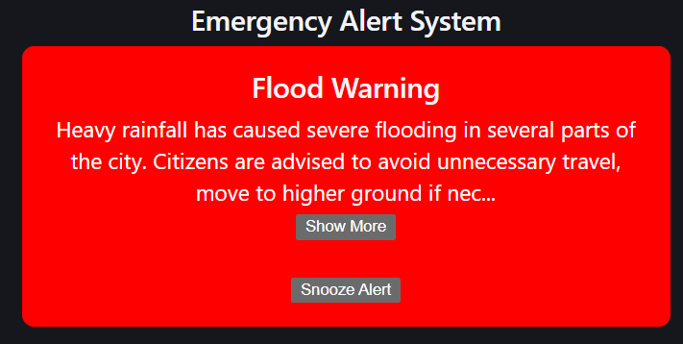

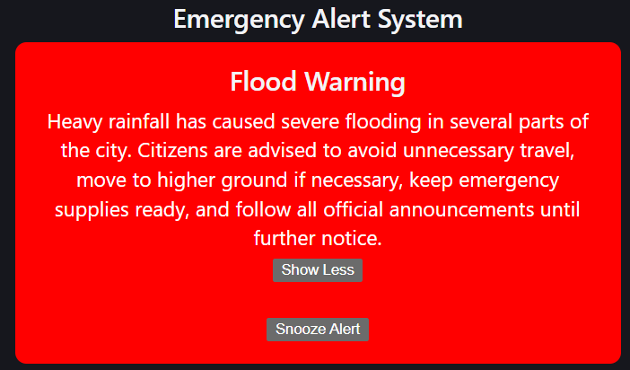

7.(b) Student Attendance Card using Class Component Scenario:
Build a remote learning application where teachers can track students' attendance in a live session.

Tasks:
- Create a StudentCard class component that:
  - Displays a student's name, attendanceStatus (e.g., "present", "absent"), and joinTime as props.
  - Changes the background color to green for "present" and red for "absent".
  - Add a "Mark Present" button that updates the attendanceStatus to "present" and logs "Student [Name] is now marked as present.".
  - If the joinTime is after 10:00 AM, display a warning saying "Late Joiner".

Program:
App.jsx
import React from "react";
import StudentCard from "./StudentCard"; class App extends React.Component { render() {
return (
<div style={{
display: "flex", justifyContent: "center",

alignItems: "center", flexDirection: "column", minHeight: "100vh", backgroundColor: "#b0bac9",
}}
>
<h1 style={{ color: "#2c3e50" }}> Remote Learning Attendance
</h1>
<StudentCard name="John" attendanceStatus="absent" joinTime="10:30 AM"
/>
</div>
);
}
}
export default App;

StudentCard.jsx
import React, { Component } from "react"; class StudentCard extends Component { constructor(props) {
super(props); this.state = {
attendanceStatus: props.attendanceStatus,
};
}
markPresent = () => {

this.setState({ attendanceStatus: "present",
});
console.log(
`Student ${this.props.name} is now marked as present.`
);
};

render() {
const bgColor = this.state.attendanceStatus === "present"
? "#d4edda"
: "#f8d7da"; const borderColor =
this.state.attendanceStatus === "present"
? "#28a745"
: "#dc3545";
const late = this.props.joinTime.includes("10:") || this.props.joinTime.includes("11:") || this.props.joinTime.includes("12:"); return (
<div style={{
backgroundColor: bgColor,
border: `3px solid ${borderColor}`, width: "420px",
padding: "25px", borderRadius: "15px",

textAlign: "center",
boxShadow: "0px 4px 10px rgba(0,0,0,0.2)",
}}
>
<h2 style={{ color: "#2c3e50" }}>{this.props.name}</h2>
<p>
<strong>Attendance Status:</strong>{" "}
{this.state.attendanceStatus}
</p>
<p>
<strong>Join Time:</strong> {this.props.joinTime}
</p>
{late && (
<h3 style={{ color: "#ff9800" }}>
⚠️ Late Joiner
</h3>
)}
<button onClick={this.markPresent} style={{
backgroundColor: "#007bff", color: "white",
border: "none", padding: "10px 20px", borderRadius: "8px", cursor: "pointer", fontSize: "15px",
}}
>

Mark Present
</button>
</div>
);
}
}
export default StudentCard;

Output:
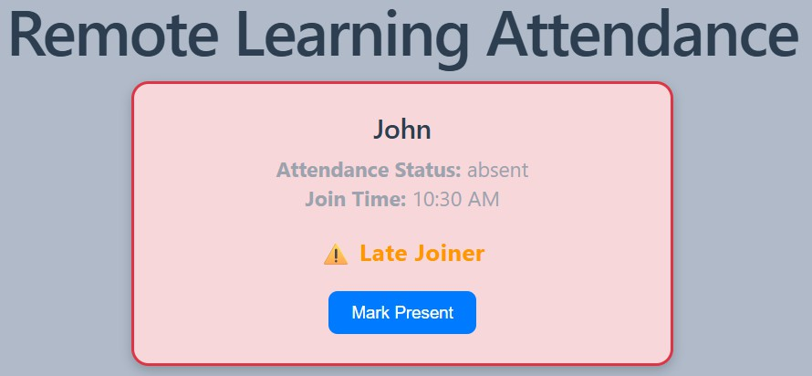
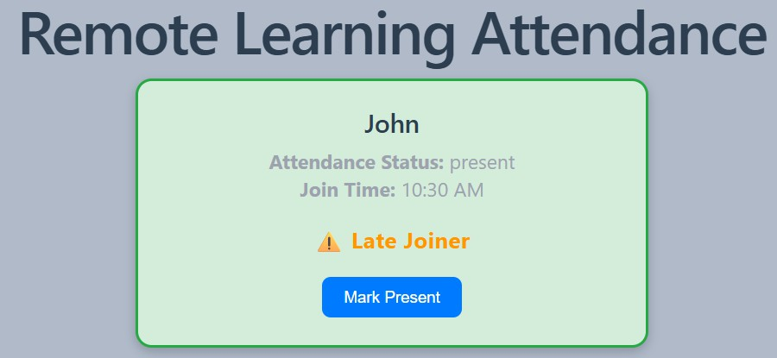

Problem Understanding  & Approach (10) | Implementation & Execution (15) | Tool / Technology Usage  (10) | Code quality & Documentation (5) | Viva (5) | Time Management  (5) | Total (50)

Result:
The React Class Components were successfully implemented. The applications dynamically displayed data based on props, updated the UI using state, handled user interactions through event handling, applied conditional rendering and dynamic styling, and produced the expected output successfully.

