Ex No : | Hooks
Date : | Hooks

AIM:
To implement an application using useState, useEffect, useContext, useCallback, useMemo, useRef and Customized Hooks on react.
- useState
  - You are developing a quiz app where the user’s selected answer must be stored for each question. How would you use useState to track the chosen options?

PROGRAM:
App.jsx
import React, { useState } from "react"; import "./App.css";
function App() { const questions = [
{
question: "Which language is mainly used with React?", options: ["Java", "Python", "JavaScript", "C++"]
},
{
question: "Which Hook is used to manage state in React?", options: ["useEffect", "useState", "useRef", "useMemo"]
}
];
const [selectedAnswers, setSelectedAnswers] = useState({}); const handleAnswer = (questionIndex, answer) => { setSelectedAnswers({
...selectedAnswers, [questionIndex]: answer

});
};
return (
<div className="page">
<div className="quiz-box">
<div className="header">
<div className="icon">C˛*</div>
<div>
<h1>Quick Quiz</h1>
</div>
</div>
<div className="progress">
<span>
{Object.keys(selectedAnswers).length} / {questions.length}
</span>
<span>Questions Answered</span>
</div>
{questions.map((q, index) => (
<div className="question-card" key={index}>
<div className="question-number"> Question {index + 1}
</div>
<h2>{q.question}</h2>
<div className="options">
{q.options.map((option) => (
<button key={option} className={
selectedAnswers[index] === option

? "option selected"
: "option"
}
onClick={() => handleAnswer(index, option)}
>
<span className="radio">
{selectedAnswers[index] === option ? "✓" : ""}
</span>
{option}
</button>
))}
</div>
{selectedAnswers[index] && (
<div className="answer">
- Selected: {selectedAnswers[index]}
</div>
)}
</div>
))}
<div className="footer">
◎’" ´● Choose one answer for each question
</div>
</div>
</div>
);
}
export default App;

OUTPUT:
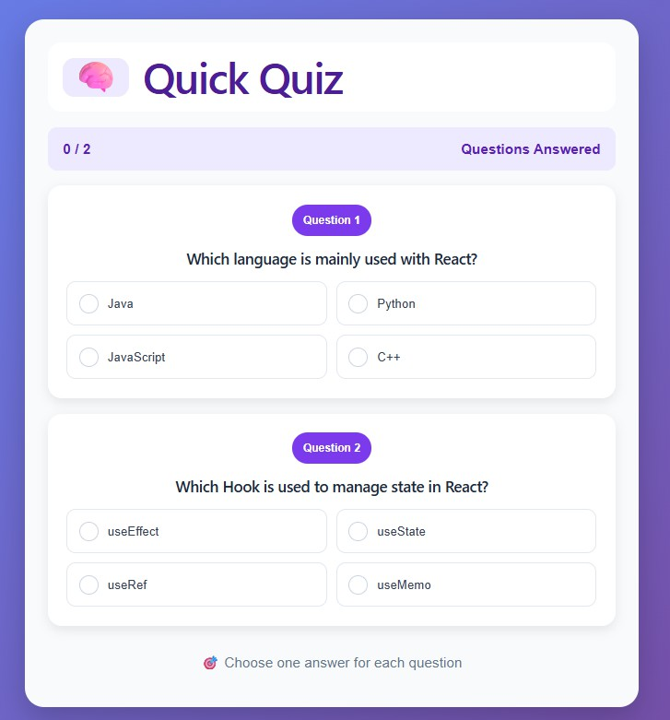
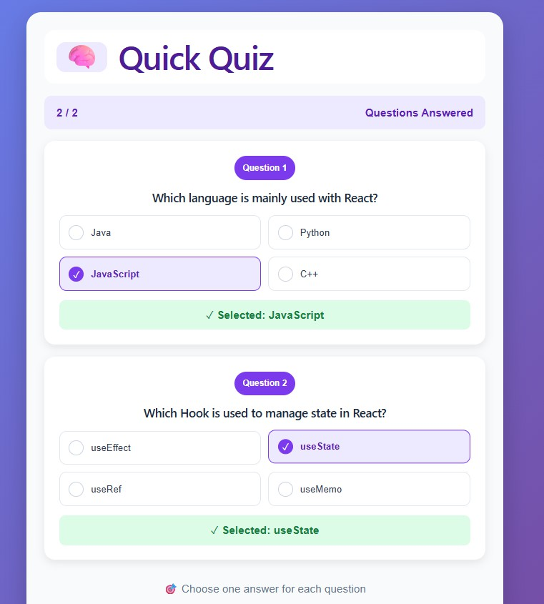

  - In a shopping app, you want to maintain the list of items added to the cart. How can useState help manage this dynamic array?

PROGRAM:
App.jsx
import React, { useState } from "react"; import "./App.css";

function App() {
const [cart, setCart] = useState([]); const products = [
{ id: 1, name: "Headphones", price: 999, icon: ",^," },
{ id: 2, name: "Smart Watch", price: 1499, icon: "' ·●•‘·" },
{ id: 3, name: "Keyboard", price: 799, icon: ". " },
{ id: 4, name: "Mouse", price: 499, icon: "'⬛" }
];
const addToCart = (product) => { setCart([...cart, product]);
};
const removeFromCart = (index) => {
const newCart = cart.filter((_, i) => i !== index); setCart(newCart);
};
const total = cart.reduce((sum, item) => sum + item.price, 0); return (
<div className="page">
<div className="shop">
<header>
<div>
<h1>.u⬛ Smart Shopping</h1>
</div>
<div className="cart-count">
/¯. {cart.length}
</div>
</header>
<h2>Products</h2>

<div className="products">
{products.map((product) => (
<div className="product-card" key={product.id}>
<div className="product-icon">
{product.icon}
</div>
<h3>{product.name}</h3>
<p>₹{product.price}</p>
<button onClick={() => addToCart(product)}>
+ Add to Cart
</button>
</div>
))}
</div>
<div className="cart">
<div className="cart-title">
<h2>/¯ . Your Cart</h2>
<span>{cart.length} items</span>
</div>
{cart.length === 0 ? (
<div className="empty">
/¯.
<p>Your cart is empty</p>
<small>Add products to see them here</small>
</div>
) : (
<>
{cart.map((item, index) => (
<div className="cart-item" key={index}>

<span className="item-icon">
{item.icon}
</span>
<div>
<b>{item.name}</b>
<p>₹{item.price}</p>
</div>
<button className="remove"
onClick={() => removeFromCart(index)}
>
✕
</button>
</div>
))}
<div className="total">
<span>Total</span>
<strong>₹{total}</strong>
</div>
</>
)}
</div>
</div>
</div>
);
}
export default App;

OUTPUT:
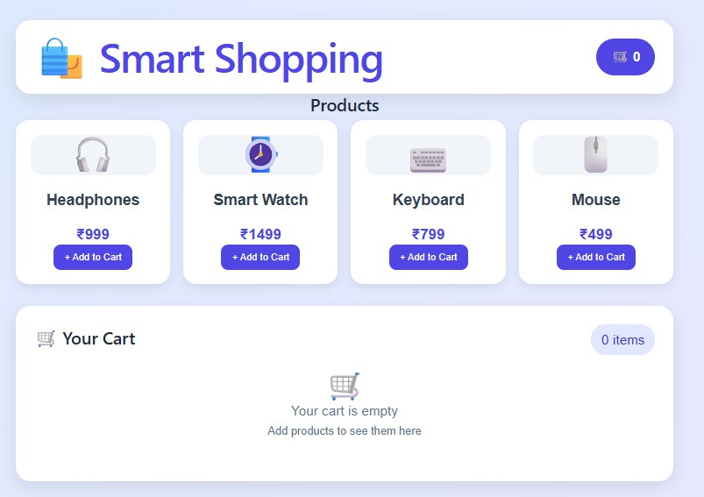
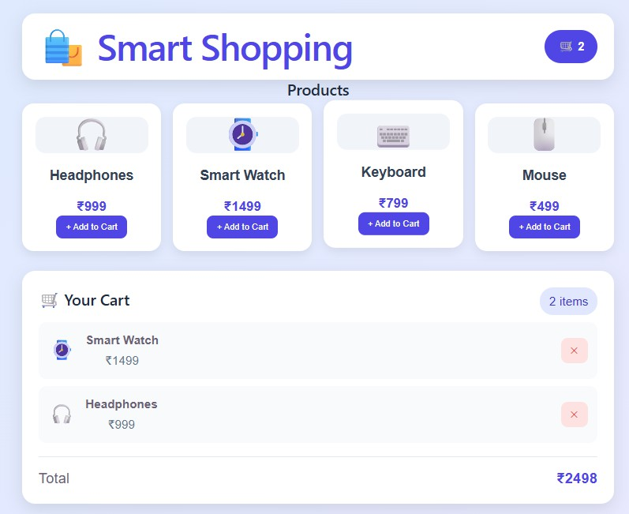

  - You are building a toggle button for showing/hiding a modal popup. How would you use useState to track the modal’s visibility state?

PROGRAM:
App.jsx:
import React, { useState } from "react"; import "./App.css";
function App() {
const [showModal, setShowModal] = useState(false); return (

<div className="page">
<div className="card">
<div className="icon">‘.y⬛□r‘</div>
<h1>Popup</h1>
<p>
Click the button below to open the modal.
</p>
<button className="open-btn"
onClick={() => setShowModal(true)}
>
Open Modal
</button>
</div>
{showModal && (
<div className="overlay">
<div className="modal">
<div className="modal-icon">·3 ˛.‘~˙.~˙ª˙</div>
<h2>Welcome!</h2>
<p>
This popup is controlled using React's
<b> useState </b> hook.
</p>
<button className="close-btn"
onClick={() => setShowModal(false)}
>
Close
</button>

</div>
</div>
)}
</div>
);
}
export default App;

OUTPUT:
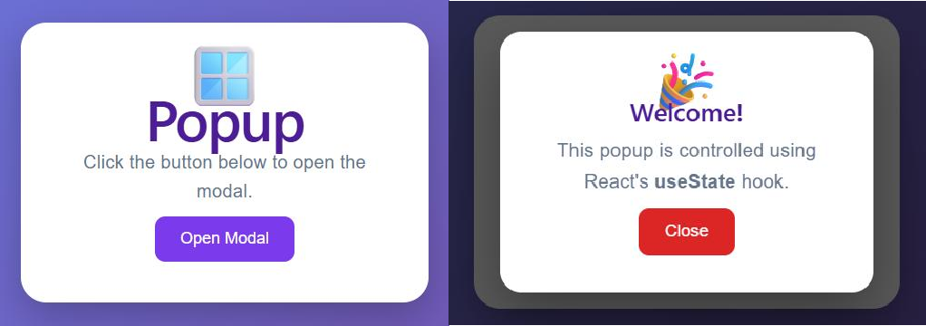
- useEffect
  - In a weather app, you need to fetch live weather data from an API whenever the page loads. How can you use useEffect to achieve this?

PROGRAM:
App.jsx:
import React, { useState, useEffect } from "react"; import "./App.css";
function App() {
const [weather, setWeather] = useState(null); const [loading, setLoading] = useState(true); useEffect(() => {
fetch("https://api.open-meteo.com/v1/forecast?latitude=11.0168&longitude=76.9558&current=temperature_2m,win d_speed_10m")
.then((response) => response.json())

.then((data) => { setWeather(data.current); setLoading(false);
})
.catch((error) => { console.log(error); setLoading(false);
});
}, []);
return (
<div className="page">
<div className="weather-card">
<div className="weather-icon"> ◆● </div>
<h1>Live Weather</h1>
<p className="location">•¡˙ Coimbatore, India</p>
{loading ? (
<div className="loading">
‡ ¯_’, Loading weather...
</div>
) : weather ? (
<div className="weather-info">
<div className="temperature">
{weather.temperature_2m}°C
</div>
<div className="details">
<div className="detail-box">
‡•<˙(.>
<span>Wind Speed</span>
<b>{weather.wind_speed_10m} km/h</b>

</div>
<div className="detail-box">
\·
<span>Temperature</span>
<b>{weather.temperature_2m}°C</b>
</div>
</div>
<div className="status">
- Live data fetched from weather API
</div>
</div>
) : (
<p className="error">
+ Unable to fetch weather data
</p>
)}
</div>
</div>
);
}
export default App;

OUTPUT:
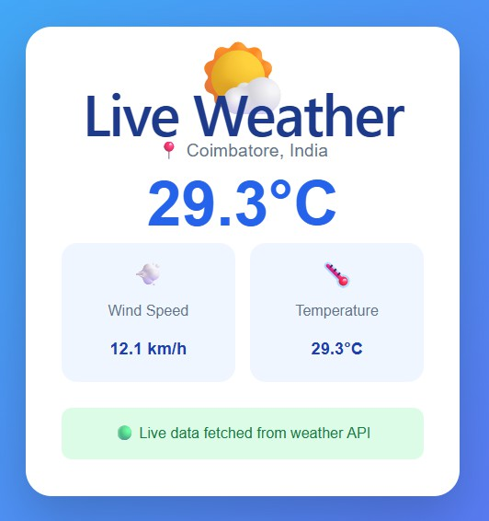

  - You are tracking a user’s scroll position to show a “Back to Top” button. How would you use useEffect to add and clean up the scroll event listener?

PROGRAM:
App.jsx:
import React, { useState, useEffect } from "react"; import "./App.css";
function App() {
const [showButton, setShowButton] = useState(false); useEffect(() => {
const handleScroll = () => { if (window.scrollY > 300) { setShowButton(true);
} else { setShowButton(false);
}
};
window.addEventListener("scroll", handleScroll); return () => {
window.removeEventListener("scroll", handleScroll);
};
}, []);
const backToTop = () => { window.scrollTo({
top: 0,
behavior: "smooth"
});
};
return (
<div className="page">

<header>
<div className="logo"> ScrollSpace</div>
<span>useEffect Demo</span>
</header>
<section className="hero">
<div className="hero-icon">⬛†</div>
<h1>Scroll Down</h1>
<p>
Scroll the page to see the Back to Top button.
</p>
</section>
<section className="content">
<div className="card">
<span>01</span>
<h2>Track Scroll Position</h2>
<p>
React monitors the user's scroll position using a scroll event listener.
</p>
</div>
<div className="card">
<span>02</span>
<h2>Show the Button</h2>
<p>
When the user scrolls more than 300 pixels, the Back to Top button becomes visible.
</p>
</div>
<div className="card">

<span>03</span>
<h2>Clean Up</h2>
<p>
When the component is removed, the event listener is removed to prevent memory leaks.
</p>
</div>
<div className="card">
<span>04</span>
<h2>Scroll Back</h2>
<p>
Click the button to smoothly return to the top of the page.
</p>
</div>
</section>
{showButton && (
<button className="top-button" onClick={backToTop}>
↑
<span>Back to Top</span>
</button>
)}
</div>
);
}
export default App;

OUTPUT:
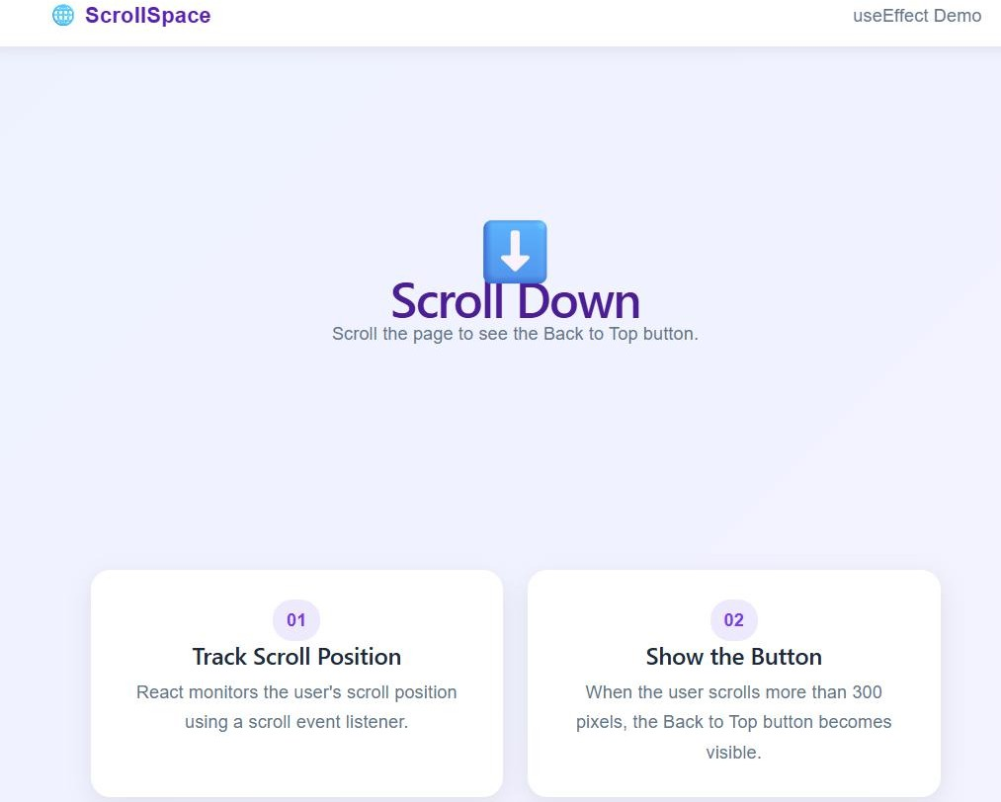
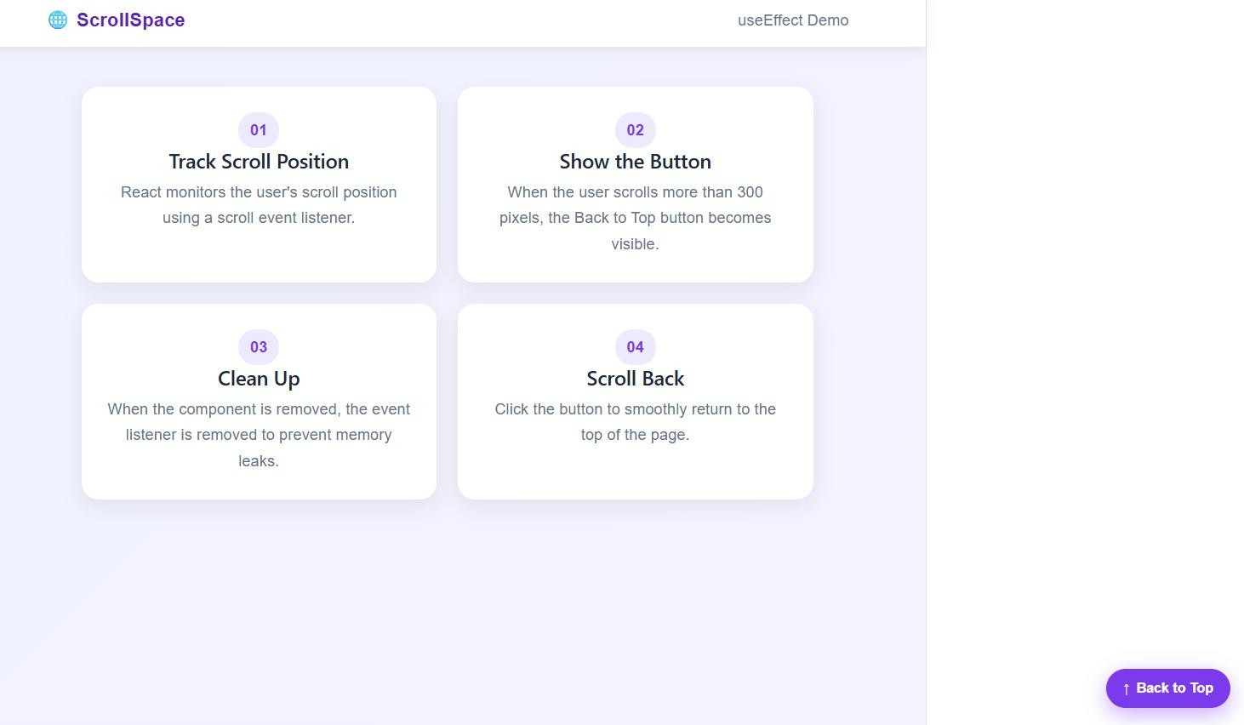

  - In a product details page, you need to fetch product info from the backend whenever the productId changes. How would you use useEffect to refetch data based on this dependency?

PROGRAM:
App.jsx:
import React, { useState, useEffect } from "react"; import "./App.css";

function App() {
const [productId, setProductId] = useState(1); const [product, setProduct] = useState(null); const [loading, setLoading] = useState(true); useEffect(() => {
setLoading(true); fetch(`https://dummyjson.com/products/${productId}`)
.then((response) => response.json())
.then((data) => { setProduct(data); setLoading(false);
})
.catch(() => { setLoading(false);
});
}, [productId]); return (
<div className="page">
<div className="product-card">
<h1>.u⬛ Product Details</h1>
<p className="subtitle"> Product ID: {productId}
</p>
<div className="buttons">
<button onClick={() => setProductId(productId - 1)} disabled={productId === 1}>
◀ Previous
</button>

<button onClick={() => setProductId(productId + 1)}> Next ▶
</button>
</div>
{loading ? (
<div className="loading">
‡ ¯_’, Loading product...
</div>
) : product ? (
<div className="details">
<img src={product.thumbnail} alt={product.title}
/>
<h2>{product.title}</h2>
<p>{product.description}</p>
<div className="info">
<span> x ${product.price}</span>
<span>★ {product.rating}</span>
<span>◆J ,u´ {product.stock} left</span>
</div>
</div>
) : (
<p>+ Product not found</p>
)}
</div>
</div>
);

}
export default App;

OUTPUT:
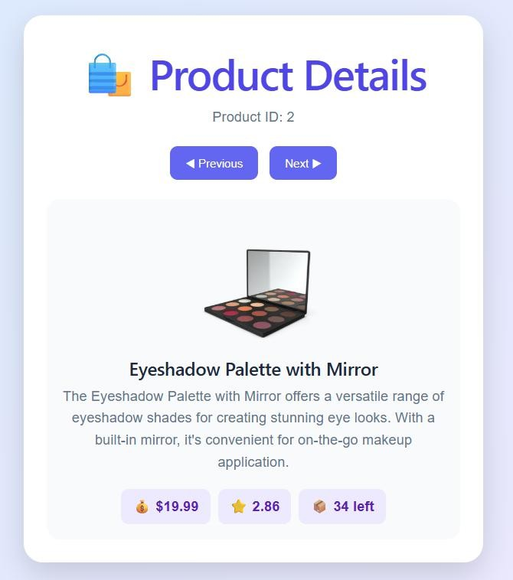
- useContext
  - In a dashboard app, you need to share the logged-in user’s profile information across multiple nested components. How can useContext help simplify this instead of prop
drilling?

PROGRAM:
UserContext.jsx
import React, { createContext } from "react"; export const UserContext = createContext(); export const UserProvider = ({ children }) => { const user = {
name: "Jeen",
email: "jeenjangelleena@gmail.com", role: "Administrator",
location: "Chennai, India"
};

return (
<UserContext.Provider value={user}>
{children}
</UserContext.Provider>
);
};
App.jsx:
import React, { useContext } from "react"; import { UserContext } from "./UserContext"; import "./App.css";
function Header() {
const user = useContext(UserContext); return (
<header>
<div className="logo">
#ç¡/ My Dashboard
</div>
<div className="user-mini">
<div className="avatar">
{user.name.charAt(0)}
</div>
<div>
<b>{user.name}</b>
<small>{user.role}</small>
</div>
</div>
</header>
);
}

function Profile() {
const user = useContext(UserContext); return (
<div className="profile-card">
<div className="large-avatar">
{user.name.charAt(0)}
</div>
<h2>{user.name}</h2>
<p>{user.email}</p>
<span className="role">
{user.role}
</span>
<div className="profile-info">
<div>
<span>¡•˙</span>
<b>Location</b>
<p>{user.location}</p>
</div>
<div>
<span>•Vʌ□ </span>
<b>Email</b>
<p>{user.email}</p>
</div>
</div>
</div>
);
}
function Welcome() {
const user = useContext(UserContext);

return (
<div className="welcome">
<div>
<p className="label">WELCOME BACK `5`‘s\³ </p>
<h1>
Hello, {user.name}!
</h1>
<p>
Here's what's happening with your dashboard today.
</p>
</div>
<div className="emoji">
’•˙.s7¸
</div>
</div>
);
}
function Dashboard() { return (
<div className="dashboard">
<Header />
<main>
<Welcome />
<div className="content">
<Profile />
<div className="stats">
<div className="stat-card">
<span>⬛#/</span>
<h3>Activity</h3>

<strong>85%</strong>
<p>Profile activity</p>
</div>
<div className="stat-card">
<span>★</span>
<h3>Status</h3>
<strong>Active</strong>
<p>Account status</p>
</div>
<div className="stat-card">
<span>çtP'</span>
<h3>Role</h3>
<strong>Admin</strong>
<p>Access level</p>
</div>
<div className="stat-card">
<span>●?</span>
<h3>Region</h3>
<strong>India</strong>
<p>User location</p>
</div>
</div>
</div>
</main>
</div>
);
}
function App() { return (

<Dashboard />
);
}
export default App;

OUTPUT:
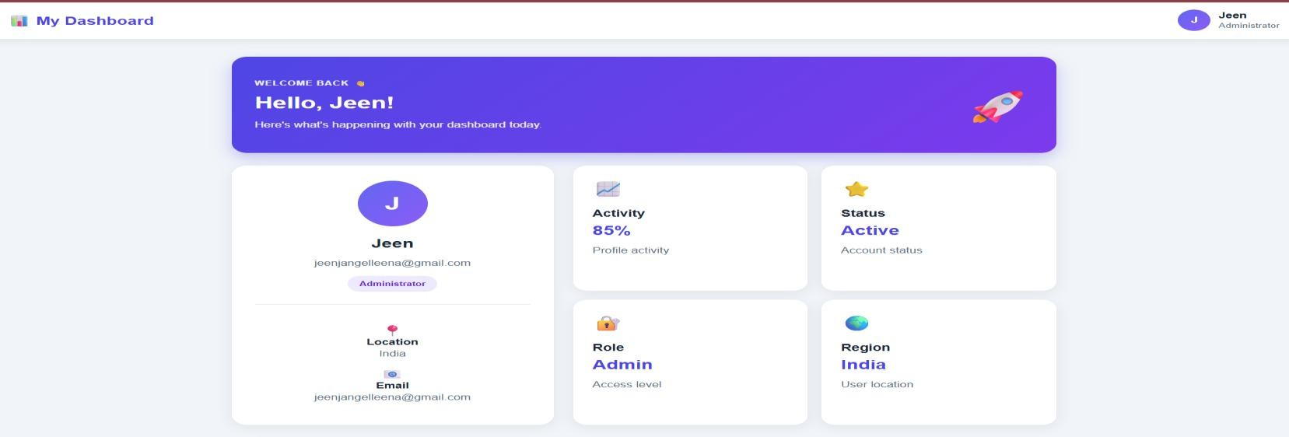
  - A shopping cart has to display the total number of items in the header, sidebar, and footer simultaneously. How would you use useContext to manage this shared state?

PROGRAM:
App.jsx
import React, { useContext } from "react"; import { CartContext } from "./CartContext"; import "./App.css";
function Header() {
const { cartCount } = useContext(CartContext); return (
<header>
<div className="logo">
.u⬛ ShopEasy
</div>
<div className="header-cart">

/¯. Cart
<span>{cartCount}</span>
</div>
</header>
);
}
function Sidebar() {
const { cartCount } = useContext(CartContext); return (
<aside>
<h2>Menu</h2>
<div className="menu-item">
·¡_ ·^_ Home
</div>
<div className="menu-item">
◆J ,u´ Products
</div>
<div className="menu-item cart-menu">
¯ ./. My Cart
<span>{cartCount}</span>
</div>
</aside>
);
}
function Products() {
const { addItem } = useContext(CartContext); return (
<main>
<div className="welcome">

<h1>Welcome to ShopEasy `‘³s\5` </h1>
<p>Add products to your shopping cart.</p>
</div>
<div className="products">
<div className="product">
<div className="product-icon">,^,</div>
<h3>Headphones</h3>
<p>₹999</p>
<button onClick={addItem}> Add to Cart
</button>
</div>
<div className="product">
<div className="product-icon">' ·●•‘·</div>
<h3>Smart Watch</h3>
<p>₹1,499</p>
<button onClick={addItem}> Add to Cart
</button>
</div>
<div className="product">
<div className="product-icon">°Qxˆ¯ </div>
<h3>Backpack</h3>
<p>₹799</p>
<button onClick={addItem}> Add to Cart
</button>
</div>
</div>

</main>
);
}
function Footer() {
const { cartCount } = useContext(CartContext); return (
<footer>
<div>
© 2026 ShopEasy
</div>
<div>
/.¯. Total Items in Cart:
<strong>{cartCount}</strong>
</div>
</footer>
);
}
function App() { return (
<div className="app">
<Header />
<div className="layout">
<Sidebar />
<Products />
</div>
<Footer />
</div>
);
}

export default App;

OUTPUT:
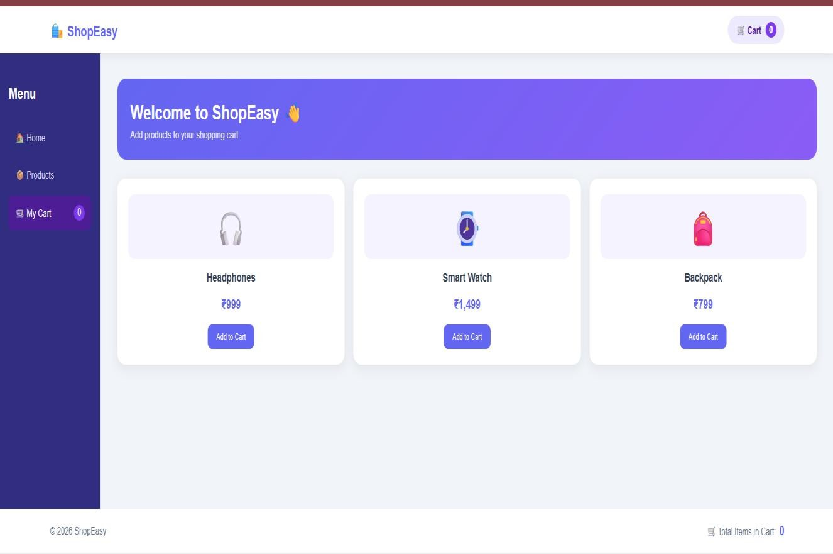
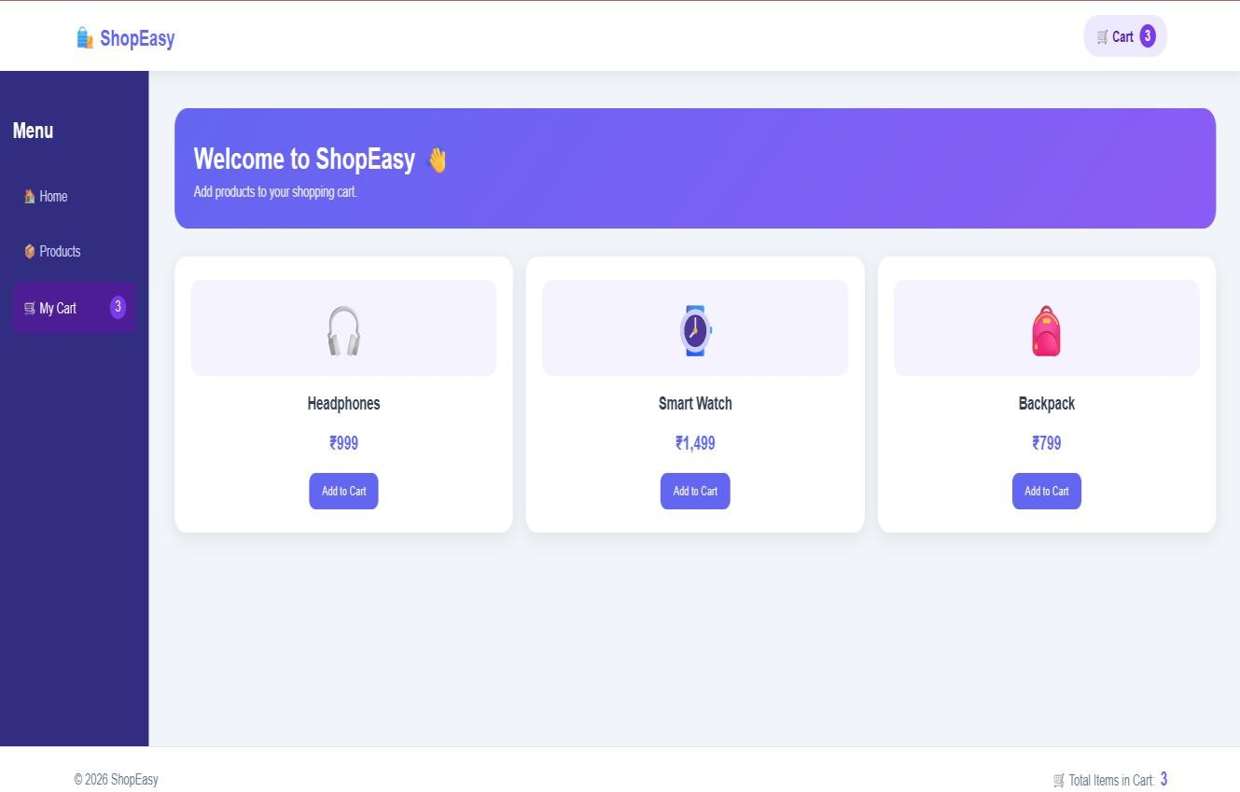

- useCallback
  - You have a list of users, and each user has a “Follow” button. The click handler is defined inside the parent component, causing performance issues. How would you optimize it using useCallback?

PROGRAM:

App.jsx:
import React, { useState, useCallback, memo } from "react"; import "./App.css";
const UserCard = memo(function UserCard({ user, onFollow }) { console.log("Rendered:", user.name);
return (
<div className="user-card">
<div className="avatar">
{user.name.charAt(0)}
</div>
<div className="user-info">
<h3>{user.name}</h3>
<p>{user.username}</p>
<span>{user.followers} followers</span>
</div>
<button
className={user.following ? "following" : ""} onClick={() => onFollow(user.id)}
>
{user.following ? "✓ Following" : "+ Follow"}
</button>
</div>
);
});
function App() {
const [users, setUsers] = useState([
{ id: 1,
name: "Ananya", username: "@ananya",

followers: 1250, following: false
},{ id: 2,
name: "Rahul", username: "@rahul", followers: 980, following: false
}, { id: 3,
name: "Priya", username: "@priya", followers: 2340, following: false
}, {
id: 4,
name: "Arjun", username: "@arjun", followers: 1750, following: false
}
]);
const handleFollow = useCallback((userId) => { setUsers((previousUsers) => previousUsers.map((user) =>
user.id === userId
? {
...user,
following: !user.following, followers: user.following
? user.followers - 1

: user.followers + 1
}
: user
)
);
}, []);
return (
<div className="page">
<div className="container">
<header>
<div>
<h1> + ConnectHub</h1>
</div>
<div className="people-count">
,ç†, {users.length} Users
</div>
</header>
<div className="title">
<h2>People You May Know</h2>
<p>Follow users to stay connected with them.</p>
</div>
<div className="user-list">
{users.map((user) => (
<UserCard key={user.id} user={user}
onFollow={handleFollow}
/>
))}

</div>
<div className="info-box">
) <b>Optimized with useCallback</b>
<br />
The Follow handler keeps the same function reference between renders.
</div>
</div>
</div>
);
}
export default App;

OUTPUT:
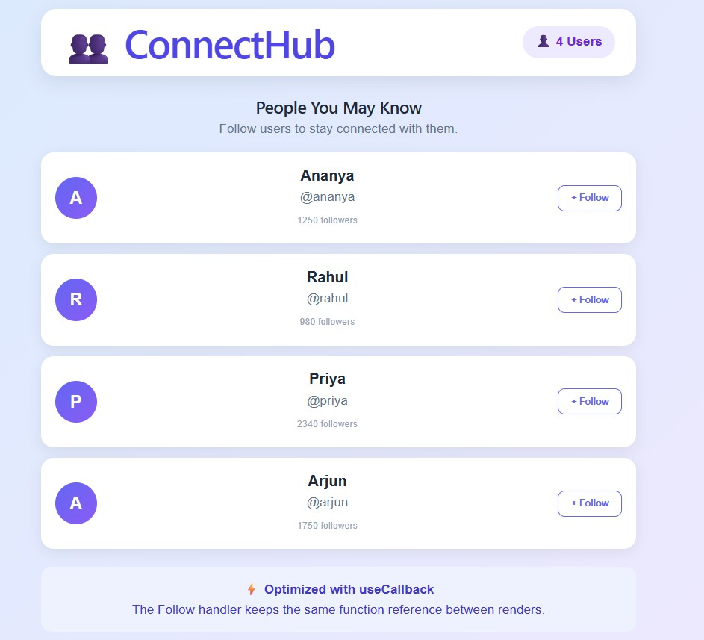

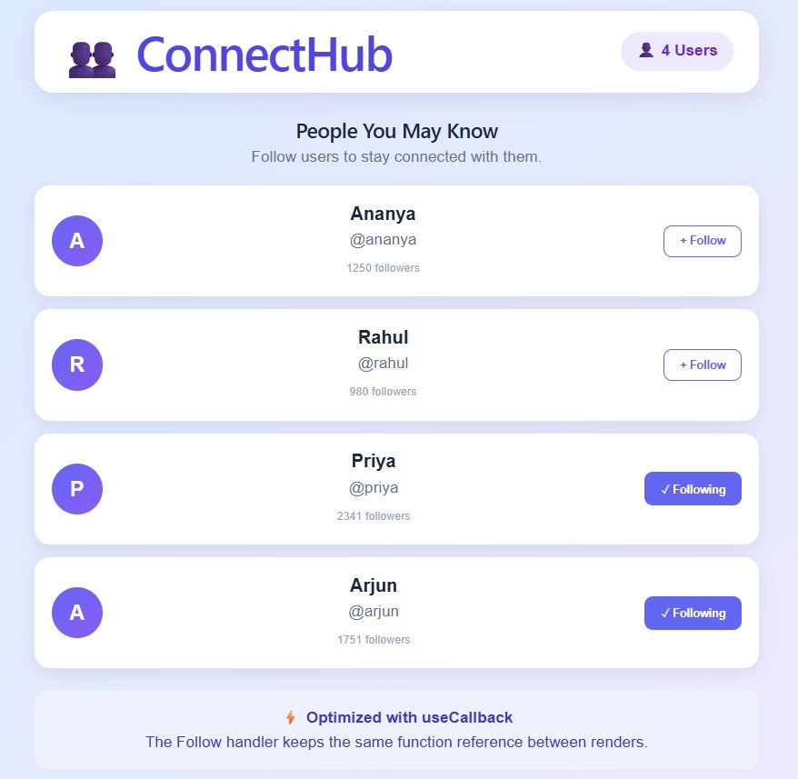
  - You are working on a form with multiple fields. Each input has an onChange handler passed from the parent. How can useCallback help reduce unnecessary re-renders of
these input components? PROGRAM:
App.jsx:
import React, { useState, useCallback, memo } from "react"; import "./App.css";
const FormInput = memo(function FormInput({ label,
name, value, onChange,
type = "text", placeholder
}) {
console.log("Rendered:", name);

return (
<div className="input-group">
<label>{label}</label>
<input type={type} name={name} value={value}
onChange={onChange} placeholder={placeholder}
/>
</div>
);
});
function App() {
const [formData, setFormData] = useState({ name: "",
email: "",
phone: "", password: ""
});
const handleChange = useCallback((e) => { const { name, value } = e.target; setFormData((previousData) => ({
...previousData, [name]: value
}));
}, []);
const handleSubmit = (e) => { e.preventDefault();

alert("Registration Successful! ˙‘·.ª˛ 3.~");
};
return (
<div className="page">
<div className="form-card">
<div className="icon">
¸ ‘ )•
</div>
<h1>Create Account</h1>
<p className="subtitle">
Fill in your details to get started
</p>
<form onSubmit={handleSubmit}>
<FormInput label="Full Name" name="name"
value={formData.name} onChange={handleChange} placeholder="Enter your full name"
/>
<FormInput label="Email Address" name="email"
value={formData.email} onChange={handleChange} type="email" placeholder="Enter your email"
/>
<FormInput

label="Phone Number" name="phone" value={formData.phone} onChange={handleChange} type="tel"
placeholder="Enter your phone number"
/>
<FormInput label="Password" name="password" value={formData.password} onChange={handleChange} type="password"
placeholder="Create a password"
/>
<button type="submit"> Create Account →
</button>
</form>
<div className="optimization">
) <b>Performance Optimized</b>
<br />
Input components use <b>React.memo</b> and the change handler uses <b>useCallback</b>.
</div>
</div>
</div>
);
}

export default App;

OUTPUT:
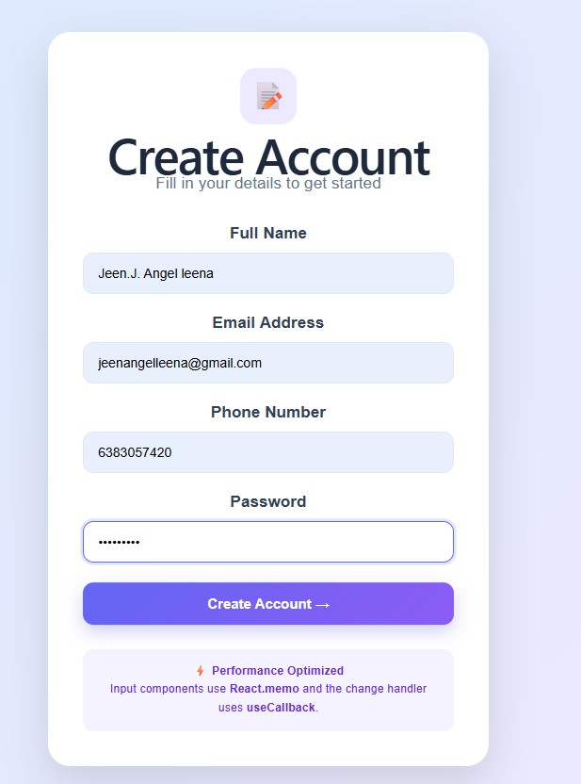
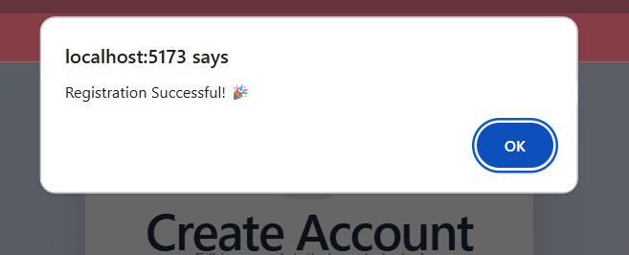

  - In a to-do app, the child component renders a list of tasks and receives a deleteTask function from the parent. How can you ensure this function reference stays stable across renders using useCallback?

PROGRAM:
App.jsx:
import React, { useState, useCallback, memo } from "react"; import "./App.css";
const TaskList = memo(function TaskList({ tasks, deleteTask }) { console.log("TaskList rendered");
return (

<div className="task-list">
{tasks.length === 0 ? (
<div className="empty">
• ¸‘ )
<h3>No tasks yet</h3>
<p>Add a task to get started!</p>
</div>
) : (
tasks.map((task) => (
<div className="task" key={task.id}>
<div className="task-left">
<div className="check">✓</div>
<span>{task.text}</span>
</div>
<button className="delete-btn"
onClick={() => deleteTask(task.id)}
>
¯_
</button>
</div>
))
)}
</div>
);
});
function App() {
const [tasks, setTasks] = useState([
{ id: 1, text: "Complete React assignment" },

{ id: 2, text: "Practice useCallback" },
{ id: 3, text: "Prepare for practical exam" }
]);
const [newTask, setNewTask] = useState(""); const deleteTask = useCallback((id) => { setTasks((previousTasks) =>
previousTasks.filter((task) => task.id !== id)
);
}, []);
const addTask = () => {
if (newTask.trim() === "") { return;
}
setTasks((previousTasks) => [
...previousTasks,
{
id: Date.now(), text: newTask
}
]);
setNewTask("");
};
return (
<div className="page">
<div className="todo-container">
{/* Header */}
<div className="header">
<div>
<div className="logo">✓</div>

</div>
<div>
<h1>My Tasks</h1>
<p>Stay organized and productive</p>
</div>
<div className="task-count">
{tasks.length}
</div>
</div>
{/* Add Task */}
<div className="add-box">
<input type="text"
value={newTask}
placeholder="What needs to be done?" onChange={(e) => setNewTask(e.target.value)} onKeyDown={(e) => {
if (e.key === "Enter") { addTask();
}
}}
/>
<button className="add-btn" onClick={addTask}>
+ Add Task
</button>
</div>
{/* Child Component */}
<TaskList tasks={tasks}

deleteTask={deleteTask}
/>
{/* Footer */}
<div className="footer">
<span>
⬛|, ¯–− {tasks.length} {tasks.length === 1 ? "task" : "tasks"}
</span>
<span>
) Optimized with useCallback
</span>
</div>
</div>
</div>
);
}
export default App;

OUTPUT:
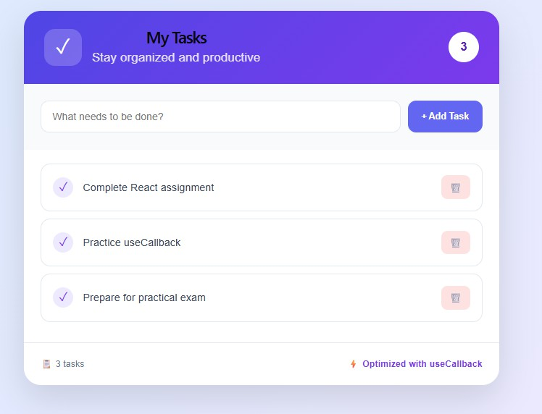

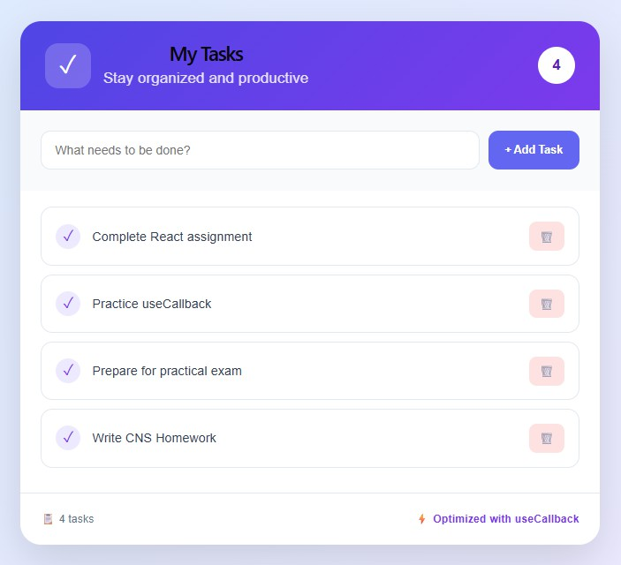
- useMemo
  - In a financial dashboard, calculating the total revenue requires iterating over thousands of records. How can you prevent recalculating it on every render using useMemo?

PROGRAM:
App.jsx:
import React, { useState, useMemo } from "react"; import "./App.css";
function App() {
const [transactions] = useState([
{ id: 1, customer: "John", amount: 25000 },
{ id: 2, customer: "Sarah", amount: 18500 },
{ id: 3, customer: "David", amount: 32000 },
{ id: 4, customer: "Emma", amount: 27500 },
{ id: 5, customer: "Michael", amount: 41000 }
]);
const [count, setCount] = useState(0); const totalRevenue = useMemo(() => {
console.log("Calculating total revenue..."); return transactions.reduce(

(total, transaction) =>
total + transaction.amount, 0
);
}, [transactions]);
const averageRevenue = useMemo(() => { return totalRevenue / transactions.length;
}, [totalRevenue, transactions]); return (
<div className="page">
<div className="dashboard">
{/* HEADER */}
<header>
<div>
<h1> x FinancePro</h1>
<p>Financial Revenue Dashboard</p>
</div>
<div className="status">
- LIVE
</div>
</header>
{/* SUMMARY */}
<div className="summary">
<div className="card revenue">
<div className="card-icon">
I I.
</div>
<div>
<p>Total Revenue</p>

<h2>
₹{totalRevenue.toLocaleString()}
</h2>
<span>↗ 12.5% this month</span>
</div>
</div>
<div className="card">
<div className="card-icon">
¡#ç/
</div>
<div>
<p>Transactions</p>
<h2>
{transactions.length}
</h2>
<span>Successful payments</span>
</div>
</div>
<div className="card">
<div className="card-icon">
⬛#/
</div>
<div>
<p>Average Revenue</p>
<h2>
₹{Math.round(averageRevenue).toLocaleString()}
</h2>
<span>Per transaction</span>
</div>

</div>
</div>
{/* TRANSACTIONS */}
<section className="transactions">
<div className="section-title">
<div>
<h2>Recent Transactions</h2>
<p>Revenue generated from customers</p>
</div>
<div className="transaction-count">
{transactions.length} Records
</div>
</div>
<div className="table">
<div className="table-header">
<span>ID</span>
<span>Customer</span>
<span>Amount</span>
<span>Status</span>
</div>
{transactions.map((transaction) => (
<div className="table-row" key={transaction.id}>
<span className="id"> #{transaction.id}
</span>
<span className="customer">
ç†, {transaction.customer}
</span>
<span className="amount">

₹{transaction.amount.toLocaleString()}
</span>
<span className="paid">
  - Paid
</span>
</div>
))}
</div>
</section>
{/* TEST BUTTON */}
<div className="test-box">
<div>
<strong>) Test useMemo</strong>
<p>
Clicking this button re-renders the component, but the revenue calculation is not repeated.
</p>
</div>
<button onClick={() => setCount(count + 1)}> Re-render ({count})
</button>
</div>
{/* FOOTER */}
<footer>
<span>© 2026 FinancePro</span>
<span>
) Total revenue optimized with useMemo
</span>
</footer>

</div>
</div>
);
}
export default App;

OUTPUT:
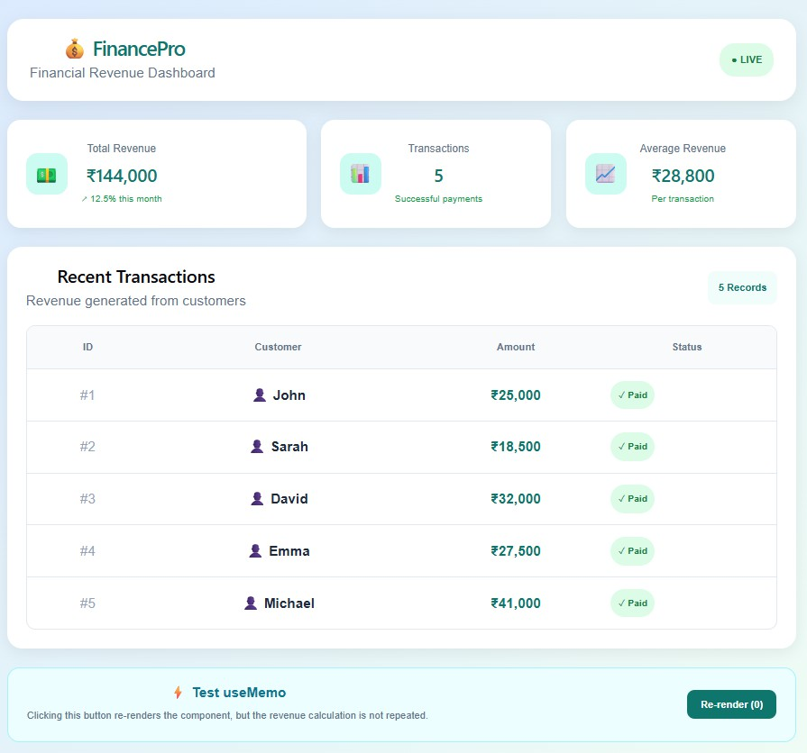
  - You are building a search bar that filters a large dataset of products. The filtering
logic is slow. How can you optimize this so filtering only happens when the search term changes?

PROGRAM:
App.jsx:
import React, { useState, useMemo } from "react"; import "./App.css";
function App() {
const [searchTerm, setSearchTerm] = useState(""); const [count, setCount] = useState(0);
const products = [

{ id: 1, name: "Laptop", category: "Electronics", price: 75000 },
{ id: 2, name: "Smartphone", category: "Electronics", price: 35000 },
{ id: 3, name: "Headphones", category: "Accessories", price: 2500 },
{ id: 4, name: "Keyboard", category: "Accessories", price: 1800 },
{ id: 5, name: "Mobile", category: "Accessories", price: 1200 },
];
const filteredProducts = useMemo(() => { console.log("Filtering products..."); return products.filter((product) =>
product.name.toLowerCase().includes(searchTerm.toLowerCase())
);
}, [searchTerm]); return (
<div className="container">
<div className="card">
<h1>.u⬛ Product Search</h1>
<p className="subtitle">
</p>
<input type="text"
placeholder="˙Q• Search for a product..." value={searchTerm}
onChange={(e) => setSearchTerm(e.target.value)}
/>
<div className="info">
<span>
Search: <b>{searchTerm || "All Products"}</b>
</span>
<span>

Results: <b>{filteredProducts.length}</b>
</span>
</div>
<div className="products">
{filteredProducts.length > 0 ? ( filteredProducts.map((product) => (
<div className="product" key={product.id}>
<div>
<h3>{product.name}</h3>
<p>{product.category}</p>
</div>
<strong>₹{product.price}</strong>
</div>
))
) : (
<p className="no-result">No products found +</p>
)}
</div>
<button onClick={() => setCount(count + 1)}> Test Re-render: {count}
</button>
</div>
</div>
);
}
export default App;

OUTPUT:
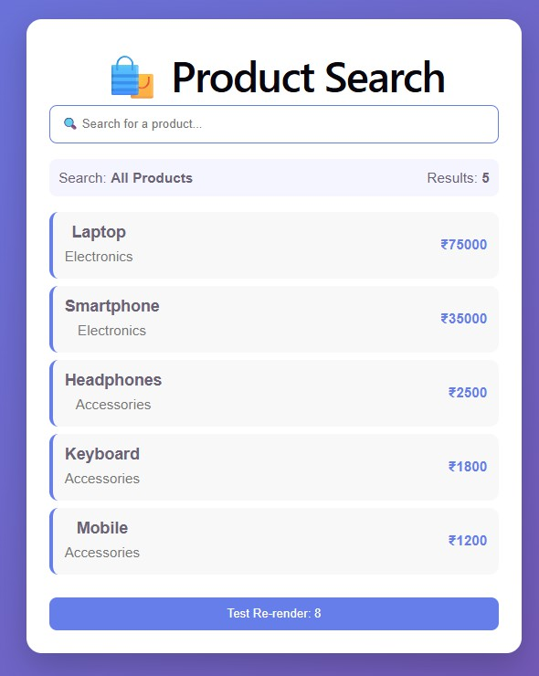
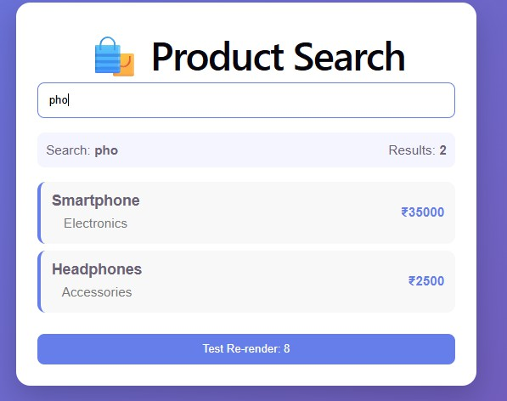
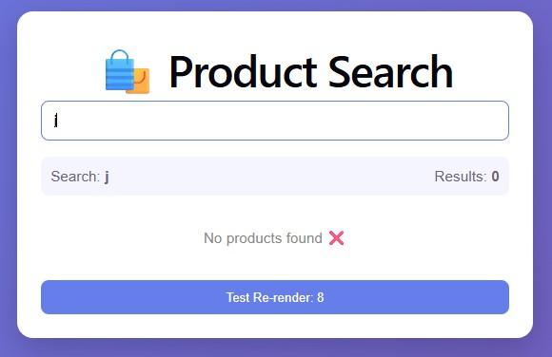

- useRef
  - Track Previous State : Create a counter (count) that increases on button click. Use useRef to store the previous value of count. Display both the current and previous values.

PROGRAM:
App.jsx:

import React, { useState, useRef, useEffect } from "react"; import "./App.css";
function App() {
const [count, setCount] = useState(0);
// Stores the previous count
const previousCount = useRef(0); useEffect(() => { previousCount.current = count;
}, [count]); return (
<div className="container">
<div className="card">
<h1>s²⬛¹t Counter</h1>
<p className="subtitle">Track Current and Previous State</p>
<div className="values">
<div className="box current">
<h3>Current Value</h3>
<p>{count}</p>
</div>
<div className="box previous">
<h3>Previous Value</h3>
<p>{previousCount.current}</p>
</div>
</div>
<button onClick={() => setCount(count + 1)}>
+ Increase Count
</button>
</div>
</div>

);
}
export default App;

OUTPUT:
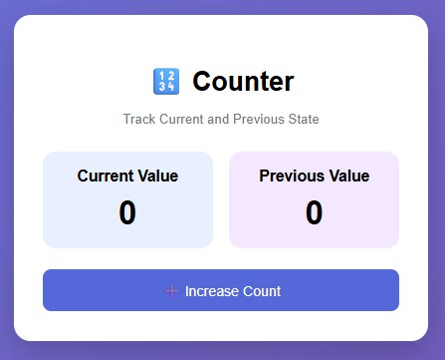
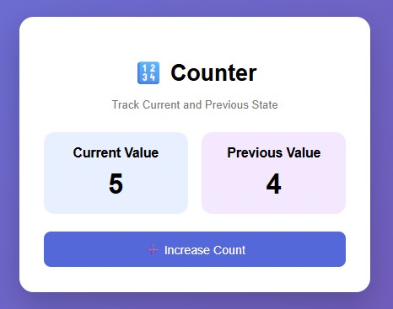
  - Scroll to an Element: Create a long list of items. Use useRef to point to a specific item (e.g., the 50th item). Add a button that scrolls directly to that item.

PROGRAM:
App.jsx:
import React, { useRef } from "react"; import "./App.css";
function App() {
const item50Ref = useRef(null); const scrollToItem50 = () => { item50Ref.current.scrollIntoView({
behavior: "smooth", block: "center"
});
};
return (
<div className="container">

<h1>¸ ˆ Long Item List</h1>
<button onClick={scrollToItem50}>
◎ ’●"´ Go to Item 50
</button>
<div className="list">
{Array.from({ length: 100 }, (_, index) => { const itemNumber = index + 1;
return (
<div key={itemNumber}
ref={itemNumber === 50 ? item50Ref : null} className={`item ${
itemNumber === 50 ? "target" : ""
}`}
>
Item {itemNumber}
{itemNumber === 50 && (
<span> ★ Target Item</span>
)}
</div>
);
})}
</div>
</div>
);
}
export default App;

OUTPUT:
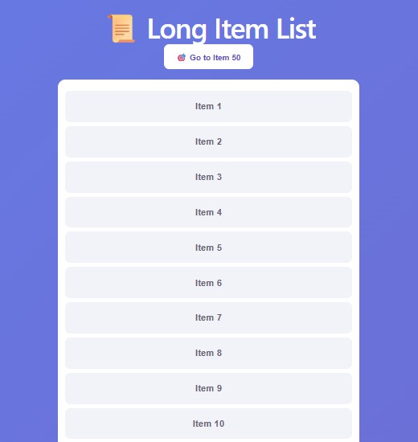
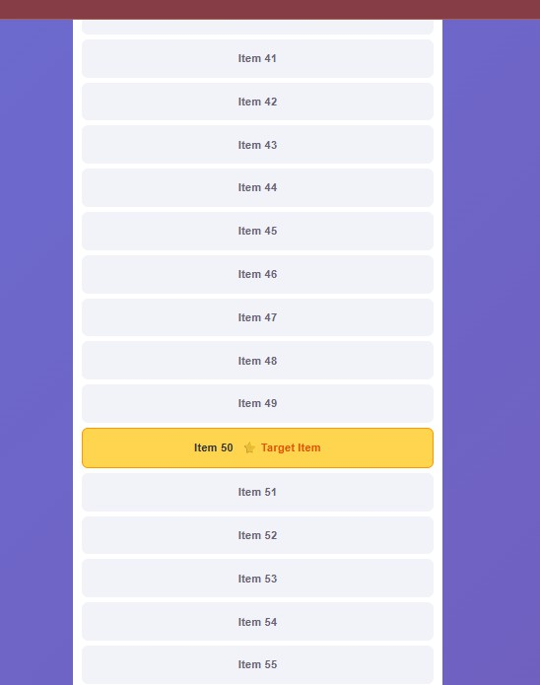
- Customized Hooks
useDebounce Hook: Accept a value and delay. Return the debounced value (only update after no changes for given delay).
App.jsx
import React, { useState } from "react"; import useDebounce from "./useDebounce"; import "./App.css";
function App() {
const [search, setSearch] = useState("");
// Debounce for 1 second
const debouncedSearch = useDebounce(search, 1000); return (
<div className="container">
<div className="card">
<h1>•˙QSearch</h1>
<p className="subtitle">

</p>
<input type="text"
placeholder="Type something..." value={search}
onChange={(e) => setSearch(e.target.value)}
/>
<div className="result">
<h3>. Current Value</h3>
<p>{search || "Nothing typed yet"}</p>
</div>
<div className="result debounced">
<h3> ●· ’ Debounced Value</h3>
<p>{debouncedSearch || "Waiting..."}</p>
</div>
<div className="delay">
’¯ ‡_, Delay: <b>1000 ms</b>
</div>
</div>
</div>
);
}
export default App;
useDebounce.jsx
import { useState, useEffect } from "react"; function useDebounce(value, delay) {
const [debouncedValue, setDebouncedValue] = useState(value); useEffect(() => {
const timer = setTimeout(() => {

setDebouncedValue(value);
}, delay); return () => {
clearTimeout(timer);
};
}, [value, delay]); return debouncedValue;
}
export default useDebounce;

OUTPUT:
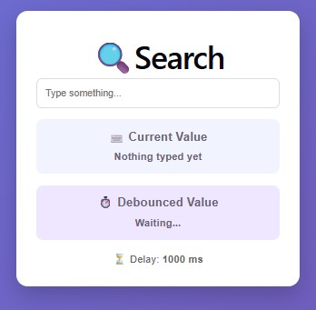
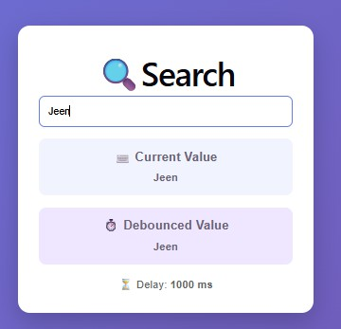
2. useEventListener Hook: Create a hook that attaches/detaches an event listener to any target (window, document, ref.current).

PROGRAM:
App.jsx:
import React, { useState, useRef } from "react"; import useEventListener from "./useEventListener"; import "./App.css";
function App() {
const [width, setWidth] = useState(window.innerWidth); const [key, setKey] = useState("None");

const [mouseMessage, setMouseMessage] = useState( "Move your mouse inside the box"
);
const boxRef = useRef(null); const handleResize = () => { setWidth(window.innerWidth);
};
useEventListener("resize", handleResize, window); const handleKeyDown = (event) => { setKey(event.key);
};
useEventListener("keydown", handleKeyDown, document); const handleMouseEnter = () => {
setMouseMessage("⬛' Mouse is inside the box!");
};
const handleMouseLeave = () => { setMouseMessage("Move your mouse inside the box");
};
useEventListener("mouseenter", handleMouseEnter, boxRef.current); useEventListener("mouseleave", handleMouseLeave, boxRef.current); return (
<div className="container">
<div className="card">
<h1>) useEventListener</h1>
<p className="subtitle">
</p>
<div className="section">
<h2>⬛y.‘□r‘ Window Event</h2>
<p>

Current Window Width:
<strong> {width}px</strong>
</p>
<small>Resize your browser window</small>
</div>
<div className="section">
<h2>. Document Event</h2>
<p>
Last Key Pressed:
<strong> {key}</strong>
</p>
<small>Press any keyboard key</small>
</div>
<div ref={boxRef}
className="mouse-box"
>
<h2>'⬛ Ref Element Event</h2>
<p>{mouseMessage}</p>
</div>
</div>
</div>
);
}
export default App;
useEventListener.js
import { useEffect } from "react";
function useEventListener(eventName, handler, target = window) { useEffect(() => {

if (!target) return; target.addEventListener(eventName, handler); return () => { target.removeEventListener(eventName, handler);
};
}, [eventName, handler, target]);
}
export default useEventListener;

OUTPUT:
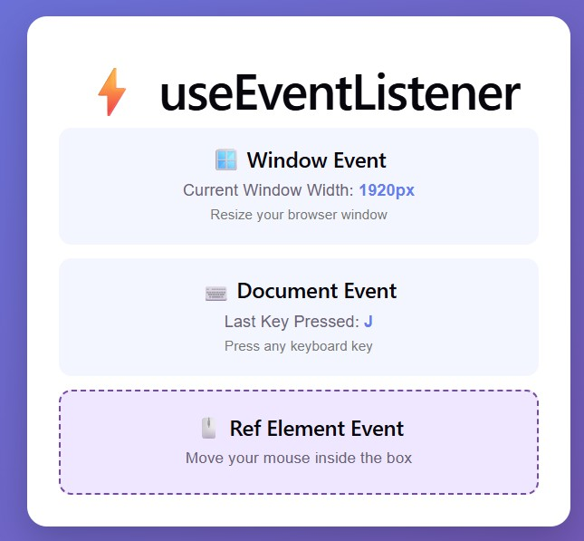

Problem Understanding & Approach  (10) | Implementation & Execution (15) | Tool/Technology Usage  (10) | Code Quality & Documentation  (5) | Viva (5) | Time Management (5) | Total (50)

Result:
Thus, the program using useState, useEffect, useContext, useCallback, useMemo, useRef and Customized Hooks is completed and the output is verified.

