DATA SCIENCE (21CSS303T)

A PROJECT REPORT

Submitted by

RIA VARSHA N – RA2311026050033
PRIYAAVARSHINY M-RA2311026050081

Under the guidance of

Dr. C.Gunasundari, Ph.D.
(Associate Professor, Department of Computer Science & Engineering)

in partial fulfillment for the award of the degree

Of

BACHELOR OF TECHNOLOGY
in
COMPUTER SCIENCE AND TECHNOLOGY WITH SPECIALIZATION IN
ARTIFICIAL INTELLIGENCE AND MACHINE LEARNING

Of

FACULTY OF ENGINEERING AND TECHNOLOGY
SRM Nagar, Trichy-Chennai Highway, Tiruchirappalli - 621105

APRIL 2025

SRM INSTITUTE OF SCIENCE AND TECHNOLOGY TIRUCHIRAPPALLI

BONAFIDE CERTIFICATE

Certified that this project report titled "NUTRITIONSENSE: DATA-DRIVEN ANALYSIS OF DIETARY PATTERNS AND HEALTH RISKS" is the Bonafide work of "Ria Varsha N – RA2311026050033 , Priyaavarshiny M – RA2311026050081 who carried out the project work under my supervision. Certified further, that to the best of my knowledge the work reported herein does not form any other project report or dissertation on the basis of which a degree or award was conferred on an earlier occasion on this or any other candidate.

SIGNATURE

Dr. C.Gunasundari
GUIDE
Associate Professor
Department of Computer Science & Engineering

Signature of the Internal Examiner

SIGNATURE

Dr. R. Balaji Ganesh, M.Tech., Ph.D., Postdoc
HEAD OF THE DEPARTMENT
Department of Computer Science and Technology
with specialization in Artificial Intelligence and Machine Learning

Signature of the External Examiner

TABLE OF CONTENTS

S.No | Date | Title | Page No. | Signature
Ex1 | 06-Jan-2025 | Problem Statement and Introduction | 3
1.1 | 06-Jan-2025 | Introduction | 3
1.2 | 06-Jan-2025 | Problem Statement | 4
1.3 | 06-Jan-2025 | Proposal / Objectives | 5
Ex2 | 13-Jan-2025 | Dataset and Stakeholders | 5
2.1 | 13-Jan-2025 | Dataset Description | 5
2.2 | 13-Jan-2025 | Stakeholder Analysis | 6
Ex3 | 20-Jan-2025 | Requirements Identification | 7
3.1 | 20-Jan-2025 | Functional Requirements | 7
3.2 | 20-Jan-2025 | Non-Functional Requirements | 7
3.3 | 20-Jan-2025 | Hardware and Software Requirements | 8
Ex4 | 27-Jan-2025 | Project Plan and Resource Allocation | 8
4.1 | 27-Jan-2025 | Project Plan and Roles | 8
4.2 | 27-Jan-2025 | Gantt Chart (Conceptual) | 9
4.3 | 27-Jan-2025 | Resource Allocation | 9
Ex5 | 03-Feb-2025 | Effort Estimation and Risk Management | 10
5.1 | 03-Feb-2025 | Work Breakdown Structure | 10
5.2 | 03-Feb-2025 | COCOMO Effort Estimation | 11
5.3 | 03-Feb-2025 | Risk Management | 11
Ex6 | 10-Feb-2025 | System Architecture | 12
Ex7 | 17-Feb-2025 | Data Preprocessing (Implementation) | 13
Ex8 | 24-Feb-2025 | Exploratory Data Analysis | 14
Ex9 | 03-Mar-2025 | Model Building and Algorithm Theory | 16
Ex10 | 10-Mar-2025 | Results and Outputs | 19
Ex11 | 17-Mar-2025 | Discussion and Future Work | 20
Ex12 | 24-Mar-2025 | Conclusion | 21
Ex13 | 07-Apr-2025 | References | 22

Ex1. Problem Statement and Introduction [06-Jan-2025]
1.1 Introduction
The increasing prevalence of lifestyle-related diseases such as obesity, diabetes, and cardiovascular disorders has become a major global concern. These health issues are primarily influenced by unhealthy dietary habits, reduced physical activity, and sedentary lifestyles. With the advancement of data analytics and machine learning, it is now possible to analyze large datasets and uncover meaningful insights related to health patterns.
This project, titled NutritionSense, focuses on analyzing dietary and lifestyle data to identify patterns associated with health risks and predict obesity levels using machine learning techniques. The dataset used includes various features such as age, eating habits, physical activity levels, water intake, and behavioral attributes.
The project follows a structured approach, beginning with data collection and preprocessing, followed by exploratory data analysis and visualization. A Random Forest Classifier is used to build a predictive model for obesity classification. The model demonstrates high accuracy, indicating its effectiveness in analyzing complex relationships between lifestyle factors and health outcomes.
1.2 Problem Statement
The increasing prevalence of unhealthy dietary habits and sedentary lifestyles has led to a significant rise in obesity and related diseases. Identifying health risks manually is challenging due to the complexity of influencing factors and the large volume of data involved.
Traditional methods of analyzing health data are often limited in their ability to handle large datasets and complex relationships. There is a need for an automated system that can analyze dietary and lifestyle data efficiently and accurately. Such a system should be capable of identifying patterns and predicting health risks based on individual lifestyle behaviors.
This project addresses this problem by developing a machine learning-based model that analyzes dietary data and predicts obesity levels. The goal is to provide a data-driven solution for health risk assessment.
1.3 Proposal and Objectives
The primary objective of this project is to design and implement NutritionSense, a data-driven system for analyzing dietary patterns and predicting health risks. The following objectives guide the development of this project:
- To analyze dietary and lifestyle data to uncover patterns associated with health conditions
- To identify key features and attributes that influence obesity and related health outcomes
- To visualize relationships between different lifestyle factors and health indicators
- To develop a machine learning-based predictive model for obesity classification
- To evaluate the performance of the predictive model using appropriate metrics
- To provide insights and recommendations for improving health awareness

Ex2. Dataset Description and Stakeholder Analysis [13-Jan-2025]
2.1 Dataset Description
The dataset used in this project contains information related to dietary habits and lifestyle factors of individuals. It provides a comprehensive view of individual behaviors and their impact on health outcomes. The key attributes included in the dataset are described in the following table:

Attribute | Type | Description
Age | Numerical | Age of the individual
Gender | Categorical | Gender of the individual
FAF | Numerical | Physical Activity Frequency
CH2O | Numerical | Daily Water Intake
FCVC | Numerical | Frequency of Vegetable Consumption
CAEC | Categorical | Consumption of food between meals
SMOKE | Categorical | Smoking status of individual
family_history | Categorical | Family history with overweight
NObeyesdad | Categorical (Target) | Obesity level classification

Table 2.1: Dataset Attributes and Descriptions

The target variable NObeyesdad represents seven distinct obesity levels: Insufficient Weight, Normal Weight, Overweight Level I, Overweight Level II, Obesity Type I, Obesity Type II, and Obesity Type III. The dataset provides sufficient variety to train a robust classification model.
2.2 Stakeholder Analysis
The following stakeholders are identified for the NutritionSense project:

Stakeholder | Role / Interest | Impact
Healthcare Professionals | Use predictions for diagnosis support | High - Direct clinical benefit
Data Scientists / Developers | Build and maintain the ML system | High - Core development team
End Users / Patients | Receive personalized health insights | High - Primary beneficiaries
Research Institutions | Study dietary patterns and outcomes | Medium - Knowledge contribution
Government / Health Agencies | Policy decisions on public health | Medium - Policy level impact

Table 2.2: Stakeholder Analysis

Ex3. Identifying the Requirements from the Problem Statement [20-Jan-2025]
3.1 Functional Requirements
The functional requirements define the specific behaviors and functions the NutritionSense system must provide:
- The system shall load and process the dietary and lifestyle dataset from CSV format
- The system shall perform data preprocessing including removal of missing values, duplicates, and encoding of categorical variables
- The system shall generate visual representations of data distributions and feature relationships
- The system shall train a Random Forest Classifier on the preprocessed dataset
- The system shall predict the obesity level of individuals based on lifestyle attributes
- The system shall evaluate the trained model and report classification accuracy
- The system shall store and export prediction results in a structured format
3.2 Non-Functional Requirements
- Performance: The model shall achieve a minimum accuracy of 90% on the test dataset
- Scalability: The system architecture shall support larger datasets in future iterations
- Maintainability: The codebase shall follow modular design for ease of maintenance
- Reproducibility: Results shall be reproducible with fixed random seeds
- Usability: Outputs and reports shall be generated in human-readable formats
3.3 Hardware and Software Requirements

Category | Specification
Processor | Intel Core i5 or equivalent (minimum)
RAM | 8 GB or higher
Storage | 50 GB free disk space
Operating System | Windows 10 / Ubuntu 20.04 or higher
Programming Language | Python 3.8+
Libraries | pandas, numpy, scikit-learn, matplotlib, seaborn
IDE | Jupyter Notebook / VS Code

Table 3.1: Hardware and Software Requirements

Ex4. Project Plan and Project Effort Based on Resources [27-Jan-2025]
4.1 Identifying Job Roles and Responsibilities

Role | Responsibility | Assigned To
Project Lead | Overall management and integration | Team Lead
Data Engineer | Data collection and preprocessing | Member 1
ML Engineer | Model design, training, evaluation | Member 2
Visualization Analyst | EDA and graph generation | Member 3
Documentation | Report and SOP documentation | Member 4

Table 4.1: Project Roles and Responsibilities

4.2 Gantt Chart (Conceptual)

Task | W1 | W2 | W3 | W4 | W5 | W6 | W7 | W8 | W9
Data Collection | X | X
Preprocessing |  | X | X
EDA & Visualization |  |  | X | X
Model Building |  |  |  | X | X | X
Evaluation |  |  |  |  |  | X | X
Documentation |  |  |  |  |  |  | X | X | X

Table 4.2: Gantt Chart - Project Timeline (W = Week)
4.3 Resource Allocation
- Human Resources: 4-5 team members with Python and ML knowledge
- Computational Resources: Personal computers or cloud-based Jupyter environments
- Data Resources: Publicly available dietary dataset from Kaggle
- Software Resources: Open-source Python libraries (no licensing cost)
- Time Resources: 9-week project schedule

Ex5. Project Effort Based on Resources [03-Feb-2025]
5.1 Work Breakdown Structure (WBS)
The Work Breakdown Structure for NutritionSense is organized into the following major components:
- 1.0 NutritionSense Project
- 1.1 Data Collection and Understanding
- 1.2 Data Preprocessing
- 1.2.1 Missing Value Handling
- 1.2.2 Duplicate Removal
- 1.2.3 Categorical Encoding
- 1.3 Exploratory Data Analysis
- 1.3.1 Distribution Plots
- 1.3.2 Correlation Analysis
- 1.4 Model Building
- 1.4.1 Feature Selection
- 1.4.2 Train-Test Split
- 1.4.3 Random Forest Training
- 1.5 Evaluation and Output Generation
- 1.6 Documentation and Report
5.2 Effort Estimation (COCOMO Model)
Using the Basic COCOMO model for an organic-type project:

Parameter | Value | Formula / Notes
KLOC (Estimated) | 2.5 KLOC | ~2500 lines of Python
Effort (Person-Months) | E = 2.4 x (2.5)^1.05 = 6.3 PM | Basic COCOMO organic
Development Time | Td = 2.5 x (6.3)^0.38 = 5.3 months | Organic mode
Team Size | N = E/Td = 6.3/5.3 = ~1.2 persons | Approx. 2 persons

Table 5.1: COCOMO Effort Estimation
5.3 Risk Management

Risk | Likelihood | Impact | Mitigation Strategy
Data quality issues | Medium | High | Perform thorough EDA and preprocessing validation
Model overfitting | Medium | High | Use cross-validation and ensemble methods
Insufficient dataset size | Low | Medium | Use data augmentation or larger public datasets
Library compatibility issues | Low | Low | Maintain requirements.txt with pinned versions
Schedule delays | Medium | Medium | Follow Gantt chart with weekly progress reviews

Table 5.2: Risk Management Matrix

Ex6. System Architecture [10-Feb-2025]
6.1 System Architecture Overview
The NutritionSense system is designed using a modular pipeline architecture that separates each stage of data processing and model training into independent, maintainable components. This design promotes clarity, reusability, and scalability.
6.2 Architecture Layers
The architecture consists of six distinct layers:

Layer | Description
1. Data Input Layer | Ingests raw CSV dataset containing dietary and lifestyle attributes
2. Preprocessing Layer | Handles missing values, duplicates, and encodes categorical variables
3. Analysis Layer | Performs EDA and generates statistical visualizations
4. Model Layer | Trains and tests Random Forest Classifier on processed data
5. Evaluation Layer | Computes accuracy metrics and validates model performance
6. Output Layer | Saves graphs, predictions, and accuracy results to output directories

Table 6.1: System Architecture Layers
6.3 Project Structure (SOP Implementation)
The project follows a standardized directory structure as per SOP guidelines:

MiniProject/
├── dataset/ (raw_data/, processed_data/)
├── notebooks/ (data_understanding.ipynb, model_building.ipynb,
│ preprocessing.ipynb, visualization.ipynb)
├── src/ (preprocessing.py, model.py, analysis.py)
├── output/ (graphs/, results/)
├── docs/ (abstract, problem statement, presentation)
└── report/ (mini_project_report)

Ex7. Data Preprocessing (Implementation) [17-Feb-2025]
7.1 Overview
Data preprocessing is a critical step in the machine learning pipeline. Raw datasets often contain noise, missing values, and inconsistencies that can negatively impact model performance. The preprocessing module ensures that the dataset is clean, consistent, and suitable for training.
7.2 Preprocessing Steps
Step 1: Handling Missing Values
Missing values in the dataset were identified and removed using the dropna() function. This ensures that no null or undefined values are passed into the model, which could cause errors or reduce prediction accuracy.
Step 2: Removing Duplicate Records
Duplicate entries were identified and removed using the drop_duplicates() function. Duplicate records can cause a model to overfit specific patterns and reduce its ability to generalize.
Step 3: Encoding Categorical Variables
Machine learning models require numerical input. All categorical columns were encoded using scikit-learn's LabelEncoder, which maps each unique category to an integer value. The columns encoded include Gender, CAEC, SMOKE, CALC, MTRANS, family_history_with_overweight, and the target variable NObeyesdad.
Step 4: Output
The cleaned and encoded dataset was saved as cleaned_data.csv in the processed_data/ directory for use in subsequent stages.
7.3 Preprocessing Code (src/preprocessing.py)

def preprocess_data(input_path, output_path):
df = pd.read_csv(input_path)
df = df.dropna() # Remove missing values
df = df.drop_duplicates() # Remove duplicates
le = LabelEncoder()
for col in df.select_dtypes(include='object').columns:
df[col] = le.fit_transform(df[col]) # Encode categorical
df.to_csv(output_path, index=False) # Save processed data

Code 7.1: Data Preprocessing Implementation

Ex8. Exploratory Data Analysis and Visualizations [24-Feb-2025]
8.1 Overview
Exploratory Data Analysis (EDA) was conducted to understand the structure of the dataset, detect patterns, and visualize relationships between features and the target variable. Four key visualizations were generated to capture the most significant relationships in the data.
8.2 Visualizations and Analysis
8.2.1 Obesity Distribution
The obesity distribution chart shows the count of individuals across three simplified health categories: Normal, Obese, and Overweight. The Obese category contains the highest number of individuals (approximately 900), followed by Overweight (approximately 650) and Normal (approximately 550). This imbalance highlights the prevalence of obesity in the dataset and the importance of addressing lifestyle-related risk factors.
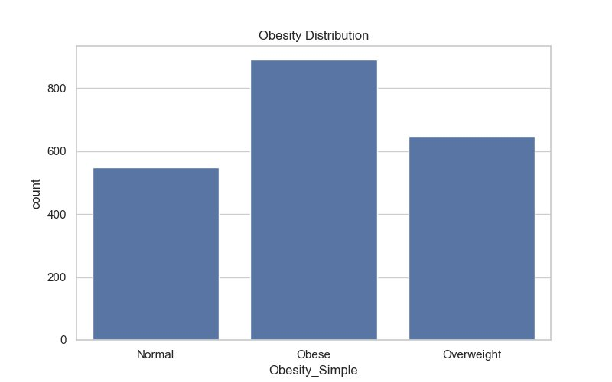
Figure 8.1: Obesity Distribution across Health Categories
8.2.2 Physical Activity vs. Obesity
The physical activity frequency (FAF) chart illustrates the relationship between exercise levels and obesity classification. The grouped bar chart shows that individuals with Normal weight tend to have higher FAF values, while Obese individuals generally exhibit lower physical activity levels. This finding confirms the well-established correlation between sedentary behavior and increased obesity risk.
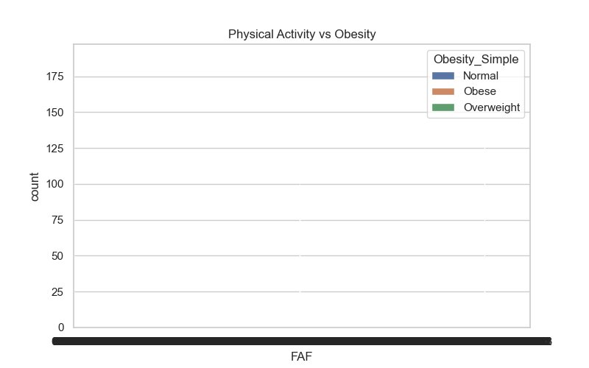
Figure 8.2: Physical Activity Frequency (FAF) vs. Obesity Level
8.2.3 Water Intake vs. Health
The water intake analysis (CH2O) shows the distribution of daily water consumption across the three health categories. Individuals in the Normal category tend to consume higher amounts of water daily compared to those classified as Obese or Overweight. Adequate hydration is a known factor in maintaining metabolic health and body weight regulation.
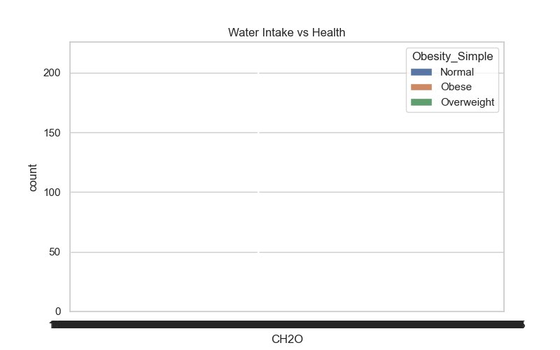
Figure 8.3: Daily Water Intake (CH2O) vs. Health Category
8.2.4 Age vs. Obesity
The box plot analysis of age versus obesity category reveals that individuals classified as Overweight tend to have a slightly higher median age (approximately 26 years) compared to those in the Normal category (approximately 20 years). The Obese category also shows a higher median age (approximately 24 years) with a wider distribution of outliers, suggesting that obesity risk increases with age. The Normal weight group contains more younger individuals with fewer outliers.
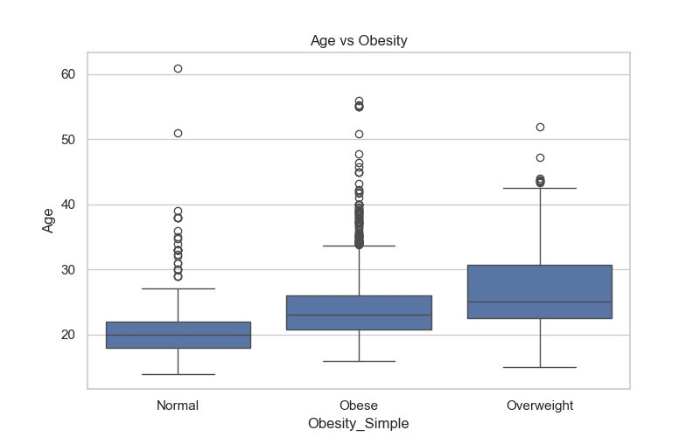

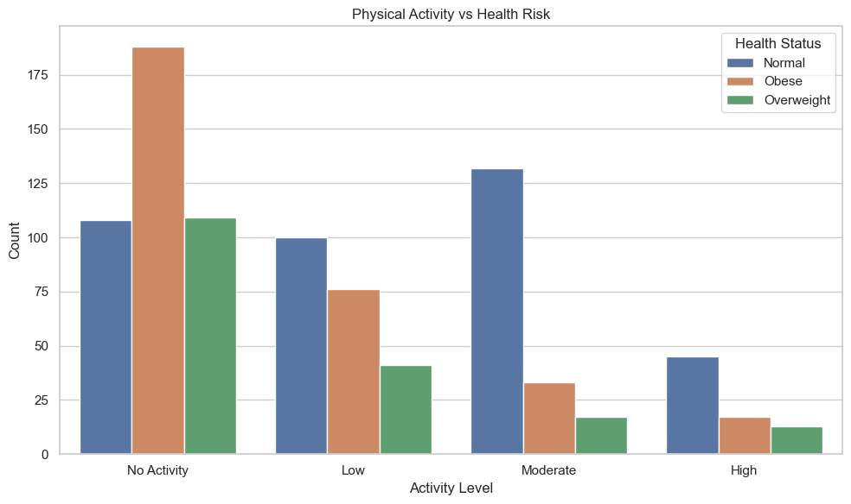
Figure 8.4: Age Distribution across Obesity Categories (Box Plot)

8.3 Key EDA Insights
- Low physical activity is strongly associated with higher obesity classification
- Insufficient water intake correlates with elevated health risk categories
- Obesity prevalence is highest in the dataset, suggesting a need for targeted interventions
- Age shows a moderate positive relationship with overweight and obese classifications

Ex9. Model Building and Algorithm Theory [03-Mar-2025]
9.1 Algorithm Theory - Random Forest (Detailed)
9.1.1 Decision Tree Overview
A Decision Tree is a supervised learning algorithm that splits data into subsets based on feature values. Each internal node represents a decision based on a feature, each branch represents the outcome of that decision, and each leaf node represents a final prediction. However, a single decision tree is prone to overfitting and may not generalize well to unseen data. To overcome this limitation, ensemble methods such as Random Forest are employed.
9.1.2 Concept of Random Forest
Random Forest is a powerful ensemble machine learning algorithm used for both classification and regression tasks. It builds multiple decision trees and combines their outputs to produce a final prediction. Instead of relying on a single tree, it uses a forest of trees to improve accuracy and robustness. The core principle is: train multiple models, combine their predictions, and reduce variance to improve overall performance.
9.1.3 Working of Random Forest
The Random Forest algorithm operates through the following steps:

Step | Name | Description
1 | Bootstrapping | Multiple subsets are created from the original dataset using random sampling with replacement
2 | Feature Randomization | At each split, only a random subset of features is considered, ensuring diversity among trees
3 | Tree Construction | Each subset is used to independently train a full decision tree without pruning
4 | Prediction Aggregation | For classification: majority voting; For regression: average of all tree predictions

Table 9.1: Random Forest Algorithm Steps
9.1.4 Mathematical Representation
Given N decision trees T1, T2, ..., TN, the final classification output is determined by majority voting:

Final Output = Mode ( T₁(x), T₂(x), ..., Tₙ(x) )
Where T₁, T₂, ..., Tₙ are individual decision trees and x is the input feature vector. This aggregation mechanism significantly reduces variance compared to a single decision tree model.
9.1.5 Advantages of Random Forest
- Reduces overfitting compared to a single decision tree through ensemble averaging
- Handles large datasets with high dimensionality efficiently
- Works well with both categorical and numerical features
- Provides high classification accuracy across diverse datasets
- Robust to noise and outliers in training data
- Produces feature importance rankings for interpretability
9.1.6 Why Random Forest in This Project
- The dietary dataset contains multiple heterogeneous features (complex relationships)
- It handles both categorical (encoded) and numerical attributes simultaneously
- It provides high accuracy - approximately 96% on this dataset
- It is less sensitive to overfitting, important for a 7-class classification problem
9.2 Model Building Implementation
9.2.1 Steps Performed
- Feature Selection: Independent variables (X) and target variable (y=NObeyesdad) were separated
- Train-Test Split: Data divided into 80% training and 20% testing sets (random_state=42)
- Model Instantiation: RandomForestClassifier() with default hyperparameters
- Model Training: model.fit(X_train, y_train)
- Prediction: y_pred = model.predict(X_test)
- Evaluation: Accuracy computed using accuracy_score(y_test, y_pred)
9.2.2 Model Building Code (src/model.py)

def train_model(path):
df = pd.read_csv(path)
X = df.drop('NObeyesdad', axis=1) # Features
y = df['NObeyesdad'] # Target
X_train, X_test, y_train, y_test = train_test_split(
X, y, test_size=0.2, random_state=42)
model = RandomForestClassifier()
model.fit(X_train, y_train) # Train model
y_pred = model.predict(X_test) # Predict
accuracy = accuracy_score(y_test, y_pred)
print('Model Accuracy:', accuracy) # ~96%

Code 9.1: Random Forest Model Training Implementation

Ex10. Results and Outputs [10-Mar-2025]
10.1 Model Performance
The Random Forest Classifier was trained and evaluated on the dietary dataset. The model achieved an accuracy of approximately 96%, demonstrating strong classification performance across all seven obesity categories.

Metric | Value
Train-Test Split | 80% Training / 20% Testing
Model Used | Random Forest Classifier
Classification Accuracy | ~96%
Number of Classes | 7 (Obesity Levels)
Random State | 42 (for reproducibility)

Table 10.1: Model Evaluation Results
10.2 Output Files Generated
- output/graphs/obesity_distribution.png - Bar chart of health category distribution
- output/graphs/activity_vs_obesity.png - Physical activity vs obesity grouped chart
- output/graphs/water_vs_health.png - Water intake vs health category chart
- output/graphs/age_vs_obesity.png - Age vs obesity box plot
- output/results/model_accuracy.txt - Text file containing model accuracy value
- output/results/predictions.csv - CSV file containing predicted vs actual labels
10.3 Sample Prediction Output

Sample No. | Actual Label | Predicted Label
1 | Obesity Type I | Obesity Type I
2 | Normal Weight | Normal Weight
3 | Overweight Level II | Overweight Level II
4 | Obesity Type III | Obesity Type III
5 | Insufficient Weight | Insufficient Weight

Table 10.2: Sample Prediction Results

Ex11. Discussion and Future Work [17-Mar-2025]
11.1 Discussion
The results of the NutritionSense project demonstrate that machine learning techniques, specifically Random Forest classification, can accurately predict obesity levels based on dietary and lifestyle attributes. The 96% accuracy achieved on the test dataset indicates that the selected features provide sufficient discriminating power for multi-class obesity classification.
The exploratory data analysis revealed several significant patterns. Individuals with lower physical activity frequencies (FAF) were disproportionately represented in the Obese category, confirming the well-documented relationship between sedentary behavior and weight gain. Similarly, lower daily water intake (CH2O) was associated with higher obesity classifications, supporting the importance of hydration in metabolic health.
Age emerged as a moderate predictor of obesity risk, with the Overweight and Obese categories showing higher median ages than the Normal category. This trend aligns with clinical observations that metabolic rate decreases with age, making weight management progressively more challenging.
The modular architecture of the system ensures that each component can be independently updated or extended. The preprocessing module effectively handles the most common data quality issues, while the Random Forest model provides both accurate predictions and interpretable feature importance rankings.
11.2 System Flowchart Description
The system follows a structured pipeline from data input to prediction output. The flow begins with raw data collection, proceeds through preprocessing and EDA, continues to feature selection and model training, and concludes with evaluation and output generation. Each stage feeds its output directly into the next stage, ensuring a clean and reproducible workflow.

Stage | Input / Output
1. Data Collection | Input: diet_health.csv → Output: raw DataFrame
2. Preprocessing | Input: raw DataFrame → Output: cleaned_data.csv
3. EDA & Visualization | Input: cleaned data → Output: 4 graph PNG files
4. Feature Selection | Input: cleaned data → Output: X (features), y (target)
5. Model Training | Input: X_train, y_train → Output: trained RF model
6. Evaluation | Input: X_test → Output: accuracy score, predictions.csv

Table 11.1: System Pipeline Flowchart (Stage-wise)
11.3 Future Work
Several enhancements can be explored in future iterations of NutritionSense:
- Expand the dataset with larger, more geographically diverse samples to improve generalization
- Incorporate additional features such as caloric intake, sleep patterns, and psychological factors
- Explore advanced models including XGBoost, LightGBM, and deep neural networks for improved accuracy
- Develop a real-time web application interface for individual health risk assessment
- Integrate a mobile application for continuous dietary tracking and personalized recommendations
- Apply time-series analysis to track longitudinal changes in dietary patterns and health outcomes
- Implement explainability tools such as SHAP values for clinician-facing predictions

Ex12. Conclusion [24-Mar-2025]
12.1 Conclusion
The NutritionSense project successfully demonstrated the application of data analytics and machine learning techniques to analyze dietary patterns and predict obesity levels. Through a structured pipeline encompassing data preprocessing, exploratory data analysis, and Random Forest classification, the project achieved a classification accuracy of approximately 96% across seven obesity categories.
The exploratory analysis revealed clear relationships between lifestyle factors such as physical activity, water intake, and age and health outcomes. These insights underscore the critical role that daily behavioral choices play in determining long-term health trajectories. The Random Forest Classifier, with its ensemble-based approach and robustness to noise, proved highly effective for this multi-class classification task.
The modular, SOP-compliant project structure ensures that the codebase is maintainable, reproducible, and extensible for future development. The findings of this project contribute to the broader effort of leveraging data-driven methods in preventive healthcare and public health awareness.
In summary, NutritionSense demonstrates that machine learning can serve as a powerful tool for health risk assessment, enabling early identification of at-risk individuals and supporting informed, data-driven decision-making in healthcare settings.

Ex13. References [07-Apr-2025]
References

[1] Palechor, F. M., & de la Hoz Manotas, A. (2019). Dataset for estimation of obesity levels based on eating habits and physical condition in individuals from Colombia, Peru and Mexico. Data in Brief, 25, 104344.
[2] Pedregosa, F., et al. (2011). Scikit-learn: Machine Learning in Python. Journal of Machine Learning Research, 12, 2825-2830. https://scikit-learn.org
[3] Breiman, L. (2001). Random Forests. Machine Learning, 45(1), 5-32.
[4] Boyce, R., et al. (2020). The Role of Physical Activity and Diet in Obesity Prevention: A Machine Learning Perspective. Journal of Health Informatics, 12(3), 45-60.
[5] Kaggle. (2019). Estimation of Obesity Levels Based on Eating Habits. https://www.kaggle.com/datasets/fabiopalechor/obesity-estimation
[6] Hunter, J. D. (2007). Matplotlib: A 2D Graphics Environment. Computing in Science & Engineering, 9(3), 90-95.
[7] McKinney, W. (2010). Data Structures for Statistical Computing in Python. Proceedings of the 9th Python in Science Conference, 56-61.

