Report

In this report we are going to build a neural network of size 3-6-2 using numpy .

1. Importing all necessary libraries

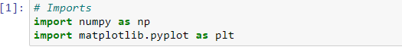

1. Now create our dataset i.e X and Y

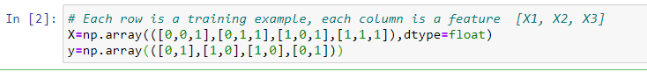

1. Let’s define useful functions that we are going to use

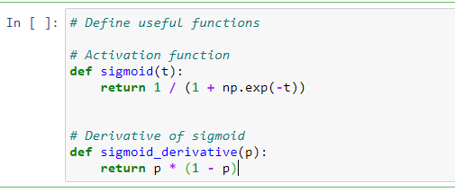

1. Let’s define our Neural Network class and let’s define our feedforward method , backprop, train and predict method inside this class

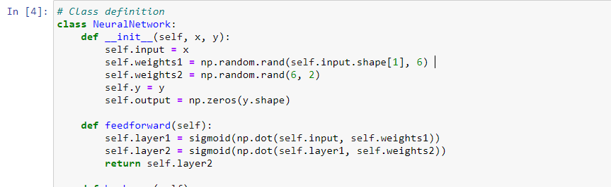

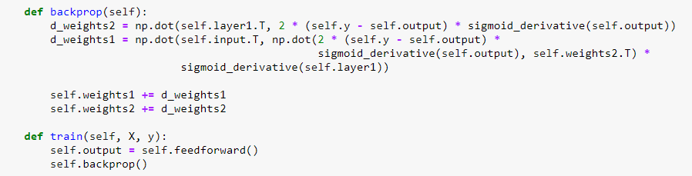

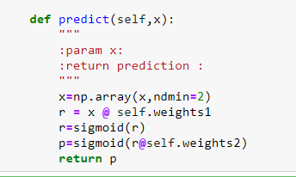

1. Ler’s train our NeuralNetwork for 1500 epochs

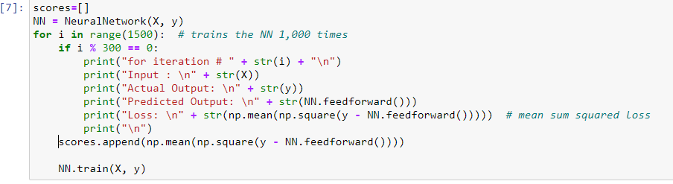

1. Let’s plot the loss versus epochs

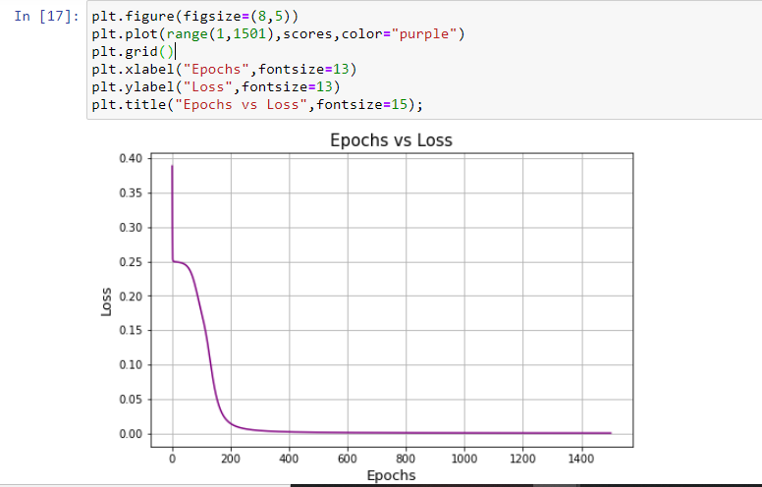

1. Let's see the weights of the neural network

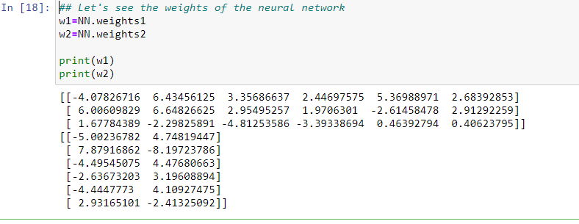

1. Let's make prediction for our new data

