**PROGRAM-1**   
**CODE:**   
**HTML FILE:**   
<!DOCTYPE html>   
<html lang="en">   
<head>   
 <meta charset="UTF-8">   
 <meta name="viewport" content="width=device-width, initial-scale=1.0"> <title>Priyan - Portfolio</title>   
 <link rel="stylesheet" href="styles.css">   
</head>   
<body>   
 <div class="total">   
 <header >   
 <h1>Portfolio</h1>   
 <nav>   
 <ul>   
 <li><a href="index.html">Home</a></li>   
 <li><a href="about.html">About</a></li>   
 <li><a href="portfolio.html">Portfolio</a></li>   
 <li><a href="contact.html">Contact</a></li>   
 </ul>   
 </nav>   
 </header>   
 <section class="hero">   
 <div class="hero-content">

<h2 style="font-size: 40px; float: left;">Hi Everyone!</h2><br>   
 <h3 style="font-size: 60px; margin: 0px; float: left;">This is Priyadarshan B</h3><br/>   
 <h3 style="font-size: 40px; margin: 0px; float: left;">Full Stack Developer</h3>

</div>   
 <div class="portfolio-image">   
 <img src="photo.jpg" alt="Your Name" class="rounded-image" height="200px" width="200px">   
 </div>   
 </section>   
 <footer>   
 <p>&copy; 2024 Priyan. All rights reserved.</p>   
 </footer>   
 </div>   
</body>   
</html>

**CSS FILE:**   
body, h1, h2, p, ul, li {   
 margin: 0;   
 padding: 0;   
}   
html{   
 height: 100vh;   
}   
body {

background-color: #f0f0f0;   
height: 100vh;   
}   
header {   
 background-color: #cdcdcd;   
 color: #000000;   
 padding: 20px;   
 display: flex;   
 flex-wrap: nowrap;   
 align-content: center;   
 align-items: center;   
 justify-content: space-between;   
}   
header h1 {   
 font-size: 24px;   
}   
nav ul {   
 list-style-type: none;

}   
nav ul li {   
 display: inline;   
 margin-right: 20px;   
}   
nav ul li a {   
 color: #000000;

text-decoration: none;   
 font-size: larger;   
}   
.hero {   
 text-align: center;   
 padding: 50px 0;   
}   
footer {   
 background-color: #cdcdcd;   
 color: #000000;   
 padding: 20px;   
 text-align: center;   
}   
.footer p {   
 margin: 0;   
}   
.hero {   
 position: relative;   
 background-image: url('wp7453794.webp');   
 background-size: cover;   
 background-position: center;   
 padding: 100px 0;   
 text-align: center;   
 color: #fff;   
 display: flex;   
 align-items: center;

justify-content: space-around;   
 opacity: 0.9;   
 height: 56vh;   
 }   
.hero::after {   
 content: '';   
 position: absolute;   
 top: 0;   
 left: 0;   
 width: 100%;   
 height: 100%;   
 background-color: rgba(0, 0, 0, 0.5);   
 z-index: -1;   
}   
.hero-content {   
 z-index: 1;   
}   
.rounded-image {   
 border-radius: 50%;   
 max-width: 100%;   
}

**OUTPUT:**

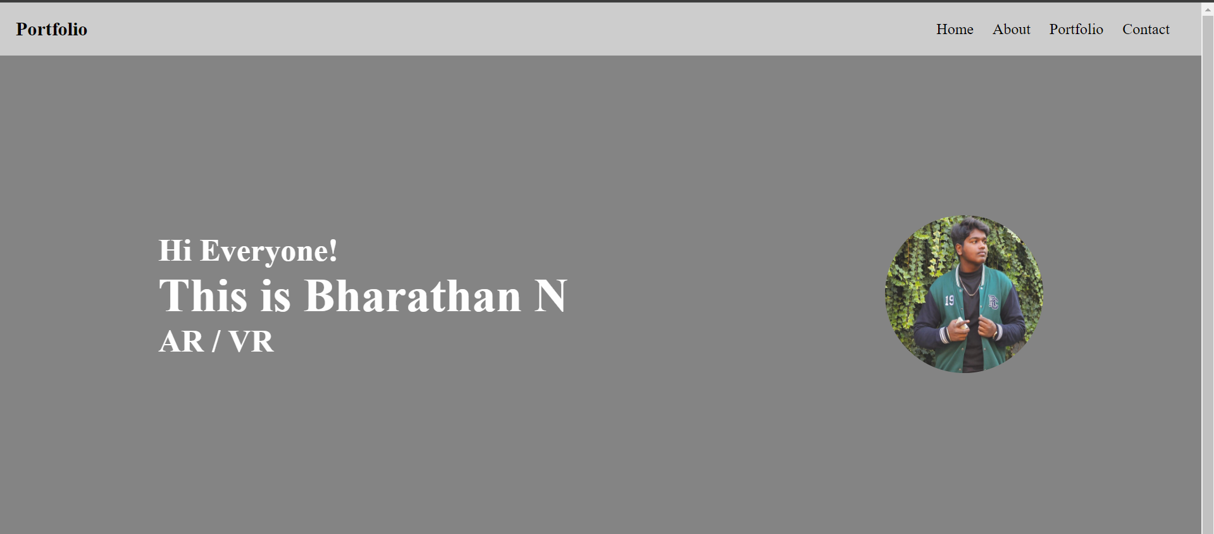

**PROGRAM-2**

**CODE:**   
**HTML FILE:**   
<!DOCTYPE html>   
<html lang="en">   
<head>   
 <meta charset="UTF-8">   
 <meta name="viewport" content="width=device-width, initial-scale=1.0">   
 <title>RPS game updated using Objects in JS</title>   
 <link rel="stylesheet" href="game.css">   
</head>   
<body>   
 <div class="container">   
 <h2 class="title">Rock Paper Scissors</h2>   
 <button class="move-button" onclick="   
 playGame('Rock');   
 "><img src="images/rock-emoji.png" alt="Rock" class="rock-image image"></button> <button class="move-button" onclick="   
 playGame('Paper');   
 "><img src="images/paper-emoji.png" alt="Paper" class="paper-image image"></button> <button class="move-button" onclick="   
 playGame('Scissors')   
 "><img src="images/scissors-emoji.png" alt="Scissors" class="scissors-image   
image"></button>   
 <p class="js-score"></p>   
 <p class="js-result"></p>   
 <p class="js-moves"></p>   
 <button class="reset-score-button" onclick="

score.wins = 0;   
 score.losses = 0;   
 score.ties = 0;   
 localStorage.removeItem('score');   
 updateScore();   
 ">   
 Reset score   
 </button>   
 </div>   
 <script src="game.js"></script>   
</body>   
</html>

**JAVASCRIPT FILE:**   
let score = JSON.parse(localStorage.getItem('score')) || { wins: 0, losses: 0, ties: 0 } updateScore();   
function playGame(playerMove) {   
 const computersMove = pickComputersMove();   
 let results = '';   
 if (playerMove === 'Rock') {   
 if (computersMove === 'rock') {   
 results = 'both tie';   
 } else if (computersMove === 'paper') {   
 results = 'you lose';   
 } else if (computersMove === 'scissors') {   
 results = 'you win';

}   
} else if (playerMove === 'Paper') {   
if (computersMove === 'rock') {   
results = 'you win';   
} else if (computersMove === 'paper') {   
results = 'both tie';   
} else if (computersMove === 'scissors') {   
results = 'you lose';   
}   
} else if (playerMove === 'Scissors') {

if (computersMove === 'rock') {   
results = 'you lose';   
} else if (computersMove === 'paper') {   
results = 'you win';   
} else if (computersMove === 'scissors') {   
results = 'both tie';   
}   
}   
if (results === 'you win') {   
score.wins += 1;   
} else if (results === 'you lose') {   
score.losses += 1;   
} else if (results === 'both tie') {   
score.ties += 1;   
}

localStorage.setItem('score', JSON.stringify(score));   
 updateScore();   
 document.querySelector('.js-result').innerHTML = ${results};   
 document.querySelector('.js-moves').innerHTML = `you : <img class="image"   
src="images/${playerMove}-emoji.png">, computer : <img class="image"   
src="images/${computersMove}-emoji.png"> `;   
}   
function updateScore() {   
 document.querySelector('.js-score').innerHTML = Wins : ${score.wins}, Losses : ${score.losses}, Ties : ${score.ties};   
}   
function pickComputersMove() {   
 let randomNumber = Math.random();   
 let computersMove = '';   
 if (randomNumber <= 1 / 3) {   
 computersMove = 'rock';   
 } else if (randomNumber > 1 / 3 && randomNumber <= 2 / 3) {   
 computersMove = 'paper';   
 } else if (randomNumber > 2 / 3) {   
 computersMove = 'scissors';   
 }   
 return computersMove;   
}

**CSS FILE:**

body {   
 color: white;

font-family: Arial, Helvetica, sans-serif;   
 display: grid;   
 place-items: center;   
 height: 100vh;   
}   
.container {   
 padding: 70px;   
 border-radius: 100px;   
 box-shadow: 10px 10px 20px rgb(66, 66, 66);   
 background-color: rgb(25, 25, 25);   
}   
.title {   
 font-size: 30px;   
 font-weight: 600;

}   
.image {   
 height: 50px;   
 background-color: transparent;   
}   
.move-button {   
 background-color: transparent;   
 border: 3px solid white;   
 width: 120px;   
 height: 120px;   
 border-radius: 10px;

margin-right: 10px;   
 cursor: pointer;   
}   
.js-score {   
 font-size: 25px;   
 font-weight: bold;   
 margin-top: 50px;   
}   
.score {   
 margin-top: 60px;   
}   
.reset-score-button {   
 background-color: rgba(243, 215, 0, 0.856);   
 border: none;   
 font-size: 15px;   
 padding: 8px 20px;   
 cursor: pointer;   
 border-radius: 10px;   
 font-weight: 600;   
 transition: all 0.3s;   
}   
.reset-score-button:hover {   
 background-color: rgba(243, 215, 0, 0.593);   
 border-radius: 10px;   
}

**OUTPUT:**

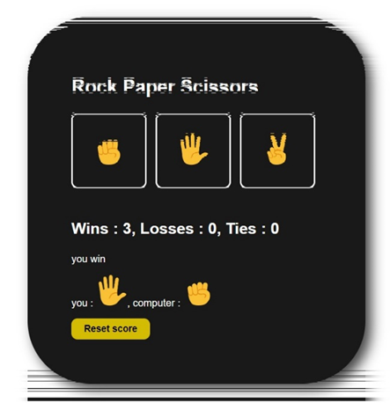

**PROGRAM-3**

**CODE:**

**Config.php**

<?php

$servername = "localhost";

$username = "root";

$password = "root";

$dbname = "qr_code_generator";

$conn = new mysqli($servername, $username, $password, $dbname);

if ($conn->connect_error) {

die("Connection failed: " . $conn->connect_error);

}

?>

**generate_qr_code.php**

<?php

require 'vendor/autoload.php';

use Endroid\QrCode\QrCode;

include 'config.php';

$id = $_GET['id'];

$sql = "SELECT * FROM products WHERE id = $id";   
$result = $conn->query($sql);

if ($result->num_rows > 0) {   
 while($row = $result->fetch_assoc()) {   
 $qrData = "Product ID: {$row['id']}\nProduct Name: {$row['name']}\nQuantity: {$row['quantity']}";   
 generateQRCode($qrData);   
 }   
} else {   
 echo "Product not found";   
}

function generateQRCode($data) {   
 $qrCode = new QrCode($data);   
 header('Content-Type: '.$qrCode->getContentType());   
 echo $qrCode->writeString();   
}

$conn->close();

?>   
**Index.php**   
<?php

require 'vendor/autoload.php';

use Endroid\QrCode\QrCode;

include 'config.php';

$id = $_GET['id'];

$sql = "SELECT * FROM products WHERE id = $id";   
$result = $conn->query($sql);

if ($result->num_rows > 0) {   
 while($row = $result->fetch_assoc()) {   
 $qrData = "Product ID: {$row['id']}\nProduct Name: {$row['name']}\nQuantity: {$row['quantity']}";   
 generateQRCode($qrData);   
 }   
} else {   
 echo "Product not found";   
}

function generateQRCode($data) {   
 $qrCode = new QrCode($data);   
 header('Content-Type: '.$qrCode->getContentType());   
 echo $qrCode->writeString();   
}

$conn->close();

?>

**Styles.css**   
body{   
 height: 90vh;   
 display: flex;   
 flex-direction: column;   
 justify-content: center;   
}   
.card{   
 padding: 20px;   
 width: 700px;   
 background-color: aliceblue;   
 border-top-right-radius: 100px;   
 border: 1px solid black;   
}   
**OUTPUT:**   
**PROGRAM-4**   
**CODE:**   
**App.py**

from flask import Flask, render_template, redirect, url_for, request, flash   
from flask_login import LoginManager, UserMixin, login_user, login_required, logout_user

app = Flask(_name_)   
app.secret_key = 'your_secret_key' # Replace with a secure secret key

login_manager = LoginManager()   
login_manager.init_app(app)   
login_manager.login_view = 'login'

class User(UserMixin):   
def _init_(self, id):   
self.id = id

@login_manager.user_loader   
def load_user(user_id):   
 return User(user_id)

@app.route('/')   
def home():   
 return redirect(url_for('login'))

@app.route('/login', methods=['GET', 'POST'])   
def login():   
 if request.method == 'POST':   
 username = request.form.get('username')   
 password = request.form.get('password')   
 # Here, you should verify the username and password against your database # For simplicity, we'll assume the user is always correct   
 user = User(1)   
 login_user(user)

return redirect(url_for('transactions'))   
return render_template('login.html')

@app.route('/logout')   
@login_required   
def logout():   
 logout_user()   
 return redirect(url_for('login'))

@app.route('/transactions', methods=['GET', 'POST'])   
@login_required   
def transactions():   
 if request.method == 'POST':   
 action = request.form.get('action')   
 amount = float(request.form.get('amount'))   
 if action == 'deposit':   
 # Simulate deposit   
 flash('Deposit successful!')   
 elif action == 'withdraw':   
 # Simulate withdrawal   
 flash('Withdrawal successful!')   
 return redirect(url_for('transactions'))   
 return render_template('transactions.html')

if _name_ == '_main_':   
 app.run(debug=True)

**Login.html**

<!DOCTYPE html>   
<html>   
<head>   
 <title>Login</title>   
 <link rel="stylesheet" href="styles.css"/>   
</head>   
<body>   
 <h1>Login</h1>   
 <form method="POST">   
 <label for="username">Username:</label>   
 <input type="text" id="username" name="username" required> <br>   
 <label for="password">Password:</label>   
 <input type="password" id="password" name="password" required> <br>   
 <input type="submit" value="Login">   
 </form>   
</body>   
<style>   
 body {   
 font-family: 'Arial', sans-serif;   
 margin: 0;   
 padding: 0;

display: flex;   
 flex-direction: column;   
 height: 100vh;   
 align-items: center;   
 background: linear-gradient(135deg, #f5f7fa 0%, #c3cfe2 100%); }

h1, h2 {   
 color: #007BFF;   
 text-align: center;   
 padding: 20px 0;   
}

form {   
 display: flex;   
 flex-direction: column;   
 align-items: center;   
 margin: 20px auto;   
 padding: 20px;   
 background-color: #ffffff;   
 border-radius: 10px;   
 box-shadow: 0px 0px 10px rgba(0, 0, 0, 0.1);   
 width: 80%;   
 max-width: 500px;   
}

input[type="number"] {   
 margin-bottom: 20px;   
 padding: 10px;   
 border: 1px solid #ddd;   
 border-radius: 5px;   
 width: 100%;   
}

input[type="submit"] {   
 padding: 10px 20px;   
 background-color: #007BFF;   
 color: white;   
 border: none;   
 border-radius: 5px;   
 cursor: pointer;   
}

input[type="submit"]:hover {   
 background-color: #0056b3;   
}

table {   
 width: 100%;   
 border-collapse: collapse;   
 margin-top: 20px;   
}

table, th, td {   
 border: 1px solid #ddd;   
 padding: 8px;   
 text-align: left;   
}

th {   
 background-color: #007BFF;   
 color: white;   
}

tr:nth-child(even) {   
 background-color: #f2f2f2;   
}

@media (max-width: 768px) {   
 form {   
 width: 90%;   
 }   
}

</style>   
</html>

**Transaction.html**

<!DOCTYPE html>   
<html>   
<head>   
 <title>Transactions</title>   
 <link rel="stylesheet" href="styles.css">   
</head>   
<body>   
 <h1>Transactions</h1>   
 <p>Welcome, {{ current_user.id }}!</p>   
 <h2>Deposit</h2>   
 <form method="POST">   
 <input type="hidden" name="action" value="deposit">   
 <label for="amount">Amount:</label>   
 <input type="number" id="amount" name="amount" required> <input type="submit" value="Deposit">   
 </form>   
 <h2>Withdraw</h2>   
 <form method="POST">   
 <input type="hidden" name="action" value="withdraw"> <label for="amount">Amount:</label>   
 <input type="number" id="amount" name="amount" required> <input type="submit" value="Withdraw">   
 </form>   
 <h2>Transaction History</h2>

<table>   
 <tr>   
 <th>Date</th>   
 <th>Action</th>   
 <th>Amount</th>   
 </tr>   
 <!-- Simulate transaction history -->   
 <tr>   
 <td>2023-04-01</td>   
 <td>Deposit</td>   
 <td>$100</td>   
 </tr>   
 <tr>   
 <td>2023-04-02</td>   
 <td>Withdraw</td>   
 <td>$50</td>   
 </tr>   
 </table>   
</body>   
<style>   
 body {   
 font-family: 'Arial', sans-serif;   
 margin: 0;   
 padding: 0;   
 display: flex;   
 flex-direction: column;

height: 100vh;   
 align-items: center;   
 background: linear-gradient(135deg, #f5f7fa 0%, #c3cfe2 100%); }   
h1, h2 {   
 color: #007BFF;   
 text-align: center;   
 padding: 20px 0;   
}   
form {   
 display: flex;   
 flex-direction: column;   
 align-items: center;   
 margin: 20px auto;   
 padding: 20px;   
 background-color: #ffffff;   
 border-radius: 10px;   
 box-shadow: 0px 0px 10px rgba(0, 0, 0, 0.1);   
 width: 80%;   
 max-width: 500px;   
}

input[type="number"] {   
margin-bottom: 20px;   
padding: 10px;   
border: 1px solid #ddd;

border-radius: 5px;   
 width: 100%;   
}

input[type="submit"] {   
 padding: 10px 20px;   
 background-color: #007BFF;   
 color: white;   
 border: none;   
 border-radius: 5px;   
 cursor: pointer;   
}   
input[type="submit"]:hover {   
 background-color: #0056b3;   
}   
table {   
 width: 100%;   
 border-collapse: collapse;   
 margin-top: 20px;   
}   
table, th, td {   
 border: 1px solid #ddd;   
 padding: 8px;   
 text-align: left;   
}   
th {

background-color: #007BFF;   
 color: white;   
}   
tr:nth-child(even) {   
 background-color: #f2f2f2;   
}   
@media (max-width: 768px) {   
 form {   
 width: 90%;   
 }   
}   
</style>   
</html>   
**OUTPUT:**

