**Project 2**

**ERD DIAGRAM**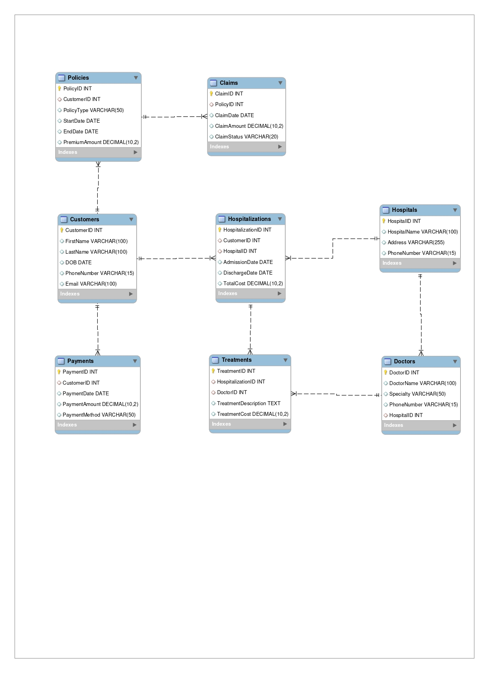

**About the Table**

**1. Customers Table:**

- Stores basic customer information such as `CustomerID`, `FirstName`, `LastName`, `DOB` (Date of Birth), `PhoneNumber`, and `Email`.

- `CustomerID` is the primary key, which uniquely identifies each customer.

**2. Policies Table:**

- Tracks the insurance policies owned by customers.

- `PolicyID` is the primary key for each policy.

- `CustomerID` is a foreign key that links each policy to a specific customer in the `Customers` table.

- Other columns include `PolicyType`, `StartDate`, `EndDate`, and `PremiumAmount`.

**3. Claims Table:**

- Manages claims made against insurance policies.

- `ClaimID` is the primary key.

- `PolicyID` is a foreign key linking each claim to a specific policy in the `Policies` table.

- Other fields include `ClaimDate`, `ClaimAmount`, and `ClaimStatus`.

**4. Payments Table:**

- Records payments made by customers.

- `PaymentID` is the primary key.

- `CustomerID` is a foreign key linking each payment to a customer in the `Customers` table.

- Fields include `PaymentDate`, `PaymentAmount`, and `PaymentMethod`.

**5. Hospitals Table:**

- Stores information about hospitals.

- `HospitalID` is the primary key.

- Other fields include `HospitalName`, `Address`, and `PhoneNumber`.

**6. Hospitalizations Table:**

- Tracks customer hospitalizations.

- `HospitalizationID` is the primary key.

- `CustomerID` is a foreign key linking each hospitalization to a customer in the `Customers` table.

- `HospitalID` is a foreign key linking each hospitalization to a hospital in the `Hospitals` table.

- Fields include `AdmissionDate`, `DischargeDate`, and `TotalCost`.

**7. Doctors Table:**

- Contains information about doctors.

- `DoctorID` is the primary key.

- `HospitalID` is a foreign key linking each doctor to a hospital in the `Hospitals` table.

- Fields include `DoctorName`, `Specialty`, and `PhoneNumber`.

**8. Treatments Table:**

- Records treatments administered during hospitalizations.

- `TreatmentID` is the primary key.

- `HospitalizationID` is a foreign key linking each treatment to a hospitalization in the `Hospitalizations` table.

- `DoctorID` is a foreign key linking each treatment to a doctor in the `Doctors` table.

- Fields include `TreatmentDescription` and `TreatmentCost`.

**CODE**

**Table Creation**

-- Customer Information Table

CREATE TABLE Customers (

CustomerID INT PRIMARY KEY AUTO_INCREMENT,

FirstName VARCHAR(100),

LastName VARCHAR(100),

DOB DATE,

PhoneNumber VARCHAR(15),

Email VARCHAR(100)

);

-- Policies Table

CREATE TABLE Policies (

PolicyID INT PRIMARY KEY AUTO_INCREMENT,

CustomerID INT,

PolicyType VARCHAR(50),

StartDate DATE,

EndDate DATE,

PremiumAmount DECIMAL(10, 2),

FOREIGN KEY (CustomerID) REFERENCES Customers(CustomerID)

);

-- Claims Table

CREATE TABLE Claims (

ClaimID INT PRIMARY KEY AUTO_INCREMENT,

PolicyID INT,

ClaimDate DATE,

ClaimAmount DECIMAL(10, 2),

ClaimStatus VARCHAR(20),

FOREIGN KEY (PolicyID) REFERENCES Policies(PolicyID)

);

-- Payments Table

CREATE TABLE Payments (

PaymentID INT PRIMARY KEY AUTO_INCREMENT,

CustomerID INT,

PaymentDate DATE,

PaymentAmount DECIMAL(10, 2),

PaymentMethod VARCHAR(50),

FOREIGN KEY (CustomerID) REFERENCES Customers(CustomerID)

);

-- Hospitals Table

CREATE TABLE Hospitals (

HospitalID INT PRIMARY KEY AUTO_INCREMENT,

HospitalName VARCHAR(100),

Address VARCHAR(255),

PhoneNumber VARCHAR(15)

);

-- Hospitalizations Table

CREATE TABLE Hospitalizations (

HospitalizationID INT PRIMARY KEY AUTO_INCREMENT,

CustomerID INT,

HospitalID INT,

AdmissionDate DATE,

DischargeDate DATE,

TotalCost DECIMAL(10, 2),

FOREIGN KEY (CustomerID) REFERENCES Customers(CustomerID),

FOREIGN KEY (HospitalID) REFERENCES Hospitals(HospitalID)

);

-- Doctors Table

CREATE TABLE Doctors (

DoctorID INT PRIMARY KEY AUTO_INCREMENT,

DoctorName VARCHAR(100),

Specialty VARCHAR(50),

PhoneNumber VARCHAR(15),

HospitalID INT,

FOREIGN KEY (HospitalID) REFERENCES Hospitals(HospitalID)

);

-- Treatments Table

CREATE TABLE Treatments (

TreatmentID INT PRIMARY KEY AUTO_INCREMENT,

HospitalizationID INT,

DoctorID INT,

TreatmentDescription TEXT,

TreatmentCost DECIMAL(10, 2),

FOREIGN KEY (HospitalizationID) REFERENCES Hospitalizations(HospitalizationID),

FOREIGN KEY (DoctorID) REFERENCES Doctors(DoctorID)

);

**Insert Queries**

-- Insert data into Customers table

INSERT INTO Customers (FirstName, LastName, DOB, PhoneNumber, Email)

VALUES

('John', 'Doe', '1980-05-15', '1234567890', 'john.doe@example.com'),

('Jane', 'Smith', '1990-07-22', '0987654321', 'jane.smith@example.com'),

('Emily', 'Davis', '1975-09-10', '1122334455', 'emily.davis@example.com'),

('Michael', 'Brown', '1985-12-05', '6677889900', 'michael.brown@example.com'),

('Sarah', 'Wilson', '1995-03-30', '4455667788', 'sarah.wilson@example.com');

-- Insert data into Policies table

INSERT INTO Policies (CustomerID, PolicyType, StartDate, EndDate, PremiumAmount)

VALUES

(1, 'Health Insurance', '2023-01-01', '2024-01-01', 12000.00),

(2, 'Health Insurance', '2023-02-15', '2024-02-15', 15000.00),

(3, 'Health Insurance', '2023-03-10', '2024-03-10', 13000.00),

(4, 'Health Insurance', '2023-04-25', '2024-04-25', 11000.00),

(5, 'Health Insurance', '2023-05-05', '2024-05-05', 14000.00);

-- Insert data into Claims table

INSERT INTO Claims (PolicyID, ClaimDate, ClaimAmount, ClaimStatus)

VALUES

(1, '2023-06-15', 5000.00, 'Approved'),

(2, '2023-07-20', 10000.00, 'Pending'),

(3, '2023-08-05', 7000.00, 'Rejected'),

(4, '2023-09-10', 3000.00, 'Approved'),

(5, '2023-10-15', 6000.00, 'Pending');

-- Insert data into Payments table

INSERT INTO Payments (CustomerID, PaymentDate, PaymentAmount, PaymentMethod)

VALUES

(1, '2023-01-01', 12000.00, 'Credit Card'),

(2, '2023-02-15', 15000.00, 'Debit Card'),

(3, '2023-03-10', 13000.00, 'Net Banking'),

(4, '2023-04-25', 11000.00, 'UPI'),

(5, '2023-05-05', 14000.00, 'Credit Card');

-- Insert data into Hospitals table

INSERT INTO Hospitals (HospitalName, Address, PhoneNumber)

VALUES

('City Hospital', '123 Main St', '5551234567'),

('Green Valley Hospital', '456 Elm St', '5559876543'),

('Sunshine Hospital', '789 Oak St', '5554567890'),

('Mountain View Hospital', '321 Pine St', '5556781234'),

('Riverdale Hospital', '654 Maple St', '5557890123');

-- Insert data into Hospitalizations table

INSERT INTO Hospitalizations (CustomerID, HospitalID, AdmissionDate, DischargeDate, TotalCost)

VALUES

(1, 1, '2023-06-10', '2023-06-15', 20000.00),

(2, 2, '2023-07-15', '2023-07-20', 30000.00),

(3, 3, '2023-08-01', '2023-08-05', 25000.00),

(4, 4, '2023-09-05', '2023-09-10', 15000.00),

(5, 5, '2023-10-10', '2023-10-15', 35000.00);

-- Insert data into Doctors table

INSERT INTO Doctors (DoctorName, Specialty, PhoneNumber, HospitalID)

VALUES

('Dr. Smith', 'Cardiology', '5551112222', 1),

('Dr. Johnson', 'Orthopedics', '5553334444', 2),

('Dr. Williams', 'Neurology', '5555556666', 3),

('Dr. Brown', 'Pediatrics', '5557778888', 4),

('Dr. Jones', 'General Medicine', '5559990000', 5);

-- Insert data into Treatments table

INSERT INTO Treatments (HospitalizationID, DoctorID, TreatmentDescription, TreatmentCost)

VALUES

(1, 1, 'Heart surgery', 15000.00),

(2, 2, 'Hip replacement', 20000.00),

(3, 3, 'Brain scan', 10000.00),

(4, 4, 'Childbirth', 8000.00),

(5, 5, 'General checkup', 5000.00);

**Permissions**

-- Grant access privileges to the policy manager

GRANT SELECT, INSERT, UPDATE, DELETE ON project.Policies TO 'policy_manager'@'localhost';

GRANT SELECT, INSERT, UPDATE, DELETE ON project.Claims TO 'policy_manager'@'localhost';

-- Grant access privileges to the customer support team

GRANT SELECT, INSERT, UPDATE ON project.Customers TO 'customer_support'@'localhost';

GRANT SELECT ON project.Payments TO 'customer_support'@'localhost';

-- Grant access privileges to the hospital administrator

GRANT SELECT, INSERT, UPDATE ON project.Hospitals TO 'hospital_admin'@'localhost';

GRANT SELECT, INSERT, UPDATE ON project.Hospitalizations TO 'hospital_admin'@'localhost';

-- Grant access privileges to the medical staff

GRANT SELECT ON project.Doctors TO 'medical_staff'@'localhost';

GRANT SELECT, INSERT ON project.Treatments TO 'medical_staff'@'localhost';

**Project Done By:**

**Divyank Harjani – 055010  
Priyadarshani Dash - 055037**