|  |  |  |  |  |  |  |  |  |  |  |  |  |
| --- | --- | --- | --- | --- | --- | --- | --- | --- | --- | --- | --- | --- |
|  | | **Hope Foundation’s**  **Finolex Academy of Management and Technology, Ratnagiri** | | | | | | | | | | |
| **Information Technology Department** | | | | | | | | | | |
| Subject name: DevOps Lab | | | | | | | | Subject Code: | | | | |
| Class | | BE IT | | Semester – VIII (CBCGS) | | | | | Academic year: 2019-20 | | | |
| Name of Student | | Priyadarshani Anil Satpute | | | | | **QUIZ Score :** | | | | | |
| Roll No | | 53 | | | Assignment/Experiment No. | | | | | | 02 | |
| **Title: Install and configure Jenkins with necessary plugin** | | | | | | | | | | | | |
|  | | | | | | | | | | | | |
| **1.Course objectives applicable**  **COB3**.  **COB6**. | | | | | | | | | | | | |
| **2. Course outcomes applicable:**  **CO2** -  **CO6**- | | | | | | | | | | | | |
| **3. Learning Objectives:**   1. To understand the CI/CD tool called Jenkins 2. To know the installations of Jenkins on Fedora 30 os. | | | | | | | | | | | | |
| **4. Practical applications of the assignment/experiment: To automate the several tasks such as automatic building the code ,deploying the code and notifying the developer about build status via sms/email etc** | | | | | | | | | | | | |
| **5. Prerequisites**:   1. Familar with Linux os 2. Internet Access 3. Knowledge of CI/CD | | | | | | | | | | | | |
| **6. Hardware Requirements**:   1. Internet Access with Browser 2. Access to root privileges   **7. Software Requirements:**  Browser like Chrome, Internet Explorer Edge | | | | | | | | | | | | |
|  | | | | | | | | | | | | |
| **8. Quiz Questions (if any): (Online Exam will be taken separately batchwise, attach the certificate/ Marks obtained)**   1. What is CI/CD? 2. What are the different CI/CD tools ? 3. What is the Jenkins? | | | | | | | | | | | | |
|  | | | | | | | | | | | | |
| **9. Experiment/Assignment Evaluation:** | | | | | | | | | | | | |
| **Sr. No.** | **Parameters** | | | | | | | | | **Marks obtained** | | **Out of** |
| **1** | Technical Understanding (Assessment may be done based on Q & A **or** any other relevant method.) Teacher should mention the other method used - | | | | | | | | |  | | 6 |
| **2** | Neatness/presentation | | | | | | | | |  | | 2 |
| **3** | Punctuality | | | | | | | | |  | | 2 |
| **Date of performance (DOP)** | | |  | | | **Total marks obtained** | | | |  | | **10** |
| **Date of checking (DOC)** | | |  | | | **Signature of teacher** | | | | | | |

**10.Theory-**

Jenkins is an open source automation server. With Jenkins, organizations can accelerate the software development process by automating it. Jenkins manages and controls software delivery processes throughout the entire lifecycle, including build, document, test, package, stage, deployment, static code analysis and much more.

**11. Installation Steps / Performance Steps –**

java -jar jenkins.war

1. The initial screen page will ask about the plugin options:

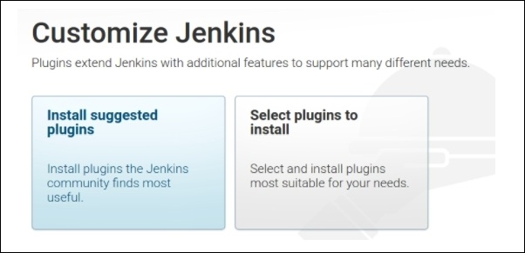

2. Plugins will be installed as per the selected configuration in the preceding

option:

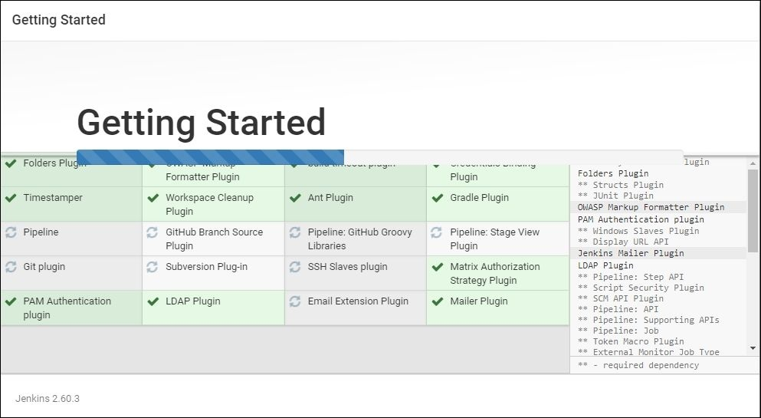

3. After successful installation, the following admin credential creation page

will pop up:

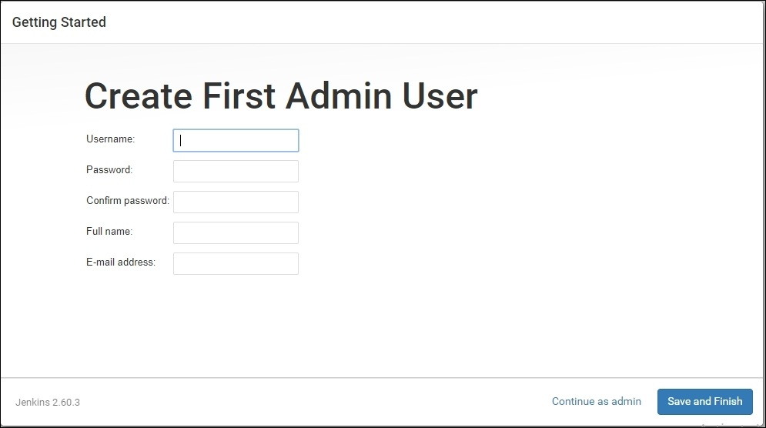

4. Accessing Jenkins: After successful installation, Jenkins can be accessed

through a web browser from your local machine as follows:http://localhost:8080

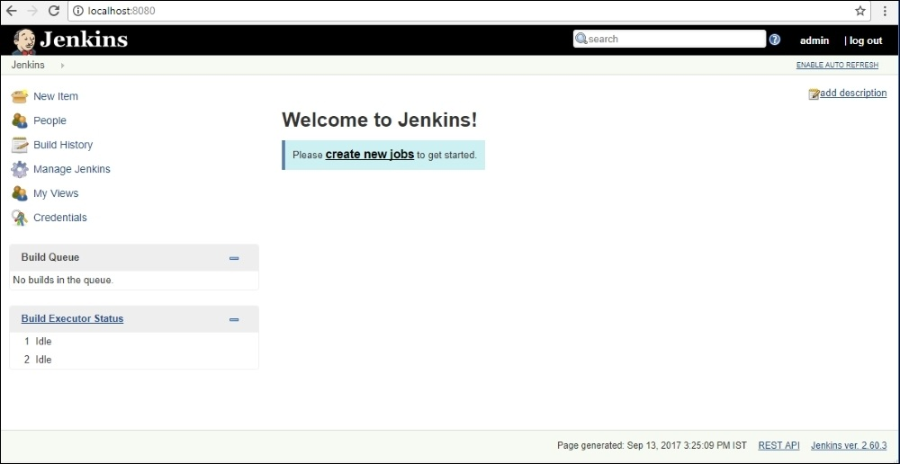

6. The Manage Jenkins option in the dashboard will provide various options

to configure various parameters

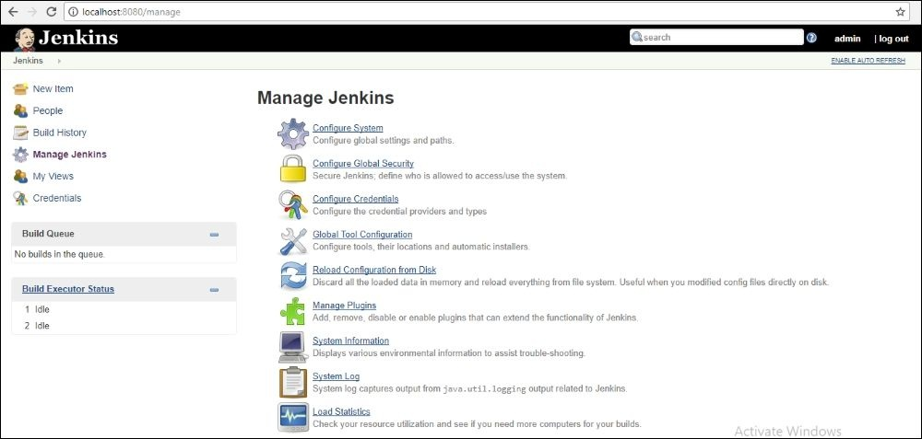

**12. Learning Outcomes Achieved.**

1.Student understood the installation process of Jenkins on Fedora 30.

2.Students understood the installations of Jenkins plugins.

3.Students understood the creating a simple project on Jenkins.

4.Students understood the removal of admin password in the event of forgot password.

**13. Conclusion:**

1. **Applications of the studied technique in industry**
   1. Jenkins are used to automate the tasks in the industry
   2. To send notifications to the developer about the build status
2. **Engineering Relevance** 
   1. Connecting Jenkins to the GitHub service
   2. To automate the continuous integration of various modules
3. **Skills Developed**
   1. Installations of Jenkins
   2. Installations of required plugins and enabling them.

**14.References:**

1.https://linuxconfig.org/how-to-install-jenkins-on-redhat-8

**2.https://www.ibm.com/cloud/learn/devops-a-complete-guide#toc-what-is-de-pMY50L7C**