Best Undertaking Review

1. Functionality
   1. If we remove/decrease load, then it shows reduced load in negatives suggesting that it is being reduced. This causes ambiguity whether total load is in negative. The way it is implemented should be changed. This appears to be a bug at first sight but it’s not. It’s for user to see how much load is decreased.

This field should be places separately to avoid confusion.

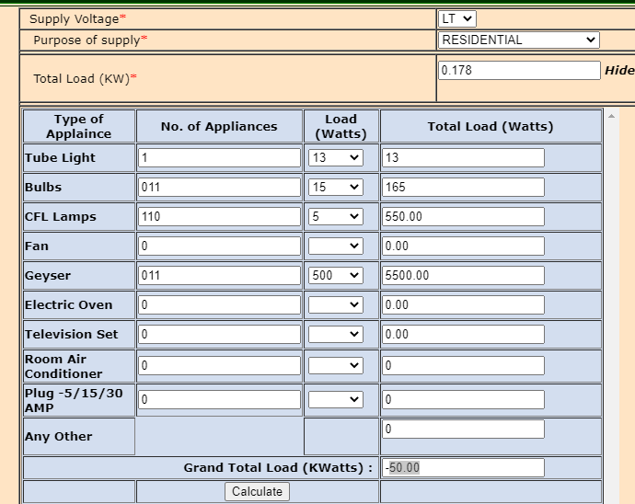

* 1. Upload photo- Only .jpg,.jpeg files should be accepted. There was no error after uploading .txt file

1. Usability
   1. UI could be simpler
   2. There is no uniformity in the format of the page. Alignment and Textboxes, Text Area, Dropdowns and Tables should be uniform in size.
   3. Confusing links: Home and Login Links are basically same page, so no need to provide two different buttons. (Download, Help docs, Notices)
   4. Apart from Headline, all other elements have same font size, it’s difficult for user to differentiate.
   5. View Photo and View Signature elements are bit confusing
   6. Consent is at two places: if purpose of those consents is different then it should be mentioned likewise.
   7. Help section should be easily accessible to user. It could be placed separately.
   8. User Friendly behavior is explained in UI aesthetics
2. UI Aesthetics
   1. Background color is not user-friendly.
   2. Connection Type could have been in dropdown
   3. All the links should be different color/underlined so that user could recognize easily that those are clickable links
   4. Size of all text area should be uniform
   5. The outer boxes () should not be that long
   6. Color combination should be better
   7. Heading is not I center aligned
   8. Some mobile devices with greater length see white space after the content
   9. Ununiform spacing e.g after Connection Details