Installation Guide

Login to AMM and go to the CATfx Module.

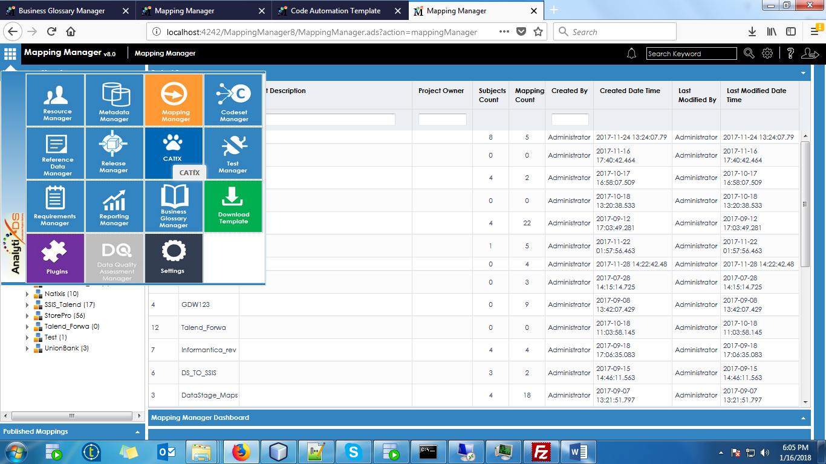

And then click on the Import icon available at Top Right Corner as shown below.



Click on Browse and select the CATfx then click on save.

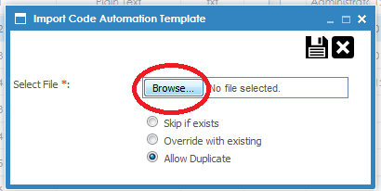

Click on the CATfx option button .



And then Provide the Following Information:

1). Username (Micro Strategy Server login user name)

2). Password (Micro Strategy Server login password)

3) Server IP (Micro Strategy Server IP)

4) Project Name (Micro Strategy Project Name)

5) Folder Name (Micro Strategy Project folder name)

6) Generate Template as Business Term (Radio button)

And then click on save icon as shown below.

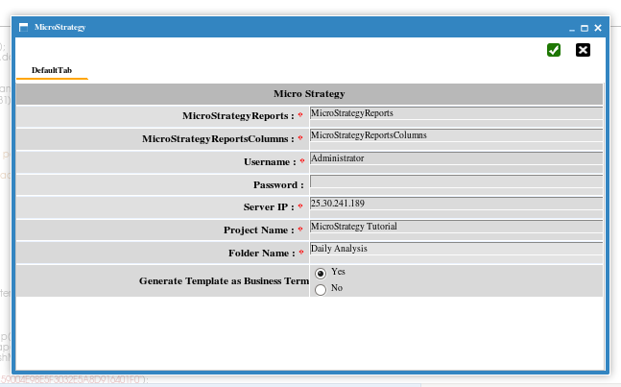

Open the CAT and click on RUN icon as shown below.

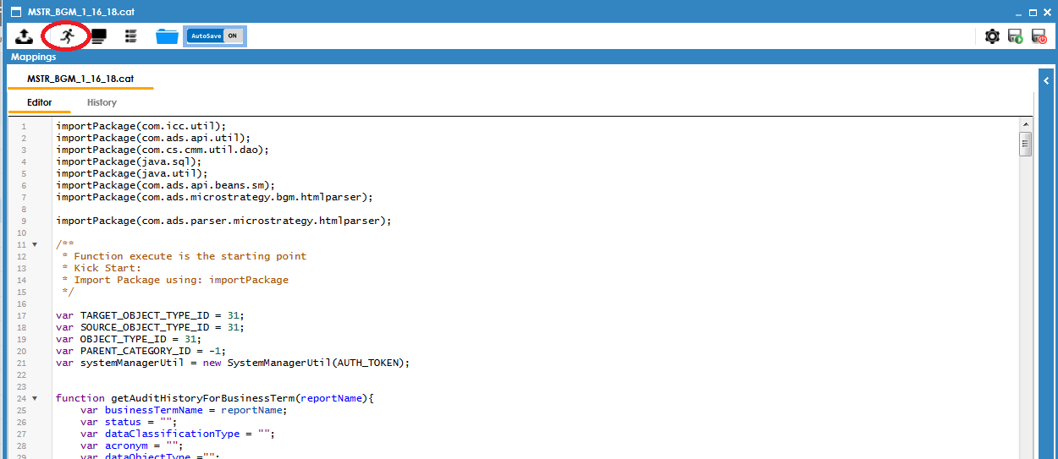

Now go to Business Glossary Module and Corresponding Business Terms Created with in the specified Catalog with specified Name.

