Data Modelling Phase I Hands-on
Order ID | Client name | Client address | Order Date | Delivery Status | Delivery Date | Contact Number | Email | Item name | Item price | Total cost
OI2 | Ara | Street B | 12-1-21 | Delivered | 2-2-21 | 98742 | abc@ac.in | DPhol | 23 | 122
OI3 | Aba | Street D | 12-2-21 | Payment Pending | NA | 11345 | def@ac.in | Antacid | 65 | 65
OI4 | Ara | Street B | 12-5-21 | Dispatched | NA | 98742 | abc@ac.in | TProd | 67 | 76
OI5 | Ava | Street C | 12-6-21 | Delivered | 2-2-21 | 6362 | efg@ac.in | Rex | 677 | 677
- Here is a table from a database that captures purchase details of a drug store. As you can see, this design causes redundancy of data. Help the store by creating a relational data model (logical) enabling an efficient table structure.

- Conceptual Model
- Create entities using the data available in the table using crow-foot notation.
- Establish relationships between the entities and define the cardinality.
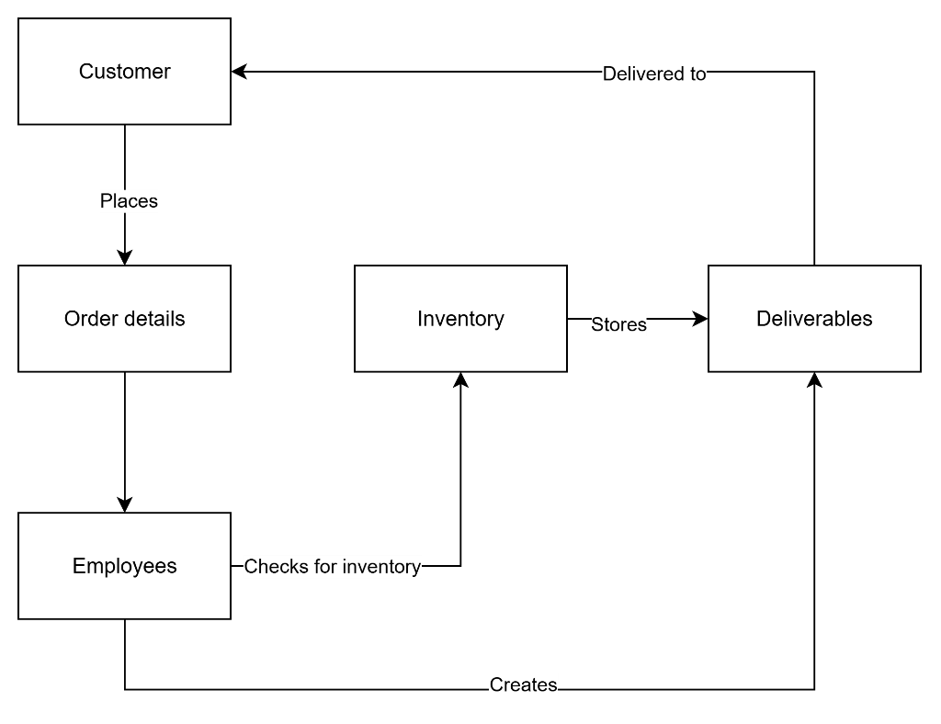

- Logical Model
- Add attributes to the entities (you can add attributes that are not mentioned in the table as well)
- Establish keys for the attributes enlisted.
- Look at how the data is captured and suggest modifications as a data modeler to implement better quality for data consumption.
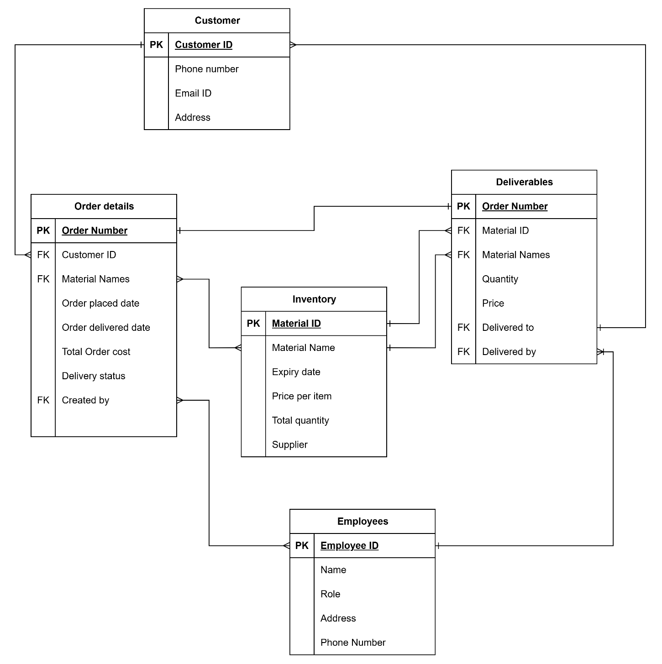

- Answer the following questions based on the schema available below.
Schema diagram for the Car Dealership relational database:
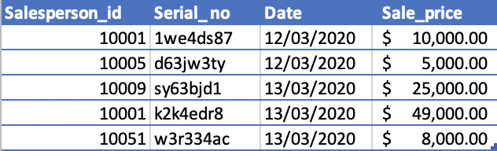
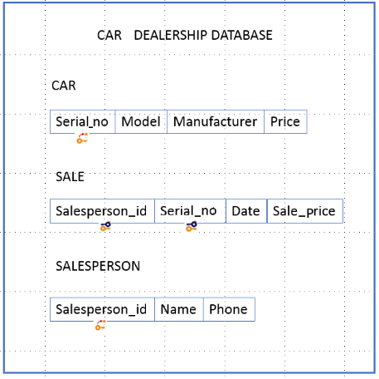

- How many relations (tables) does the Car Dealership database schema contain? - Three
- How many columns does the relation Car contain? - Four
- How many tuples does the relation Sale contain? Five

- What is the degree of the relation Salesperson? Three(Salesperson ID, Name, Phone)

- Identify the cardinality of the relation Sale. One Car can have one salesperson ; One salesperson can have many sales

- Identify the attributes of the relation Salesperson. Salesperson ID, Name, Phone

