**E-ATM Android App**

**About the App**

Developed using **Android Studio (Java) and Firebase**, this mobile banking solution enables users to perform essential ATM transactions remotely while ensuring top-notch security measures. With an intuitive interface and real-time data processing, the app transforms the way users interact with their bank accounts.

**Key Features**

✔ **Seamless Registration & Secure Login:** Users can create accounts with verified credentials, including email authentication and security questions.

✔ **Multi-layered Security:** PIN verification, OTP authentication, and security question validation ensure maximum account protection.

✔ **Comprehensive Banking Services:** Users can withdraw, deposit, transfer money, and check their balance securely.

✔ **PIN & Account Recovery:** Forgot your PIN? No worries! Reset it via OTP and by answering security questions.

✔ **Account Lock/Unlock:** Users can lock/unlock accounts instantly through OTP, PIN, or security questions, preventing unauthorized access.

**Technologies Used**

* **Android Studio**: IDE for app development using Java.
* **Firebase Authentication**: Secure login and registration.
* **Firebase Database**: Storing user and transaction data.

**Why This App Stands Out**

Unlike traditional ATMs, which require physical visits, this app provides **24/7 banking access** from any location. The integration of Firebase Realtime Database ensures instant transaction updates, while OTP-based security measures prevent unauthorized access, setting a new benchmark in digital banking. Also it enables user to lock their account if they find it useful for some circumstances through their OTP and answering security questions.

**How It Benefits Users**

🔹 **Convenience:** No more standing in ATM queues—banking is now just a tap away!

🔹 **Enhanced Security:** Eliminates risks of card theft, skimming, and unauthorized access.

🔹 **Financial Inclusion:** Empowers users in remote areas where ATM access is limited.

🔹 **Eco-Friendly:** Reduces dependency on paper-based receipts and statements.

**Future Enhancements**

As part of our commitment to innovation, we plan to integrate **biometric authentication (fingerprint, facial recognition)**, AI-driven fraud detection, and multi-bank support, making the app even more robust and user-friendly.

**Test Cases and Outcomes:**

**App Screenshots.**

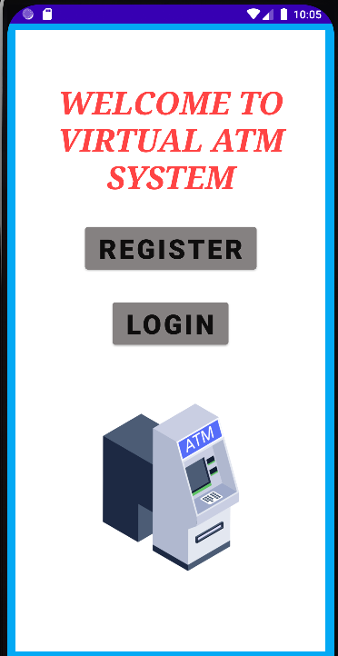

By : Priya Verma , 3122235001102, CSE ‘B’