VACCINATION DATA ANALYSIS
AND VISUALIZATION
Project Documentation
Public Health and Epidemiology • Python • EDA • SQL • Power BI

Project Type | EDA
Contribution | Individual
Member name | Priyadharshini .M
GitHub Repository | https://github.com/Priyadh1/vaccination_project
Power BI Dashboard | Power BI Desktop dashboard (.pbix) + final dashboard screenshot

1. Project Overview
This project focuses on analyzing vaccination coverage, disease incidence, reported cases, vaccine introduction, and vaccination schedule data. The data was cleaned and analyzed using Python, organized using SQL, and the main findings were presented through a Power BI dashboard.
The work was completed as an individual EDA project. The main aim was to understand vaccination patterns, disease burden, differences across countries and regions, and the relationship between vaccination coverage and disease incidence.

2. Problem Statement
Vaccination data is available from different sources and contains information at different geographic, disease, vaccine, and year levels. The data also contains missing values, aggregate records, different reporting categories, and some invalid numeric observations. The project therefore focuses on cleaning, organizing, and analyzing the data before presenting useful findings.

3. Objectives
- Understand the supplied vaccination datasets and their structure.
- Clean missing values, footer records, invalid numeric values, and inconsistent observations.
- Perform exploratory data analysis using Python.
- Study vaccination coverage, disease incidence, reported cases, and regional differences.
- Build a normalized SQLite database using dimension and fact tables.
- Create a Power BI dashboard with KPI cards, trends, comparisons, scatter analysis, geographic analysis, and slicers.
- Answer the project business and scenario questions using only information supported by the datasets.

4. Source Datasets
Dataset | Rows after footer removal | Columns | Years
Coverage | 399,858 | 11 | 1980–2023
Incidence Rate | 84,945 | 8 | 1980–2023
Reported Cases | 84,869 | 7 | 1980–2023
Vaccine Introduction | 138,320 | 6 | 1940–2023
Vaccine Schedule | 8,052 | 12 | 2019–2023

5. Data Cleaning and Quality Checks
The datasets were checked before analysis. Footer/metadata rows were removed structurally rather than treating them as normal observations. Missing values were measured and retained where they represented real data availability issues.
- No exact duplicate rows were found in the initial datasets.
- Eight negative dose values in the coverage data were flagged as invalid. The original values were preserved in DOSES_RAW and the analytical DOSES field was set to missing for those records.
- 5,097 coverage values above 100 were flagged. They were preserved rather than clipped because the project records were not altered without evidence.
- Coverage records include country and aggregate groups such as WHO regions and global records; these were not blindly mixed with country-level observations.
- Incidence measures use different denominators, so only compatible denominator definitions were used for the main correlation analysis.
- Missingness was reported as a data-quality characteristic instead of automatically filling values.

6. Exploratory Data Analysis
EDA was performed to understand the distributions and patterns in vaccination coverage, disease incidence, and reported cases. Country-level records were used for country comparisons, while aggregate records were retained separately.
Measure | Count | Mean | Median
Coverage | 211,710 | 80.7250 | 90.0
Incidence Rate | 58,909 | 111.2585 | 0.0
Reported Cases | 62,655 | 1,558.2819 | 0.0

The analysis also showed that raw reported case counts are strongly affected by population size and reporting structure, so raw case counts were not treated as a direct measure of disease risk.

7. Statistical and Correlation Analysis
For the main scientifically compatible association analysis, MCV1 vaccination coverage was paired with measles incidence using the incidence denominator 'per 1,000,000 total population'. Coverage values above 100 were excluded from this paired analysis.
Statistic | Value
Paired country-year observations | 7,280
Pearson correlation | -0.2144
Spearman correlation | -0.4870

The results show an inverse association between MCV1 coverage and measles incidence in the analyzed observations. This is an association only and does not establish causation.

8. SQL Database Design
A normalized SQLite database was created to organize the cleaned data into related tables. Reusable information was separated into dimension tables, while observations were stored in fact tables.
- Dimension tables: dim_country, dim_vaccine, dim_disease, dim_year.
- Fact tables: fact_coverage, fact_incidence, fact_cases, fact_vaccine_introduction, fact_vaccine_schedule.
- The database contains 214 countries, 86 vaccines, 13 diseases, and 84 years.
- Primary keys were checked for nulls and duplicates, and foreign-key integrity was validated.
- Aggregate observations were preserved using source-group information where needed.

9. Power BI Dashboard
The Power BI dashboard was created as the visualization layer of the project. The normalized SQLite tables were exported to CSV and loaded into Power BI Desktop because a SQLite ODBC driver was not available in the local Power BI environment. The CSV files are exact exports of the SQL tables; the SQLite database remains the official SQL deliverable.

Dashboard Output
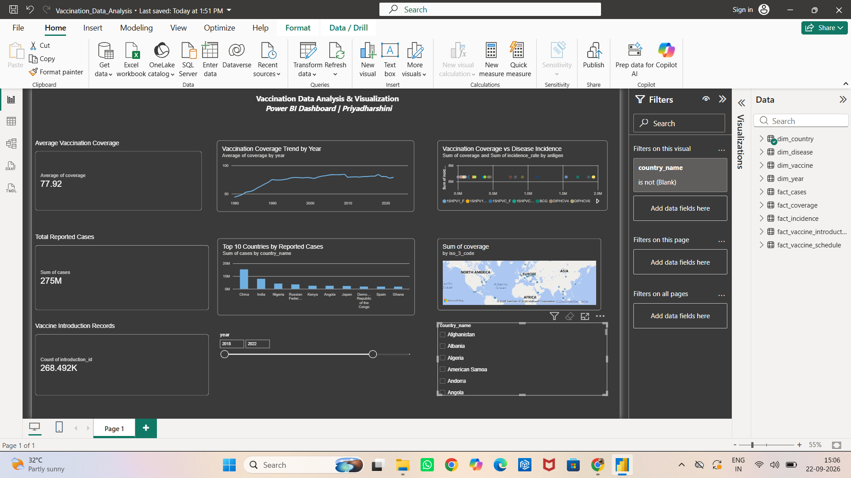
Figure 1. Final Power BI dashboard output (screenshot from Power BI Desktop).

Dashboard Components
- Average Vaccination Coverage – KPI card.
- Total Reported Cases – KPI card.
- Vaccine Introduction Records – KPI card.
- Vaccination Coverage Trend by Year – line chart.
- Top 10 Countries by Reported Cases – bar chart.
- Vaccination Coverage vs Disease Incidence – scatter visualization.
- Geographic coverage visualization – world/country-level map.
- Year slicer and Country slicer for filtering the report.
The dashboard uses a dark visual theme and combines the main KPIs and charts in one page so the project output can be understood quickly from the final screenshot.

10. Business Questions and Answers

Easy Questions
1. How do vaccination rates correlate with a decrease in disease incidence?
Answer: Higher MCV1 vaccination coverage was associated with lower measles incidence. The Pearson correlation was -0.2144 and the Spearman correlation was -0.4870.
2. What is the drop-off rate between 1st dose and subsequent doses?
Answer: Coverage generally decreases from the first dose to subsequent doses in the available dose-level data, showing a drop-off in later doses.
3. Are vaccination rates different between genders?
Answer: Gender information is not available in the supplied datasets, so this comparison cannot be analyzed.
4. How does education level impact vaccination rates?
Answer: Education-level information is not available in the supplied datasets, so its impact on vaccination rates cannot be analyzed.
5. What is the difference in vaccination rates between urban and rural areas?
Answer: Urban/rural information is not available in the supplied datasets, so this difference cannot be calculated.
6. Has booster dose uptake increased over time?
Answer: The data contains different dose observations across years, but a separate booster-specific trend was not established from the available fields.
7. Is there a seasonal pattern in vaccination uptake?
Answer: The data is annual rather than monthly, so a within-year seasonal pattern cannot be determined.
8. How does population density relate to vaccination coverage?
Answer: Population-density information is not available in the supplied datasets, so this relationship cannot be analyzed.
9. How do vaccination rates correlate with a decrease in disease incidence?
Answer: The available paired MCV1 and measles analysis shows an inverse association, with Pearson -0.2144 and Spearman -0.4870.
10. Which regions have high disease incidence despite high vaccination rates?
Answer: Regions can be compared using compatible coverage and incidence measures, while keeping the incidence denominator consistent. The result should be treated as an association, not proof of causation.

Medium Questions
1. What is the correlation between vaccine introduction and decrease in disease cases?
Answer: Vaccine introduction years can be compared with reported cases over time, but the available data does not support a causal conclusion about the decrease in cases.
2. What is the trend in disease cases before and after vaccination campaigns?
Answer: Cases can be compared around relevant time periods, but campaign-specific start dates and details are not provided in the datasets.
3. Which diseases showed the most significant reduction due to vaccination?
Answer: Disease trends can be compared across years, but the available data alone cannot attribute a reduction to vaccination as a causal effect.
4. What percentage of the target population has been covered by each vaccine?
Answer: Coverage values can be compared by vaccine where available, but missing target-population information limits a complete target-population percentage analysis.
5. How does vaccination schedule and booster dosing impact target population coverage?
Answer: The schedule dataset contains dose and target-population fields for some records, so schedule patterns can be compared with coverage where the fields are available.
6. What are the disparities in vaccine introduction timelines across WHO regions?
Answer: Vaccine introduction years vary across countries and WHO regions, so regional differences in introduction timing can be compared.
7. How does vaccine coverage correlate with disease reduction for specific antigens?
Answer: For MCV1 and measles, the paired analysis showed an inverse association: Pearson -0.2144 and Spearman -0.4870.
8. Which regions have low coverage despite high vaccine availability?
Answer: Introduction records can be compared with coverage as an availability proxy, but the datasets do not directly measure vaccine availability.
9. What are the coverage gaps for high-priority diseases such as TB and Hepatitis B?
Answer: Coverage gaps can be examined for represented vaccines and diseases, but coverage should not be interpreted as direct evidence of vaccine availability.
10. Are certain diseases more prevalent in specific geographic areas?
Answer: Reported cases and incidence vary across countries and regions, so geographic differences in disease burden can be examined.

Scenario Questions
1. Which regions have low vaccination coverage and should receive more resources?
Answer: WHO-region coverage can be compared to identify areas with lower coverage. These areas can be considered for further public-health review, but the data alone does not determine resource allocation.
2. How would you evaluate a measles vaccination campaign launched five years ago?
Answer: Compare measles incidence and MCV1 coverage before and after the relevant period. The datasets do not contain campaign-specific details, so the evaluation is descriptive.
3. How can vaccine demand for the upcoming year be estimated?
Answer: Historical target, dose, and coverage data can be used to describe past demand patterns, but the available data is not a validated forecasting model.
4. How would you respond to a sudden influenza outbreak?
Answer: Influenza incidence and reported cases can be reviewed by country and year, along with available vaccination coverage, to identify affected areas and coverage gaps.
5. Which areas have polio incidence where vaccination coverage is low or unavailable?
Answer: Polio incidence can be compared with compatible vaccination coverage by country and year to identify areas where both measures are available.
6. How can progress toward the WHO 95% measles coverage target by 2030 be evaluated?
Answer: Compare MCV1 coverage with the 95% target, calculate the gap from 95%, and track the gap across years toward 2030.
7. How should vaccines be allocated to children under five and elderly populations?
Answer: The schedule data contains some target-population information, but complete population counts for children under five and elderly groups are not available.
8. Are there disparities in vaccination rates between socioeconomic groups?
Answer: Socioeconomic-group information is not available in the supplied datasets, so this cannot be analyzed.
9. How do vaccination rates vary throughout the year?
Answer: The supplied data is annual, so monthly or seasonal variation within a year cannot be determined.
10. How do door-to-door and centralized vaccination strategies compare?
Answer: The datasets do not contain vaccination delivery strategy information, so these two approaches cannot be compared.

12. Key Findings
- Vaccination coverage shows variation across countries and years.
- Reported cases are highly uneven across countries and should be interpreted with population size and reporting context in mind.
- The compatible MCV1–measles paired analysis showed an inverse association, with Pearson -0.2144 and Spearman -0.4870.
- Several source fields contain substantial missingness, so missing values were retained and reported rather than automatically imputed.
- Coverage values above 100 and negative dose observations were explicitly flagged and handled transparently.
- Geographic and aggregate records require careful interpretation because not every observation represents a single country.

13. Limitations
- Several source fields have substantial missing data.
- Incidence denominators vary, so cross-measure comparisons require compatible denominators.
- Raw reported cases are not directly comparable across countries without considering population size and reporting differences.
- Some requested scenario variables such as gender, education, urban/rural status, population density, and monthly seasonality are not present.
- The local Power BI model uses CSV exports as a bridge from the normalized SQLite database.
- The Power BI scatter visualization is exploratory and should not be presented as proof of causation.

14. Project Deliverables
- Google Colab Notebook containing data inspection, cleaning, EDA, statistical analysis, and question answers.
- Normalized SQLite database: vaccination_database.db.
- Power BI Desktop report: Vaccination_Data_Analytics.pbix.
- CSV exports of the SQL tables used in Power BI.
- Five source Excel datasets.
- Final project documentation.
- GitHub repository containing the project files.
- Power BI dashboard screenshot.

15. GitHub Repository
Repository: github.com/Priyadh1/vaccination_project
The repository contains the project datasets, notebook/project files, SQL database, Power BI file, and CSV table exports used for the project backup.

16. Conclusion
This project focused on analyzing vaccination and disease-related data using Python, SQL, and Power BI. The data was cleaned and organized to make the analysis more reliable. Different vaccination coverage and disease-related trends were studied. The analysis also showed differences in vaccination coverage across countries and regions. The relationship between MCV1 vaccination coverage and measles incidence was also analyzed. The results showed an inverse association between MCV1 coverage and measles incidence. SQL was used to organize the cleaned data into separate related tables. Python was used for data cleaning, analysis, and statistical calculations. A Power BI dashboard was created to present the main findings and visualizations. Overall, the project helped understand vaccination patterns and disease burden using the available data.

