**Industrial Internship Report on**  **”** **Healthcare Data Management Cloud Computing”**

**Prepared by**

**Priyanka Chandrakant Dhamal**

|  |
| --- |
| *Executive Summary* |
| This report provides details of the Industrial Internship provided by upskill Campus and The IoT Academy in collaboration with Industrial Partner UniConverge Technologies Pvt Ltd (UCT).  This internship was focused on a project/problem statement provided by UCT. We had to finish the project including the report in 6 weeks’ time.  My project was Healthcare Data Management.  This internship gave me a very good opportunity to get exposure to Industrial problems and design/implement solution for that. It was an overall great experience to have this internship. |

**TABLE OF CONTENTS**

1 Preface 3

2 Introduction 3

2.1 About UniConverge Technologies Pvt Ltd 3

2.2 About upskill Campus ........................................................................................................................ 8

2.3 Objective ............................................................................................................................................ 9

2.4 Reference ......................................................................................................................................... 10

2.5 Glossary

............................................................................................................................................ 10

1. Problem Statement ............................................................................................................................... 11
2. Existing and Proposed solution ............................................................................................................. 12
3. Proposed Design/ Model ...................................................................................................................... 14
4. Performance Test .................................................................................................................................. 15 6.1 Test Plan/ Test Cases ....................................................................................................................... 15
   1. Test Procedure ................................................................................................................................. 16
   2. Performance Outcome .................................................................................................................... 17
5. My learnings .......................................................................................................................................... 18
6. Future work scope ................................................................................................................................ 19

# **1 Preface**

Summary of the whole 6 weeks’ work.

About need of relevant Internship in career development.

Brief about Your project/problem statement.

Opportunity given by USC/UCT.

How Program was planned

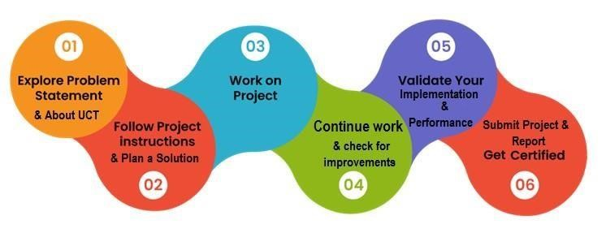

Your Learnings and overall experience.

Thank to all (with names), who have helped you directly or indirectly.

Your message to your juniors and peers.

# **2 Introduction**

## 2.1 About UniConverge Technologies Pvt Ltd

A company established in 2013 and working in Digital Transformation domain and providing Industrial solutions with prime focus on sustainability and RoI.

For developing its products and solutions it is leveraging various **Cutting Edge Technologies e.g. Internet of Things (IoT), Cyber Security, Cloud computing (AWS, Azure), Machine Learning, Communication Technologies (4G/5G/LoRaWAN), Java Full Stack, Python, Front end** etc.

iii. 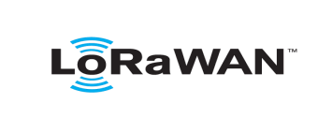 based Solution

UCT is one of the early adopters of LoRAWAN teschnology and providing solution in Agritech, Smart cities, Industrial Monitoring, Smart Street Light, Smart Water/ Gas/ Electricity metering solutions etc. iv.

Predictive Maintenance

UCT is providing Industrial Machine health monitoring and Predictive maintenance solution leveraging Embedded system, Industrial IoT and Machine Learning Technologies by finding Remaining useful life time of various Machines used in production process.

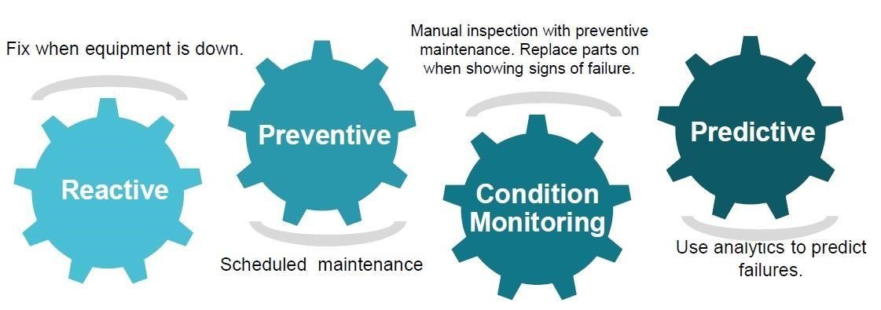

### 2.2 About upskill Campus (USC)



7



Industrial Internship Report Page



upskill Campus along with Uniconverge technologies has facilitated the smooth execution of the complete internship process.

USC is a career development platform that delivers **personalized executive coaching** in a more affordable, scalable and measurable way.

### 2.4 Objectives of this Internship program

The objective of this report is to explore the current state of healthcare data management, in cloud computing identify key challenges, and propose solutions to improve data handling and processing in the healthcare sector. This includes examining the benefits of effective data management, discussing existing and proposed solutions, and outlining a performance testing plan.

### 2.5 Reference

Healthcare Data Management: An Overview



The Importance of Data Management in Healthcare

Healthcare Data Management: Challenges and Solutions

### 2.6 Glossary

|  |  |
| --- | --- |
| •EHR (Electronic Health Record): A digital version of a patient’s paper chart. | •EHR (Electronic Health Record)**:** A digital version of a patient’s paper chart. |
| • PHI (Protected Health  Information)**:** Any information about health status, provision of healthcare, or | • PHI (Protected Health Information)**:** Any information about health status, provision of healthcare, or payment for healthcare that can be linked to an individual. |

5

|  |  |  |
| --- | --- | --- |
|  | |  |
| payment for healthcare that can be linked to an individual. |  | |
| • HIPAA (Health  Insurance  Portability and Accountability Act): A US law designed to provide privacy standards to protect patients' medical records and other health information. | •HIPAA (Health Insurance Portability and Accountability Act)**:** A US law designed to provide privacy standards to protect patients' medical records and other health information. | |
| •  Interoperability: The ability of different information systems, devices, or applications to connect and exchange data in a coordinated manner. | • Interoperability: The ability of different information systems, devices, or applications to connect and exchange data in a coordinated manner. | |

### 3 Problem Statement

Effective healthcare data management is essential for delivering quality care, improving patient outcomes, and optimizing operational efficiency. However, the healthcare sector faces numerous challenges, including data fragmentation, lack of interoperability, data privacy concerns, and the complexity of integrating data from multiple sources. These challenges hinder the efficient use of data and pose risks to patient privacy and security.

### 4 Existing and Proposed solution

#### Existing Solution

Existing healthcare data management solutions include Electronic Health Records (EHRs), Health Information Exchanges (HIEs), and cloud-based data storage systems. These solutions aim to centralize patient information, facilitate data sharing, and enhance data accessibility. However, they often encounter issues such as data silos, inadequate security measures, and limited interoperability.

#### Proposed Solution

To address these challenges, a comprehensive healthcare data management system needs to be developed. This system should leverage advanced technologies such as blockchain for enhanced security, artificial intelligence (AI) for data analytics, and the Internet of Things (IoT) for real-time data collection. Key features of the proposed solution include:

* **Interoperability**: Ensuring seamless data exchange between different healthcare systems and devices.
* **Data Security**: Implementing robust encryption, access control mechanisms, and blockchain technology to protect PHI.
* **Scalability**: Utilizing cloud computing to handle large volumes of healthcare data and accommodate future growth.
* **AI and Analytics**: Leveraging machine learning algorithms to analyze healthcare data and provide actionable insights.

**4.1 Code submission (Github link) :**

#### 4.2 Code submission

**(Github link) :**

<https://github.com/Priyadhamal/upskillcampus/blob/main/index.html>

#### Report Submission

https://github.com/Priyadhamal/upskillcampus

### 5 Proposed Design/ Model

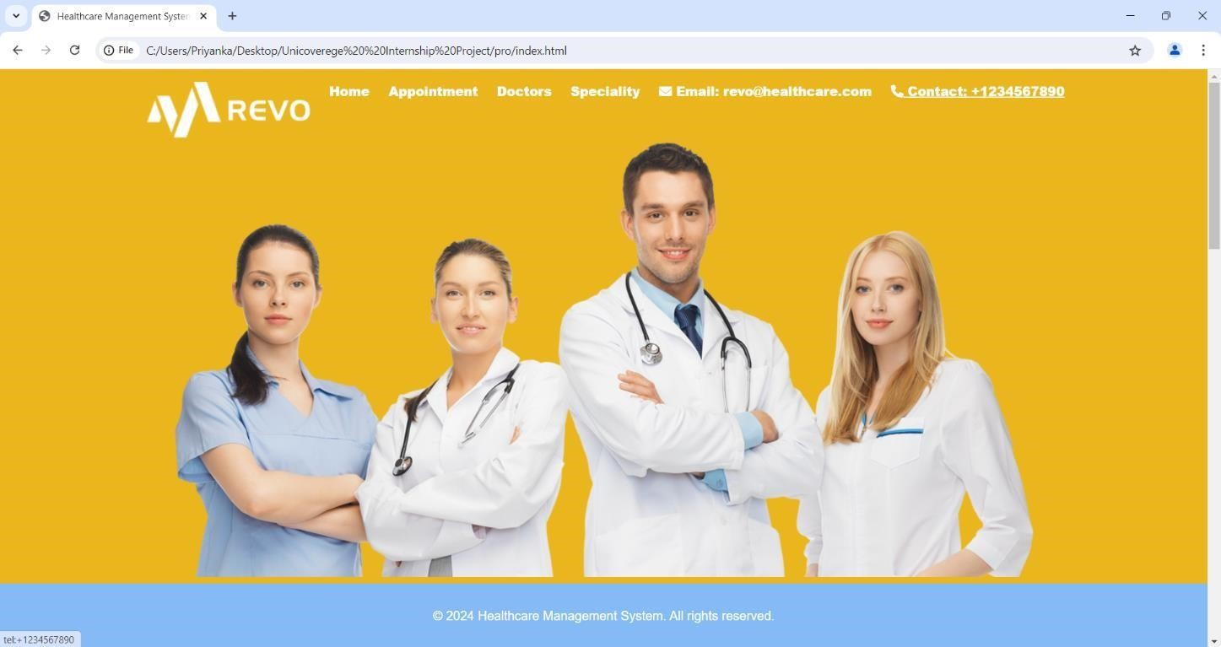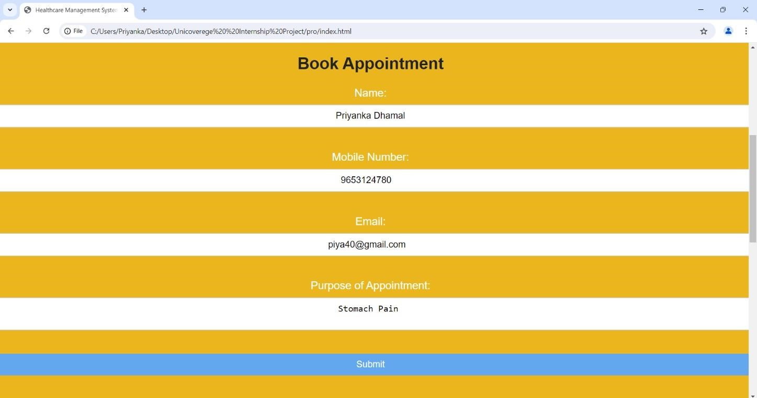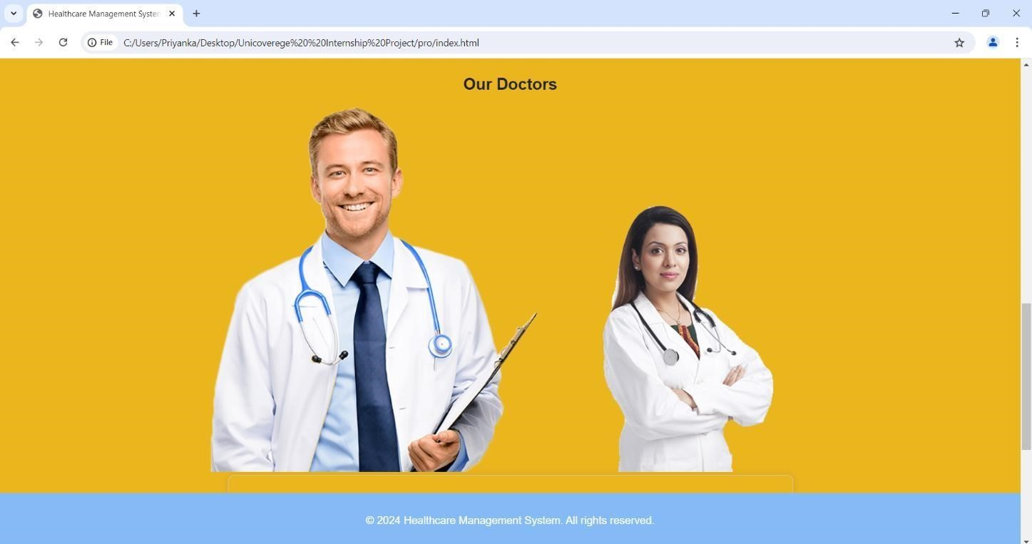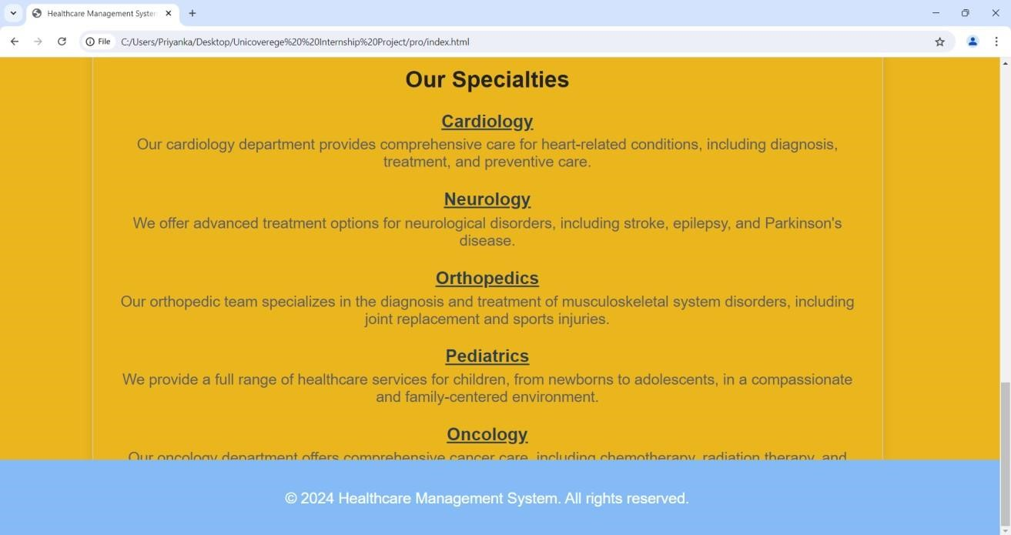

### 6 Performance Test

* ***Objective***
* Performance testing is a crucial step in ensuring that the healthcare data management system can handle the expected load, maintain security, and deliver timely and accurate insights. This section outlines the performance test plan, test cases, test procedures, and expected outcomes.

#### 6.1 Test Plan/ Test Cases

The performance test plan includes the following test cases:

* **Data Ingestion Test**: Evaluates the system's capability to handle data from multiple sources simultaneously without data loss or significant delay.
* **Data Processing Test**: Measures the efficiency and accuracy of AI algorithms in processing and analyzing large datasets.
* **Data Security Test**: Assesses the effectiveness of encryption, access control, and blockchain mechanisms in protecting PHI.
* **Scalability Test**: Tests the system's ability to scale and manage increasing volumes of data without performance degradation.

#### 6.2 Test Procedure

The test procedure involves the following steps:

1. **Setup**: Configure the healthcare data management system with test data and necessary infrastructure.

|  |  |
| --- | --- |
| 2. **Execution**: Execute each | test case |
| multiple times under varying metrics. | conditions to gather performance |

1. **Monitoring**: Use monitoring tools to track system performance, resource utilization, and response times during the tests.
2. **Analysis**: Analyze the test results to identify any performance bottlenecks, security vulnerabilities, or areas for improvement.

##### 6.3 Performance Outcome

expected performance outcomes include:

* **High Data Throughput**: The system should efficiently handle large volumes of data from multiple sources without significant delays.
* **Accurate Data Analysis**: AI algorithms should provide accurate and timely insights from the data, supporting clinical decision-making.
* **Robust Security**: The system should protect sensitive health information from unauthorized access and data breaches.
* **Scalability**: The system should scale efficiently to accommodate growing data volumes and ensure consistent performance.

### 7 My learnings

Importance of Healthcare Data Management

Healthcare data management is crucial for several reasons:

Improved Patient Care: Effective data management enables healthcare providers to access comprehensive and up-to-date patient information, leading to better diagnosis and treatment decisions.

Regulatory Compliance: Proper data management ensures compliance with regulations such as HIPAA, protecting patient privacy and avoiding legal issues.

Data-Driven Insights: Analyzing healthcare data can uncover patterns and trends, supporting evidence-based practices and improving population health management.

7.2 Current Challenges in Healthcare Data Management

The healthcare industry faces several challenges in managing data:

Data Fragmentation: Patient data is often spread across multiple systems and formats, making it difficult to consolidate and access comprehensive information.

Lack of Interoperability: Different healthcare systems and devices often use incompatible standards, hindering seamless data exchange and integration.

Data Privacy and Security: Protecting sensitive patient information from unauthorized access and breaches is a major concern, requiring robust security measures.

Complex Data Integration: Integrating data from various sources, such as EHRs, wearables, and imaging systems, is complex and resource-intensive.

### Future work scope

Future work can focus on enhancing the proposed healthcare data management system by:

|  |  |
| --- | --- |
| • **Integrating Real-Time** | **Analytics**: |
| Developing real-time analytics | capabilities to provide immediate |

insights for healthcare providers, enabling quicker response to patient needs.

* **Improving User Interface**: Creating a more user-friendly and intuitive interface to improve accessibility and usability for healthcare professionals.
* **Expanding Interoperability**: Ensuring compatibility with a broader range of healthcare systems, devices, and standards to facilitate seamless data exchange.
* **Advanced Data Security**: Implementing more sophisticated security measures, such as multi-factor authentication and advanced encryption techniques, to address emerging threats and vulnerabilities.

**Scalability and Modularity**:

Designing the system architecture to easily scale for different door types (e.g., sliding doors, revolving doors) and building sizes.

Modular design approach to facilitate future upgrades and component replacements without significant system downtime.