**Introduction:**

**Project Title**: Cryptoverse

**Team Members**:

* Srivathsaan K
* Sanjay Kumar S
* Nivedhini E
* Priyanka R

**Project Overview**

**Purpose:**

Cryptoverse aims to create a user-friendly, real-time platform for cryptocurrency enthusiasts, investors, and analysts to access comprehensive information regarding the cryptocurrency market. The platform offers live price tracking, historical data visualizations, cryptocurrency news, and user-specific features like portfolio tracking.

In an age where cryptocurrency is gaining immense popularity and volatility, accurate, up-to-date, and easily accessible data is crucial for users making informed decisions. Cryptoverse allows individuals to monitor market trends, keep track of their portfolios, and stay up-to-date on the latest news in real-time. This platform is designed to bridge the gap between crypto data complexities and user accessibility, presenting a simplified and interactive dashboard that can be customized for personal preferences.

**Features:**

The Cryptoverse platform integrates several key features to support the user’s needs in navigating the world of cryptocurrency:

1. **Live Cryptocurrency Price Tracking**:
   * The platform offers real-time price tracking of various cryptocurrencies, including Bitcoin, Ethereum, and hundreds of others. Users can view prices and their fluctuations within set time intervals (e.g., minute-wise, hourly, daily).
2. **Historical Price Data Visualization**:
   * Cryptoverse allows users to analyze the historical performance of specific cryptocurrencies. Users can access detailed charts and graphs illustrating price movements over time, which helps in assessing past trends and predicting future patterns.
3. **Interactive Charts and Graphs**:
   * The interactive charts provide users with a visual representation of price fluctuations, trading volumes, market caps, and other key metrics. The charts are designed to allow zoom-in/zoom-out functionalities, making them more versatile for in-depth analysis.
4. **User Authentication**:
   * Cryptoverse includes a user authentication system that allows users to sign up, log in, and manage their accounts. This feature ensures security and privacy for individuals accessing their portfolio data, and it also helps in personalizing the user experience.
5. **News Updates**:
   * The platform keeps users updated with the latest news and developments from the cryptocurrency world. Real-time news articles, trends, and announcements related to cryptocurrency markets, regulations, and projects are provided to help users stay informed.

**Architecture**

**Component Structure:**

The architecture of Cryptoverse is designed with modularity and reusability in mind. The components are organized logically and separated according to their functional role in the application.

* **Header: Navigation Bar**:  
  This component acts as the main point of navigation for users within the application. It contains links to major sections such as the Home page, Portfolio, Crypto Details page, and the News section. A search bar is also present, allowing users to find specific cryptocurrencies by name or symbol.
* **Dashboard: Live Market Data**:  
  The Dashboard is the landing page of the platform, where users can access the latest live market data for all available cryptocurrencies. The dashboard typically includes a list of cryptocurrencies sorted by market cap or other relevant metrics, along with their real-time price and 24-hour changes.
* **Crypto Details: Individual Cryptocurrency Info**:  
  This component provides a deep dive into individual cryptocurrencies. It displays detailed information such as current prices, historical price data, market trends, and other fundamental data about the selected cryptocurrency.
* **Portfolio: User Holdings Tracking**:  
  The Portfolio section allows users to manage and track their cryptocurrency holdings. Users can add, remove, and view their investments. They can also monitor how the value of their portfolio changes over time based on real-time market data.
* **News Section: Real-time Updates**:  
  This section pulls in the latest news articles from multiple crypto news sources, providing real-time updates on the cryptocurrency industry. Articles can range from price predictions, regulatory updates, or major events in the crypto space.

**State Management:**

To manage the application’s state, **Redux Toolkit** is utilized. Redux Toolkit simplifies state management, reducing the boilerplate code and providing powerful tools for efficient and predictable state updates. In Cryptoverse, Redux is used for managing global application states such as:

* User authentication status
* Portfolio data (cryptocurrency holdings)
* Real-time market data
* News updates

By using Redux Toolkit, the application maintains a central store that makes it easy to keep track of various pieces of data and ensures that updates are made in a controlled, predictable manner.

**Routing:**

**React Router** is used to handle navigation between pages. The routing configuration ensures that users can easily navigate through the different sections of the app without any page reloads. Below are the key routes:

* **Home ("/")**: The home route serves as the dashboard, displaying live market data and summaries of cryptocurrencies.
* **Crypto Details ("/crypto/:id")**: This route displays detailed information about a selected cryptocurrency. The ":id" part of the URL is dynamic, so it displays the data for whichever crypto the user selects.
* **Portfolio ("/portfolio")**: This page allows the user to manage their cryptocurrency portfolio.
* **News ("/news")**: Displays real-time cryptocurrency-related news updates.

**Setup Instructions**

**Prerequisites:**

Before you can set up and run Cryptoverse, ensure that you have the following software installed on your machine:

* **Node.js**: This is the JavaScript runtime that allows you to run the app locally and manage dependencies.
* **npm** (Node Package Manager) or **Yarn**: These tools are used to install the dependencies required to run the application.
* **React.js**: Cryptoverse is built using React, a popular JavaScript library for building user interfaces.
* **Redux Toolkit**: This is used for managing global state in the app.

**Installation:**

Follow these steps to set up the project locally on your machine:

1. **Clone the repository**:  
   Open a terminal or command prompt and run the following command to clone the repository:
2. git clone https://github.com/your-repo/cryptoverse.git
3. **Install dependencies**:  
   After cloning the repository, navigate to the project folder and install the required dependencies:
4. npm install

or, if you prefer using Yarn:

yarn install

1. **Configure environment variables**:  
   Some sensitive information, such as API keys for real-time crypto data, will need to be stored as environment variables. Create a .env file at the root of the project and add your API keys there:
2. REACT_APP_CRYPTO_API_KEY=your_api_key_here

**Folder Structure**

The folder structure of Cryptoverse is organized to allow easy navigation and scalability as the app grows. Below is a breakdown of the core folders:

/cryptoverse

├── /src

├── /components

├── /pages

├── /redux

├── /utils

├── /assets

├── package.json

├── README.md

* **/src**: This is the main source code directory containing all application logic, components, and state management.
  + **/components**: This directory contains reusable components, such as buttons, charts, and loaders.
  + **/pages**: Contains page-level components, such as the home page, portfolio page, and crypto details page.
  + **/redux**: Holds all Redux logic (actions, reducers, and store configuration).
  + **/utils**: Utility functions or helper files.
  + **/assets**: Static assets like images, icons, or SVG files.

**Running the Application**

To start the development server and run Cryptoverse locally:

1. Open the terminal and navigate to the project folder.
2. Run the following command:
3. npm start

This will start the React development server, and you can open the app in your browser at http://localhost:3000.

**Component Documentation**

**Key Components:**

1. **CryptoCard**:  
   The CryptoCard component is designed to display a quick overview of a cryptocurrency. It includes the name, symbol, current price, and percentage change in price over 24 hours. This component is used throughout the Dashboard page.
2. **PriceChart**:  
   The PriceChart component is responsible for displaying the historical price data for individual cryptocurrencies. It integrates with charting libraries such as Chart.js or Recharts to plot the data.
3. **NewsFeed**:  
   The NewsFeed component displays real-time cryptocurrency-related news articles. It pulls in data from an external API that aggregates news from multiple sources.

**Reusable Components:**

1. **Button**:  
   A customizable button component used throughout the platform. The button can be styled with different colors, sizes, and actions, depending on its use case.
2. **Loader**:  
   A simple loading animation component shown when data is being fetched from the server or external APIs.

**Styling**

The styling for Cryptoverse is handled using **Tailwind CSS**, a utility-first CSS framework that enables rapid UI development. The custom theme built with Tailwind allows Cryptoverse to have a modern, clean, and responsive design. The design is mobile-first, ensuring that users on any device can access and navigate the platform easily.

**Testing**

**Testing Strategy:**

Testing is a crucial part of ensuring the functionality and stability of the Cryptoverse application. The platform adopts the following testing strategies:

* **Unit Testing**: Jest and React Testing Library are used to test individual components. These tests check that components render correctly and behave as expected under different conditions.
* **Integration Testing**: **Cypress** is used for end-to-end (E2E) tests, ensuring that the entire app functions correctly in a real-world scenario. This includes navigating between pages, interacting with buttons, and verifying that the correct data is displayed.

**Screenshots and Demo:**

**Demo Link:**

A live demo of Cryptoverse can be accessed [here](https://chatgpt.com/).

**Screenshots:**

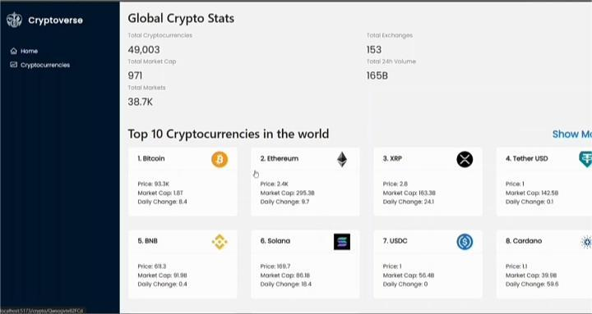

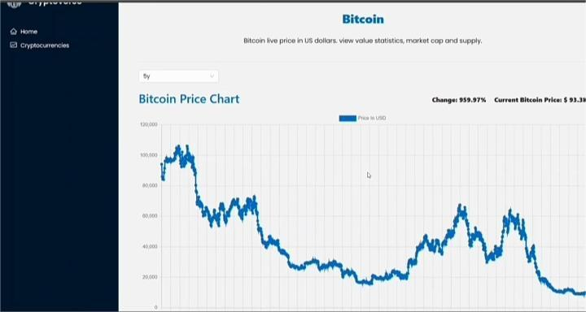

**Known Issues**

* **API Rate Limits**: Due to API rate limits, the application may experience delays in fetching live data. This can be alleviated with API key upgrades or more efficient handling of API requests.
* **Dark Mode**: Dark mode support is under development. Users can expect an update in the future to allow for a dark theme toggle.

**Future Enhancements**

Future plans for Cryptoverse include adding more advanced features like AI-driven price predictions, push notifications, and the ability to stake cryptocurrencies for rewards. These features would further enhance the user experience and make the platform even more useful for crypto enthusiasts and investors.

Github Repository link: <https://github.com/Priyadharshanrepository/Crypto_verse.git>

Demo video link: <https://drive.google.com/file/d/1x2i5u20uCwkuFCelznYje2bY-O3iB%20VK/view?usp=drivesdk>