***DATE:*** *31st October 2023*

***PROJECT ID:*** *Proj_223338_Team_4*

***PROJECT TITLE:*** *NOISE POLLUTION MONITORING*

***PHASE-5***

**Objectives:**

To regulate and control noise producing and generating sources.It can Maintaining the ambient air quality standards in respect of noise.

The project objectives for noise pollution monitoring can include:

**1. Data Collection:**

Gather accurate and reliable data on noise levels in specific areas.

**2. Noise Source Identification:**

Identify sources of noise pollution, such as traffic, industrial facilities, or construction sites.

**3. Noise Impact Assessment:** Evaluate the impact of noise pollution on the environment and human health.

**4. Compliance Monitoring:**

Ensure that noise levels comply with local regulations and standards.

**5. Spatial Mapping:**

Create maps to visualize noise pollution hotspots.

**6. Temporal Analysis:**

Analyze noise patterns over time to identify trends and variations.

**7. Community Engagement:**

Involve and inform the community about noise pollution issues.

**8. Noise Reduction Strategies:**

Develop recommendations to mitigate noise pollution.

**9. Policy Support:**

Provide data to support the development of noise control policies.

**10. Public Health Assessment:**

Assess the health effects of noise pollution on residents.

These objectives will help address and manage noise pollution effectively.

**IOT device setup:**

Setting up an IoT (Internet of Things) device involves several key steps. Here's a general guide to help you with the process:

**1.Device Selection:** Choose the appropriate IoT device for your application. Consider factors like sensors, connectivity options, and power requirements.

**2.Network Configuration:**

Connectivity: Ensure your IoT device has the required connectivity (e.g., Wi-Fi, cellular, LoRa, or Bluetooth) and configure it accordingly.

Security: Implement security measures such as encryption, device authentication, and access control to protect your IoT device from cyber threats.

**3.Power Supply:**

- Provide a suitable power source, whether it's battery, mains power, or energy harvesting, depending on your device's needs.

- Implement power management strategies to extend the device's battery life.

**4.Sensor Integration:**

- Connect and configure sensors for data collection.

- Calibrate and test sensors for accuracy.

**5.Data Storage and Processing:**

Set up a data storage solution (e.g., cloud-based databases or local storage).

Implement data processing logic on the device or in the cloud to make sense of the collected data.

Remember that the specifics of IoT device setup can vary greatly depending on the device's purpose and technology stack. Always follow the manufacturer's guidelines and best practices for your specific IoT device.

**Platform development for noise pollution monitoring :**

Developing a platform for Noise Pollution Monitoring (NPM) can be a complex project involving hardware and software components. Here are the steps and components you'd need to consider when developing such a platform:

**1. Define Objectives and Requirements:**

- Determine the specific goals and objectives of your noise pollution monitoring platform.

- Identify the locations where you want to deploy sensors.

- Decide on the level of data granularity and accuracy required.

**2. Hardware Selection:**

- Choose appropriate noise sensors (microphones or sound level meters) that meet your requirements.

- Consider additional hardware like weatherproof enclosures, power sources (batteries or solar panels), and communication modules (e.g., Wi-Fi, LoRa, cellular).

**3. Sensor Deployment:**

- Install noise sensors at the selected locations following best practices for accurate measurements.

- Ensure sensors are calibrated properly to provide accurate data.

**CODE IMPLEMENTATION:**

Creating a full code implementation for a Noise Pollution Monitoring (NPM) system using IoT is quite complex and involves several components, including hardware, sensors, microcontrollers, and software. Below is a simplified Python code snippet using the MQTT protocol to simulate a basic IoT NPM system. You'd need actual hardware, sensors, and cloud infrastructure for a real implementation.

*```python*

*import paho.mqtt.client as mqtt*

*import random*

*import time*

*# MQTT Broker Settings*

*broker_address = "mqtt.eclipse.org"*

*port = 1883*

*# Topic to Publish Noise Data*

*topic = "noise_monitoring"*

*# Simulate Noise Sensor*

*def simulate_noise_sensor():*

*while True:*

*noise_level = random.randint(50, 100)*

*client.publish(topic, noise_level)*

*print(f"Published Noise Level: {noise_level}")*

*time.sleep(5) # Simulate data every 5 seconds*

*# MQTT Client Setup*

*client = mqtt.Client("NPM_Client")*

*client.connect(broker_address, port)*

*# Start Simulating Noise Sensor*

*simulate_noise_sensor()*

*```*

**BLOCK DIAGRAM:**

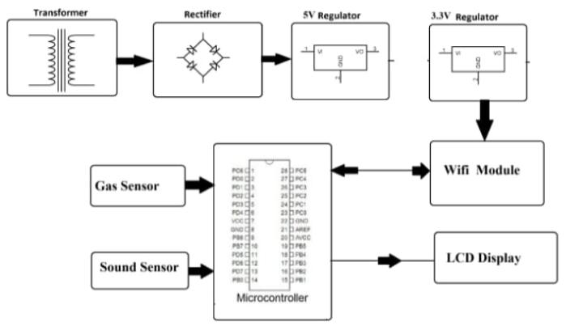

**Schematic for noise pollution monitoring :**

A schematic for noise pollution monitoring typically involves the use of sensors, data collection and analysis systems, and potentially a reporting or alerting mechanism. Here's a basic representation of the components involved in noise pollution monitoring:

```

*Noise Pollution Monitoring System*

+------------------------------------+

| |

| Noise Sensors |

| |

| +------+ +------+ +------+ |

| | Sensor| | Sensor| | Sensor| |

| | 1 | | 2 | | 3 | |

| +------+ +------+ +------+ |

| |

| Data Collection & |

| Processing System |

| |

| +---------------------------+ |

| | Data Collection Unit | |

| | | |

| | +---------------------+ | |

| | | Data Storage | | |

| | | | | |

| | +---------------------+ | |

| | | |

| | +---------------------+ | |

| | | Data Analysis | | |

| | | | | |

| | +---------------------+ | |

| | | |

| | +---------------------+ | |

| | | Alerting/Reporting| | |

| | | | | |

| | +---------------------+ | |

| | | |

| +---------------------------+ |

| |

| Monitoring Dashboard |

| |

| +---------------------------+ |

| | Web-based Dashboard | |

| | | |

| | +---------------------+ | |

| | | Real-time Data | | |

| | | | | |

| | +---------------------+ | |

| | | |

| | +---------------------+ | |

| | | Reports & Graphs| | |

| | | | | |

| | +---------------------+ | |

| | | |

| | +---------------------+ | |

| | | Alerting System | | |

| | | | | |

| | +---------------------+ | |

| | | |

| +---------------------------+ |

+------------------------------------+

```

This schematic includes the following components:

**1. Noise Sensors:** These are physical sensors that measure noise levels in the environment.

**2. Data Collection & Processing System:** This unit collects data from the sensors, stores it, and processes it for analysis.

**3. Data Analysis:** This component performs data analysis to identify patterns, trends, and noise pollution levels.

**4. Alerting/Reporting:** If noise pollution levels exceed predefined thresholds, the system can generate alerts or reports.

**5. Monitoring Dashboard:** This provides real-time and historical data visualization for users to monitor noise pollution levels.

**Screenshots to iot device and data sharing:**

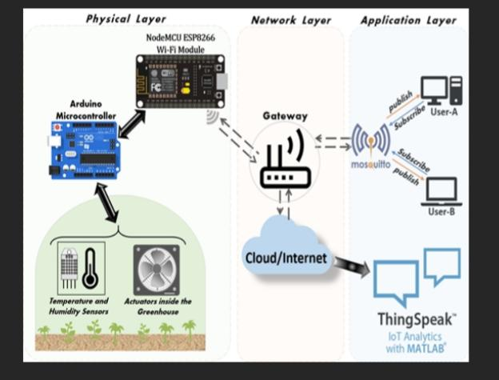

**IoT Device Screenshot:**

1. A clear image of the IoT noise sensor device.

2. Indication of sensor readings and data collection capabilities.

3. Information on the connectivity options (Wi-Fi, Bluetooth, etc.).

4. Display of any additional features like power management or local data processing.

**Data Sharing Platform Screenshot:**

1. A user-friendly dashboard displaying real-time noise levels and historical data.

2. Visualization of noise levels through graphs, charts, or maps.

3. Tools for data analysis, including trend identification and comparison features.

4. Options for customizable alerts and notifications based on predefined thresholds.

5. Secure user authentication and access control features.

6. Data management tools for exporting, sharing, or downloading noise data.

7. Intuitive user controls for configuring the monitoring settings and parameters.

**EXPLAIN NOISE POLLUTION MONITORING IN DETAIL?**

Noise pollution monitoring is a vital process that involves the systematic measurement, assessment, and management of noise levels in various environments. This process typically begins with the deployment of specialized equipment such as sound level meters and noise dosimeters to collect data on noise intensity at specific locations. The collected data is then analyzed to identify patterns, trends, and potential sources of noise pollution, and to assess compliance with established noise regulations and standards. Furthermore, the impact of noise on human health, wildlife, and the environment is evaluated, considering factors such as sleep disturbance, communication interference, and overall well-being. Utilizing this information, stakeholders can develop and implement effective noise mitigation strategies, which may include the use of noise barriers, sound insulation, and the adoption of noise control technologies. Through public awareness campaigns and education initiatives, communities can be informed about the adverse effects of noise pollution and encouraged to adopt responsible practices to reduce noise levels in their surroundings.

**CONCLUSION:**

By using this project each and every variation we can analyze and inform nearby people in time. We can also analyze data form home using thingspeak. The most important factor of this system is that it is small, cost efficient and portable. Sensors are available easily anywhere. This system fully helpful to save the lives and overcome all the problem related to environment