SKILLBUILDER DAY 4
PRIYADHARSHIKA L T – 727723EUCB041
QUESTION 2 – HR DATA ANALYST

TASK 1 – PROMPT DESIGN
Generate exactly 5 candidate profiles for an HR dashboard.
Requirements:
- Generate exactly 5 candidate profiles
- Age must be between 21 and 35 years
- Experience must be between 0 and 10 years.
- Each candidate must have at least 3 skills
- Each candidate profile must include – “name”, “age”, “experience (years)”, “skills_count (array)”
- Produce the output in Valid JSON format and a well-formatted table
- Ensure the JSON is syntactically valid and the table matches the JSON data exactly.

TASK 2 – OUTPUT GENERATION
JSON FORMAT
[
{
"name": "Aarav Sharma",
"age": 24,
"experience": 2,
"skills": ["Python", "SQL", "Power BI"]
},
{
"name": "Priya Nair",
"age": 27,
"experience": 5,
"skills": ["Java", "Spring Boot", "MySQL"]
},
{
"name": "Rahul Verma",
"age": 31,
"experience": 8,
"skills": ["React", "JavaScript", "Node.js"]
},
{
"name": "Sneha Reddy",
"age": 22,
"experience": 1,
"skills": ["Excel", "Tableau", "Communication"]
},
{
"name": "Karan Mehta",
"age": 35,
"experience": 10,
"skills": ["AWS", "Docker", "Kubernetes"]
}
]

TABLE FORMAT
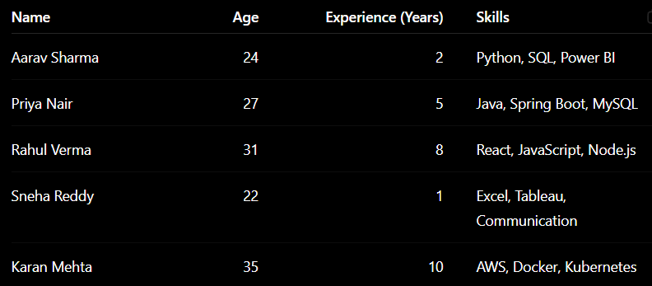

TASK 3 – OUTPUT VALIDATION
CHECKS | RESULT
All constraints are satisfied – age, experience, skills count | ✅
JSON is correctly formatted with no syntax errors | ✅
Table formatting is clear and properly structured | ✅

TASK 4 – REFINEMENT & REGENERATION
There was no errors or inconsistencies found in the output generated.

