Project Title: Insurance Claim Management System
Technology Stack: Spring Boot, MySQL Workbench, HTML/CSS, JavaScript, Bootstrap

1. Introduction
1.1 Purpose
The purpose of this document is to define the functional and non-functional requirements for the Insurance Claim Management System (ICMS). This system is designed to simplify insurance management by allowing users to register, apply for policies, pay premiums, and claim reimbursements, while providing administrators the ability to verify users, approve policies, and process claims efficiently.
1.2 Scope
The system is a web-based platform where:
- Users can register/login (with OTP & Aadhaar verification), apply for policies, upload documents, pay premiums, and claim reimbursements.
- Admins can review user applications, approve/reject policies, track active/inactive policies, and manage reimbursement approvals.
The backend will be implemented in Spring Boot, the database in MySQL, and frontend in HTML/CSS/JS.
1.3 Definitions, Acronyms, and Abbreviations
- ICMS: Insurance Claim Management System
- OTP: One-Time Password
- DB: Database
- UI: User Interface
- CRUD: Create, Read, Update, Delete
1.4 References
- IEEE 830-1998 Software Requirements Specification standard.
- Spring Boot official documentation.
- MySQL Workbench 8.0 documentation.

2. Overall Description
2.1 Product Perspective
The ICMS is a standalone web application using a 3-tier architecture:
- Frontend Layer: HTML, CSS, JavaScript, Bootstrap
- Backend Layer: Spring Boot REST APIs
- Database Layer: MySQL Workbench
It will include modules for Authentication, Policy Management, Claim Management, and Admin Dashboard.
2.2 Product Functions
2.2.1 User Functions
- Register (with OTP and Aadhaar verification)
- Login (role-based access: user/admin)
- Apply for a policy
- View application status and notifications
- Make premium payments and view payment history
- Upload claim documents for reimbursement
- View wallet balance (for approved claims)
2.2.2 Admin Functions
- Login as admin
- Verify and approve/reject user registrations
- Check policy details and approve/reject applications
- Verify premium payments
- Approve reimbursement claims and transfer to wallet
2.3 User Characteristics
- User: General public with Aadhaar number and insurance interest.
- Admin: Authorized insurance company employee with approval privileges.
2.4 Constraints
- Aadhaar API mock for verification (simulated)
- OTP generated via email or random generator (mocked)
- Internet connection required
- Data stored securely in MySQL
2.5 Assumptions and Dependencies
- Users provide correct Aadhaar and contact details.
- Payment gateway simulation for premium and reimbursement.

3. Specific Requirements
3.1 Functional Requirements
3.1.1 User Registration & Login
- Users can register using name, email, password, role (admin/user), Aadhaar number.
- OTP verification before account creation.
- Password strength check and confirm password validation.
- Aadhaar verification (name-number match).
- Login page redirects based on role.
3.1.2 Policy Management
- User can view available policies.
- User can apply for a selected policy.
- Admin can view all user policy requests.
- Admin can approve, reject, or set pending status.
3.1.3 Payment Management
- User can pay premium online.
- Admin can track payments.
- System marks policy as Active only if payment received.
- Payment history shown in user dashboard.
3.1.4 Claim Management
- User can upload claim documents (PDF/JPG).
- Admin verifies documents and approves/rejects claim.
- On approval, reimbursement amount credited to user's wallet.
- User notified via dashboard.
3.1.5 Notification System
- Notifications appear for policy applied, approval/rejection, payment, and claim updates.

3.2 Non-Functional Requirements
3.2.1 Performance
- Response time < 3 seconds per API request.
- Support 1000 concurrent users.
3.2.2 Security
- Passwords hashed using BCrypt.
- Role-based authentication (Spring Security).
- Aadhaar & OTP validation for authenticity.
3.2.3 Usability
- User-friendly UI with dashboard navigation.
- Simple forms and validation hints.
3.2.4 Maintainability
- Code modularized with controllers, services, and repositories.
- JPA for database interaction.

4. System Design
4.1 Use Case Diagram
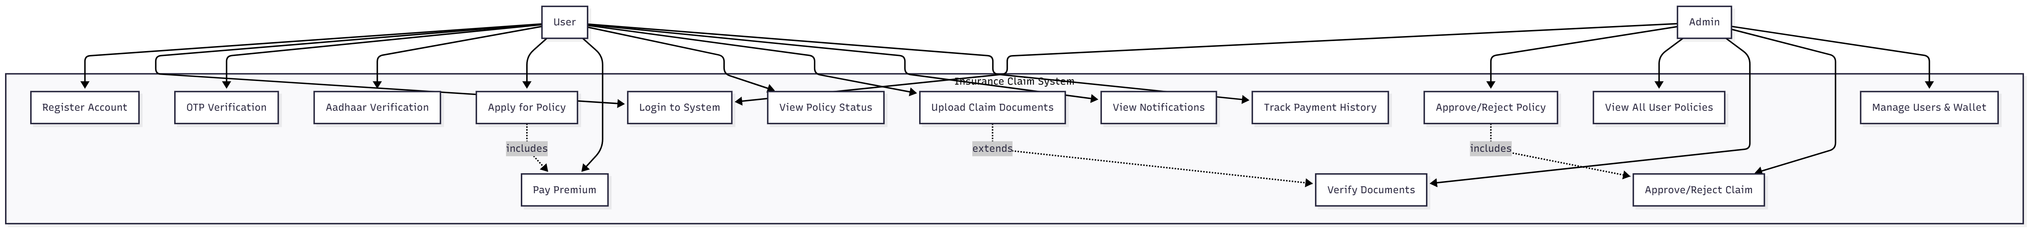4.2 Class Diagram
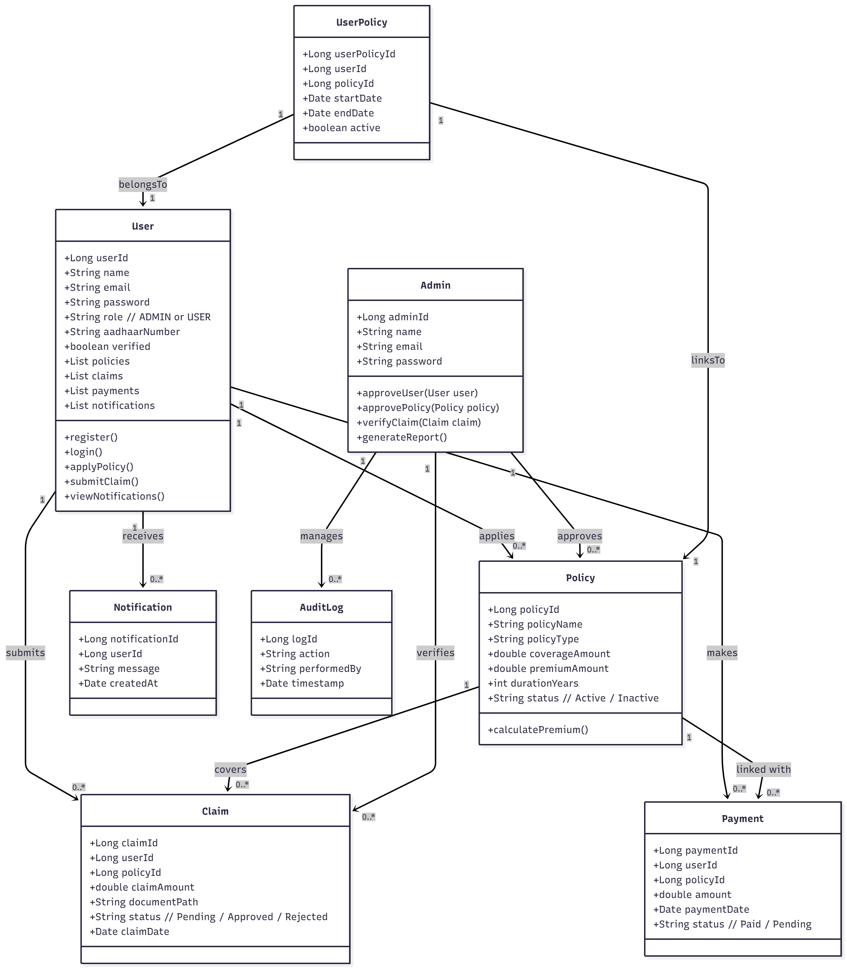
4.3 Interaction Diagram
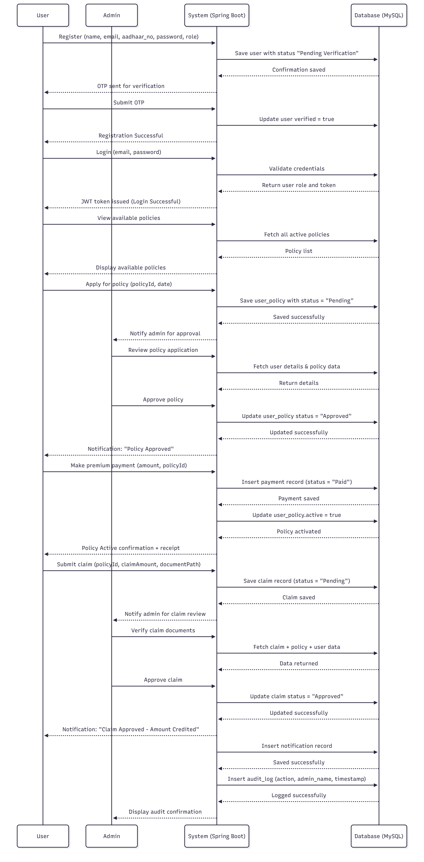
4.4 ER Diagram
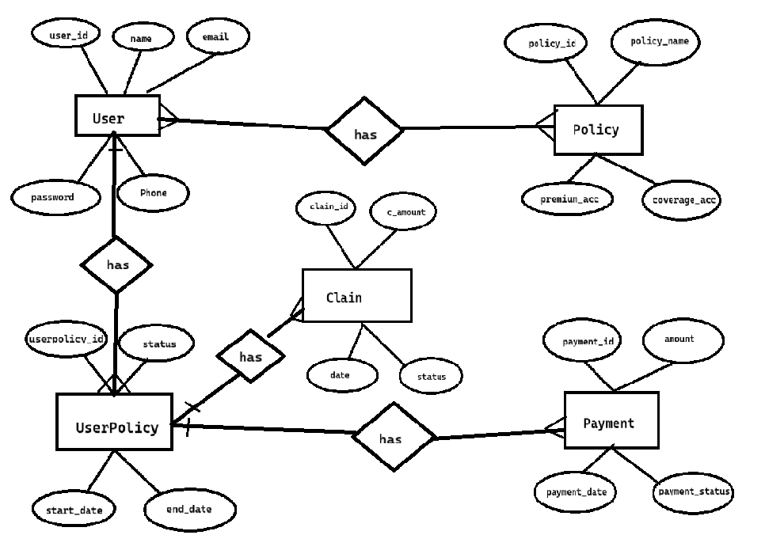
4.5 Database Schema
