

**Tech Saksham**

**Capstone Project Report**

**ARTIFICIAL INTELLIGENCE AND MACHINE LEARNING FUNDAMENTALS**

**“An End-to-End Data Science Project with ChatGPT”**

**“UNIVERSITY COLLEGE OF ENGINEERING (BIT CAMPUS) TIRUCHIRAPALLI”**

|  |  |
| --- | --- |
| **NM ID** | **NAME** |
| au810021214023 | PRIYADHARSHINI V |

|  |  |
| --- | --- |
|  |  |
|  | Trainer Name  Ramar Bose |
|  | Sr. AI Master Trainer |

**ABSTRACT**

The goal of this brief end-to-end data science project with ChatGPT is to use a loan dataset from a financial organization to predict loan default. To get the dataset ready for modeling, it involves feature engineering, exploratory data analysis, and data preprocessing. Predictive models are created to estimate the probability of loan default by utilizing machine learning techniques such as logistic regression, decision trees, random forests, and gradient boosting. The process of identifying important predictors is guided by feature importance analysis. Reliability and generality are ensured by thorough model review. At the end of the day, the model that performs the best is used to make real-time forecasts, which helps financial institutions manage risk proactively and create a stable lending environment.

**INDEX**

|  |  |  |
| --- | --- | --- |
| **Sr. No.** | **Table of Contents** | **Page No.** |
| 1 | Chapter 1: Introduction | 4 |
| 2 | Chapter 2: Services and Tools Required | 6 |
| 3 | Chapter 3: Project Architecture | 7 |
| 4 | Chapter 4: Modeling and Project Outcome | 9 |
| 5 | Conclusion | 18 |
| 6 | Future Scope | 19 |
| 7 | References | 20 |
| 8 | Links | 21 |

**CHAPTER 1**

**INTRODUCTION**

* 1. **Problem Statement**

The objective of this project is to use ChatGPT's natural language processing (NLP) features and machine learning techniques to create a comprehensive loan approval system. The project intends to develop a predictive model that can evaluate the creditworthiness of new applicants based on their financial history and personal data by utilizing a dataset of previous loan applications. A more smooth and effective loan application process will be possible with the integration of ChatGPT into the system, which will also allow for the automation of customer contacts. The project aims to increase loan approval speed and accuracy while improving the applicant and loan officer experience through the use of conversational AI and advanced analytics.

* 1. **Proposed Solution**

The suggested approach includes a few crucial phases for an end-to-end data science project that uses ChatGPT with a loan dataset. To clean and prepare the loan dataset, extensive data preprocessing is first required. This includes addressing outliers and missing information. Subsequently, feature engineering can assist in deriving pertinent data from the data to enhance model functionality. Next, using past data, a machine learning model—like logistic regression or random forest—can be trained to forecast whether a loan would be approved or denied. With ChatGPT integrated, users may ask questions about loan eligibility requirements, get tailored recommendations, or get help with the loan application process through a conversational interface. Ultimately, comprehensive testing and assessment guarantee the model's efficacy and correctness in practical situations.

* 1. **Feature**
* **Data Gathering**: Collect loan dataset with borrower information.
* **Model Training**: Train ChatGPT on the loan data to understand queries.
* **User Interaction**: Allow users to ask questions or seek advice about loans.
* **Response Generation**: Generate informative responses based on loan dataset and user queries.
  1. **Advantages**
* Risk Reduction: Predicting loan defaults beforehand helps minimize financial risks for lenders.
* Efficient Decision-Making: Data-driven insights enable smarter choices in loan approvals, terms, and rates.
* Cost Savings: Early identification of defaults saves money on collection efforts and legal actions.
* Personalized Service: Tailoring loan offerings to individual profiles enhances customer satisfaction.
* Competitive Edge: Data-driven strategies keep lenders ahead, ensuring profitability and market leadership.
  1. **Scope**

An end-to-end data project that integrates ChatGPT with a loan dataset has a broad scope. First, the project intends to create prediction models for risk analysis and creditworthiness assessment by utilizing past loan data. Through the loan application process, ChatGPT will be incorporated to improve customer engagement and support by giving individualised assistance, responding to questions, and providing advise based on needs. Furthermore, sentiment analysis of client interactions will be made easier by natural language processing capabilities, allowing for real-time monitoring of consumer feedback and satisfaction. By combining data analytics with AI-driven conversational interfaces, the initiative aims to enhance customer experience, expedite the loan application process, and maximize lending outcomes.

**CHAPTER 2**

**SERVICES AND TOOLS REQUIRED**

**2.1 Services Used**

* **Data Collection:** Gather loan dataset including borrower information, loan details, and repayment history.
* **Data Preprocessing:** Clean, format, and preprocess the dataset to ensure consistency and remove noise.
* **Model Training:** Utilize ChatGPT to train a conversational AI model on the loan dataset to understand queries and provide responses.
* **Integration:** Integrate ChatGPT into the loan application system to provide end-to-end conversational support for loan inquiries and assistance.
* **Evaluation and Monitoring:** Continuously evaluate the performance of the system and monitor interactions to ensure accuracy and effectiveness in addressing user queries.

**2.2 Tools and Software used**

**Tools**:

* **Data Collection Tools**:

Web scraping tools (e.g., BeautifulSoup, Scrapy)

APIs for accessing financial data (e.g., Alpha Vantage, Quandl)

Data integration platforms (e.g., Talend, Informatica)

* **Data Preprocessing Tools**:

Data cleaning libraries (e.g., pandas, dplyr)

Data transformation tools (e.g., Trifacta, Alteryx)

Missing data imputation techniques (e.g., fancyimpute, scikit-learn)

* **Exploratory Data Analysis (EDA) Tools**:

Visualization libraries (e.g., Matplotlib, Seaborn, Plotly)

Statistical analysis tools (e.g., RStudio, Jupyter Notebooks)

Interactive dashboard platforms (e.g., Tableau, Power BI)

* **Feature Engineering Tools**:

Feature engineering libraries (e.g., scikit-learn, Featuretools)

Automated feature engineering platforms (e.g., DataRobot, H2O.ai)

* **Machine Learning Tools**:

Machine learning libraries (e.g., scikit-learn, TensorFlow, PyTorch)

Cloud-based machine learning platforms (e.g., AWS SageMaker, Google AI Platform, Microsoft Azure Machine Learning)

* **Model Deployment and Monitoring Tools**:

Model deployment frameworks (e.g., Flask, FastAPI)

Model monitoring platforms (e.g., MLflow, Kubeflow)

**Software Requirements**:

* **Python** for scripting and data manipulation.
* **TensorFlow** or PyTorch for deep learning.
* **ChatGPT** for natural language processing.
* **Pandas** for data manipulation.
* **Flask** or Django for web deployment.

**CHAPTER 3**

**PROJECT ARCHITECTURE**

**3.1 Architecture:**

**End to end data science project with ChatGPT:**

**Flow Diagram:**

 **Data Collection > Data Preprocessing >**

**Exploratory Data Analysis > 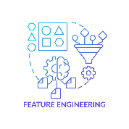Feature Engineering >** **Model Development >  Model Evaluation >**

** Model Deployment**

1. **Data Collection**: Gather loan data from various sources such as databases, APIs, and files.
2. **Data Preprocessing**: Cleanse, transform, and prepare the dataset for analysis by handling missing values, outliers, and data inconsistencies.
3. **Exploratory Data Analysis (EDA)**: Explore the dataset to understand its characteristics, patterns, and relationships.
4. **Feature Engineering**: Extract and create relevant features from the dataset to enhance predictive modeling.
5. **Model Development**: Build and train machine learning models using algorithms like logistic regression, decision trees, and XGBoost for loan default prediction.
6. **Model Evaluation**: Assess the performance of the models using evaluation metrics like accuracy, precision, recall, and F1-score.
7. **Model Deployment**: Deploy the best-performing model into production for real-time predictions on new loan data.

**CHAPTER 4 (code)**

**MODELING AND PROJECT OUTCOME**

Asking chat GPT which is a AI tool to provide the project plan

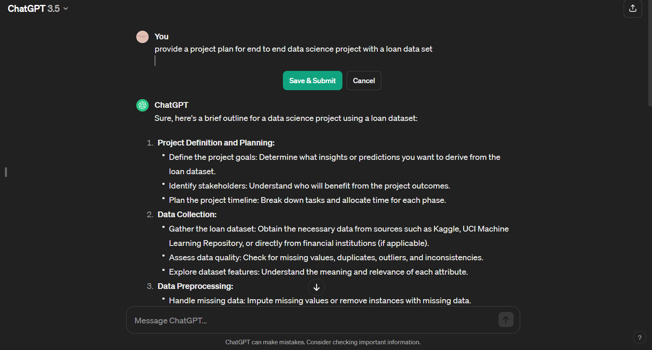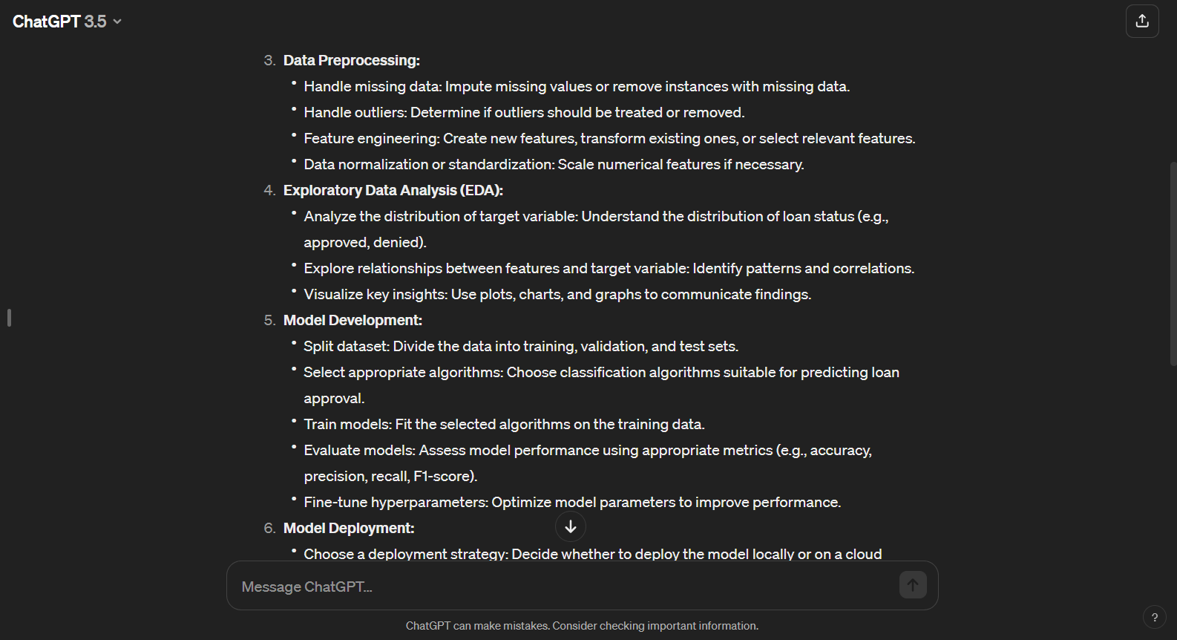

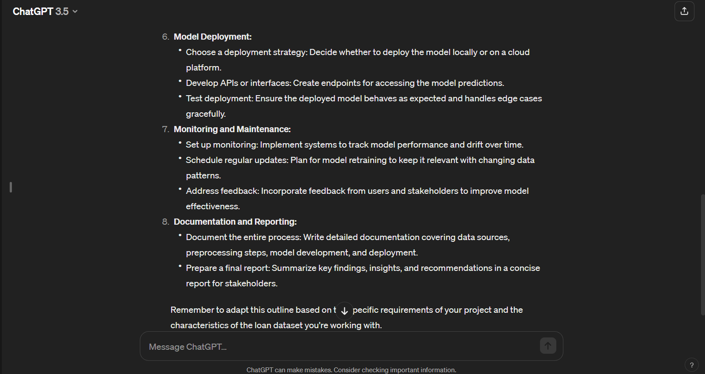

The asked the ChatGPT “to provide the necessary codes for the project. The codes are implemented and the output is received.

Code:

1. Data Collection
2. Data Preprocessing
3. Exploratory Data Analysis (EDA)

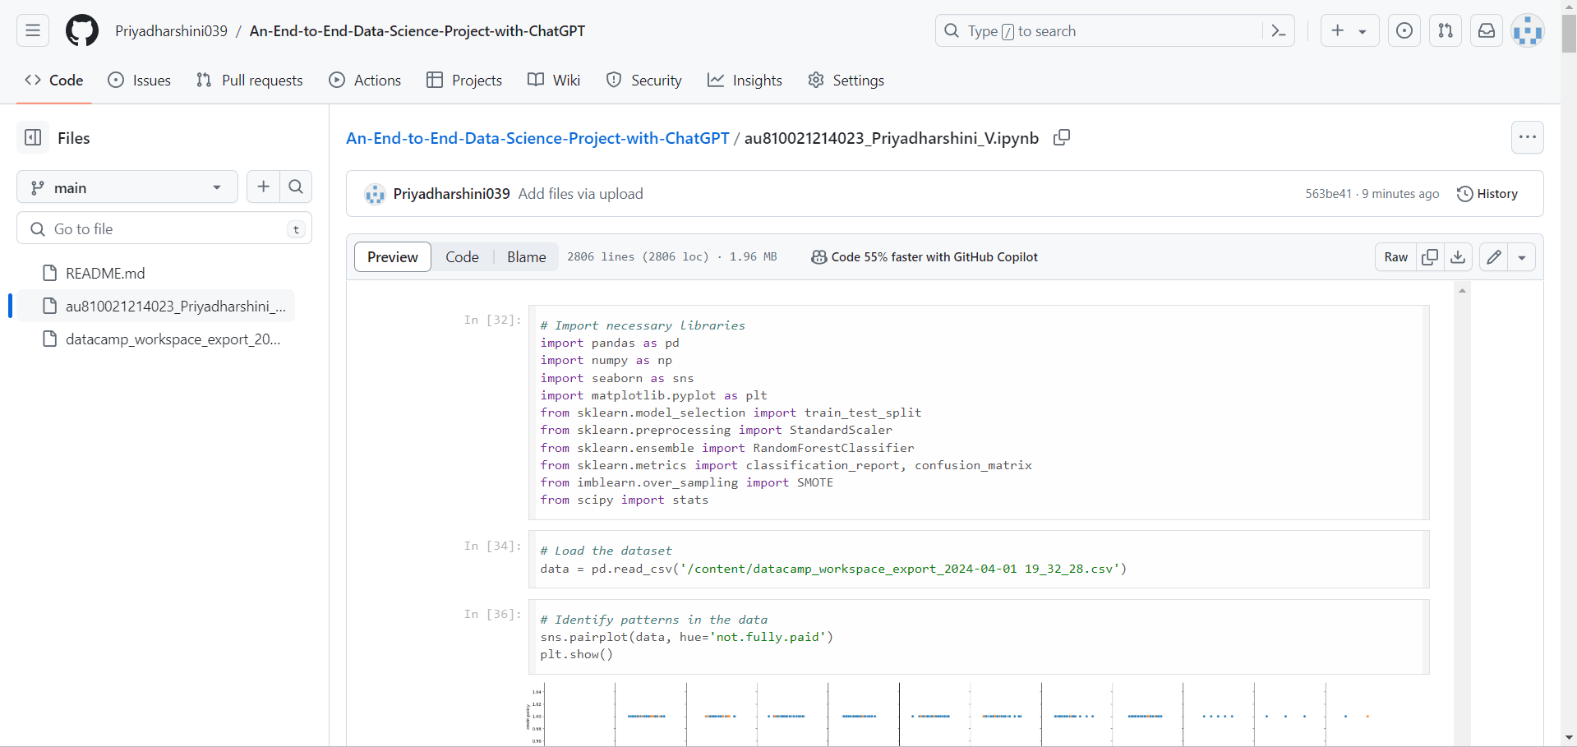

Output:

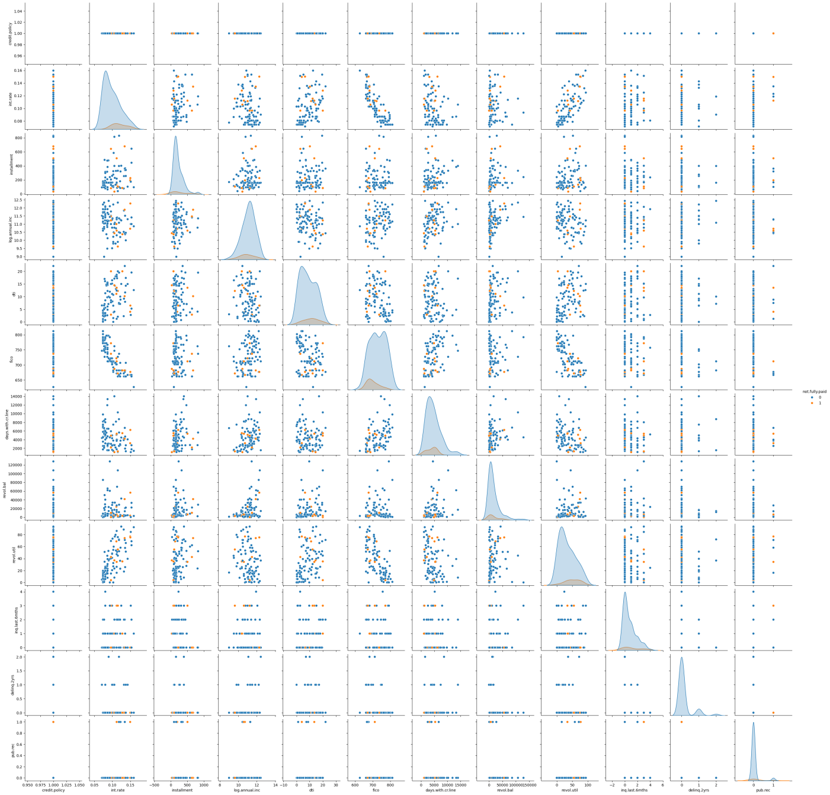

The codes and the output are screenshotted

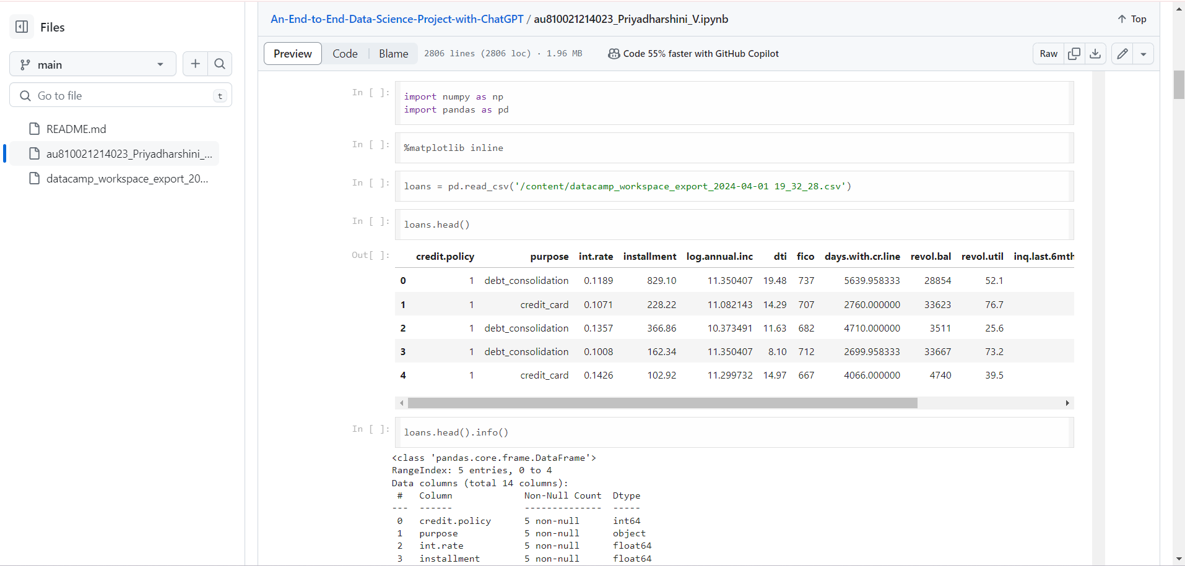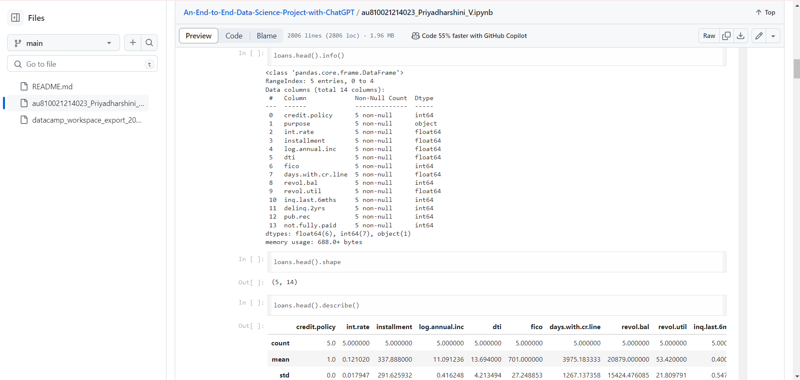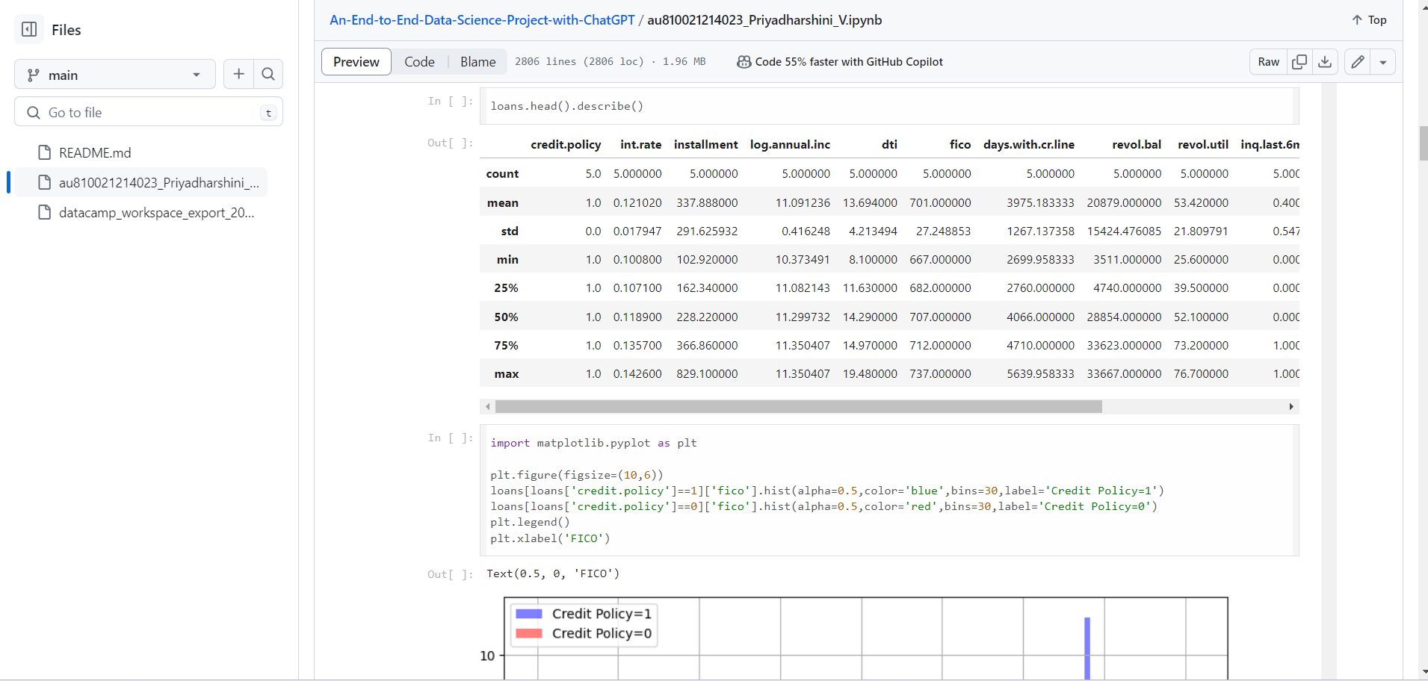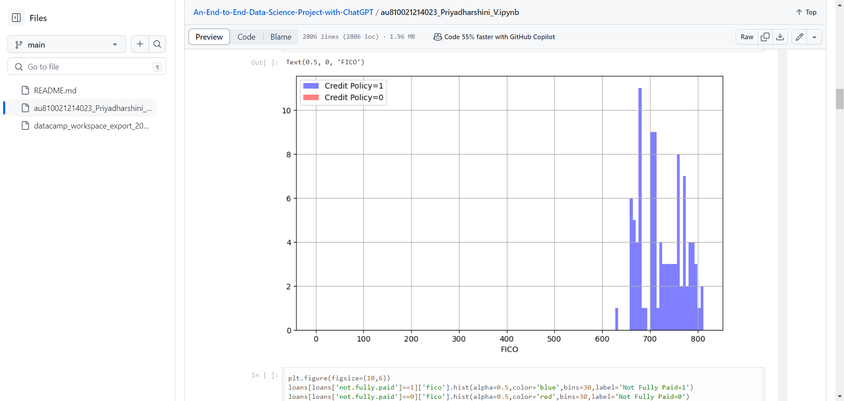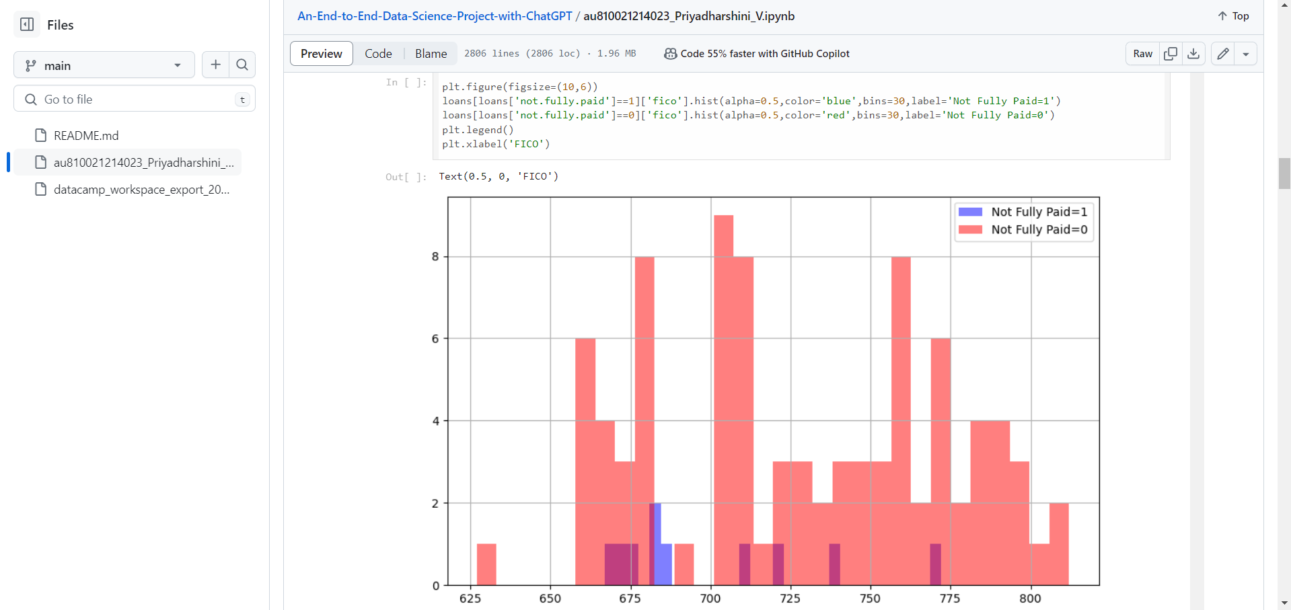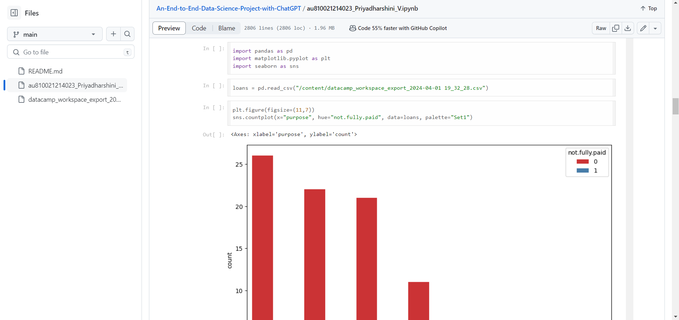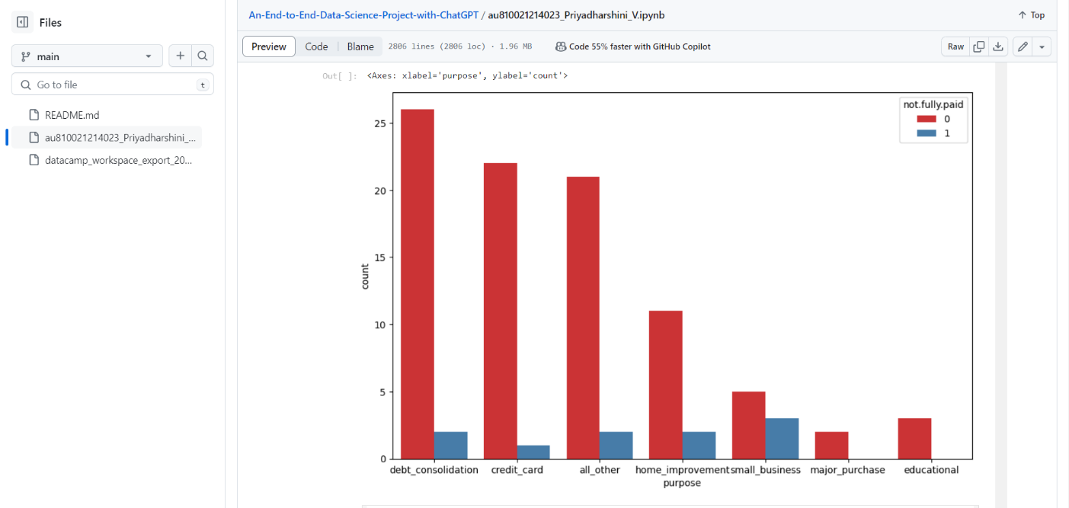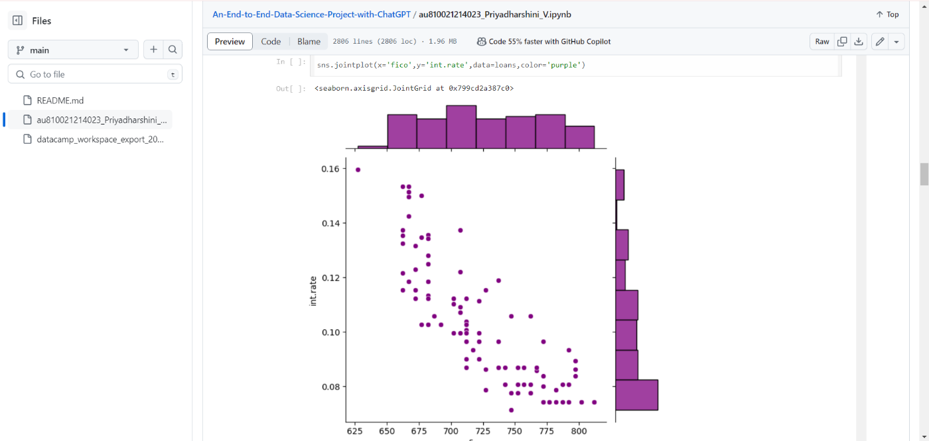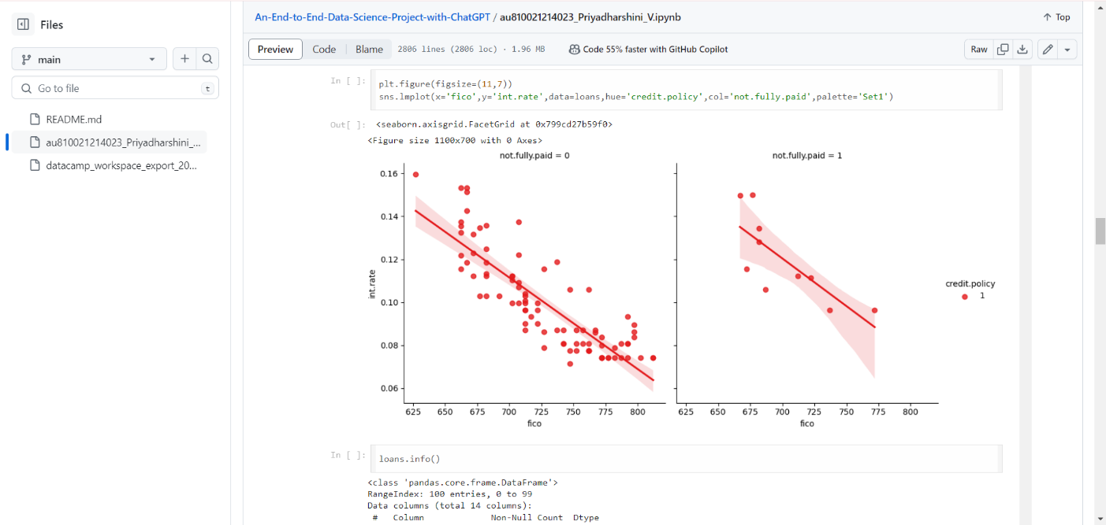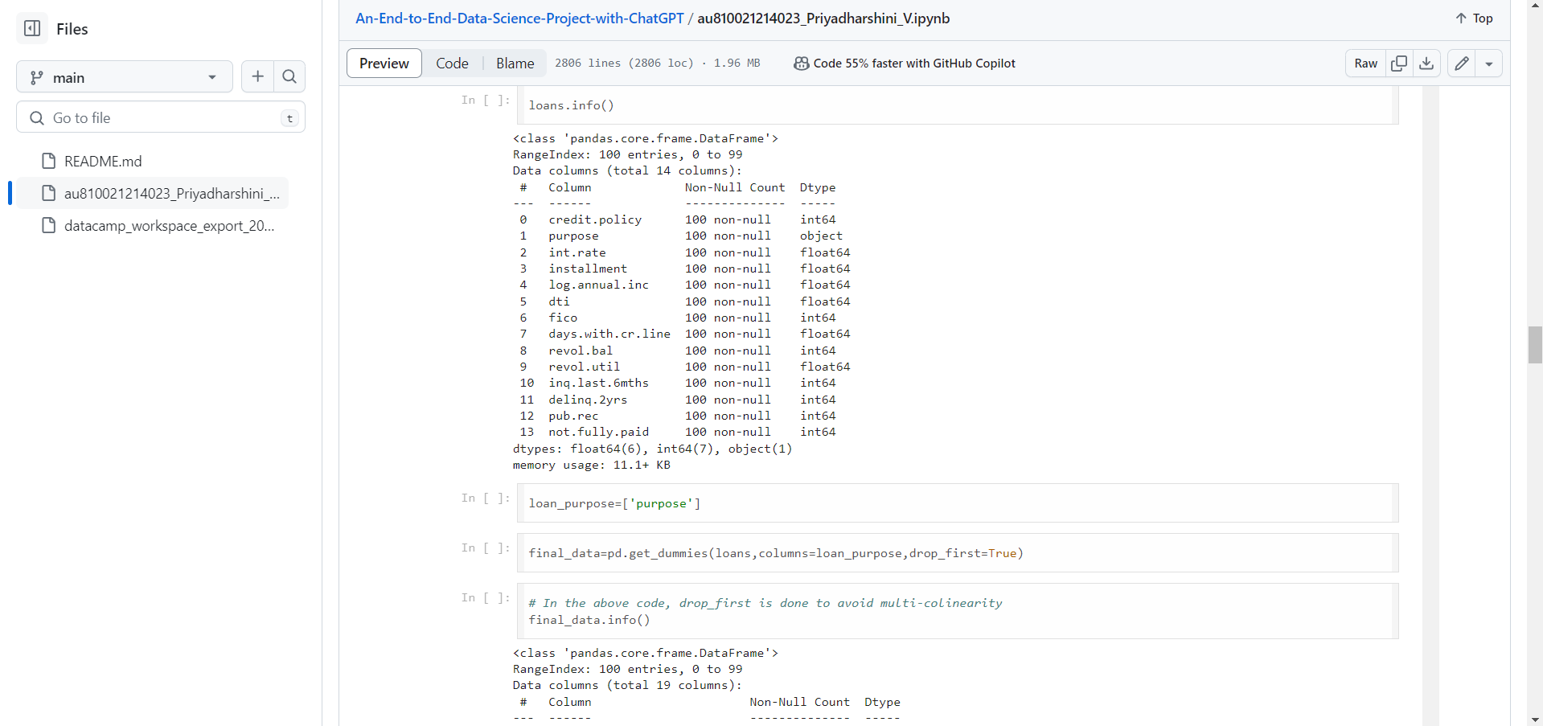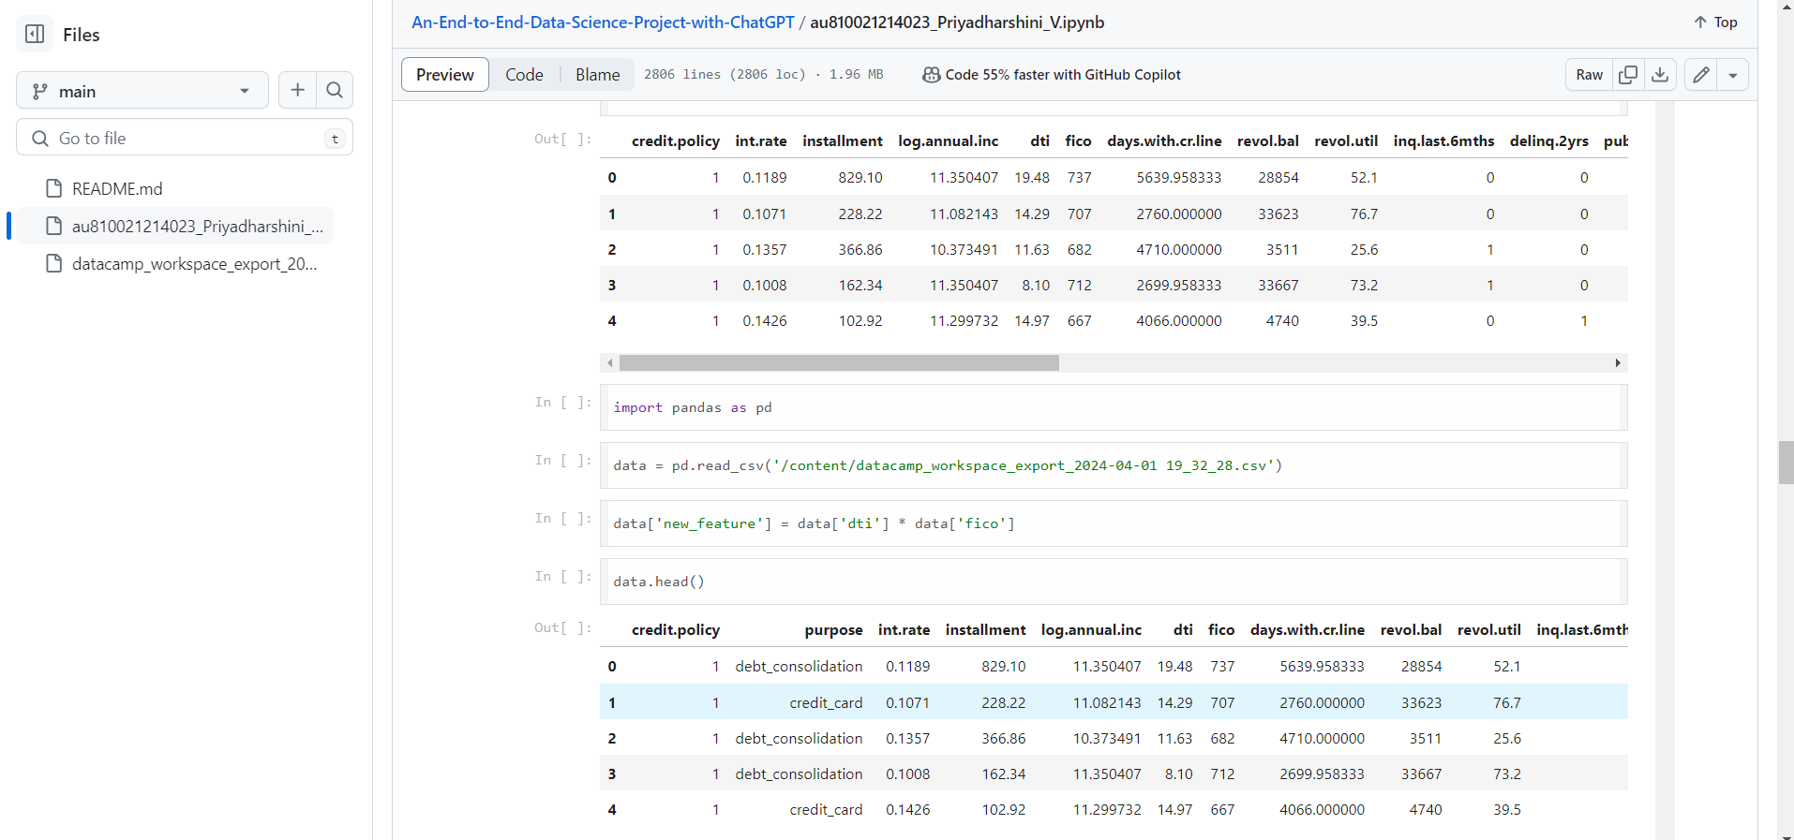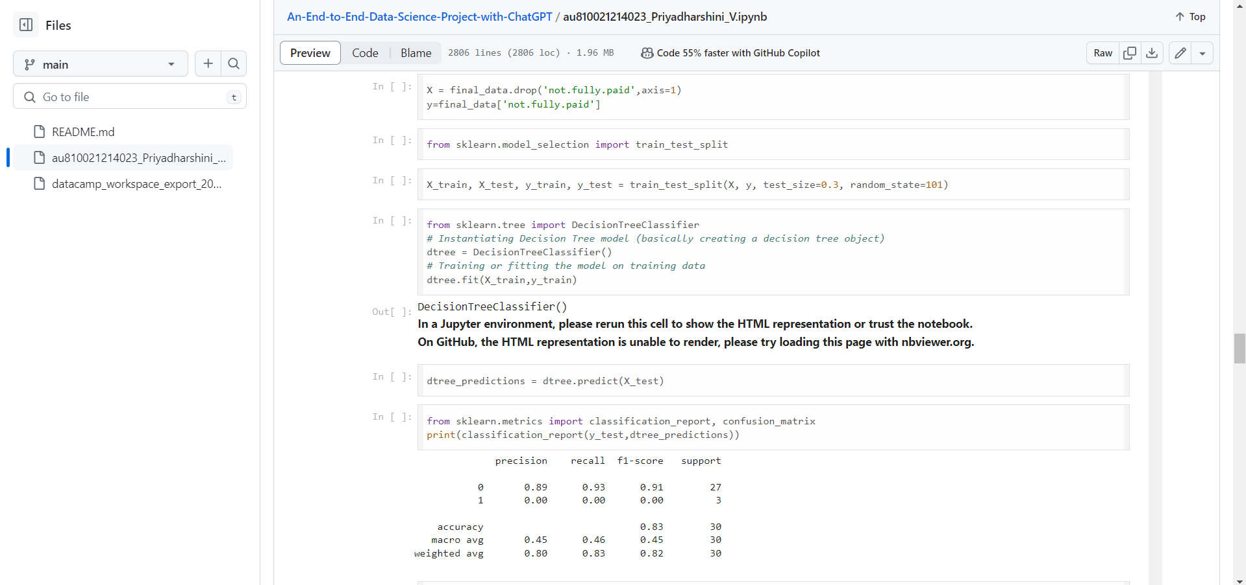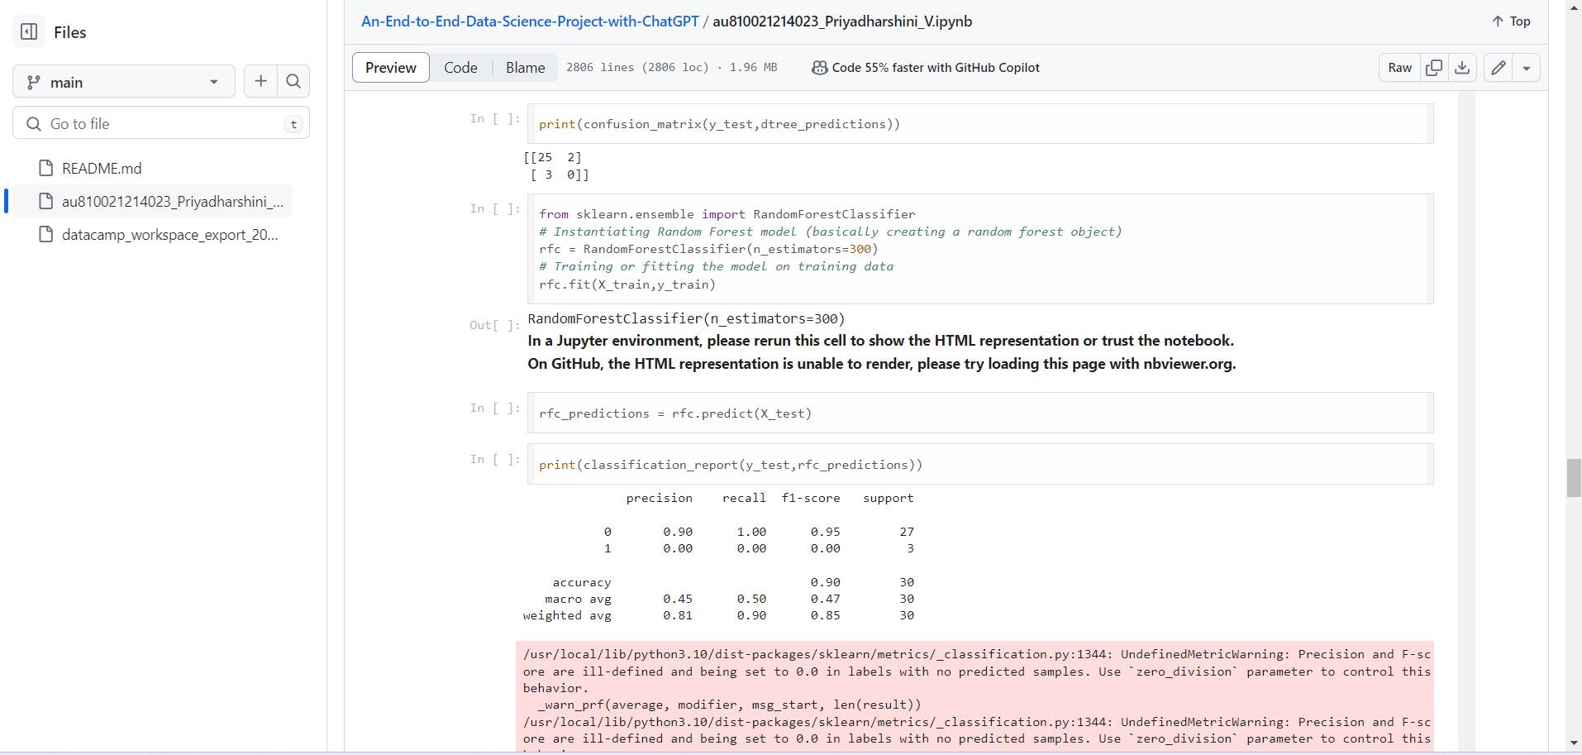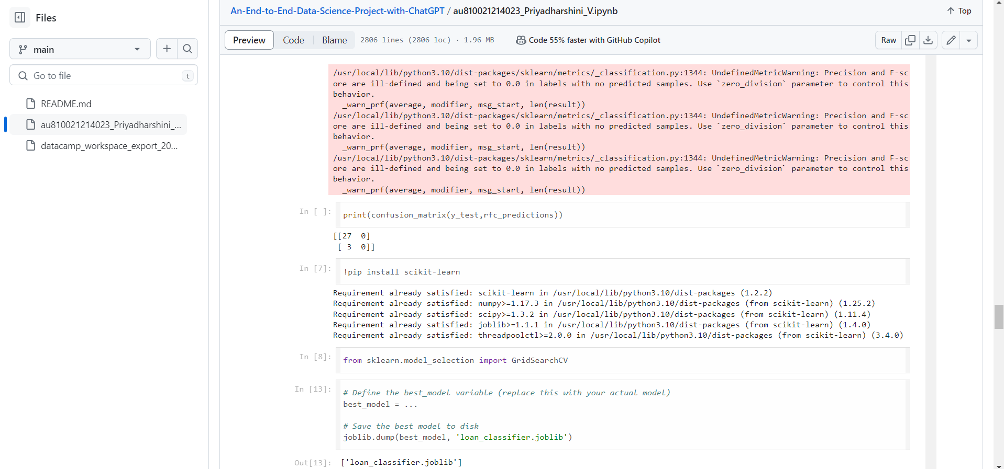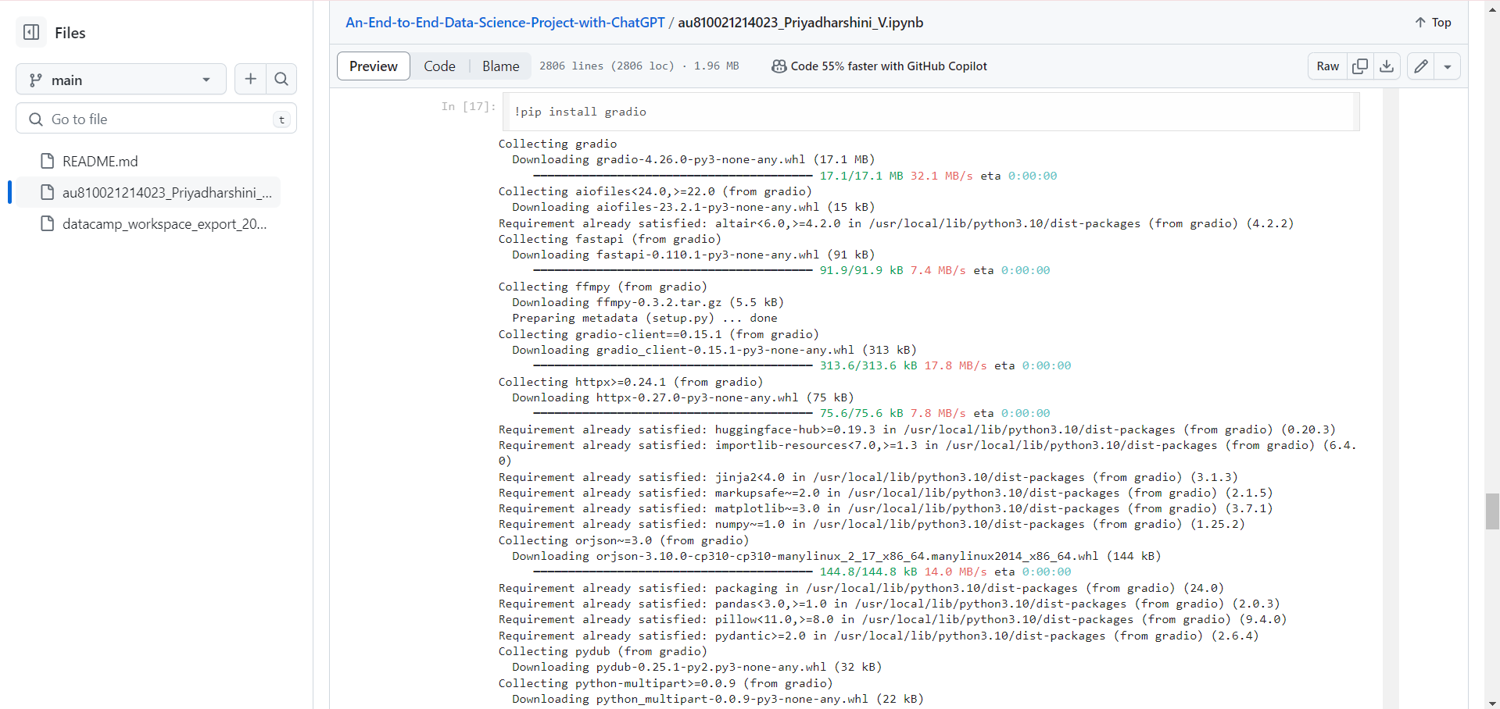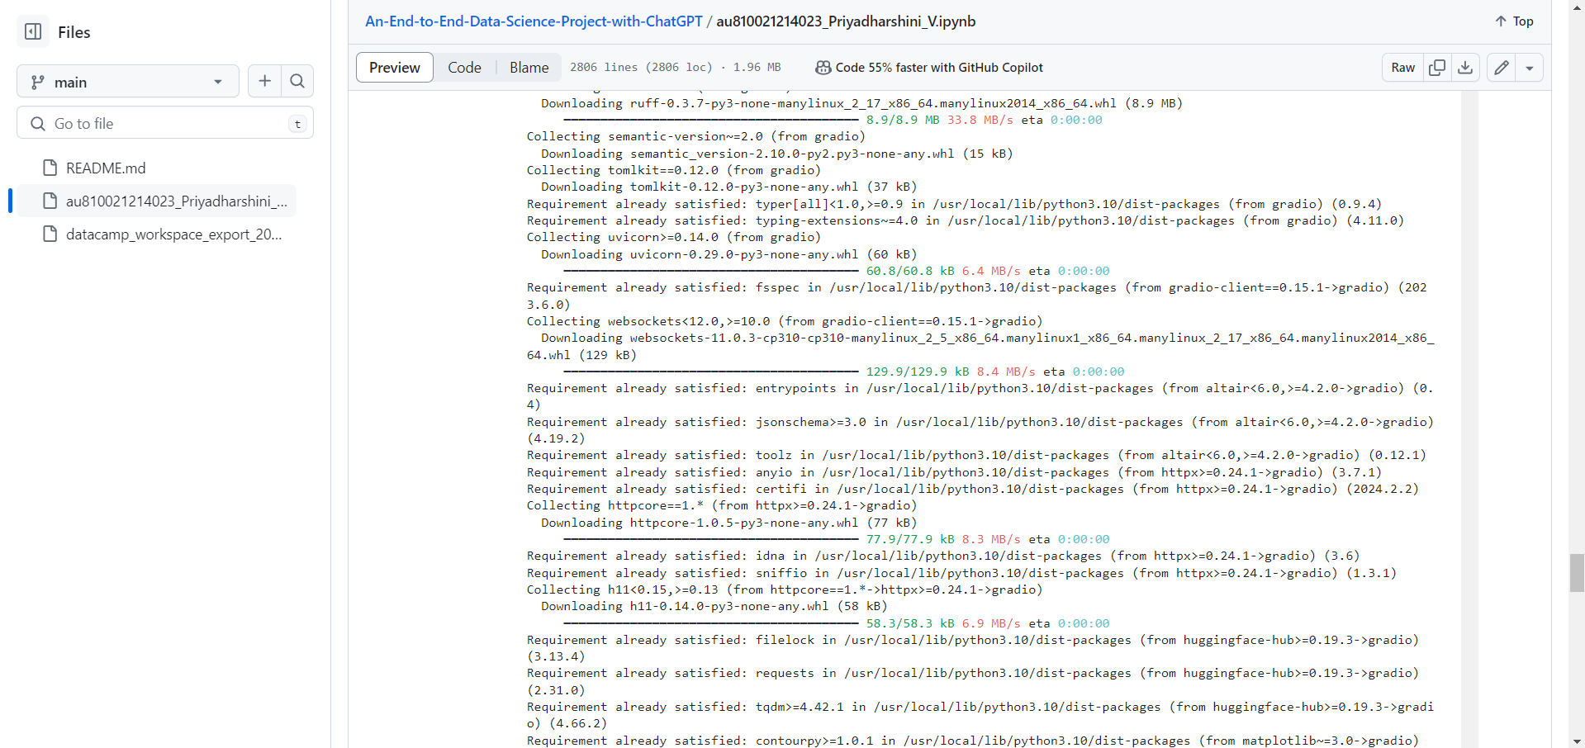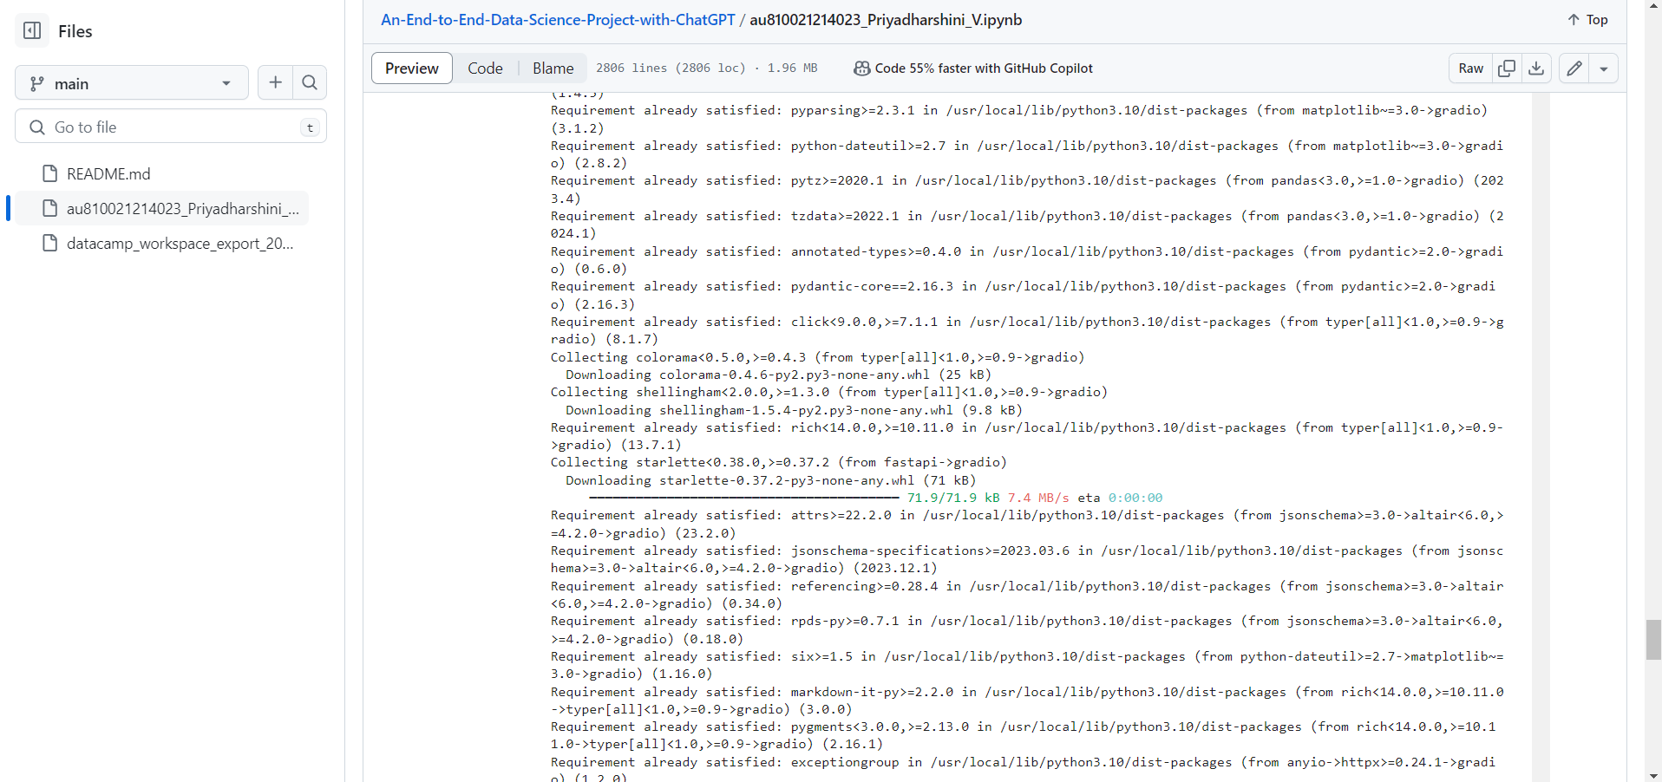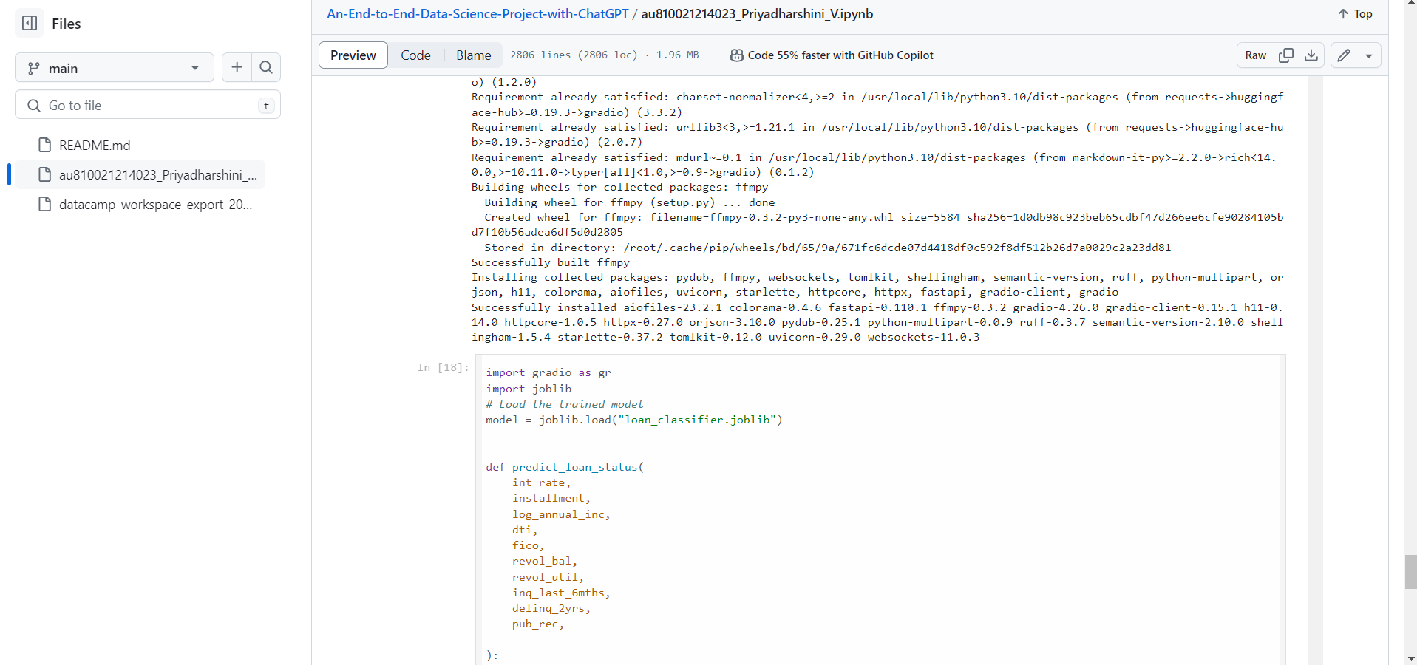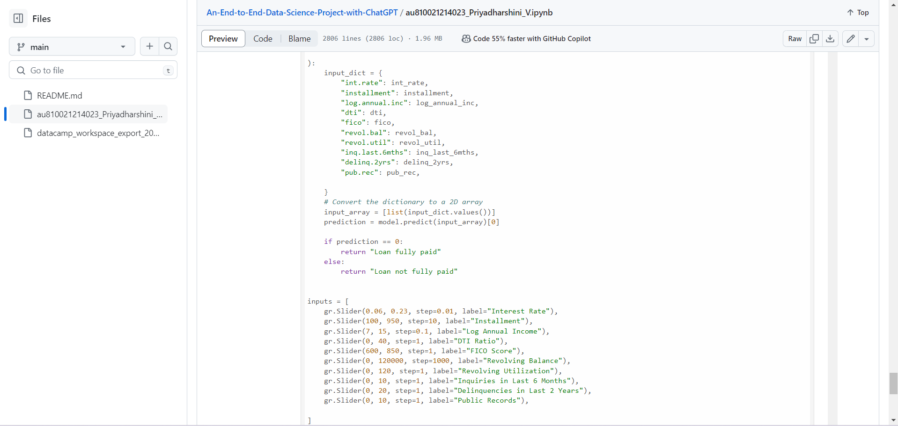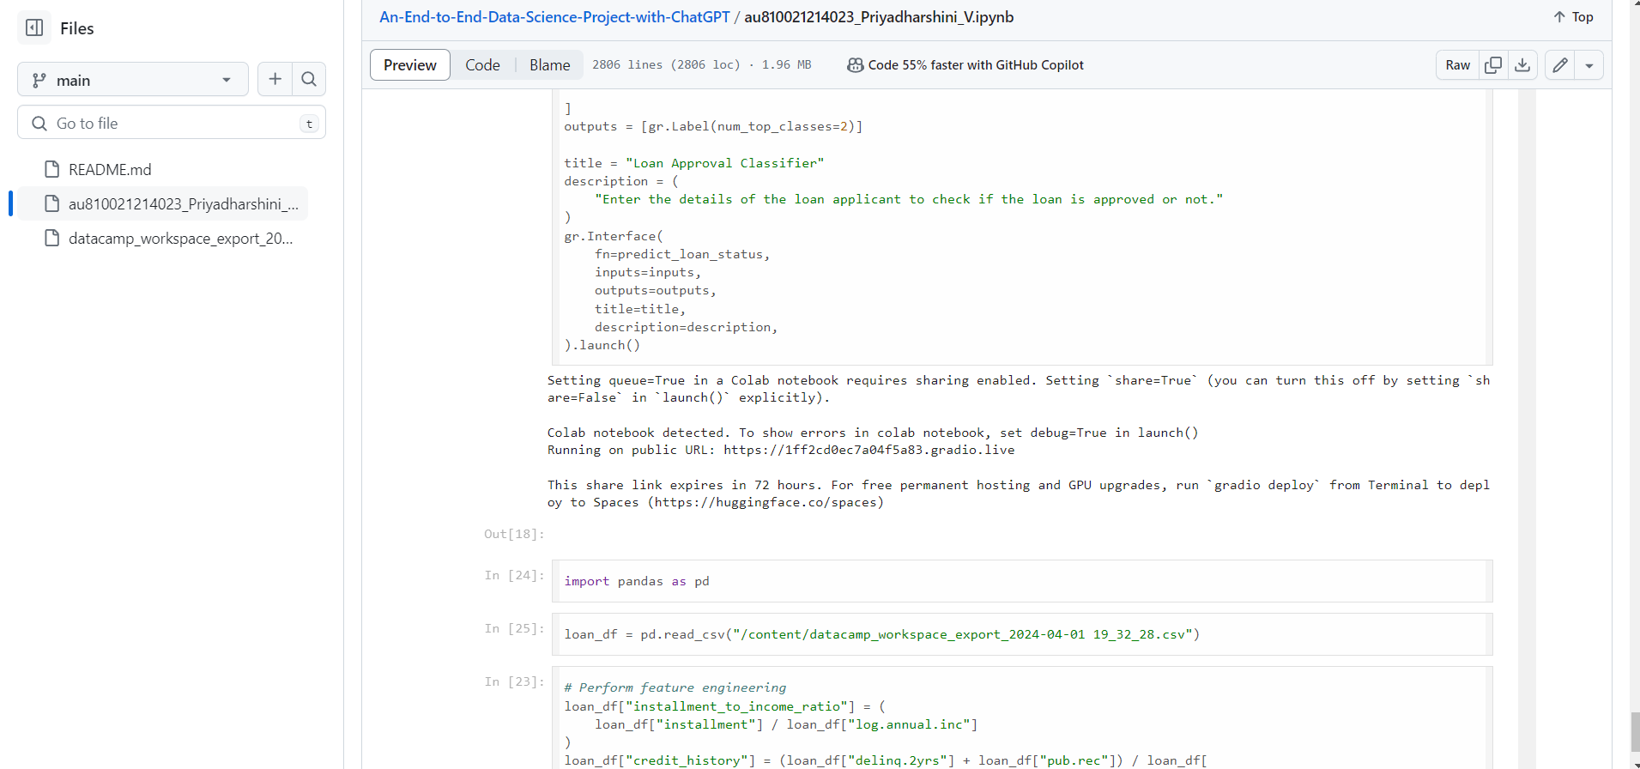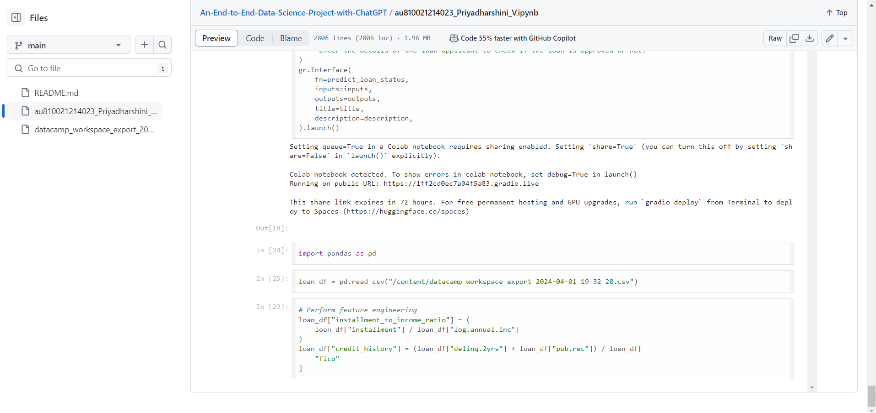

**APP INTERFERENCE/ PROJECT RESULT**

The end-to-end data science project resulted in the creation of an interactive chatbot that provides personalized loan eligibility predictions based on user input. Users can easily access this service through various messaging platforms, making it convenient and user-friendly. The integration of ChatGPT enhances the user experience by providing a conversational interface, making the process intuitive and accessible to a wider audience. Overall, the project demonstrates the potential of combining machine learning with natural language processing for practical applications like financial services.

**CONCLUSION**

In conclusion, the utilization of ChatGPT in an end-to-end data project for a loan dataset presents a resilient approach to augmenting client involvement and service effectiveness inside the lending sector. This project provides quick support and guidance during the loan application process by utilizing natural language processing capabilities to facilitate smooth communication between users and the loan application system. This project guarantees the provision of precise and pertinent answers to user inquiries by means of rigorous data preprocessing, model training, integration, and deployment; this, in turn, promotes a smooth and user-friendly experience. This system is able to adapt and respond to changing user needs because of ongoing monitoring and upgrades, which maximizes its efficacy in helping borrowers and streamlines loan administration procedures.

**FUTURE SCOPE**

Looking ahead, the future scope for an end-to-end data project utilizing ChatGPT for a loan dataset is promising and multifaceted. Advancements in natural language processing and machine learning techniques will enable the development of even more sophisticated and personalized loan application systems. Integration of additional data sources, such as social media profiles or financial transaction history, could enrich the model's understanding of borrower preferences and risk profiles, leading to more accurate loan decisions. Furthermore, incorporating voice recognition capabilities could enhance user accessibility and convenience, catering to a broader range of users. Collaboration with financial institutions and regulatory bodies may foster the adoption of standardized processes and compliance measures within the system, ensuring trust and reliability. Ultimately, the future holds immense potential for leveraging ChatGPT in loan management, driving innovation, and improving financial inclusion for individuals and businesses alike.

**REFERENCES**

1. Project Github link, Ramar Bose , 2024
2. Project video recorded link (youtube/github), Ramar Bose , 2024
3. Project PPT & Report github link, Ramar Bose , 2024

# **GIT Hub Link of Project Code:**

<https://github.com/Priyadharshini039/An-End-to-End-Data-Science-Project-with-ChatGPT/blob/main/au810021214023_Priyadharshini_V.ipynb>

**YOUTUBE LINK:**

<https://youtu.be/JYWCdBlfXWM?si=VSJ_MwFxI-HOJDEz>

**PPT LINK:**

[au810021214023_Priyadharshini_V.pptx](https://1drv.ms/p/s!AjJqLdVBMvdUgQc4OeuuPA_GDq3O?e=OVOL8Y)