**EXERCISE 1: IMPLEMENTING THE SINGLETON PATTERN**

**Singleton class:** class named logger

public class Logger {

private static Logger instance;

private Logger() {

System.out.println("Logger Initialized.");

}

public static Logger getInstance() {

if (instance == null) {

instance = new Logger();

}

return instance;

}

public void log(String message) {

System.out.println("LOG: " + message);

}

}

**Testing:**

public class Main {

public static void main(String[] args) {

Logger logger1 = Logger.getInstance();

logger1.log("This is the first log message.");

Logger logger2 = Logger.getInstance();

logger2.log("This is the second log message.");

if (logger1 == logger2) {

System.out.println("Both logger instances are the same (Singleton works).");

} else {

System.out.println("Different instances (Singleton failed).");

}

}

}

**Output:**

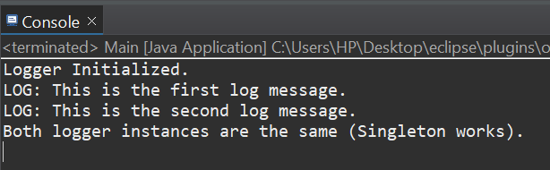

**EXERCISE 2: IMPLEMENTING THE FACTORY METHOD PATTERN**

**Document interface:**

public interface Document {

void open();

}

**Concrete document classes:**

public class WordDocument implements Document {

public void open() {

System.out.println("Opening Word document...");

}

}

public class PdfDocument implements Document {

public void open() {

System.out.println("Opening PDF document...");

}

}

public class ExcelDocument implements Document {

public void open() {

System.out.println("Opening Excel document...");

}

}

**Factory method:**

public abstract class DocumentFactory {

public abstract Document createDocument();

}

**Concrete factories:**

public class WordDocumentFactory extends DocumentFactory {

public Document createDocument() {

return new WordDocument();

}

}

public class PdfDocumentFactory extends DocumentFactory {

public Document createDocument() {

return new PdfDocument();

}

}

public class ExcelDocumentFactory extends DocumentFactory {

public Document createDocument() {

return new ExcelDocument();

}

}

**Testing factory method implementation:**

public class FactoryPatternTest {

public static void main(String[] args) {

DocumentFactory wordFactory = new WordDocumentFactory();

Document wordDoc = wordFactory.createDocument();

wordDoc.open();

DocumentFactory pdfFactory = new PdfDocumentFactory();

Document pdfDoc = pdfFactory.createDocument();

pdfDoc.open();

DocumentFactory excelFactory = new ExcelDocumentFactory();

Document excelDoc = excelFactory.createDocument();

excelDoc.open();

}

}

**Output:**

