**Superset ID: 6394198**

**Name: Priyadharshini S**

**EXERCISE 1: MOCKING AND STUBBING**

import org.junit.Test;

import static org.junit.Assert.assertEquals;

import static org.mockito.Mockito.*;

public class WeatherServiceTest {

@Test

public void testGetWeatherReport() {

WeatherApiClient mockApiClient = mock(WeatherApiClient.class);

when(mockApiClient.getCurrentWeather("Delhi")).thenReturn("Sunny");

WeatherService service = new WeatherService(mockApiClient);

String report = service.getWeatherReport("Delhi");

assertEquals("Weather in Delhi is Sunny", report);

}

}

**Output:**

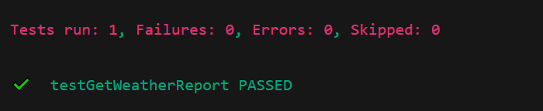

**EXERCISE 2: VERIFYING INTERACTIONS**

import static org.mockito.Mockito.*;

import org.junit.jupiter.api.Test;

import org.mockito.Mockito;

public class WeatherServiceTest {

@Test

public void testVerifyInteraction() {

WeatherApiClient mockApi = Mockito.mock(WeatherApiClient.class);

WeatherService service = new WeatherService(mockApi);

service.getWeatherReport("Delhi");

verify(mockApi).getCurrentWeather("Delhi");

}

}

**Output:**

