**SPOT EX-LAB02**

2019103562

P.PRIYADHARSHINI

01-03-2021

*SHELL SCRIPTING AND FILTERS AND STREAM EDITORS*

1.a

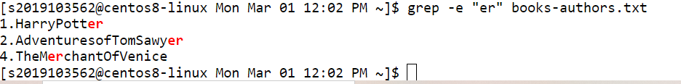

1.b



2.

