Terraform
Task 01
CREATE A NETWORK
1. CREATE A VPC AND ADD 2 SUBNETS NAMES SUBNET-A SUBNET-B
2. CREATE SERVERS ON EACH SUBNETS
3. ADD PREVENT DESTROY AND IGNORE CHANGES BOTH
4. MODIFY THINGS IN CLOUD AND CHECK DRIFT

Desired state
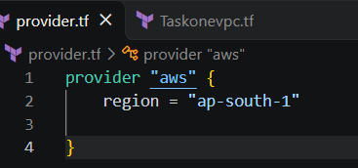
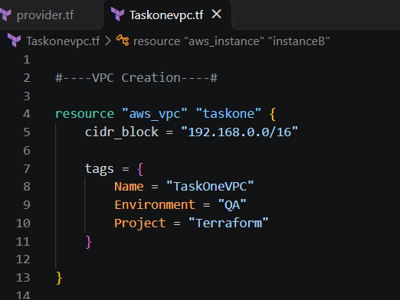
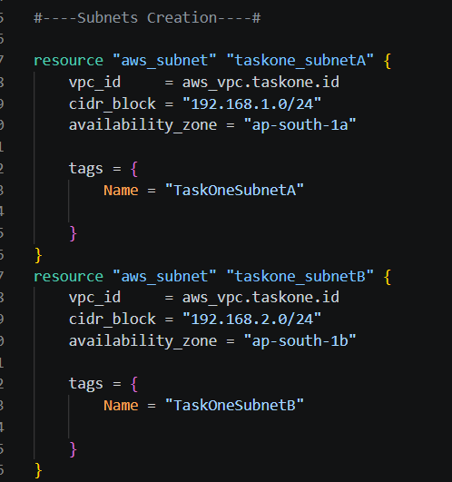
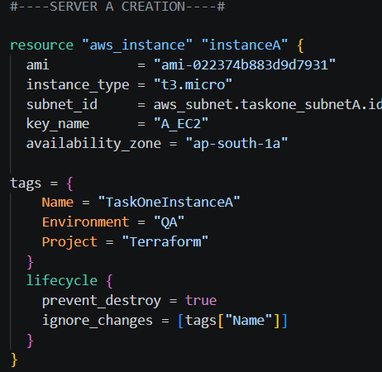
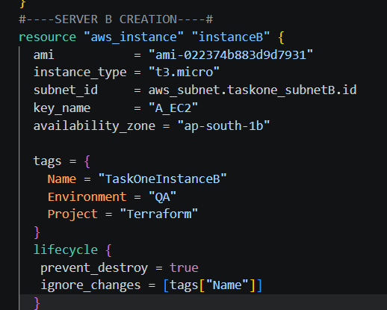
Commands performed
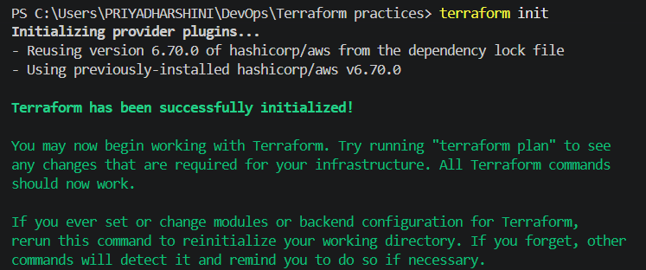
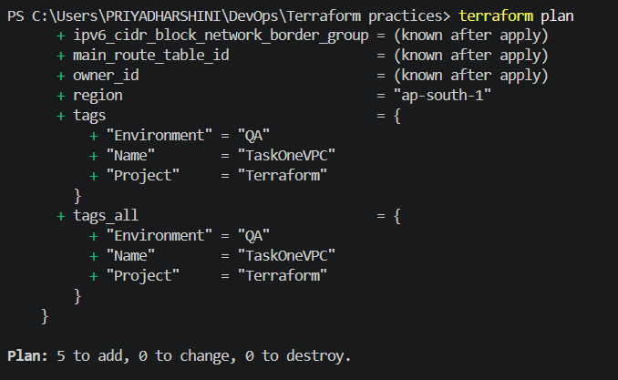
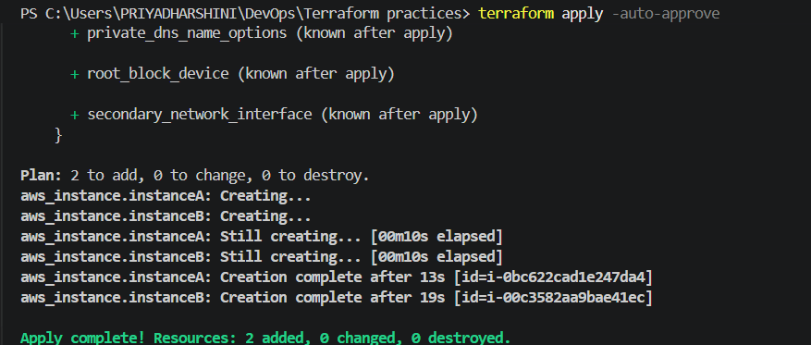
Since lifecycle prevent_destroy =true, we cant delete any resources
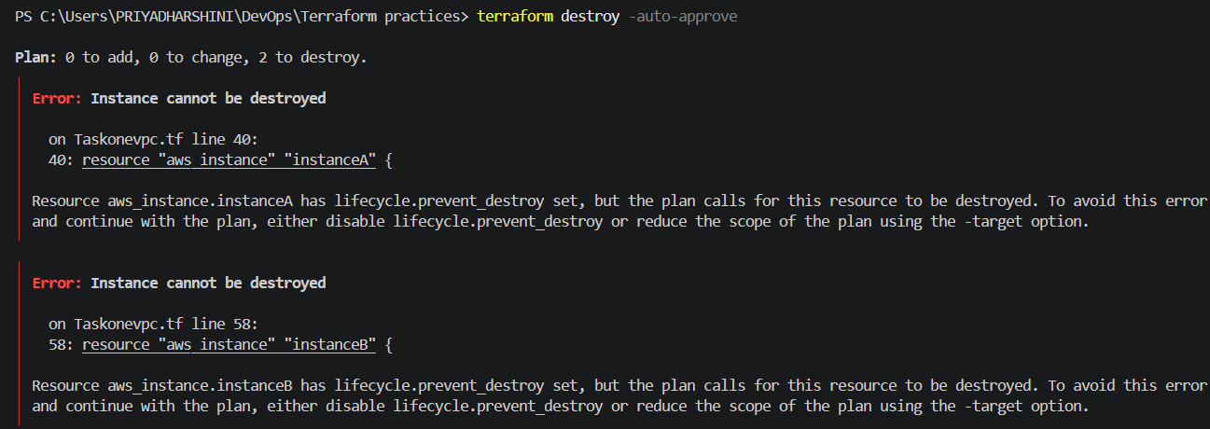
Current state in AWS
EC2 SERVER IS CREATED
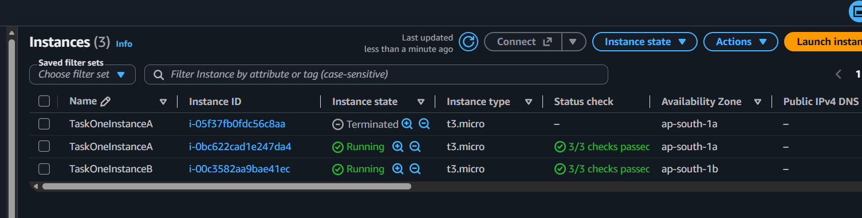

VPC IS CREATED
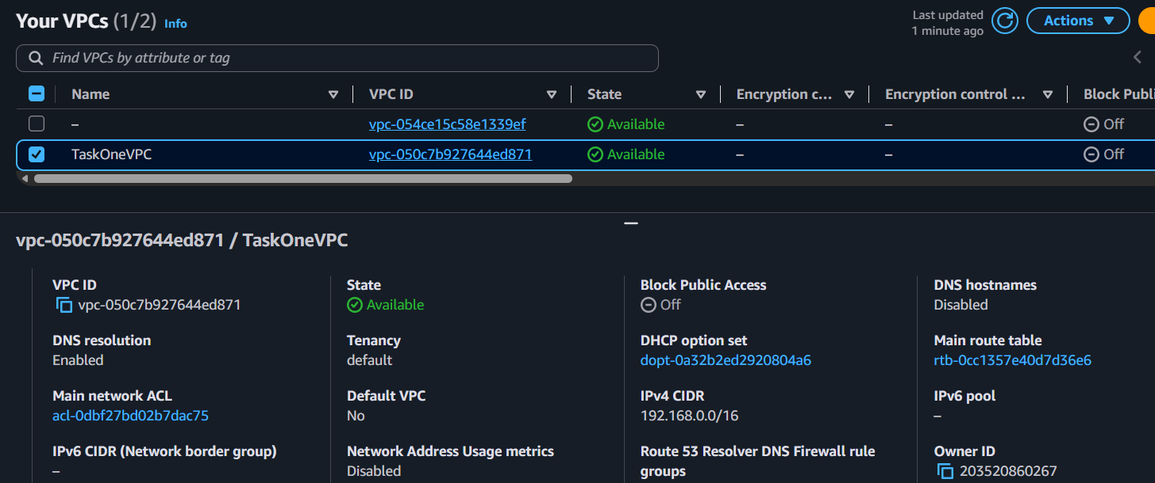
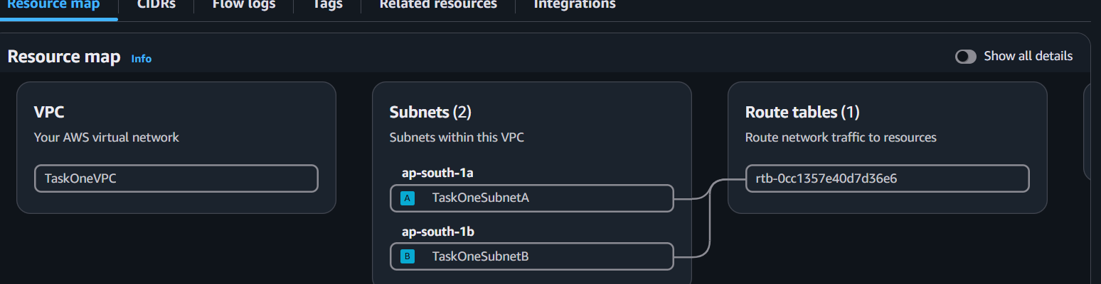
After name modification is done in the cloud manually, Drift checks
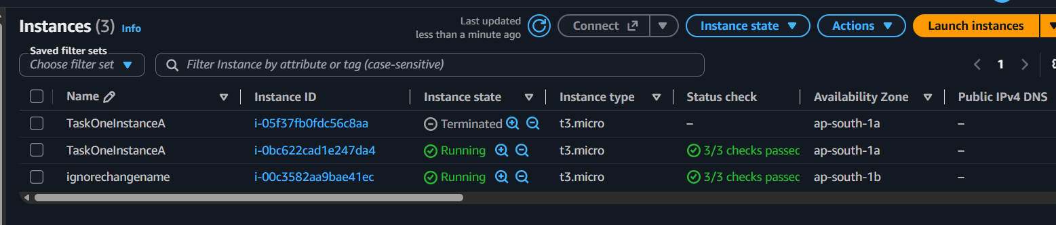
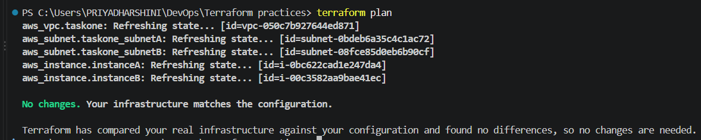

Terraform code
#----VPC Creation----#

resource "aws_vpc" "taskone" {
cidr_block = "192.168.0.0/16"

tags = {
Name = "TaskOneVPC"
Environment = "QA"
Project = "Terraform"
}

}

#----Subnets Creation----#

resource "aws_subnet" "taskone_subnetA" {
vpc_id = aws_vpc.taskone.id
cidr_block = "192.168.1.0/24"
availability_zone = "ap-south-1a"

tags = {
Name = "TaskOneSubnetA"

}
}
resource "aws_subnet" "taskone_subnetB" {
vpc_id = aws_vpc.taskone.id
cidr_block = "192.168.2.0/24"
availability_zone = "ap-south-1b"

tags = {
Name = "TaskOneSubnetB"

}
}

#----SERVER A CREATION----#

resource "aws_instance" "instanceA" {
ami = "ami-022374b883d9d7931"
instance_type = "t3.micro"
subnet_id = aws_subnet.taskone_subnetA.id
key_name = "A_EC2"
availability_zone = "ap-south-1a"

tags = {
Name = "TaskOneInstanceA"
Environment = "QA"
Project = "Terraform"
}
lifecycle {
prevent_destroy = true
ignore_changes = [tags["Name"]]
}
}
#----SERVER B CREATION----#
resource "aws_instance" "instanceB" {
ami = "ami-022374b883d9d7931"
instance_type = "t3.micro"
subnet_id = aws_subnet.taskone_subnetB.id
key_name = "A_EC2"
availability_zone = "ap-south-1b"

tags = {
Name = "TaskOneInstanceB"
Environment = "QA"
Project = "Terraform"
}
lifecycle {
prevent_destroy = true
ignore_changes = [tags["Name"]]
}
}

