**Technical assessment**

Priyadharshini. M

18bcs035

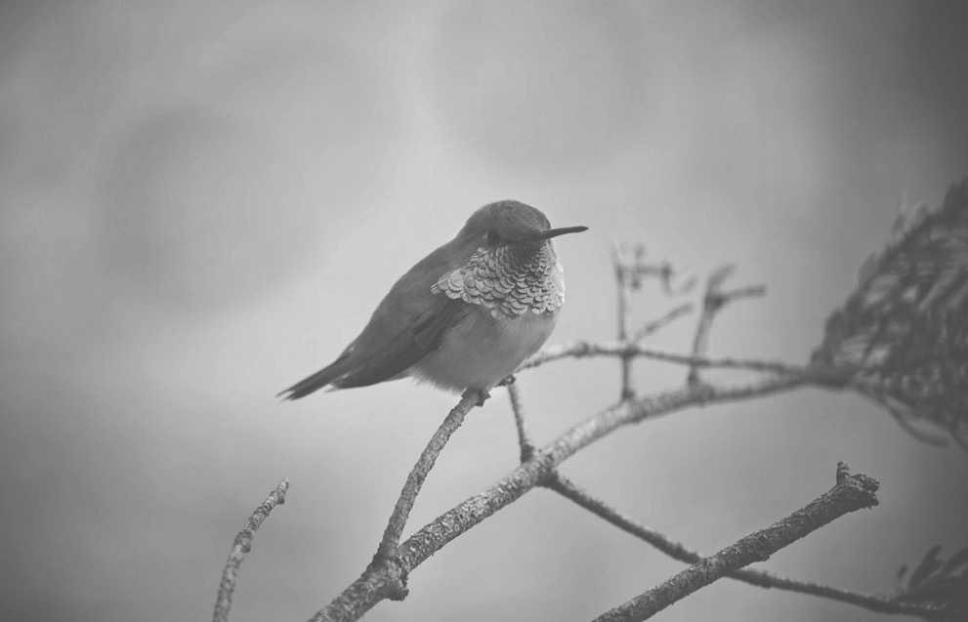Input