

REACT JS PROJECT REPORT ON

COMMENT AND REPLY THREAD SYSTEM – MERN STACK

Submitted by
S R PRIYADHARSHINI
24BIT136

Under the Guidance of
ARAVIND
Technical Trainer
Technical Department, KG College of Arts and Science

Academic Year: 2025 – 2026
APRIL 2026

DECLARATION
I hereby declare that the project entitled “CO-MENTS” submitted in partial fulfillment of the requirements for the course B.Sc INFORMATION TECHNOLOGY is a record of my original work carried out under the guidance of ARAVIND, Technical Trainer, Technical Department, KG College of Arts and Science.
I further declare that this project has not been submitted previously, either in part or in full, for the award of any degree, diploma, or other similar title, at this or any other institution.
I have acknowledged all sources of information used in this project wherever applicable.

April 2026
Coimbatore

________________________
S R PRIYADHARSHINI

CERTIFICATE
This is to certify that the project entitled “CO-MENTS” is a bona fide work carried out by S R PRIYADHARSHINI ,2 nd YEAR , B.Sc-INFORMATION TECHNOLOGY, KG College of Arts & Science, in partial fulfillment of the requirements for the course B.SC IT.
This project has been completed under my supervision and guidance during the academic period April 2026.

Place:
Date:09/04/20026

Submitted for the Viva-Voce Examination held on _____09/04/2026_____________________________

Guide: Head of the Department
(Technical Trainer, KGCAS) (Technical Head, KGCAS)
______________________ _______________________

TABLE OF CONTENTS
S. No. | Topics | Page. No.
1 | Introduction
1.1 | Background of the Study
1.2 | Problem Statement
1.3 | Objectives of the Project
1.4 | Purpose and Significance
1.5 | Scope and Limitations
1.6 | Methodology Overview
2 | System Analysis
2.1 | Existing System
2.2 | Drawbacks of the Existing System
2.3 | Proposed System
2.4 | Features of the Proposed System
2.5 | Feasibility Study
2.6 | Requirement Analysis
3 | System Design
3.1 | System Architecture
3.2 | Use Case Diagram
3.3 | Data Flow Diagram (DFD)
3.4 | Entity Relationship Diagram (ERD)
3.5 | User Interface Design
4 | System Implementation
4.1 | Development Tools
4.2 | Module Description
4.3 | Algorithms
4.4 | System Integration
4.5 | Security and Validation
5 | System Testing
5.1 | Testing Methodology
5.2 | Test Cases
5.3 | Error Handling
5.4 | Performance
6 | Input and Output Screens
6.1 | System Outputs
6.2 | Discussion
6.3 | Comparison
6.4 | User Feedback
7 | Conclusion and Future Enhancement
7.1 | Summary
7.2 | Limitations
7.3 | Future Scope
8 | References
Appendices
- Source Code Snippets
- Screenshots of Web Pages

ABSTRACT

CO-MENTS is a comprehensive full-stack web application designed to deliver a structured and real-time comment discussion platform. The system empowers users to register, authenticate securely, post original comments, reply to existing threads, and engage through likes and dislikes. Built using cutting-edge technologies including React for the dynamic frontend, Node.js and Express for the robust backend, MongoDB for efficient data management, and Socket.IO for seamless real-time communication, CO-MENTS offers a modern and scalable solution suitable for blogs, social platforms, educational forums, and collaborative environments.
The live deployment of the application is accessible at: https://co-ments-client.vercel.app/ (frontend hosted on Vercel, backend on Render, and database on MongoDB Atlas). This project showcases the effective integration of full-stack development principles to create an interactive and responsive user experience.

Chapter 1: Introduction
1.1 Background of the Study
In the modern digital era, communication platforms play a vital role in user interaction. Comment systems are an essential component of blogs, forums, and social applications. Traditional comment systems lack real-time updates and structured threading, leading to poor user experience. CO-MENTS addresses these gaps by providing threaded discussions, real-time updates, secure authentication, and scalable backend architecture using the MERN stack and Socket.IO.

1.2 Problem Statement
Traditional comment systems offer only static updates with no real-time interaction, poor thread structure, and limited scalability. Users face delays in seeing replies, and there is no seamless integration of likes, dislikes, or threaded replies.

1.3 Objectives of the Project
• To design a real-time comment system.
• To implement secure user authentication using JWT.
• To develop RESTful APIs for comment operations.
• To integrate MongoDB for persistent storage.
• To deploy the application on cloud platforms (Vercel + Render).
• To ensure real-time bidirectional communication via Socket.IO.

1.4 Purpose and Significance of the Study
The main purpose of this project is to enhance user engagement through an engaging, real-time comment platform. It helps users interact seamlessly while allowing moderators to track discussions easily. The system contributes to digital collaboration initiatives and promotes technology-enabled interactive environments.

1.5 Scope and Limitations
Scope:
Real-time threaded comments, likes/dislikes, JWT authentication, and responsive UI.
Limitations:
Current version focuses on core comment threading; advanced features like file uploads or notifications are planned for future releases.

1.6 Methodology Overview
The project follows a structured Software Development Life Cycle (SDLC) approach consisting of Requirement Analysis, Design, Development, Testing, and Implementation. The tools used include Visual Studio Code, React, Node.js, Express, MongoDB, and Socket.IO for creating a high-performance, real-time user experience.

Chapter 2: System Analysis

2.1 Existing System
In the existing comment systems, users rely on static page refreshes or basic comment sections that lack real-time interaction and structured threading.

2.2 Drawbacks of the Existing System
• Static comment updates with no real-time interaction.
• No proper threaded reply structure.
• Limited scalability and poor performance under concurrent users.
• Insecure or basic authentication without JWT.

2.3 Proposed System
The proposed CO-MENTS system provides a centralized, interactive platform where users can post comments, reply in threads, and receive real-time updates. The system uses React, Node.js, MongoDB, and Socket.IO to create a responsive, user-friendly interface. New comments and replies appear instantly across all connected users.

2.4 Features of the Proposed System
• Threaded discussions with nested replies.
• Real-time updates via Socket.IO.
• Secure authentication using JWT.
• Like and dislike reactions on comments.
• Responsive React UI.

2.5 Feasibility Study
Technical Feasibility:
- Uses open-source MERN stack and Socket.IO – fully supported and scalable.
Economic Feasibility:
- Minimal cost using free-tier cloud services (Vercel, Render, MongoDB Atlas).
Operational Feasibility:
- Intuitive UI requires no special training.

2.6 Requirement Analysis
Functional Requirements:
- User registration/login, post/reply to comments, like/dislike, real-time updates.
Non-Functional Requirements:
- High performance
- Secure data handling
- Cross-device responsiveness.

Chapter 3: System Design
3.1 Introduction
System design translates requirements into a blueprint for implementation, defining the overall architecture and data flow. For the CO-MENTS system, the design focuses on real-time interaction between users through threaded comments..

3.2 System Architecture
The system follows a three-tier architecture.
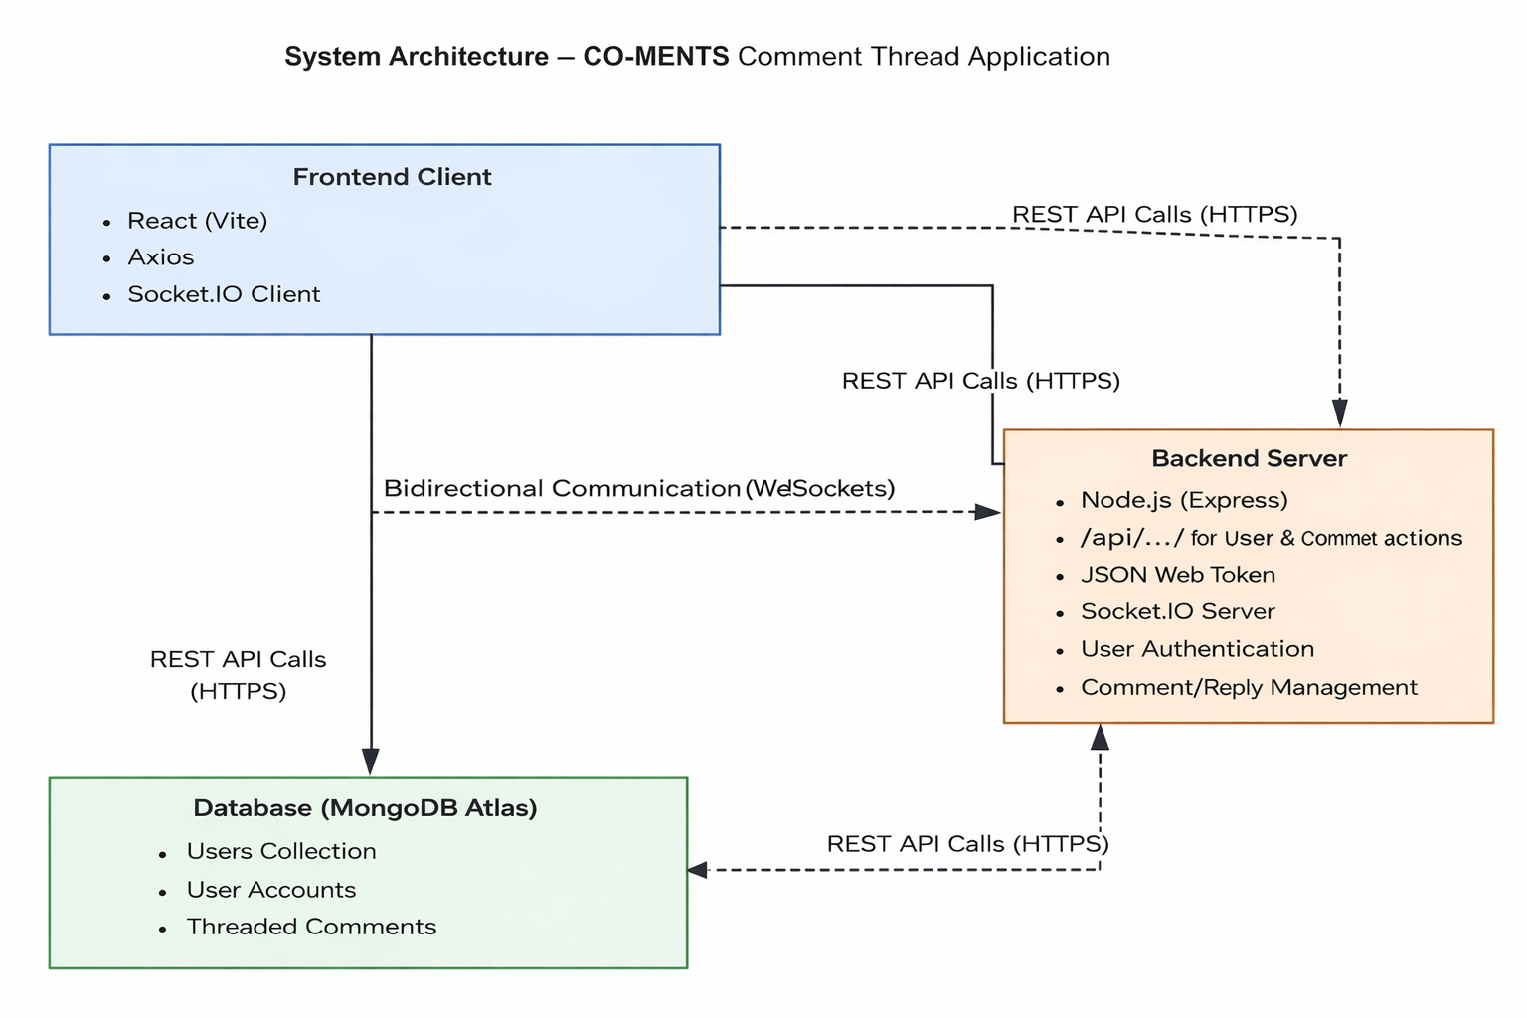

• Client Tier (Presentation Layer):

This layer is developed using React.js with Vite. It provides a rich Single Page Application (SPA) experience with efficient routing, state management, and interactive components. Users can register, login, post comments, reply to threads, and react with likes or dislikes through a modern and responsive interface.

• Edge / Delivery Tier:

This tier includes a CDN for fast delivery of static assets, an API Gateway or Load Balancer for routing requests, and an Authentication service using JWT (JSON Web Tokens). It ensures secure login, token validation, and proper handling of Cross-Origin Resource Sharing (CORS) policies.

• Application Data Tier (Backend + Database Layer):
- The Application Server is built with Node.js and Express.js, which processes all RESTful API requests and manages business logic.
- MongoDB serves as the primary NoSQL database for storing user profiles and threaded comments (including parent-child relationships for replies).
- Socket.IO is integrated to enable real-time bidirectional communication. When a user posts a comment or reply, the data is saved in MongoDB and instantly broadcasted to all connected clients, providing a truly real-time experience.

3.3 Use Case Diagram

Actors: User Main Use Cases: Register/Login, Post Comment, Reply to Comment, Like/Dislike Comment, View Threaded Comments.
It helps you explain “Who does what” in your system.

4. Data Flow Diagram (Structure Example)
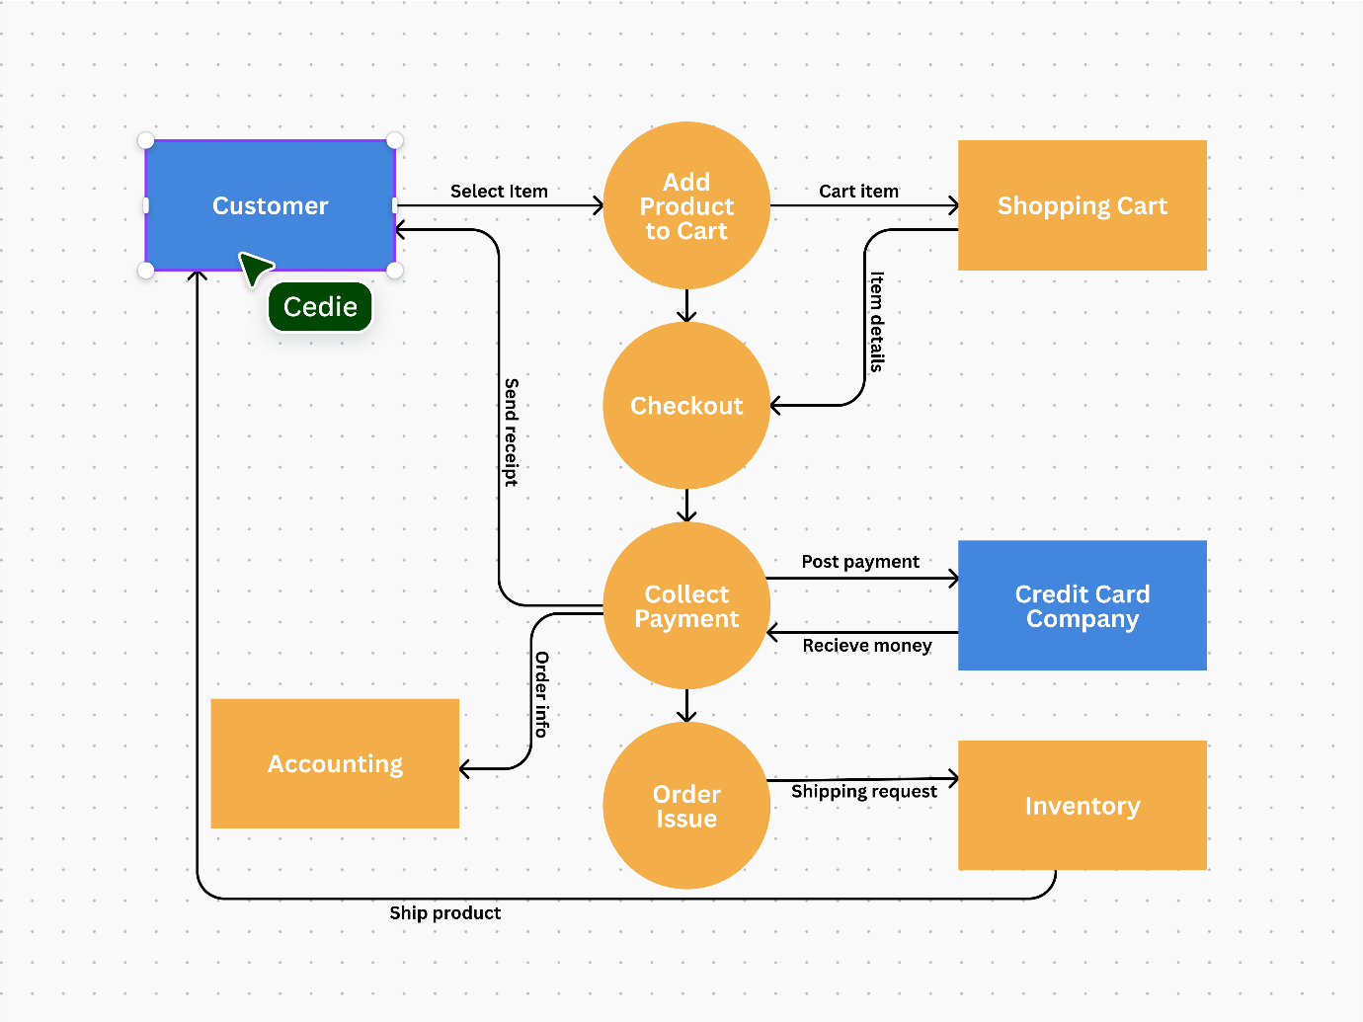

6. Entity Relationship Diagram (ERD) :

Entities:
- Users (_id, username, email, password)
- Comments (_id, text, userId, parentId, likes, dislikes)

6. User Interface Design:
The UI is designed to be simple, responsive, and accessible. It uses React for structure, modern CSS for styling, and Socket.IO for interactivity.
Main Pages:
- Login/Register
- Comment Feed with threaded replies
- Interactive like/dislike buttons.

Chapter 4: System Implementation
4.1 Introduction
System implementation is the crucial stage where the logical design is translated into a working corporate application. This phase involves actual coding, integrating various front-end and back-end modules, configuring real-time communication protocols, and ensuring the platform performs reliably under simulated operational loads. CO-MENTS is implemented using a full-stack, event-driven approach—utilizing the MERN stack (MongoDB, Express, React, Node.js) and Socket.io

4.2 Development Tools and Technologies
Tool / Technology | Purpose
React + Vite | Frontend UI library
Express.js | A back-end web framework for Node.js that handles RESTful API routes, server logic, and middleware integrations.
React.js | The front-end user interface library for building dynamic, single-page dashboards, managing component state, and handling user interaction.
Node.js | The JavaScript runtime environment that executes server-side code and facilitates real-time data flow.
Socket.io | A JavaScript library that enables real-time, bidirectional, event-driven communication between the client browsers and the Node.js server.
JWT (JSON Web Tokens) | A standard used for secure user authentication and session management without storing session state on the server.
Visual Studio Code | The Integrated Development Environment (IDE) utilized for all coding, debugging, and project management.
Browser (Chrome/Edge) | The client-side environment for executing, debugging, and testing the React application.

4.3 System Modules Description
Module | Description
Authentication Module | Handles registration and login with JWT.
Comment Module | Add, reply, edit, and delete comments
Reaction Module | Like and dislike functionality.
Real-time Module | Socket.IO for instant updates.

4.5 Algorithm / Logic of Core Function
User Authentication Flow

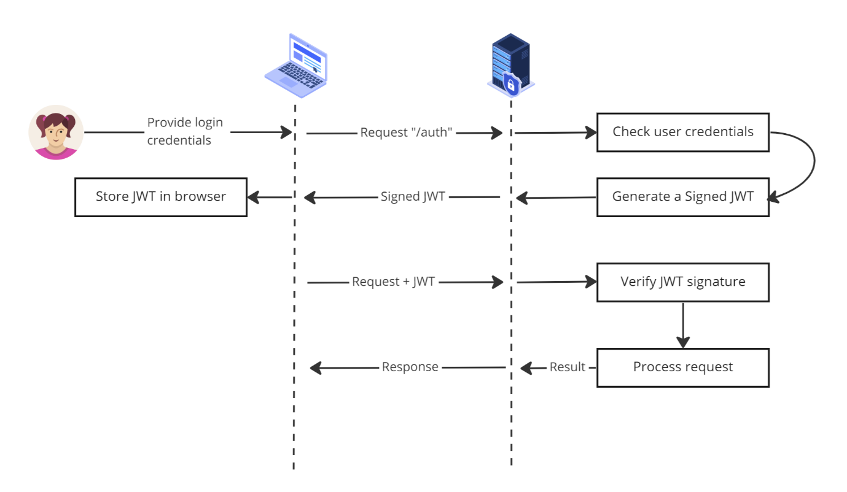

Comment Posting Flow
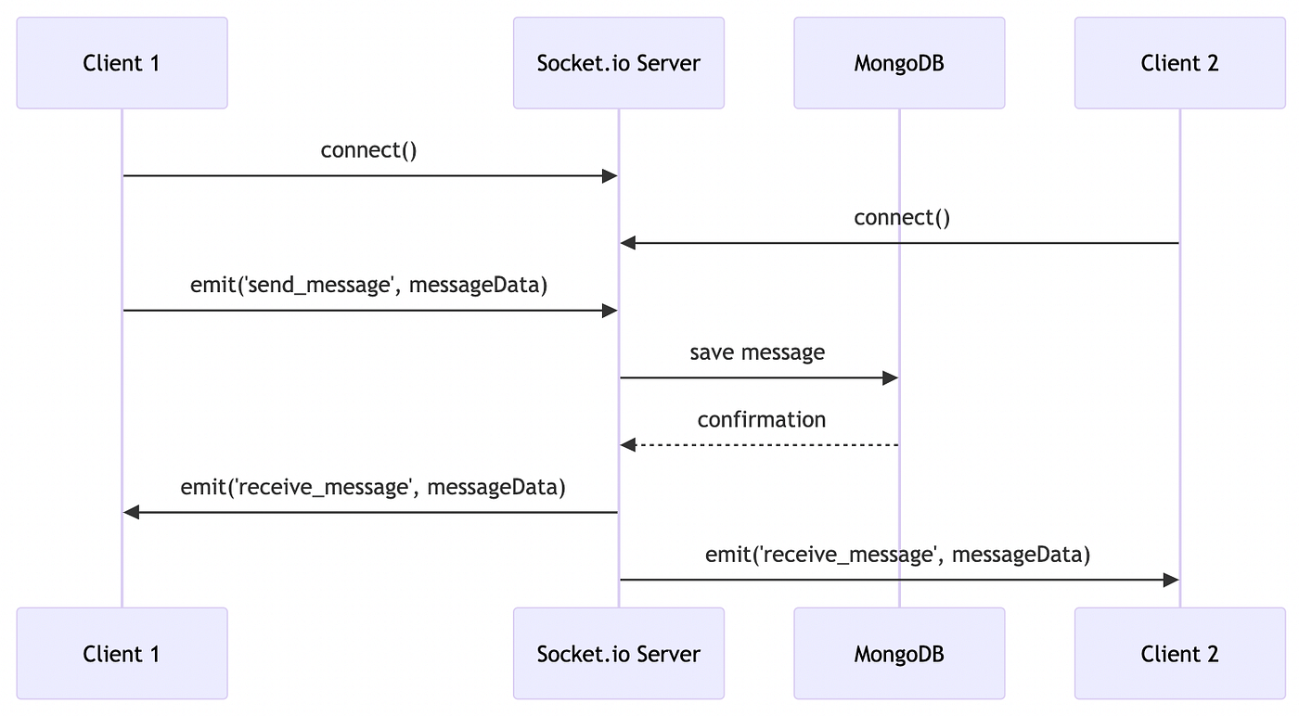

4.6 Security and Validation
- JWT-based authentication, input sanitization, and role-based access.

4.7 Integration
Frontend uses Axios for REST calls and Socket.IO-client for real-time. Backend validates JWT and emits events on comment creation.

4.8 Output Screens (Snapshots)

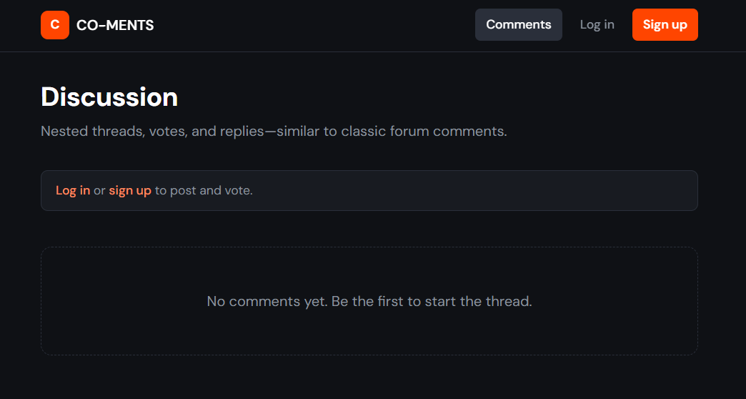

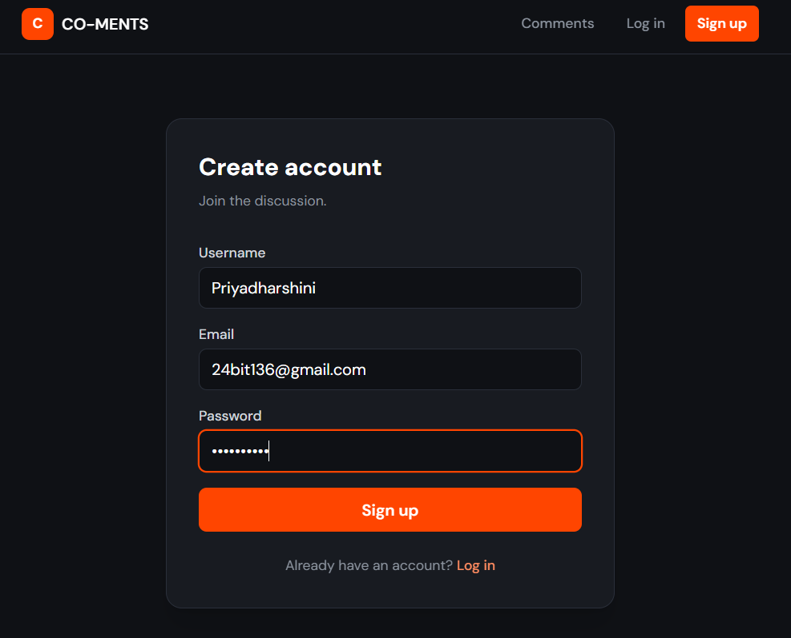
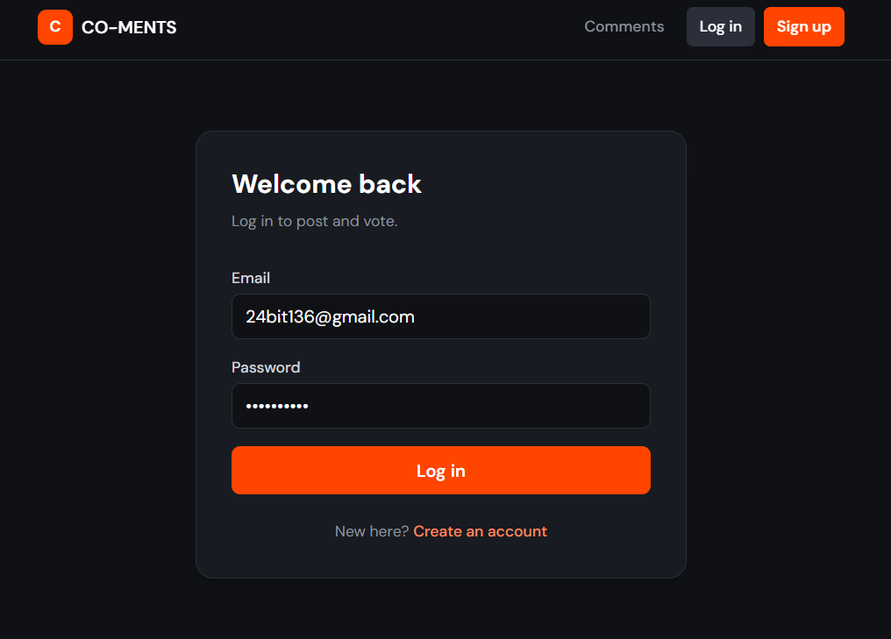

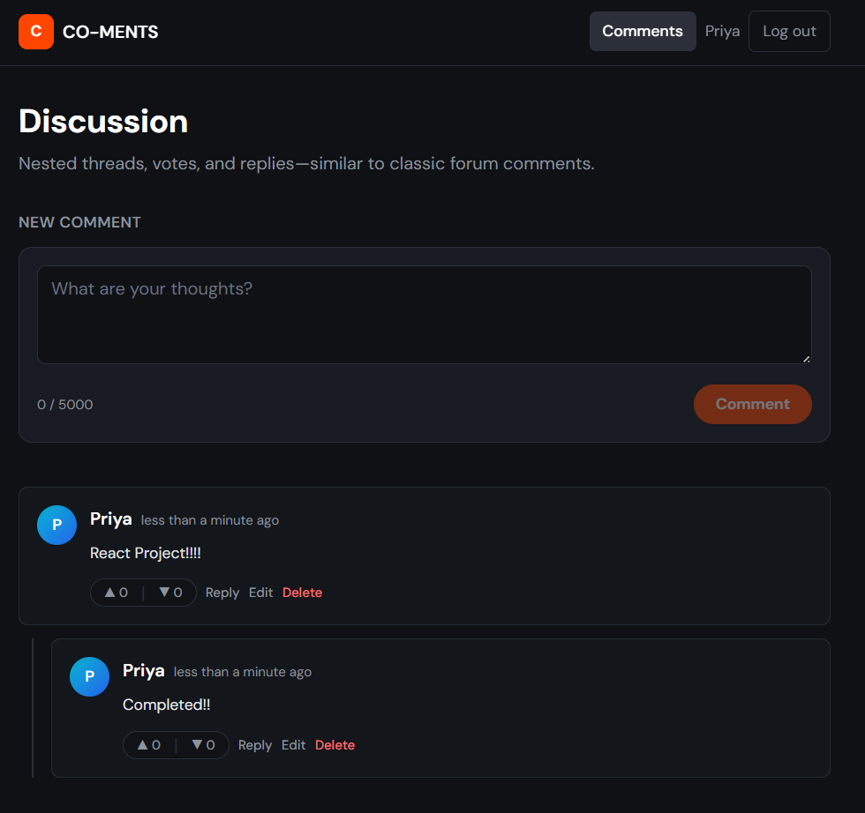

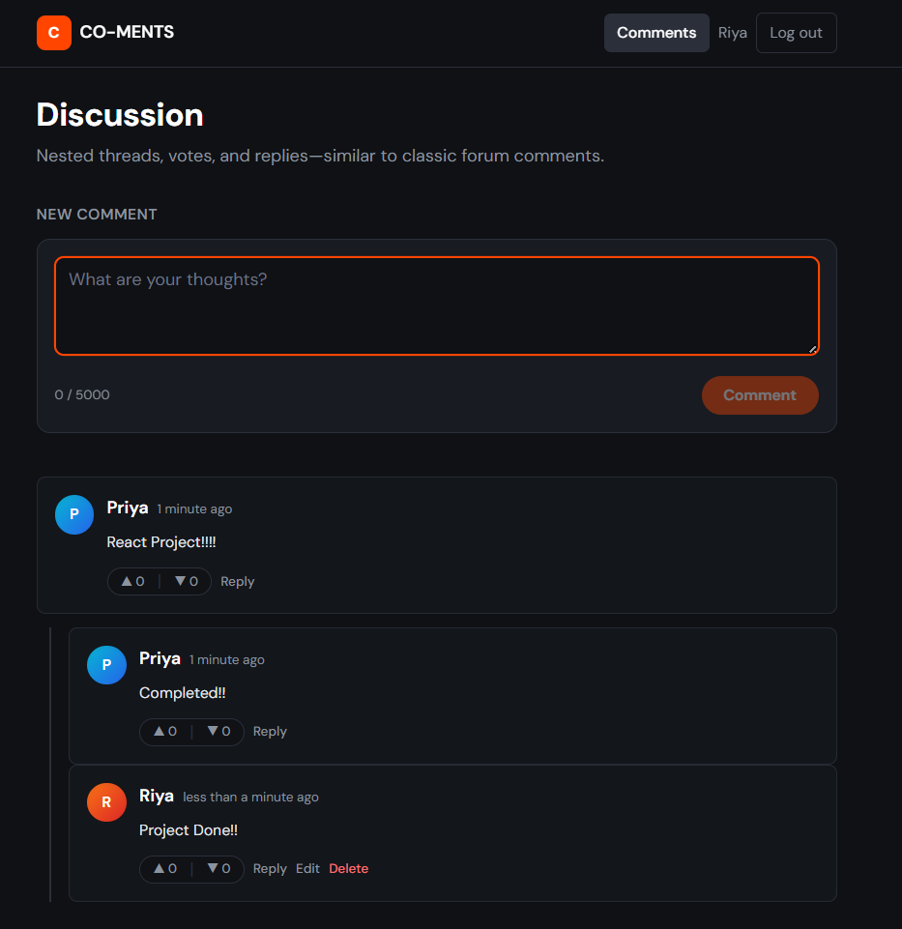

Chapter 5: System Testing
5.1 Introduction
System testing is a critical phase in the software development lifecycle that ensures the developed application meets all specified functional and non-functional requirements. In the case of CO-MENTS, comprehensive testing was conducted to validate the reliability of real-time communication, user authentication, comment threading, and reaction features under various conditions and user loads. This chapter presents the testing methodology, test cases, error handling mechanisms, and overall performance observations.

5.2 Testing Methodology :
- A combination of unit testing, integration testing, system testing, and user acceptance testing (UAT) was employed. Each module was individually tested before being integrated into the complete system. Special emphasis was placed on verifying the real-time functionality provided by Socket.IO and the security of JWT-based authentication.

5.3 Test cases:
- Detailed test cases were prepared covering all major functionalities including user registration, login, posting comments, replying to threads, liking/disliking comments, and real-time updates across multiple browser sessions. All test cases were executed successfully with expected outputs.

5.6 Error Handling
- Robust error handling mechanisms were implemented throughout the application. Try-catch blocks were used in both frontend and backend code to gracefully manage exceptions. User-friendly validation messages and alerts guide users when invalid inputs are detected or network issues occur.

5.7 Performance and Usability Testing
- The application demonstrated excellent performance during testing. Real-time comment updates were delivered in less than one second, and average page load time remained under two seconds across different devices and browsers. The system maintained stability even with multiple concurrent users.

5.8 Results and Observations
All modules functioned as expected. The website performed well under all threaded commands and replies with reactions and authorized register and logins.

Chapter 6: Results and Discussion
6.1 Introduction
This chapter illustrates the practical outcomes of the implemented system by presenting key input and output screens of the CO-MENTS application. It provides visual evidence of the user interface design, real-time functionality, and overall user experience delivered by the platform.

6.2 Discussion
During execution, the system produced the following key results:
- The outputs clearly demonstrate that the system successfully achieves its core objective of providing a smooth and interactive real-time commenting experience. The threaded structure and instant updates significantly enhance user engagement.

6.3 Performance Analysis
- When compared with traditional static comment systems, CO-MENTS offers superior performance in terms of speed, usability, and interactivity, making it a more effective solution for modern web applications.

6.4 User Feedback
- A group of test users evaluated the prototype and provided highly positive feedback. They particularly appreciated the real-time threading capability and the intuitive, clean user interface design.

Chapter 7: Conclusion and Future Enhancement

7.1 Conclusion
In conclusion, the CO-MENTS project has been successfully developed as a complete full-stack real-time comment thread application. By leveraging the MERN stack and Socket.IO technology, the system delivers a responsive, secure, and highly interactive platform that meets all defined objectives. The successful cloud deployment further validates the project’s readiness for real-world usage.

7.2 Limitations
- Although the current version performs efficiently, it has certain limitations such as dependency on stable internet connectivity and minor latency that may occur on free-tier hosting services.

7.3 Future Enhancement
- The project holds immense potential for further enhancement.
- Future versions can incorporate advanced features such as real-time notification systems
- Support for image and file uploads
- A comprehensive moderation dashboard
- Dedicated mobile applications with push notification support.

Chapter 8: References

8.1 Books & Journals
- Full Stack Development with MongoDB, Express, React, and Node — Shama Hoque, Packt Publishing.
- Learning React: Modern Patterns for Developing React Apps — Alex Banks & Eve Porcello, O’Reilly Media.
- Socket.io Real-time Web Application Development — Rohit Rai, Packt Publishing.
8.2 Online Resources
- React Documentation — https://react.dev.
- Socket.io Official Docs — https://socket.io.
- MDN Web Docs (JavaScript ES6) — https://developer.mozilla.org.
- Render Deployment Guide — https://docs.render.com.
- Official documentation of React, Node.js, Express.js, MongoDB, and Socket.IO.

8.3 Tools & Frameworks Used
- Editor: Visual Studio Code.
- Frontend: React.js (Vite), Axios, Lucide-React.
- Backend: Node.js, Express.js, Socket.io.
- Database: MongoDB Atlas.
- Deployment: Render, Vercel (Web Services & Static Sites).

Appendices

Appendix A – Source Code
- Register.jsx: Defines the React Router structure and Protected Route logic.
- Login.jsx: Handles JWT authentication and role-based redirection.
- CommentSection.jsx: Contains the logics of real time threaded comments.

Appendix B – User Manual / Installation Guide
Steps to Run the Project:
- Clone Repository: Download the frontend and backend folders from GitHub.
- Install Dependencies: Run npm install in both the frontend and backend directories.
- Environment Setup: Create a .env file in the backend with your MONGO_URI and JWT_SECRET.
- Launch Backend: Run npm start to initialize the Express and Socket.io server.
- Launch Frontend: Run npm run dev to start the Vite development server.
System Requirements:
- OS: Windows 10+ / macOS / Linux.
- Environment: Node.js (v16 or higher).
- Browser: Latest Chrome, Firefox, or Edge.
- Internet: Required for MongoDB Atlas and Socket.io connectivity.

