 

**Placement Empowerment Program**

***Cloud Computing and DevOps Centre***

Automate File Copying with a Script

Create a script to copy files from one folder to another automatically.

Name: Priyadharshini S Department: CSE



**Introduction**

Automating repetitive tasks, such as file copying, boosts efficiency by saving time, minimizing errors, and streamlining processes like backups, file organization, or directory synchronization. This proof-of-concept script showcases an easy and practical method for automating the transfer of files from one folder to another.

### ****Overview****

This script streamlines the task of transferring files from a source folder to a destination folder, ensuring all files are copied efficiently and without errors. It can be tailored to specific requirements, such as filtering files by type, modification date, or size. Depending on the operating environment, the script can be implemented using languages like Python, Shell scripting, or PowerShell.

**Objectives**

The primary goals of this automation task are:

* **Streamline File Management:** Minimize manual effort by automating file transfers between directories.
* **Boost Efficiency:** Save time and enhance productivity through automation.
* **Maintain Data Integrity:** Ensure files are copied accurately without corruption or data loss.
* **Adaptable Workflow:** Provide flexibility to tailor the process for specific needs, such as filtering files by type or modification date.
* **Scalable Design:** Ensure the script can efficiently handle la

**Importance**

1. **Saves Time:** Automation removes the need for manual file transfers, significantly reducing workload and saving hours of effort.

2. **Minimizes Errors:** Lowers the risk of mistakes, such as missing files or unintentionally overwriting critical data.

3. **Enhances Organization:** Ensures a consistent and well-structured system for file storage and backups.

4. **Versatile Application:** Beneficial for IT professionals, businesses, and individuals who frequently manage file transfers or backups.

5. **Reusable and Scalable:** The script can be adapted and expanded to tackle more complex file management tasks in the future.

**Step-by-Step Overview**

Step 1

Create two folders named Source and Destination 

Step 2

Store some files inside it to automate it

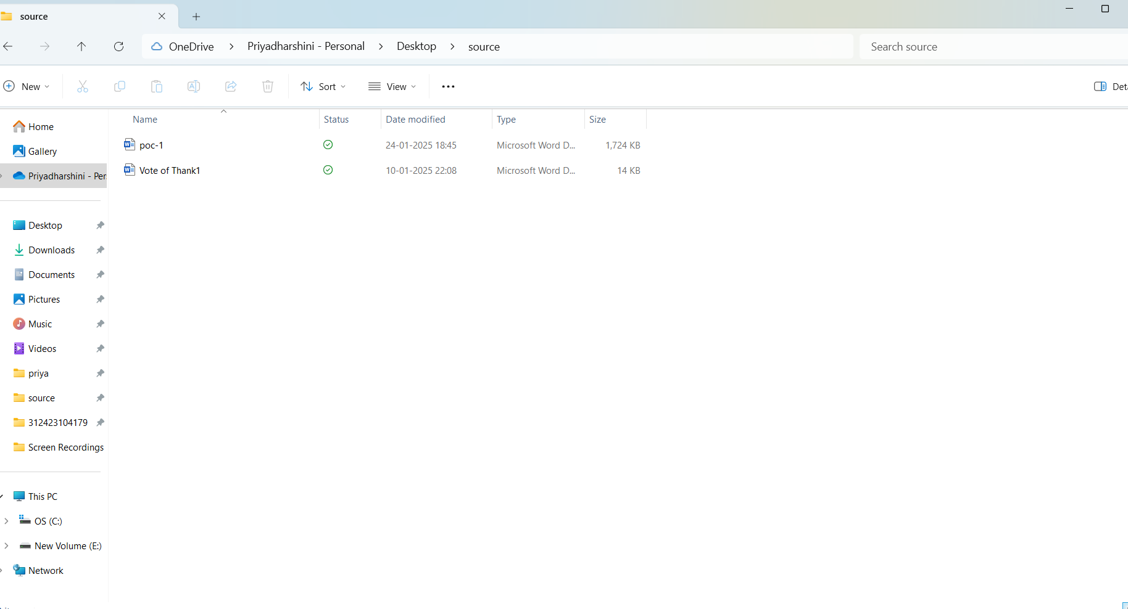

Step 3

Open the note pad and type the code and make sure that in set SOURCE give your Source folder address and in set DESTINATION give your Destination Folder address

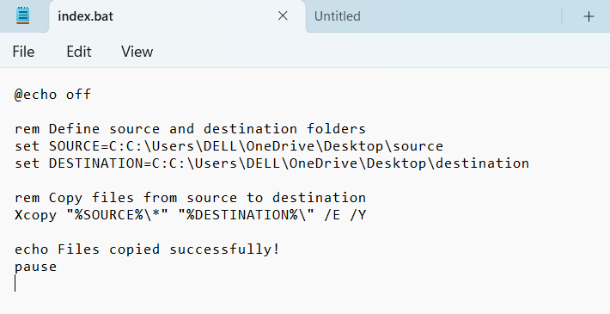

Step 4

Then save the file in desktop with .bat extension (eg : index.bat) so the file looks like this



Step 5

Press **Win + R** on your keyboard.

A small "Run" dialog box will pop up.

Type **taskschd.msc** (without quotes) in the Run box.

Press Enter or click OK.This will open the Task Scheduler window.

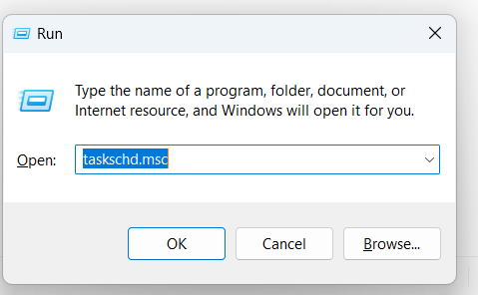

Step 6

In the Task Scheduler window, look to the right-hand side for a button called **"**Create Basic Task**"**.

Click it.

A wizard will open to guide you through the setup

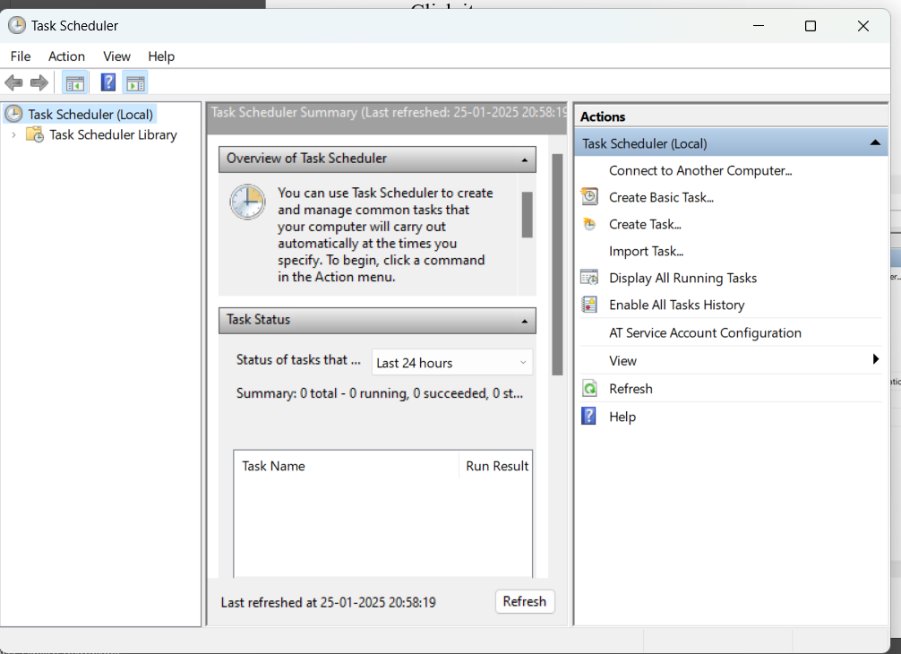

Step 7

1. Enter a Name for the Task:

For example: "Automate File Copying".(This can be anything that helps you remember what the task does.)

Optionally, you can add a description like "Copies files from folder A to folder B".

1. Click Next to continue.
2. 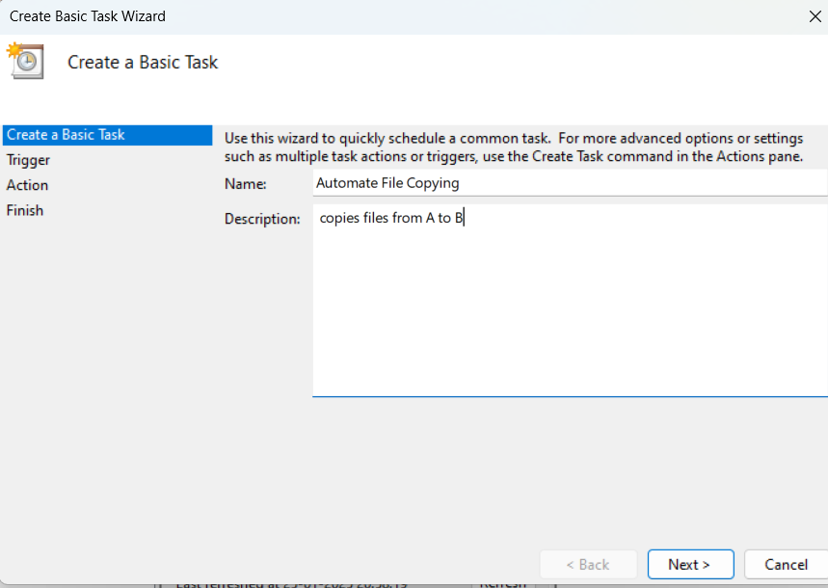

Step 8

Choose a Schedule:

You will see options like:

Daily (runs every day).

Weekly (runs once a week).

One time (runs only once at a specific time).

Choose what works for you (e.g., Daily) and click Next.

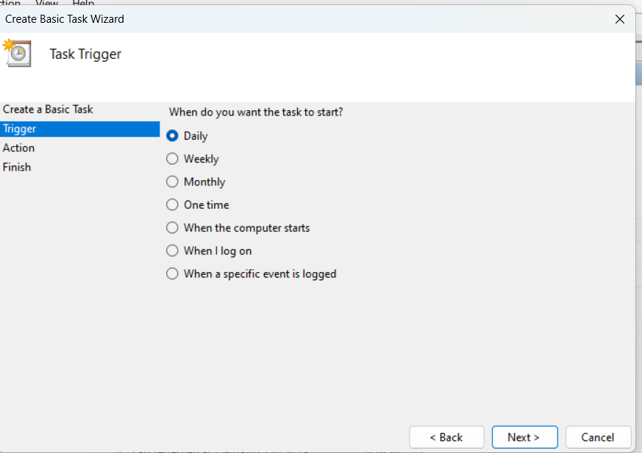

Step 9

Set the Time and Frequency:

If you chose Daily, specify:

The start date (it defaults to today).

The time (e.g., 10:00 AM).

Click Next to move on.

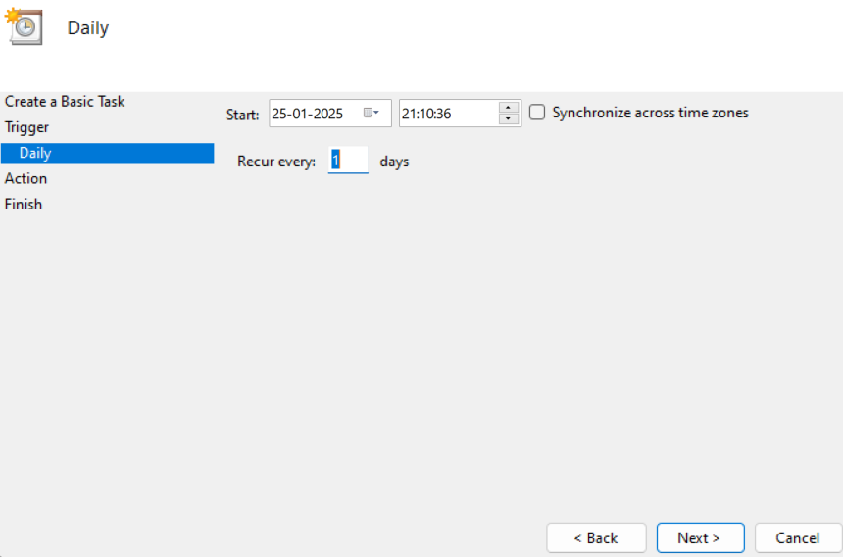

Step 10

Set the Action

Now, we tell Task Scheduler what to do when it runs.

Select "Start a Program":

On the "Action" screen, select the option **"**Start a Program**"** and click Next.

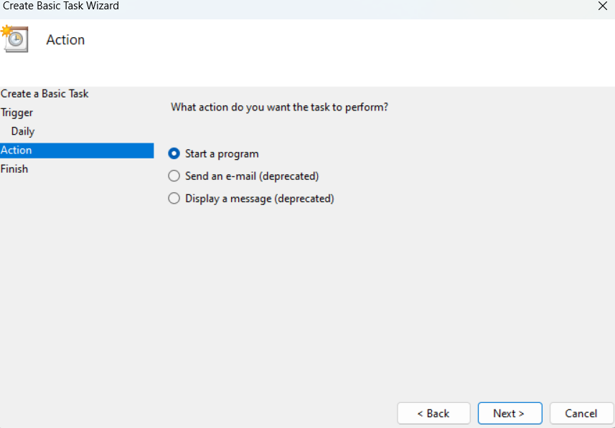

Step 11

Point to the Program or Script:

In the Program/script field, click **Browse** and navigate to the location of your .bat file.

Example: If your script is named index.bat and saved on the desktop, navigate to that file and select it.

Click Next.

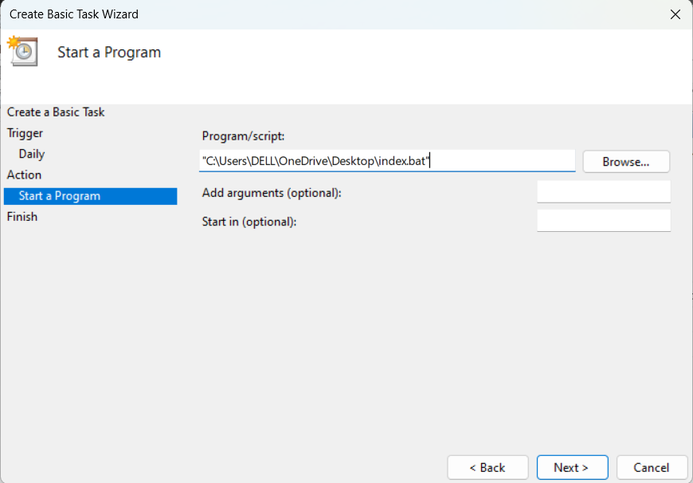

Step 12

Review and Finish

Click **Finish** to save and schedule the task.

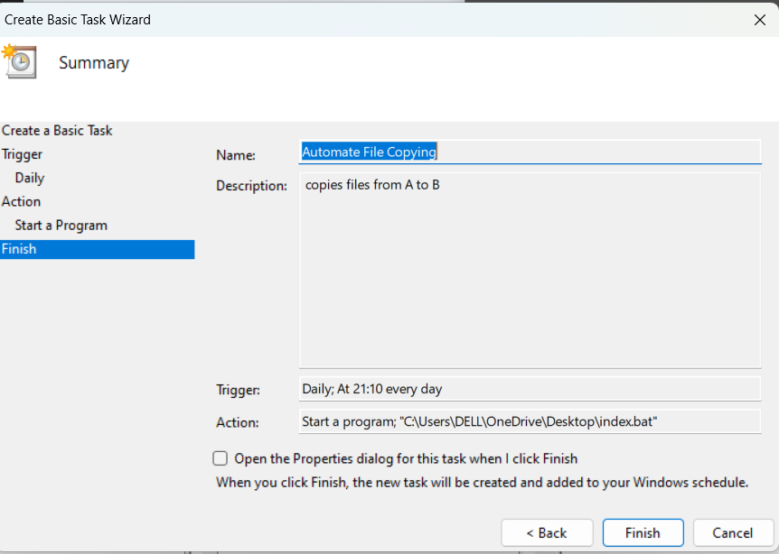

Step 13

In Task Scheduler, go to the **Task Scheduler Library** (on the left-hand side).

Find your task (it should have the name you gave it, e.g., "Automate File Copying").

Right-click the task and select **Run**.

This will manually trigger the task immediately.

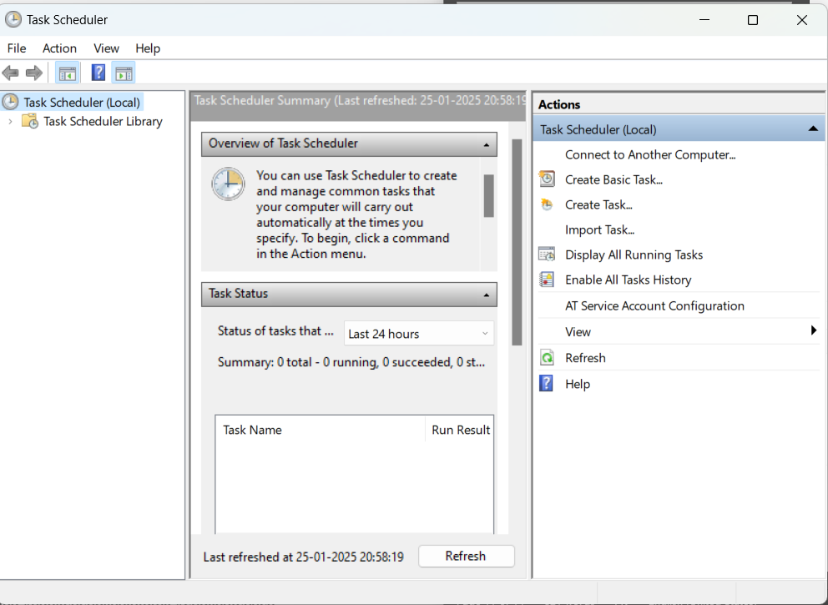

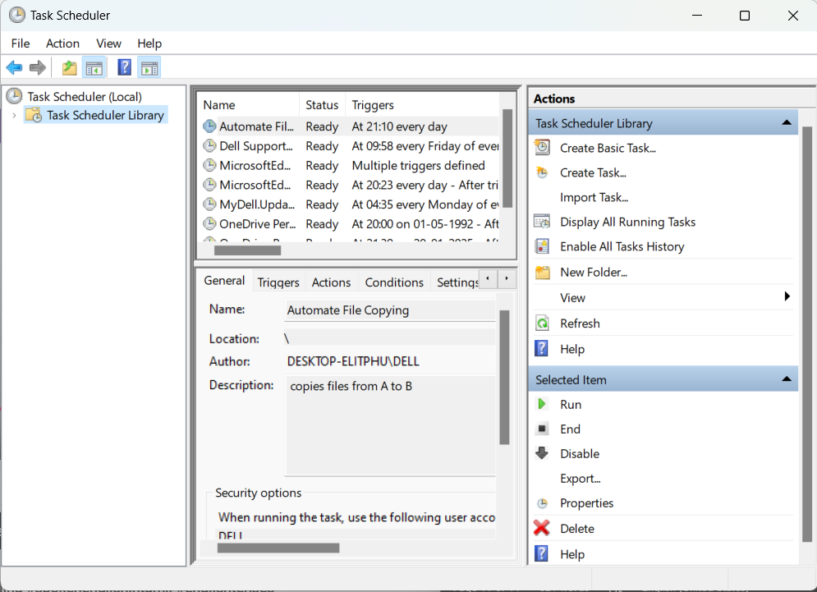

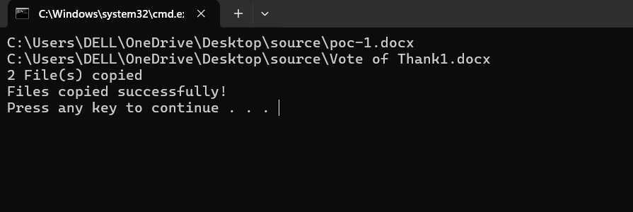

Step 14

If your task was set up to copy files, go to the destination folder and confirm that the files have been copied.

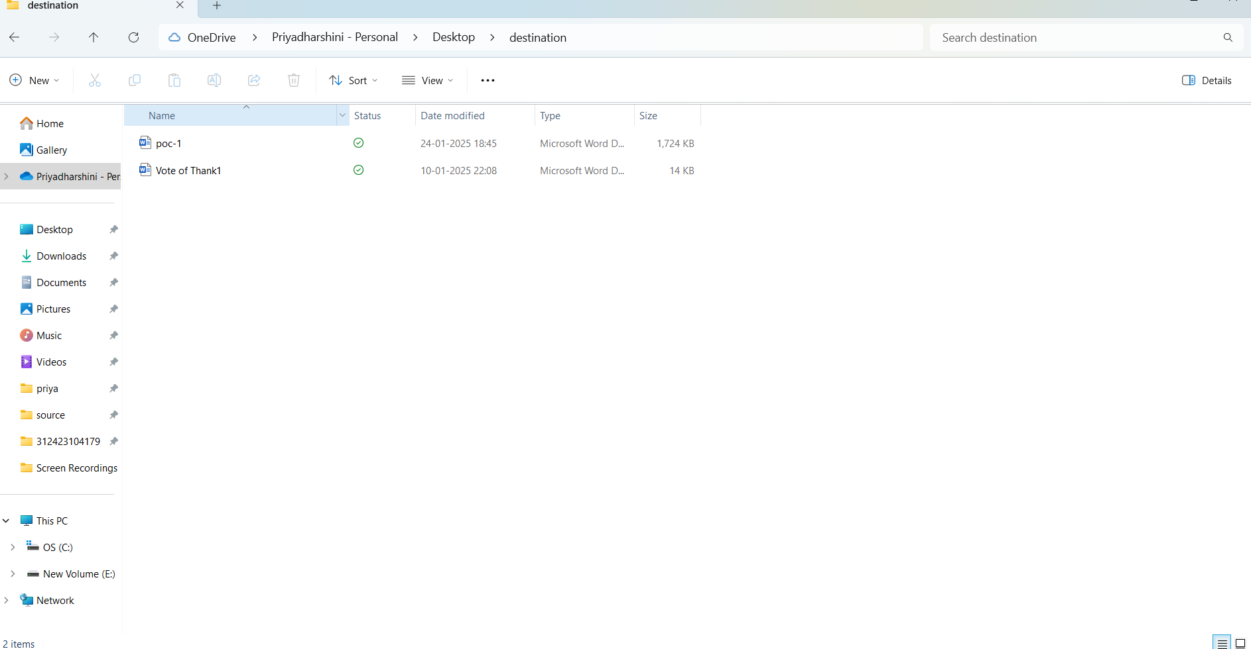

**Outcome**

By completing this Proof of Concept (PoC) of automating a task using Task Scheduler, you will:

1. Successfully set up an automated task that triggers on a schedule or when manually run.

2. Execute a batch script to copy files from a source folder to a destination folder automatically.

3. Understand how to use Task Scheduler to automate repetitive tasks in Windows.

4. Gain familiarity with task triggers, actions, and conditions in Task Scheduler.

5. Save time and ensure consistent execution of file operations without manual intervention.

6. Optionally test the task to verify that it runs as expected and achieves the desired outcome.

7. Enhance your workflow automation skills with practical hands-on experience.