Week 2 Task: Data Collection, Cleaning, and Pre-processing for Logistics Analysis
Submitted By: Priya Bapuso Kale

1. Introduction
This project focuses on the collection, cleaning, and pre-processing of logistics data using Python. The main purpose is to prepare a high-quality dataset for further analysis and machine learning.
The pre-processing process includes checking the dataset structure, identifying missing values, detecting duplicate and invalid records, identifying outliers, handling data quality issues, and applying normalization techniques.

2. Objective
The main objectives of this task are:
- To simulate the collection of logistics data.
- To understand the structure and characteristics of the dataset.
- To identify and handle missing values.
- To identify duplicate and invalid records.
- To detect and handle outliers.
- To convert data into appropriate formats.
- To create useful features from the dataset.
- To normalize numerical data.
- To prepare a clean dataset for further analysis.
- To understand the impact of data quality on logistics decision-making.

3. Dataset Characteristics
The logistics dataset contains 300 delivery records and 16 attributes. The dataset includes information related to orders, warehouse locations, customer locations, delivery distance, order quantity, vehicle type, traffic level, expected and actual delivery time, transportation cost, delay time, delivery status, vehicle capacity, and vehicle utilization.
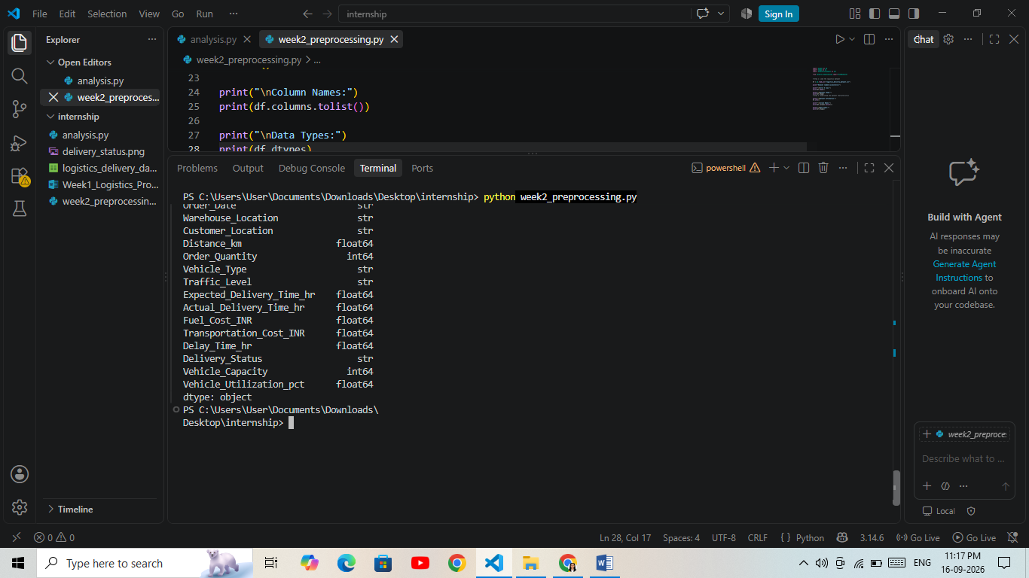
Explanation
The df.info () function was used to understand the overall structure of the dataset, including the number of records, columns, and data types. The df.columns.tolist() function was used to display all column names. The df.dtypes function was used to identify the data type of each column. This information is important because different data types require different preprocessing techniques.

4. Missing Value Detection and Handling
Missing values are common data quality problems in logistics datasets. They may occur because of incomplete data entry, system errors, or missing information during data collection. Missing values can affect statistical analysis and machine learning results. Therefore, missing values were first identified using the Pandas isnull() function.
Method Used
Numerical missing values were handled using median imputation. Median was selected because it is less affected by extreme values compared with the mean. For categorical columns, missing values were handled using the mode, which represents the most frequently occurring category.

Python Implementation
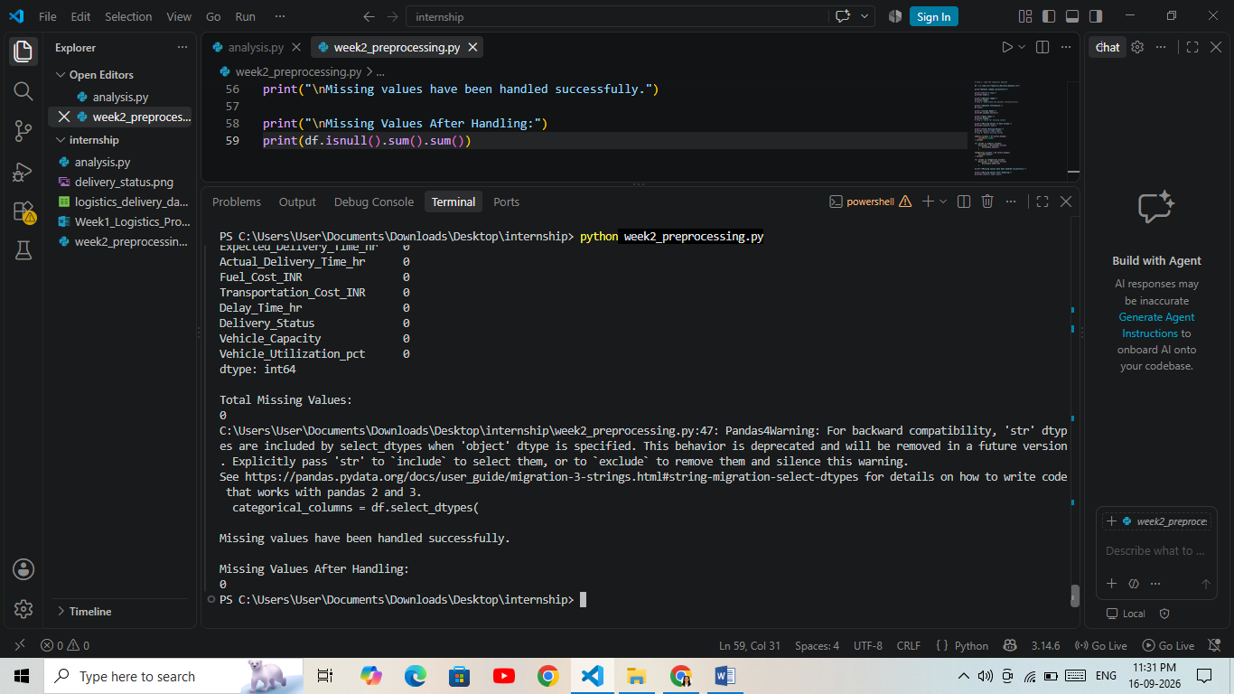
Result
The dataset was checked for missing values before pre-processing. The analysis showed that the current dataset did not contain missing values. The missing-value handling procedure was nevertheless implemented to make the pre-processing pipeline robust for future datasets containing missing records.
5. Duplicate Record Detection and Removal
Duplicate records can occur when the same delivery information is entered more than once during data collection or data integration. Duplicate records may affect statistical analysis and can lead to incorrect business conclusions. Therefore, duplicate records were identified using the Pandas duplicated() function and removed using the drop_duplicates() function.
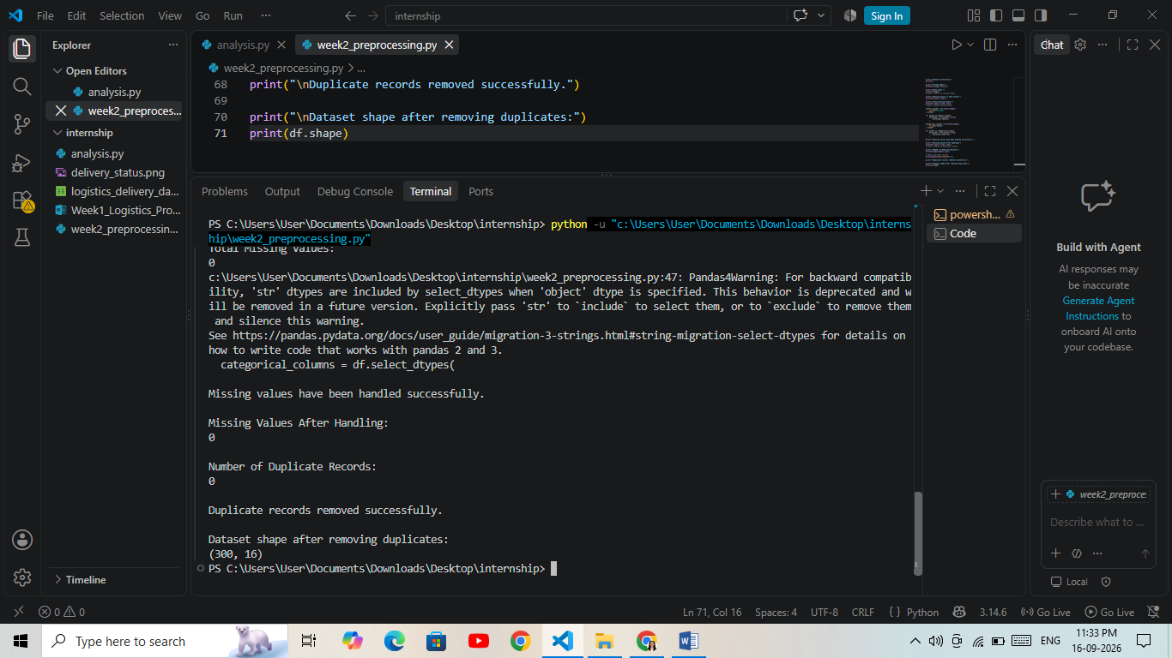Result:
The dataset was checked for duplicate records. No duplicate records were found in the current dataset. The dataset therefore retained all 300 records after duplicate removal.
6. Invalid Value Detection
Invalid values can negatively affect logistics analysis and machine learning models. For example, a negative distance or transportation cost is not logically valid. Therefore, numerical columns were checked for values that violate their expected business rules.
Method:
Business rules were applied to identify invalid values. Distance, order quantity, fuel cost, and transportation cost were checked for negative values. Delivery time and vehicle capacity were checked for zero or negative values. Vehicle utilization was checked to ensure that it remained between 0% and 100%.
Result:
The numerical fields were checked for invalid values using logical business rules. The current dataset did not contain invalid values based on these checks. Therefore, no records needed to be removed or corrected at this stage.
7. Outlier Detection
Outliers are observations that are significantly different from the majority of the data. In logistics datasets, outliers may occur because of unusually long delivery distances, high order quantities, large transportation costs, or unusual delivery times. Outliers can affect statistical analysis and machine learning models.
Method:
The Interquartile Range (IQR) method was used to identify potential outliers. Q1 represents the 25th percentile and Q3 represents the 75th percentile. The IQR is calculated as Q3 − Q1. Values below Q1 − 1.5 × IQR or above Q3 + 1.5 × IQR were considered potential outliers.
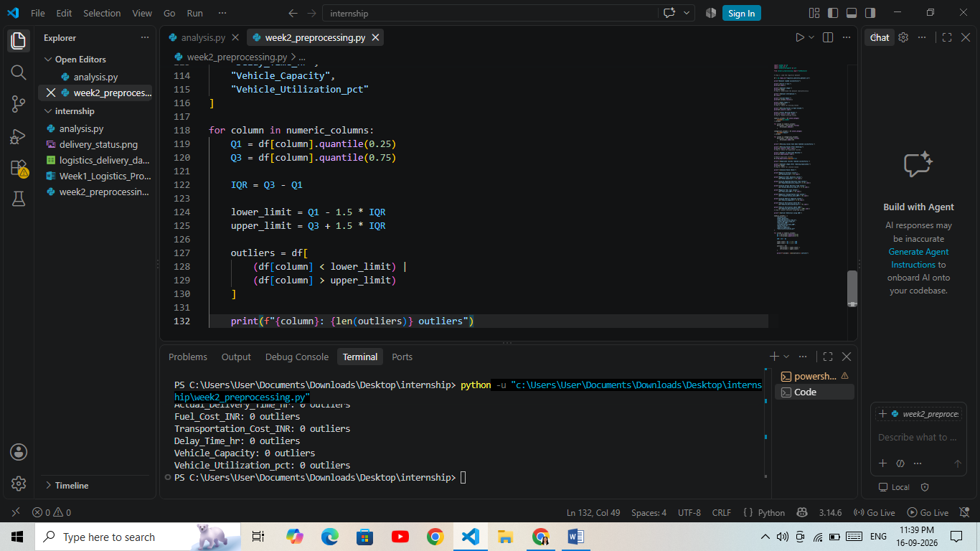
Result:
The IQR method was applied to the selected numerical columns to identify potential outliers. The detected outlier counts were recorded for further preprocessing. Outliers were not immediately deleted because an extreme logistics value may represent a genuine business situation rather than an incorrect record.
8. Outlier Visualization
Write:
After detecting potential outliers using the IQR method, boxplots were used to visualize the distribution of numerical variables. Boxplots provide a simple visual method for identifying unusually high or low observations.
Method:
Boxplots were created for the selected numerical logistics variables using Matplotlib and Pandas. The visualization helps understand the spread of the data and identify potential extreme observations.
Result:
The boxplot visualization provided a graphical view of the numerical variables and helped identify potential extreme values. These observations were considered for further preprocessing rather than being automatically removed, because some extreme values may represent genuine logistics operations.

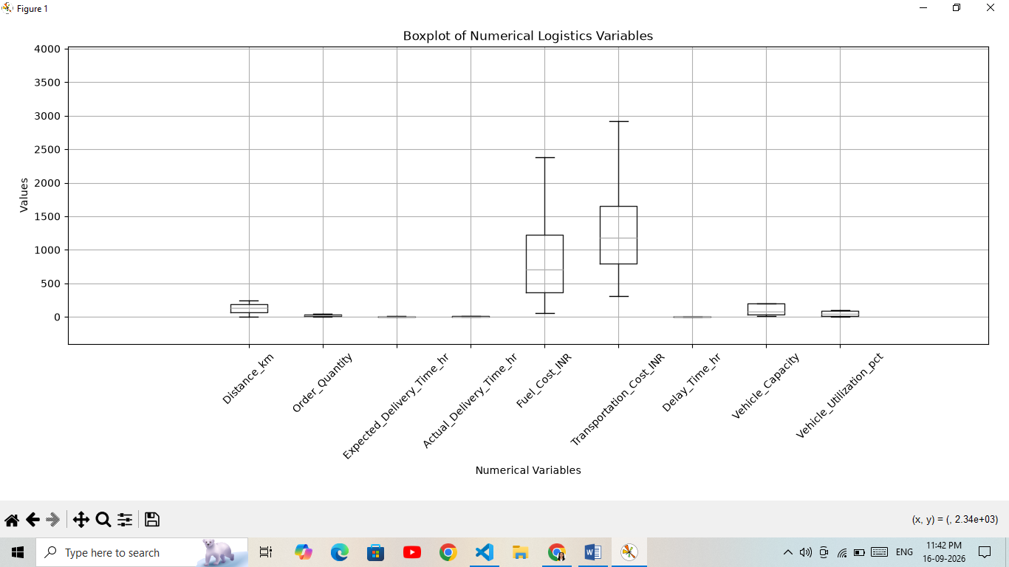

9. Outlier Handling
After identifying potential outliers, an IQR capping technique was used to reduce the influence of extreme values. Instead of deleting complete records, values outside the calculated IQR limits were capped at the corresponding lower or upper limit.
Why IQR Capping?
Removing complete records can result in loss of useful logistics information. IQR capping preserves the records while reducing the influence of extreme numerical values. This makes the dataset more suitable for further statistical analysis and machine learning.
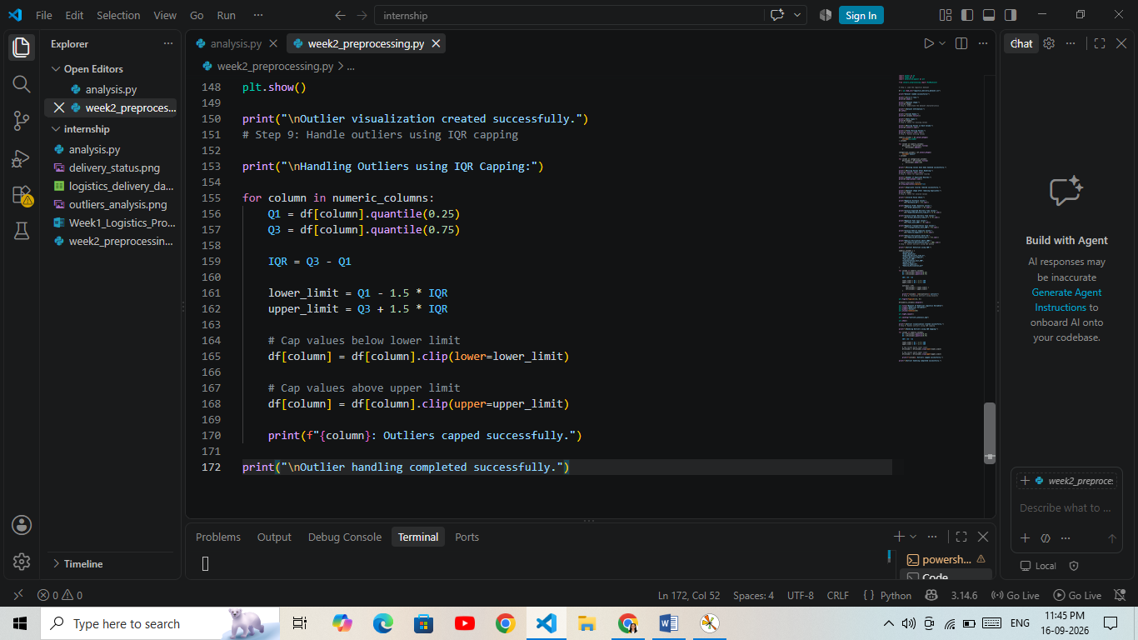

Result:
Potential extreme values in the selected numerical variables were handled using IQR capping. The records were retained while extreme numerical values were limited to the calculated IQR boundaries.
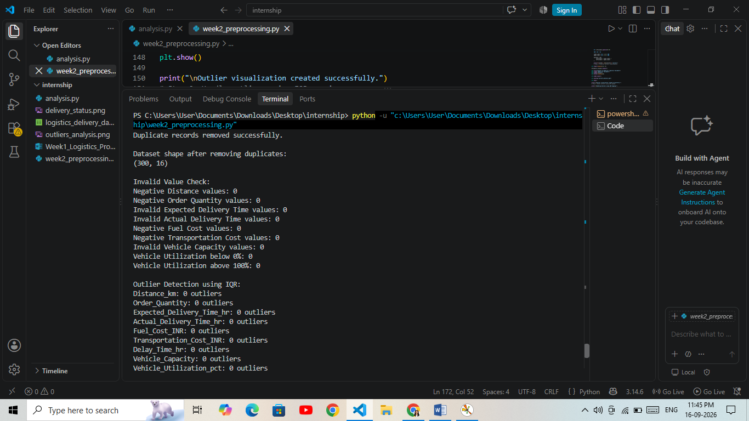
10. Saving the Cleaned Dataset
After completing the data cleaning and outlier handling process, the processed dataset was saved as a separate CSV file named cleaned_logistics_data.csv. The original dataset was kept unchanged so that the preprocessing process could be reproduced and compared with the original data.

11. Feature Engineering
Feature engineering is the process of creating new meaningful variables from existing data. It helps make the dataset more useful for analysis and machine learning.
In this project, three new features were created:
- Delivery_Delay_Status
- Cost_Per_Quantity
- Delivery_Time_Difference_hr

Methodology
The Delivery_Delay_Status feature identifies whether an order was delayed based on its delay time.
The Cost_Per_Quantity feature calculates the transportation cost associated with each unit of ordered quantity.
The Delivery_Time_Difference_hr feature calculates the difference between actual and expected delivery time.

Python Code
# Step 11: Feature Engineering

print("\nCreating new features...")

# Feature 1: Delivery Delay Status
df["Delivery_Delay_Status"] = np.where(
df["Delay_Time_hr"] > 0,
"Delayed",
"On Time"
)

# Feature 2: Transportation Cost per Quantity
df["Cost_Per_Quantity"] = (
df["Transportation_Cost_INR"] / df["Order_Quantity"]
)

# Feature 3: Difference between actual and expected delivery time
df["Delivery_Time_Difference_hr"] = (
df["Actual_Delivery_Time_hr"]
- df["Expected_Delivery_Time_hr"]
)

print("\nNew features created successfully!")

print("\nNew Feature Preview:")
print(
df[
[
"Order_ID",
"Delivery_Delay_Status",
"Cost_Per_Quantity",
"Delivery_Time_Difference_hr"
]
].head()
)
Result
Three additional features were successfully created from the existing logistics data. These features provide useful information about delivery delays, transportation cost efficiency, and the difference between expected and actual delivery time.

12. Data Normalization
Normalization is a preprocessing technique used to bring numerical variables to a common scale.
In the logistics dataset, different numerical variables have different ranges. For example, transportation cost can have much larger values than vehicle utilization percentage.
Methodology
The Min-Max Scaling technique was used to transform selected numerical variables into a range between 0 and 1.
The general formula is:
X_scaled = (X - X_min) / (X_max - X_min)
Normalization is particularly useful for machine learning algorithms that are affected by differences in feature scales. It is also useful for distance-based algorithms such as K-Means clustering.

Python Code
# Step 12: Normalize numerical data using Min-Max Scaling

print("\nStarting Min-Max Normalization...")

normalization_columns = [
"Distance_km",
"Order_Quantity",
"Expected_Delivery_Time_hr",
"Actual_Delivery_Time_hr",
"Fuel_Cost_INR",
"Transportation_Cost_INR",
"Delay_Time_hr",
"Vehicle_Capacity",
"Vehicle_Utilization_pct",
"Cost_Per_Quantity",
"Delivery_Time_Difference_hr"
]

scaler = MinMaxScaler()

df[normalization_columns] = scaler.fit_transform(
df[normalization_columns]
)

print("\nNormalization completed successfully!")

print("\nNormalized Data Preview:")
print(df[normalization_columns].head())

Result
The selected numerical features were successfully normalized using Min-Max Scaling. The transformed numerical values are represented on a common 0–1 scale, making the dataset more suitable for further analysis and machine learning.

13. Saving the Normalized Dataset
After normalization, the processed data was saved as a separate CSV file.
The original dataset and cleaned dataset were kept separately to preserve the different stages of the pre-processing pipeline.

Python Code
# Step 13: Save the normalized dataset

df.to_csv("normalized_logistics_data.csv", index=False)

print("\nNormalized dataset saved successfully!")
print("File name: normalized_logistics_data.csv")

print("\nFinal Dataset Shape:")
print(df.shape)

Result
The normalized logistics dataset was successfully saved as normalized_logistics_data.csv. The file is ready for further analysis and machine learning applications.

14. Final Data Quality Verification
After completing all pre-processing operations, a final quality check was performed.
The final dataset was checked for:
- Missing values
- Duplicate records
- Number of rows and columns
- Data types

Python Code
# Step 14: Final data quality verification

print("\n========== FINAL DATA QUALITY CHECK ==========")

# Check missing values
print("\nTotal Missing Values:")
print(df.isnull().sum().sum())

# Check duplicate records
print("\nTotal Duplicate Records:")
print(df.duplicated().sum())

# Check dataset shape
print("\nFinal Dataset Shape:")
print(df.shape)

# Check data types
print("\nFinal Data Types:")
print(df.dtypes)

print("\n========== DATA PREPROCESSING COMPLETED ==========")
Result
A final data quality verification was performed after preprocessing. The checks confirmed the condition of the processed dataset and ensured that it was ready for further analysis.

15. Final Pre-processing Summary

Python Code
# Step 15: Final preprocessing summary

print("\n========== PREPROCESSING SUMMARY ==========")

print("Original Dataset File: logistics_delivery_dataset.csv")
print("Cleaned Dataset File: cleaned_logistics_data.csv")
print("Normalized Dataset File: normalized_logistics_data.csv")

print("\nFinal Number of Records:", len(df))
print("Final Number of Columns:", len(df.columns))

print("\nTotal Missing Values:", df.isnull().sum().sum())
print("Total Duplicate Records:", df.duplicated().sum())

print("\nPreprocessing steps completed:")
print("1. Data collection and loading")
print("2. Dataset structure analysis")
print("3. Missing value detection and handling")
print("4. Duplicate detection and removal")
print("5. Invalid value detection")
print("6. Outlier detection")
print("7. Outlier handling using IQR capping")
print("8. Feature engineering")
print("9. Min-Max normalization")
print("10. Final data quality verification")

print("\n========== PREPROCESSING COMPLETED SUCCESSFULLY ==========")
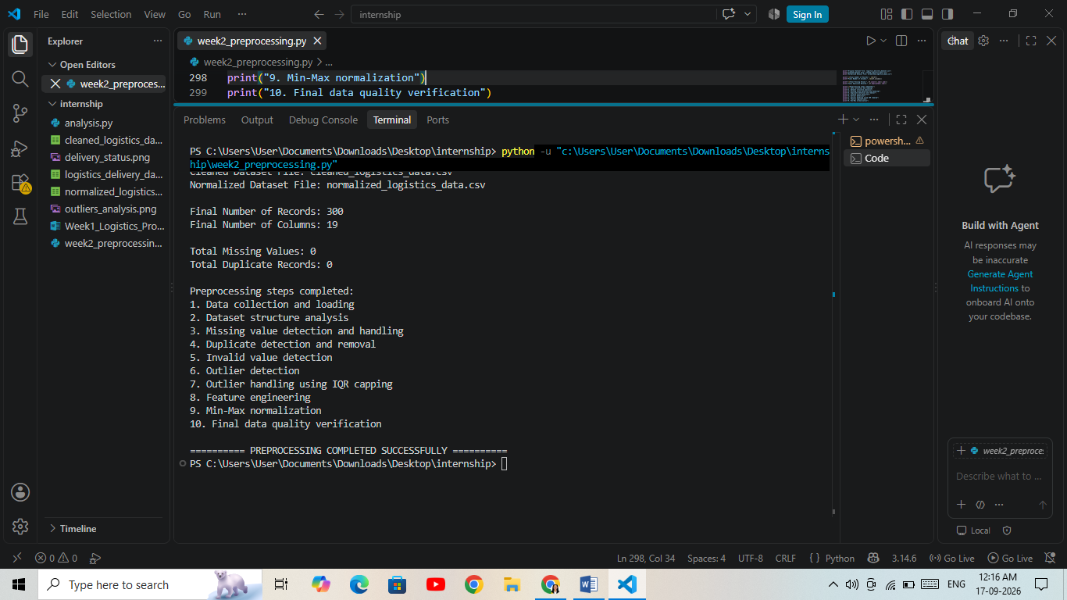
Result
The complete logistics data pre-processing pipeline was successfully implemented using Python. The process included data loading, structural analysis, missing-value checking, duplicate detection and removal, invalid-value checking, outlier detection and handling, feature engineering, normalization, and final quality verification.
Separate cleaned and normalized datasets were generated during the process. The final processed dataset is prepared for further logistics analysis and machine learning.

16. Common Data Quality Issues and Correction Methods
Data Quality Issue | Detection Method | Correction Method
Missing values | isnull() | Median or mode imputation
Duplicate records | duplicated() | drop_duplicates()
Invalid values | Business-rule checks | Correct/remove invalid records
Outliers | IQR method | IQR capping
Different scales | Min-Max Scaling | MinMaxScaler()
Incorrect data types | dtypes / info() | Convert to appropriate type

Logistics datasets can contain several data quality problems. Missing values may occur because of incomplete data collection. Duplicate records may occur because the same order is recorded more than once. Invalid values may result from incorrect data entry. Outliers may represent unusual logistics events or data errors. Different numerical scales can also affect some machine learning algorithms.
The pre-processing techniques used in this project help improve the quality and consistency of the dataset before analysis.

17. Impact of Data Quality on Logistics Analysis
Data quality has a direct impact on logistics analysis and decision-making. Incorrect, incomplete, or duplicated data can produce misleading results.
For example, an incorrect delivery time can affect the calculation of delivery performance. Missing transportation costs can affect cost analysis, while duplicate orders can incorrectly increase the number of deliveries.
Proper pre-processing helps ensure that analytical results are based on reliable and consistent information. This can support better understanding of delivery performance, transportation costs, delays, and vehicle utilization.

18. Reflection
During this task, I learned that data pre-processing is an important part of any data analytics project. Before applying analysis or machine learning techniques, the dataset needs to be carefully examined and prepared.
I worked with Python, Pandas, NumPy, Matplotlib, and Scikit-learn to perform different pre-processing activities. I learned how to identify missing values, duplicate records, invalid values, and potential outliers. I also learned how feature engineering and normalization can make data more useful for further analysis.
This task helped me understand that good-quality data is important for producing reliable analytical results and supporting better business decisions.

19. Tools and Technologies Used
- Python — Main programming language
- Pandas — Data loading, cleaning, and manipulation
- NumPy — Numerical operations
- Matplotlib — Data visualization
- Scikit-learn — Min-Max normalization
- Visual Studio Code — Development environment
- Microsoft Word — Documentation
- GitHub — Project version control and submission

20. Conclusion
This project successfully demonstrated a complete data collection, cleaning, and pre-processing workflow for logistics data using Python.
The dataset was examined for structural issues, missing values, duplicate records, invalid values, and potential outliers. Appropriate pre-processing techniques were applied, including IQR-based outlier capping, feature engineering, and Min-Max normalization.
The cleaned and normalized datasets were saved separately for future use. The final quality verification provided a structured dataset that can be used for further logistics analysis, visualization, predictive modeling, and route optimization.

21. Future Scope
The pre-processed dataset can be used for several future logistics applications, including:
- Delivery time prediction
- Route optimization
- Vehicle utilization analysis
- Transportation cost optimization
- Delivery delay prediction
- Customer location clustering
- Demand forecasting
- Machine learning-based logistics planning

22. References
- World Bank — Logistics Performance Index
World Bank Logistics Performance Index
- Pandas Documentation
Pandas Documentation
- NumPy Documentation
NumPy Documentation
- Matplotlib Documentation
Matplotlib Documentation
- Scikit-learn Documentation
Scikit-learn Documentation

