**47.C.1,2**

**GET INPUT AND ASCII SPCIFICATONS**

**COUNT**

#include<stdio.h>

#include<stdlib.h>

#include<string.h>

int* count(char* ,int ); //function declaration

int main()

{

int i,length,cc=0,dc=0,vc=0; //cc->consonant, vc->vowel ,dc->digit count

int *iptr; //pointer to receive address from function

char a[100]; //character array to get the text

printf("\n\n\t\t\t\tANALYZING A LINE OF ALPHANUMERIC TEXT\n\n================================================================================================================");

printf("\n\nENTER THE TEXT TO BE ANALYZED:");

scanf("\n%[^\n\t]s",a);

length=strlen(a);

printf("\nThe length of the string is %d",length);

for(i=0;i<length;i++)

{

if(a[i]>='a' && a[i]<='z') //to check if the symbol is lowercase letter

{

printf("\n\t\t\tSYMBOL : %c",a[i]);

printf("\n\t\t\tTYPE : ALPHABET,LOWERCASE");

printf("\n\t\t\tASCII : %d",a[i]);

/* if(a[i]=='a' || a[i]=='e' || a[i]=='i' || a[i]=='o' || a[i]=='u')

vc++;

Else //commented lines

cc++;*/

}

else if(a[i]>='A' && a[i]<='Z') //to check if the symbol is uppercase letter

{

printf("\n\t\t\tSYMBOL : %c",a[i]);

printf("\n\t\t\tTYPE : ALPHABET,UPPERCASE");

printf("\n\t\t\tASCII : %d",a[i]);

/* if(a[i]=='A' || a[i]=='E' || a[i]=='I' || a[i]=='O' || a[i]=='U')

vc++;

Else //commented lines

cc++;*/

}

else if(a[i]>='0' && a[i]<='9')

{

printf("\n\t\t\tSYMBOL : %c",a[i]);

printf("\n\t\t\tTYPE : DIGIT");

printf("\n\t\t\tASCII : %d",a[i]);

// dc++; commented line

}

else if(a[i]==' '||'&'||'*'||'$') //checks if the symbol is special character

{

printf("\n\t\t\tSYMBOL : %c",a[i]);

printf("\n\t\t\tTYPE : SPECIAL CHARACTER");

printf("\n\t\t\tASCII : %d",a[i]);

}

}

iptr=count(&a,length); //function call by address

printf("\nCOUNT OF VOWELS : %d",*(iptr));

printf("\nCOUNT OF CONSONENTS : %d",*(iptr+1));

printf("\nCOUNT OF DIGITS : %d",*(iptr+2));

return 0;

}

int* count(char* ch,int n) //function definition

{

int coun[3]={0,0,0}; //coun[0]-->vowel count

int i; //coun[1]-->consonant count

for(i=0;i<n;i++) //coun[2]-->digit count

{

if(ch[i]>='a' && ch[i]<='z')

{

if(ch[i]=='a' || ch[i]=='e' || ch[i]=='i' || ch[i]=='o' || ch[i]=='u')

coun[0]++; //increments vowel counter

else

coun[1]++; //increments consonant counter

}

else if(ch[i]>='A' && ch[i]<='Z')

{

if(ch[i]=='A' || ch[i]=='E' || ch[i]=='I' || ch[i]=='O' || ch[i]=='U')

coun[0]++; //increments vowel counter

Else

coun[1]++; //increments consonant counter

}

else if(ch[i]>='0' && ch[i]<='9')

{

coun[2]++; //increments digit counter

}

}

return (&coun); //returns the base address of the array containing counter variables

}

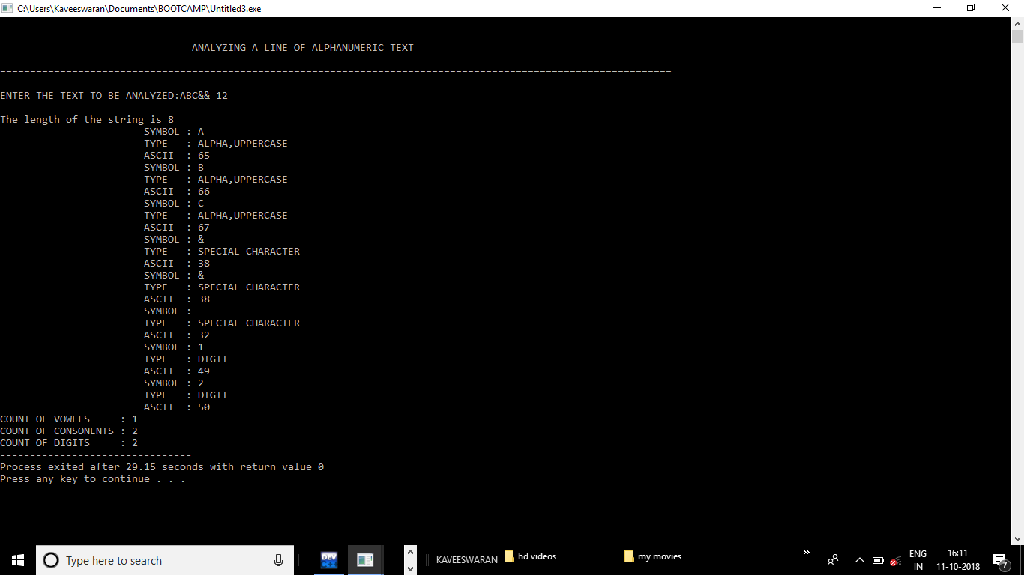

**47.C.3**

**USER ID VALIDATION CHECK**

#include<stdio.h>

#include<string.h>

static int i=0; //static global variable declaration

struct web //structure to store name and password of n users

{

char name[30],pass[30];

}w[99];

int n;

void reg(void); //function declaration

int main()

{

printf("\n\n\n\n\n\t\t\t\tWELCOME TO OUR PROJECT");

printf("\n\t\t\t\t=====================");

printf("\n\n\n\n\t\t\tPress Enter to proceed...!!");

if(getch()==13)

XY:

printf("\n\n\n\t\t\t1.REGISTER");

printf("\n\n\n\t\t\t\tPRESS 1 TO CONTINUE: ");

scanf("%d",&n);

switch(n)

{

case 1:

reg(); //function call

break;

default: printf("\n\n\t\t\t\tNO MATCH FOUND");

printf("\n\n\t\t\tPress Enter to re-Enter the choice");

if(getch()==13)

goto XY;

}

return 0;

}

void reg() //function definition

{

FILE *fp; //file pointer declaration

char c,checker[30]; int z=0;

fp=fopen("user_name.txt","ab+"); //creates file in append binary mode

printf("\n\n\t\t\t\tWELCOME TO REGISTER ZONE");

printf("\n\t\t\t\t^^^^^^^^^^^^^^^^^^^^^^^^");

for(i=0;i<100;i++)

{

printf("\n\n\t\t\t\t ENTER USERNAME: ");

scanf("%s",checker);

while(!feof(fp)) //termination condition

{

fread(&w[i],sizeof(w[i]),1,fp);

if(strcmp(checker,w[i].name)==0) //checks for duplicates

{

printf("\n\n\t\t\tUSERNAME ALREDY EXISTS");

reg();

}

else

{

strcpy(w[i].name,checker); //writes the name to structure

break;

}

}

// printf("\n\n\t\t\t\t DESIRED PASSWORD: ");

while((c=getch())!=13)

fwrite(&w[i],sizeof(w[i]),1,fp); //writes the name to file

fclose(fp);

printf("\n\n\tPress enter if you agree with Username");

if((c=getch())==13)

{

printf("\n\n\t\tYou are successfully registered");

}

break;

}

getch();

}

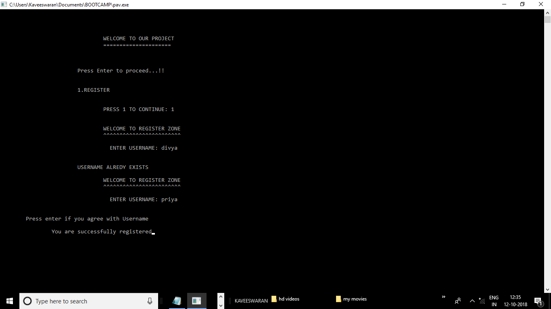

**47.C.4**

**PASSWORD VALIDATION CHECK**

#include<stdio.h>

#include<stdlib.h>

#include<string.h>

int main()

{

int i,length,lcc=0,dc=0,ucc=0,spcc; //lcc->lowercase count,ucc->uppercase

char a[100]; //dc->digit count,spcc->special character

printf("\n\n\t\t\t\tANALYZING A PASSWORD\n\n================================================================================================================");

printf("\n\nENTER THE PASSWORD:");

scanf("\n%[^\n\t]s",a);

length=strlen(a);

printf("\n\n\nThe length of the string is %d",length);

if(length>=8) //checks if the length of the password is //greater than or equal to 8 characters. {

for(i=0;i<length;i++)

{

if(a[i]>='a' && a[i]<='z')

{

lcc++; //increments lower case counter

}

else if(a[i]>='A' && a[i]<='Z')

{

ucc++; //increments uppercase counter

}

else if(a[i]>='0' && a[i]<='9')

{

dc++; //increments digit counter

}

else if(a[i]==' '||'&'||'*'||'$')

{

spcc++; //increments special char counter

}

}

printf("\n\n\nTHE LOWERCASE COUNT IS %d",lcc);

printf("\n\n\nTHE UPPERCASE COUNT IS %d",ucc);

printf("\n\n\nTHE DIGIT COUNT IS %d",dc);

printf("\n\n\nTHE SPECIAL CHARACTER COUNT IS %d",spcc);

if(ucc>=1 && dc>=2 && spcc>=2 &&lcc>=1) //checks constraints

{

printf("\n\n\nVALID PASSWORD");

}

else

printf("\n\n\nINVALID PASSWORD");

}

else

printf("\n\n\nINVALID PASSWORD");

}

