OrthoPharynx:

1. Fluconazole 200 MG Tablet

<http://navahealthcare.com/wp-content/uploads/2020/07/50-2-1024x1004.jpg>

1. [**Betahistine Dihydrochloride Tablets IP 16mg**](https://tajpharma.in/portfolio-item/betahistine-dihydrochloride-tablets-ip-16mg-taj-pharma-2/)

<https://tajpharma.in/wp-content/uploads/cache/images/BETAHISTINE-DIHYDROCHLORIDE-16MG-TABLETS-IP-BETHATAJ-TAJ-PHARMA-scaled/BETAHISTINE-DIHYDROCHLORIDE-16MG-TABLETS-IP-BETHATAJ-TAJ-PHARMA-scaled-2546697246.jpg>

1. Oravig 50 mg tablets

<https://media.empr.com/images/2010/04/21/oravig-product-shot2-copy_97036.jpg?format=jpg&zoom=1&quality=70&anchor=middlecenter&width=320&mode=pad>

1. ForTuss Otosan Syrup

<https://en.functional-cosmetics.com/out/pictures/generated/product/1/540_540_75/otosan-natuerlicher-hustensirup-fortuss.png>

1. Broncold Syrup

<http://health-zoom.worldwideshoppingmall.co.uk/health-aid-broncold-syrup-200ml.jpg>

Endocrine System:

1. Metformin Hydrochloride Prolonged-release & Glimepiride Tablets IP

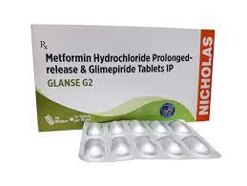

1. Endocrine Complete

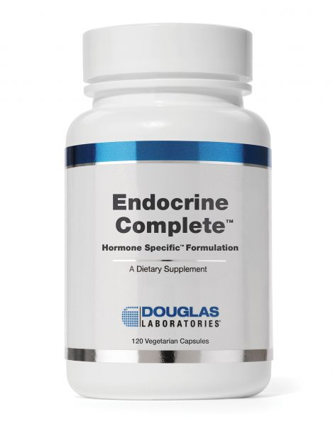

1. Glandin tablets

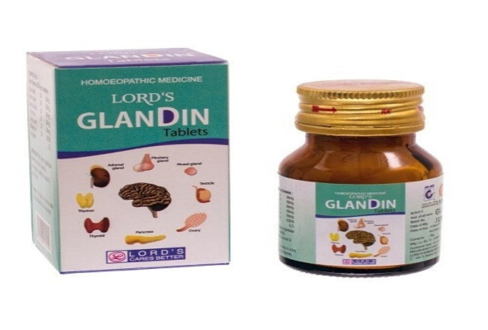

1. AntaGolin tablets

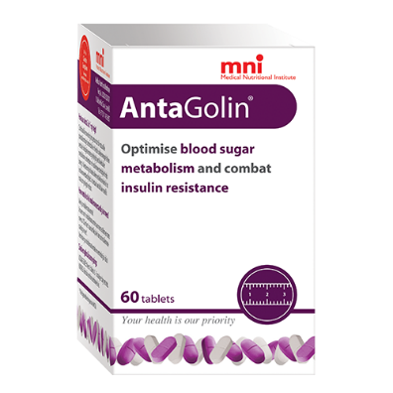

1. Hyponidd tablets

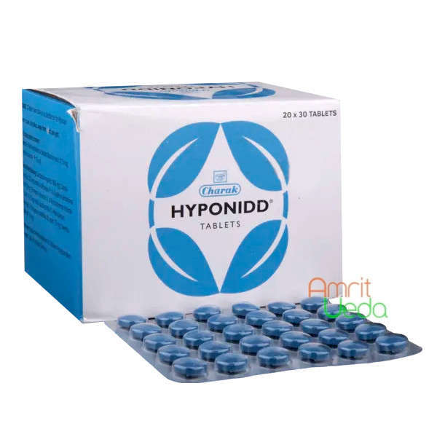

Skin :

# Himalaya Wellness Pure Herbs Skin Wellness Tablets - 60 Count (Neem)

# <https://m.media-amazon.com/images/I/61vrqywBOBL._AC_UL480_FMwebp_QL65_.jpg>

# 

# VAREY BOTANICS L-Glutathione Tablets 1000mg, Skin Whitening Capsules, Glowing Skin supplements with Vitamin C & E and Grape Seed Extract-For Men and Women -60 Capsules

# <https://m.media-amazon.com/images/I/71lXozvkiUL._AC_UL480_FMwebp_QL65_.jpg>

# 

# Neuherbs Hair Skin Vitamins Supplement with Biotin, Keratin booster for hair growth, Turmeric, Primrose Oil, Glutathione & Collagen- 60 Capsules for Men and Women

# <https://m.media-amazon.com/images/I/61ONMoYGVTL._AC_UL480_FMwebp_QL65_.jpg>

# 

# OZiva Glutathione Builder (with Vitamin C, ALA, Skin Vitamins & Selenium) for Skin Brightening, 60 Capsules

# <https://m.media-amazon.com/images/I/71KFTF0IniL._AC_UL480_FMwebp_QL65_.jpg>

# 

# Simply Herbal Collagen Supplement Tablets With Vitamin C & White Kidney Beans Promotes Skin & Hair Health Support Strong Nail & Joints For Women Girls - 60 Capsules

# <https://m.media-amazon.com/images/I/71XxduRHLQL._AC_UL480_QL65_.jpg>

# Nutrition:

# Pure Nutrition Iron tablets

# Pure Nutrition Iron, 60 Tablets Price, Uses, Side Effects, Composition - Apollo Pharmacy

# Mypro-Sport-Nutrition-Vitamin-Antioxidant

# Mypro Sport Nutrition Vitamin - C &amp; Zinc,Magnesium &amp; D3 Chewable Tablet Promotes A Healthy Immune Support,Antioxidant,(60 Tablet) Vegan,Keto Friendly &amp; Sugar Free,Immunity booster, For Men &amp; Women : Amazon.in: Health &amp;

# [Herbalife-nutrition-multivitamin-mineral-herbal-](https://www.google.com/url?sa=i&url=https%3A%2F%2Fwww.flipkart.com%2Fherbalife-nutrition-multivitamin-mineral-herbal-tablet%2Fp%2Fitmc8a33838bab8f&psig=AOvVaw0ATG_CXIxxYvum277mA77z&ust=1646130495267000&source=images&cd=vfe&ved=2ahUKEwiRhdWMmKL2AhWAR2wGHbclCK4Qr4kDegUIARDaAg)

# Herbalife Nutrition MULTIVITAMIN MINERAL &amp; HERBAL TABLET Price in India - Buy Herbalife Nutrition MULTIVITAMIN MINERAL &amp; HERBAL TABLET online at Flipkart.com

# multivitamins-tablets

# Multivitamins Tablets Efficacy: Promote Nutrition, Price Range 150.00 - 250.00 INR/Box | ID: c2370194

# Nutrition-Plus-Multivitamins-Tablets

# Nutrition Plus Multivitamins 1200 Mg+, 28 Essential Nutrients Including 24 Vitamins &amp; Minerals, 60 Tablets Health Supplement for Daily use to Boost Immunity, Energy &amp; Stamina to Stay Healthy : Amazon.in: Health &amp; Personal Care

# Overweight and Obesity:

# Xenical 120mg

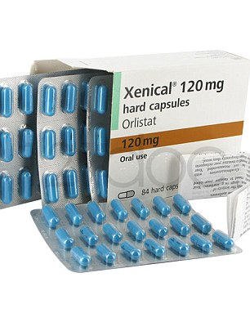

1. Obenyl tablets

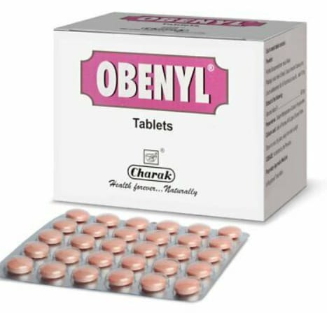

Injury Relief:

1. Injury Relief

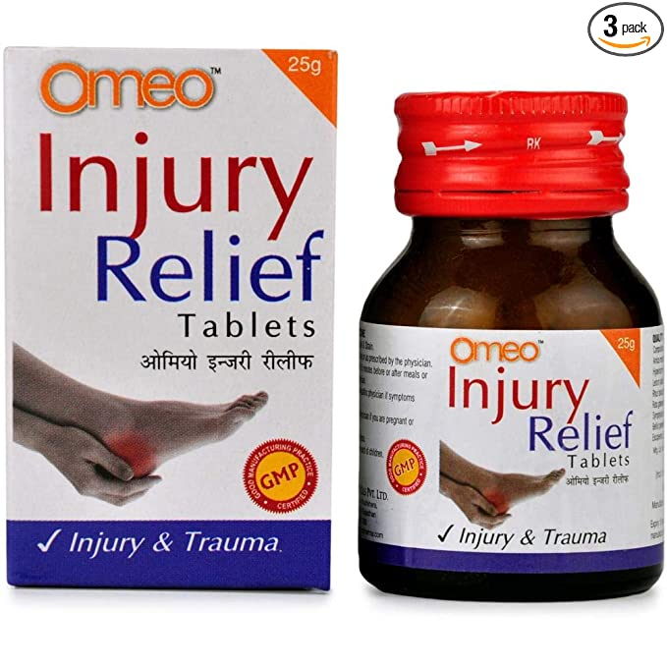

1. HealFast

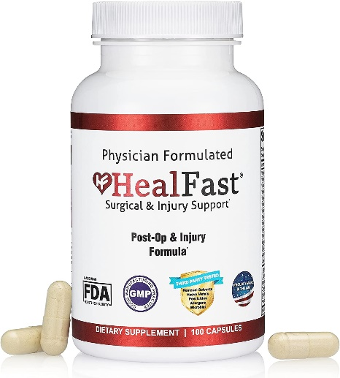

1. Cipladine Ointment

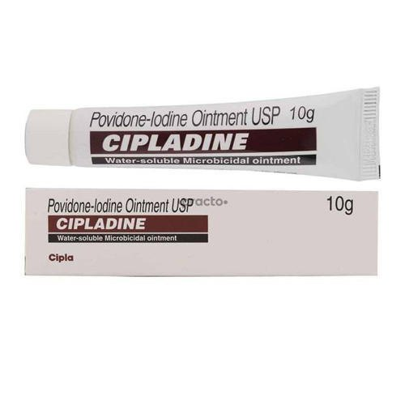

1. Betadine

